Supplementary Figure 1
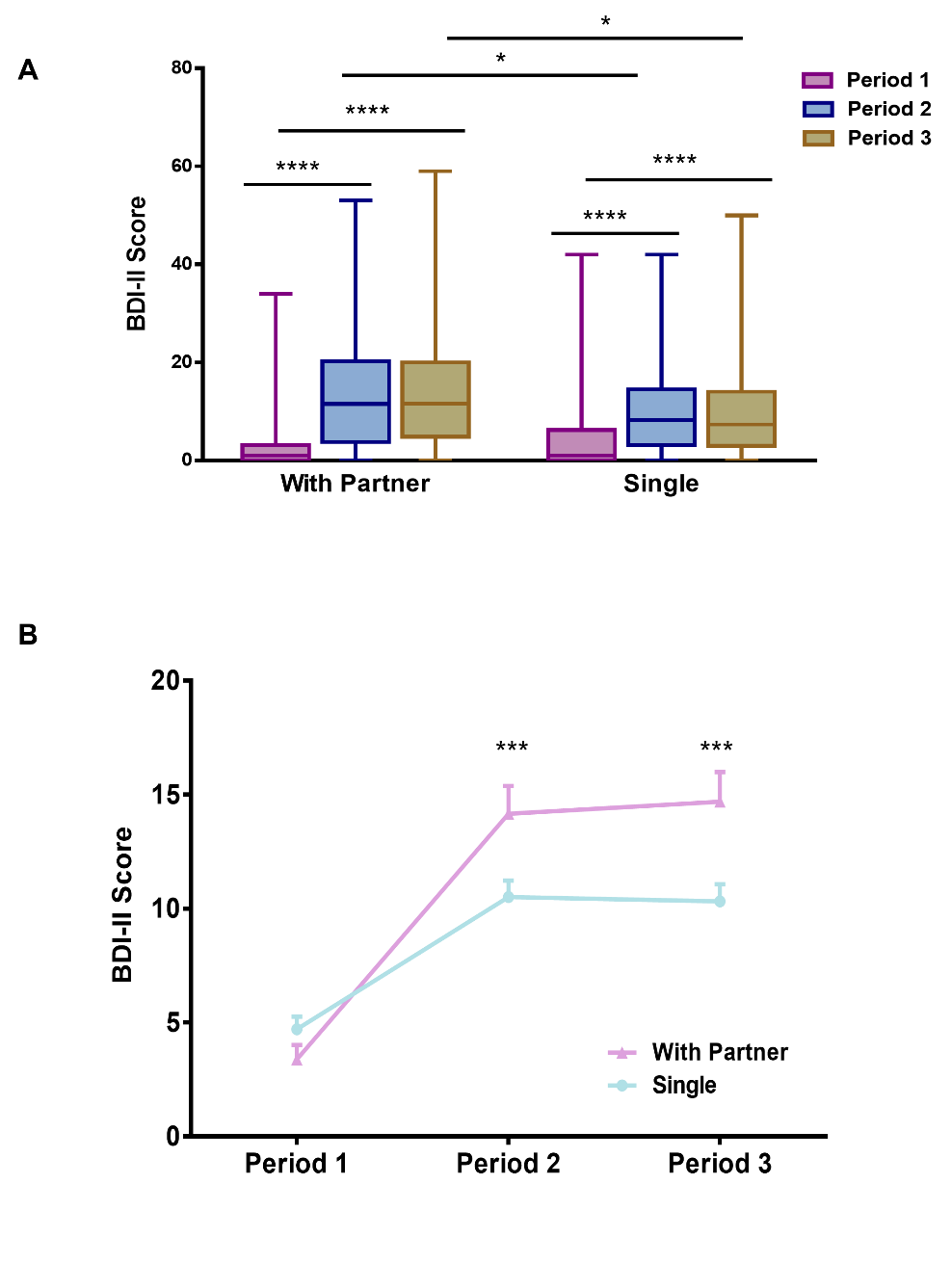
Figure 2：Effect of quarantine romantic relationship on depression. (A) BDI-II scores of students with (with a partner) or without (single) romantic relationships in three quarantine periods. The box plot shows the lower quartile/25th percentile (bottom of the box), the upper quartile/75th percentile (top of the box), and the median (line within the box). (B) Median change in BDI-II scores over three periods. (*, **, ***, ****: p < 0.05, 0.01, 0.001, 0.0001 respectively, otherwise not significant).

Supplementary Figure 2
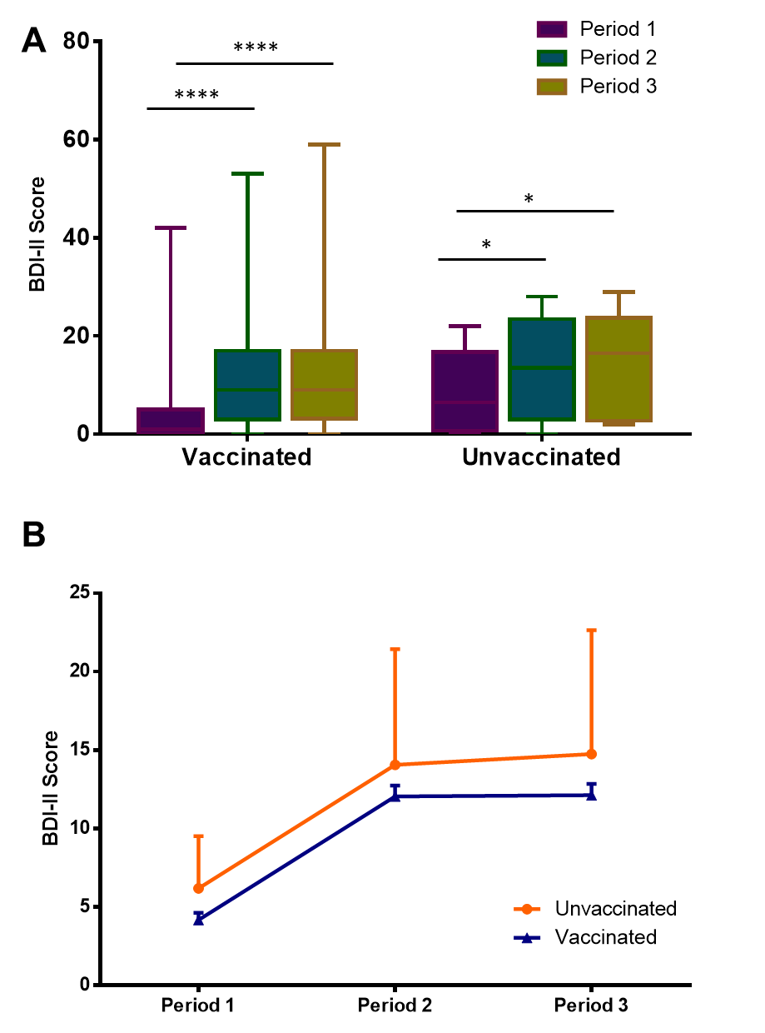
Supplementary Figure 1： Effect of COVID-19-vaccination on Psychological protection against depression. (A)BDI-II scores of students whether vaccinated in three quarantine periods. The box plot shows the lower quartile/25th percentile (bottom of the box), the upper quartile/75th percentile (top of the box), and the median (line within the box). (B) Median change in BDI-II scores over three periods. (*, **, ***, ****: p < 0.05, 0.01, 0.001, 0.0001 respectively, otherwise not significant).

