Supporting information for
ISPRF: a machine learning model to predict the immune subtype of kidney cancer samples by four genes
Zhifeng Wang^{1†}, Zihao Chen^{2†}, Hongfan Zhao^{3,} Hao Lin², Junjie Wang¹, Ning Wang¹, Xiqing Li⁴, Degang Ding¹

1 Department of Urology, Henan Provincial People’s Hospital, Zhengzhou, 450003, China
2 Department of Urology, Nanfang Hospital, Southern Medical University, Guangzhou, 510515, China
3 Department of Nephrology and Medical Intensive Care, Charité-Universitätsmedizin, Berlin, Germany
4 Oncology Department, Henan Provincial People’s Hospital, Zhengzhou, 450003, China

*Corresponding author:
Degang Ding, Department of Urology, Henan Provincial People’s Hospital, Zhengzhou, 450003, China. E-mail: drdegang@126.com
†These authors contributed equally to this work

Pathway | Padj | NES | Size
PPAR signaling pathway | <0.05 | -2.076462405 | 69
Oxidative phosphorylation | <0.05 | -2.075496402 | 116
Vibrio cholerae infection | <0.05 | -2.01780083 | 52
Fatty acid metabolism | <0.05 | -1.99482005 | 42
Retinol metabolism | <0.05 | -1.927153616 | 63
Tyrosine metabolism | <0.05 | -1.908248892 | 41
Drug metabolism cytochrome P450 | <0.05 | -1.829246779 | 70
Glycolysis gluconeogenesis | <0.05 | -1.793530881 | 61
Propanoate metabolism | <0.05 | -1.779770488 | 32
Epithelial cell signaling in Helicobacter pylori infection - | <0.05 | -1.773782491 | 67

Supplement Table 1. The enriched pathways in immune subtype1. NES: normalized enrichment score. Padj: adjusted P-values [the false discovery rate (FDR)]. A negative NES means that genes over-represented in the gene set are upregulated in immune subtype1.

Pathway | Padj | NES | Size
Natural killer cell mediated cytotoxicity | <0.05 | 2.101136753 | 130
Leishmania infections | <0.05 | 2.112326976 | 69
Asthma | <0.05 | 2.147862606 | 28
T cell receptor signaling pathway | <0.05 | 2.203600853 | 106
Chemokine signaling pathway | <0.05 | 2.213683506 | 184
Allograft rejection | <0.05 | 2.244700522 | 35
Graft versus host disease | <0.05 | 2.25556481 | 37
Primary immunodeficiency | <0.05 | 2.271887799 | 35
Cytokine-cytokine receptor interaction | <0.05 | 2.28028487 | 257
Intestinal immune network for IgA production | <0.05 | 2.310500831 | 46
Antigen processing and presentation | <0.05 | 2.363167045 | 79
Supplement Table 2. The enriched pathways in immune subtype2. NES: normalized enrichment score. Padj: adjusted P-values [the false discovery rate (FDR)]. A positive NES means that genes over-represented in the gene set are upregulated in immune subtype2.

Characteristics | Type | Sample (Rate)
Immunotherapy outcome | CR/PR  SD/PD  NA | 68(19%)  230(66%)  50(15%)
Gender | Male  Female | 272(78%)  76(22%)
Tobacco history | Previous  Never  Current | 197(57%) 116(33%)  35(10%)
Received Platinum | Yes  No | 272(78%) 76(22%)
Immunotype | CTL+  Treg+  Non-infiltrating | 116(33%)  116(33%) 116(33%)

Supplement Table 3. Baseline characteristics of patients in the IMvigor210 cohort. Note: CR = complete remission; PR = partial remission; SD = Stable Disease; PD = Progressive Disease; NA = Data is not available.

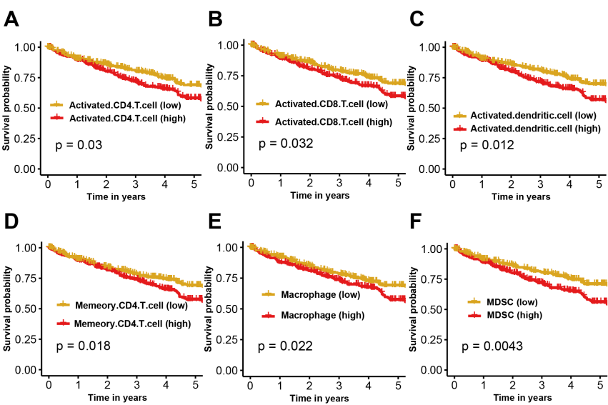
Supplementary Figure 1. Overall survival results of immune cells are significantly different between groups (determined by the median value).

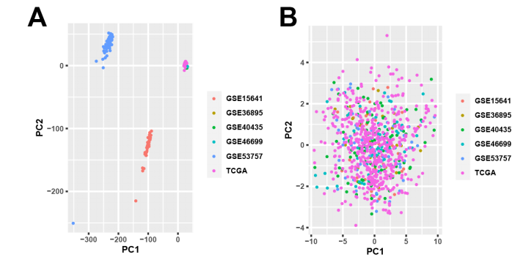

Supplementary Figure 2. Two-dimensional plots are shown of principal components calculated principal components analysis (PCA). (a) PCA of the expression matrix of six different datasets. (b) PCA of the immune cells enrichment scores of six different datasets.

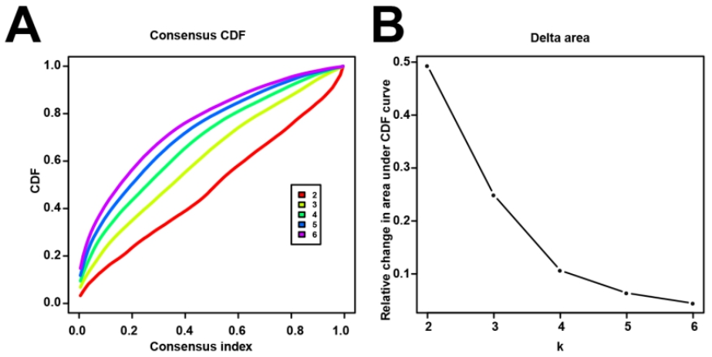
Supplementary Figure 3. (a) Consensus clustering cumulative distribution function (CDF) for k=2 to 6. (b) Delta area curve of consensus clustering, indicating the relative change in area under CDF curve for each category number k compared with k−1. The horizontal axis represents the category number k, and the vertical axis represents the relative change in area under the CDF curve.

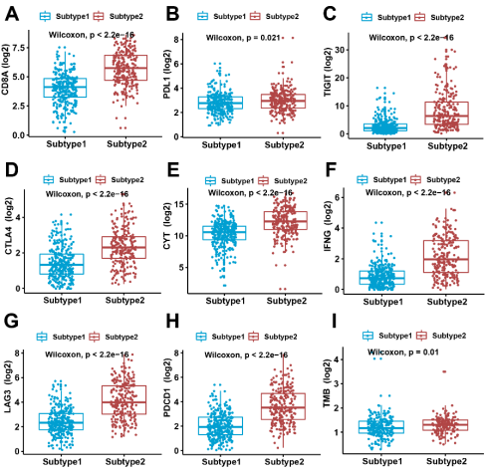
Supplementary Figure 4. Comparison of the tumor immunotherapy indicators between the two immune subtypes in TCGA dataset. Subtype2 tumors had significantly higher CD8A, PDL1, TIGIT, CTLA4, CYT, IFNG, LAG3, PD1 (PDCD1) and tumor mutational burden (TMB) than subtype1 tumors (p < 0.05).

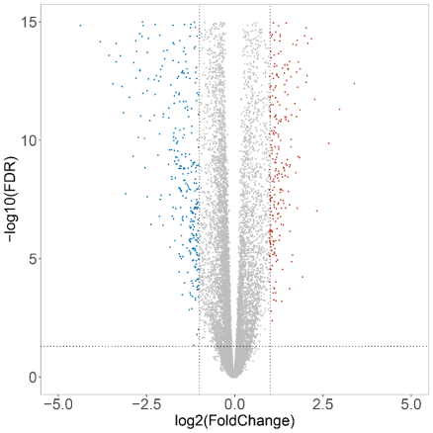
Supplementary Figure 5. Volcano plot showing the gene expression differences between immune subtypes. Blue dots, down-regulated genes in subtype2. Red dots, up-regulated genes in subtype2.

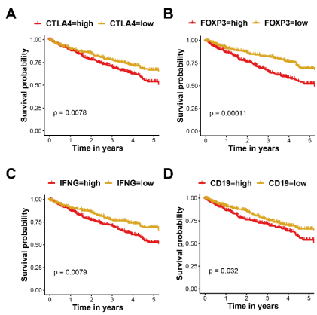
Supplementary Figure 6. Overall survival results of four hub genes in turquoise module are significantly different between groups (determined by the median value).

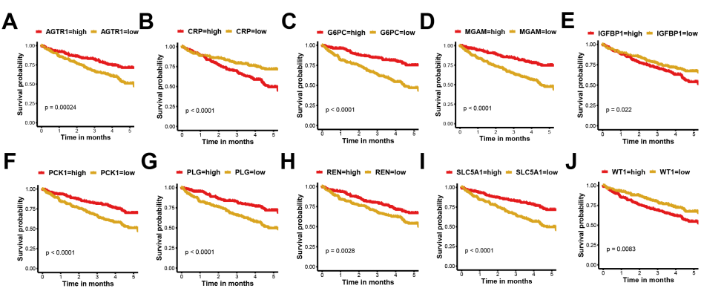
Supplementary Figure 7. Overall survival results of ten hub genes in blue module are significantly different between groups (determined by the median value).

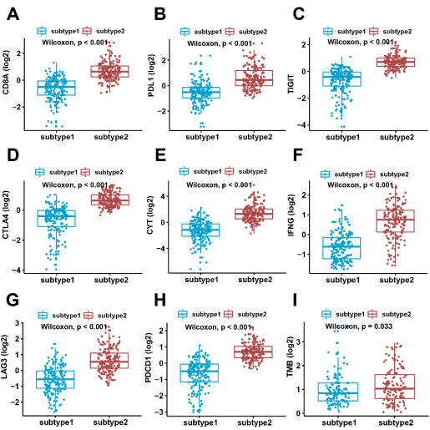
Supplementary Figure 8. Comparison of the tumor immunotherapy indicators between the two immune subtypes in IMvigor210 dataset. Subtype2 tumors had significantly higher CD8A, PDL1, TIGIT, CTLA4, CYT, IFNG, LAG3, PD1 (PDCD1) and TMB than subtype1 tumors (p < 0.05).

