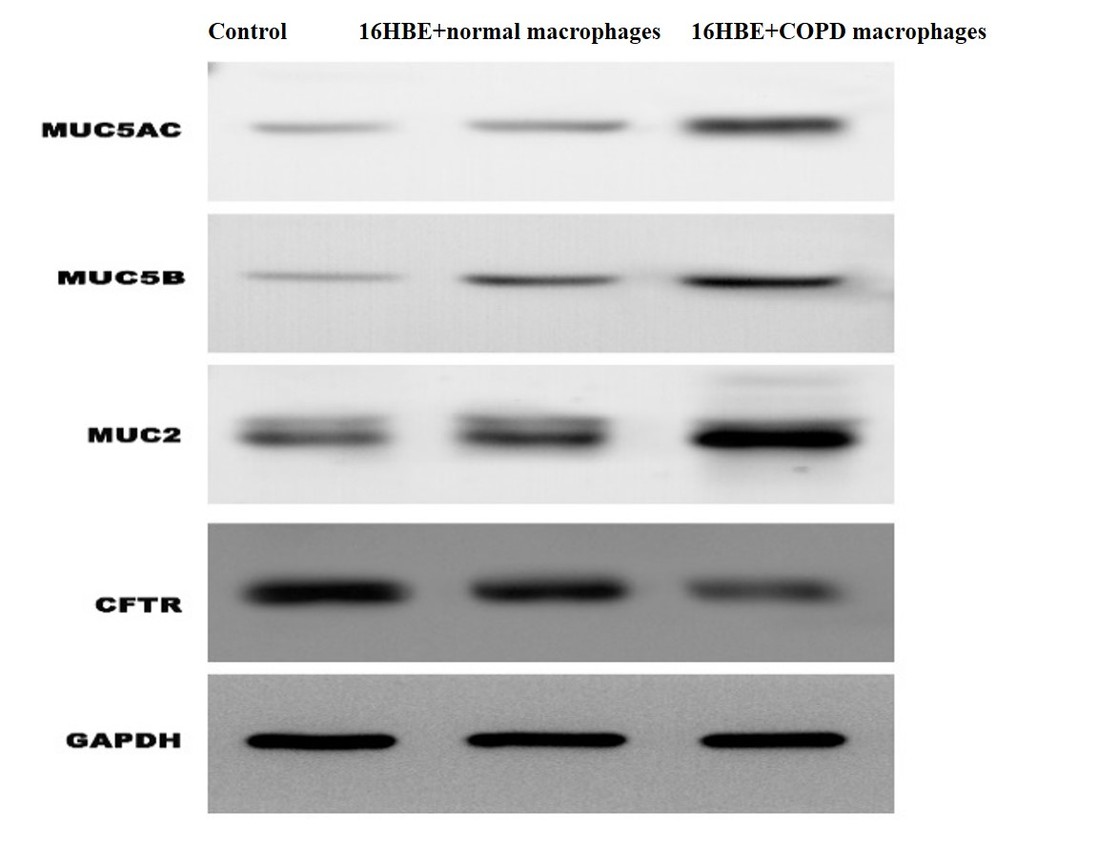
Figure 2A
The western blot of expression of mucin and CFTR in 16HBE. The expression of mucin in 16HBE was increased after co-culture with macrophages from COPD. The expression level of CFTR in 16HBE was decreased after co-culture with macrophages from COPD.
Figure 2A.a (MUC5AC)

Figure 2A.b (MUC5B)
Figure 2A.c (MUC2)

Figure 2A.d (CFTR)

Figure 2A.e (GAPDH)

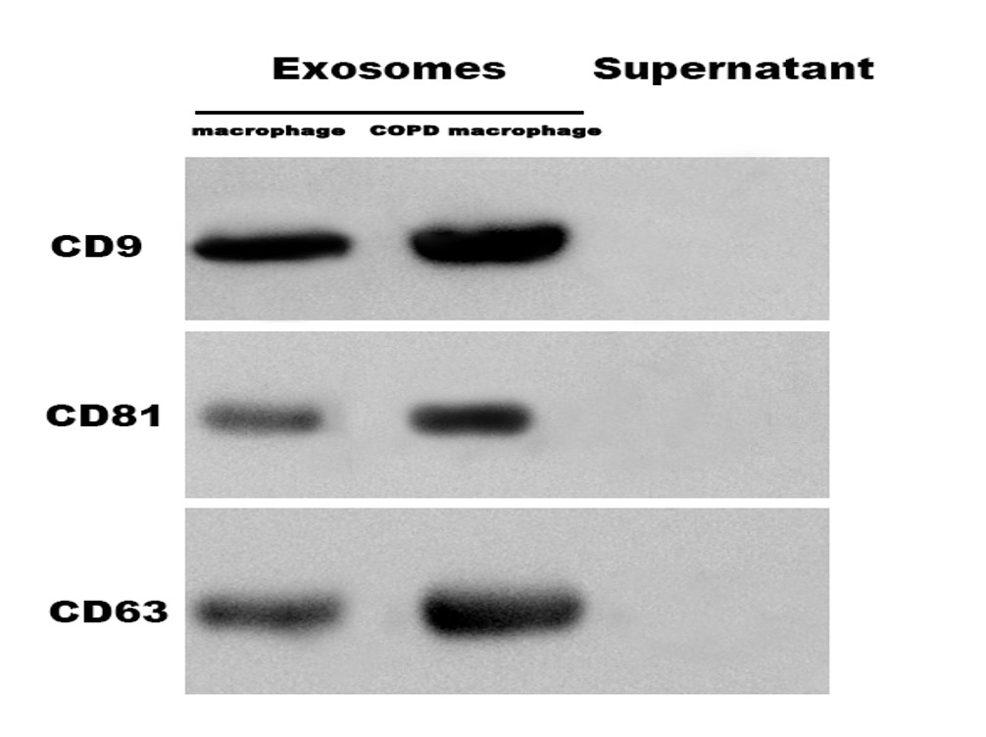
Figure 3A
Western blot bands for specific markers on the surface of exosomes. CD9, CD63 and CD81 were positive in exosomes.

Figure 3A.a (CD9)
Figure 3A.b (CD81)

Figure 3A.c (CD63)

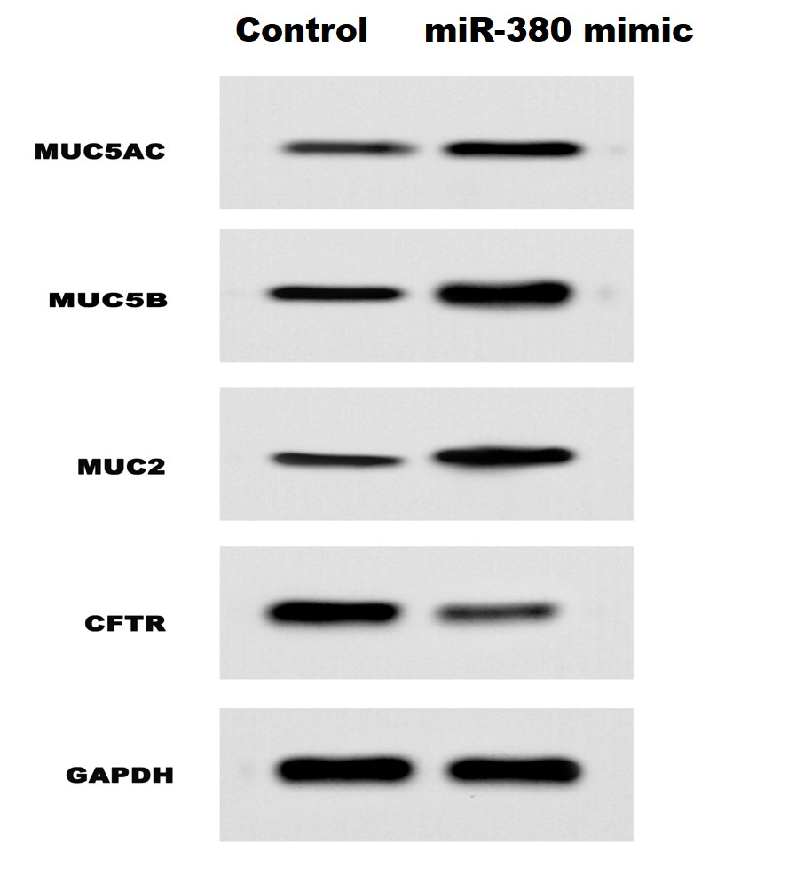
Figure 6A The western blot of expression of mucin and CFTR in 16HBE. The expression levels of MUC5AC, MUC5B and MUC2 of 16HBE in miR-380 mimic group were significantly higher than those in the control group. The CFTR expression level was down-regulated in miR-380 mimic group.

Figure 6A.a (MUC5AC)

Figure 6A.b (MUC5B)

Figure 6A.c (MUC2)

Figure 6A.d (CFTR)

Figure 6A.e (GAPDH)

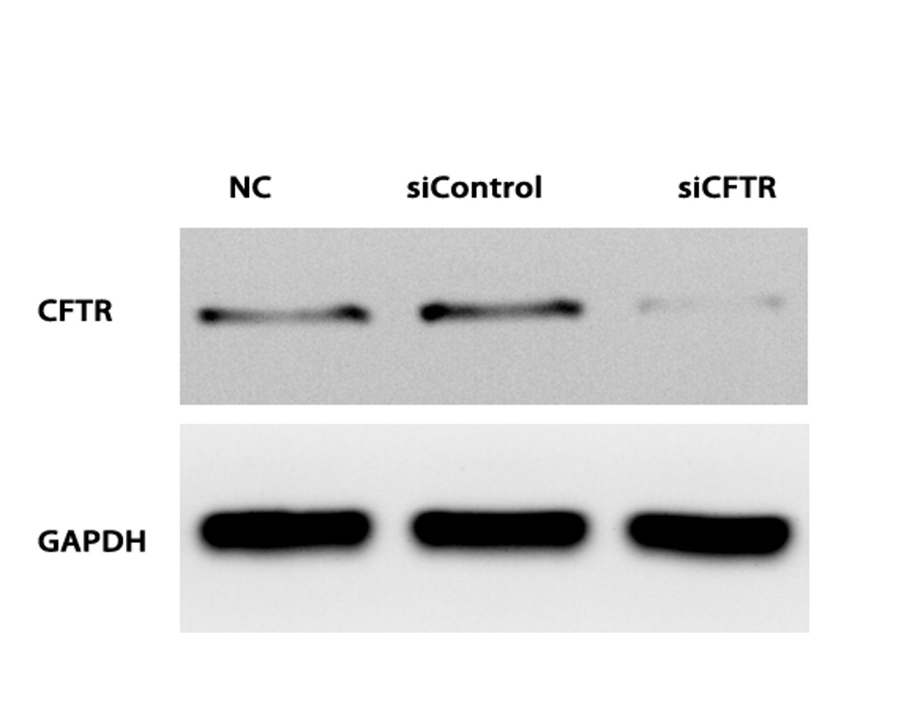
Figure 8A The western blot of CFTR expression in 16HBE. CFTR of 16HBE was significantly decreased by siRNA in 16HBE.

Figure 8A.a (CFTR)

Figure 8A.b (GAPDH)

