Bereziskii-Kosterlitz-Thouless transition in the Weyl system PtBi₂
Supplementary information
Arthur Veyrat$​^{1}$ , Valentin Labracherie$​^{1}$ , Rohith Acharya$​^{1}$ , Dima L. Bashlakov$​^{2}$, Federico Caglieris$​^{1,3}$, Jorge I. Facio$​^{1}$, Grigory Shipunov$​^{1}$, Lukas Graf$​^{1}$, Johannes Schoop$​^{1,4}$, Yurii Naidyuk$​^{2}$, Romain Giraud$​^{1,5}$, Jeroen van den Brink$​^{1,4}$, Bernd Büchner$​^{1,4}$, Christian Hess$​^{1,6,7}$, Saicharan Aswartham$​^{1}$ & Joseph Dufouleur $​^{1,6,*,†}$
$​^{1}$Leibniz Institute for Solid State and Materials Research (IFW Dresden), Helmholtzstraße 20, D-01069 Dresden, Germany
$​^{2}$B. Verkin Institute for Low Temperature Physics and Engineering, NASU, 47 Nauky Ave., 61103 Kharkiv, Ukraine
$​^{3}$CNR-SPIN, Corso Perrone 24, 16152 Genova, Italy
$​^{4}$Department of Physics, TU Dresden, D-01062 Dresden, Germany
$​^{5}$Université Grenoble Alpes, CNRS, CEA, Grenoble-INP, Spintec, F-38000 Grenoble, France
$​^{6}$Center for Transport and Devices, TU Dresden, D-01069 Dresden, Germany
$​^{7}$Fakultät für Mathematik und Naturwissenschaften, Bergische Universität Wuppertal, D-42097 Wuppertal, Germany

S1 - Fermi arcs
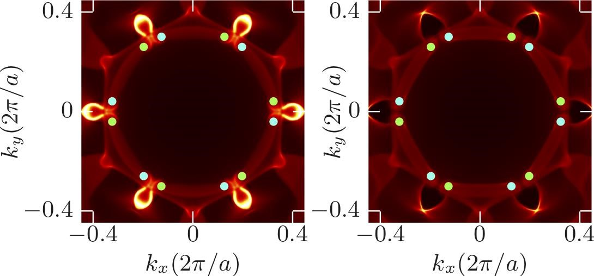
Fig-SI 1 Surface Fermi surface corresponding to the charge neutrality point. Green (light blue) points correspond to the projection of Weyl nodes of positive (negative) chirality. Left: [001] Bi₂-terminated surface. Right: [001] Bi₄-terminated surface.

S2 - Temperature dependence
We present below the temperature dependence of the resistivity of a single macroscopic crystal exhibiting a residual resistance ratio of about 130.
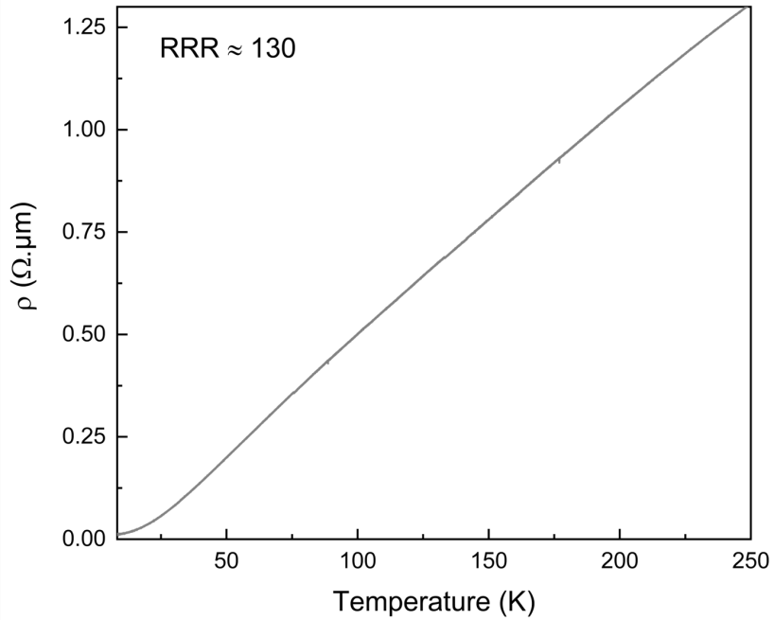
Fig-SI 2 Temperature dependence of the resistivity of a macroscopic crystal between 𝑇 = 300 K and 4.2K.

S3 - Isotropy of the critical field in a macroscopic structure
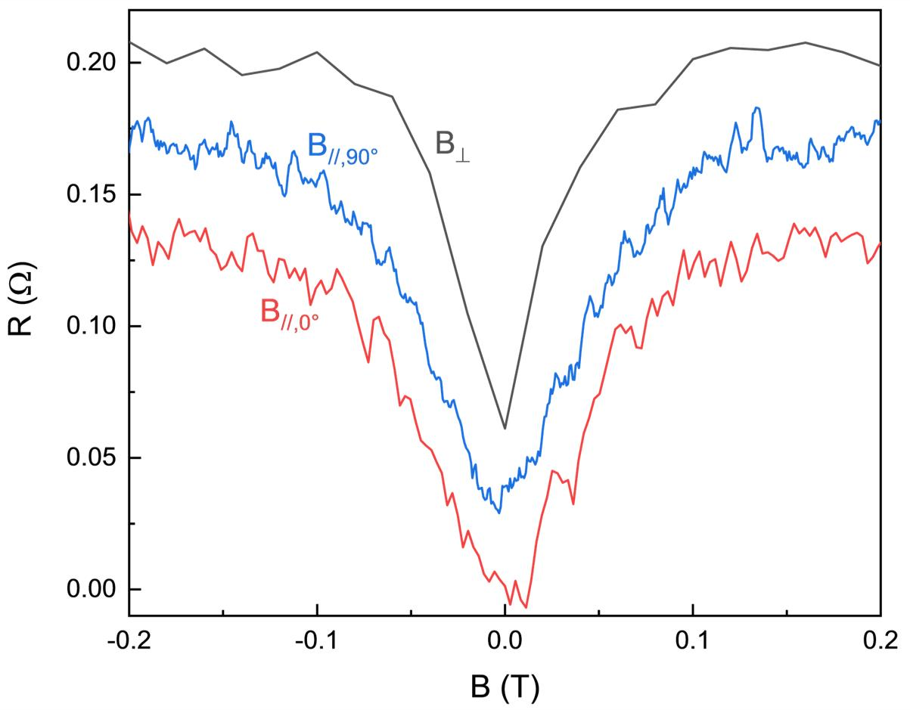
Fig-SI 3 Magnetoresistance of a macroscopic crystal of PtBi₂ with the magnetic field applied out-of-plane (𝐵⊥) or along the two perpendicular in-plane directions (𝐵_{∥,0°} and 𝐵_{∥,90°}) measured at low temperature (𝑇 ∼ 100 mK). For the sake of clarity, the different curves are shifted.

S4 - Point contact measurements for different magnetic fields
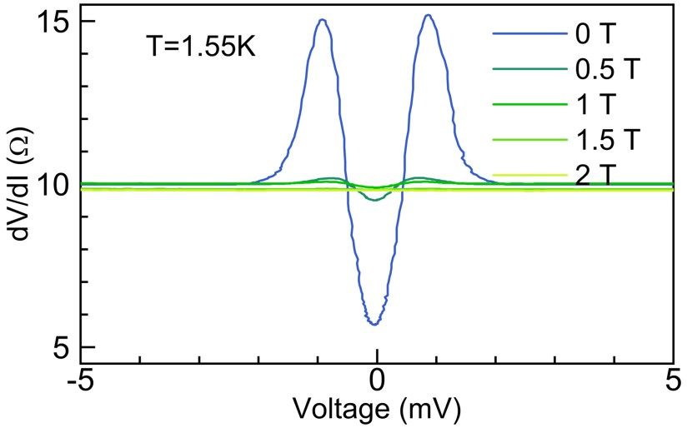
Fig-SI 4 Differential resistance 𝑑𝑉/𝑑𝐼 as a function of the DC voltage in point contact measurements at different magnetic fields between 0 T and 2 T at 1.55 K, indicating the onset of the superconductivity below 1 T for 𝑇 = 1.55 K.
As for the temperature, point-contact measurements show an enhanced local superconductivity in magnetic field likely due to local pressure, with indications of superconductivity at magnetic fields up to 1T. This value is six times larger than its bulk pressure value (≈ 150 mT). The Fig-SI 4 shows the enhancement of 𝐵_{c} at 𝑇 = 1.55 K under the point contact for a magnetic field applied along the c-axis. The differential resistance (dV/dI) shows a zero-bias drop of almost 50% at 0 T and 1.55 K. At this temperature, a deviation from the ohmicity is observed at magnetic field up to 1 T, far beyond its bulk value.

S5 - Magnetoresistances of the nanostructure
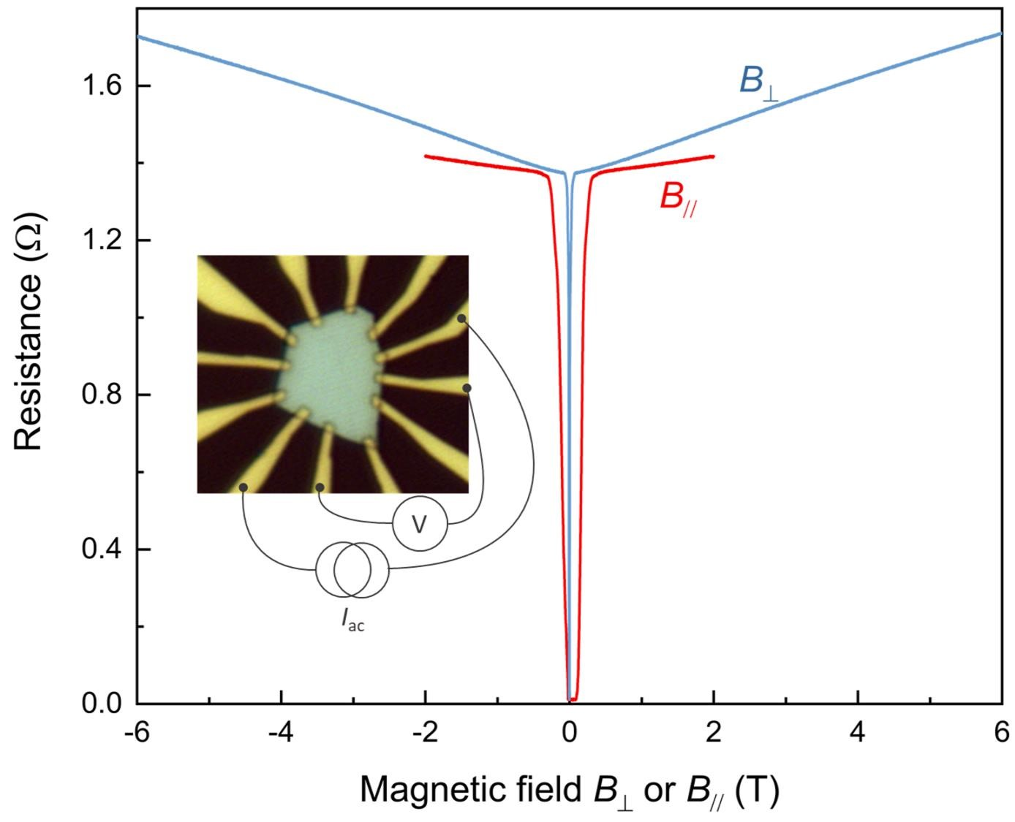
Fig-SI 5 The magnetoresistances at 𝑇 ∼ 100 mK for an in-plane and out-of-plane magnetic fields are shown in red and blue respectively. A picture of the sample can be seen in the graph together with the connection configuration for the measurements of the magnetoresistances. The typical size of the sample is about 10𝜇m.
The Fig-SI 5 shows the magnetoresistances along the c-axis of the exfoliated crystal and for a field aligned in the a-b plane of the nanostructure. Measurements are done at 𝑇 ≃ 100 mK and with an AC current of 5 𝜇A. The perpendicular field can be swept up to ± 6T (the main coil of the 3D magnet system) whereas the parallel field could be swept only up to ± 2T. As for the macroscopic single crystal, the magnetoresistance is found to be almost linear and it is larger for a perpendicular field.

S6 - dV/dI for different contact pairs
Although the critical current is almost independent of the set of contacts considered, the exact shape of the differential resistance dV/dI(𝐼_{dc}) depends on the set considered. Some contacts shows a single peak shape whereas others have several peaks, as seen in the Fig-SI
6.
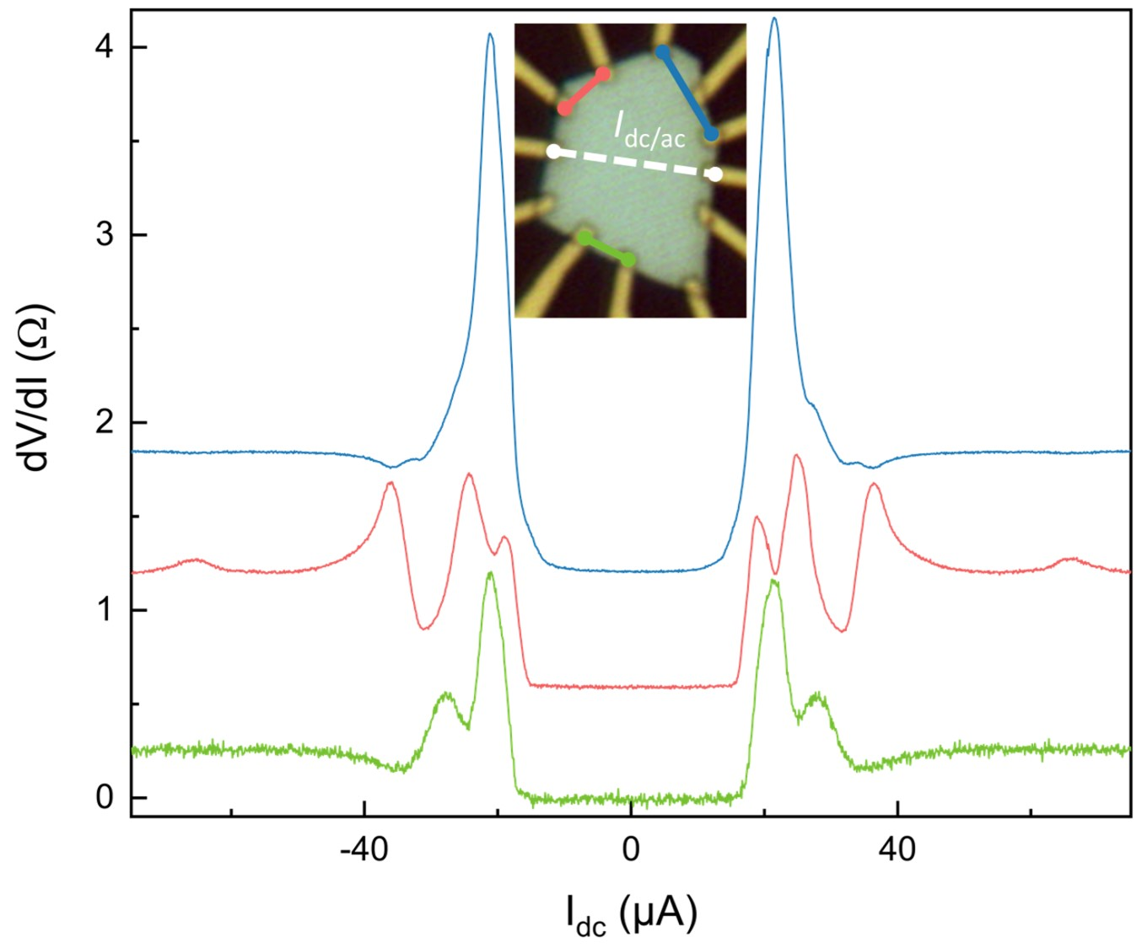
Fig-SI 6 𝑑𝑉/𝑑𝐼(𝐼_{dc}) measured at 𝑇 ≃ 100~mK for different set of contacts. The ac current is 1 µA and the differential resistance remains constant for higher dc-current. The contact configuration is indicated in the picture with the colors corresponding to the color of the curves.
Moreover, this feature does not depend on the contacts used for current bias, as shown in Fig-SI 6 and Fig-SI 7.
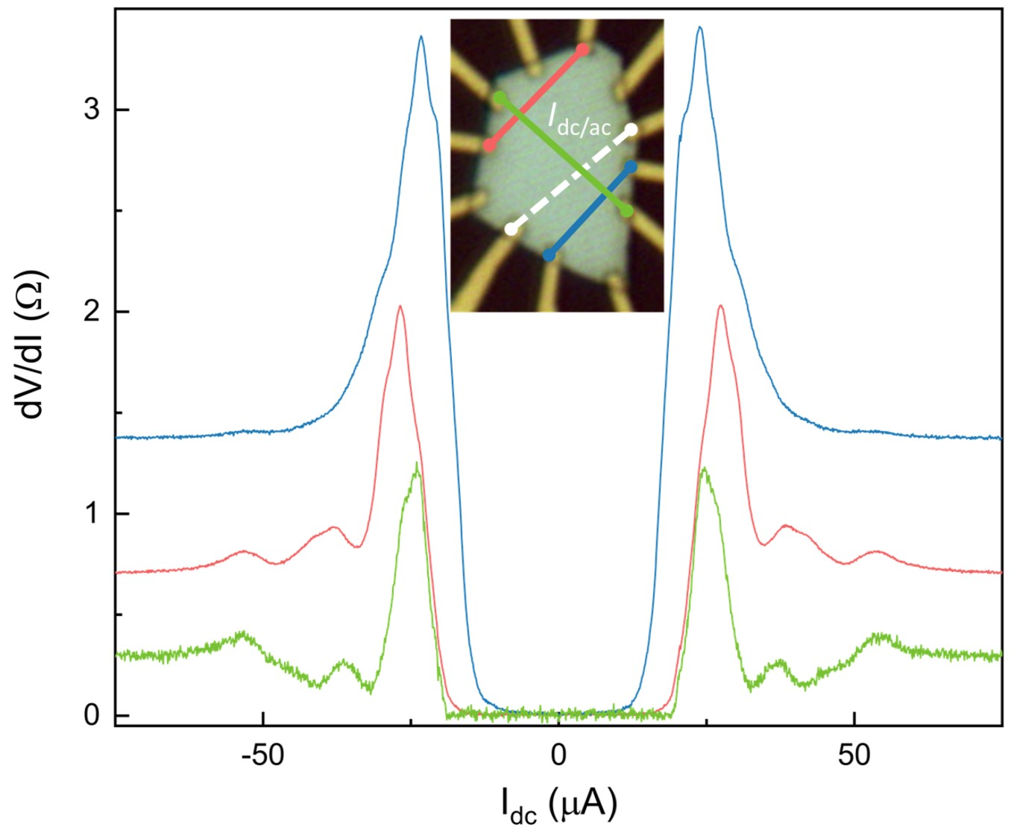
Fig-SI 7 Similar measurements as shown in Fig-SI 6 with different contacts used for both current bias and voltage probes.

S7 - Critical current versus magnetic field
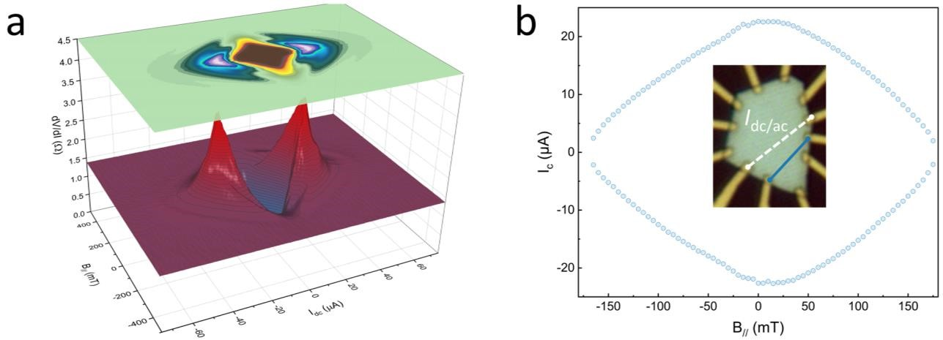
Fig-SI 8 (a) Mapping of 𝑑𝑉/𝑑𝐼(𝐼_{dc}) for different parallel magnetic field measured for − 75𝜇𝐴 ≤ 𝐼_{dc} ≤ 75𝜇𝐴 and with 𝐼_{ac} = 1A. (b) Parallel magnetic field dependency of the critical current as defined in the text for the same contacts as for (a). The contacting configuration is indicated in the inset of (b).
We measured the dependence of the dV/dI(𝐼_{dc}) with the magnetic field. In both directions 𝐵⊥ and 𝐵∥, the critical current as defined in the main text (𝑅(𝐼_{c}) = 𝑅_{N}/2) is found to be proportional to the magnetic field with a larger sensitivity when the field is applied along the perpendicular direction. The results are indicated in Fig-SI 8 for an in-plane magnetic field and in Fig-SI 9 for an out-of-plane magnetic field. The diamond shape of 𝐼_{c}(𝐵) in both directions indicates the proportionality of 𝐼_{c} with 𝐵.
All the dV/dI show a similar diamond shape like, including the multi-peaked differential resistance.
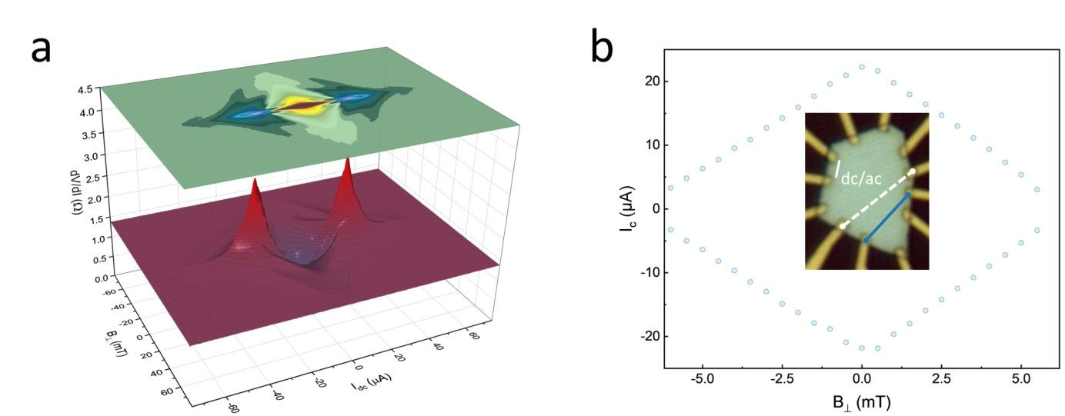
Fig-SI 9 (a) Mapping of 𝑑𝑉/𝑑𝐼(𝐼_{dc}) for perpendicular parallel magnetic field measured for −75𝜇A ≤ 𝐼_{dc} ≤ 75𝜇A and with 𝐼_{ac} = 1A. (b) Perpendicular magnetic field dependency of the critical current as defined in the text for the same contacts as for (a). The contacting configuration is the same as in Fig-SI 8 and is indicated in the inset of (b).

S8 - Critical current versus temperature
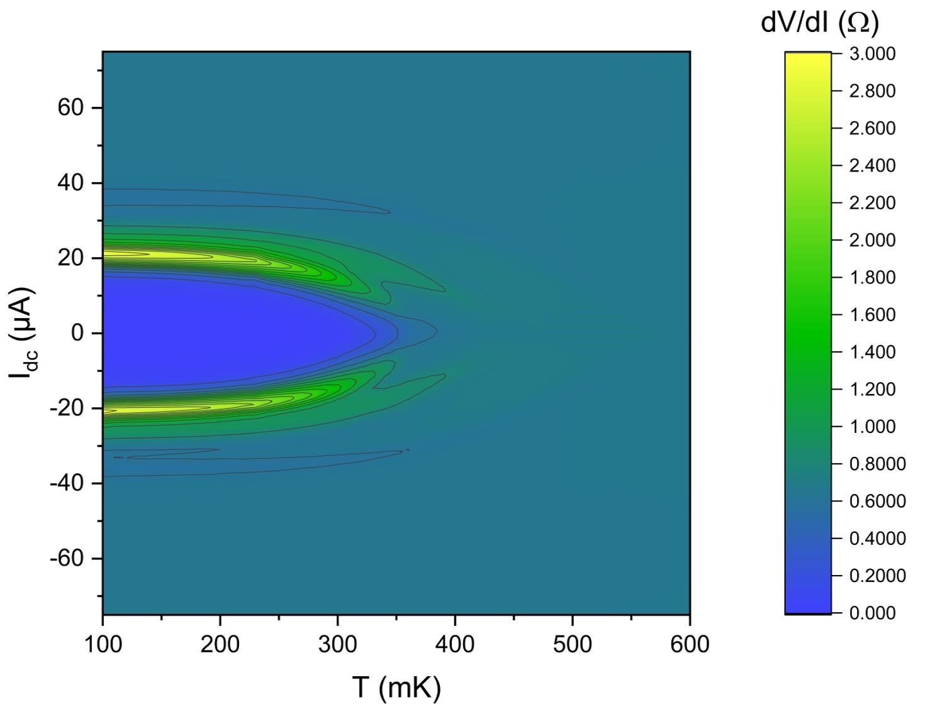
Fig-SI 10 𝑑𝑉/𝑑𝐼(𝐼_{dc}) measured at different temperatures, for −75𝜇A ≤ 𝐼_{dc} ≤ 75𝜇A and with 𝐼_{ac} = 1 𝜇A.
Data of the Figure 3.a presented in a two-dimensional plot where the temperature dependency of the maximum of the dV/dI can be shown. Such a maximum is located at a dc current that corresponds almost exactly to the critical current so that the temperature evolution of the maximum also stands for the temperature dependency of 𝐼_{c}. The measurements are done by increasing the temperature by steps of 10 mK with a stabilization time of about 35 min between two dV/dI(𝐼_{dc}) sweeps so that the sample is very well thermalized.

S9 - temperature dependence of the critical field for another set of contacts
An example of the temperature dependence of 𝐵_{c,⊥} is shown in black in Fig-SI 11 for a set of contacts indicating a discontinuous slope at about 330 mK, similar to the contact indicated in the main text (reproduced in blue). A set of contacts for which the accuracy of the measurement of 𝐵⊥ is not enough to resolve the discontinuity of the slope is also indicated in red.
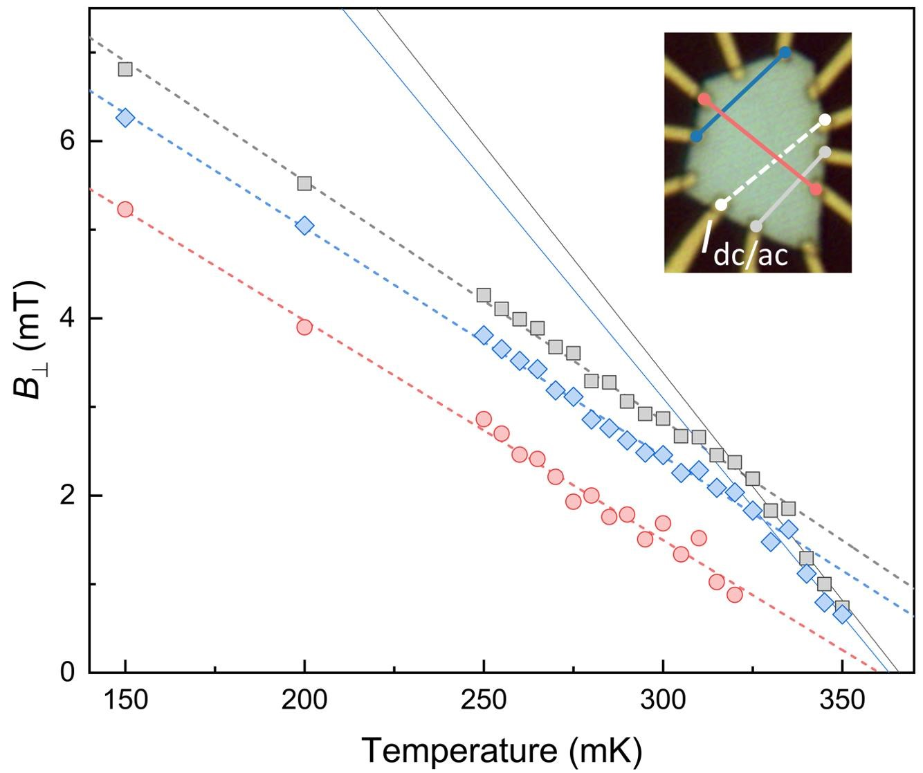
Fig-SI 11 Temperature dependence 𝐵_{c,⊥(𝑇)} for different set of contacts indicated in the inset. The blue points are the data points already shown in the main text. The black points are the data points for a set of contact where the discontinuity of the slope is clearly visible, similar to the one reproduced in the main text whereas the red points are the points for which no discontinuity could be measured because of the too low accuracy of the determination of 𝐵⊥ close to 𝑇_{c}.

S10 - Temperature dependence of the resistance for different contacts with the fit to BKT
Three additional temperature dependences were measured and fitted with the BKT model for different set of contacts for voltage probes, source and drain. The results are shown in the Fig-SI 12.
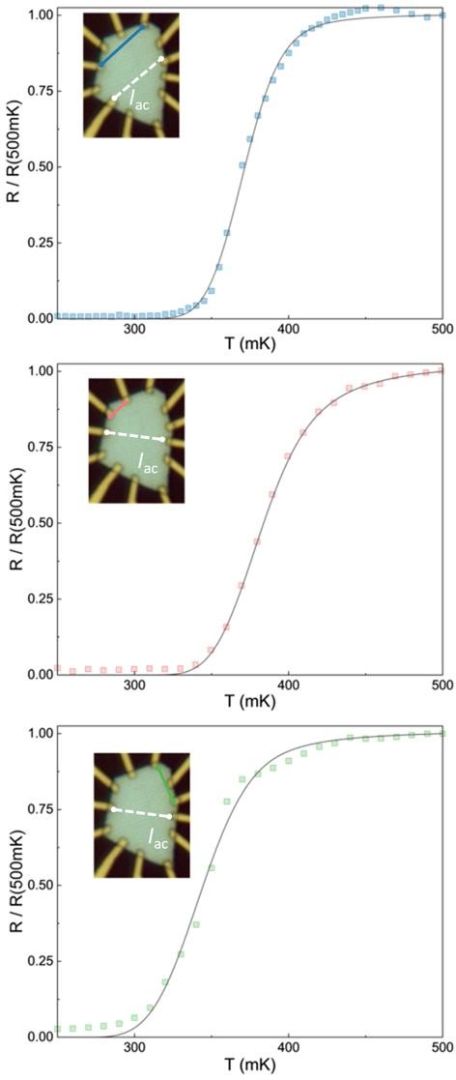
Fig-SI 12 The 𝑅(𝑇) measured for different set of contacts indicated in the inset and fitted by equation 6 in the main text. The ac current was 1 𝜇A and the measurements were done by increasing the temperature by steps of 10 mK with a total stabilization time longer than one hour so that the sample is very well thermalized.
We summarize in Table-SI 1 the results obtained from the fit of the different experimental data with the equation (6) in the main text. The value of the BCS critical temperature is calculated based on the parameter given by the fit of 𝑅(𝑇) assuming 𝛼 = 1. The value of 𝑇_{BKT} is fixed by the analysis of the 𝐼(𝑉) at different temperature as explained in the main text.
contact | $T_{\text{BKT}}$ (mK) | parameter $b$ | parameter $A$ | $$α$$ | $δ$ (mK) | $T_{\text{c}}$ (mK)
main text | 310 | 1.15 | 13.4 | 1 | 23.6 | 412
blue | 345 | 1.09 | 57.8 | 1 | 15.1 | 447
red | 340 | 1.14 | 25.1 | 1 | 16.1 | 450
green | 310 | 1.1 | 30.9 | 1 | 19.5 | 404
Table-SI 1 Results of the temperature dependence of the resistance from the normal regime down to below the BKT transition. The value of $T_{\text{BKT}}$ is fixed by non-equilibrium measurements and $α$ is assumed to be equal to unity whereas $b$, $A$ and $δ$ are the free parameters of the fit. $T_{\text{c}}$ is calculated based on the value of $b$ and $α$.
We notice that the standard deviation of 𝑇_{BKT} is in very good agreement with the typical value obtained for 𝛿.

S11 - determination of 𝐁_{c}(𝛉, 𝐓)
In order to extract the angle and temperature dependences of 𝐵_{c}, we replace in the solution of the equation (4) the thermal dependence of 𝐵⊥(𝑇) and 𝐵∥(𝑇) given in the main text by equation (2) and equation (1) respectively. Such a solution is given by:
$$B_{\text{c}}\left(θ,T\right)=\frac{1}{2}\frac{B_{∥}(T)^{2}}{B_{⊥}\left(T\right)}\frac{\left|\text{cos}θ\right|}{{\text{sin}}^{2}θ}\left(\sqrt{1+4\frac{B_{⊥}(T)^{2}}{B_{∥}(T)^{2}}\frac{{\text{sin}}^{2}θ}{{\text{cos}}^{2}θ}}-1\right)$$
where 𝜃 is the angle of the magnetic field with the perpendicular direction of the exfoliated flake.

