Appendix
Table 7. Diagnostic checks in standardized residuals for EU carbon emission allowances market and fossil energy markets
 | Pre-COVID-19 |  |  |  | Post-COVID-19
 | $$Q^{2}(5)$$ | $$Q^{2}(10)$$ | $$Q^{2}(15)$$ | $$Q^{2}(20)$$ | $$Q^{2}(5)$$ | $$Q^{2}(10)$$ | $$Q^{2}(15)$$ | $$Q^{2}(20)$$
 | [p-vaule] | [p-vaule] | [p-vaule] | [p-vaule] | [p-vaule] | [p-vaule] | [p-vaule] | [p-vaule]
Brent Futures | 4.264 | 7.468 | 10.722 | 12.259 | 3.006 | 7.940 | 12.258 | 23.631
 | [0.512] | [0.681] | [0.772] | [0.907] | [0.699] | [0.635] | [0.659] | [0.259]
EUA Futures | 2.071 | 8.506 | 11.483 | 18.719 | 8.0864 | 12.395 | 23.742 | 32.783
 | [0.839] | [0.580] | [0.718] | [0.540] | [0.152] | [0.260] | [0.070] | [0.036]
WTI Futures | 3.177 | 5.545 | 10.437 | 16.588 | 0.063 | 0.306 | 2.215 | 2.524
 | [0.673] | [0.852] | [0.791] | [0.680] | [1.000] | [1.000] | [1.000] | [1.000]
EUA Futures | 2.075 | 8.779 | 11.573 | 18.722 | 8.114 | 12.061 | 24.989 | 34.866
 | [0.839] | [0.553] | [0.711] | [0.540] | [0.150] | [0.281] | [0.050] | [0.021]
Rotterdam Futures | 2.660 | 3.583 | 5.318 | 12.036 | 1.380 | 5.225 | 5.739 | 8.801
 | [0.752] | [0.964] | [0.989] | [0.915] | [0.927] | [0.876] | [0.984] | [0.985]
EUA Futures | 2.146 | 10.195 | 12.842 | 19.040 | 8.031 | 11.276 | 21.832 | 33.808
 | [0.829] | [0.424] | [0.615] | [0.519] | [0.155] | [0.336] | [0.112] | [0.027]
Richards Bay Futures | 5.923 | 10.307 | 19.711 | 20.789 | 6.529 | 11.911 | 15.981 | 26.221
 | [0.314] | [0.414] | [0.183] | [0.410] | [0.258] | [0.291] | [0.383] | [0.159]
EUA Futures | 2.120 | 8.408 | 11.170 | 18.297 | 8.031 | 11.276 | 21.832 | 33.808
 | [0.832] | [0.589] | [0.741] | [0.568] | [0.155] | [0.336] | [0.112] | [0.027]
UK Futures | 1.891 | 5.523 | 12.037 | 13.146 | 3.602 | 7.155 | 16.344 | 24.852
 | [0.864] | [0.854] | [0.676] | [0.871] | [0.608] | [0.711] | [0.360] | [0.207]
EUA Futures | 2.799 | 8.266 | 13.133 | 18.553 | 7.313 | 10.980 | 23.349 | 33.473
 | [0.731] | [0.603] | [0.592] | [0.551] | [0.198] | [0.359] | [0.077] | [0.030]
Texas Spot | 8.806 | 16.435 | 25.403 | 31.156 | 2.801 | 10.355 | 10.964 | 26.210
 | [0.117] | [0.088] | [0.045] | [0.053] | [0.731] | [0.410] | [0.755] | [0.159]
EUA Futures | 2.730 | 9.846 | 16.027 | 17.295 | 5.630 | 9.914 | 15.385 | 17.081
 | [0.742] | [0.454] | [0.380] | [0.634] | [0.344] | [0.448] | [0.424] | [0.648]
Notes: $Q^{2}(p)$ denotes the Ljung-Box statistics for the test of lack of correlation of squared residuals from each ARMA-GARCH (1,1) model for different lags, p=5, 10, 15, and 20.

Table 8. BDS bootstrap p-values for the filtered residual series
 | Pre-COVID-19 |  |  |  |  |  |  |  |  |  |  | Post-COVID-19
Panel A: EU carbon emission allowances market and crude oil markets
Dimension | Brent Futures |  |  | EUA Futures |  |  |  | WTI Futures |  | EUA Futures |  | Brent Futures |  | EUA Futures |  |  | WTI Futures |  | EUA Futures
m=2 | 0.810 |  |  | 0.105 |  |  |  | 0.502 |  | 0.086 |  | 0.393 |  | 0.356 |  |  | 0.791 |  | 0.277
m=3 | 0.824 |  |  | 0.265 |  |  |  | 0.237 |  | 0.275 |  | 0.443 |  | 0.711 |  |  | 0.780 |  | 0.692
m=4 | 0.768 |  |  | 0.099 |  |  |  | 0.260 |  | 0.125 |  | 0.731 |  | 0.700 |  |  | 0.829 |  | 0.693
m=5 | 0.639 |  |  | 0.200 |  |  |  | 0.409 |  | 0.214 |  | 0.954 |  | 0.525 |  |  | 0.887 |  | 0.568
m=6 | 0.522 |  |  | 0.241 |  |  |  | 0.460 |  | 0.302 |  | 0.991 |  | 0.409 |  |  | 0.936 |  | 0.445
Panel B: EU carbon emission allowances market and coal markets
Dimension |  | Rotterdam Futures |  |  | EUA Futures |  | Richards Bay Futures |  |  |  | EUA Futures | Rotterdam Futures |  |  | EUA Futures |  | Richards Bay Futures |  |  |  | EUA Futures
m=2 |  | 0.946 |  |  | 0.004 |  | 0.305 |  |  |  | 0.010 | 0.096 |  |  | 0.178 |  | 0.977 |  |  |  | 0.263
m=3 |  | 0.769 |  |  | 0.124 |  | 0.382 |  |  |  | 0.253 | 0.154 |  |  | 0.613 |  | 0.757 |  |  |  | 0.926
m=4 |  | 0.992 |  |  | 0.355 |  | 0.304 |  |  |  | 0.534 | 0.261 |  |  | 0.645 |  | 0.791 |  |  |  | 0.919
m=5 |  | 0.867 |  |  | 0.409 |  | 0.242 |  |  |  | 0.591 | 0.388 |  |  | 0.536 |  | 0.470 |  |  |  | 0.870
m=6 |  | 0.540 |  |  | 0.382 |  | 0.221 |  |  |  | 0.595 | 0.531 |  |  | 0.516 |  | 0.379 |  |  |  | 0.771
Panel C: EU carbon emission allowances market and natural gas markets
Dimension |  |  | UK Futures |  |  | EUA Futures |  |  | Texas Spot |  | EUA Futures |  | UK Futures |  |  | EUA Futures |  | Texas Spot |  | EUA Futures
m=2 |  |  | 0.096 |  |  | 0.008 |  |  | 0.293 |  | 0.051 |  | 0.495 |  |  | 0.244 |  | 0.132 |  | 0.110
m=3 |  |  | 0.068 |  |  | 0.209 |  |  | 0.617 |  | 0.271 |  | 0.446 |  |  | 0.932 |  | 0.114 |  | 0.429
m=4 |  |  | 0.085 |  |  | 0.475 |  |  | 0.175 |  | 0.381 |  | 0.265 |  |  | 0.934 |  | 0.355 |  | 0.460
m=5 |  |  | 0.152 |  |  | 0.563 |  |  | 0.291 |  | 0.772 |  | 0.706 |  |  | 0.880 |  | 0.642 |  | 0.393
m=6 |  |  | 0.245 |  |  | 0.587 |  |  | 0.596 |  | 0.162 |  | 0.207 |  |  | 0.792 |  | 0.867 |  | 0.314
Notes: The BDS test proposed by Brock, Dechect, Scheinkman, and Lebaron (1996) is used to test the identically and independently distributed error term (i.i.d.) assumption of standardized residuals. In the table, we present the bootstrap p-values specifying the number of repetitions equal to 1000, m=2, …, 6 denotes the number of embedding dimensions.

Pre-COVID-19
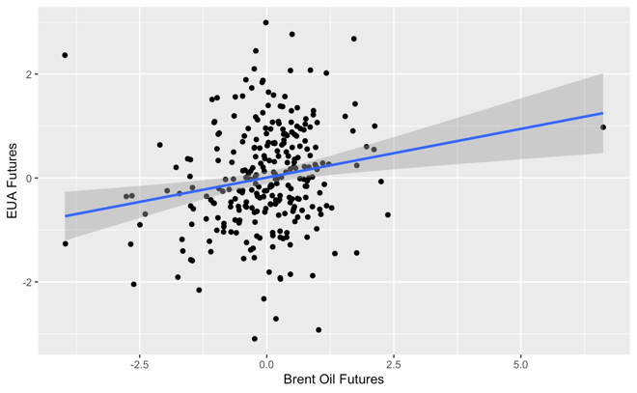 | 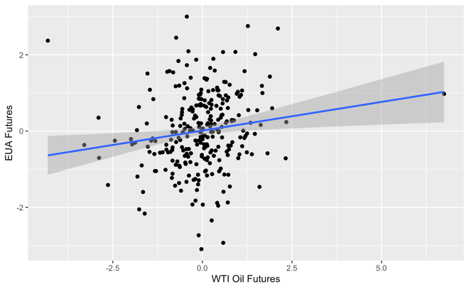
Brent Oil Futures and EUA Futures | WTI Oil Futures and EUA Futures
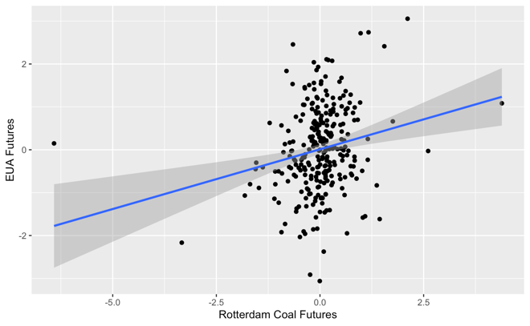 | 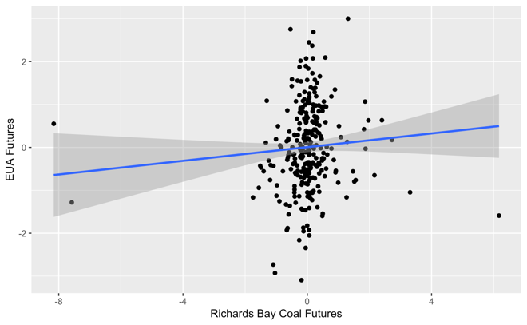
Rotterdam Coal Futures and EUA Futures | Richards Bay Coal Futures and EUA Futures
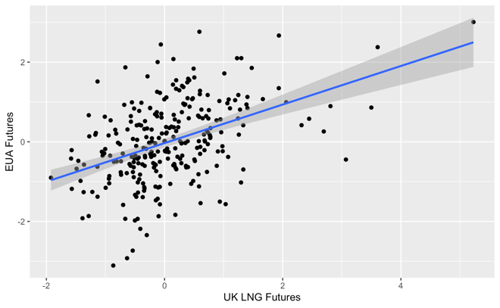 | 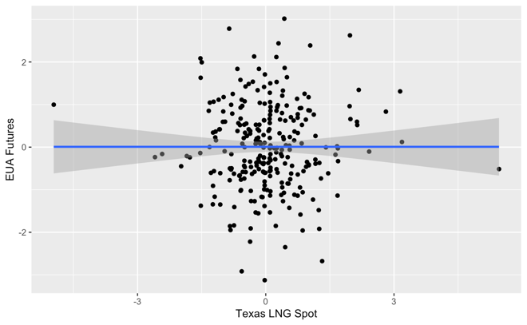
UK Gas Futures and EUA Futures | Texas Gas Spot and EUA Futures

Figure 4. Scatterplots with superimposed linear regression lines for the pairs between fossil energy markets and EUA futures before the COVID-19 pandemic.

Post-COVID-19
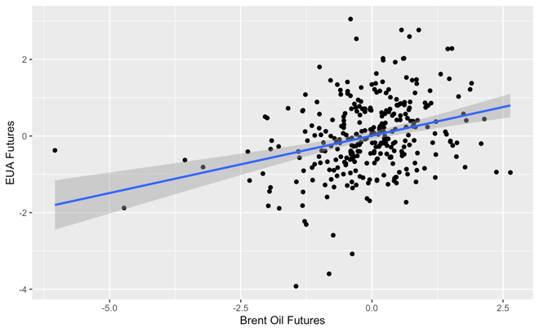 | 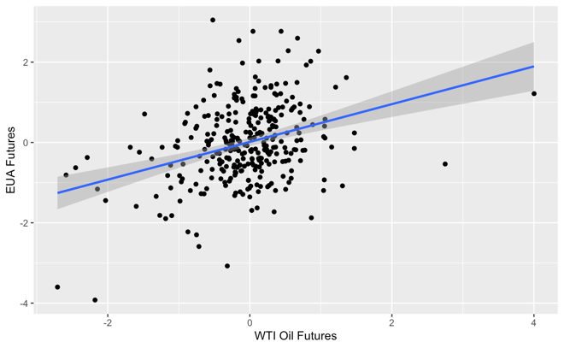
Brent Oil Futures and EUA Futures | WTI Oil Futures and EUA Futures
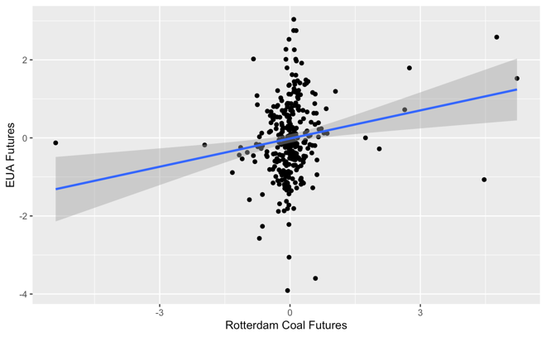 | 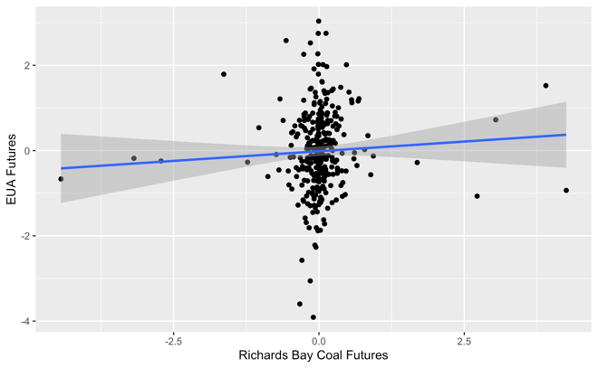
Rotterdam Coal Futures and EUA Futures | Richards Bay Coal Futures and EUA Futures
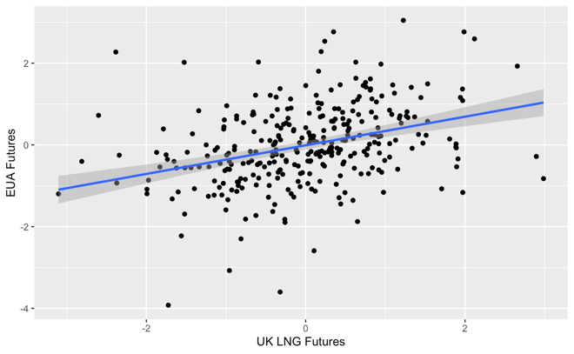 | 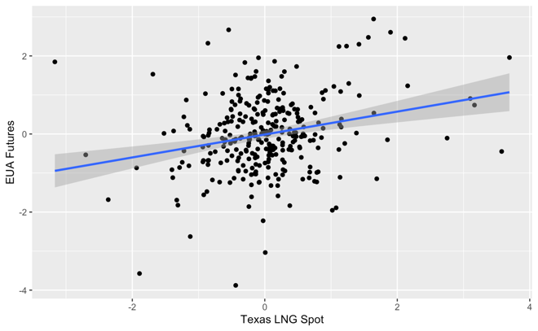
UK Gas Futures and EUA Futures | Texas Gas Spot and EUA Futures
Figure 5. Scatterplots with superimposed linear regression lines for the pairs between fossil energy markets and EUA futures after the COVID-19 pandemic.

