Supplementary Figure legends

Supplementary Fig. 1
Identification and verification of ara/arb TILLING mutant medaka
a Protein structures of medaka Ara and Arb and positions of the mutations identified in this study.
b WT and heterozygous mutant (+/-) medaka sequence data. Serine (S) in the WT was altered to a stop codon by cytosine-to-adenine substitution in ara (+/-). Leucine (L) in WT was altered to a stop codon by a thymine-to-adenine substitution in arb (+/-).
c Alignment of protein sequences of vertebrates Ars. Multiple alignments of amino acid sequences of the LBD surrounding the mutated amino acid with vertebrate Ars. Arrowheads indicate the premature stop codon of obtained ara/arb TILLING mutant medaka. human AR: NM_000044.2; chicken Ar: AB193190; brown-banded bambooshark Ar: AB213019; Nile tilapia Ara: AB045211, Nile tilapia Arb: AB045212
medaka Ara: AB252233; medaka Arb: AB252679.
d Loss of ligand-dependent transactivation of ara and arb mutant alleles. COS-7 cells were transfected with an expression construct for either ara⁺, ara⁻, arb⁺ or arb⁻ allele (pCMV-medaka Ara⁺, pCMV-medaka Ara⁻, pCMV-medaka Arb⁺, or pCMV-medaka Arb⁻), and pGL3 PRE/ARE tk Luc as a reporter plasmid. pRL-SV40 was used as an internal control to calculate transfection efficiency. Transfected cells were treated with 10⁻⁸ M 11KT or vehicle alone as a control. The relative transcriptional activity of Ar is shown as values normalised to pRL-induced activities. Bars represent the mean and SD. Statistical differences were assessed using the Mann–Whitney U test. *P < 0.05.

Supplementary Fig. 2
Ar mutant females exhibited normal fecundity
a Percentage of fertilisation of ovulated oocytes from WT, ara KO, arb KO, and ar DKO females in natural mating with WT males (n = 4 for WT females, ara KO females, arb KO females, and ar DKO females, respectively).
b Frequency of mating tests in which a female laid eggs within 30 min after mating started with a WT male.
c Total number of fertilised eggs in 10 days.
For each female, the average value of mating tests in 10 days with distinct males was calculated. Statistical differences were assessed using the Kruskal–Wallis test followed by the Steel test (a–c).

Supplementary Fig. 3
Differentiation of medulla surrounding the sperm duct near the opening of the digestive tract in ar KO males
Representative micrographs of Masson/trichrome-stained sections of the urogenital region of WT, ara KO, arb KO, and ar DKO males. Scale bars represent 200 μm. The urethra, sperm duct, enlarged medulla surrounding the sperm duct, and digestive tract are indicated by *, arrowhead, arrow, and #, respectively.

Supplementary Fig. 4
Reduced expression of lef1 gene expression in anal fin of ar DKO males.
The graph showed the expression level of lef1 relative to rpl7 in the posterior half of the anal fin of WT, ara KO, arb KO, and ar DKO medaka (n = 3 for each genotype). Statistical differences were assessed using Bonferroni's multiple t-tests. *p < 0.05.

Supplementary Fig. 5
Reduced reproductive success of ara KO males and arb KO males compared with WT males
Percentage of mating success of WT, ara KO, and arb KO males in the mate choice tests. The mate choice test was performed using a round-robin tournament with five males.
The chi-squared (χ2) test of independence was used to assess whether the mutation had a significant effect on mating success.

Supplementary Fig. 6
Gene ontology (GO) enrichment analysis of the differentially expressed genes between WT males and ar DKO males
Significantly enriched pathways (hypergeometric test followed by false discovery rate (FDR) correction; FDR cutoff < 0.05) are shown. Colours indicate FDR values. Each dot size represents the number of genes in each pathway, including differentially expressed genes.

Supplementary Fig. 7
Gene ontology (GO) enrichment analysis of the differentially expressed genes between WT males and ara KO males
Significantly enriched pathways (hypergeometric test followed by false discovery rate (FDR) correction; FDR cutoff < 0.05) are shown. Colours indicate FDR values. Each dot size represents the number of genes in each pathway, including differentially expressed genes.

Supplementary Fig. 8
Gene ontology (GO) enrichment analysis of the differentially expressed genes between WT males and arb KO males
Significantly enriched pathways (hypergeometric test followed by false discovery rate (FDR) correction; FDR cutoff < 0.05) are shown. Colours indicate FDR values. Each dot size represents the number of genes in each pathway, including differentially expressed genes.

Supplementary Table 1.
Primers used in this study are listed.

Supplementary Movie 1
Aggressive male-male competition
Two WT males were placed in the same tank as a WT female and recorded from the top of the tank using a high-speed camera system at 300 frames per second with a resolution of 800×600 pixels. This movie file is a slow-motion replay at 30 frames per second.

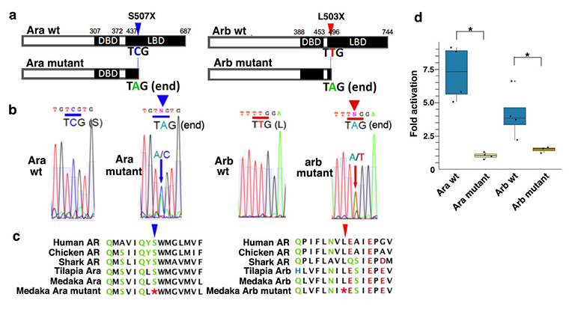
Supplementary Fig. 1

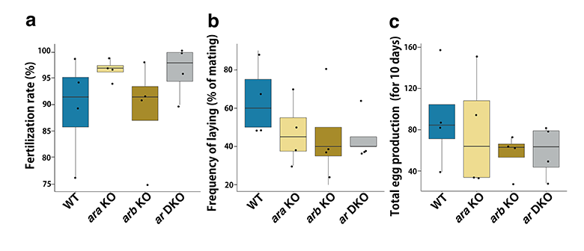
Supplementary Fig. 2

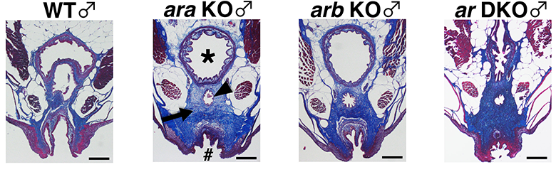Supplementary Fig. 3

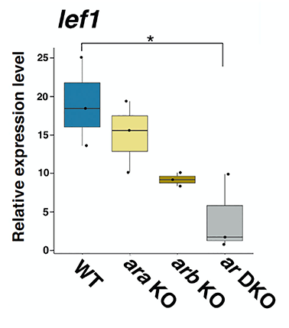 Supplementary Fig. 4

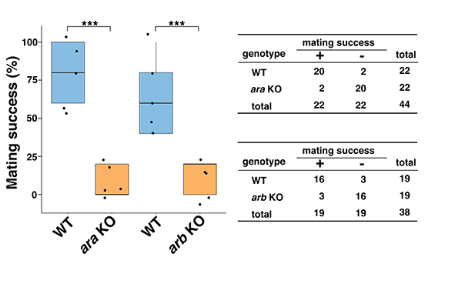
Supplementary Fig. 5

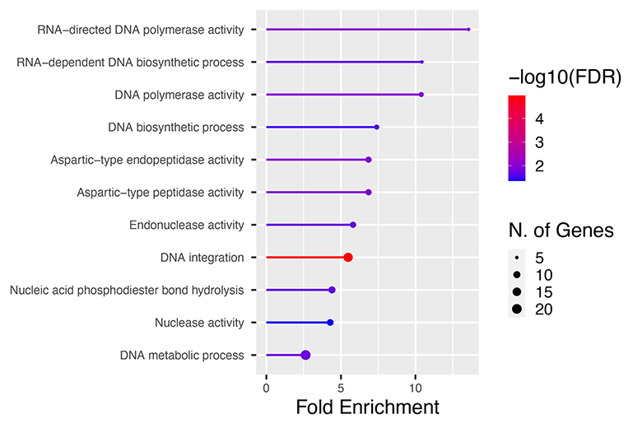
Supplementary Fig. 6
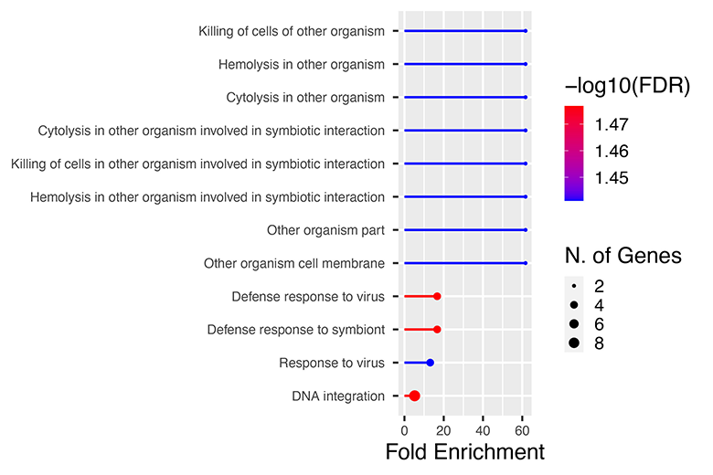
Supplementary Fig. 7

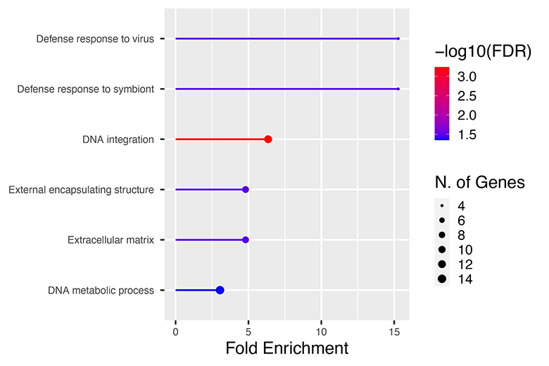
Supplementary Fig. 8
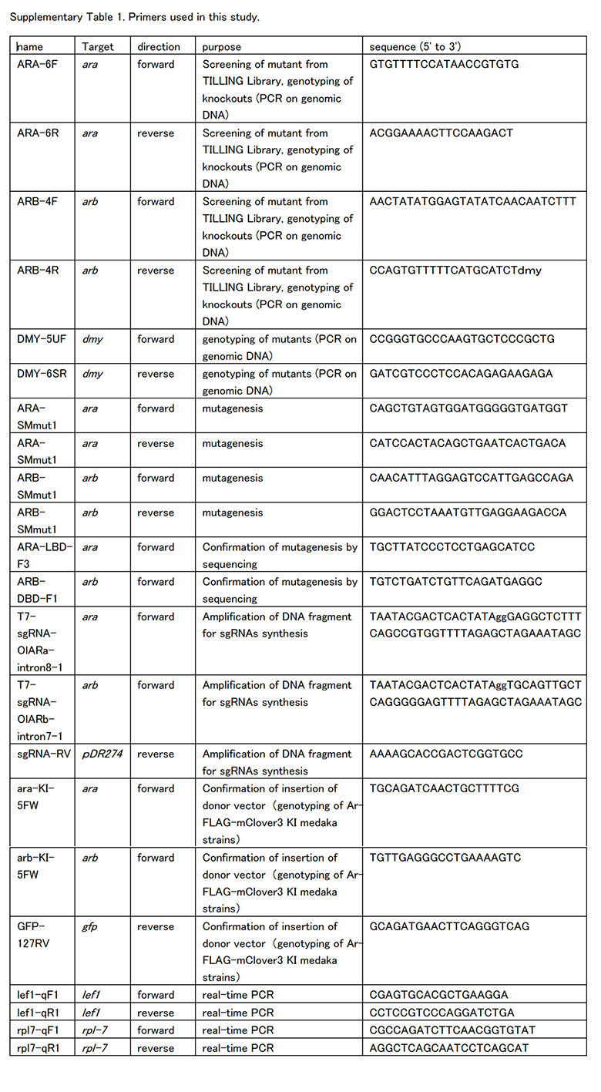
Supplementary Table 1
Supplementary Movie 1: it is attached as a separate file.

