Supporting information

A multidimensional perspective on microbial ecology of gut microbiota and progression of preT2D to T2D: linkages to keystone taxa in a Mexican cohort

Esquivel-Hernández Diego A.^{1*}, Martínez-López Yoscelina Estrella^{1,2,3}, Sánchez-Castañeda Jean Paul^{1,4}, Neri-Rosario Daniel^{1,4}, Padrón-Manrique Cristian^{1,5}, Girón-Villalobos, David^{1,4}, Mendoza-Ortíz Cristian^{1,4}, Resendis-Antonio Osbaldo^{1,6}*
¹Human Systems Biology Laboratory. Instituto Nacional de Medicina Genómica (INMEGEN). México City, México.
²Programa de Doctorado en Ciencias Médicas y de la Salud, Universidad Nacional Autónoma de México (UNAM). Ciudad de México, México.
³Metabolic Research Laboratory, Department of Medicine, and Nutrition. University of Guanajuato. León, Guanajuato, México.
⁴Programa de Maestría en Ciencias Bioquímicas, Universidad Nacional Autónoma de México (UNAM). Ciudad de México, México.
⁵Programa de Doctorado en Ciencias Biomédicas, Universidad Nacional Autónoma de México (UNAM). Ciudad de México, México
⁶Coordinación de la Investigación Científica – Red de Apoyo a la Investigación, Universidad Nacional Autónoma de México (UNAM). Ciudad de México, México.

Supplementary Figures
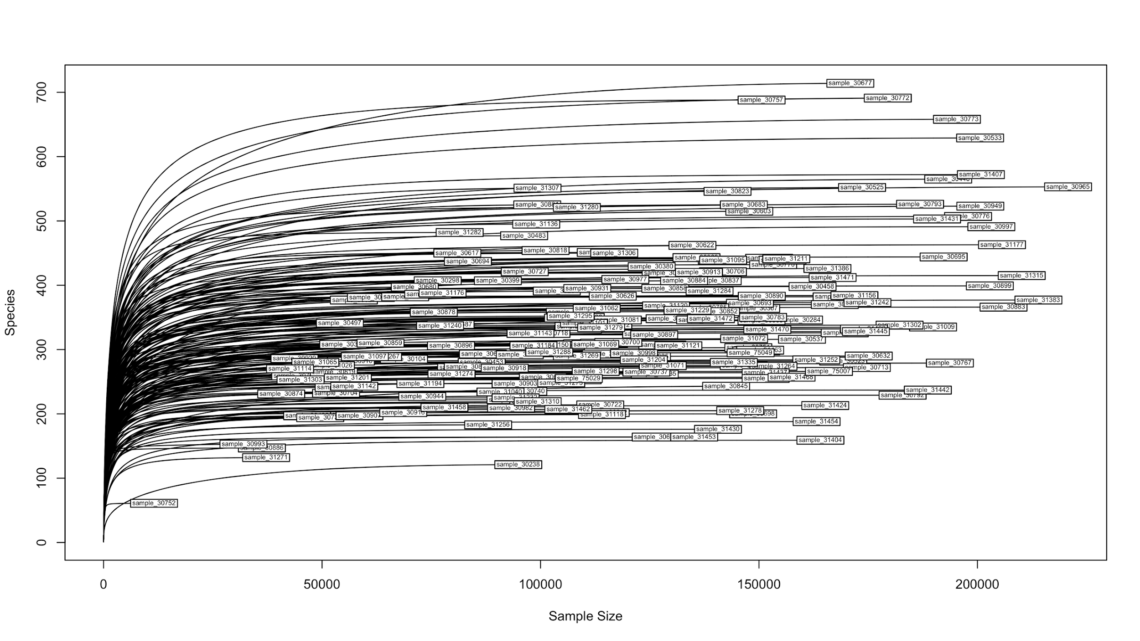
Figure S1-A. Rarefaction curve for healthy patients

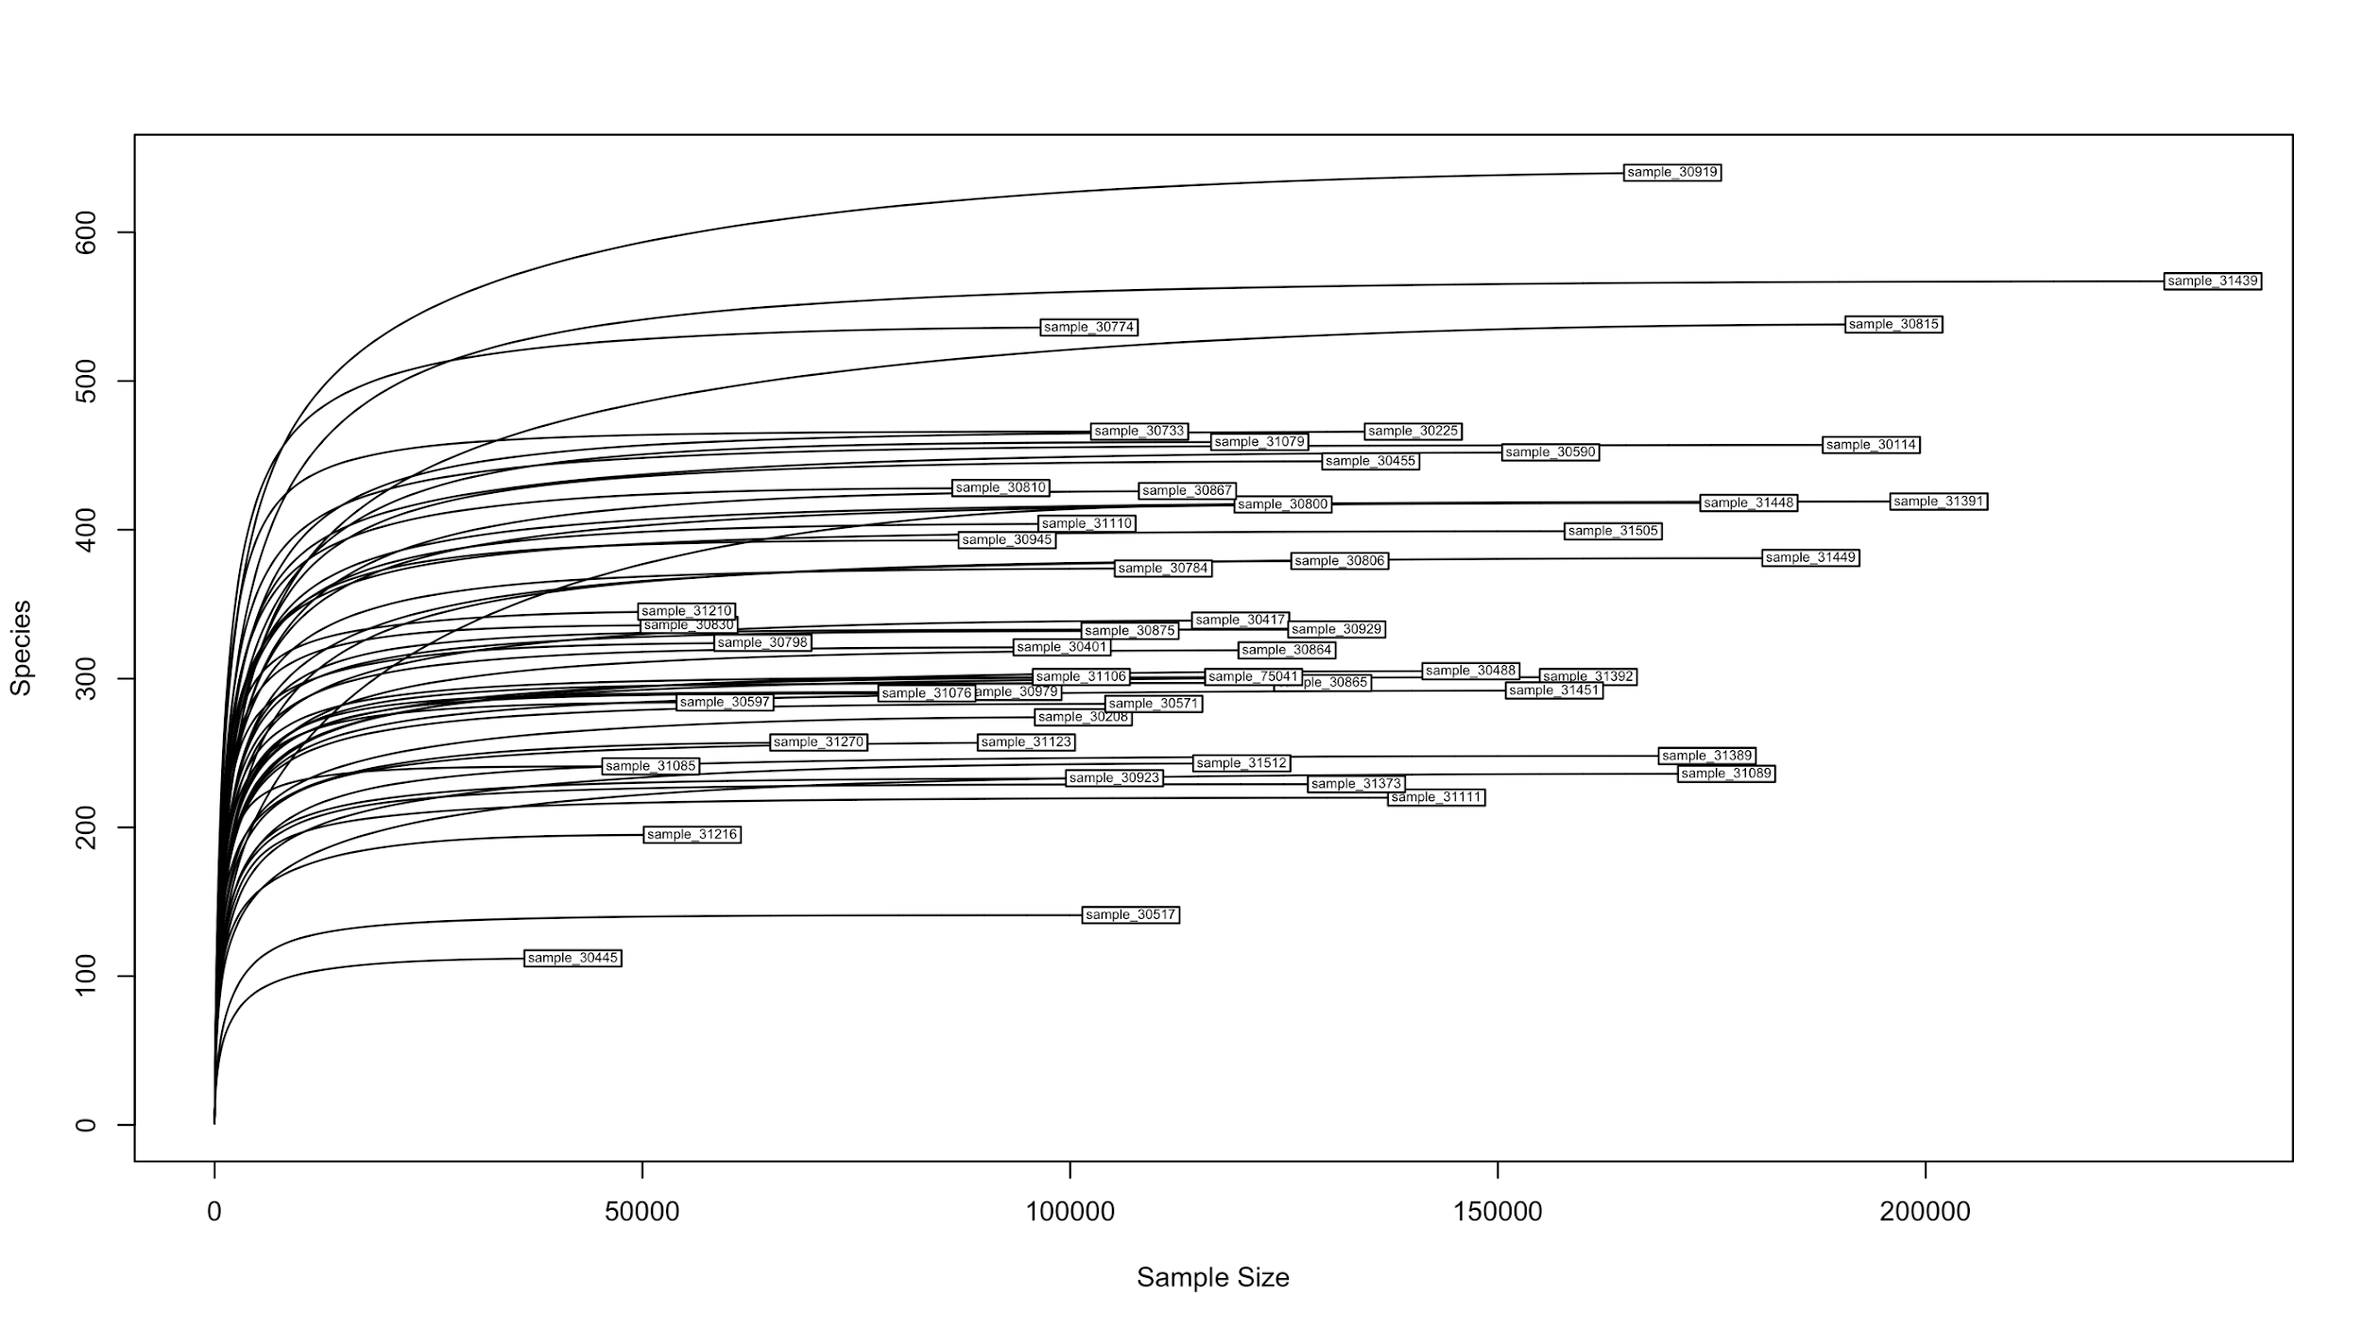
Figure S1-B. Rarefaction curve for IFG patients

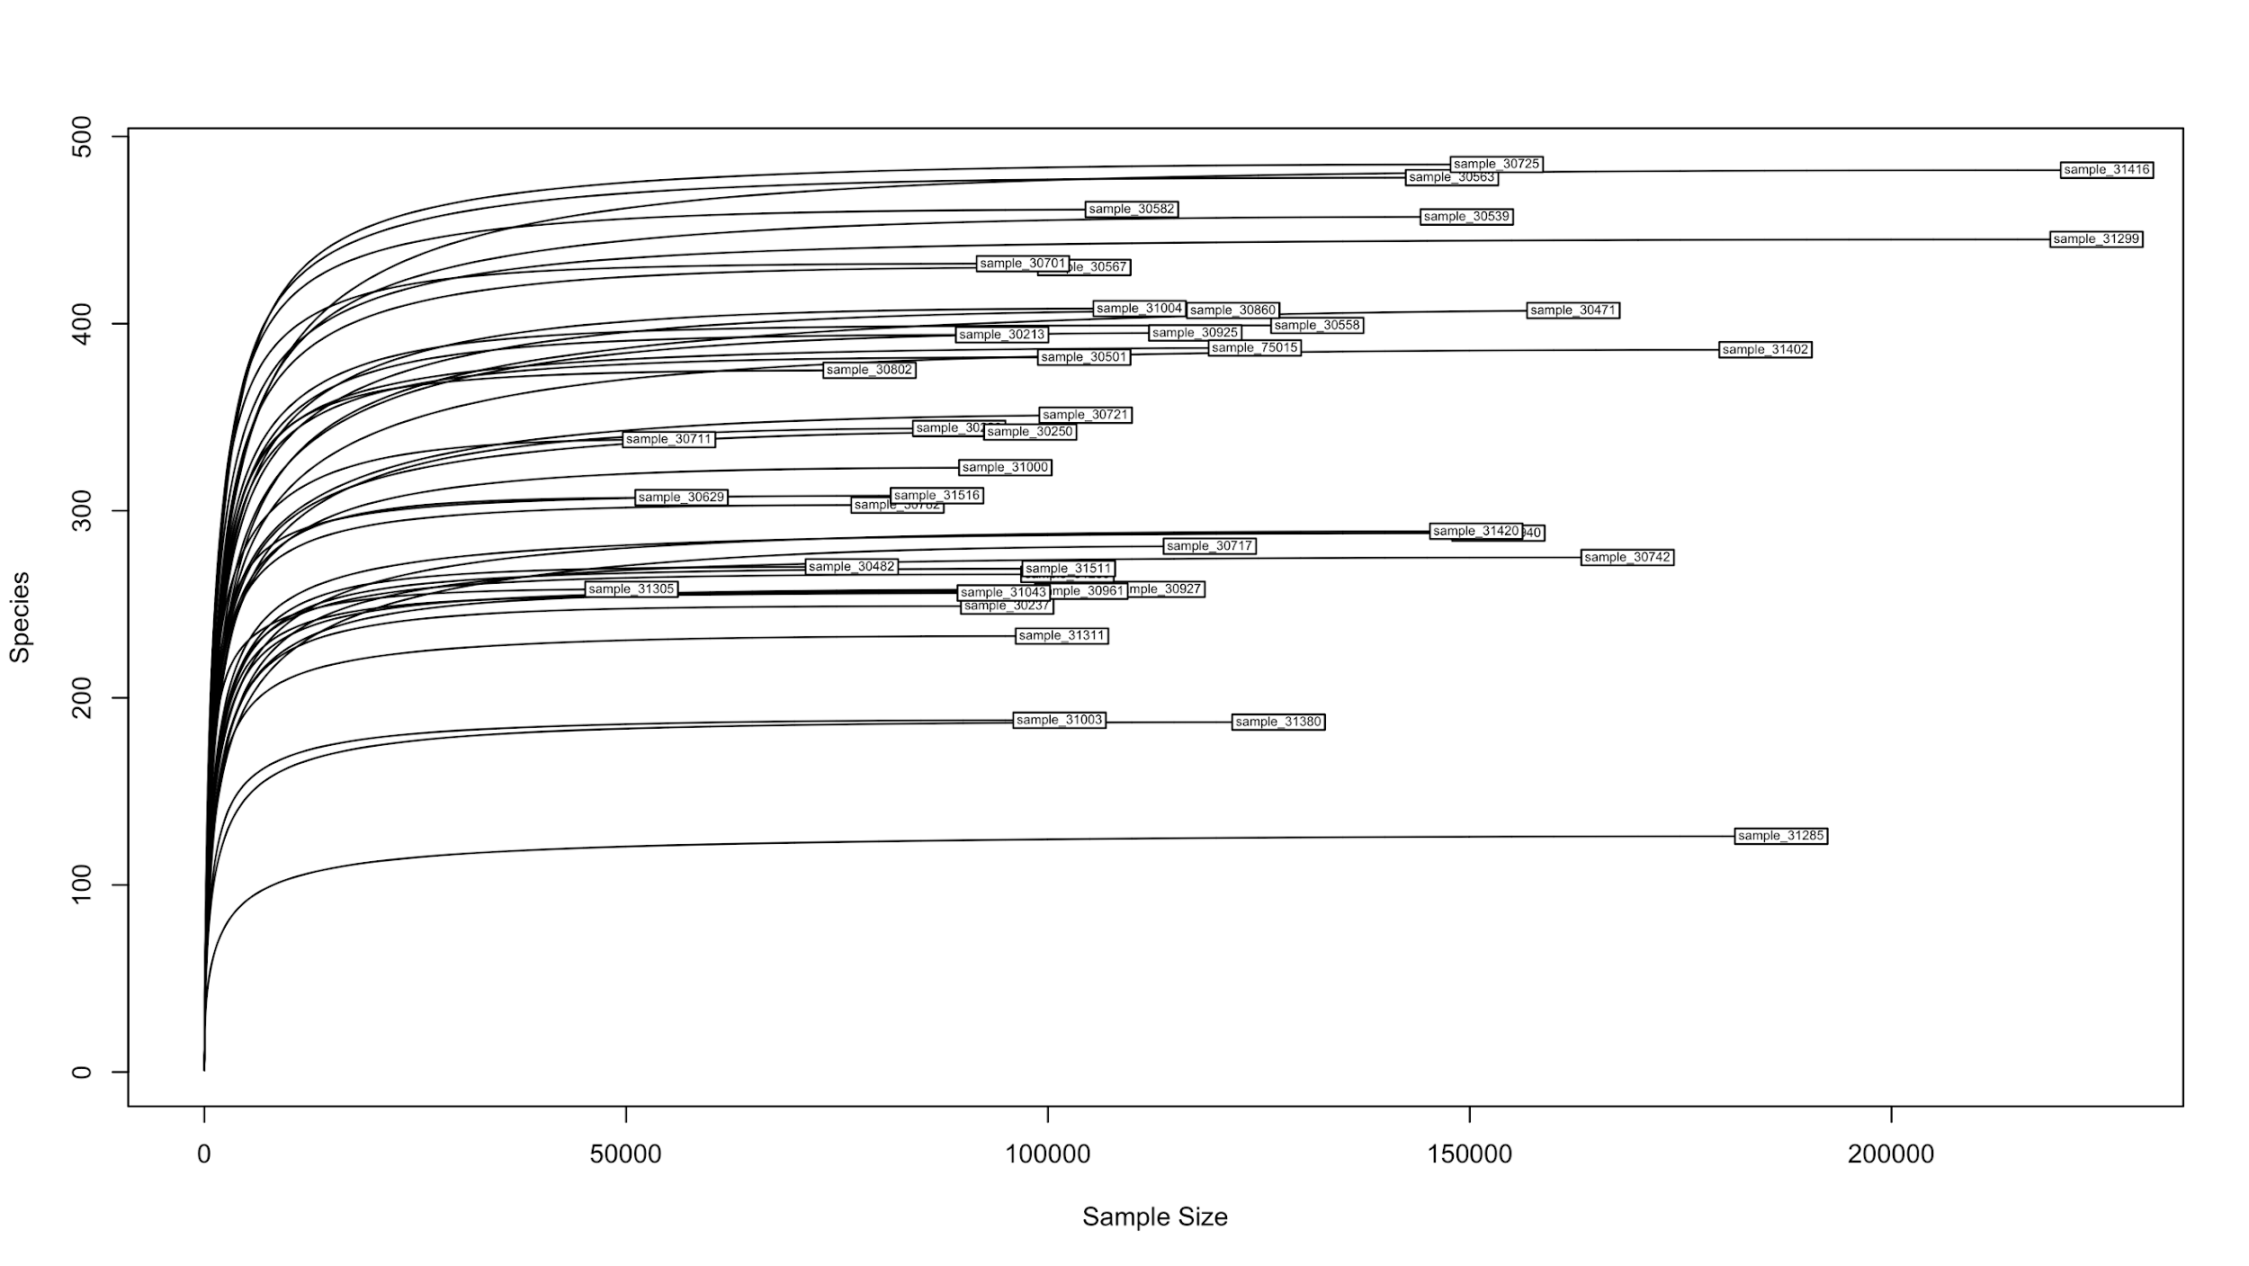
Figure S1-C. Rarefaction curve for IGT patients

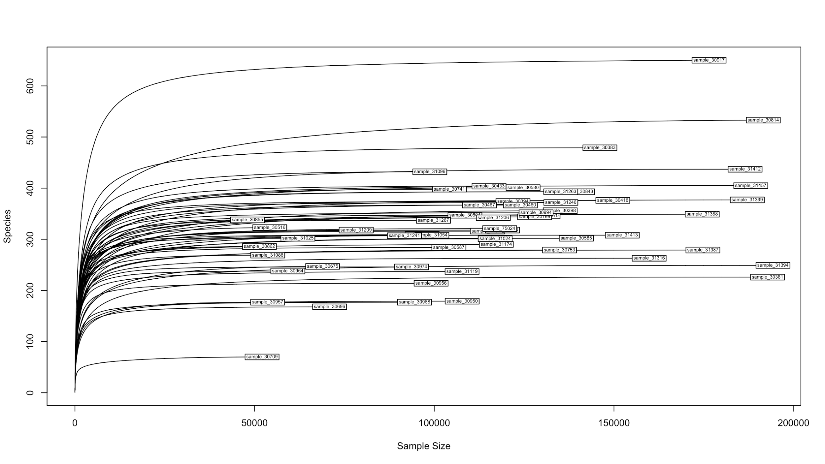
Figure S1-D. Rarefaction curve for IFG+IGT patients

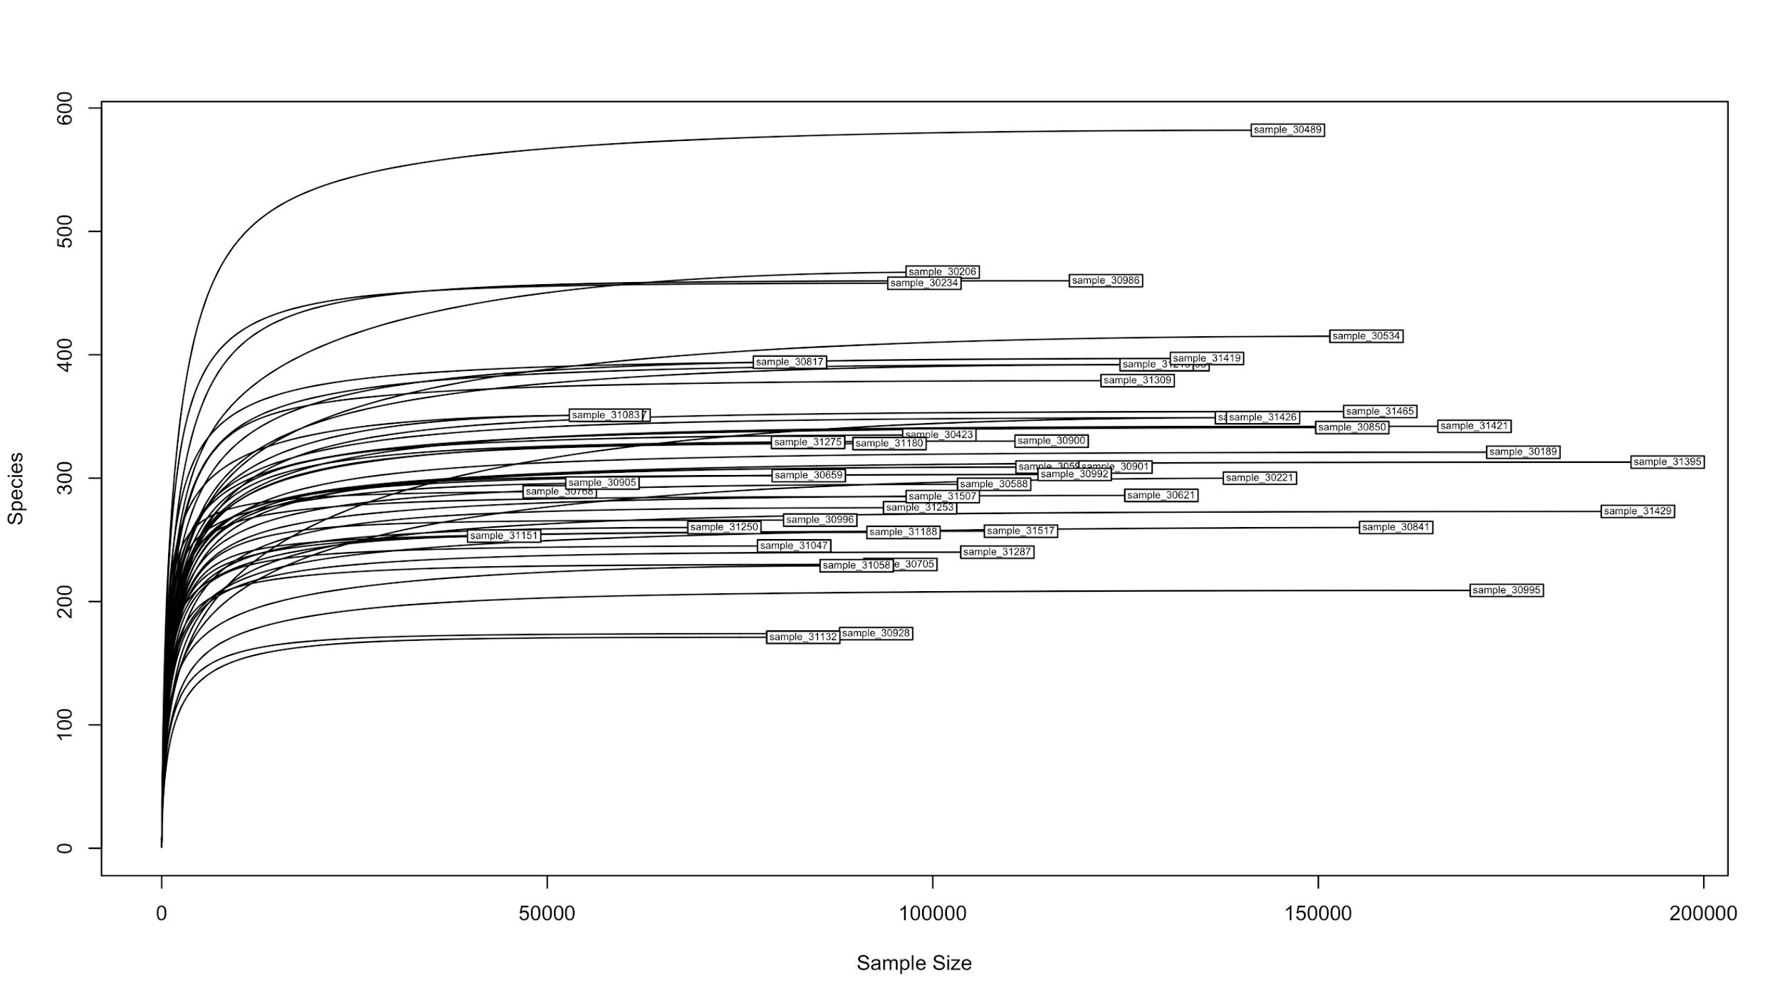
Figure S1-E. Rarefaction curve for T2D patients

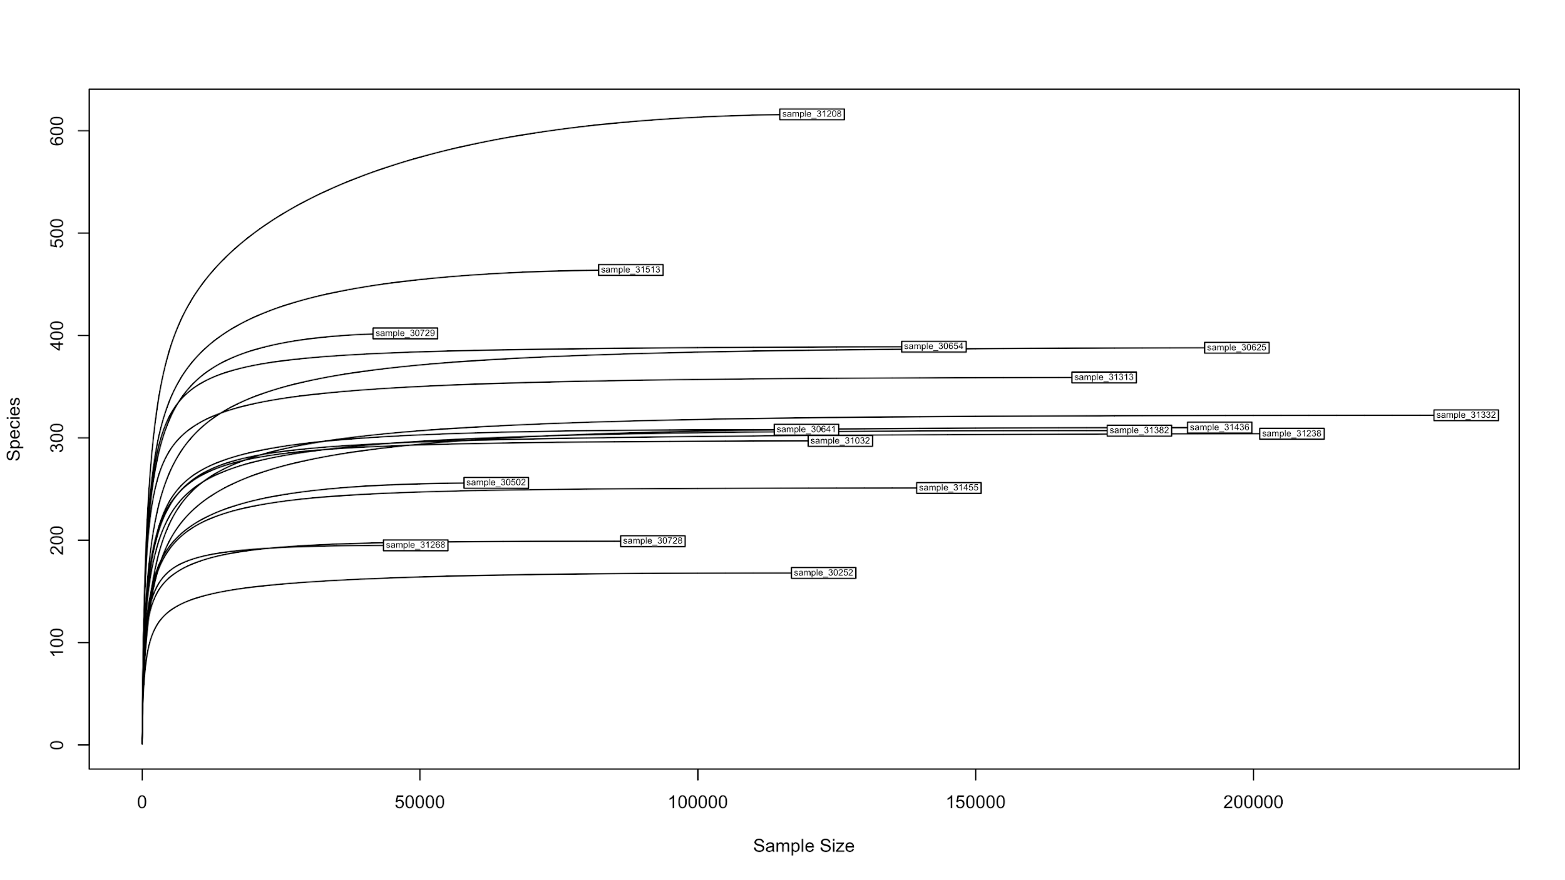
Figure S1-F. Rarefaction curve for T2D_treated patients

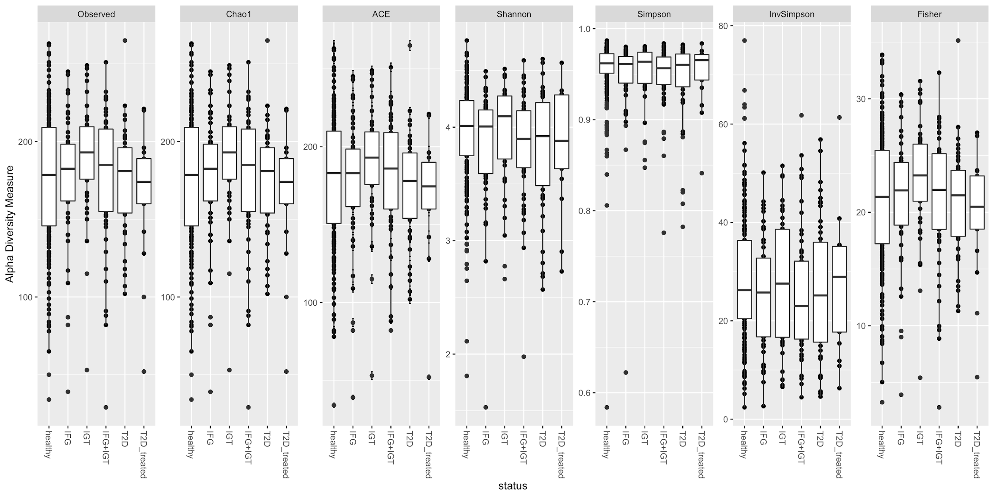

Figure S2. Alpha diversity index for all groups: Healthy, IFG, IGT, IFG+IGT, T2D, and T2D_treated

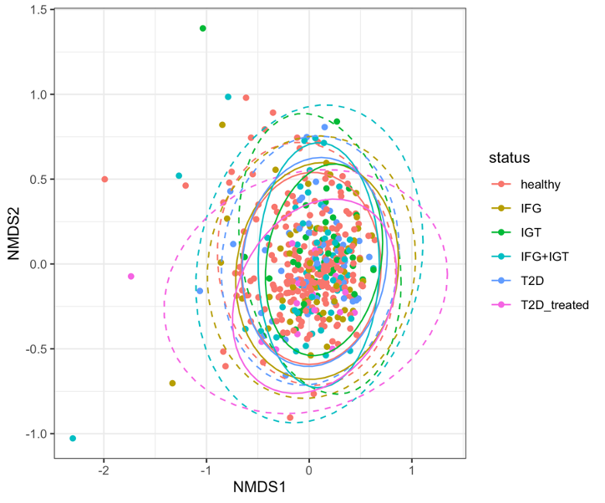
Figure S3-A NMDS analysis colored by groups: Healthy, IFG, IGT, IFG+IGT, T2D, and T2D_treated.

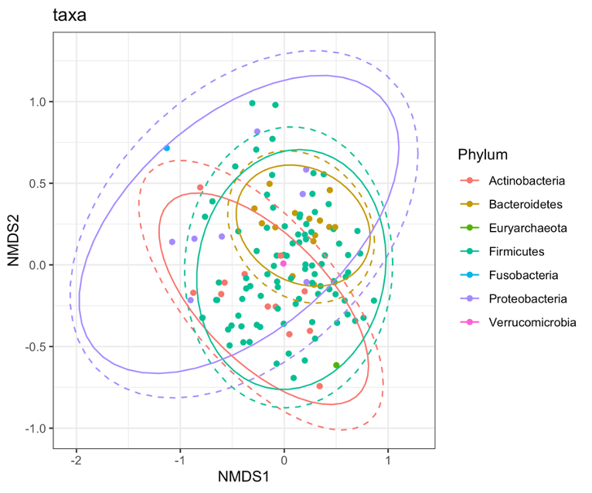
Figure S3-B NMDS analysis colored by phyla: Actinobacteria, Bacteroidetes, Euryarchaeota, Firmicutes, Fusobacteria, Proteobacteria, Verrucomicrobia.

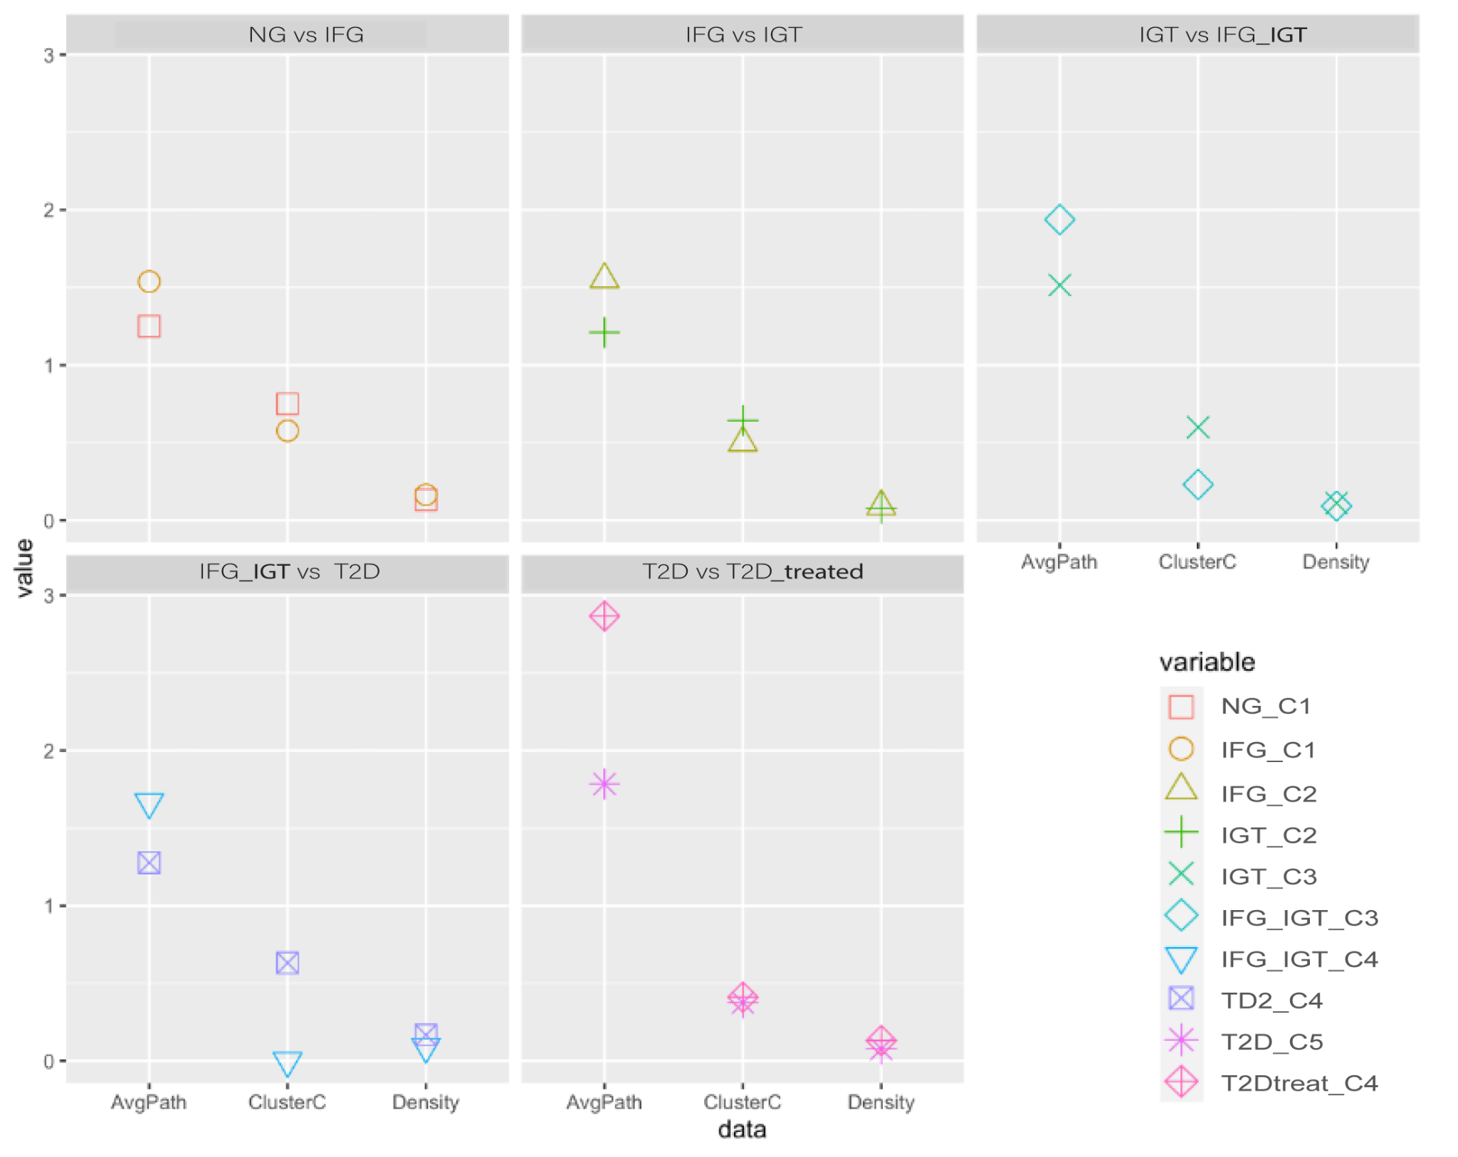
Figure S4-A Network statistics for all pairwise comparisons between groups (NG, IFG, IGT, IFG+IGT, T2D, and T2D treated). The X-axis indicates network statistics (AvgPath: Average Path, ClusterC: Cluster coefficient, and Density) while Y-axis indicates their corresponding values.

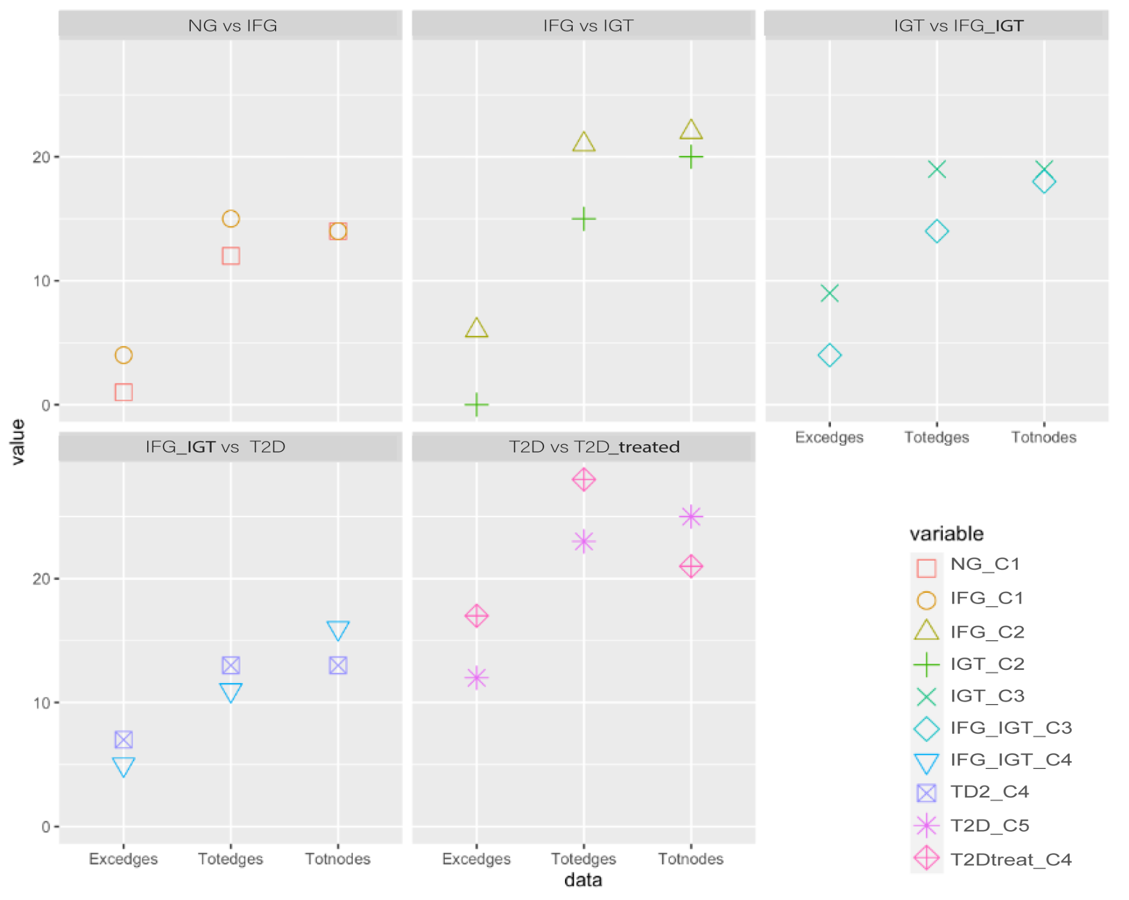
Figure S4-B Network statistics for all pairwise comparisons between groups (NG, IFG, IGT, IFG+IGT, T2D, and T2D treated). The X-axis indicates network statistics (Excedges: Exclusive edges, Totedges: Total edges, Totnodes: Total nodes) all of these are for each network while Y-axis indicates their corresponding values.

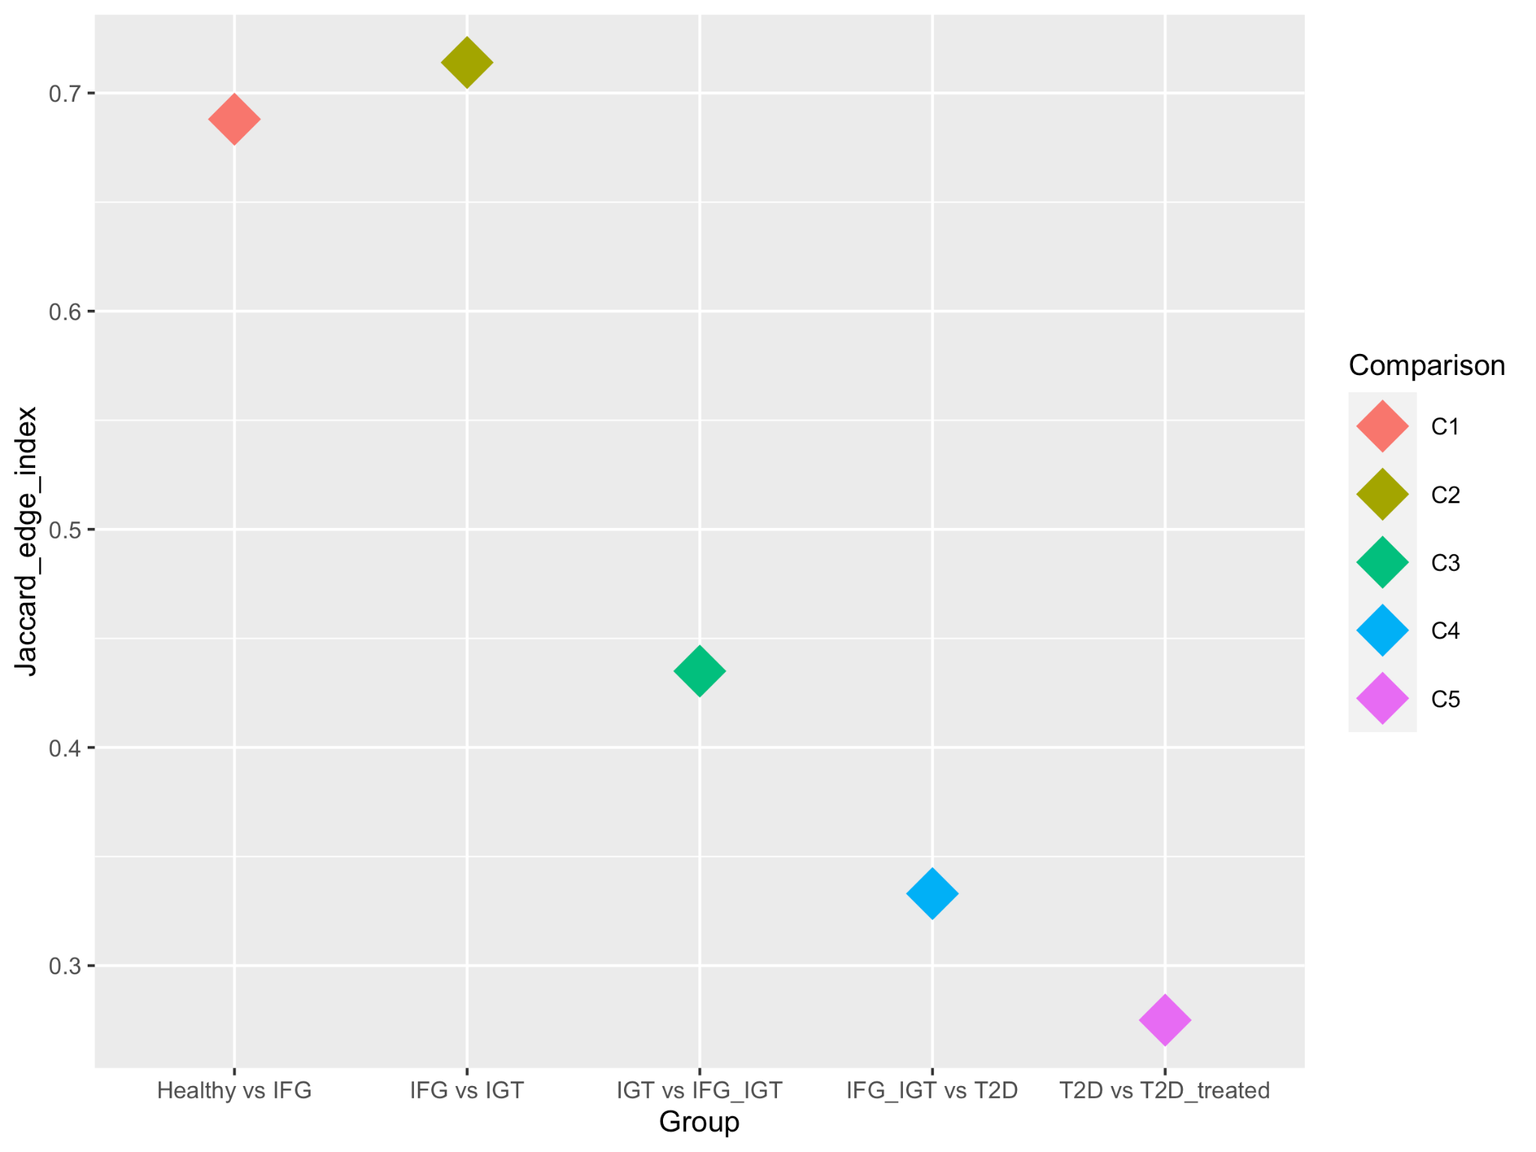
Figure S4-C. Jaccard Edge Index (JEI) for all pairwise comparisons in the T2D Mexican cohort.

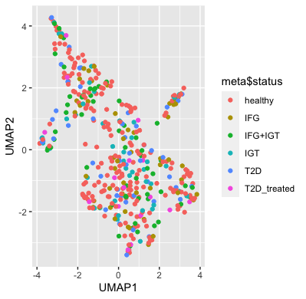
Figure S5-A UMAP analysis colored by groups: Healthy, IFG, IGT, IFG+IGT, T2D, and T2D_treated.

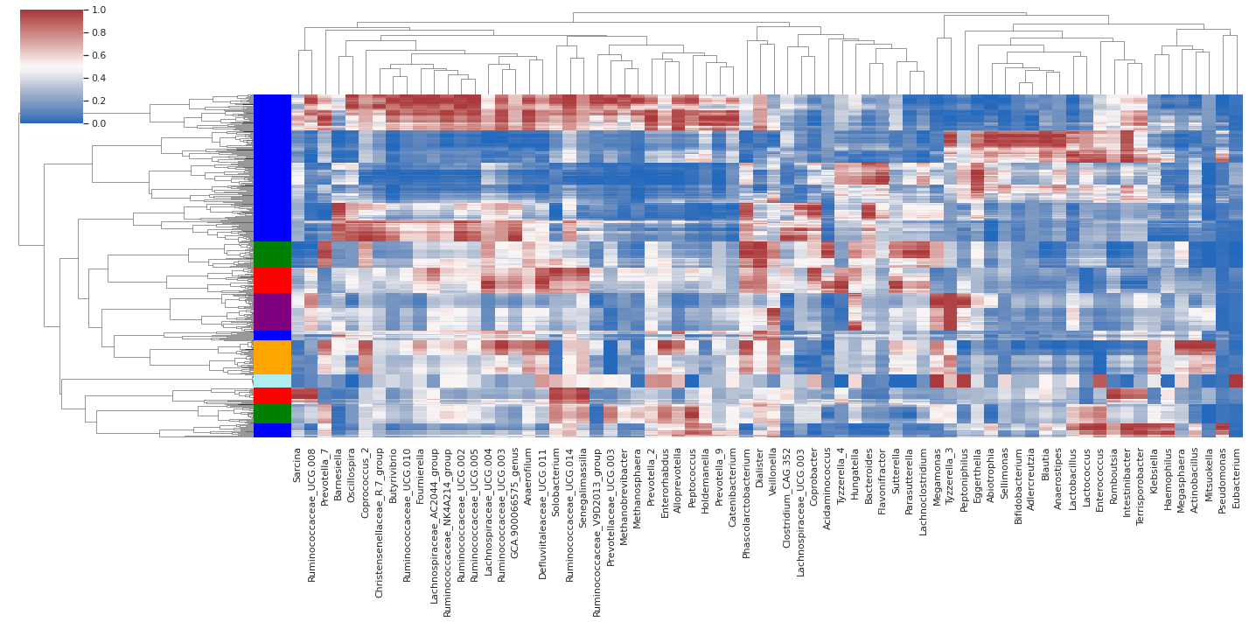
Figure S5-B Hierarchical analysis of the data imputed by mb-PHENIX imputed data.
We observed the top variable taxa (percentile=60) relevant abundance taxa data.

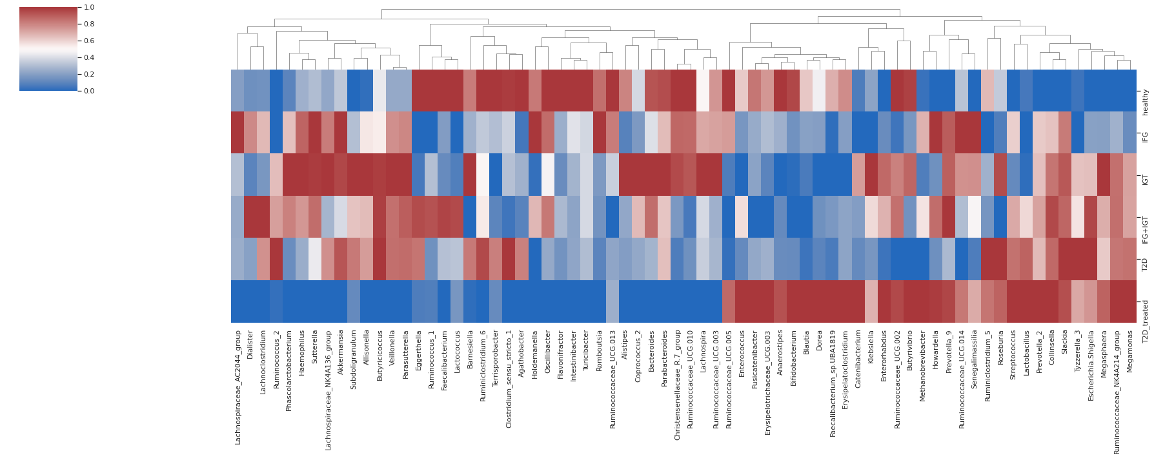
Figure S5-C Hierarchical analysis of the top 70 most relevant taxa before mb-PHENIX imputation among T2D states.

Supplementary Methods

S1-M Differential abundance analysis

First, we filtered out OTUs for which the variance across all samples is very low (1e-5) and did this before ever passing the data to edgeR. Also, we estimated a series of log-linear generalized linear models predicting each ASV abundance. ASVs were considered differentially abundant at a false discovery rate (FDR) < 0.01. To examine potential keystone taxa at the genus level, we analyzed differentially abundant bacteria between two stages of T2D: NG vs IFG, IFG vs IGT, IFG+IGT vs T2D, and T2D vs T2D treated. Finally, we performed an upset plot graph to describe intersections of differentially abundant genera between comparisons.

S2-M Network inference

SparCC [1], a network inference tool, was run based on in-house scripts and adaptations from Netherlands Bioinformatics and Systems Biology Research School. First, we computed correlations (compositionality-robust) as the median of ten iterations, where SparCC averages its results over several estimates of the true fractions, with the Dirichlet distribution. Second, we calculated bootstraps and prepared one correlation matrix from one resampled dataset (n=100 iterations). Third, we computed p-values, based on bootstrapped correlation scores. Fourth, we selected nodes and edges based on the determined cut point of correlation level (0.60). The results from SparCC were plotted in an interactive network with VisNetwork R library [2] and were uploaded to Github (https://github.com/resendislab/MEXT2D_Networks).

S3-M Denoised microbiota data analysis by supervised machine learning
We denoised microbiota data (ASV table) by a hybrid denoising manifold learning approach (mb-PHENIX) to observe the driver nodes involved in the transition of T2D states [3] and because of the high rate of missing information of microbiome data [4] that do not let find cluster structure with traditional unsupervised methods. The mb-PHENIX method consists of mapping different classes (here T2D stages) in the low dimensional space as far apart as possible, while maintaining the internal class structure and the inter-class relationships. Then, the missing taxa data is recovered (denoising) by sharing taxa information among the nearest neighbors.
We preprocessed the ASV table for imputation with the following steps: 1) We filtered the ASV by the number of counts above 20 which detection is deemed non-negligible and at least appears in 5 samples. 2) We performed L1 normalization. 3) Root squared transformation with the parameters of mb-PHENIX as follows: for PCA (n_components=100,random_state=1), then for the PCA space we applied supervised embedding with UMAP (n_components=2, verbose=True, metric='cosine', n_epochs=1000, min_dist=0.1, random_state=1, n_neighbors=500, target_weight=0.5), and last the imputation via diffusion (t=5,decay=50,metric='euclidean',knn=17). After imputation, we calculated the most significant taxa for each T2D stage within the imputed ASV data with the earth mover’s distance metric (EMD) [5]. Particularly, we compared each T2D stage against the rest of the groups to quantify the differences between distributions among T2D stages. Then, the EMD was multiplied by the sign of the mean difference of each cluster to denote the overall direction of the shift (EMD score). Lastly, the imputed ASV table was collapsed to identify their taxonomical annotation at the genus level. We used EMD [6], a nonparametric measure of the distance between two distributions that quantifies the flow required to morph one distribution to another. It is defined as the L1 norm of the cumulative density functions, DEMD = \\CDF1 -CDF2\\1; and has successfully been used to quantify gene expression differences in single-cell data and microbiome data [5]. Also, the EMD metric was used for imputed data via diffusion [7]. Additionally, the EMD metric does not make parametric assumptions about their underlying distributions [7].

References

1. Friedman J, Alm EJ. Inferring correlation networks from genomic survey data. 2012.
2. Kassambara A. Network Analysis and Visualization in R: Quick Start Guide. STHDA; 2017.
3. Padron-Manrique C, Vazquez-Jimenez A, Esquivel-Hernandez DA, Martinez-Lopez YE, Neri-Rosario D, Sanchez JP, et al. mb-PHENIX: Diffusion and Supervised Uniform Manifold Approximation for denoising microbiota data. bioRxiv. 2022.
4. Ghannam RB, Techtmann SM. Machine learning applications in microbial ecology, human microbiome studies, and environmental monitoring. Computational and Structural Biotechnology Journal. 2021;19:1092-107.
5. McClelland J, Koslicki D. EMDUniFrac: Exact linear time computation of the UniFrac metric and identification of differentially abundant organisms. Journal of mathematical biology. 2018;77(4):935-49.
6. Levina E, Bickel P: The earth mover's distance is the mallows distance: Some insights from statistics. In: Proceedings Eighth IEEE International Conference on Computer Vision ICCV 2001. vol. 2: IEEE; 2001: 251-6.
7. Ramdas A, García Trillos N, Cuturi M. On wasserstein two-sample testing and related families of nonparametric tests. Entropy. 2017;19(2):47.

