eAppendix

Fig 1. Clinical Protocol in Virtual Ward (N: Nurse, Dr: Doctor, TDS: three times daily, BD: twice daily, OM: once daily)
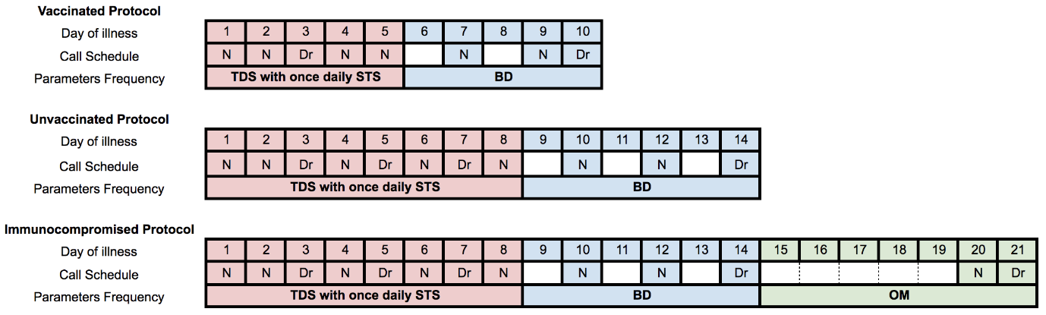

Fig 2. Triaging Protocol for Admission Avoidance Patients
