Highly Efficient and Durable Antimicrobial Nanocomposite Textiles

Vinni Thekkudan Novi¹, Andrew Gonzalez², John Brockgreitens², Abdennour Abbas^{1,2}*

¹ Department of Bioproducts and Biosystems Engineering
University of Minnesota-Twin Cities
2004 Folwell Ave
St. Paul, MN 55108, USA

² Claros Technologies Inc.
1000 Westgate Drive
Suite 1005
St. Paul, MN 55114, USA

Corresponding author: Dr. Abdennour Abbas
Email: aabbas@umn.edu, dennor@clarostech.com
Phone #: +1 (612) 624-4292

Supplementary Information
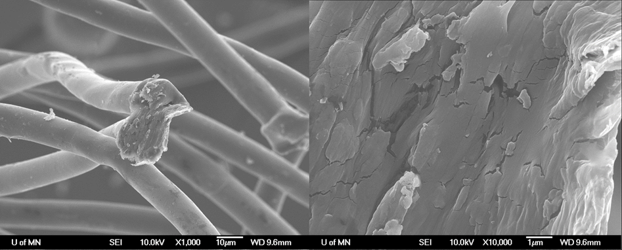

Supplementary Figure 1: SEM images of untreated polyester control fabric

Supplementary Table S1: Synthetic Precipitate Leachate Procedure results from Pace Analytical for three types of cotton samples. The samples were washed 1, 50 and 100 times after functionalization.
Zinc Discharge (µg/L)
 | # of Washes
 | 1 |  |  | 50 |  |  | 100
Cot #1 | 5030 | 5610 | 4680 | 543 | 575 | 366 | 1150 | 848 | 1160
Cot #2 | 12800 | 11100 | 9350 | 519 | 371 | 352 | 571 | 558 | 544
Cot #3 | 57100 | 106000 | N/A | 1500 | 1180 | 1930 | 1180 | 1140 | 961

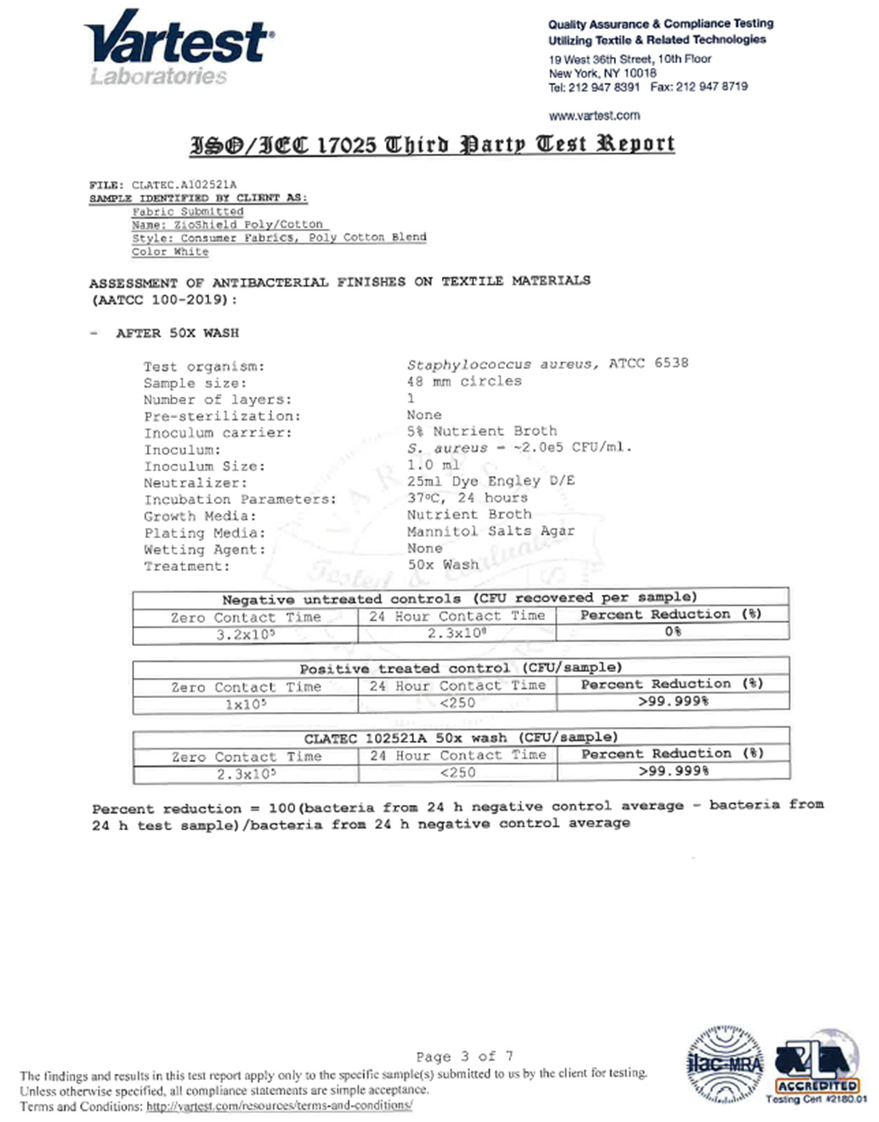

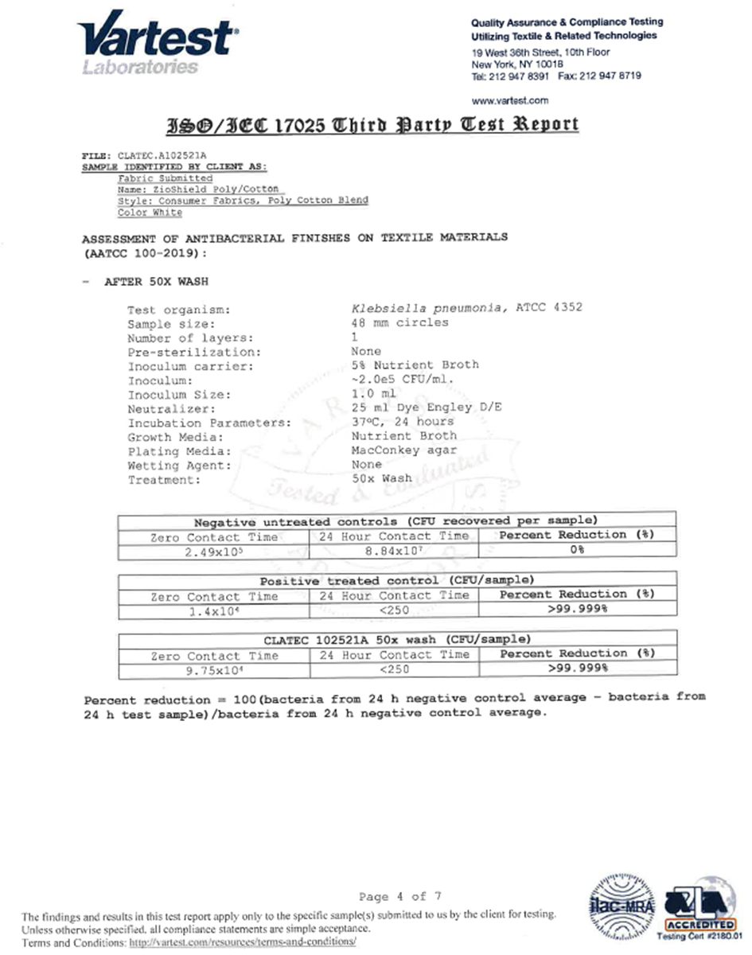

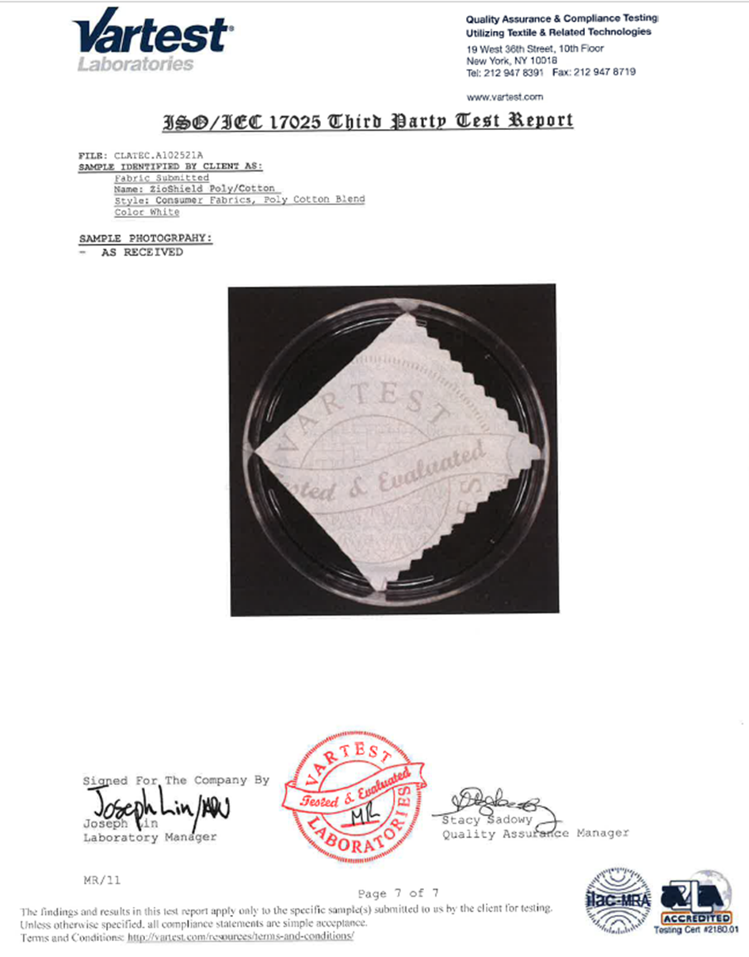
Parts of the antimicrobial test results from the third-party testing company Vartest Laboratories LLC is displayed here. The full report is available upon request.
