Supplement material: Pressure prediction from VPT TEOS and PVT TEOS of gold (Au)
A data set of volume vs temperature under the atmosphere of Ar + 7% H₂ gas mixture of Gold (Au) is selected from the reported data in paper (Suh et al.1988, J. Mater. Sci., 23(2), 757-760), measured by x-ray diffraction up to 1324 K in 1988. The following supplemental material describes how the pressure is predicted from VPT TEOS and traditional PVT TEOS model, and the predicted pressure is compared with experimental pressure of zero (0) GPa.
- From the lattice constant vs temperature in the paper, the unit cell volume V and V/V₀ are calculated.
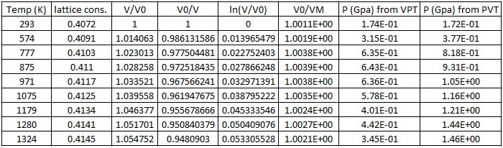
- Zero order volume thermal expansion coefficient is fitted by least square from the ln(V/V₀) vs temperature, and get $α_{0}=$5.619E-5 (1/K), shown as in Fig. 1. The thermal expansion coefficient of Au is the slope of the fitted line,
$\frac{d[\ln\left(V\right)]}{dT}=\frac{1}{V}\frac{dV}{dT}=α$

Figure 1. ln (V/V₀) vs temperature. Used for thermal expansion coefficient fitting.
3. The modified volume in our manuscript
$V_{M}=V∙\exp\left(-\int_{T_{0}}^{T}{α_{P}∙dx}\right)$ (1)
is calculated and listed in the above table as V₀/V_{M}.
4. K₀, $K_{0}^{'}$, and $α_{0}$ for pressure prediction
The bulk modulus and the pressure derivative of the bulk modulus are quoted from
Heinz, D. L., & Jeanloz, R. (1984). Journal of applied physics, 55(4), 885-893, and Anderson, O. L., Isaak, D. G., & Yamamoto, S. (1989. Journal of Applied Physics, 65(4), 1534-1543.
K₀: 166.6500
$K_{0}^{'}$: 5.4823
$α_{0}$ : 5.619E-5 (1/K), from step 2 above.

5. The pressure predicted by the VPT TEOS are calculated by Eq. (12) in our manuscript, and listed in the above table.
$P_{V,T}=\frac{3K_{0}}{2}\left[\left({\left(\frac{V_{0}}{V_{M}}\right)}^{\frac{7}{3}}\right)-{\left(\frac{V_{0}}{V_{M}}\right)}^{\frac{5}{3}}\right]\left\{1+\frac{3}{4}\left(K_{0}^{'}-4\right)\left[\left({\left(\frac{V_{0}}{V_{M}}\right)}^{\frac{2}{3}}\right)-1\right]\right\}$ (2)
while the pressures predicted by the PVT TEOS are calculated by
$P_{V,T}=\frac{3K_{0}}{2}\left[\left({\left(\frac{V_{0}}{V}\right)}^{\frac{7}{3}}\right)-{\left(\frac{V_{0}}{V}\right)}^{\frac{5}{3}}\right]\left\{1+\frac{3}{4}\left(K_{0}^{'}-4\right)\left[\left({\left(\frac{V_{0}}{V}\right)}^{\frac{2}{3}}\right)-1\right]\right\}+α_{0}{•K}_{0}(T-T_{0})$ (3)
6. The pressure prediction from VPT TEOS and from PVT TEOS are listed in the above table, and plotted below. For VPT TEOS, the maximum pressure predicted is around the 0.6 GPa, which is high than the experimental pressure of ambient pressure of zero (0) GPa. The accuracy of the predicted pressure depends on the accuracy of the data collected in the publication, and the accuracy of K₀, $K_{0}^{'}$ in another publication. On the other hand, the trend of the pressure prediction is reasonable, and a flat trend. The pressure prediction from PVT TEOS show a wrong trend, and deviated from experimental pressure up to 1.5 GPa at 1324 K for gold.
The shape of the pressure prediction of Au in Fig. 2 is very similar to Figure 3, which is the pressure prediction of MgO in our manuscript.

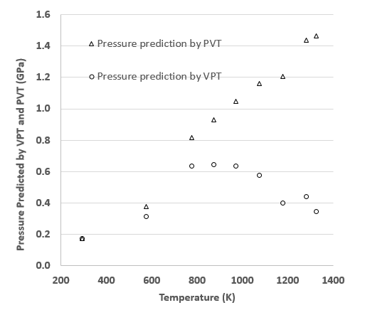
Figure 2. Pressure prediction from VPT TEOS and PVT TEOS both from experimental data points and extrapolated data points of gold (Au).

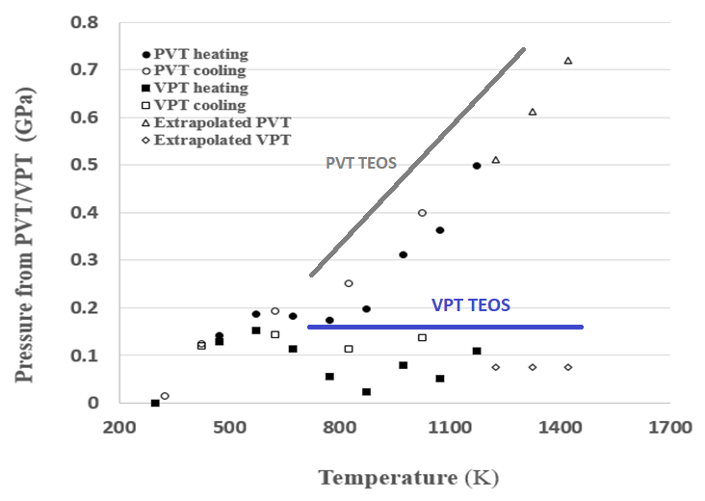
Figure 3. Pressure prediction from VPT TEOS and PVT TEOS both from experimental data points and extrapolated data points of MgO, from our manuscript.

