SUPPLEMENTARY FILE 1

1. Comparative genomics analyses
Ortholog analysis was performed to identify paralogous and/or orthologous relationships between genomes of L. curvatus, L. sakei and L. fuchuensis strains. Genomic properties of Latilactobacillus strains using OrthoFinder are listed in Supplementary Tables 1 and 2. Overall, 98.6% of the genes were shared between strains with 1215 orthogroups having membership of at least one gene in all 18 genomes. L. curvatus strains PTA-16 and PTA-17 shared 1681 and 1663 genes among them, respectively (Supplementary Table 1). Orthology-based multi-protein phylogenetic tree was used to identify optimal strain combinations from different clades (Supplementary Figure 1).

2. Screening for prophages, ISs and transposases
Genomes were scanned for the presence of mobile genetic elements such as prophages, ISs and transposases. Both PTA-16 and PTA-17 strains contained seven prophage regions each. However, there were 3 phage genes (all coding for Tyrosine recombinase protein) in both genomes that were outside of prophage regions (Supplementary Table 3). Putative IS and associated proteins predicted by ISEscan revealed 79 ORFs in 10 IS families in strain PTA-16 and 68 ORFs in 10 IS families in strain PTA-17 (Supplementary Table 4).

3. Absence of virulence factors and toxins
Both PTA-16 (3 contigs) and PTA-17 (2 contigs) strains were confirmed to be free of known virulence factors and/or toxins by comparing against virulence factor database (VFDB; search parameters of ³80% identity and ³80% alignment length/coverage), which is an integrated comprehensive online resource database for curating information about bacterial virulence factors and/or toxins (56). All other genomes were also free of virulence factors and toxins.

4. Absence of acquired antimicrobial resistance genes
The genomes of PTA-16 and PTA-17 along with other Latilactobacillus strains were searched for potential antimicrobial resistance genes against multiple AMR databases including NCBI-AMR, Resfinder DB and ARG-ANNOT using Abricate. The screening did not identify any potential antimicrobial resistance genes in any of the genomes except for LcELA65. LcELA65 contained a gene encoding tetracycline-resistant ribosomal protection protein (tetW) that confers resistance to tetracycline.

5. Screening for genes involved in biogenic amines and toxins
Functional annotation of the PTA-16 and PTA-17 genomes revealed that these strains do not contain any known protein-encoding genes involved in the production of biogenic amines with the exception of ornithine decarboxylase in the genome of PTA-16. Interestingly, both genomes had incomplete CDSs encoding tyrosine decarboxylase. No other toxins were identified in the genomes of both strains (Supplementary Table 5).

6. Genes involved in the production of lactic acid and other beneficial metabolites
Both PTA-16 and PTA-17 strains contained one CDS encoding for L-lactate dehydrogenase (EC 1.1.1.27). However, no CDS encoding for D-lactate dehydrogenase (EC 1.1.1.28) was found in any of the sequenced strains (Supplementary Table 6).
Several coding sequences involved in adhesion of Lactobacilli to intestinal epithelium including chaperonin GroEL, signal peptidase II and elongation factor Tu were identified in both PTA-16 and PTA-17 genomes (Supplementary Table 7). Search for desired stress tolerance features in PTA-16 and PTA-17 strains revealed the presence of three CDSs encoding for DNA protection during starvation. Another stress resistant gene putatively encoding for phosphate starvation-inducible PhoH-like protein was also found in both strains.
Supplementary Tables

Supplementary Table 1. Orthologs shared between Latilactobacillus strains.
 | LcELA23 | LcELA29 | LcELA33 | LcELA92 | PTA-16 | LcELA96 | LcELA98 | PTA-17 | LcELA2 | LcELA59 | LcELA60 | LcELA61 | LcELA62 | LsELA64 | LsELA65 | LfELA68 | LcELA388 | LcELA391
LcELA23 | 0 | 1649 | 1786 | 1787 | 1775 | 1785 | 1648 | 1638 | 1646 | 1582 | 1581 | 1629 | 1604 | 1466 | 1444 | 1346 | 1640 | 1452
LcELA29 | 1648 | - | 1652 | 1647 | 1651 | 1644 | 1825 | 1811 | 1832 | 1579 | 1577 | 1631 | 1584 | 1472 | 1460 | 1360 | 1639 | 1455
LcELA33 | 1786 | 1654 | - | 1791 | 1783 | 1794 | 1654 | 1645 | 1653 | 1591 | 1593 | 1635 | 1606 | 1470 | 1444 | 1348 | 1653 | 1453
LcELA92 | 1787 | 1650 | 1789 | - | 1777 | 1789 | 1647 | 1638 | 1645 | 1587 | 1586 | 1633 | 1607 | 1466 | 1443 | 1347 | 1643 | 1453
PTA-16 | 1805 | 1681 | 1812 | 1815 | - | 1809 | 1676 | 1681 | 1678 | 1619 | 1609 | 1661 | 1636 | 1520 | 1493 | 1363 | 1677 | 1487
LcELA96 | 1785 | 1650 | 1794 | 1790 | 1776 | - | 1647 | 1640 | 1647 | 1585 | 1585 | 1634 | 1604 | 1467 | 1444 | 1346 | 1645 | 1452
LcELA98 | 1646 | 1825 | 1650 | 1643 | 1650 | 1641 | - | 1812 | 1826 | 1575 | 1573 | 1623 | 1583 | 1471 | 1459 | 1359 | 1639 | 1457
PTA-17 | 1639 | 1826 | 1650 | 1648 | 1663 | 1643 | 1822 | - | 1823 | 1574 | 1569 | 1633 | 1589 | 1483 | 1472 | 1354 | 1656 | 1466
LcELA2 | 1646 | 1833 | 1653 | 1644 | 1649 | 1643 | 1825 | 1811 | - | 1575 | 1576 | 1628 | 1580 | 1471 | 1460 | 1358 | 1640 | 1455
LcELA59 | 1586 | 1580 | 1595 | 1590 | 1593 | 1586 | 1578 | 1572 | 1577 | - | 1696 | 1565 | 1599 | 1460 | 1430 | 1346 | 1578 | 1443
LcELA60 | 1586 | 1580 | 1596 | 1590 | 1592 | 1587 | 1578 | 1572 | 1578 | 1697 | - | 1565 | 1600 | 1458 | 1428 | 1347 | 1579 | 1441
LcELA61 | 1631 | 1639 | 1635 | 1633 | 1633 | 1635 | 1629 | 1629 | 1633 | 1570 | 1569 | - | 1581 | 1460 | 1439 | 1326 | 1628 | 1458
LcELA62 | 1607 | 1594 | 1610 | 1613 | 1609 | 1608 | 1590 | 1586 | 1590 | 1602 | 1602 | 1583 | - | 1493 | 1462 | 1347 | 1589 | 1481
LsELA64 | 1488 | 1498 | 1491 | 1490 | 1493 | 1489 | 1500 | 1495 | 1500 | 1485 | 1483 | 1487 | 1518 | - | 1737 | 1422 | 1540 | 1805
LsELA65 | 1454 | 1467 | 1452 | 1454 | 1455 | 1453 | 1469 | 1465 | 1469 | 1444 | 1442 | 1451 | 1474 | 1715 | - | 1411 | 1471 | 1727
LfELA68 | 1405 | 1429 | 1407 | 1406 | 1407 | 1405 | 1428 | 1423 | 1425 | 1412 | 1413 | 1390 | 1409 | 1471 | 1469 | - | 1408 | 1481
LcELA388 | 1659 | 1686 | 1677 | 1679 | 1691 | 1670 | 1673 | 1672 | 1665 | 1597 | 1590 | 1653 | 1612 | 1550 | 1493 | 1354 | - | 1545
LcELA391 | 1473 | 1487 | 1478 | 1480 | 1492 | 1476 | 1490 | 1485 | 1480 | 1466 | 1461 | 1487 | 1507 | 1808 | 1761 | 1424 | 1542 | -

Supplementary Table 2. Summary of ortholog statistics of all Latilactobacillus strains.
 | LcELA23 | LcELA29 | LcELA33 | LcELA92 | PTA-16 | LcELA96 | LcELA98 | PTA-17 | LcELA2 | LcELA59 | LcELA60 | LcELA61 | LcELA62 | LsELA64 | LsELA65 | LfELA68 | LcELA388 | LcELA391
Number of genes | 1791 | 1842 | 1808 | 1793 | 1867 | 1804 | 1833 | 1854 | 1842 | 1699 | 1700 | 1781 | 1743 | 2012 | 1839 | 1808 | 1965 | 1999
Number of genes in orthogroups | 1791 | 1840 | 1808 | 1793 | 1865 | 1801 | 1833 | 1854 | 1842 | 1698 | 1699 | 1722 | 1717 | 1911 | 1802 | 1668 | 1923 | 1935
Number of unassigned genes | 0 | 2 | 0 | 0 | 2 | 3 | 0 | 0 | 0 | 1 | 1 | 59 | 26 | 101 | 37 | 140 | 42 | 64
Percentage of genes in orthogroups | 100 | 99.9 | 100 | 100 | 99.9 | 99.8 | 100 | 100 | 100 | 99.9 | 99.9 | 96.7 | 98.5 | 95 | 98 | 92.3 | 97.9 | 96.8
Percentage of unassigned genes | 0 | 0.1 | 0 | 0 | 0.1 | 0.2 | 0 | 0 | 0 | 0.1 | 0.1 | 3.3 | 1.5 | 5 | 2 | 7.7 | 2.1 | 3.2
Number of orthogroups containing species | 1768 | 1803 | 1777 | 1770 | 1764 | 1777 | 1801 | 1789 | 1806 | 1678 | 1677 | 1697 | 1682 | 1836 | 1769 | 1535 | 1791 | 1837
Percentage of orthogroups containing species | 72 | 73.4 | 72.4 | 72.1 | 71.9 | 72.4 | 73.4 | 72.9 | 73.6 | 68.4 | 68.3 | 69.1 | 68.5 | 74.8 | 72.1 | 62.5 | 73 | 74.8
Number of species-specific orthogroups | 0 | 0 | 0 | 0 | 0 | 0 | 0 | 0 | 0 | 0 | 0 | 0 | 2 | 3 | 0 | 16 | 14 | 11
Number of genes in species-specific orthogroups | 0 | 0 | 0 | 0 | 0 | 0 | 0 | 0 | 0 | 0 | 0 | 0 | 5 | 6 | 0 | 36 | 28 | 23
Percentage of genes in species-specific orthogroups | 0 | 0 | 0 | 0 | 0 | 0 | 0 | 0 | 0 | 0 | 0 | 0 | 0.3 | 0.3 | 0 | 2 | 1.4 | 1.2

Supplementary Table 3. Prophage regions in L. curvatus strains PTA-16 and PTA-17.
Chromosome | Feature | Start | End
L. curvatus PTA-16
LCUR093_C2 | prophage_region | 181581 | 199968
LCUR093_C2 | attL | 181565 | 181579
LCUR093_C2 | attR | 197767 | 197781
LCUR093_C2 | prophage_region | 268408 | 299250
LCUR093_C2 | attL | 272006 | 272020
LCUR093_C2 | attR | 298277 | 298291
LCUR093_C2 | prophage_region | 853933 | 873317
LCUR093_C2 | attL | 853917 | 853931
LCUR093_C2 | attR | 870119 | 870133
LCUR093_C2 | prophage_region | 912886 | 931408
LCUR093_C2 | attL | 916688 | 916703
LCUR093_C2 | attR | 930282 | 930297
LCUR093_C2 | prophage_region | 974382 | 1003232
LCUR093_C2 | attL | 977980 | 977994
LCUR093_C2 | attR | 1004251 | 1004265
LCUR093_C2 | prophage_region | 1057551 | 1070992
LCUR093_C2 | attL | 1059650 | 1059665
LCUR093_C2 | attR | 1068113 | 1068128
LCUR093_C2 | prophage_region | 1435309 | 1457469
LCUR093_C2 | attL | 1438014 | 1438029
LCUR093_C2 | attR | 1458041 | 1458056
L. curvatus PTA-17
LCUR100_C1 | prophage_region | 437719 | 457745
LCUR100_C1 | attL | 437207 | 437219
LCUR100_C1 | attR | 458540 | 458552
LCUR100_C1 | prophage_region | 828138 | 835107
LCUR100_C1 | attL | 831270 | 831284
LCUR100_C1 | attR | 833078 | 833092
LCUR100_C1 | prophage_region | 886098 | 914123
LCUR100_C1 | attL | 889754 | 889766
LCUR100_C1 | attR | 914250 | 914262
LCUR100_C1 | prophage_region | 986251 | 1025100
LCUR100_C1 | attL | 987383 | 987396
LCUR100_C1 | attR | 1025491 | 1025504
LCUR100_C1 | prophage_region | 1605278 | 1635616
LCUR100_C1 | attL | 1604704 | 1604718
LCUR100_C1 | attR | 1636559 | 1636573
LCUR100_C1 | prophage_region | 1697109 | 1717945
LCUR100_C1 | attL | 1695185 | 1695200
LCUR100_C1 | attR | 1715272 | 1715287
LCUR100_C1 | prophage_region | 1755737 | 1761501
LCUR100_C1 | attL | 1753813 | 1753828
LCUR100_C1 | attR | 1773900 | 1773915

Supplementary Table 4. IS elements identified in L. curvatus strains PTA-16 and PTA-17 genomes.
L. curvatus PTA-16
Sequence identifier | Family name of IS element | Number of IS copies | % of genome sequence content spanned by IS elements | Length of sequence segments spanned by IS elements in a sequence | Length of specific sequence
LCUR093_C1 | IS1380 | 1 | 6.12 | 1636 | 26736
LCUR093_C2 | IS982 | 1 | 0.05 | 1007 | 1913219
LCUR093_C2 | ISL3 | 1 | 0.08 | 1571 | 1913219
LCUR093_C3 | IS5 | 1 | 1.84 | 886 | 48160
LCUR093_C2 | IS110 | 2 | 0.18 | 3504 | 1913219
LCUR093_C2 | IS21 | 2 | 0.27 | 5121 | 1913219
LCUR093_C3 | IS30 | 5 | 12.52 | 6032 | 48160
LCUR093_C2 | IS1380 | 6 | 0.51 | 9787 | 1913219
LCUR093_C2 | IS3 | 14 | 0.92 | 17689 | 1913219
LCUR093_C2 | IS30 | 46 | 2.5 | 47878 | 1913219
ELA204093 | Total | 79 | 4.78 | 95111 | 1988115

L. curvatus PTA-17
Sequence identifier | Family name of IS element | Number of IS copies | % genome sequence content spanned by IS elements | Length of sequence segments spanned by IS elements in a sequence | Length of specific sequence
LCUR100_C1 | IS256 | 1 | 0.05 | 996 | 1934542
LCUR100_C1 | IS6 | 1 | 0.02 | 446 | 1934542
LCUR100_C2 | IS6 | 1 | 6.01 | 2096 | 34896
LCUR100_C2 | IS30 | 2 | 5.99 | 2092 | 34896
LCUR100_C1 | IS21 | 3 | 0.29 | 5580 | 1934542
LCUR100_C1 | IS5 | 3 | 0.26 | 5102 | 1934542
LCUR100_C2 | IS3 | 3 | 5.55 | 1936 | 34896
LCUR100_C1 | IS1380 | 5 | 0.44 | 8536 | 1934542
LCUR100_C1 | IS3 | 19 | 1.18 | 22920 | 1934542
LCUR100_C1 | IS30 | 30 | 1.73 | 33395 | 1934542
ELA204100 | Total | 68 | 4.22 | 83099 | 1969438

Supplementary Table 5. Identified protein-coding genes putative for arginine deiminase pathway in L. curvatus PTA-16 and PTA-17.
Locus tag | Gene function | Start | End | Strand | Size (bp)
L. curvatus PTA-16
K9847_05050 | Arginine repressor | 944607 | 945068 | Forward | 462
K9847_05360 | Arginine repressor | 1002780 | 1003232 | Forward | 453
K9847_08625 | Putrescine-ornithine Antiporter | 1653796 | 1655115 | Reverse | 1320
K9847_08630 | ornithine decarboxylase (EC 4.1.1.17) | 1655189 | 1657345 | Reverse | 2157
K9847_08960 | Arginine--tRNA ligase (EC 6.1.1.19) | 1724718 | 1726409 | Reverse | 1692
K9847_05865* | Tyrosine decarboxylase | 1103609 | 1104739 | Forward | 1131
L. curvatus PTA-17
LBW11_00900 | Arginine--tRNA ligase (EC 6.1.1.19) | 180044 | 181735 | Forward | 1692
LBW11_04440 | Arginine repressor | 885565 | 886017 | Reverse | 453
LBW11_04745 | Arginine repressor | 943482 | 943943 | Reverse | 462
LBW11_03945** | Tyrosine decarboxylase | 790102 | 791968 | Reverse | 1867
Note: *internal stop; incomplete; partial in the middle of a contig; missing C-terminus; ** frameshifted; internal stop

Supplementary Table 6. Putative genes in L. curvatus strains PTA-16 and PTA-17 involved in lactic acid production.
Gene function | Strain | Chromosome | Position | Locus Tag | Size (bp) | Strand
L-lactate dehydrogenase (EC 1.1.1.27) | PTA-16 | LCUR093_C2 | 20800- 21777 | K9847_00245 | 978 | Forward
 | PTA-17 | LCUR100_C1 | 1917737- 1918714 | LBW11_09790 | 978 | Reverse

Supplementary Table 7. Identified protein-encoding genes putative for adhesion by L. curvatus strains PTA-16 and PTA-17.
Locus Tag | Size |  | Gene Function | Strand
L. curvatus PTA-16
K9847_03715 |  | 1626 | Chaperonin GroEL | Forward
K9847_05010 |  | 1017 | Type I glyceraldehyde-3-phosphate dehydrogenase | Forward
K9847_05025 |  | 1296 | Phosphopyruvate hydratase | Forward
K9847_06155 |  | 1191 | Elongation factor Tu | Forward
K9847_06750 |  | 456 | Signal peptidase II | Reverse
L. curvatus PTA-17
LBW11_03055 |  | 456 | Signal peptidase II | Forward
LBW11_03645 |  | 1191 | Elongation factor Tu | Reverse
LBW11_04775 |  | 1296 | Phosphopyruvate hydratase | Reverse
LBW11_04790 |  | 1017 | type I glyceraldehyde-3-phosphate Dehydrogenase | Reverse
LBW11_05950 |  | 1626 | Chaperonin GroEL | Reverse
LBW11_03055 |  | 456 | Signal peptidase II | Forward

Supplementary Figures

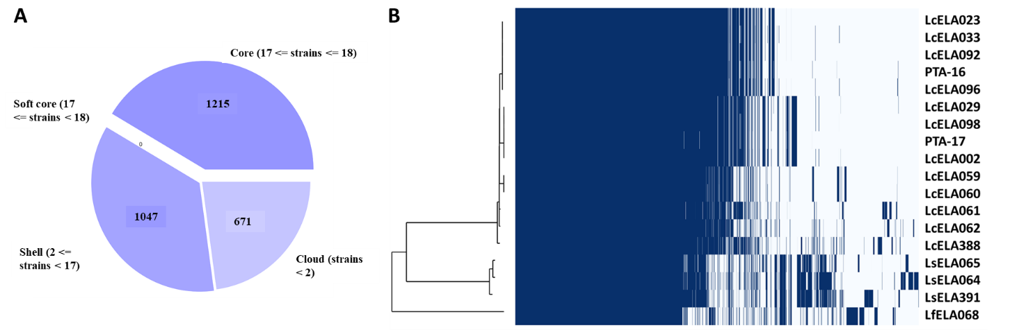
Supplementary Figure 1. Pan-genome analyses of L. curvatus, L. sakei and L. fuchuensis strains as determined by Orthofinder. A. The pan-genome pie chart showing gene content from core and accessory genes. B. A heatmap showing gene presence (dark blue) or absence (light blue) in each of the 18 Latilactobacillus strains. The core-genome tree generated was compared with a matrix where the core and accessory genes were either present or absent. Core, genes present in all strains; soft core, genes shared by the majority of the strains (>80%); shell, genes present in 15-80% of the strains; cloud, genes present in < 15% of the strains.

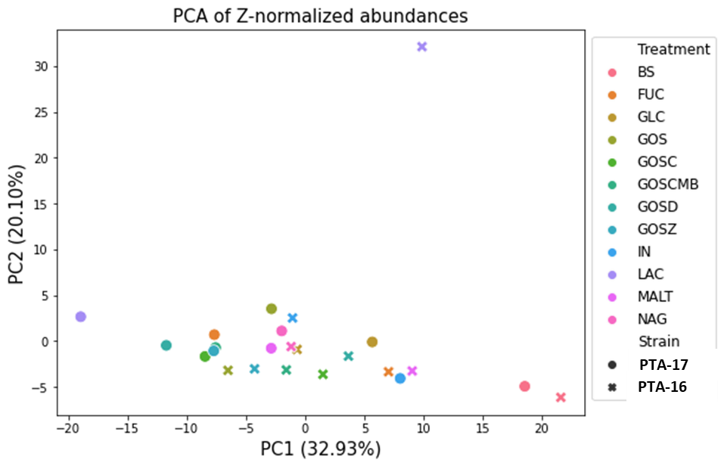
Supplementary Figure 2. PCA plot (2-component) for standardized feature abundances in PTA-16 and PTA-17. Each marker in the figure represents the mean of three replicates for each strain and growth condition. Abundance data for each feature was Z-score standardized before PCA analysis. Numbers in parenthesis indicate the variance explained by each of the principal components.

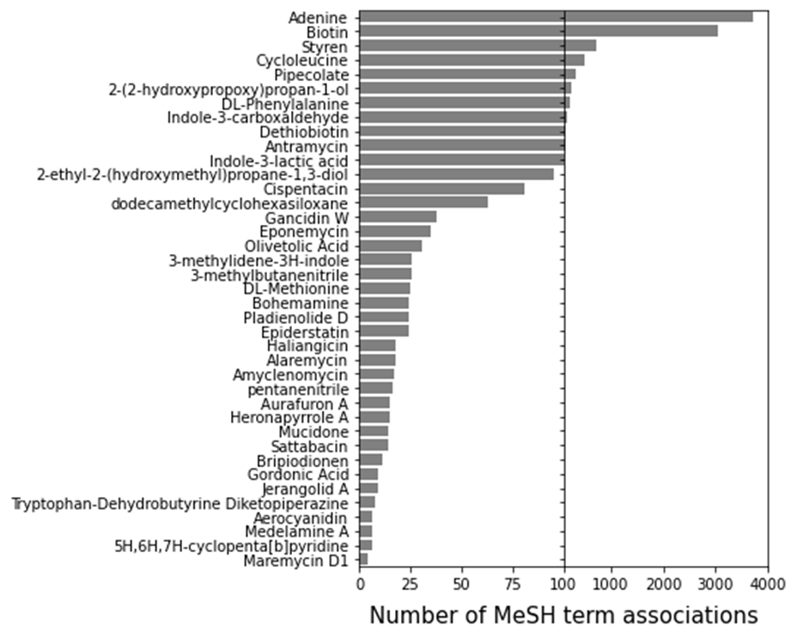
Supplementary Figure 3. Number of MeSH terms associated with possible metabolites produced by PTA-16 and PTA-17. MeSH terms were identified by their significant co-annotation with metabolites across PubMed articles.

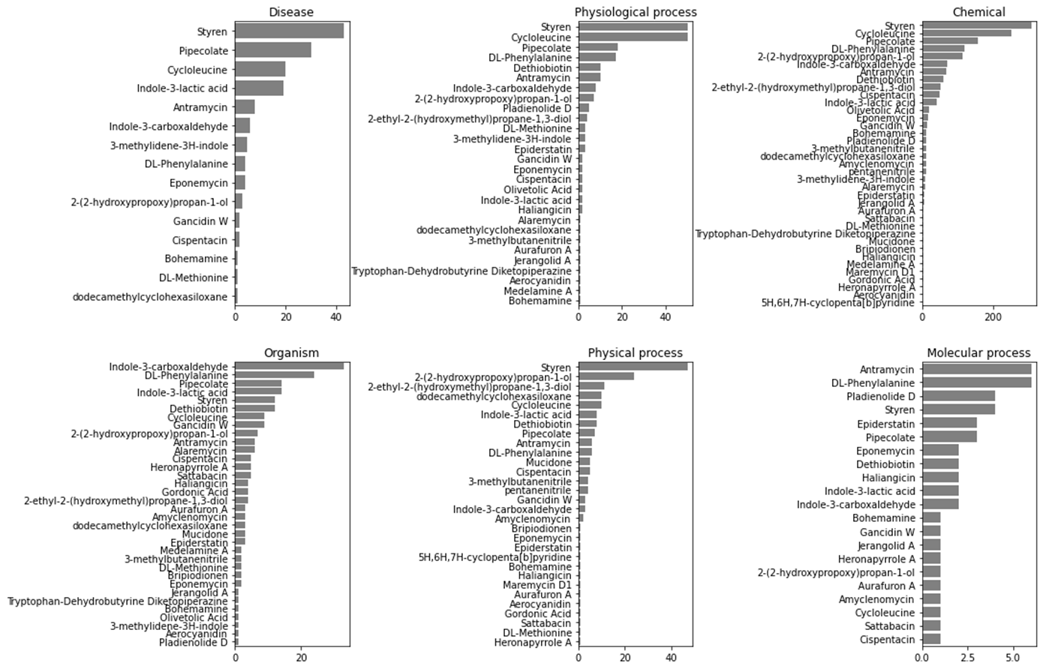
Supplementary Figure 4. MeSH terms in different categories associated with potential compounds produced by PTA-16 and PTA-17. MeSH terms associated via co-annotation in PubMed publications were classified based on the MeSH term ontology. Numbers for adenine and biotin were excluded.

