Consumption of acetaminophen during pregnancy: a survey on knowledge, attitudes and practices of Lebanese women

Online Resource

Sample size
The required sample size was calculated using Epi Info™ version 7.2. Relevant studies have shown that about 72.9% of Lebanese women consumed APAP during pregnancy (Rachidi et al. 2013), 45% of the Lebanese pregnant women had a good overall knowledge about APAP use (Ramia et al. 2017), while 80% agreed that it would be better for the fetus if they were more careful or stopped taking some drugs during pregnancy (Zaki and Albarraq 2014). A 95% confidence interval and a 5% margin of error were fixed for the sample size calculation taking into account the expected percentage that would give the highest minimum sample size (i.e. 45% by Ramia et al). Thus, a minimum of 380 participants were required.

Study tool
The survey questionnaire was established after reviewing the literature (Brandlistuen et al. 2013; Lupattelli et al. 2014; Zaki and Albarraq 2014; Mouhieddine et al. 2015; Kontogiorgis et al. 2016; Devkota et al. 2017; Navaro et al. 2018; Amundsen et al. 2019; de Waard et al. 2019; Atmadani et al. 2020) and consulting experts’ opinion (two midwives and one gynecologist). It was originally constructed in English then translated into Arabic by the main investigator. To be noted that a certified translator and another investigator compared and verified the two versions separately. Finally, both versions have been tested using a pilot study on 15 individuals and minimal changes have been made. The 8 sections was:
Information concerning the pregnancy
This part includes the age of the participants, the previous number of pregnancies, births, and abortions as well as the complications experienced in previous pregnancies. The term of pregnancies was assessed by calculating the gestational age of the pregnancy (the date of the last menstruation and the expected date of delivery were collected for those women currently pregnant) or by asking those who delivered in the last 12 months if the baby was born before or after 9 months / 36 weeks. Multiple pregnancy (twins, triplets, etc.) was also mentioned.
Health problems and use of drugs during pregnancy
The participants were asked to specify if they had any chronic problems or complications during the last / current pregnancy, as well as to specify the drugs taken, the duration of their consumption during pregnancy and the dose used. In addition, somatic symptoms (stomach pain, back pain, headache, dizziness, etc.) and the intake of dietary supplements were assessed.
Consumption of APAP among participants
The participants were asked about any consumption of APAP during pregnancy. They had also to specify during which month(s) they used APAP, for how many days per month, its indication, the average and maximum number of tablets taken per day, the tablets dosage in milligrams, and finally, the person that prescribed the medication.
Women's knowledge of APAP
In this section, participant’s knowledge about APAP was assessed, specifically its indications, the maximum daily dose allowed for pregnant women, the potential side effects on pregnancy and newborn baby, the risk of mortality with an overdose, and the possibility of using APAP with alcohol. A knowledge score (Cronbach α = 0.686) was created using a principal component analysis (PCA). This generated score was compared to the literacy score measured by “the Brief Health Literacy Screening items” (SBSQ) scale (Chew et al. 2004). To be noted that SBSQ is a self-rated health literacy scale consisting of three questions “How often do you have someone help you read hospital materials?”, “How confident are you filling out medical forms by yourself?” and “How often do you have problems learning about your medical condition because of difficulty understanding written information?”. These questions are used to detect marginal or inadequate health literacy (area under the ROC curve of 0.87, 0.80 and 0.76, respectively) (Chew et al. 2004). In addition, this scale has been validated in Lebanon (Fadda et al. 2018). A score was assigned ranging from 0 (presence of reading or comprehension problems and a lack of confidence in filling out medical forms) to 4 points (absence of reading or learning problems and extreme confidence in filling out medical forms). Then, these scores were added and a 12 point scale was obtained. A higher score indicates better health literacy.
Attitudes of women towards the use of APAP during pregnancy
The attitudes of pregnant women regarding APAP were assessed by asking women to rate the degree of their agreement or disagreement using the five item Likert scale with any statement regarding the use of APAP during pregnancy, its safety and the effects of its use on pregnancy and offspring. Women were also asked to specify from zero (Not harmful) to ten (very harmful), the degree of perceived toxicity of APAP and other substances for the fetus.
Sources of information
Women were asked to specify the source of their medical information (whether her physician, her family, the internet, etc.), the concordance of the received information between the different sources, their behavior in case of contradictory information, the most and the least trustworthy source. The women were also asked if they usually read the medication’s leaflet.
Personal information
We asked for the educational level and the professional status of the participant and her partner, the household monthly income, the number of rooms in the house, and the number of family members living in the house.

Generating a knowledge score: Principal Component Analysis
A PCA with a Promax rotation was carried out to assess the construct validity of the different dimensions of the APAP knowledge items. The adequacy of the Kaiser-Meyer-Olkin (KMO) and of the sample by Bartlett Tester was ensured. Furthermore, the reliability of the construction was assessed and Cronbach's α was calculated. Afterwards, the score was generated then compared to the literacy score. This is how the Receiver Operating Characteristic (ROC) curve was sketched to determine the optimal cutoff point that would predict a high knowledge score. The sensitivity (Se) and specificity (Sp) for the generated score were calculated to assess the validity of the criteria. Notably, several constructs were made by including the influencing factors of the women’s knowledge, but the validity and reliability of the score were not improved.
Validity and reliability of the knowledge score
A PCA was carried out, thus the 30 variables assessing the APAP’s knowledge of women were entered. In fact, 24 items were kept and were allocated over 8 factors, explaining 65.61% of the total variance. This index had good reliability with a Cronbach α equal to 0.686 (Table 1).

Knowledge score thresholds and proprieties
The ROC curve was illustrated in figure 1. The area under the curve was equal to 0.656 (0.580-0.732; p <0.001). The determination of Youden Index (J) an optimal cut-point of 11.5 with a Se equal 60.3% and Sp equal 68%. However, we were able to identify 2 cut-points having Se and Sp around 90%. The first one was equal to 8.5 (Se= 91.4% and Sp= 18.6%) and the second one equal to 14.5 (Se=15.5% and Sp=93%). Thereby, this score has been divided into 3 categories for descriptive purposes.

References

Amundsen S, Øvrebø TG, Amble NMS, Poole AC, Nordeng H (2019) Risk perception, beliefs about medicines and medical adherence among pregnant and breastfeeding women with migraine: findings from a cross-sectional study in Norway. BMJ Open 9:e026690. https://doi.org/10.1136/bmjopen-2018-026690
Atmadani RN, Nkoka O, Yunita SL, Chen Y-H (2020) Self-medication and knowledge among pregnant women attending primary healthcare services in Malang, Indonesia: a cross-sectional study. BMC Pregnancy and Childbirth 20:42. https://doi.org/10.1186/s12884-020-2736-2
Brandlistuen RE, Ystrom E, Nulman I, Koren G, Nordeng H (2013) Prenatal paracetamol exposure and child neurodevelopment: a sibling-controlled cohort study. Int J Epidemiol 42:1702–1713. https://doi.org/10.1093/ije/dyt183
Chew LD, Bradley KA, Boyko EJ (2004) Brief questions to identify patients with inadequate health literacy. Fam Med 36:588–594
de Waard M, Blomjous BS, Hol MLF, Sie SD, Corpeleijn WE, van Goudoever J (Hans) B, van Weissenbruch MM (2019) Medication Use During Pregnancy and Lactation in a Dutch Population. J Hum Lact 35:154–164. https://doi.org/10.1177/0890334418775630
Devkota R, Khan GM, Alam K, Sapkota B, Devkota D (2017) Impacts of counseling on knowledge, attitude and practice of medication use during pregnancy. BMC Pregnancy and Childbirth 17:131. https://doi.org/10.1186/s12884-017-1316-6
Fadda M, Kanj M, Kabakian-Khasholian T, Johannes Schulz P (2018) Validation of three Arabic health literacy assessment tools in Lebanon. Health Promot Int 33:261–267. https://doi.org/10.1093/heapro/daw079
Kontogiorgis C, Nena E, Berberoglou E, Moschoni K, Polyzois S, Tselemponis A, Constantinidis TC (2016) Estimating Consumers’ Knowledge and Attitudes Towards Over-The-Counter Analgesic Medication in Greece in the Years of Financial Crisis: The Case of Paracetamol. Pain Ther 5:19–28. https://doi.org/10.1007/s40122-015-0042-x
Lupattelli A, Spigset O, Twigg MJ, Zagorodnikova K, Mårdby AC, Moretti ME, Drozd M, Panchaud A, Hämeen-Anttila K, Rieutord A, Gjergja Juraski R, Odalovic M, Kennedy D, Rudolf G, Juch H, Passier A, Björnsdóttir I, Nordeng H (2014) Medication use in pregnancy: a cross-sectional, multinational web-based study. BMJ Open 4. https://doi.org/10.1136/bmjopen-2013-004365
Mouhieddine TH, Olleik Z, Itani MM, Kawtharani S, Nassar H, Hassoun R, Houmani Z, El Zein Z, Fakih R, Mortada IK, Mohsen Y, Kanafani Z, Tamim H (2015) Assessing the Lebanese population for their knowledge, attitudes and practices of antibiotic usage. J Infect Public Health 8:20–31. https://doi.org/10.1016/j.jiph.2014.07.010
Navaro M, Vezzosi L, Santagati G, Angelillo IF, Collaborative Working Group (2018) Knowledge, attitudes, and practice regarding medication use in pregnant women in Southern Italy. PLoS ONE 13:e0198618. https://doi.org/10.1371/journal.pone.0198618
Rachidi S, Awada S, Al-Hajje A, Bawab W, Zein S, Saleh N, Salameh P (2013) DHPS-44525-risky-exposures-during-pregnancy--a-pilot-study-from-lebanes 051413
Ramia E, Zeenny RM, Hallit S, Salameh P, Order of Pharmacists Scientific Committee – Medication Safety Subcommittee (2017) Assessment of patients’ knowledge and practices regarding their medication use and risks in Lebanon. Int J Clin Pharm 39:1084–1094. https://doi.org/10.1007/s11096-017-0517-4
Zaki NM, Albarraq AA (2014) Use, attitudes and knowledge of medications among pregnant women: A Saudi study. Saudi Pharm J 22:419–428. https://doi.org/10.1016/j.jsps.2013.09.001

Tables & figures

Table 1: Validity and reliability of knowledge score
Items | Factors
Items | 1 | 2 | 3 | 4 | 5 | 6 | 7 | 8
Propriety : antiemetic’s | 0.812
Propriety : antidiarrheal | 0.810
Propriety : antibiotics | 0.742
Propriety : anti-ulcer | 0.723
Effect : eye damage | -0.695
Propriety : sleep aid | 0.547
Safety during pregnancy |  | 0.819
Stage of pregnancy in which APAP can be use |  | 0.688
Propriety : analgesic |  | 0.652
Spasfon is a type of APAP |  |  | 0.820
Profenid is a type of APAP |  |  | 0.766
Propriety : antipyretic |  |  | 0.443
Effect : malformations |  |  |  | 0.851
Effect : asthma |  |  |  | 0.837
Effect : growth retardation |  |  |  | 0.542
Possible effect for woman |  |  |  |  | 0.921
Possible effect for fetus |  |  |  |  | 0.734
Effect : kidney damage |  |  |  |  | 0.588 |  |  | -0.435
Effect : autism |  |  |  |  |  | 0.801
Effect : hyperactivity |  |  |  |  |  | 0.648
APAP and death |  |  |  |  |  |  | 0.734
Effect : liver damage |  |  |  |  |  |  | 0.612
Minimum time of waiting between 2 doses |  |  |  |  |  |  |  | 0.714
Maximum allowed dose of APAP |  |  |  |  |  |  |  | 0.500
KMO = 0.705; Bartlett’s test of sphericity p < 0.001; α = 0⋅686.

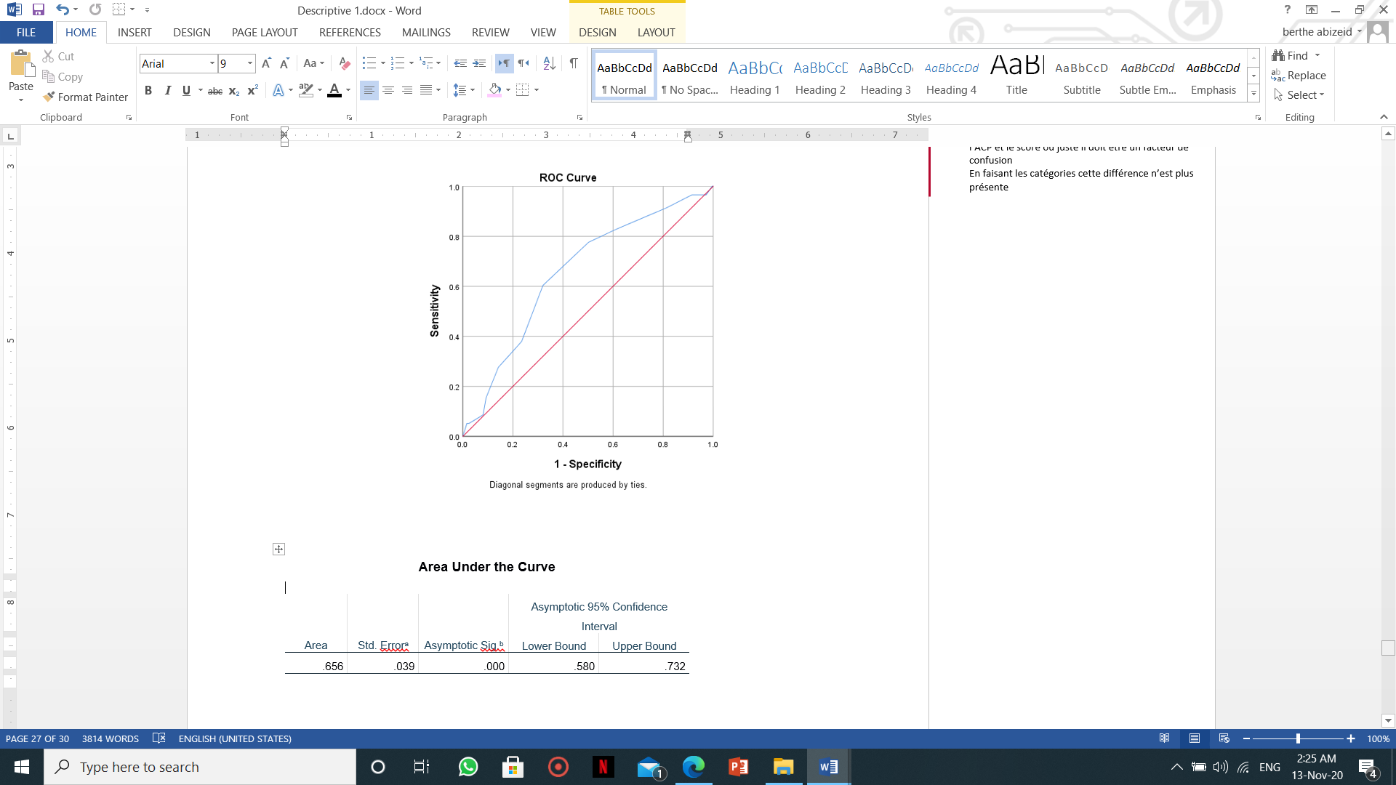
Figure 1 : ROC curve of knowledge score

