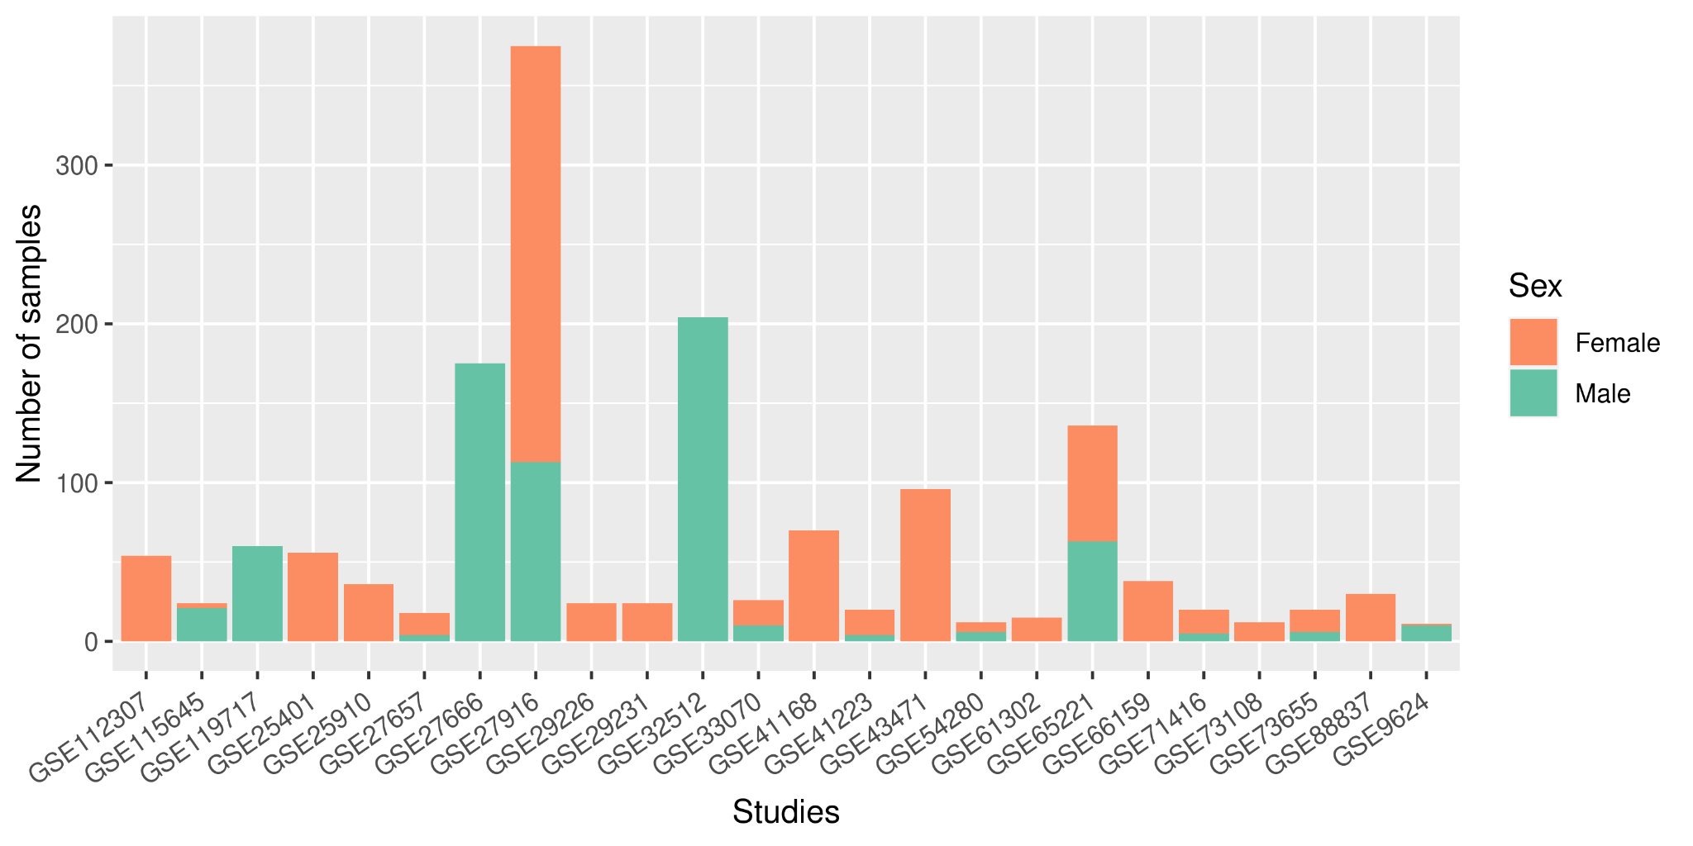
Figure S1. Summary of the number of female and male samples found in each Hsa study.

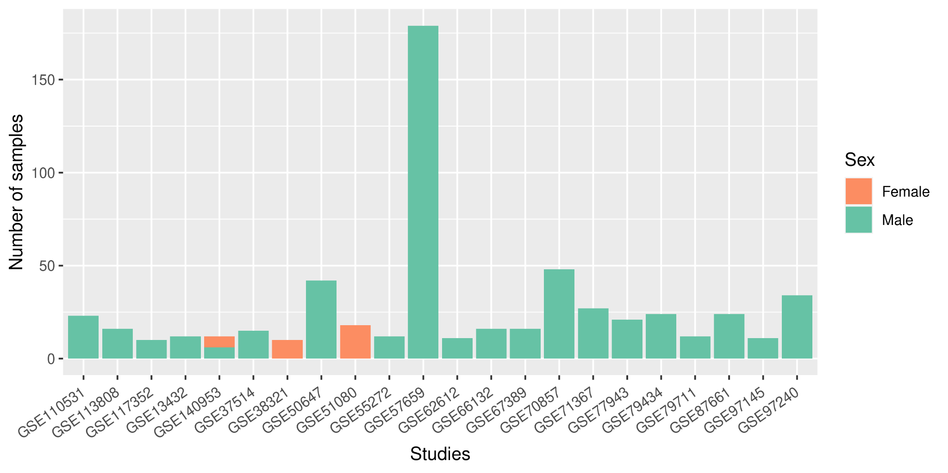
Figure S2. Summary of the number of female and male samples from each Mmu study. One study included samples from both sexes. Most collected samples corresponded to males, evidencing the striking absence of females.

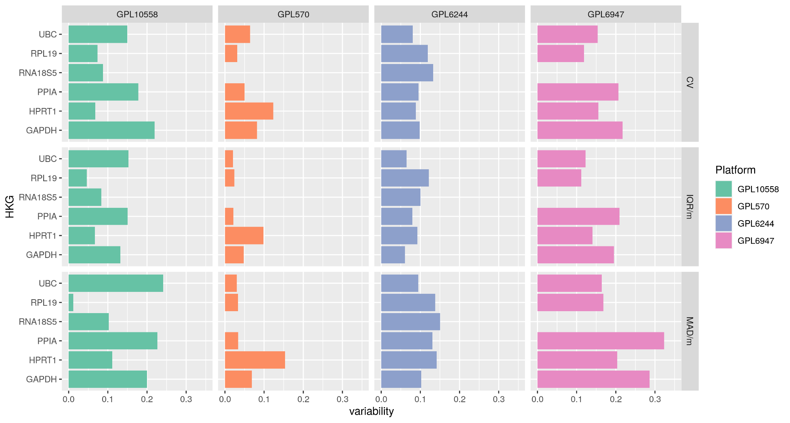
Figure S3. Variability levels for classic HKGs evaluated in Hsa females. The variability level found in the selected microarray platforms with the three statistical approaches (CV, IQR/median, and MAD/median) for each HKG is described on the X-axis.

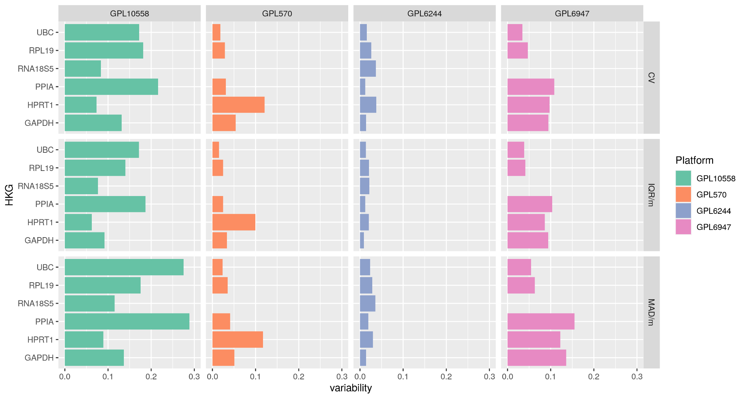
Figure S4. Variability levels for classic HKGs evaluated in Hsa males. The variability level found in the selected microarray platforms with the three statistical approaches (CV, IQR/median, and MAD/median) is described on the X-axis for each HKG.

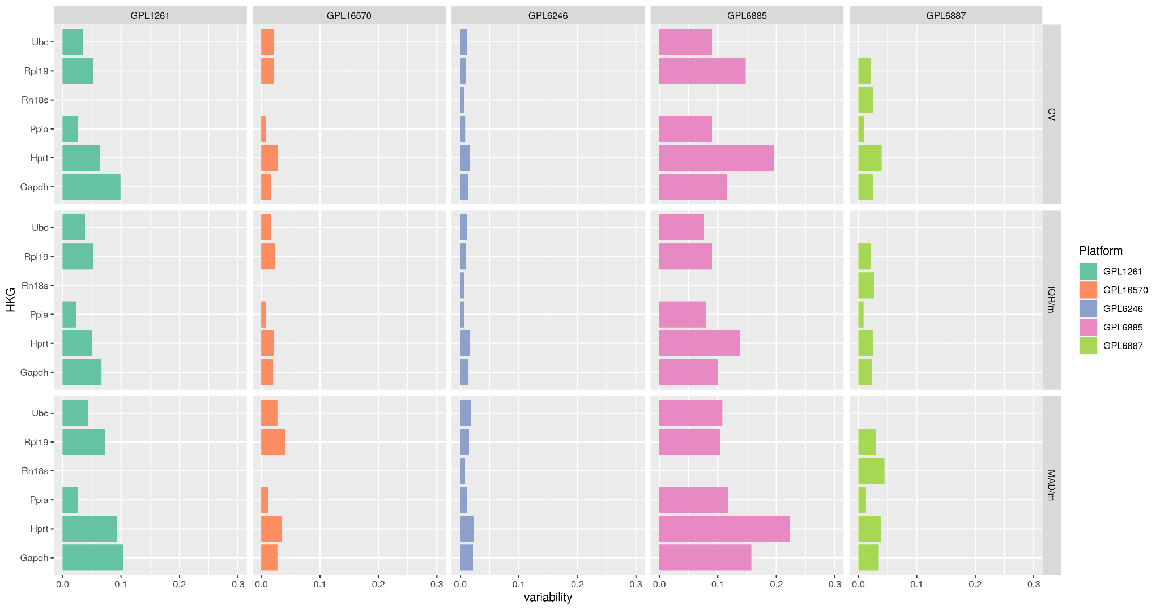
Figure S5. Variability levels for classic HKGs evaluated in all Mmu samples. The variability level found in the selected microarray platforms with the three statistical approaches (CV, IQR/median, and MAD/median) is described on the X-axis for each HKG.

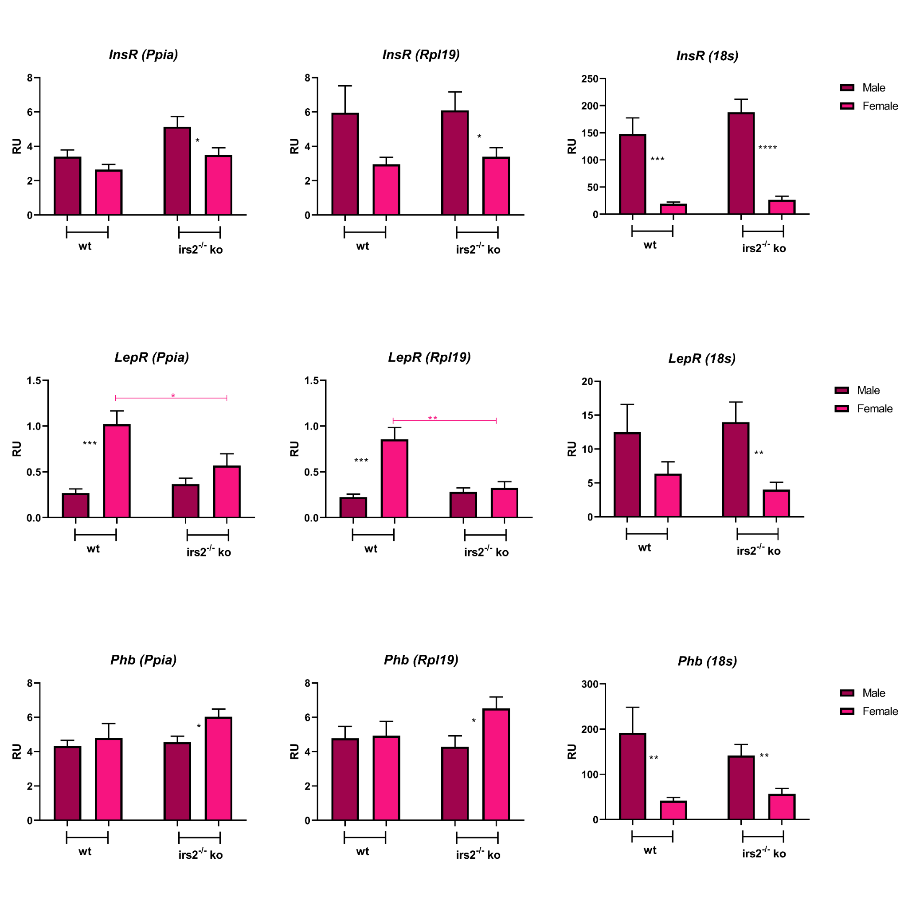
Figure S6. Candidate HKG analysis in mouse adipose tissue, using wt and irs2-/- KO male and female samples, showing Insr, Lepr, and Phb gene expression analysis using Ppia, Rpl19, and 18s as HKGs. Male wt n=11; Female wt n=13; Male KO n=16 and Female KO n=14. One-way ANOVA and t-test were performed for statistical analysis. The differences observed were considered significant when: p<0.05 (*), p<0.01 (**), and p<0.001 (***).

