Supplementary Information
Fluorine anion modification of high-voltage Mn-rich phosphate cathodes for high-power and long-lasting sodium-ion batteries
Wei Zhang, ^{1, 2, 5} Yulun Wu, ^{1,5} Zhenming Xu, ^{3,} * Jianwei Li, ² Yuhang Dai, ² Wei Zong, ² Ruwei Chen, ² Shihao Li, ¹ Fei Guo, ² Simin Li, ¹Feixiang Wu, ¹ Zhian Zhang,^{1,}* Guanjie He,^{2 ,4}* Yanqing Lai,^{1,}* and Ivan P. Parkin,^{2,}*
¹ School of Metallurgy and Environment, Engineering Research Center of the Ministry of Education for Advanced Battery Materials, Hunan Provincial Key Laboratory of Nonferrous Value-Added Metallurgy, Central South University, Changsha 410083, P. R. China
² Christopher Ingold Laboratory, Department of Chemistry, University College London, London WC1H 0AJ, UK
³ Jiangsu Key Laboratory of Electrochemical Energy Storage Technologies, College of Materials Science and Technology, Nanjing University of Aeronautics and Astronautics, Nanjing 210016, P. R. China
⁴ Electrochemical Innovation Lab (EIL), Department of Chemical Engineering, University College London, London WC1E 7JE, UK
⁵ These authors contributed equally: Wei Zhang, Yulun Wu.
*E-mail: xuzhenming@nuaa.edu.cn; zhangzhian@csu.edu.cn; g.he@ucl.ac.uk; laiyanqing@csu.edu.cn; i.p.parkin@ucl.ac.uk

Supplementary Figures and Tables
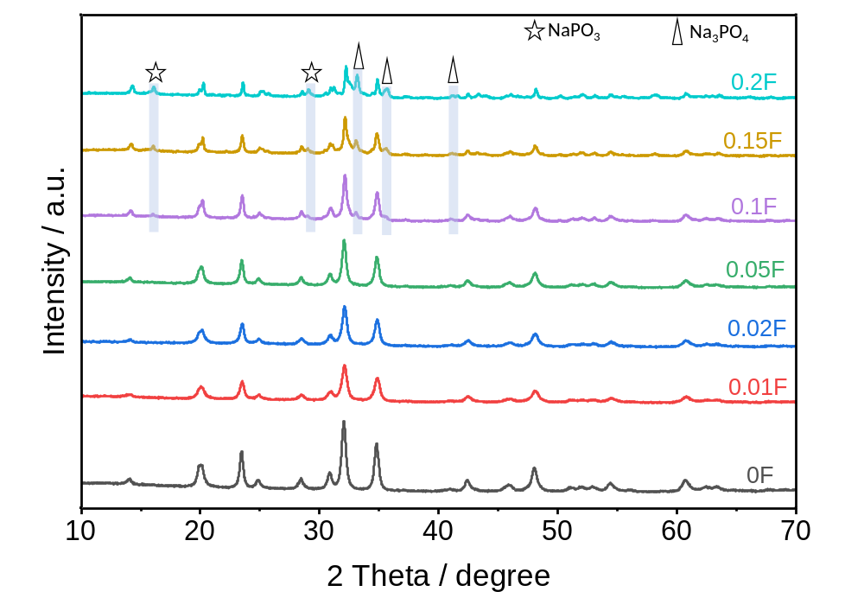
Supplementary Fig. 1 Comparison of X-ray diffraction (XRD) results of different as-prepared samples.

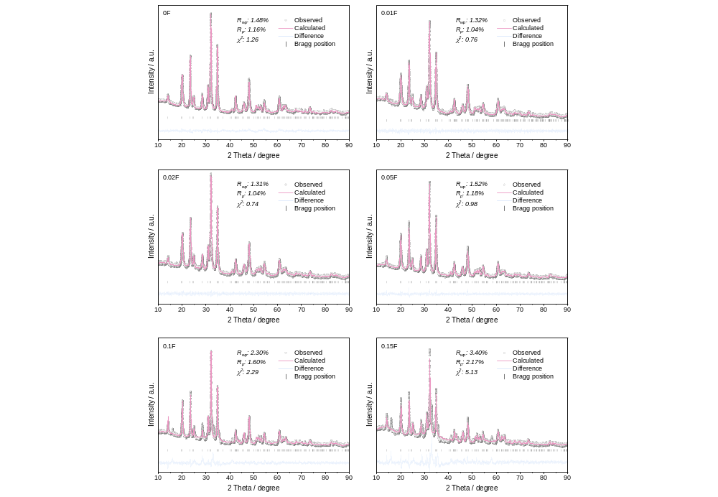
Supplementary Fig. 2 XRD Rietveld refinement results of Na_{4-3x}MnCr(PO_{4-x}F_{x})₃.
Supplementary Table 1 Detailed structural information of NMCP (0F) derived from Rietveld refinement.
Space group = R3c |  | R_{wp} = 1.48% |  | R_{p} = 1.16%
a (Å) = 8.915 |  | c (Å) = 21.422 |  | α (°) = 90
β (°) = 90 |  | γ (°) = 120 |  | V (Å³) = 1474.323
Atom | x | y | z | frac | site
Na1 | 0.00000 | 0.00000 | 0.00000 | 1.040 | 6b
Na2 | 0.64984 | 0.00000 | 0.25000 | 0.971 | 18e
Mn | 0.00000 | 0.00000 | 0.14935 | 0.500 | 12c
Cr | 0.00000 | 0.00000 | 0.14935 | 0.500 | 12c
P | 0.29936 | 0.00000 | 0.25000 | 1.000 | 18e
O1 | 0.01594 | 0.21084 | 0.19159 | 1.000 | 36f
O2 | 0.18785 | 0.17284 | 0.08423 | 1.000 | 36f

Supplementary Table 2 Detailed structural information of 0.01F derived from Rietveld refinement.
Space group = R3c |  | R_{wp} = 1.32% |  | R_{p} = 1.04%
a (Å) = 8.919 |  | c (Å) = 21.443 |  | α (°) = 90
β (°) = 90 |  | γ (°) = 120 |  | V (Å³) = 1477.099
Atom | x | y | z | frac | site
Na1 | 0.00000 | 0.00000 | 0.00000 | 1.003 | 6b
Na2 | 0.64209 | 0.00000 | 0.25000 | 0.943 | 18e
Mn | 0.00000 | 0.00000 | 0.15135 | 0.500 | 12c
Cr | 0.00000 | 0.00000 | 0.15135 | 0.500 | 12c
P | 0.29683 | 0.00000 | 0.25000 | 1.000 | 18e
O1 | 0.01650 | 0.21000 | 0.19300 | 0.998 | 36f
O2 | 0.18569 | 0.17236 | 0.08364 | 0.998 | 36f
F1 | 0.01650 | 0.21000 | 0.19300 | 0.002 | 36f
F2 | 0.18569 | 0.17236 | 0.08364 | 0.002 | 36f

Supplementary Table 3 Detailed structural information of 0.02F derived from Rietveld refinement.
Space group = R3c |  | R_{wp} = 1.31% |  | R_{p} = 1.04%
a (Å) = 8.916 |  | c (Å) = 21.414 |  | α (°) = 90
β (°) = 90 |  | γ (°) = 120 |  | V (Å³) = 1474.182
Atom | x | y | z | frac | site
Na1 | 0.00000 | 0.00000 | 0.00000 | 1.266 | 6b
Na2 | 0.63993 | 0.00000 | 0.25000 | 1.055 | 18e
Mn | 0.00000 | 0.00000 | 0.15015 | 0.500 | 12c
Cr | 0.00000 | 0.00000 | 0.15015 | 0.500 | 12c
P | 0.29976 | 0.00000 | 0.25000 | 1.000 | 18e
O1 | 0.01696 | 0.20785 | 0.19541 | 0.995 | 36f
O2 | 0.18717 | 0.17457 | 0.08400 | 0.995 | 36f
F1 | 0.01696 | 0.20785 | 0.19541 | 0.005 | 36f
F2 | 0.18717 | 0.17457 | 0.08400 | 0.005 | 36f

Supplementary Table 4 Detailed structural information of NMCPF (0.05F) derived from Rietveld refinement.
Space group = R3c |  | R_{wp} = 1.52% |  | R_{p} = 1.18%
a (Å) = 8.907 |  | c (Å) = 21.409 |  | α (°) = 90
β (°) = 90 |  | γ (°) = 120 |  | V (Å³) = 1470.906
Atom | x | y | z | frac | site
Na1 | 0.00000 | 0.00000 | 0.00000 | 1.058 | 6b
Na2 | 0.63891 | 0.00000 | 0.25000 | 0.948 | 18e
Mn | 0.00000 | 0.00000 | 0.14920 | 0.500 | 12c
Cr | 0.00000 | 0.00000 | 0.14920 | 0.500 | 12c
P | 0.29689 | 0.00000 | 0.25000 | 1.000 | 18e
O1 | 0.02285 | 0.20794 | 0.19536 | 0.988 | 36f
O2 | 0.18276 | 0.17623 | 0.08464 | 0.988 | 36f
F1 | 0.02285 | 0.20794 | 0.19536 | 0.012 | 36f
F2 | 0.18276 | 0.17623 | 0.08464 | 0.012 | 36f

Supplementary Table 5 Detailed structural information of 0.1F derived from Rietveld refinement.
Space group = R3c |  | R_{wp} = 2.30% |  | R_{p} = 1.60%
a (Å) = 8.921 |  | c (Å) = 21.398 |  | α (°) = 90
β (°) = 90 |  | γ (°) = 120 |  | V (Å³) = 1474.886
Atom | x | y | z | frac | site
Na1 | 0.00000 | 0.00000 | 0.00000 | 1.168 | 6b
Na2 | 0.64161 | 0.00000 | 0.25000 | 1.052 | 18e
Mn | 0.00000 | 0.00000 | 0.16000 | 0.500 | 12c
Cr | 0.00000 | 0.00000 | 0.16000 | 0.500 | 12c
P | 0.30093 | 0.00000 | 0.25000 | 1.000 | 18e
O1 | 0.02760 | 0.21321 | 0.19434 | 0.975 | 36f
O2 | 0.19387 | 0.17092 | 0.08709 | 0.975 | 36f
F1 | 0.02760 | 0.21321 | 0.19434 | 0.025 | 36f
F2 | 0.19387 | 0.17092 | 0.08709 | 0.025 | 36f

Supplementary Table 6 Detailed structural information of 0.15F derived from Rietveld refinement.
Space group = R3c |  | R_{wp} = 3.40% |  | R_{p} = 2.17%
a (Å) = 8.931 |  | c (Å) = 21.380 |  | α (°) = 90
β (°) = 90 |  | γ (°) = 120 |  | V (Å³) = 1476.950
Atom | x | y | z | frac | site
Na1 | 0.00000 | 0.00000 | 0.00000 | 0.941 | 6b
Na2 | 0.64377 | 0.00000 | 0.25000 | 0.989 | 18e
Mn | 0.00000 | 0.00000 | 0.14700 | 0.500 | 12c
Cr | 0.00000 | 0.00000 | 0.14700 | 0.500 | 12c
P | 0.30176 | 0.00000 | 0.25000 | 1.000 | 18e
O1 | 0.02658 | 0.20495 | 0.19196 | 0.962 | 36f
O2 | 0.20857 | 0.17458 | 0.09034 | 0.962 | 36f
F1 | 0.02658 | 0.20495 | 0.19196 | 0.038 | 36f
F2 | 0.20857 | 0.17458 | 0.09034 | 0.038 | 36f

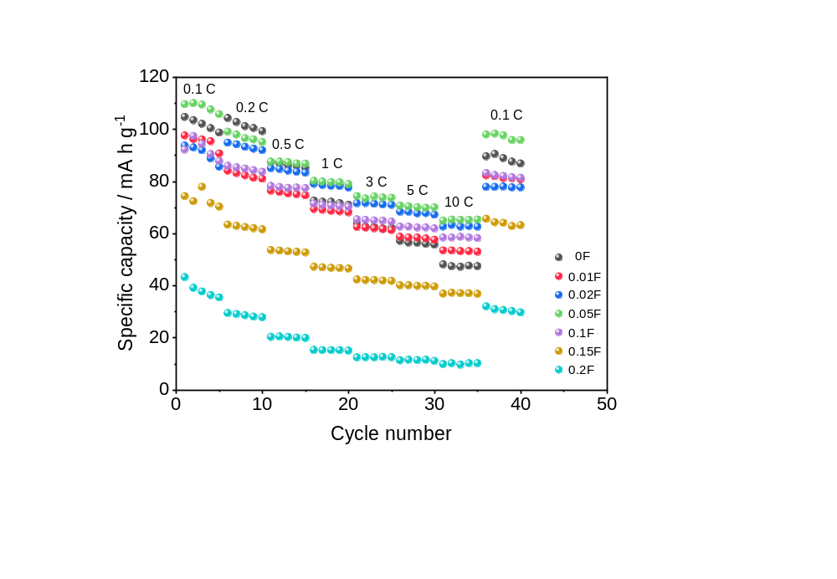
Supplementary Fig. 3 Rate performances of Na_{4-3x}MnCr(PO_{4-x}F_{x})₃ samples under 1.5-4.3 V (vs. Na⁺/Na).

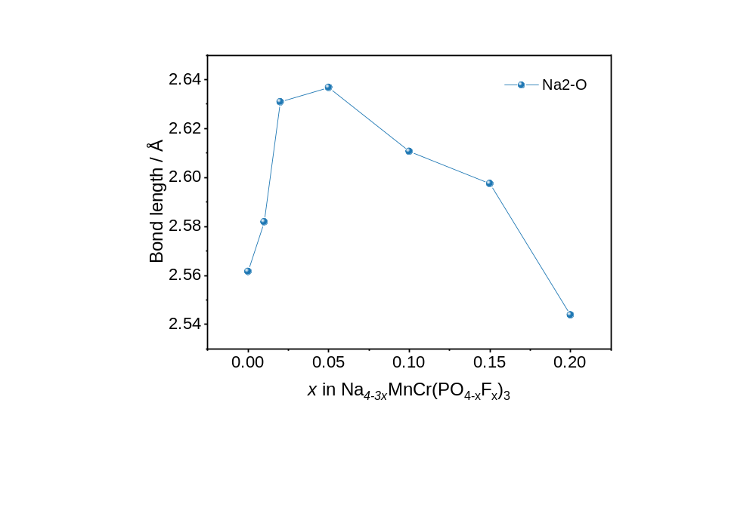
Supplementary Fig. 4 Bond length of Na(2)-O for Na_{4-3x}MnCr(PO_{4-x}F_{x})₃ samples.

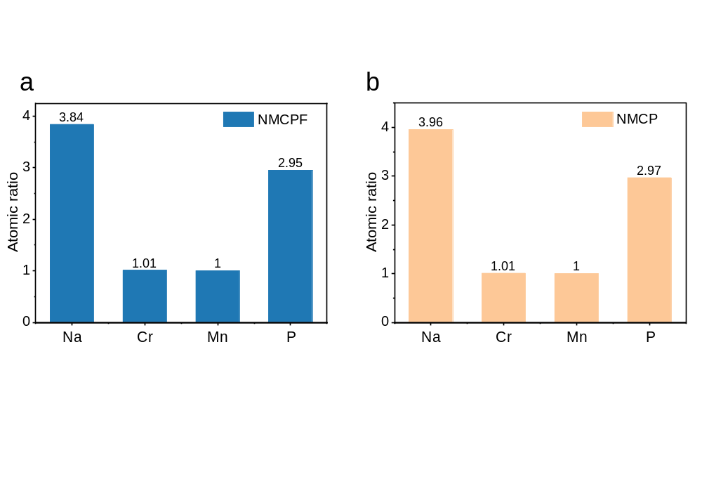
Supplementary Fig. 5 ICP results of a NMCPF and b NMCP.
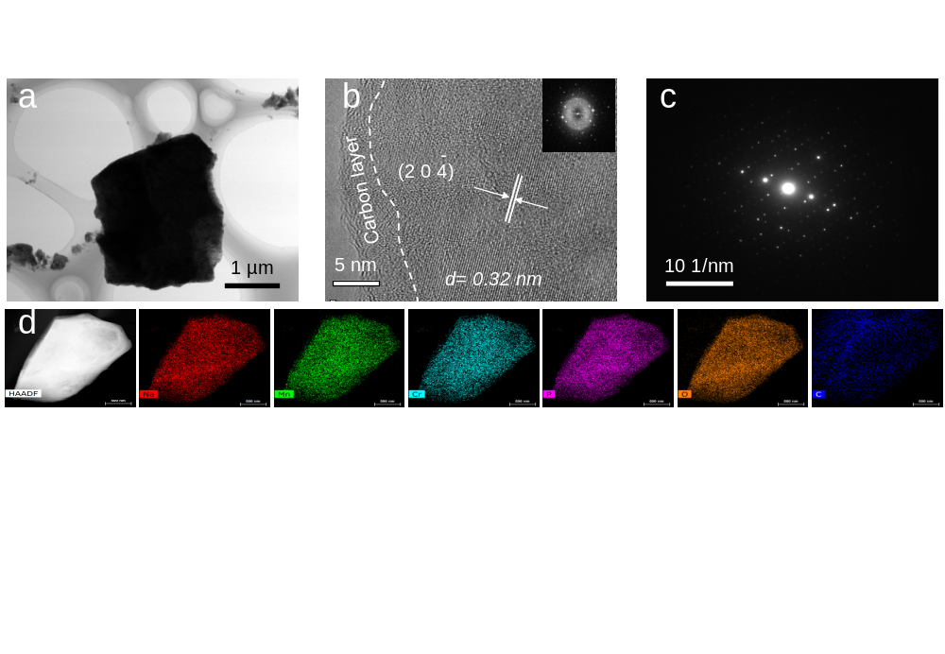
Supplementary Fig. 6 a TEM and b HRTEM images (inset: FFT pattern), c SAED pattern and d EDS mapping images of NMCP sample.
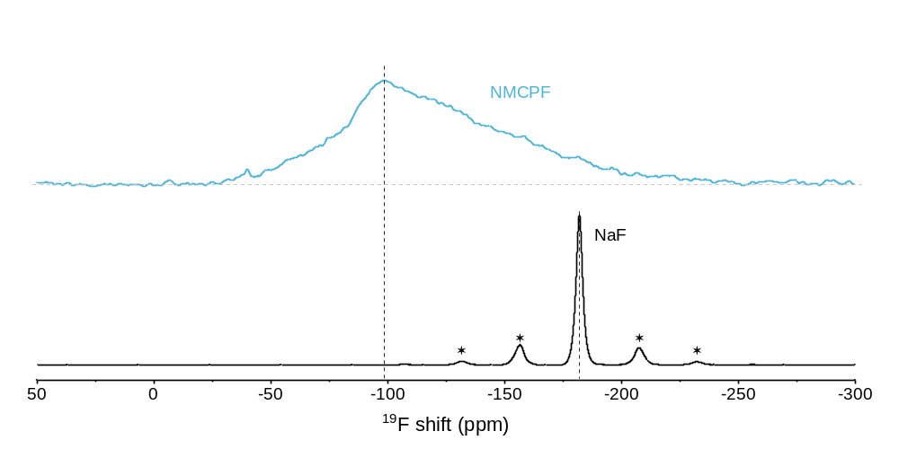
Supplementary Fig. 7 Solid-state ¹⁹F NMR spectra of the pristine NMCPF and the reference NaF. The asterisks indicate spinning sidebands (SSBs).

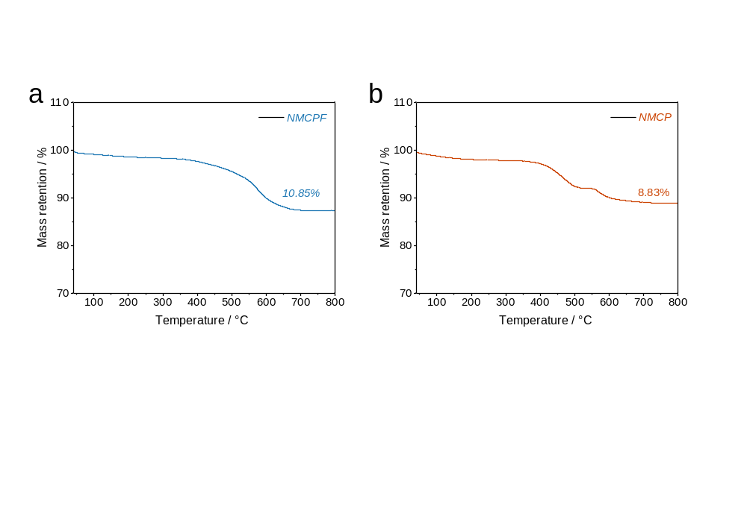
Supplementary Fig. 8 TG results of a NMCPF and b NMCP.

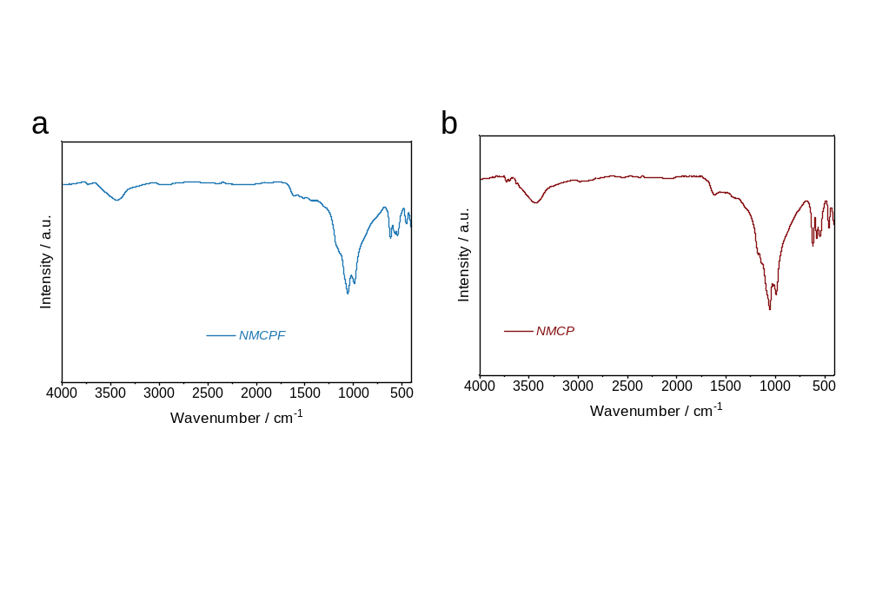
Supplementary Fig. 9 FT-IR results of a NMCPF and b NMCP.

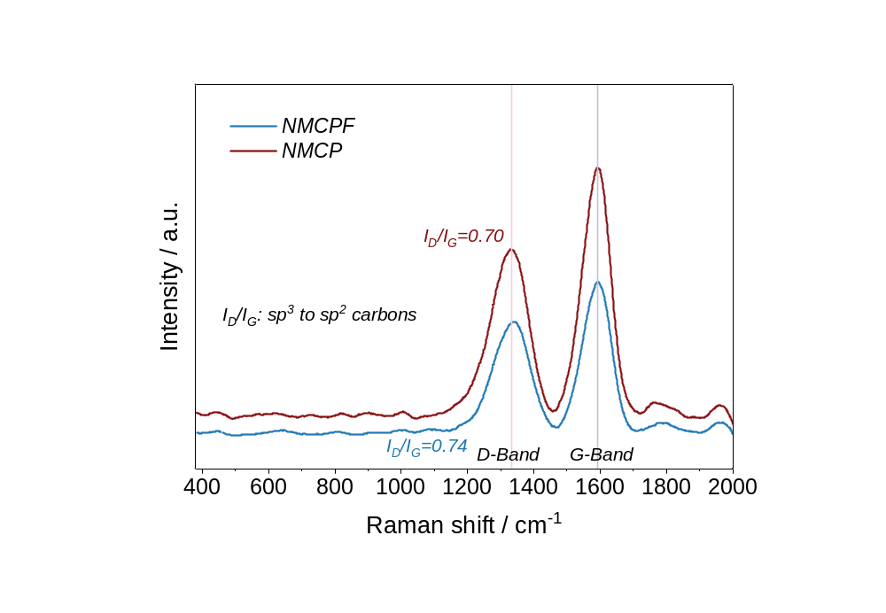
Supplementary Fig. 10 Raman spectra of NMCPF and NMCP.

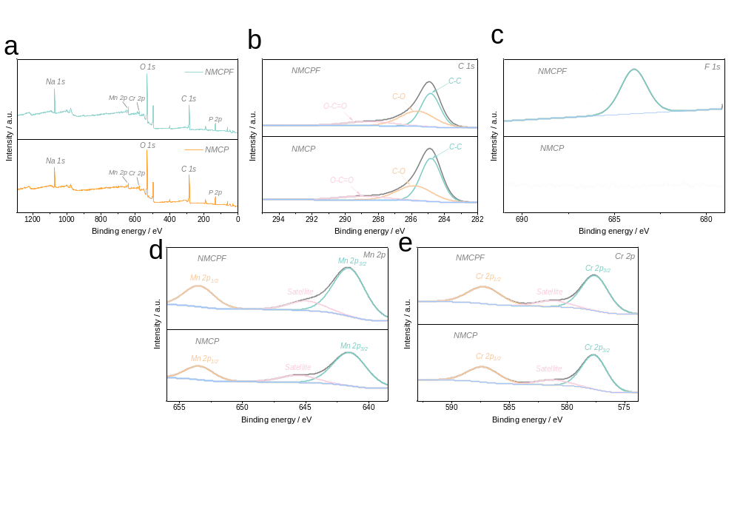
Supplementary Fig. 11 XPS spectra of NMCPF and NMCP.

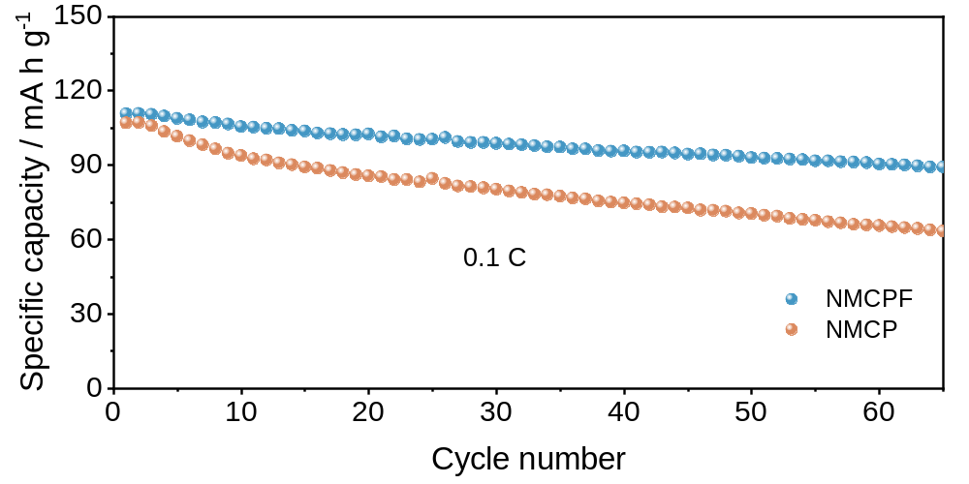
Supplementary Fig. 12 Cycling stability at 0.1 C for NMCPF and NMCP within 1.5–4.3 V.

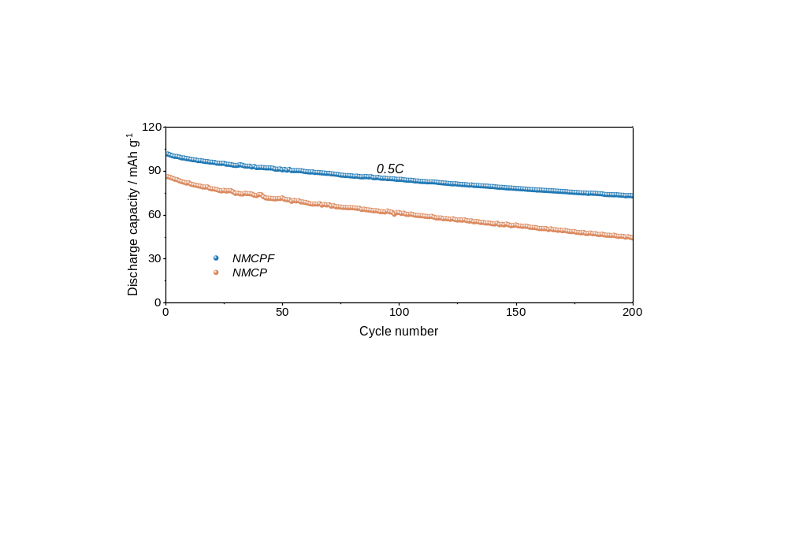
Supplementary Fig. 13 Cycling stability at 0.5 C for NMCPF and NMCP within 1.5–4.3 V.

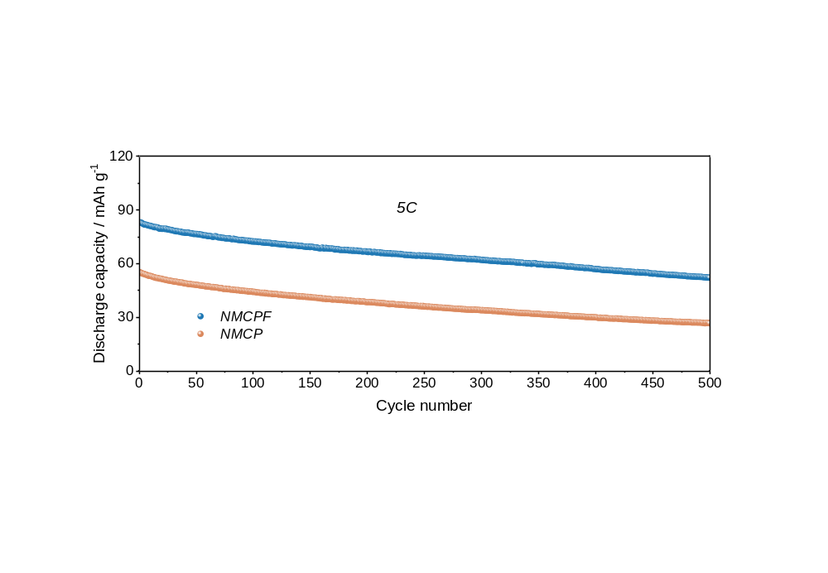
Supplementary Fig. 14 Cycling stability at 5 C for NMCPF and NMCP within 1.5–4.3 V.

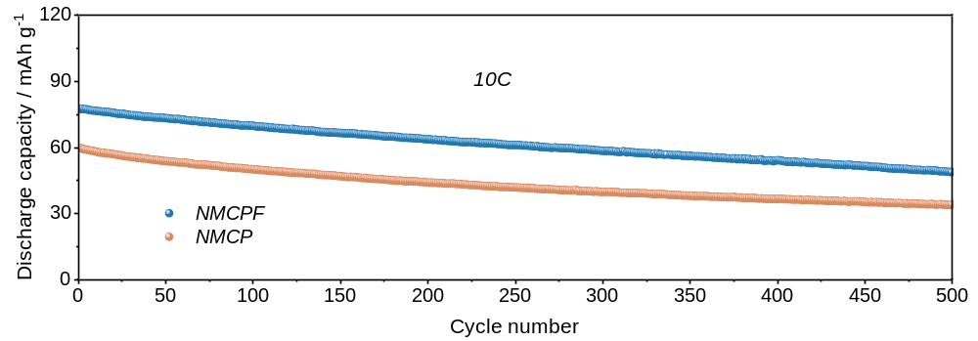
Supplementary Fig. 15 Cycling stability at 10 C for NMCPF and NMCP within 1.5–4.3 V.

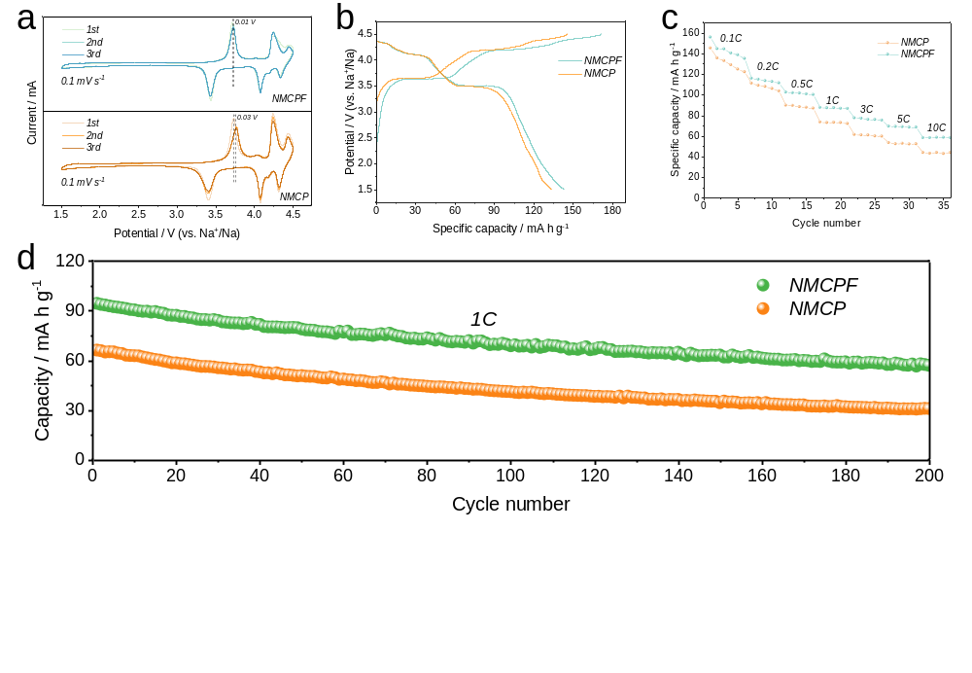
Supplementary Fig. 16 Electrochemical capabilities within 1.5–4.5 V. a CV curves at 0.1 mV s⁻¹. b Initial charge/discharge curve at 0.1 C. c Rate properties. d Cycling capabilities at 1 C.

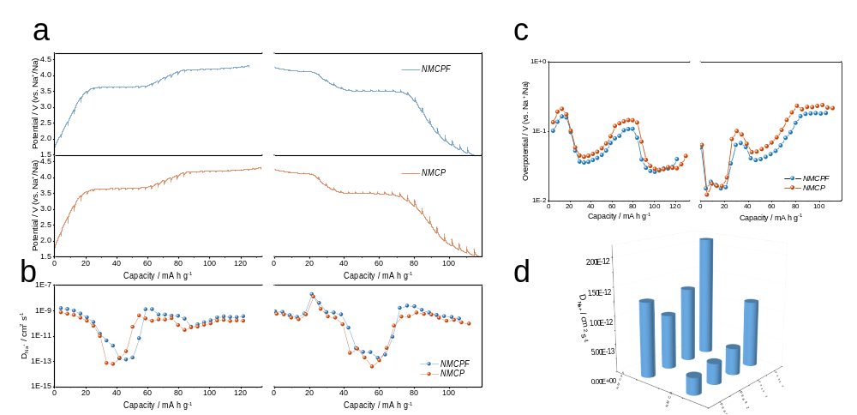
Supplementary Fig. 17 Kinetics properties of NMCPF and NMCP. a GITT profiles and corresponding b D_{Na+} as well as c overpotentials. d D_{Na+} obtained from CV methods at various scan rates.

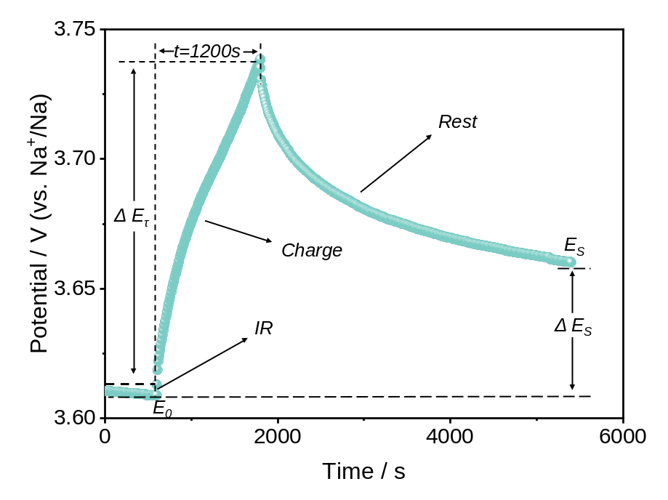
Supplementary Fig. 18 Detailed schematic diagram of a single-step GITT experiment at ~3.6 V for NMCPF cathode (current density: 0.1 C, 11 mA g⁻¹).
GITT calculation. 1200 s (τ) was set as the charging time, followed by a rest time of 3600 s. To calculate the diffusion coefficient of Na⁺ (D), the equation is as follow¹:
$\text{D}\text{ =} \frac{\text{4}}{ \text{πτ}}{\left(\frac{{\text{m}}_{\text{B}}{\text{V}}_{\text{m}}}{{\text{M}}_{\text{B}}\text{S}}\right)}^{\text{2}}{\left(\frac{\text{∆}{\text{E}}_{\text{s}}}{\text{∆}{\text{E}}_{\text{τ}}}\right)}^{\text{2}} \left(\text{τ}\text{≪}{\text{L}}^{\text{2}}\text{/D}\right)$ (Supplementary Equation 1)
Where L, m_{B}, M_{B}, V_{m}, S represent the thickness of the electrode, mass, molecular weight, molar volume, surface area of NMCPF or NMCP.

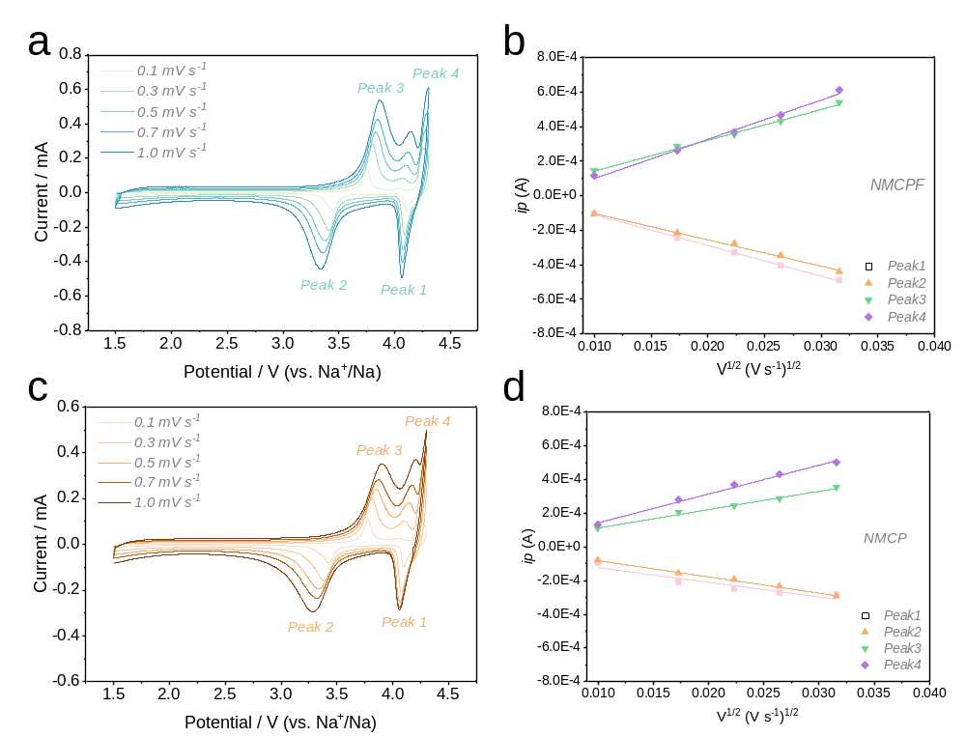
Supplementary Fig. 19 a CV curves at various scan rates from 0.1 to 1.0 mV s⁻¹ and b the linear fitting for the relationship between i_{p} and v^{1/2} from CV profiles of NMCPF. c CV curves at various scan rates from 0.1 to 1.0 mV s⁻¹ and d the linear fitting for the relationship between i_{p} and v^{1/2} from CV profiles of NMCP.
The D_{Na+} from CV tests can be calculated based on the Randles-Sevcik equation^{2, 3}:
$i_{p} \text{=} \text{2.69 × }{10}^{5}n^{3/2}\text{A}D^{1/2}\text{C}v^{1/2}$ (Supplementary Equation 2)
Where i_{p} refers to the peak current, n (2 in this test) is the amounts of transferred electrons, A (0.785 cm²) is the surface area of electrode, C represents the Na⁺ molar concentration (2.66 × 10⁻² mol cm⁻³), and v refers to the scan rates.

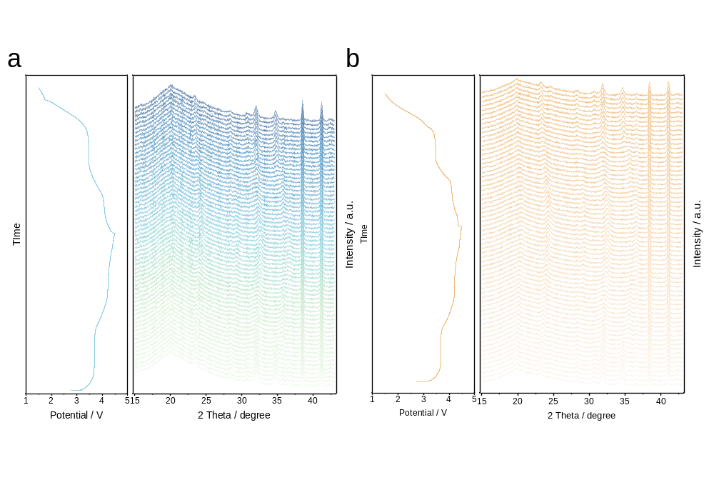
Supplementary Fig. 20 Full scope of in-situ XRD patterns of a NMCPF and b NMCP.

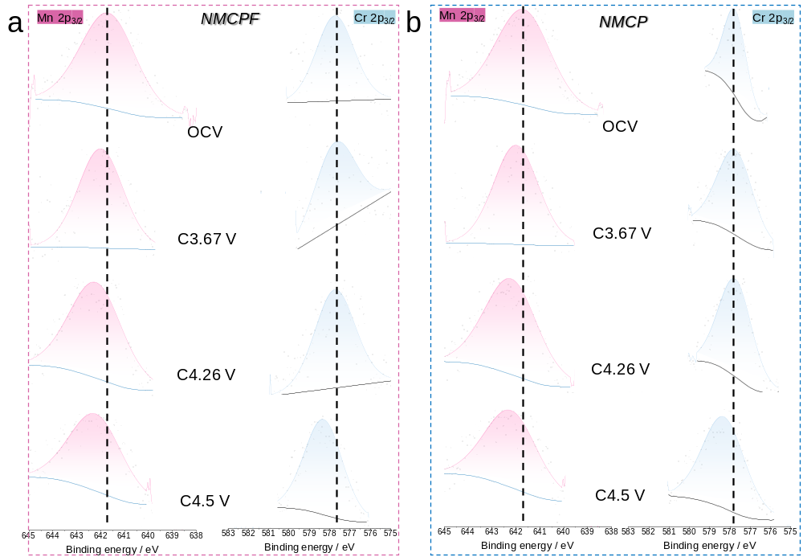
Supplementary Fig. 21 Ex-situ XPS spectra of Mn 2p_{3/2} and Cr 2p_{3/2} of a NMCPF and b NMCP at different charging states.
Supplementary Table 7 Magnetic moments of Mn, Cr, and F sites in Na_{x}MnCr(PO_{3.95}F_{0.05})₃ (x= 3.85, 2.85, 1.85 and 0.85).
Compositions | Magnetic Moment (μ_{B})
 | Mn×6 | Cr×6 | F×1
Na_{3.85}MnCr(PO_{3.95}F_{0.05})₃ | 4.462  4.46  4.464  4.463  4.471  4.451 | 2.817  2.829  2.835  2.841  2.83  2.829 | 0.012
Na_{2.85}MnCr(PO_{3.95}F_{0.05})₃ | 3.595  3.593  3.465  3.766  3.635  3.561 | 2.588  2.739  2.679  2.685  2.722  2.722 | 0.013
Na_{1.85}MnCr(PO_{3.95}F_{0.05})₃ | -3.357  -3.329  -3.419  -3.351  -3.398  -3.685 | -2.548  2.592  2.6  -2.617  2.62  2.622 | -0.018
Na_{0.85}MnCr(PO_{3.95}F_{0.05})₃ | 2.699  2.679  2.715  2.719  2.735  2.702 | 1.966  2.069  1.884  2.037  2.005  1.95 | 0.002

Supplementary Table 8 Magnetic moments of Mn and Cr sites in Na_{x}MnCr(PO₄)₃ (x= 4, 3, 2 and 1).
Compositions | Magnetic Moment (μ_{B})
 | Mn×6 | Cr×6
Na₄MnCr(PO₄)₃ | 4.63×6 | 2.93×6
Na₃MnCr(PO₄)₃ | 3.868×6 | 2.912×6
Na₂MnCr(PO₄)₃ | 3.23×6 | 2.886×6
Na₁MnCr(PO₄)₃ | 3.115×6 | -2.56×6

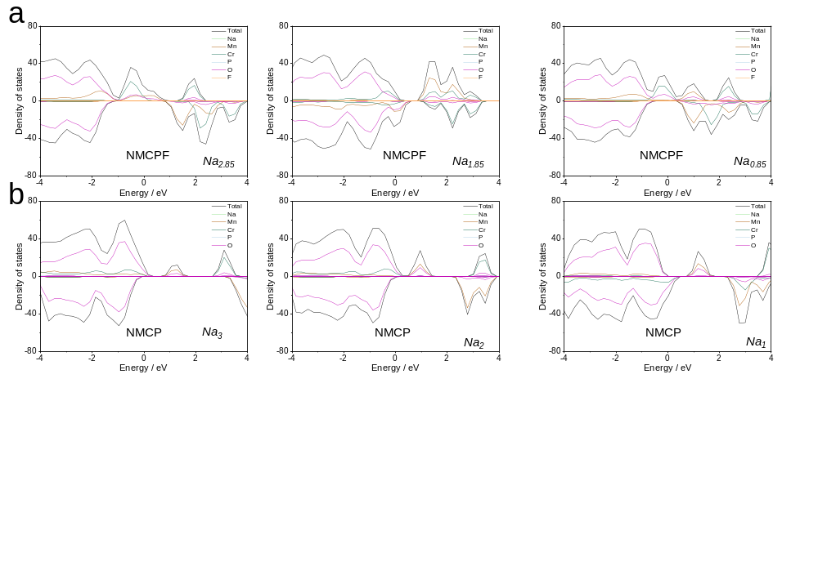
Supplementary Fig. 22 DOS patterns of a NMCPF and b NMCP with different Na contents.

Supplementary Table 9 Integrated crystal orbital Hamilton population (ICOHP) of Mn-O or Mn-F bonds in NMCPF.
Type of bond | Distance / Å | Spin direction | ICOHP / eV
Mn29-F125 | 2.49 | Spin up | -0.09
Mn29-F125 | 2.49 | Spin down | -0.16
Mn29-O121 | 2.24 | Spin up | -0.18
Mn29-O121 | 2.24 | Spin down | -0.32
Mn29-O120 | 2.20 | Spin up | -0.25
Mn29-O120 | 2.20 | Spin down | -0.43
Mn29-O86 | 2.06 | Spin up | -0.60
Mn29-O86 | 2.06 | Spin down | -0.86
Mn29-O85 | 2.13 | Spin up | -0.41
Mn29-O85 | 2.13 | Spin down | -0.58
Mn29-O84 | 2.07 | Spin up | -0.36
Mn29-O84 | 2.07 | Spin down | -0.66
Accumulated ICOHP / eV |  |  | -4.91

Supplementary Table 10 Integrated crystal orbital Hamilton population (ICOHP) of Mn-O bonds in NMCP.
Type of bond | Distance / Å | Spin direction | ICOHP / eV
Mn30-O123 | 2.25 | Spin up | -0.15
Mn30-O123 | 2.25 | Spin down | -0.31
Mn30-O122 | 2.25 | Spin up | -0.15
Mn30-O122 | 2.25 | Spin down | -0.31
Mn30-O121 | 2.25 | Spin up | -0.15
Mn30-O121 | 2.25 | Spin down | -0.31
Mn30-O87 | 2.12 | Spin up | -0.41
Mn30-O87 | 2.12 | Spin down | -0.59
Mn30-O86 | 2.12 | Spin up | -0.41
Mn30-O86 | 2.12 | Spin down | -0.59
Mn30-O85 | 2.12 | Spin up | -0.41
Mn30-O85 | 2.12 | Spin down | -0.59
Accumulated ICOHP / eV |  |  | -4.38

Supplementary Fig. 23 COHP and ICOHP results of Mn29 atom interacting with different O/F atoms around it in NMCPF.
Supplementary Fig. 24 COHP and ICOHP results of Mn30 atom interacting with different O atoms around it in NMCP.

Supplementary References
1. Rui X. H., Ding N., Liu J., Li C. & Chen C. H. Analysis of the chemical diffusion coefficient of lithium ions in Li₃V₂(PO₄)₃ cathode material. Electrochim. Acta 55, 2384-2390 (2010).
2. Gu Z. Y. et al. An Advanced High-Entropy Fluorophosphate Cathode for Sodium-Ion Batteries with Increased Working Voltage and Energy Density. Adv. Mater. 34, 2110108 (2022).
3. Zhang J. et al. A Novel NASICON‐Type Na₄MnCr(PO₄)₃ Demonstrating the Energy Density Record of Phosphate Cathodes for Sodium‐Ion Batteries. Adv. Mater. 32, 1906348 (2020).

