Supplementary Table 1. Results of the visual analysis and qualitative evaluation with the derived hypometabolism pattern.
Patient ID | Frontal | Temporal | Parietal | Occipital | Thalamus | Basal Ganglia | Cerebellum | Pattern Matching
P0001 | 2 | 2 | 0 | 0 | 3 | 0 | 3 | 3
P0002 | 0 | 1 | 0 | 0 | 3 | 1 | 3 | 1
P0003 | 3 | 2 | 0 | 0 | 2 | 1 | 0 | 1
P0004 | 3 | 1 | 2 | 1 | 3 | 0 | 3 | 3
P0005 | 2 | 2 | 1 | 0 | 0 | 0 | 3 | 2
P0006 | 1 | 2 | 0 | 1 | 1 | 0 | 2 | 1
P0007 | 3 | 3 | 3 | 0 | 3 | 0 | 3 | 2
P0008 | 3 | 2 | 2 | 0 | 3 | 0 | 3 | 3
P0009 | 0 | 1 | 0 | 0 | 0 | 0 | 1 | 0
P0010 | 1 | 1 | 0 | 0 | 2 | 0 | 3 | 2
P0011 | 2 | 2 | 0 | 0 | 3 | 1 | 3 | 3
P0012 | 0 | 2 | 1 | 0 | 3 | 1 | 3 | 2
P0013 | 1 | 0 | 0 | 0 | 0 | 0 | 1 | 0
P0014 | 2 | 1 | 0 | 0 | 1 | 1 | 0 | 1
P0015 | 0 | 1 | 0 | 1 | 2 | 0 | 3 | 2
P0016 | 0 | 1 | 0 | 1 | 2 | 0 | 3 | 2
P0017 | 1 | 0 | 0 | 0 | 3 | 0 | 2 | 2
P0018 | 3 | 2 | 1 | 0 | 3 | 0 | 3 | 3
P0019 | 2 | 0 | 0 | 0 | 1 | 1 | 0 | 0
P0020 | 1 | 0 | 0 | 0 | 3 | 0 | 1 | 1
P0021 | 1 | 0 | 2 | 1 | 0 | 1 | 1 | 1
P0022 | 1 | 3 | 0 | 0 | 2 | 1 | 2 | 2
Average | 1.45 | 1.32 | 0.55 | 0.23 | 1.95 | 0.36 | 2.09 | 1.68
Median | 1 | 1 | 0 | 0 | 2 | 0 | 3 | 2

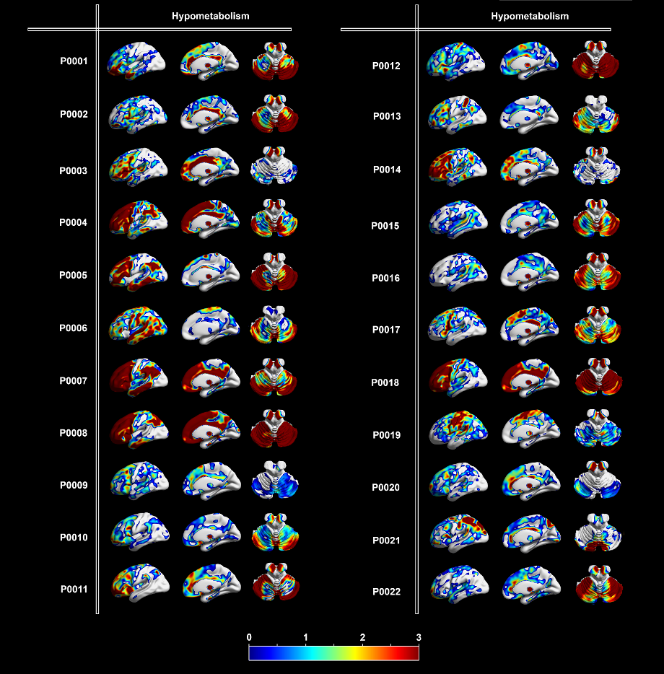
Supplementary Figure 1: Single-subject PET quantification patterns (colour scale in z-scores)

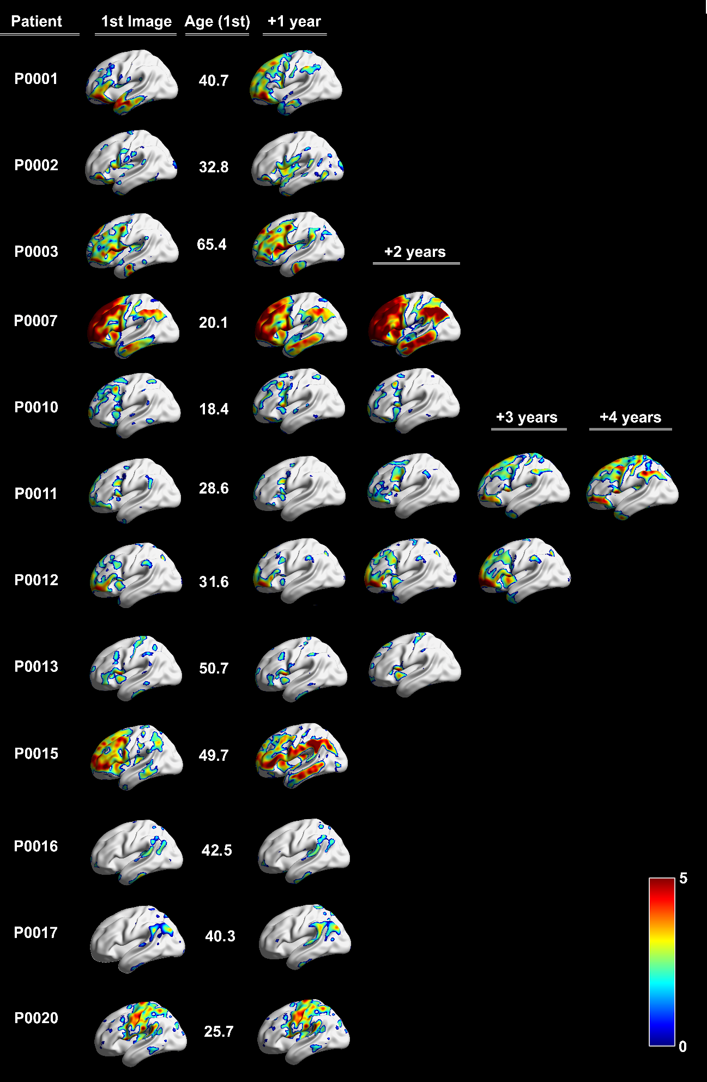
Supplementary Figure 2 Cortical hypometabolism progression (colour scale in z-scores).

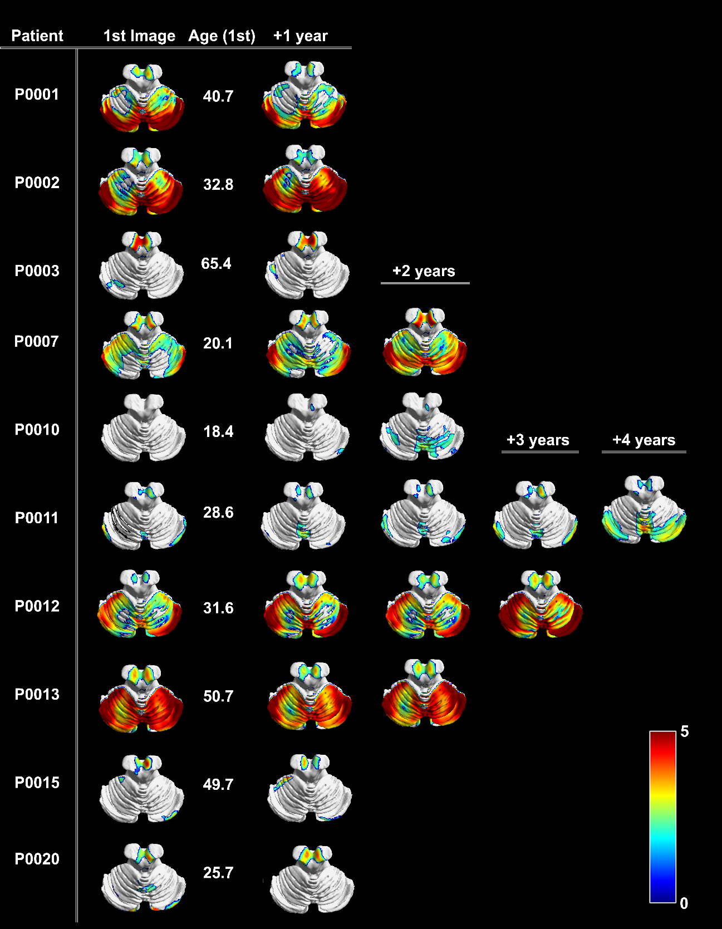Supplementary Figure 3: Cerebellar hypometabolism progression (colour scale in z-scores).

