Appendices:
Appendix F1

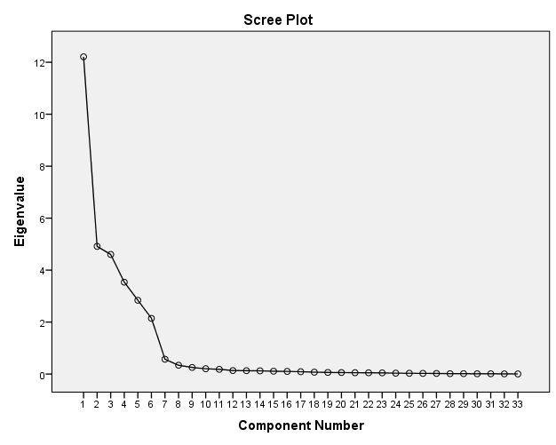
F1: Scree plot showing the number of factors in the Arabic version of DAS.

Appendix F2: Factorial structure of Driver Anger Scale (DAS-A)
Factorial structure of Driver Anger Scale (DAS)

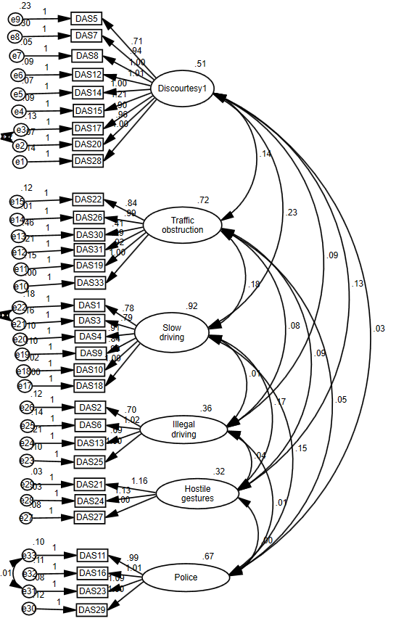
Appendix T1: Rerun of EFA after changes made to the model: Similar six-factor solution of DAS items, eigenvalues, Cronbach’s alpha coefficients, and variance explained by each DAS subscale among Lebanese drivers

 |  | DAS factors
 |  | Discourtesy | Traffic obstruction | Slow driving | Police presence | Illegal driving | Hostile gesture
DAS8 | Someone cuts in and takes the parking spot you have been waiting for | 0.875
DAS20 | Someone pulls right in front of you when there is no one behind you | 0.847
DAS14 | Someone coming toward you at night does not dim their headlights | 0.836
DAS15 | At night someone is driving right behind you with bright lights on | 0.818
DAS12 | Someone backs right out in front of you without looking | 0.817
DAS17 | Someone speeds up when you try to pass them | 0.806
DAS28 | A motorcyclist is riding in the middle of the lane and slowing traffic | 0.792
DAS7 | Someone cuts in right in front of you on the motorway | 0.749
DAS5 | Someone is driving very close to your rear bumper | 0.698
DAS33 | You encounter road construction and detours |  | 0.848
DAS26 | You are driving behind a truck that is material flapping around in the back |  | 0.841
DAS19 | You are stuck in a traffic jam |  | 0.813
DAS22 | You hit a deep pothole that was not marked |  | 0.801
DAS31 | A truck kicks up sand or gravel on the car you are driving |  | 0.788
DAS30 | You are behind a vehicle that is smoking badly or giving off diesel fumes |  | 0.701
DAS18 | Someone is slow in parking and holding up traffic |  |  | 0.883
DAS10 | A slow vehicle on a mountain road will not pull over and let people by |  |  | 0.809
DAS4 | Someone is driving too slowly in the passing lane holding up traffic |  |  | 0.804
DAS9 | Someone is driving slower than reasonable for the traffic flow |  |  | 0.801
DAS2 | A pedestrian walks slowly across the middle of the street, slowing you |  |  | 0.777
DAS1 | Someone in front of you does not start up when the light turns green |  |  | 0.735
DAS23 | A police car is driving in traffic close to you |  |  |  | 0.874
DAS16 | You pass a radar speed trap |  |  |  | 0.835
DAS11 | You see a police car watching traffic from a hidden position. |  |  |  | 0.831
DAS29 | A police officer pulls you over |  |  |  | 0.901
DAS25 | Someone is driving well above the speed limit |  |  |  |  | 0.878
DAS6 | Someone is weaving in and out of traffic |  |  |  |  | 0.858
DAS2 | Someone is driving too fast for the road conditions |  |  |  |  | 0.857
DAS13 | Someone runs a red light or stop sign |  |  |  |  | 0.783
DAS21 | Someone makes an obscene gesture toward you about your driving |  |  |  |  |  | 0.879
DAS24 | Someone honks at you about your driving |  |  |  |  |  | 0.843
DAS27 | Someone yells at you about your driving |  |  |  |  |  | 0.813
 | Eigenvalue | 9.560 | 5.813 | 3.538 | 3.302 | 2.179 | 2.021
 | Variance | 35.431 | 14.786 | 13.852 | 10.812 | 8.348 | 7.187
Note: 88.6% of the variance was explained, Extraction Method: PCA, Rotation Method: Varimax with Kaiser Normalization.

Appendix T2: Correlation matrix for the driver behavior questionnaire (DBQ-L) subscales
 | Hostile gesture | Illegal driving | Discourtesy | Police presence | Traffic obstruction | Slow driving | DAS  scale
Hostile gesture | 1 | 0.287** | 0.341** | 0.010 | 0.217** | 0.309** | 0.478**
Illegal driving |  | 1 | 0.510** | 0.051 | 0.321** | 0.205** | 0.612**
Discourtesy |  |  | 1 | 0.064 | 0.274** | 0.396** | 0.775**
Police presence |  |  |  | 1 | 0.080 | 0.178** | 0.376**
Traffic obstruction |  |  |  |  | 1 | 0.258** | 0.617**
Slow driving |  |  |  |  |  | 1 | 0.702**
DAS scale |  |  |  |  |  |  | 1
Note: ** Correlation is significant at the 0.001 level (p<0.01), * Correlation is significant p<0.05

