Supplementary Table 1.
L-WRN conditioned media
Component | Manufacturer | Cat.No.
L-WRN cell line | ATCC | ATCC-CRL-3276
FBS | Gibco | 10500064
G-418 | Gibco | 11811031
Hygromycin B | Invitrogen | 10687010
ATCC-formulated DMEM | ATCC | ATCC-30-2002
Kanamycin Sulfate | Gibco | 15160054
Antibiotic-Antimycotic (100X) | Gibco | 15240062
Supplementary Table 2.
Generation of human pancreas organoid cultures and manipulation of cell polarity
Spitting media
Component | Manufacturer/Cat.No. | Final cc/volume
Advanced DMEM/F-12 | Gibco, Catalog No.: 12634-010 | 500 ml
1 M HEPES | Gibco, Catalog No.: 15630080 | 5 ml  (10 mM)
GlutaMax Supplement(100X) | Gibco, Catalog No.: 35050061 | 5ml  (1X)
Primocin (400X) | Invivogen, Catalog No.: ant-pm-2 | 1,25 ml  (1X)
Supplementary Table 3.
Generation of human pancreas organoid cultures and manipulation of cell polarity
Digestion Media
Component | Manufacturer/Cat.No. | Final cc/volume
Splitting media | - | 19,0984 ml
Collagenase IV. | Worthington, Catalog No.: LS004188 | 1250 U/ml
Dispase | Sigma-Aldrich, Catalog No: D4693-1G | 0,5 U/ml
FBS | Gibco, Catalog No: 10500064 | 0,5 ml  2,5%
Soybean Trypsin Inhibitor | Sigma-Aldrich, Catalog No: T9128-1G | 1mg/ml
Kanamycin Sulfate | Gibco, Catalog No: 15160054 | 200 µl  1X
Antibiotic-Antimycotic Solution | Gibco, Catalog No: 15240062 | 200 µl  1X
Voriconazole (25mg/ml) | Tocris, Catalog No: 3760/10 | 1,6 µl  (cc:2 µg/ml)

Supplementary Table 4.
Generation of human pancreas organoid cultures and manipulation of cell polarity
Wash Medium
Component | Manufacturer/Cat.No. | Final cc/volume
Splitting media | - | 47,7484 ml
FBS | Gibco, Catalog No: 10500064 | 1,25 ml (2,5%)
Kanamycin Sulfate | Gibco, Catalog No: 15160054 | 500 µl (1X)
Antibiotic-Antimycotic Solution | Gibco, Catalog No: 15240062 | 500 µl (1X)
Voriconazole (25mg/ml) | Tocris, Catalog No: 3760/10 | 4 µl  (cc:2 µg/ml)
Supplementary Table 5.
Generation of human pancreas organoid cultures and manipulation of cell polarity
Feeding Medium
Component | Manufacturer/Cat.No. | Final cc/volume
Splitting media | - | 22,808 ml
A-83 | TOCRIS, Catalog No: 2939 | 500 nM  (50 µl)
EGF | Gibco, Catalog No: PMG8041 | 50 ng/ml  (5 µl)
FGF | Gibco, Catalog No: PHG0360 | 100 ng/ml  (5 µl)
Gastrin I | TOCRIS, Catalog No: 3006 | 0.01 µM  (5 µl)
N-acetylcytsteine | Sigma-Aldrich, Catalog No: A9165-56 | 1.25 mM  (125 µl)
Nicotinamide | Sigma-Aldrich, Catalog No: NO636-100G | 10 mM  (500 µl)
B-27 Supplement  (50X) | Gibco, Catalog No: 17504001 | 1X  (1ml)
L-WRN conditioned media | - | 25 ml
Y-27632 Rho-Kinase Inhibitor | TOCRIS, Catalog No: 1254 | 10.5 µM  (50 µl)
Prostaglandin E2 (PGE2) | TOCRIS, Catalog No: 2296 | 1 µM  (50 µl)
Kanamycin Sulfate | Gibco, Catalog No: 15160054 | 1X  (500 µl)
Antibiotic-Antimycotic Solution | Gibco, Catalog No: 15240062 | 1X  (500 µl)
Voriconazole (25mg/ml) | Tocris, Catalog No: 3760/10 | 4 µl  (cc:2 µg/ml)

Supplementary Table 6.
Generation of human pancreas organoid cultures and manipulation of cell polarity
Component | Manufacturer | Cat.No.
Matrigel | Corning | 354234
24-well plate | Greiner | 662160
TrypLE™ Express Enzyme | Gibco | 12605028
Anti-Adherence Rinsing Solution | StemCell Technologies | 07010
Supplementary Table 7.
Cryopreservation of primary epithelial cells
Component | Manufacturer | Cat.No.
DMSO | Sigma | D5879-1L
2-Propanol | Molar Chemicals | 00390
Mr. Frosty | Sigma | C1562
Supplementary Table 8.
Gene expression analysis by qRT-PCR
Component | Manufacturer | Cat.No.
NucleoZOL | Macherey-Nagel | 740404
NanoDrop One/OneC UV-Vis Spectrophotometer | Thermo Scientific | ND-ONEC-W
iScript cDNA Synthesis kit | Bio-Rad | 1708890
SsoAdvanced Universal SYBR Green Supermix | Bio-Rad | 1725274
Supplementary Table 9.
Gene expression analysis by qRT-PCR (primers)
Gene | Fwd (5’-3’) | Rev (5’-3’).
CFTR | CTGGAGCAGGCAAGACTTCA | TTGGCATGCTTTGATGACGC
ANO1 | TCACCAAGATCGAGGTCCCA | GCCACGTAAAAGATGGGGGT
GAPDH | TCCAAAATCAAGTGGGGCGA | CAAATGAGCCCCAGCCTTCT
B2M | TGGAGGCTATCCAGCGTACT | CTCTGCTGGATGACGTGAGT
Supplementary Table 10.
Gene expression analysis of hPOCs by RNA-Seq
Component | Manufacturer | Cat.No.
NucleoSpin RNA Plus kit | Macherey-Nagel | 740984.250

Supplementary Table 11.
siRNA transfection
Component | Manufacturer | Cat.No.
siGLO Green transfection indicator | Horizon | D-001630-01
Lipofectamine 2000 | Invitrogen | 11668019
Opti-MEM | Gibco | 31985070
Cftr siRNA | Dharmacon | L-042164-00-0005
ANO1 siRNA | Dharmacon | L-027200-00-0005
SCNN1A | Dharmacon | L-006504-00-0005
SCNN1D | Dharmacon | L-006506-00-0005
Supplementary Table 12.
Immunofluorescent labeling for confocal microscopy
Component | Manufacturer | Cat.No.
Shandon Cryomatrix | ThermoFisher S. | 6769006
Cryostat | Leica | CM 1860 UV
Microscope slides | ThermoFisher S. | J3800AMNZ
PFA | Alfa Aesar | 43368
PBS | Sigma | P4417-100TAB
Sodium Citrate | Sigma | 71402
Tween-20 | Sigma | P1379
Goat Serum | Sigma | G9023
Bovine Serum Albumin (BSA) | Pan-Biotech | P061391100
Anti-CFTR antibody | Abcam | ab2784
Cytokeratin 19 Antibody | ThermoFisher S. | MA5-31977
Anti-SLC4A4/NBC | Abcam | ab187511
Occludin Monoclonal Antibody | ThermoFisher S. | 33-1500
Recombinant Anti-SOX9 antibody | Abcam | ab185966
Phalloidin | Abcam | ab176759
Anti-HNF-1B antibody | Abcam | ab236759
Recombinant Anti-FOXA2 antibody | Abcam | ab108422
DOG-1 antibody | ThermoFisher S | MA5-16358
alpha-ENaC antibody | ThermoFisher S | PA1-920A
Extracellular Anti-Orai1 antibody | Alomone Labs | ACC-062
Anti-PIEZO1 antibody | Alomone Labs | APC-087
Goat anti-Mouse Alexa 488 | ThermoFisher S. | A11001
Goat anti-Rabbit Alexa 488 | ThermoFisher S. | A11034
Donkey anti-Mouse Alexa 647 | ThermoFisher S. | A31571

Supplementary Table 13.
Scanning Electron Microscopy (SEM)
Component | Manufacturer | Cat.No.
Glutaraldehyde | Electron Microscopy Sciences | 16220
Sodium Cacodylate Tryhidrate | Electron Microscopy Sciences | 12310
Poly-L-Lysine | Merck Millipore | A-005-C
HMDS | Sigma | 440191

Supplementary Table 14.
Fluorescent microscopy and reverse swelling assay
 |  | Applied solutions
Component | Manufacturee  Cat.No. | Standard HEPES pH=7.5 | Ca²⁺ free HEPES pH=7.5 | Standard HCO₃⁻ | Cl⁻ free HCO₃⁻
NaCl | Sigma, S9888 | 140 mM | 142 mM | 115 mM | -
KCl | Sigma, P3911 | 5 mM | 5 mM | 5 mM | -
MgCl₂ | Sigma, M2670 | 1 mM | 1 mM | 1 mM | -
CaCl₂ | Sigma, 223506 | 1 mM | - | 1 mM | -
HEPES | Sigma, H3375 | 10 mM | 10 mM | - | -
Glucose | Sigma, G8270 | 10 mM | 10 mM | 10 mM | 10 mM
NaHCO₃⁻ | Sigma, S6014 | - | - | 25 mM | 25 mM
EGTA | Sigma, E4378 | - | 1 mM | - | -
Na-gluconate | Sigma, S2054 | - | - | - | 115 mM
K₂SO₄ | Sigma, P9458 | - | - | - | 2.5 mM
Mg-gluconate | Sigma, M7554 | - | - | - | 1 mM
Ca-gluconate | Sigma, C8231 | - | - | - | 6 mM
Supplementary Table 15.
Fluorescent microscopy and reverse swelling assay
Component | Manufacturer | Cat.No.
Poly-L-lysine | Sigma | P8920-100ML
Cover glass | VWR | ECN 631-1583
Fura2-AM | Invitrogen | F1201
MQAE | Invitrogen | E3101
BCECF, AM | Biotium | 51012
CPA | Tocris | 1235
GSK7975A | Sigma | 5.34351
Forskolin | Tocris | 1099
CFTRinh-172 | Biotechne | 3430
VX-770 | Merck Millipore | 530541

Supplementary Table 16.
Gene abbreviation | Gene name
LGR5 | Leucine-rich repeat-containing G-protein coupled receptor 5
CFTR | Cystic fibrosis transmembrane conductance regulator
KRT19 | Cytokeratin 19
OCLN | Occludin
SOX9 | SRY-Box transcription factor 9
EPCAM | epithelial cell adhesion molecule
CDH1 | E-cahderin
HES1 | Hes family BHLH Transcription Factor 1
AMY1A | Amylase alpha 1A
AMY1B | Amylase alpha 1B
AMY1C | Amylase alpha 1C
PPY | Pancreatic polypeptide
INS | Insulin
CHGA | Chromogranin A
CHGB | Chromogranin B
CDH5 | Vascular endothelial cadherin

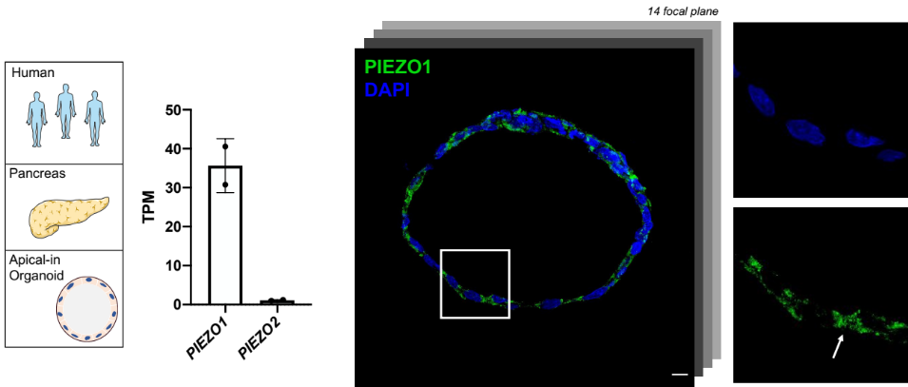
Supplementary Figure 1. Bar chart shows active gene expression of PIEZO1 and lack of PIEZO2 mechanosensitive Ca²⁺ channel in apical-in hPOCs. RNA-Seq data are indicated in TPM values (transcripts/million). Merged confocal (Z-stack) picture demonstrates the presence of PIEZO1 protein on Apical-in hPOCs. The highlighted detail and the arrow show the localization of PIEZO1 mainly between the elongated cells (scale bar: 10 µm).
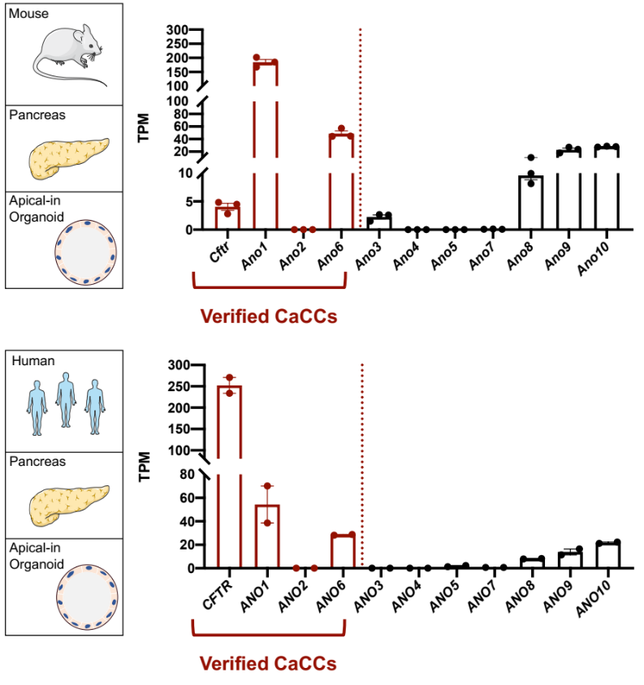
Supplementary Figure 2. Bar charts demonstrate RNA-seq data of CFTR and ANO family members with verified Ca²⁺-activated Cl⁻ current activity in mouse (N=3) and human (N=2) (CFTR, ANO1) pancreas derived organoid cultures. Data are indicated in TPM value (Transcript/million). (Gene abbreviations: Cftr – Cystic Fibrosis Transmembrane Conductance Regulator, Ano1-10 – Anoctamin 1-10)

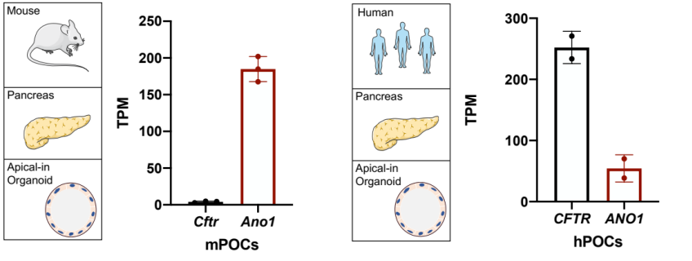
Supplementary Figure 3. Gene expression analysis of Cftr and Ano1 in mouse (N=3) and human (N=2) (CFTR, ANO1) pancreas derived organoid cultures by RNA-sequencing. Data are indicated in TPM value (Transcript/million). (Gene abbreviations: Cftr – Cystic Fibrosis Transmembrane Conductance Regulator, Ano1 – Anoctamin 1)

