Table S1 An example of the land cover transfer matrix.
T_{j} |  | Y₁
 |  | L₁ | L₂ | L₃ | ... | L_{n} | Total | Difference
Y₂ | L₁ | C₁₁ | C₂₁ | C₃₁ | ... | C_{n1} | C₊₁ | C₊₁-C₁₊
 | L₂ | C₁₂ | C₂₂ | C₃₂ | ... | C_{n2} | C₊₂ | C₊₂-C₂₊
 | L₃ | C₁₃ | C₂₃ | C₃₃ | ... | C_{n3} | C₊₃ | C₊₃-C₃₊
 | ... | ... | ... | ... | ... | ... | ... | ...
 | L_{n} | C₁₄ | C₂₄ | C₃₄ | ... | C_{nn} | C_{+n} | C_{+n}-C_{n}
 | Total | C₁₊ | C₂₊ | C₃₅ | ... | C_{n+} | - | -
Specifically, $T_{j}$means the land cover conversions during each study period, $Y_{1}$and $Y_{2}$are the start and end times of the period. $C_{nn }$is the size of land cover type $L_{n}$in $Y_{1}$, converted into land cover type $L_{n}$ in $Y_{2}$, C_{n+} and C_{+n} means the total area of land cover type${ L}_{n}$ in $Y_{1}$ and land cover type $L_{n}$ in $Y_{2}$, respectively.

Table S2 Requisition date of the Landsat images in the preprocessing composite for land cover map and NDVI.
Scenes | Position |  | Stages
Scenes | Path | Row | 1990 | 1995 | 2000 | 2005 | 2010 | 2015
No.1 | 121 | 044 | 15/07/1989 | 19/08/1996 | 15/09/2000 | 26/09/2004 | 23/08/2009 | 28/08/2014
No.2 | 121 | 045 | 15/07/1989 | 18/07/1996 | 13/07/2000 | 11/07/2005 | 25/07/2010 | 25/07/2016
No.3 | 122 | 044 | 06/07/1989 | 25/07/1996 | 19/08/1999 | 18/07/2005 | 21/09/2011 | 18/09/2016
No.4 | 122 | 045 | 06/07/1989 | 25/07/1996 | 19/08/1999 | 18/07/2005 | 21/09/2011 | 18/09/2016
No.5 | 123 | 044 | 17/08/1990 | 31/08/1995 | 13/09/2000 | 11/09/2005 | 22/09/2009 | 23/07/2016
No.6 | 123 | 045 | 14/08/1989 | 02/09/1996 | 13/09/2000 | 11/09/2005 | 22/09/2009 | 23/07/2016

Table S3. Results of land cover transfer matrix method. T1: Conversions between 1990 and 1995; T2: Conversions between 1995 and 2000; T3: Conversions between 2000 and 2005; T4: Conversions between 2005 and 2010; T5: Conversions between 2010 and 2015; T6: Conversions between 1990 and 2015.
T1 |  | 1990
 |  | Build-up |  | Forest |  | Water |  | Grassland |  | Bare land |  | Total | Difference
 |  | km2 | % | km2 | % | km2 | % | km2 | % | km2 | % | km2
1995 | Build-up | 1053.56 | 53.56 | 313.19 | 1.37 | 214.15 | 5.93 | 417.98 | 3.30 | 72.33 | 9.43 | 2071.20 | 54.15
 | Forest | 92.08 | 4.56 | 16341.85 | 71.71 | 118.45 | 3.28 | 2193.32 | 17.33 | 81.36 | 10.60 | 18827.06 | -3859.25
 | Water | 184.94 | 9.17 | 458.44 | 2.01 | 2468.30 | 68.32 | 907.42 | 7.17 | 20.10 | 2.62 | 4039.19 | 426.47
 | Grassland | 653.92 | 32.42 | 5483.08 | 24.06 | 787.95 | 21.81 | 8996.92 | 71.10 | 449.74 | 58.61 | 16371.61 | 3773.62
 | Bare land | 32.56 | 1.61 | 89.76 | 0.39 | 23.87 | 0.66 | 82.36 | 0.65 | 43.91 | 5.72 | 272.46 | -394.99

T2 |  | 1995
 |  | Build-up |  | Forest |  | Water |  | Grassland |  | Bare land |  | Total | Difference
 |  | km2 | % | km2 | % | km2 | % | km2 | % | km2 | % | km2
2000 | Build-up | 1519.13 | 73.35 | 202.64 | 1.08 | 569.43 | 14.10 | 1287.16 | 7.86 | 123.96 | 45.50 | 3702.31 | 1631.11
 | Forest | 17.24 | 0.83 | 15361.75 | 81.59 | 173.81 | 4.30 | 3288.82 | 20.09 | 0.72 | 0.26 | 18842.33 | 15.27
 | Water | 51.28 | 2.48 | 113.74 | 0.60 | 2759.33 | 68.31 | 758.30 | 4.63 | 1.87 | 0.69 | 3684.51 | -354.68
 | Grassland | 433.38 | 20.92 | 3106.04 | 16.50 | 500.92 | 12.40 | 10766.92 | 65.77 | 66.77 | 24.51 | 14874.03 | -1497.58
 | Bare land | 50.1741 | 2.42 | 42.8994 | 0.23 | 35.7084 | 0.88 | 270.4059 | 1.65 | 79.1442 | 29.05 | 478.332 | 205.87

T3 |  | 2000
 |  | Build-up |  | Forest |  | Water |  | Grassland |  | Bare land |  | Total | Difference
 |  | km2 | % | km2 | % | km2 | % | km2 | % | km2 | % | km2
2005 | Build-up | 2742.34 | 74.07 | 182.75 | 0.97 | 456.51 | 12.39 | 1615.55 | 10.86 | 197.50 | 41.29 | 5194.65 | 1492.34
 | Forest | 112.33 | 3.03 | 16336.61 | 86.70 | 63.90 | 1.73 | 3644.24 | 24.50 | 11.52 | 2.41 | 20168.60 | 1326.27
 | Water | 214.97 | 5.81 | 136.81 | 0.73 | 2794.00 | 75.83 | 325.49 | 2.19 | 8.06 | 1.68 | 3479.33 | -205.18
 | Grassland | 553.30 | 14.94 | 2141.14 | 11.36 | 351.72 | 9.55 | 8999.84 | 60.51 | 156.20 | 32.66 | 12202.20 | -2671.83
 | Bare land | 79.38 | 2.14 | 45.01 | 0.24 | 18.38 | 0.5 | 288.92 | 1.94 | 105.05 | 21.96 | 536.74 | 58.41

T4 |  | 2005
 |  | Build-up |  | Forest |  | Water |  | Grassland |  | Bare land |  | Total | Difference
 |  | km2 | % | km2 | % | km2 | % | km2 | % | km2 | % | km2
2010 | Build-up | 3507.88 | 67.53 | 156.14 | 0.77 | 389.01 | 11.18 | 1241.86 | 10.18 | 257.74 | 48.02 | 5552.63 | 357.98
 | Forest | 131.15 | 2.52 | 16596.37 | 82.29 | 111.59 | 3.21 | 2231.12 | 18.28 | 10.04 | 1.87 | 19080.26 | -1088.34
 | Water | 139.08 | 2.68 | 114.04 | 0.57 | 2529.08 | 72.69 | 208.49 | 1.71 | 4.37 | 0.81 | 2995.07 | 515.74
 | Grassland | 1298.01 | 24.99 | 3244.52 | 16.09 | 425.53 | 12.23 | 8337.27 | 68.33 | 191.86 | 35.75 | 13497.19 | 1294.99
 | Bare land | 118.53 | 2.28 | 57.53 | 0.29 | 24.13 | 0.69 | 183.45 | 1.50 | 72.73 | 13.55 | 456.36 | -80.38

T5 |  | 2010
 |  | Build-up |  | Forest |  | Water |  | Grassland |  | Bare land |  | Total | Difference
 |  | km2 | % | km2 | % | km2 | % | km2 | % | km2 | % | km2
2015 | Build-up | 4500.52 | 81.05 | 125.97 | 0.66 | 433.45 | 14.47 | 1602.69 | 11.87 | 262.47 | 57.51 | 6925.09 | 1372.46
 | Forest | 7.28 | 0.13 | 16433.26 | 86.13 | 10.42 | 0.35 | 1113.78 | 8.25 | 2.40 | 0.53 | 17567.15 | -1513.11
 | Water | 130.05 | 2.34 | 58.45 | 0.31 | 2150.29 | 71.79 | 222.65 | 1.65 | 8.39 | 1.84 | 2569.83 | -425.24
 | Grassland | 656.50 | 11.82 | 2447.02 | 12.82 | 394.14 | 13.16 | 10308.18 | 76.73 | 70.62 | 15.48 | 13876.46 | 379.27
 | Bare land | 258.28 | 4.65 | 15.56 | 0.08 | 6.77 | 0.23 | 249.89 | 1.85 | 112.48 | 24.65 | 642.98 | 186.62

T6 |  | 1990
 |  | Build-up land |  | Forest |  | Water |  | Grassland |  | Bare land |  | Total | Difference
 |  | km2 | % | km2 | % | km2 | % | km2 | % | km2 | % | km2
2015 | Build-up | 1221.49 | 60.56 | 1537.28 | 6.75 | 1039.85 | 28.78 | 2975.13 | 23.62 | 151.35 | 22.68 | 6925.09 | 4908.04
 | Forest | 101.31 | 5.02 | 15642.56 | 68.65 | 39.61 | 1.10 | 1643.62 | 13.05 | 140.05 | 20.98 | 17567.15 | -5319.17
 | Water | 36.47 | 1.81 | 178.18 | 0.78 | 1711.77 | 47.38 | 629.58 | 5.00 | 13.82 | 2.07 | 2569.83 | -1042.89
 | Grassland | 597.29 | 29.61 | 5126.73 | 22.50 | 763.21 | 21.13 | 7052.74 | 55.98 | 336.49 | 50.41 | 13876.46 | 1278.47
 | Bare land | 60.50 | 3.00 | 201.55 | 0.88 | 58.28 | 1.61 | 296.92 | 2.36 | 25.73 | 3.86 | 642.98 | -24.47

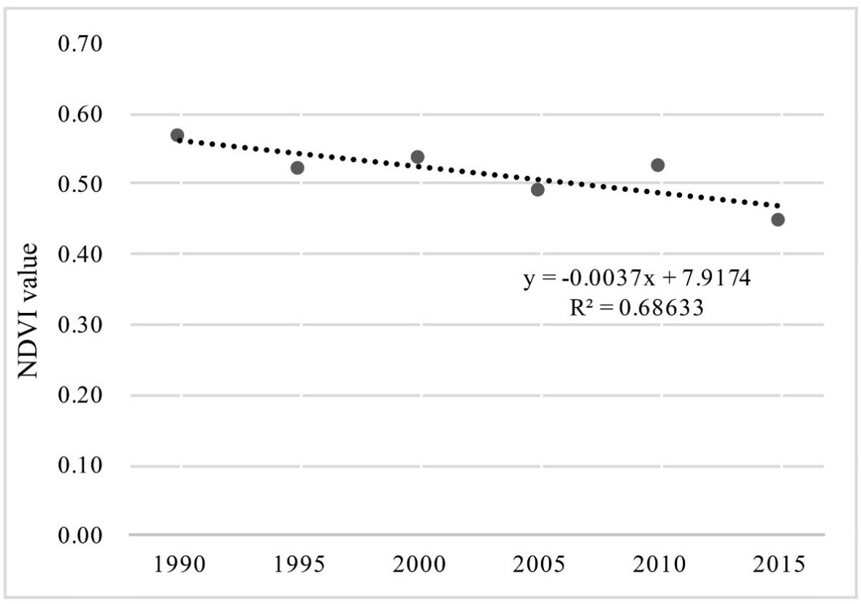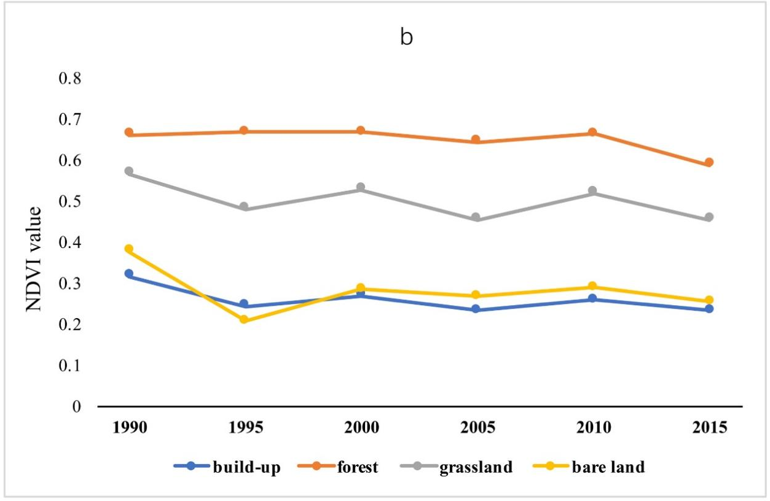
Figure S1. a: Time series trends of average NDVI in the PRDR; b: Average NDVI of each land cover type and their variations by different stages.

