Appendix A.1

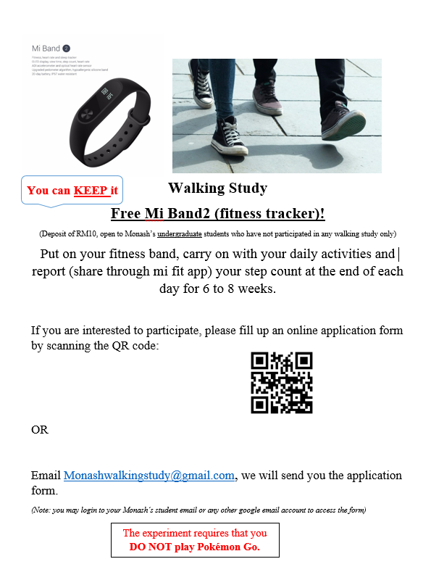

Appendix A.2
This section provides the actual questionnaire during the recruitment stage.
Name: ________________________________________________
Phone number: ______________________________________ __
Email: ________________________________________________
Please provide your primary email account, one that you’ll access frequently.

Gender
- Male
- Female
Year of birth: ____ Age: ____
Which year of studies are you currently in?
- Year____ Semester ____ School of ______________________ (business, engineering, etc.)

What is your current living arrangements?
- Living alone
- Living with others (e.g. renting a residence with strangers or friends)
- Living with family members

What is your mode of transportation to go to university?
- Public transportation (bus/BRT/LRT/KTM)
- Private transport (drive/driven)
- Walk
Fitness
What is your average activity level in the past four weeks? Please indicate the average number of days each activity is performed per week and the time span per session.
Light activities – e.g. walking (as a means of exercise) __ day/week _ _min/session
Moderate activities – e.g. brisk walk 4mph, light bicycling __ day/week _ _min/session
Vigorous activities – e.g. jogging 6mph, hiking, fast bicycling (14-16mph), basketball game, soccer game, badminton __ day/week _ _min/session
Do you participate in any types of physical activities that do not stimulate movements similar to walking (such as weight lifting, swimming, etc)
- Yes, please state the activities performed: _________________________________________
- No

What is your height in centimetres? ________ cm
What is your weight in kilograms? ________ kg
Appendix A.3
The following information sheet was printed and given to participants when they collected their pedometers.
- Charge your mi-band and start wearing it this evening (charger is in the box)
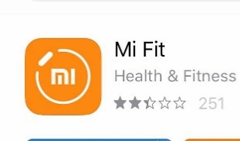
- Download the ‘Mi-fit’ app, sign up an account and sync it with your mi-band (once you sign up, there’s a very clear instruction on the syncing part)

For more information:
https://www.mi.com/en/miband2/
- Important notes:
- Wear the mi-band on the wrist of your NON-WRITING hand (i.e., if you are a right-hander, please wear it on your left wrist)
- Wear it at all times and remove only when you need to charge it (the battery should last about 2 weeks)
- It is water proof so there isn’t a need to remove when you shower or swim
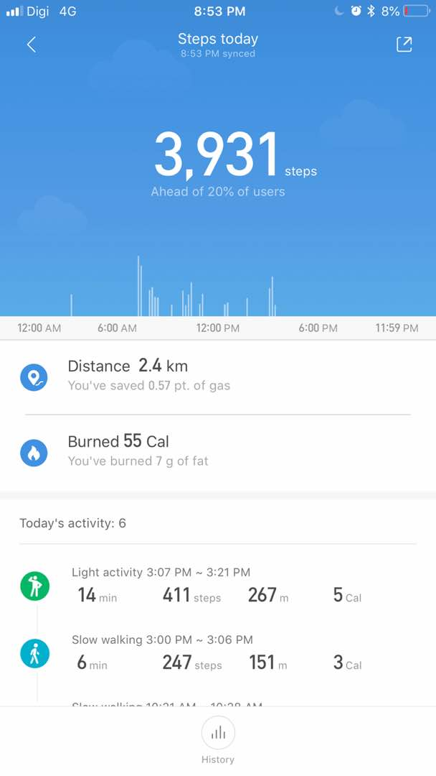
Tap on ‘history’
Tap on ‘3931’ steps which appears on the screen, and you will ‘history’ at the bottom of the screen

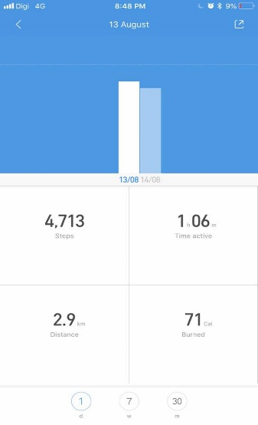 Thanks again for your participation!
Tap on the date the day before. If today is 15 Aug, you tap on the date on 14 Aug. Take a screen shot of the information and Whatsapp to 016-7303569 daily
*we will send you a daily reminder to do so

(The data you provide is private and confidential, a random number will replace your identity and everyone is kept anonymous)

Appendix A.4
Mean of step improvement for the overweight students

Appendix A.5 Message Coding Instructions

Thank you for coming! You’ve earned RM10 for showing up on time, and the following instructions will explain your task in this session.

Your task:

You will be given a list of messages. Your task is to classify the messages according to the categories given to you. You may pick multiple categories for the same message.

The messages were written by participants in another experiment. That experiment consisted of two stages: Stage I and Stage II.

The following is a summary of the previous experiment:

- Stage I: Each participant was given a fitness tracker (mi-band) that they wore on their wrist. They were required to send us their step counts on a daily basis. After four weeks of the experiment, participants who were inactive (those who walked less than 7500 steps per day on average) were invited to participate in a 10,000 steps challenge that would last for a month. They were told that it was merely a challenge and no action would be taken if they did not achieve the goal. They got to keep the mi-band for free whether or not they participated in the 10,000 steps challenge.

- Stage II: Participants who signed up for the challenge continued to send us their step counts daily for another four weeks. At the end of the challenge, each challenge participant was asked to fill out a survey. The messages you will be asked to evaluate are the participants’ explanations for their decisions to sign up for the 10,000 steps challenge. Specifically, the question is:

What is/are your reason/s in joining 10,000 steps challenge?

While for coding the messages, please use the following reasons:

- Reasons related to health.
You should assign a message to this category, if you think the message writer suggested in the message that he/she signed up for health reasons.

- Reasons related to weight loss.
You should assign a message to this category, if you think the message writer suggested in the message that he/she signed up in order to lose weight.

- Reasons related to peer influence
You should assign a message to this category, if you think the message writer suggested in the message that he/she signed up due to peer influence.

- Reasons related to having fun
You should assign a message to this category, if you think the message writer suggested in the message that he/she signed up just for the fun of it.

- Reasons related to challenge
You should assign a message to this category, if you think the message writer suggested in the message that he/she would like to challenge himself/herself.

6. Other – please specify.
You should assign a message to this category, if it does not belong to any of the above categories. In this case, please also briefly explain your interpretation of the message.

While for coding the messages, please pay attention to the following:

1) You should code all messages independently. Please do not discuss with anyone else in this room how to code the messages.
2) Your job is to capture the underlying reasons for the decisions to compete for the leader position. Think of yourself as a “coding machine.”
3) When you complete the coding, please go through the entire list of messages a second time to (i) review all your codes and revise them if needed for accuracy; (ii) make sure that you have coded every message.

Each participant is assigned the same set of messages to evaluate. The session ends after everyone finishes the coding task. At the end of the session, In addition to the show-up fee, each participant will be paid another RM10 for completing the coding task. 3 messages will be randomly chosen for payment. For each of these 3 messages, if your evaluation matches the most commonly chosen evaluation by the other participants in the session, you will be paid RM5 for that message. For example, for the chosen message, if most of the other participants in the session have picked Category 2, then you will receive RM5 if you have also picked Category 2. Similarly, if most of the other participants have picked both Category 1 and 5, then you will receive RM5 if you have also picked both Category 1 and 5. Hence, for payment, your answer should exactly match the most frequently given answer.

To evaluate the messages, you need to first understand the experiment. Please raise your hand if you need any clarification.

