Annexes:
Annex F1:
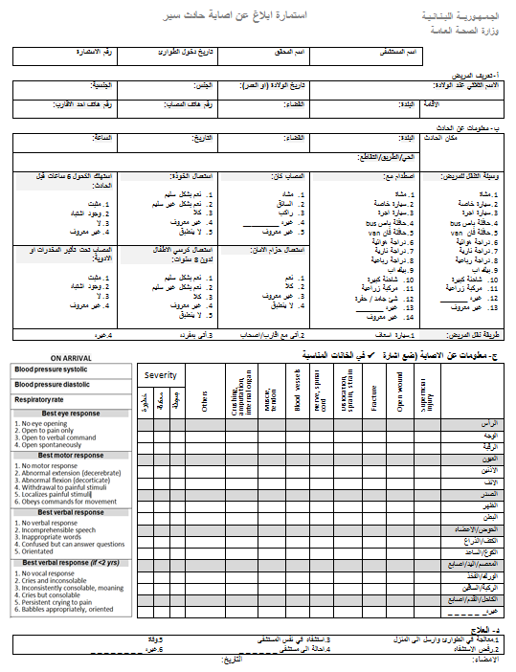
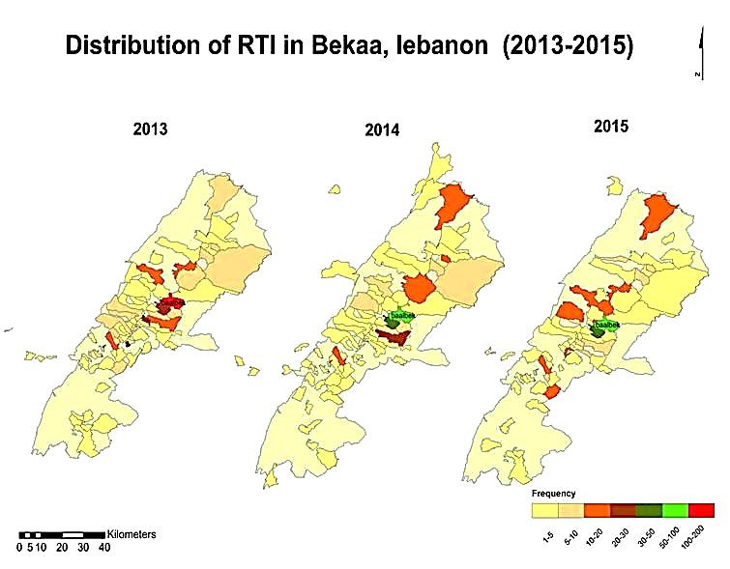

Annex F3: Correlation between RTS and TRISS

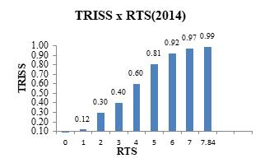

Annex F4: Summary of the protocol of establishing an Integrated Road Traffic Injuries Surveillance (IRIS)-Lebanon.
Setting
Lebanon, is one of the EMR countries, with an estimated population of more than 6 million. Road traffic casualties and risks are still poorly quantified in this country. Epidemiological data on road traffic deaths, injuries, and disabilities are critical to inform policy initiatives to improve road safety and prevention of traffic casualties. At least four stand-alone surveillance systems operated by different organizations in Lebanon collect data related to road traffic accidents. These systems do not have a common set of indicators, no formal case definitions, or standard operating procedures (SOPs). There is a lack of quality assurance systems at all levels and there are also large discrepancies in reported casualties between these organizations (MoPH and the police).
Before embarking on establishing an integrated road traffic causality, it is necessary and a prerequisite to doing a situation analysis to understand the strength and weaknesses of the data systems about RTI in Lebanon using general assessment methodology for surveillance systems and registries (World Health Organization and Center for Disease Control). Such assessment should be carried out in close collaboration with the Ministry of Public Health (MoH) and the Ministry of Interior (MoI) and other data sources (EMS, NGOs, insurance companies). The analysis will identify gaps and help in building the existing system and integration with other data sources.

Phase 1: Situational Assessment for understanding the RTI data systems

Based on the WHO’s Data Systems, which is a road safety manual for decision-makers and practitioners, there are four steps to be followed for conducting a situational assessment:

Situational assessment steps:

  - Stakeholder analysis:
It includes the following:
- Identification of organizations, potential partners, and individuals who have an interest in data collection and/or use of road safety data. This should be exhaustive including all the present organizations/Individuals involves in data collection and use of road safety data (the law enforcement, transport and health sectors, the insurance industry, NGOs, academic institutions, emergency transport services…)
- Examination of the roles and activities of all stakeholders (data collectors, data managers, data users), stakeholders' attitudes (supporter or opponent)), the nature, mode, and form of participation of the stakeholders in the proposed system (advisers or consultants, collaborating partners, member of a working group, individual participant, representative of a group)

  - Assessment of data sources and existing systems:
- Assess data sources
It covered the following
  - organizations or individuals involved in the collection of data pertaining to RTI (Police, transport departments, hospitals, emergency transport services, Insurance companies)
  - variables collected in the data sources (Demographic details, vehicle-related details, crash-related details, road-related details, person-related details, pre-hospital care, emergency transport details, medical care and management, the outcome of the event
  - the format used for data collection (electronic or hard copy)
  - storage and data processing (Case-level records, tabulations provided to customized specifications, pre-tabulated results)

- Assess data systems
It included queries about:
- the population or geographical area covered
- the availability of estimates of population coverage/completeness
- census of incidents among a whole population, or data from a sample of the population only
- type of captured events (fatalities, non-fatal injuries, damage- only crashes),
- used definition
- data transfer from the crash scene to the database (real-time, delayed, manual)
- reporting requirements (existing and potential linkages with other databases, data availability and accessibility, formal/informal data-sharing mechanisms with other agencies/sectors, training tools, and training status of the staff in data systems)

- Assess data quality:
It included questions about:
- the availability of standard definitions available for inclusion and exclusion of crashes and injuries
- the availability of SOPs for the entire data flow management process,
- completeness and accuracy of events captured
- under-reporting of crashes/Injuries to and by the authorities(Crash not being reported, reported but not included for data collection, incomplete data collection, delayed or no data entry, data lost)
- validation procedures
- frequency of missing data/underreporting
- errors in data coding and data entry
- timeliness of data
  - accessibility (Open source, public domain, or paid)

  - End-user needs assessment:
This is crucial for setting up and expanding the Road safety information system to enhance its usability of the system. It includes:
the definition of the users of data systems based on the circumstances or situations that lead to requiring road safety information, the sources of information users currently relying on, the required type of information, and the preferred format in which users would like to access information as well as the factors that affect or determine their access to, and use of, road safety information

  - Environmental analysis:
It comprises an overview of the political environment: the presence of a lead agency responsible for road safety and its main function, main government departments involved in road
safety decision-making, the role does each department, existing policies in transport, law enforcement, health, and finance that are relevant to road safety, data components, political environment factors driving or opposing change, and adequate capacity for implementation/improvement of data collection, data processing, data analysis, and dissemination and use of data.

Developing a framework for integrated RTI surveillance
The establishment of an integrated RTI surveillance system should comprise the development of a framework for all essential parts of a registry, including stakeholder relations and a comprehensive quality assurance system. It includes establishing a multisectoral working group; developing a common set of indicators and case definitions; revising data collection forms and developing SOPs for the whole continuum of data flow.
There will be four main stages in the development of a framework for a road traffic injury surveillance system.

There will be four main stages in the development of framework for road traffic injury surveillance systems. The first stage will be a review of the literature to identify the characteristics that have been used or recommended to be used when establishing effective injury surveillance or road traffic injuries surveillance systems previously. The review will be undertaken using Medline and Embase using a variety of combinations of the keywords related to surveillance systems 'surveillance', 'implementation', 'evaluation', 'guidelines', 'road traffic injury surveillance' 'framework', 'injury surveillance', 'injury', 'comparison', 'review', 'assess', and 'quality'.
The second stage will be the assessment of these characteristics by testing them against the SMART criteria, and characteristics that did not meet the criteria will be removed. The SMART criteria will be adapted to evaluate the characteristics of the RTI surveillance system. The five criteria of the SMART framework, are defined as: Specific – Measurable – Appropriate – Reliable and Time-consistent. The characteristics will be grouped into three categories based on the nature of the information they provide on road traffic injury surveillance. These will be (1) data quality characteristics, which provide evaluative information regarding the quality of the information obtained from a surveillance system; (2) operational characteristics, which describe key aspects of processes governing the way a surveillance system works; and (3) practical characteristics, which describe the functional capabilities and practical elements of a surveillance system. Each characteristic will be assessed using the SMART criteria. The characteristics that met all of these criteria will move to the next stage of RTI surveillance development.
The third stage will use expert judgments obtained using a Modified-Delphi study to assess the remaining characteristics. Characteristics will be tested in this stage using a two-round Modified-Delphi study. The most important requirements for the use of Delphi are the need for experts' judgment, group consensus to achieve the results, anonymity in data collection, a complex, multidimensional, and interdisciplinary problem, lack of consensus and imperfect knowledge, experienced and capable experts, dispersion of experts, no time limitation, and lack of cost-effective method.
A Modified-Delphi study will be conducted using anonymous questionnaires. It also allowed panel members to provide their point of view anonymously and all opinions could be considered which is not always possible during in-person meetings.
An accurate mechanism does not exist for identifying the number of individuals or the number of panels for inclusion in any individual study. Recommended panel size may vary according to the topics covered, the nature of different viewpoints included, and the time and money available and it is also suggested to use a combination of individuals with multiple specialties and heterogeneous groups better than the homogeneous groups. A core group of researchers and professionals interested in road safety will be composed, including health officers, senior police officers, and designated road safety professionals from the national road safety council. Expert panel members will be selected based on some criteria: (i) working in the field of road injury prevention; (ii) familiarity with surveillance systems; (iii) awareness of the strengths and limitations of surveillance systems; (iv) familiarity with RTI data collection forms; and (v) willingness to contribute. Lastly, the final stage created a system for rating each characteristic of RTI surveillance.
Developing the collection tool:
Based on the Delphi technique, an agreed data collection form in Arabic will be used. The proposed form is characterized by closed-ended questions for easy completion and easy data entry, along with a simple layout. The form will be designed to contain the core minimum data and core optional data recommended by international organizations (Holder et al, 2001) in addition to data specific to road traffic injuries (supplementary data). It includes demographic information, contributory factors, details of injury mechanism and severity, vehicular information as well as means of transport and eventual outcome.
The form could be customized on DHIS2 using a case-based module and then piloted. According to this pilot phase, modifications will be made before the formal initiation of data collection.
The developed project will be piloted in a province in Lebanon and later the model will be scaled up throughout the country. This scaled-up model can later be expanded to a national integrated trauma registry

Training:
Training adapted to each data source should be performed. For example, at hospitals, focal persons (Nurse or physicians) working in the emergency department will be trained in completing the data collection form on DHIS2, ICD-10 coding, and Injury scoring systems. Trauma patients presenting to the emergency department will be screened for road traffic crash as the cause of the injury by the data collectors. All patients, irrespective of the severity of the injury, will be included in the surveillance. Data will be collected from the victims themselves whenever feasible. In cases where information will be not available in the ED, data collectors visited patients in the hospital to interview patients or their family members, and occasionally hospital’s inpatient records and/or police records will be used when no other source of information will be available to obtain the requisite information. Data quality will be assured by the rules already set on DHIS2. Random checks will be done by the project coordinator.

Data flow and data analysis:
Based on the situational assessment performed, data available at multiple levels and sectors should be merged and shared with other stakeholders based on their roles and needs. A formal mechanism for sharing information should be established. DHIS2 will provide automated analysis and dashboards will be updated once data will be uploaded, and access to its analyzed data.

