Supporting Information for
An Environmentally Friendly Phosphorus-Modified Cellulose/Silica Hybrid Hydrogel for Fire Prevention and Firefighting
Hafezeh Nabipour ª, Hu Shi ª, Xin Wang ^{a,*}, Xiangming Hu ^{b}, Lei Song ª, Yuan Hu ^{a,*}
ª State Key Laboratory of Fire Science, University of Science and Technology of China, 96 Jinzhai Road, Hefei, Anhui 230026, P. R. China.
^{b} Key Lab of Mine Disaster Prevention and Control, College of Mining ad Safety Engineering, Shandong University of Science and Technology, Qingdao, Shandong 266590, P. R. China.
*Corresponding authors. Tel/Fax: +86-551-63601664. E-mail address: yuanhu@ustc.edu.cn (Y. Hu), wxcmx@ustc.edu.cn (X. Wang).

Table S1. Power law and Herschel-Bulkley parameters for steady flow measurement.
Sample | Power law parameter |  |  | Herschel-Bulkley parameter
Sample | k | n | R² | τ₀ | k | n | R²
H1 | 6.0735 | 0.6650 | 0.9937 | 1.5564 | 6.8003 | 0.6401 | 0.9998
H2 | 11.663 | 0.6803 | 0.9991 | 1.4835 | 13.1990 | 0.6530 | 0.9996
H3 | 1.1446 | 0.6704 | 0.9997 | 0.1744 | 3.3436 | 0.6755 | 0.9998
H4 | 16.386 | 0.4640 | 0.9975 | 5.4227 | 12.595 | 0.5201 | 0.9995
H5 | 85.465 | 0.2312 | 0.9836 | 48.9581 | 38.603 | 0.3763 | 0.9987

Table S2. Power law parameters for storage (G') and loss (G") moduli.
Sample | G’ |  |  | G”
Sample | a₁ | b₁ | R² | a₂ | b₂ | R²
H1 | 1.1896 | 0.8646 | 0.9990 | 4.5226 | 0.6427 | 0.9965
H2 | 2.1970 | 0.9328 | 0.9967 | 13.442 | 0.5738 | 0.9920
H3 | 0.4147 | 0.9991 | 0.9948 | 2.8689 | 0.6784 | 0.9946
H4 | 9.3471 | 0.5681 | 0.9989 | 10.111 | 0.5501 | 0.9986
H5 | 173.73 | 0.2243 | 0.9953 | 31.680 | 0.4274 | 0.9987

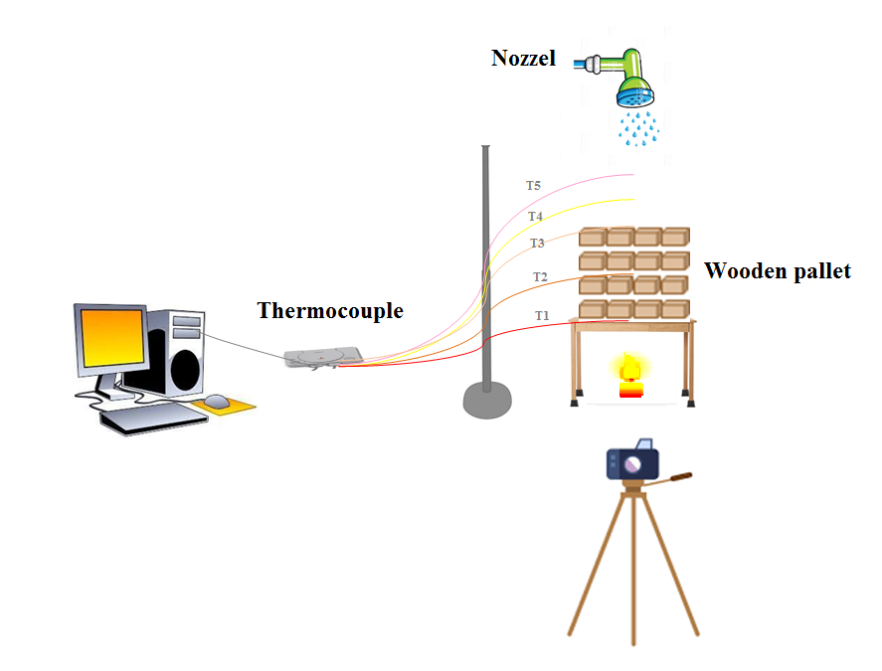
Fig. S1. The applied fire-extinguishing test set-up.

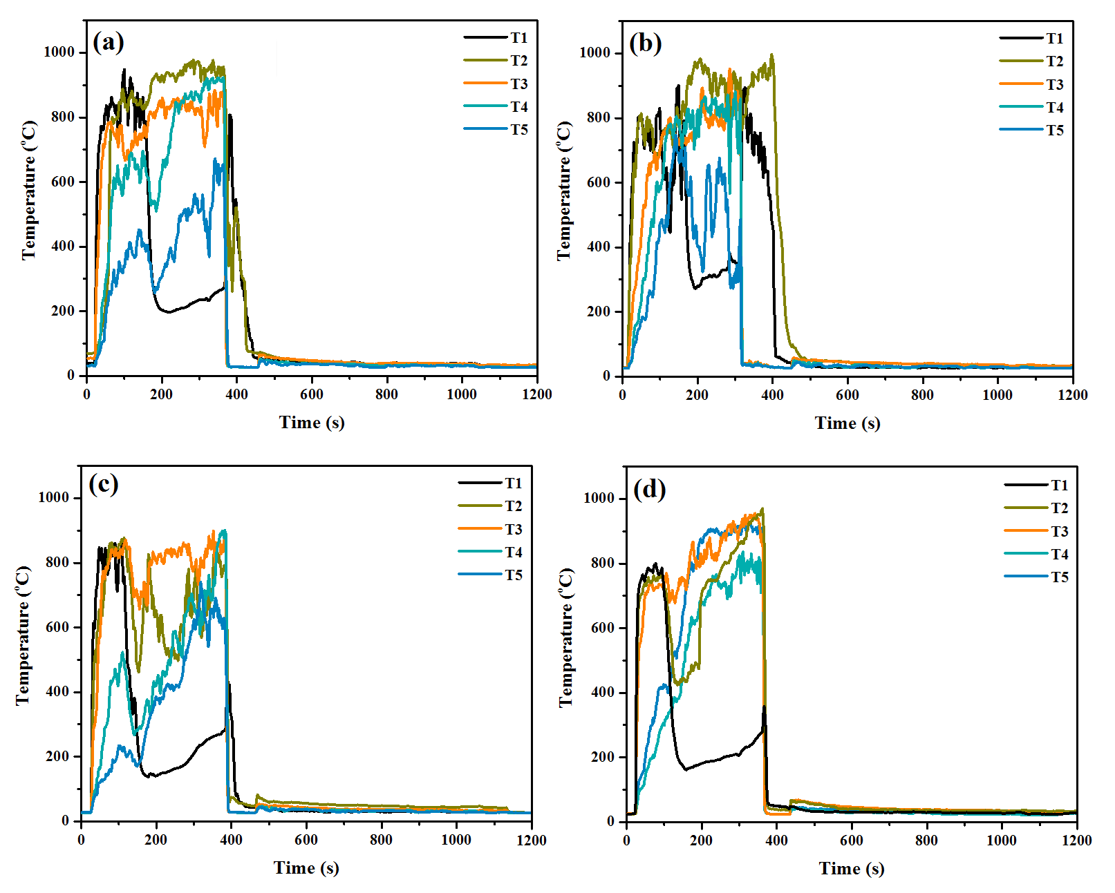
Fig. S2. The temperature versus time plots of firefighting experiments using (a) water, (b) H1, (c) H2, and (d) H4.

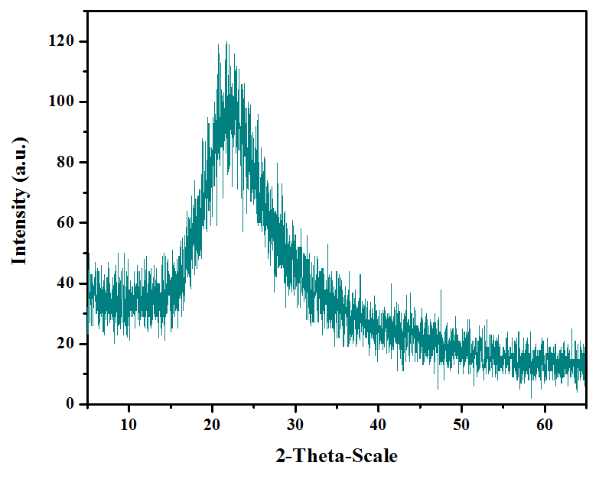

Fig. S3. XRD pattern of the char residue of wood quenched by H4 hydrogel.

