Supplementary file 1

Pleotropic potential of quorum sensing mediated N-acyl homoserine lactones (AHLs) at the LasR and RhlR receptors of Pseudomonas aeruginosa
Devasahayam Arokia Balaya Rex^{1†}, Kanekar Saptami^{1†}, Jaikanth Chandrasekaran^{2#}, Punchappady Devasya Rekha^{1#}
¹ Yenepoya Research Centre, Yenepoya (Deemed to be University), Mangalore, India.
²School of Pharmacy & Technology Management, SVKM'S NMIMS, Hyderabad, Telangana, India.

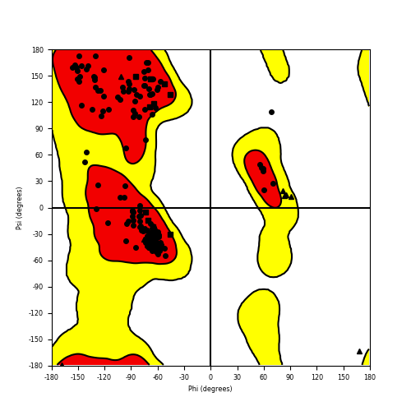
Figure S1. Ramachandran plot representing phi/psi distribution for RhlR

Table S1: Comparative Root Mean Square Fluctuation (RMSF) analysis of interacting active residues in the LasR and RhlR complex systems
Sl. No | Interacting Residue (LasR) | AHL/receptor complex system | RMSF (nm) | Complex | RMSF (nm) | Complex | RMSF (nm)
1 | TYR56 | 3-oxo-C₁₂-HSL/LasR | 0.1035 | C₁₆-HSL/LasR | 0.1197 | 3-oxo-C₁₀-HSL/LasR | 0.1087
2 | TRP60 | 3-oxo-C₁₂-HSL/LasR | 0.1184 | C₁₆-HSL/LasR | 0.1867 | 3-oxo-C₁₀-HSL/LasR | 0.1288
3 | ASP73 | 3-oxo-C₁₂-HSL/LasR | 0.1734 | C₁₆-HSL/LasR | 0.0861 | 3-oxo-C₁₀-HSL/LasR | 0.0716
4 | SER129 | 3-oxo-C₁₂-HSL/LasR | 0.0613 | C₁₆-HSL/LasR | 0.0759 | 3-oxo-C₁₀-HSL/LasR | 0.0509
5 | ARG61 | 3-oxo-C₁₂-HSL/LasR | 0.1337 | C₁₆-HSL/LasR | 0.237 | 3-oxo-C₁₀-HSL/LasR | 0.1632
Sl. No | Interacting Residue (RhlR) | Complex | RMSF (nm) | Complex | RMSF (nm) | Complex | RMSF (nm)
1 | TYR64 | C₄-HSL/RhlR | 0.1061 | C₆-HSL/RhlR | 0.0765 | 3-oxo-C₆-HSL/RhlR | 0.1393
2 | TRP68 | C₄-HSL/RhlR | 0.1578 | C₆-HSL/RhlR | 0.109 | 3-oxo-C₆-HSL/RhlR | 0.1791
3 | ASP81 | C₄-HSL/RhlR | 0.1754 | C₆-HSL/RhlR | 0.1468 | 3-oxo-C₆-HSL/RhlR | 0.1787
4 | SER135 | C₄-HSL/RhlR | 0.0769 | C₆-HSL/RhlR | 0.0692 | 3-oxo-C₆-HSL/RhlR | 0.083

Table S2: MM/PBSA energy for top ranked AHLs in complex with LasR and RhlR
 | AHL/receptor complex system | (ΔGbind)  (kJ/mol)
1 | 3-oxo-C₁₂-HSL/LasR | -130.19 ± 11.721
2 | C₁₆-HSL/LasR | -216.544 ± 17.043
3 | 3-oxo-C₁₀-HSL/LasR | -180.655 ± 17.165
4 | C₄-HSL/RhlR | -56.08 ± 9.268
5 | C₆-HSL/RhlR | -60.998 ± 16.661
6 | 3-oxo-C₆-HSL/RhlR | -69.254 ± 15.15

Table S3: Pre-residue energy contribution of critical residues in selected LasR and RhlR complex systems
Sl. No | Interacting Residue (LasR) | AHL/receptor complex system | Binding energy (kJ/mol) | Complex | Binding energy (kJ/mol) | Complex | Binding free energy (kJ/mol)
1 | TYR56 | 3-oxo-C₁₂-HSL/LasR | -2.5983 | C₁₆-HSL/LasR | -3.7684 | 3-oxo-C₁₀-HSL/LasR | -6.4120
2 | TRP60 | 3-oxo-C₁₂-HSL/LasR | -1.2202 | C₁₆-HSL/LasR | -7.1366 | 3-oxo-C₁₀-HSL/LasR | -4.2878
3 | ASP73 | 3-oxo-C₁₂-HSL/LasR | 1.2993 | C₁₆-HSL/LasR | 1.4367 | 3-oxo-C₁₀-HSL/LasR | -0.7234
4 | SER129 | 3-oxo-C₁₂-HSL/LasR | -0.0112 | C₁₆-HSL/LasR | 0.3728 | 3-oxo-C₁₀-HSL/LasR | 0.7717
5 | ARG61 | 3-oxo-C₁₂-HSL/LasR | 2.7734 | C₁₆-HSL/LasR | 0.7989 | 3-oxo-C₁₀-HSL/LasR | 1.4534
Sl. No | Interacting Residue (RhlR) | AHL/receptor complex system | Binding energy (kJ/mol) | Complex | Binding energy (kJ/mol) | Complex | Binding energy (kJ/mol)
1 | TYR64 | C₄-HSL/RhlR | -1.948 | C₆-HSL/RhlR | -1.1915 | 3-oxo-C₆-HSL/RhlR | -3.3844
2 | TRP68 | C₄-HSL/RhlR | -2.7921 | C₆-HSL/RhlR | 0.3487 | 3-oxo-C₆-HSL/RhlR | -2.6927
4 | SER135 | C₄-HSL/RhlR | 1.6122 | C₆-HSL/RhlR | 1.2517 | 3-oxo-C₆-HSL/RhlR | 0.4164

