Participant Questionnaire

Dear Participant,
Thank you for participating in this study. The purpose of this research is to investigate changes in ocular structures and ocular and cerebral blood flow within migraine sufferers and non-sufferers. This will allow for a more in-depth understanding of the migraine condition and for better treatments to be designed.
Please complete this questionnaire before you come for your appointment. Be sure to call us as soon as possible if you cannot make your appointment.
Today’s date:
Name:
DOB: | Gender:
Email: | Tel:
Address:

1. Have you ever been diagnosed with any of the following conditions?
(Please tick & give details where applicable)
☐ Asthma/COPD ☐ Arthritis  ☐ Epilepsy  ☐ Headaches  ☐ Migraines  ☐ Heart Disease  ☐ Vasculitis  ☐ Thyroid Disease | ☐ Renal failure  ☐ High Cholesterol  ☐ High Blood Pressure  ☐ Low Blood Pressure  ☐ Depression  ☐ Anaemia  ☐ Diabetes  ☐ Glaucoma | ☐ Ocular Hypertension  ☐ Optic Neuritis  ☐ Cataract  ☐ Ocular Surface Disorder  ☐ Lazy eye  ☐ Squint operation  ☐ Inherited Retinal Disease  ☐ Blindness/Partial Blindness
☐ Other Please give details

2. When were you first diagnosed with this condition?
Please give details

3. Have any of your first-degree relatives experienced any of the aforementioned conditions? Yes ☐ No ☐
If yes, please give details

4. Have you ever had surgery? Yes ☐ No ☐
If yes, please give details

5. Are you taking medication? Yes ☐ No ☐
If yes, please list any medication you are currently taking

6. Are you taking vitamins or supplements? Yes ☐ No ☐
If yes, please give details
7. Do you smoke? Yes ☐ No ☐ If yes, how many cigarettes per day

8. Do you wear spectacles or contact lenses? Yes ☐ No ☐
If yes, how would you describe your vision wearing them?
☐ Good / perfect | ☐ Moderate | ☐ Poor

9. Could you please tell us which of the following best describes you?
☐ | Asian
☐ | Black/African
☐ | Caucasian
☐ | Hispanic/Latino
☐ | Native American
☐ | Pacific Islander
☐ | Prefer not to answer
☐ | Other: Please give details

10. If female, Are you pregnant? Yes ☐ No ☐
If no, please give details of the menstrual cycle you will be at the appointment date:
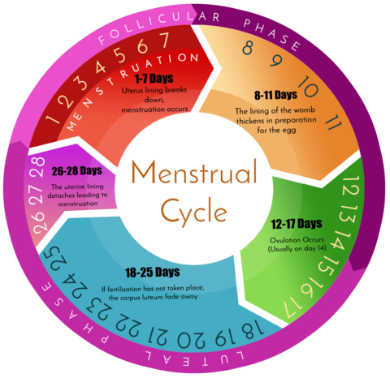 | ☐ | Day 1-7
 | ☐ | Day 8-11
 | ☐ | Day 12-17
 | ☐ | Day 18-25
 | ☐ | Day 26- 28
 | ☐ | Not known

11. If you suffer from headaches, since how long have you been having headaches? Please give details

12. Over the past 2 months, how many individual headache attacks have you had on average per month? Please give details

13. How long does a typical headache attack last?
☒ 0-1 hour | ☐ >1-6 hours | ☐ >6-12 hours | ☐ >12-24 hours | ☐ >24-48 hours
☐ >72 hours | ☐ constant | ☐ too variable | ☐ unknown

14. Check any of the following factors which seems to trigger a headache attack in you:
☐ Alcohol | ☐ Odours | ☐ Changes in weather
☐ Caffeine | ☐ Emotional stress | ☐ Lack of routine physical activity
☐ Menstruation | ☐ Fatigue | ☐ Other Please give details
☐ Exercise | ☐ Missing meals

15. What other factors seem to help to relief your headache? Please give details

16. Are your headaches ever incapacitating? Please, answer the questions below

16.1. On how many days in the last 3 months did you miss work or school because of your headaches? If you did not attend work or school write zero

16.2. How many days in the last 3 months was your productivity at work or school reduced by half or more because of your headaches? Do not include days you counted in question 16.1, where you did not attend work or school. If you did not attend work or school write zero.

16.3. On how many days in the last 3 months did you not do household work because of your headaches?Please give details

16.4. How many days in the last 3 months was your productivity in household work reduced by half or more because of your headaches? Do not include days you counted in question 16.3, where you did not do household work. Please give details

16.5. On how many days in the last 3 months did you miss family, social, or leisure activities because of your headaches?Please give details

16.6. On how many days in the last 3 months did you have a headache? If headache lasted more than one day, count each day

16.7. On a scale of 0-10, on average, how painful were these headaches? (Where 0=no pain at all and 10=pain which is as bad as it can be)

17. How would you describe your headache?
☐ Throbbing/pulsating pain
☐ Pain over the scalp region (cutaneous allodynia)
☐ Mild pressure
☐ Unknown

18. Is your headache ever localized to one side? Yes ☐ No ☐ If yes, please give details

19. Does your headache typically occur at a certain time of day or of certain days of the week or month? Yes ☐ No ☐ If yes, please give details

20. Do you have any warning symptoms which alert you are going to have a headache attack? Yes ☐ No ☐ If yes, please give details

21. Do you ever experience any of the following symptoms in association with your headache attacks (before, during or after)
☐ Nausea | ☐ Speech disturbance
☐ Vomiting | ☐ Numbness and/or tingling in face, arm or leg
☐ Nasal congestion | ☐ Loss of balance
☐ Diarrhoea | ☐ Vertigo (spinning sensation)
☐ Inability to tolerate loud noise (phonophobia) | ☐ Visual changes (visual distortion, flashes, blind spots, sparkles)
☐ Inability to tolerate bright light (photophobia) | ☐ Visual Aurea  If visual Aurea, please give detail of duration
☐ Extreme thirst, food cravings

