Supplementary data

Activated carbon nanofiber nanoparticles incorporated electrospun polycaprolactone scaffolds to promote fibroblast behaviors for application to skin tissue engineering

Sangmun Choi ^{1,a}. Iruthayapandi Selestin Raja ^{2,a}. Aravindha Raja Selvaraj ³. Moon Sung Kang ⁴. Suong-Hyu Hyon ⁵. Dong-Wook Han ^{2,4,}*. Jong-Chul Park ^{1,}*

¹ Department of Medical Engineering, Graduate School of Medical Science, Brain Korea 21 Project, Yonsei University College of Medicine, Seoul 03722, Republic of Korea
² BIO-IT Fusion Technology Research Institute, Pusan National University, Busan 46241, Republic of Korea
³ Department of Electrical Engineering, Pusan National University, Busan 46241, Republic of Korea
⁴ Department of Cogno-Mechatronics Engineering, College of Nanoscience & Nanotechnology, Pusan National University, Busan 46241, Republic of Korea
⁵ BMG Inc., Kyoto 601-8023, Japan

* Corresponding authors: nanohan@pusan.ac.kr (D.-W.H.); parkjc@yuhs.ac (J.-C.P.)
ª These authors contributed equally to this work.

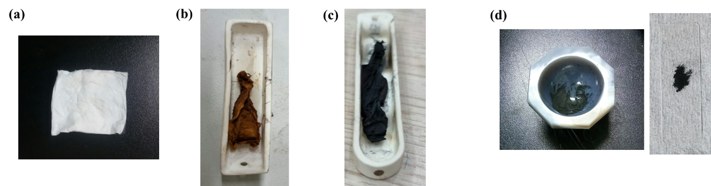
Fig. S1. Digital photographs of electrospun nanofiber mats of (a) as-prepared PAN, (b) CNF after stabilization, (c) CNF/ACNF after calcination, and (d) the CNF/ACNF nanoparticles after manual grinding using pestle and mortar.

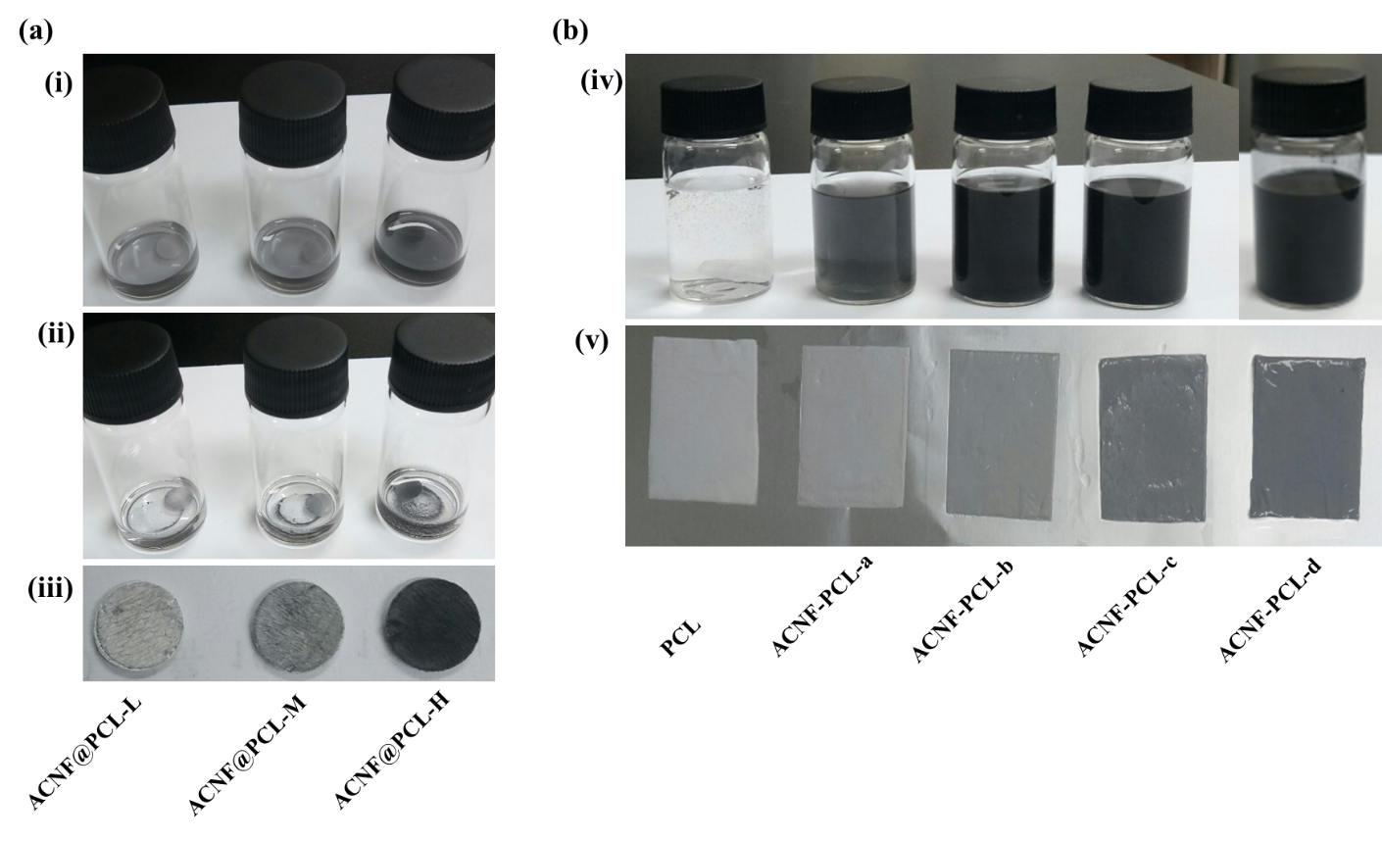
Fig. S2. (a) Preparation of ACNF@PCL nanofiber mats. Incubation of ACNF NPs with the disc shaped mats at (i) 0 h, (ii) 12 h, and (iii) after drying in open air. (B) Preparation of PCL and ACNF-PCL nanofiber mats. (iv) The polymeric composite solution of PCL, ACNF-PCL-a, ACNF-PCL-b, ACNF-PCL-c, and ACNF-PCL-d, and (v) their electrospun nanofiber mats (wet by EtOH).

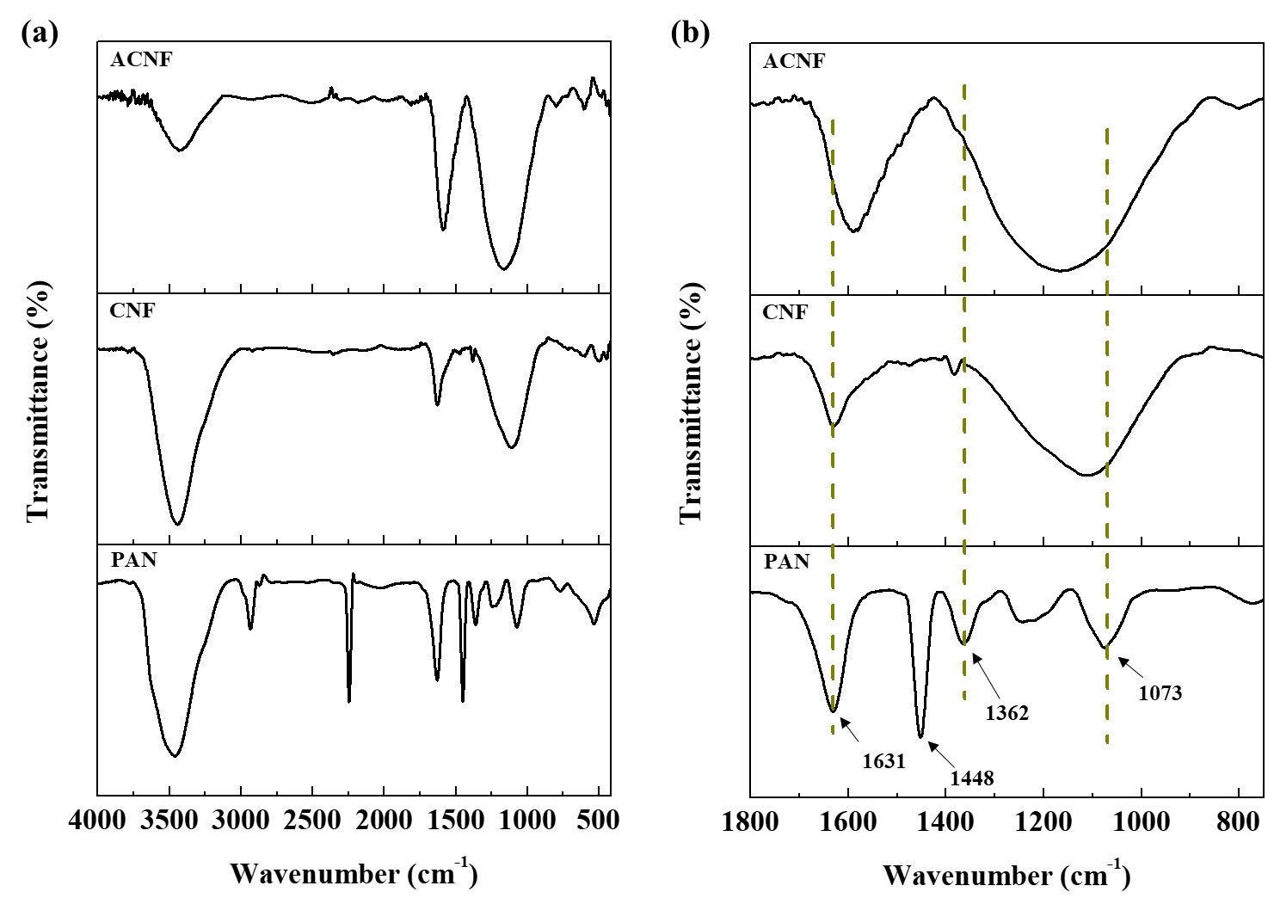
Fig. S3. (a) FTIR spectra of PAN, CNF, and ACNF NPs. (b) The wavenumber range (800 - 1800 cm⁻¹) has been shown in expanded form. The dashed line indicates the shift in wavenumber.

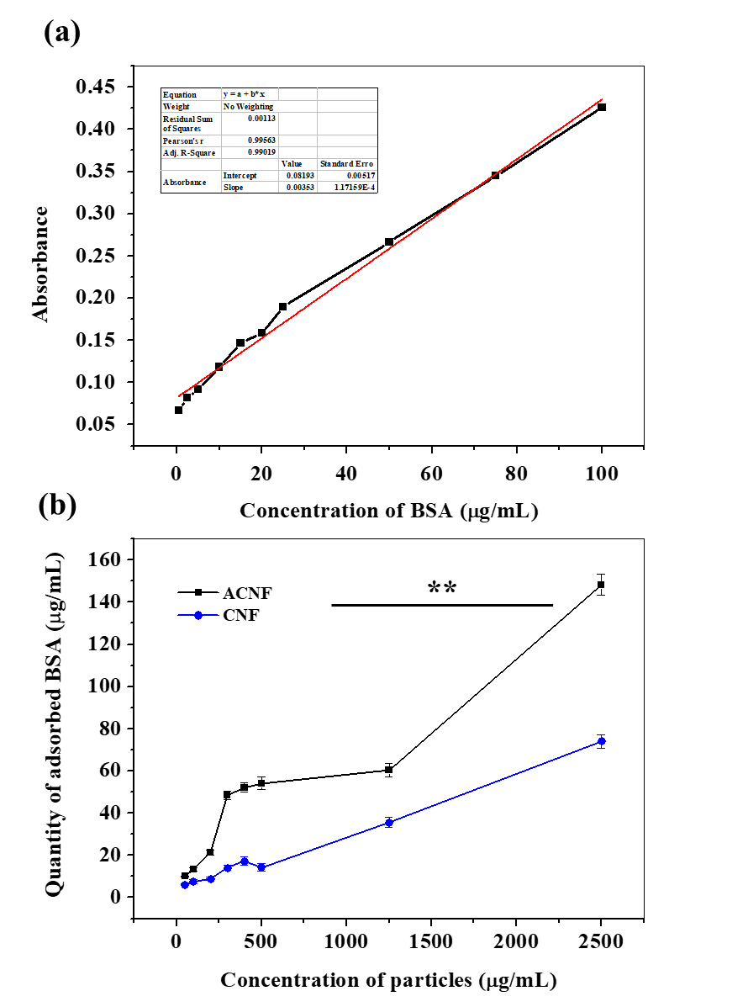
Fig. S4. (a) A linear plot curve between the concentration of standard BSA solution and their optical absorption at 562 nm. (b) A comparison of protein adsorption between various concentrated CNF and ACNF NPs (0.5 - 100 µg/mL). Statistical value p < 0.001.

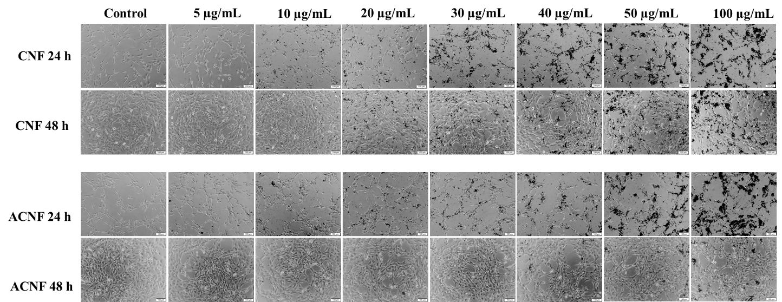
Fig. S5. Optical microscope images of CNF or ACNF NPs (5 - 100 µg/mL) treated NIH3T3 cells at 24 and 48 h of incubational periods. Control is the untreated cells. The scale bar is 100 µm.

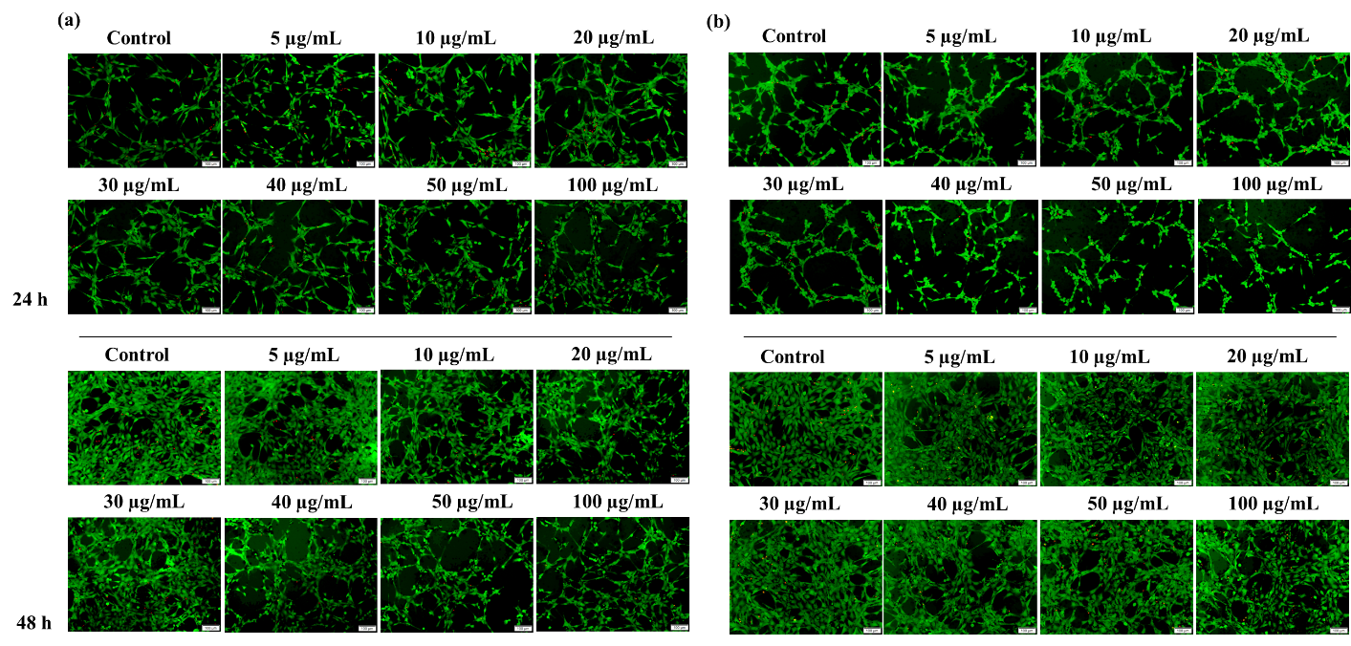
Fig. S6. Fluorescent microscope images of live and dead cells after treatment with (a) CNF or (b) ACNF NPs (5 - 100 µg/mL) on different incubational periods, 24 and 48 h. The control is the cell line without treatment. Scale bar is 100 µm.

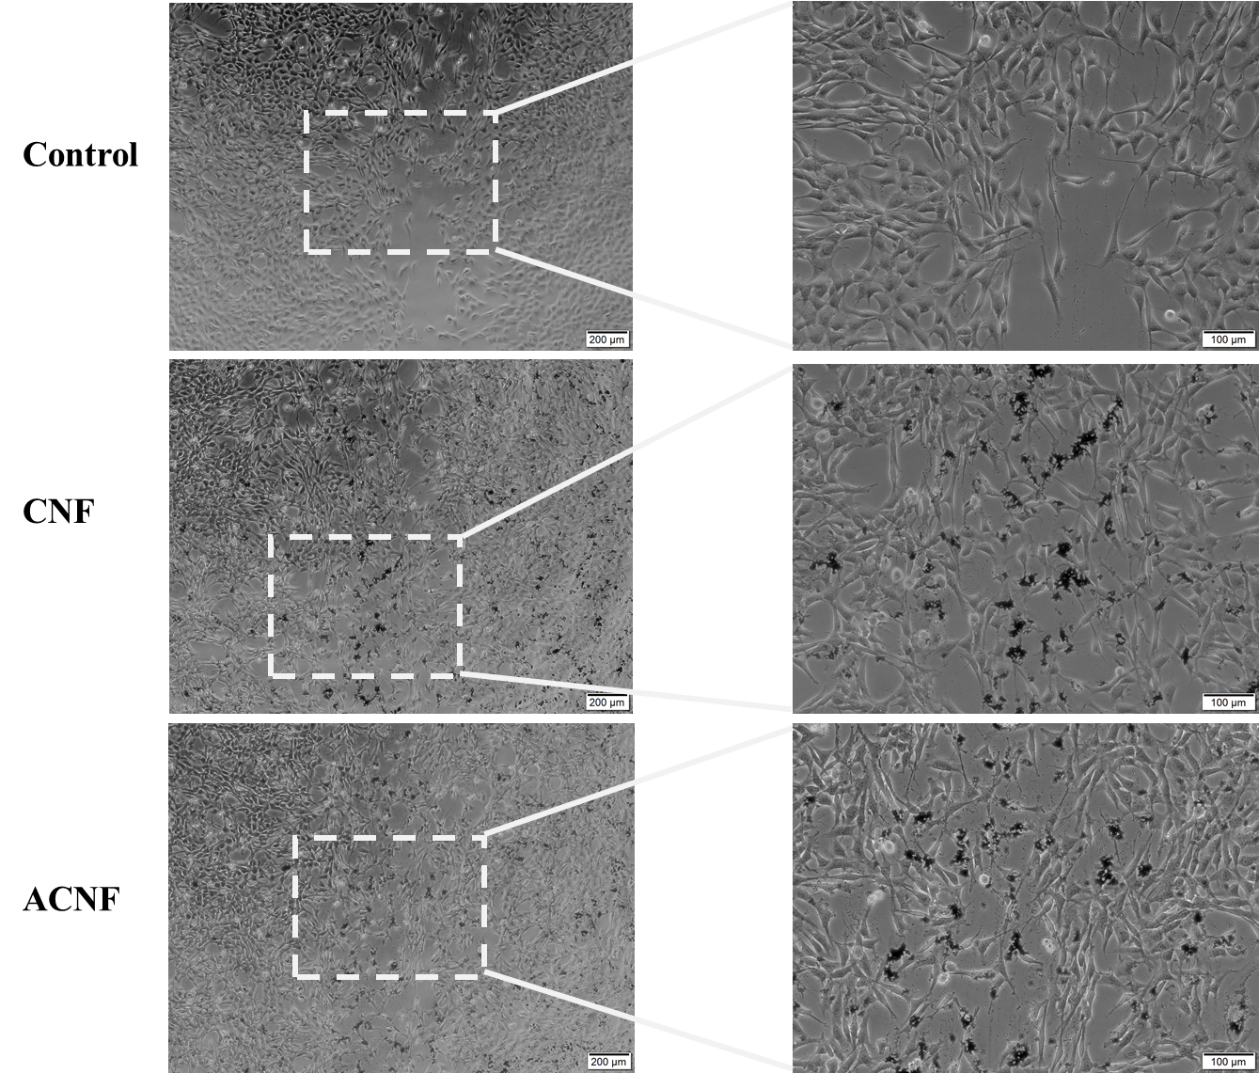
Fig. S7. An enlarged view of the optical microscope images of the NPs treated cells after 24 h in in vitro wound healing.

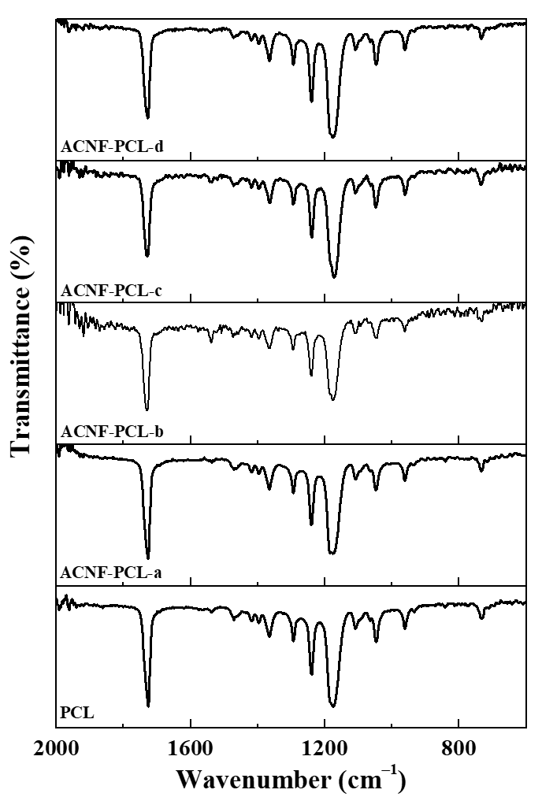
Fig. S8. ATR-FTIR spectra of electrospun nanofiber mats of PCL and ACNF-PCL group. The wavenumber range of 600 - 2000 cm⁻¹ has been shown.

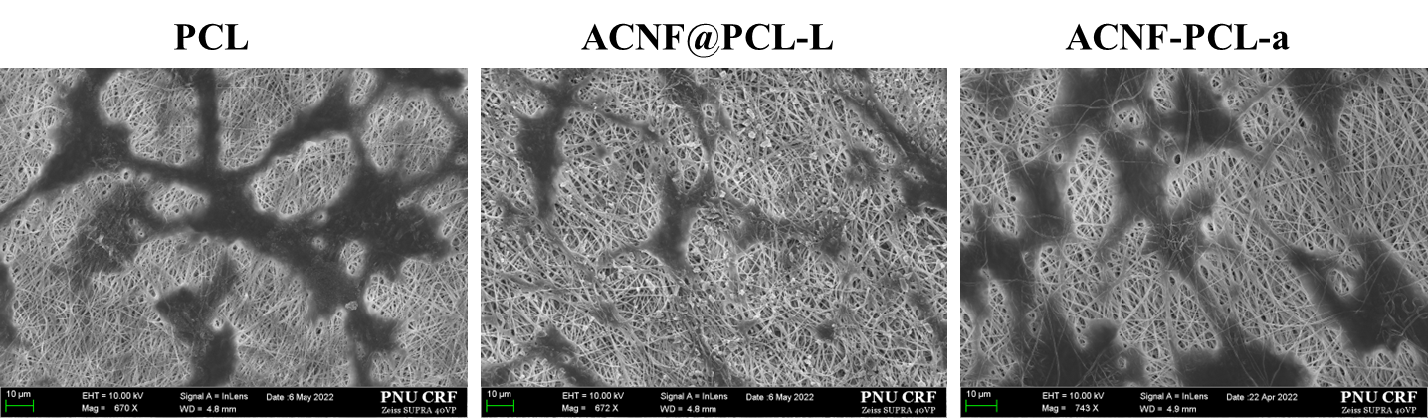

Fig. S9. SEM images of cells grown on PCL, ACNF@PCL-L, and ACNF-PCL-a to demonstrate cell-cell communication on day 3. ACNF NPs can be clearly viewed in AC NF@PCL-L scaffold.

