Additional file
a
d
b
e
c
f

Fig. S1 Association of typical biological processes with the expression of hormone receptors estimated using the gene expression profile of breast cancer. (a-f) Summary of results of GSEA performed on the METABRIC datasets is shown. Biological processes positively or inversely correlated with each gene expression are shown in the descending order of the absolute value of the normalized enrichment score (NSE) with absolute values of the log-transformed nominal p-values and FDR q-values. Thresholds of the nominal p-value and FDR q-value were set to <0.05 and <0.25, respectively, and the boundaries are shown in the graph by dashed lines.

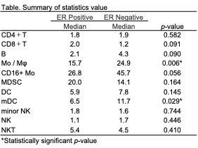
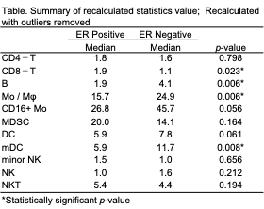
a
b
c
d
e
f
g
h
i
j
k

Fig. S2 Programmed death-ligand 1 (PD-L1) positive ratio in each immune cell fraction according to estrogen receptor (ER) status. (a-k) the percentage of PD-L1 positive cells in each immune cell fraction by ER status is shown. A summary of statistics value is shown at left side of figure. A summary of the recalculated statistics values excluding outliers is shown in the lower left of the figure.

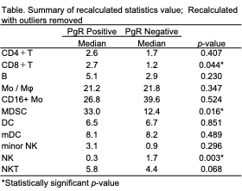
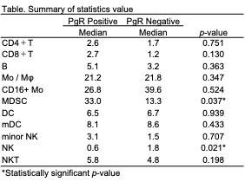
a
b
c
d
e
f
g
h
i
j
k

Fig. S3 Programmed death-ligand 1 PD-L1 positive ratio in each immune cell fraction according to progesterone receptor (PgR) status. (a-k) the percentage of PD-L1 positive cells in each immune cell fraction by PgR status is shown. A summary of statistics value is shown at left side of figure. A summary of the recalculated statistics values excluding outliers is shown in the lower left of the figure.

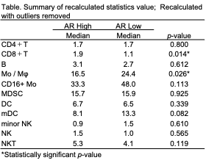
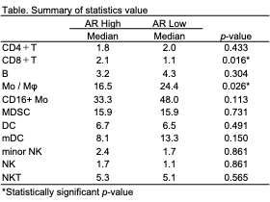
a
b
c
d
e
f
g
h
i
j
k

Fig. S4 Programmed death-ligand 1 (PD-L1) positive ratio in each immune cell fraction according to androgen receptor (AR) status. (a-k) the percentage of PD-L1 positive cells in each immune cell fraction by AR status is shown. A summary of statistics value is shown at left side of figure. A summary of the recalculated statistics values excluding outliers is shown in the lower left of the figure.

Table S1. Clinico-pathological characteristics by ER status
 | ER Positive (N=17) | ER Negative (N=28) | p-value*
Menopausal status |  |  | 0.198
Post | 9.0 (52.9%) | 20.0 (74.1%)
Pre | 8.0 (47.1%) | 7.0 (25.9%)
Unknown | 0 | 1
Neo-adjuvant therapy |  |  | 0.452
Present | 4.0 (23.5%) | 4.0 (14.3%)
Absent | 13.0 (76.5%) | 24.0 (85.7%)
Hystological Type |  |  | 0.057
IDC | 16.0 (94.1%) | 23.0 (82.1%)
ILC | 1.0 (5.9%) | 0.0 (0.0%)
Special | 0.0 (0.0%) | 5.0 (17.9%)
Invasive tumor size |  |  | 0.689
≥20mm | 14.0 (87.5%) | 22.0 (78.6%)
< 20mm | 2.0 (12.5%) | 6.0 (21.4%)
Unknown | 1 | 0
Lymph node metastasis |  |  | 0.533
Positive | 9.0 (56.2%) | 12.0 (42.9%)
Negative | 7.0 (43.8%) | 16.0 (57.1%)
Unknown | 1 | 0
Lymphatic invasion |  |  | 0.344
Positive | 11.0 (68.8%) | 14.0 (50.0%)
Negative | 5.0 (31.2%) | 14.0 (50.0%)
Unknown | 1 | 0
Vascular invasion |  |  | 0.652
Positive | 3.0 (18.8%) | 3.0 (10.7%)
Negative | 13.0 (81.2%) | 25.0 (89.3%)
Unknown | 1 | 0
Histological Grade |  |  | 0.001
Grade 3 | 0.0 (0.0%) | 11.0 (45.8%)
Grade 1 or 2 | 16.0 (100.0%) | 13.0 (54.2%)
Unknown | 1 | 4
PgR status |  |  | <.001
Positive | 7.0 (41.2%) | 0.0 (0.0%)
Negative | 10.0 (58.8%) | 28.0 (100.0%)
AR status |  |  | 0.005
High | 14.0 (82.4%) | 10.0 (35.7%)
Low | 3.0 (17.6%) | 18.0 (64.3%)
HER2 status |  |  | 0.455
Positive | 2.0 (11.8%) | 6.0 (22.2%)
Negative | 15.0 (88.2%) | 21.0 (77.8%)
Unknown | 0 | 1
Ki67 RI |  |  | 0.163
≥ 20% | 10.0 (58.8%) | 23.0 (82.1%)
< 20% | 7.0 (41.2%) | 5.0 (17.9%)
*Fisher's exact test

Table S2. Clinico-pathological characteristics by PgR status
 | PgR Positive (N=7) | PgR Negative (N=38) | p-value*
Menopausal status |  |  | 0.036
Post | 2.0 (28.6%) | 27.0 (73.0%)
Pre | 5.0 (71.4%) | 10.0 (27.0%)
Unknown | 0 | 1
Neo-adjuvant therapy |  |  | 1.000
Present | 1.0 (14.3%) | 7.0 (18.4%)
Absent | 6.0 (85.7%) | 31.0 (81.6%)
Hystological Type |  |  | 0.641
IDC | 7.0 (100.0%) | 32.0 (84.2%)
ILC | 0.0 (0.0%) | 1.0 (2.6%)
Special | 0.0 (0.0%) | 5.0 (13.2%)
Invasive tumor size |  |  | 0.593
≥20mm | 5.0 (71.4%) | 31.0 (83.8%)
< 20mm | 2.0 (28.6%) | 6.0 (16.2%)
Unknown | 0 | 1
Lymph node metastasis |  |  | 1.000
Positive | 3.0 (42.9%) | 18.0 (48.6%)
Negative | 4.0 (57.1%) | 19.0 (51.4%)
Unknown | 0 | 1
Lymphatic invasion |  |  | 1.000
Positive | 4.0 (57.1%) | 21.0 (56.8%)
Negative | 3.0 (42.9%) | 16.0 (43.2%)
Unknown | 0 | 1
Vascular invasion |  |  | 1.000
Positive | 1.0 (14.3%) | 5.0 (13.5%)
Negative | 6.0 (85.7%) | 32.0 (86.5%)
Unknown | 0 | 1
Histological Grade |  |  | 0.159
Grade 3 | 0.0 (0.0%) | 11.0 (33.3%)
Grade 1 or 2 | 7.0 (100.0%) | 22.0 (66.7%)
Unknown | 0 | 5
ER status |  |  | <0.001
Positive | 7.0 (100.0%) | 10.0 (26.3%)
Negative | 0.0 (0.0%) | 28.0 (73.7%)
AR status |  |  | 0.422
High | 5.0 (71.4%) | 19.0 (50.0%)
Low | 2.0 (28.6%) | 19.0 (50.0%)
HER2 status |  |  | 0.318
Positive | 0.0 (0.0%) | 8.0 (21.6%)
Negative | 7.0 (100.0%) | 29.0 (78.4%)
Unknown | 0 | 1
Ki67 RI |  |  | 0.362
≥ 20% | 4.0 (57.1%) | 29.0 (76.3%)
< 20% | 3.0 (42.9%) | 9.0 (23.7%)
*Fisher's exact test

Table S3. Clinico-pathological characteristics by AR status
 | AR high (N=24) | AR low (N=21) | p-value*
Menopausal status |  |  | 1.000
Post | 16.0 (66.7%) | 13.0 (65.0%)
Pre | 8.0 (33.3%) | 7.0 (35.0%)
Unknown | 0 | 1
Neo-adjuvant therapy |  |  | 1.000
Present | 4.0 (16.7%) | 4.0 (19.0%)
Absent | 20.0 (83.3%) | 17.0 (81.0%)
Hystological Type |  |  | 1.000
IDC | 20.0 (83.3%) | 19.0 (90.5%)
ILC | 1.0 (4.2%) | 0.0 (0.0%)
Special | 3.0 (12.5%) | 2.0 (9.5%)
Invasive tumor size |  |  | 0.448
≥20mm | 20.0 (87.0%) | 16.0 (76.2%)
< 20mm | 3.0 (13.0%) | 5.0 (23.8%)
Unknown | 1 | 0
Lymph node metastasis |  |  | 0.246
Positive | 13.0 (56.5%) | 8.0 (38.1%)
Negative | 10.0 (43.5%) | 13.0 (61.9%)
Unknown | 1 | 0
Lymphatic invasion |  |  | 0.127
Positive | 16.0 (69.6%) | 9.0 (42.9%)
Negative | 7.0 (30.4%) | 12.0 (57.1%)
Unknown | 1 | 0
Vascular invasion |  |  | 1.000
Positive | 3.0 (13.0%) | 3.0 (14.3%)
Negative | 20.0 (87.0%) | 18.0 (85.7%)
Unknown | 1 | 0
Histological Grade |  |  | 0.001
Grade 3 | 1.0 (4.8%) | 10.0 (52.6%)
Grade 1 or 2 | 20.0 (95.2%) | 9.0 (47.4%)
Unknown | 3 | 2
ER status |  |  | 0.005
Positive | 14.0 (58.3%) | 3.0 (14.3%)
Negative | 10.0 (41.7%) | 18.0 (85.7%)
PgR status |  |  | 0.422
Positive | 5.0 (20.8%) | 2.0 (9.5%)
Negative | 19.0 (79.2%) | 19.0 (90.5%)
HER2 status |  |  | 0.710
Positive | 5.0 (20.8%) | 3.0 (15.0%)
Negative | 19.0 (79.2%) | 17.0 (85.0%)
Unknown | 0 | 1
Ki67 RI |  |  | 0.329
≥ 20% | 16.0 (66.7%) | 17.0 (81.0%)
< 20% | 8.0 (33.3%) | 4.0 (19.0%)
*Fisher's exact test

