Pulmonary artery smooth muscle cells with pulmonary arterial hypertension depends metabolism on glycolysis under normoxia and mitochondrial respiration under hypoxia

Satoshi Akagi^{1*}; Kazufumi Nakamura¹; Megumi Kondo¹; Satoshi Hirohata²; Heiichiro Udono³; Mikako Nishida³; Yukihiro Saito¹; Masashi Yoshida¹; Toru Miyoshi¹; Hiroshi Ito¹

¹Department of Cardiovascular Medicine, Okayama University Graduate School of Medicine, Dentistry and Pharmaceutical Sciences, Okayama, Japan
²Department of Medical Technology, Graduate School of Health Sciences, Okayama University, Okayama, Japan
³Department of Immunology, Okayama University Graduate School of Medicine, Dentistry, and Pharmaceutical Sciences, Okayama, Japan

Correspondence: Satoshi Akagi. Department of Cardiovascular Medicine, Okayama University Graduate School of Medicine, Dentistry and Pharmaceutical Sciences, Okayama, Japan. E-mail: akagi-s@cc.okayama-u.ac.jp

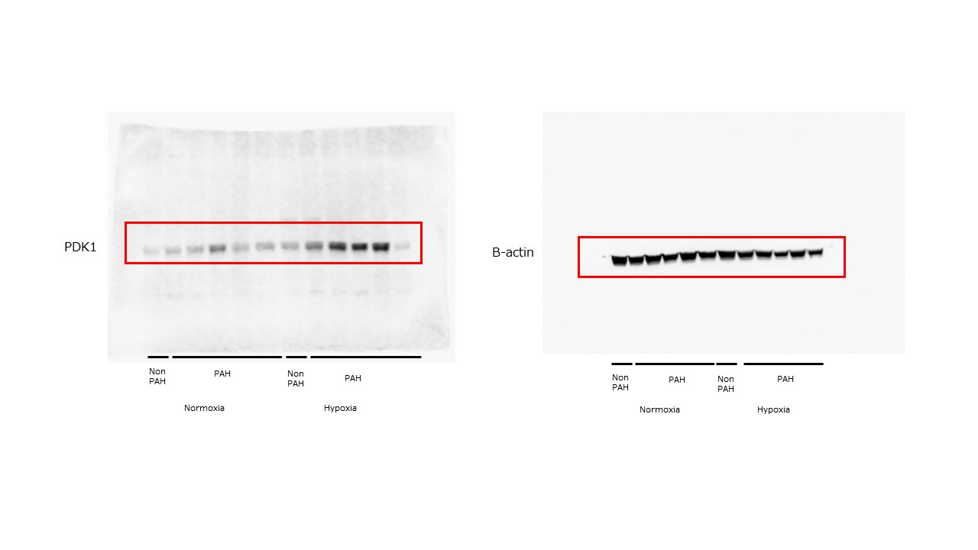

Supplementary Figure S1. Original western blot images used in Figure 1C.

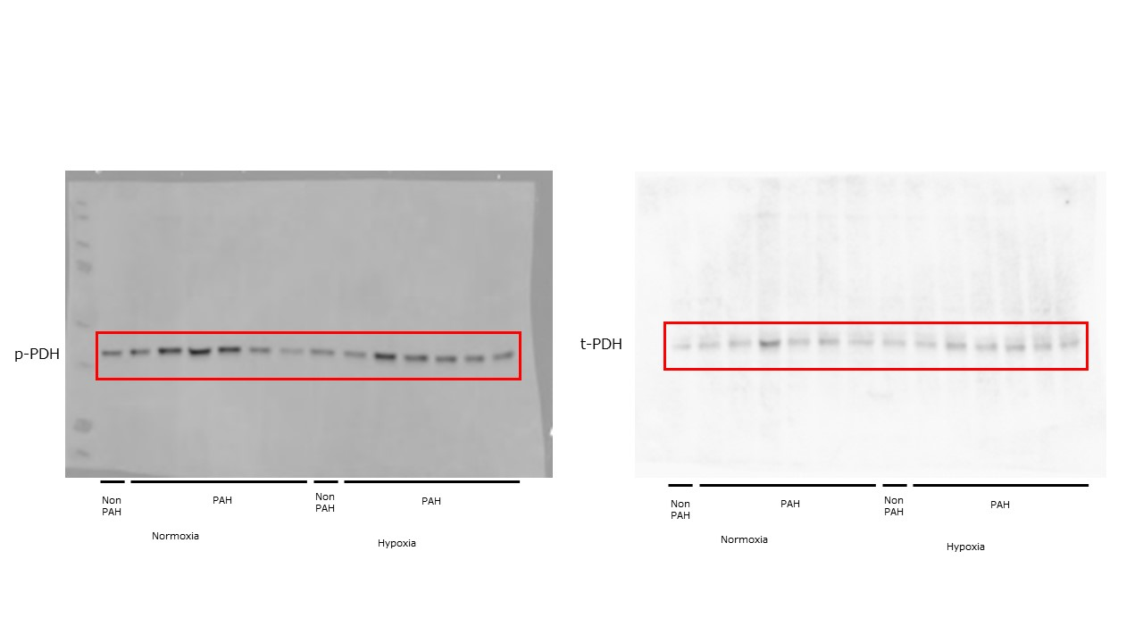

Supplementary Figure S2. Original western blot images used in Figure 1D.

