Supplementary Information for “Dual-comb optical activity spectroscopy for the analysis of vibrational optical activity induced by external magnetic field”

Daowang Peng^{1,2}, Chenglin Gu^{1,2}, Zhong Zuo¹, Yuanfeng Di¹, Xing Zou¹, Lulu Tang¹, Lunhua Deng¹, Daping Luo¹, Yang Liu¹ & Wenxue Li^{1,}*
¹State Key Laboratory of Precision Spectroscopy, East China Normal University, Shanghai 200062, China.
²These authors contributed equally to this work.
*e-mail: wxli@phy.ecnu.edu.cn.

Supplementary note 1: Simulation of the Zeeman effect
- NO₂
The Zeeman behaviour of NO₂ has been explained by CD Hause¹, TJ Sears² and JT Hougen³ et al. In the external magnetic field, the total Hamiltonian of NO2 consists of the vibration-rotation Hamiltonian, the spin-rotation interaction Hamiltonian and the Zeeman Hamiltonian,
$H_{tot}=H_{vr}+H_{sr}+H_{z}$.
The matrix element of the spin-rotation interaction Hamiltonian is given by⁴
$$\left\langle N,K_{a},S,J\left|H_{sr}\right|N,K_{a},S,J\right\rangle =γ_{sr}\frac{J(J+1)-N(N+1)-S(S+1)}{2}$$
The parameter is $γ_{sr}$defined as $γ_{sr}=\left[{\overset{‾}{ε}}_{bb}+\frac{\left(ε_{aa}-{\overset{‾}{ε}}_{bb}\right){K_{a}}^{2}}{N(N+1)}\right]$, where ${\overline{ε}}_{bb}=\frac{ε_{bb}+ε_{cc}}{2}$; $ε_{aa}$, $ε_{bb}$ and $ε_{cc}$ are the spin-rotation interaction constants. The Zeeman Hamiltonian $H_{z}$ of NO2 can be written as¹
$$H_{Z}=-μ⋅H=\left(g_{S}μ_{B}/ħ\right)S⋅H$$
where $g_{S}=+2.00232$ is the electron spin gyromagnetic ratio and $μ_{B}=+0.046686 {cm}^{-1}/kG$ is the Bohr magneton. The Hamiltonian matrix has the form³
$$\left[\begin{aligned}&E_{vr}-\frac{1}{2}γ_{sr}\left(M_{J}+\frac{1}{2}\right)-\frac{1}{2}g_{B}H, +\frac{1}{2}γ_{sr}{\left[{\left(N+\frac{1}{2}\right)}^{2}-{M_{J}}^{2}\right]}^{1/2} \\ &+\frac{1}{2}γ_{sr}{\left[{\left(N+\frac{1}{2}\right)}^{2}-{M_{J}}^{2}\right]}^{1/2}, E_{vr}+\frac{1}{2}γ_{sr}\left(M_{J}-\frac{1}{2}\right)+\frac{1}{2}g_{B}H\end{aligned}\right].$$
This matrix must be replaced by a matrix containing only the lower right (upper left) diagonal element when $M_{J}=±\left(N+\frac{1}{2}\right)$. Then, molecular energy levels in the magnetic field are given by the eigenvalues of the matrix,
$$E(N,M_{J},±1/2)=E_{vr}-\frac{1}{4}γ_{sr}±\frac{1}{2}{\left[{γ_{sr}}^{2}{\left(N+\frac{1}{2}\right)}^{2}+2γ_{sr}M_{J}g_{s}μ_{B}H+{g_{s}}^{2}μ_{B}^{2}H^{2}\right]}^{\frac{1}{2}},$$
for $\left|M_{J}\right|≤\left(N-\frac{1}{2}\right)$, and
$$E=E_{vr}+\frac{1}{2}γ_{sr}N±\frac{1}{2}g_{s}μ_{B}H$$
for $M_{J}=±\left(N+\frac{1}{2}\right)$. Through the direction cosines in Table S1⁵, the transition probability for an electric dipole transition from a state $|n⟩$ to a state $|m⟩$ is given by
$$|\left\langle n\left|M_{A}\right|m\right\rangle |^{2}={\left|\sum_{α}{ }M_{α}{\left(Φ_{Aα}\right)}_{n,m}\right|}^{2}$$
Here, $A=X, Y, or Z$ and $α=x, y, or z$.

Table S1. Values of the elements of all direction-cosine matrices for the prolate-symmetric-top molecule, NO₂.
Matrix-element factor | $$∆J=+1$$ | $$∆J=0$$ | $$∆J=-1$$
$${\left(Φ_{Aα}\right)}_{J,J^{'}}$$ | $$[4(J+1)\sqrt{(2J+1)(2J+3)}]^{-1}$$ | $$[4J(J+1)]^{-1}$$ | $${\left[4J\sqrt{4J^{2}-1}\right]}^{-1}$$
$${\left(Φ_{Az}\right)}_{J, K_{a};J^{'},K_{a}}$$ | $$2\sqrt{(J+K_{a}+1)(J-K_{a}+1)}$$ | $$2K_{a}$$ | $$-2\sqrt{J^{2}-{K_{a}}^{2}}$$
$$\begin{aligned}&{\left(Φ_{Ay}\right)}_{J,K_{a};J^{'},K_{a}±1} \\ &{\left.=(Φ_{Ax}\right)}_{J,K_{a};J^{'},K_{a}±1}\end{aligned}$$ | $$∓\sqrt{(J±K_{a}+1)(J±K_{a}+2)}$$ | $$\sqrt{(J∓K_{a})(J±K_{a}+1)}$$ | $$∓\sqrt{(J∓K_{a})(J∓K_{a}-1)}$$
$${\left(Φ_{Zα}\right)}_{J,M_{J};J^{'},M_{J}}$$ | $$2\sqrt{(J+M_{J}+1)(J-M_{J}+1)}$$ | $$2M_{J}$$ | $$-2\sqrt{J^{2}-{M_{J}}^{2}}$$
$$\begin{aligned}&{\left(Φ_{Yα}\right)}_{J,M_{J};J^{'},M_{J}±1} \\ &=±i{\left(Φ_{Xα}\right)}_{J,M_{J};J^{'},M_{J}±1}\end{aligned}$$ | $$∓\sqrt{(J±M_{J}+1)(J±M_{J}+2)}$$ | $$\sqrt{(J∓M_{J})(J±M_{J}+1)}$$ | $$∓\sqrt{(J∓M_{J})(J∓M_{J}-1)}$$

- NO
For the diatomic molecule of nitric oxide, the additional energy due to the magnetic field can be expressed as
$$ΔE=-M_{J}g_{J}μ_{B}B$$
where $M_{J}$ are the magnetic quantum numbers, $g_{J}$ is the Lande g-factor, $μ_{B}$ is the Bohr magneton, and $B$ is the magnetic field strength. The ro-vibrational transitions between the Zeeman sublevels of $v^{'}J^{'}M_{J^{'}}^{'}$ and $v^{''}J^{''}M_{J^{''}}^{''}$ are given by
$$v_{v^{'}J^{'}M_{J^{'}}^{'}←v^{''}J^{''}M_{J^{''}}^{''}}=v_{0}+\left(M_{J^{'}}^{'}g_{J^{'}}^{v^{'}}-M_{J^{''}}^{''}g_{J^{''}}^{v^{''}}\right)\frac{μ_{B}B}{hc}$$
where $vJM_{J}$ are vibrational quantum numbers, rotational quantum numbers and magnetic quantum numbers, and the primes and double primes refer to upper and lower states, respectively. $h$ is the Planck constant, $c$ is the speed of light, and $v_{0}$ is the transition frequency without the external field. The Lande g-factor $g_{J}$ of NO is given by Hund’s coupling case (a–b)^{6,7},
$$g_{J}=\frac{3/2±[2(J-1/2)(J+3/2)-3Y/2+3]/X}{J(J+1)}$$
where $X=\sqrt{4(J-1/2)(J+3/2)+(Y-2)^{2}}$ and $Y=A_{v}/B_{v}$, $A_{v}$ and $B_{v}$ are the spin–orbit coupling and rotational constants of the vibrational quantum number $v$, respectively; the upper and lower signs represent the $X^{2}Π_{1/2}$ and $X^{2}Π_{3/2}$ fine-structure components, respectively. For the overtone ($2←0$) band of NO, $A_{0}=123.13361 {cm}^{-1}$, $B_{0}=1.6961483 {cm}^{-1}$ and $A_{2}=122.63486 {cm}^{-1}$, $B_{0}=1.6609632 {cm}^{-1}$ ^{8,9}. The centre frequency of the Zeeman transitions $σ^{±}$ ($∆M_{J}=±1$) is described by
$v_{σ^{±}}=v_{0}+\left[\left(M_{J^{''}}^{''}±1\right)g_{J^{'}}^{v^{'}}-M_{J^{''}}^{''}g_{J^{''}}^{v^{''}}\right]\frac{μ_{B}B}{hc}$.
As shown in Table S2, the line intensities of the Zeeman subtransitions, $S_{M^{'}M^{''}}={\overset{‾}{S}}_{M^{'}M^{''}}⋅S_{ΩJ^{'}J^{''}}$, can be calculated by the corresponding 3J symbol¹⁰
${\overset{‾}{S}}_{M^{'}M^{''}}={\left(\begin{matrix}J^{'} & 1 & J^{''} \\ -M^{'} & ΔM & M^{''}\end{matrix}\right)}^{2}$ and $∑_{M^{'}M^{''}} {\overset{‾}{S}}_{M^{'}M^{''}}=1$.
The integrated line intensity $S_{ΩJ^{'}J^{''}}$ can be obtained in the HITRAN database, as well as the zero-field parameters, such as the transition frequency and the quantum numbers of the upper levels and lower levels.
Table S2. Table of relative strength, ${\overset{‾}{S}}_{M^{'}M^{''}}$, for the Zeeman transitions.
$$∆J$$ | $$∆M_{J}=+1$$ | $$∆M_{J}=-1$$
+1 | $$\frac{(J+M_{J}+1)(J+M_{J}+2)}{2(J+1)(2J+1)(2J+3)}$$ | $$\frac{(J-M_{J}+1)(J-M_{J}+2)}{2(J+1)(2J+1)(2J+3)}$$
0 | $$\frac{(J-M_{J})(J+M_{J}+1)}{2J(J+1)(2J+1)}$$ | $$\frac{(J+M_{J})(J-M_{J}+1)}{2J(J+1)(2J+1)}$$
-1 | $$\frac{(J-M_{J})(J-M_{J}-1)}{2J(2J+1)(2J-1)}$$ | $$\frac{(J+M_{J})(J+M_{J}-1)}{2J(2J+1)(2J-1)}$$

Supplementary note 2: Calculation of the MVCD and MORD spectra
The transition frequency $v_{±}$ and the line strength $S_{±}$ of the Zeeman components ($σ^{±}$) under a magnetic field are given by the above analysis. The transmission spectra are described as¹¹
$$T_{±}\left(v\right)=exp⁡[-ϕ(v_{±})S_{±}\frac{P}{P_{0}}N_{0}\frac{T_{0}}{T}L]$$
where $ϕ\left(v_{±}\right)$ is the Voigt-shape function, $N_{0}$ is the number density at $T_{0}=273.15K$ and $P_{0}=1$ atm, $P$ and $T$ are the temperature and pressure under the experimental conditions. The MVCD ($∆A$) is defined as the difference in absorbance between $σ^{±}$,
$$∆A=-\lg{T_{+}}+\lg{T_{-}}=-\lg{\frac{T_{+}}{T_{-}}}$$
The phase spectrum of the Zeeman components ($σ^{±}$) is obtained by the Kramers-Kronig relationship, and the MORD ($∆φ$)
$∆φ=\frac{φ_{+}-φ_{-}}{2}$.
The calculations of magnetic linear dichroism and magnetic birefringence in a transverse magnetic field can be performed easily by replacing $σ^{+}/σ^{-}$ with $σ/π$.

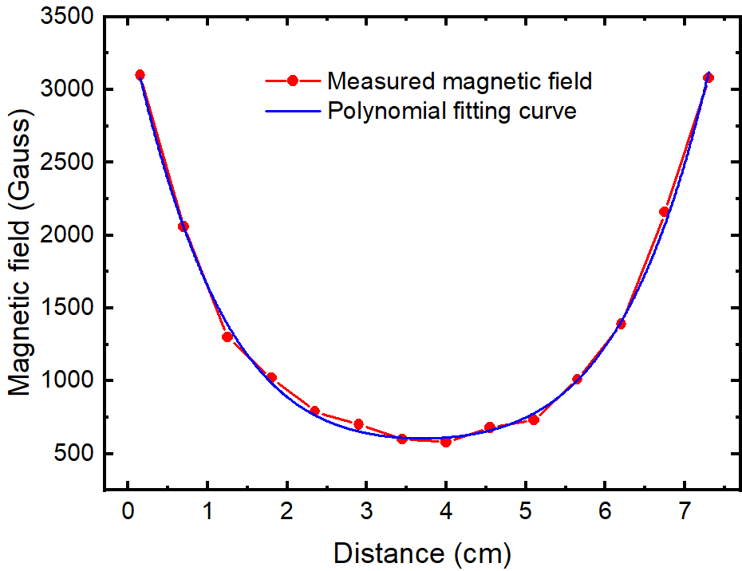
Fig. S1 Measured magnetic field (red curve) and polynomial fitting curve (blue curve).

In the simulation, the inhomogeneous distribution of the magnetic field should be considered. As shown in Fig. S1, the distribution of the longitudinal magnetic field strength along the cell is measured by using a Gaussmeter. A polynomial fit was applied to characterize the strength distribution of our magnetic field along the propagation direction of the incident beams. The fitting curve can be expressed as:
$$B\left(d\right)=9.91d^{4}-147.54d^{3}+892.68d^{2}-2553.13d+3447.66$$
Based on the polynomial fitting function of the magnetic-field distribution and the molecular models of NO₂ and NO, calculations of the MOA spectra are carried out to explain the experimental results.

Reference
- Olman M. D. & Hause C. D. Analysis of the high‐resolution zeeman spectra of nitrogen dioxide in the near infrared. J. Chem. Phys. 49, 4575-4583 (1968).
- Brown J. M. & Sears T. J. A determination of Zeeman parameters for NO₂ in its ground state. Mol. Phys. 34, 1595-1610 (1977).
- Hougen J. T. The assignment of molecular infrared spectra from a laser magnetic resonance spectrometer. J. Mol. Spectrosc. 54, 447-71 (1975).
- Tada K., Hirata M. & Kasahara S., Hyperfine interaction constants of ¹⁴NO₂ in 14 500–16 800 cm⁻¹ energy region. J. Chem. Phys. 147, 164304 (2017).
- Cross P. C., Hainer R. M. & King G. W. The asymmetric rotor II. Calculation of dipole intensities and line classification. J. Chem. Phys. 12, 210-243 (1944).
- Radford H. E., Microwave Zeeman effect of free hydroxyl radicals. Phys. Rev. 122, 114 (1961).
- Herrmann W., Rohrbeck W. & Urban W. Line shape analysis for Zeeman modulation spectroscopy. Appl. Phys. 22, 71-75 (1980).
- Brown J. M., Kaise M., Kerr C. M. L. & Milton D. J. A determination of fundamental Zeeman parameters for the OH radical. Mol. Phys. 36, 553-582 (1978).
- Pine A. S., Johns J. W. C. & Robiette A. G. Λ-Doubling in the v= 2← 0 overtone band in the infrared spectrum of NO. J. Mol. Spectrosc. 74, 52-69 (1979).
- Borkov Y. G., Klimachev Y. M. & Sulakshina O. N. Dependence of Zeeman splitting of spectral lines on the magnetic field magnitude for NO molecule. Atmos. Ocean. Opt. 29, 103-118 (2016).
- Li J., Yu B., Zhao W. & Chen W. A review of signal enhancement and noise reduction techniques for tunable diode laser absorption spectroscopy. Appl. Spectrosc. Rev. 49, 666-691 (2014).

