SUPPLEMENTARY INFORMATION:
Supplementary Figure 1: Diagnostic accuracy for the prediction of RISN treatment for the constructed RISN severity scale and the final prediction model for the indication to RISN treatment
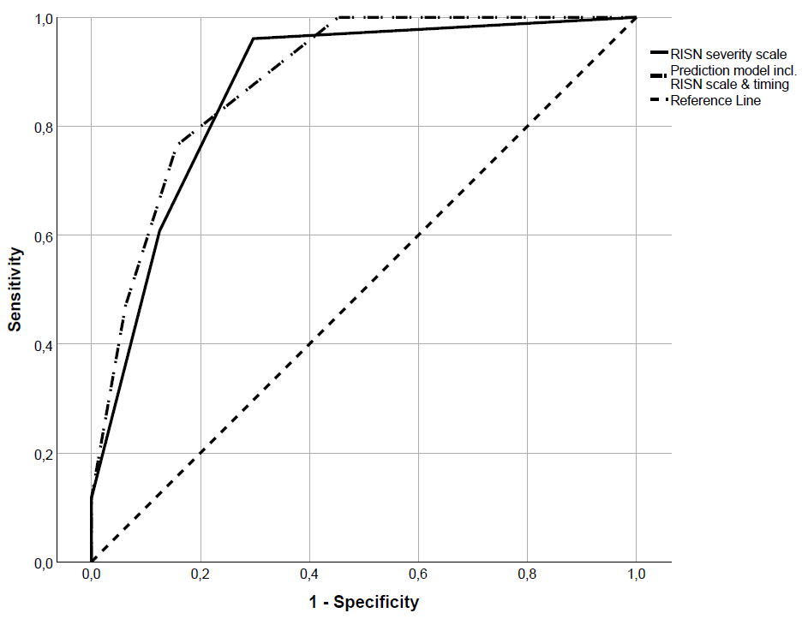

Abbreviations: RISN- radiation induced scleral necrosis

Supplementary Table E1: Estimated time interval without therapy after RISN diagnosis in different grade values of the severity scale for RISN
Severity grade | Meanª
Severity grade | Estimate | 95% CI
1 | 152.47 | (141.59 - 163.36)
2 | 73.57 | (33.09-114.04)
3 | 15.09 | (6.18-23.99)
4 | 1.92 | (0.00-4.86)
Abbreviations: RISN- progressive radiation-induced scleral necrosis; CI- confidence interval.

