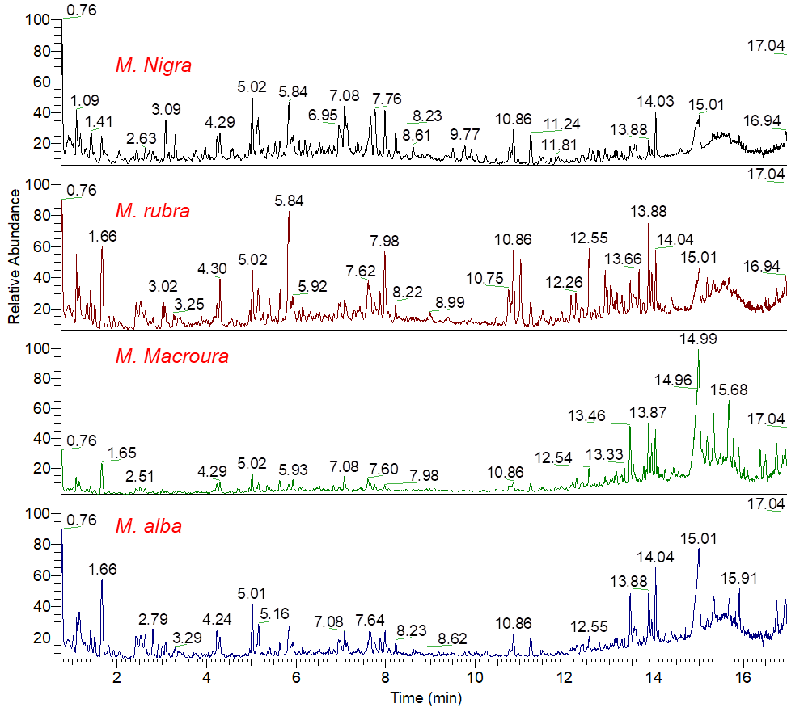
Figure S1. Total ion chromatogram (TIC) of the polyphenol-rich extracts from different Morus leaves analyzed by UPLC–HR–ESI– MS/MS in positive ionization mode.
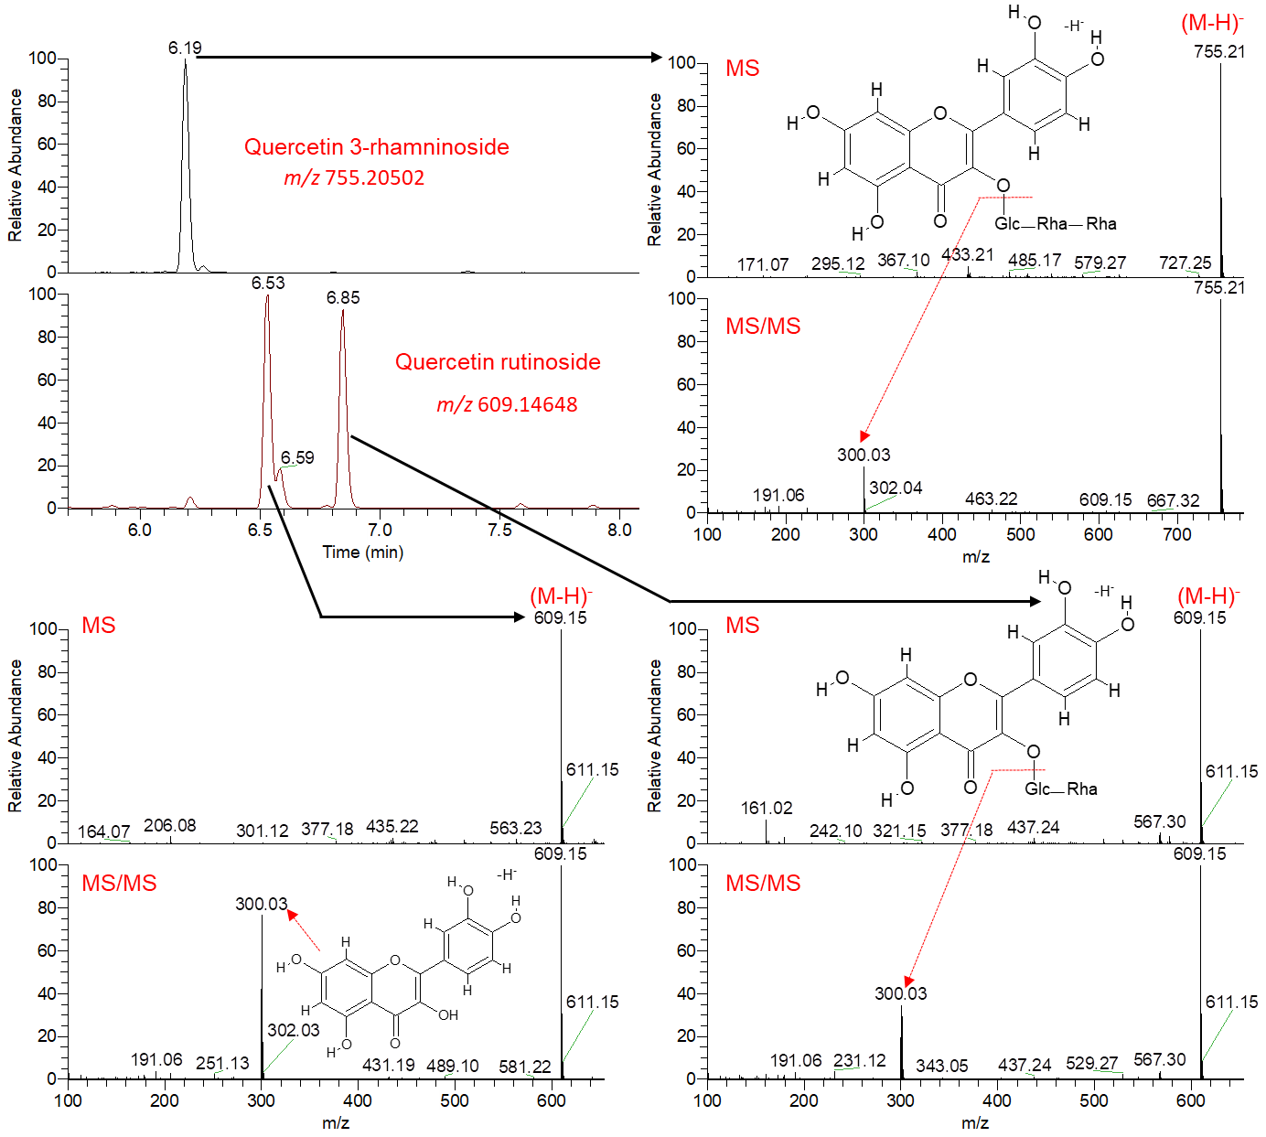
Figure S2. Annotation of quercetin glycosides of the polyphenol-rich extracts from different Morus leaves as analyzed by UPLC–HR–ESI–MS/MS in negative ionization mode.
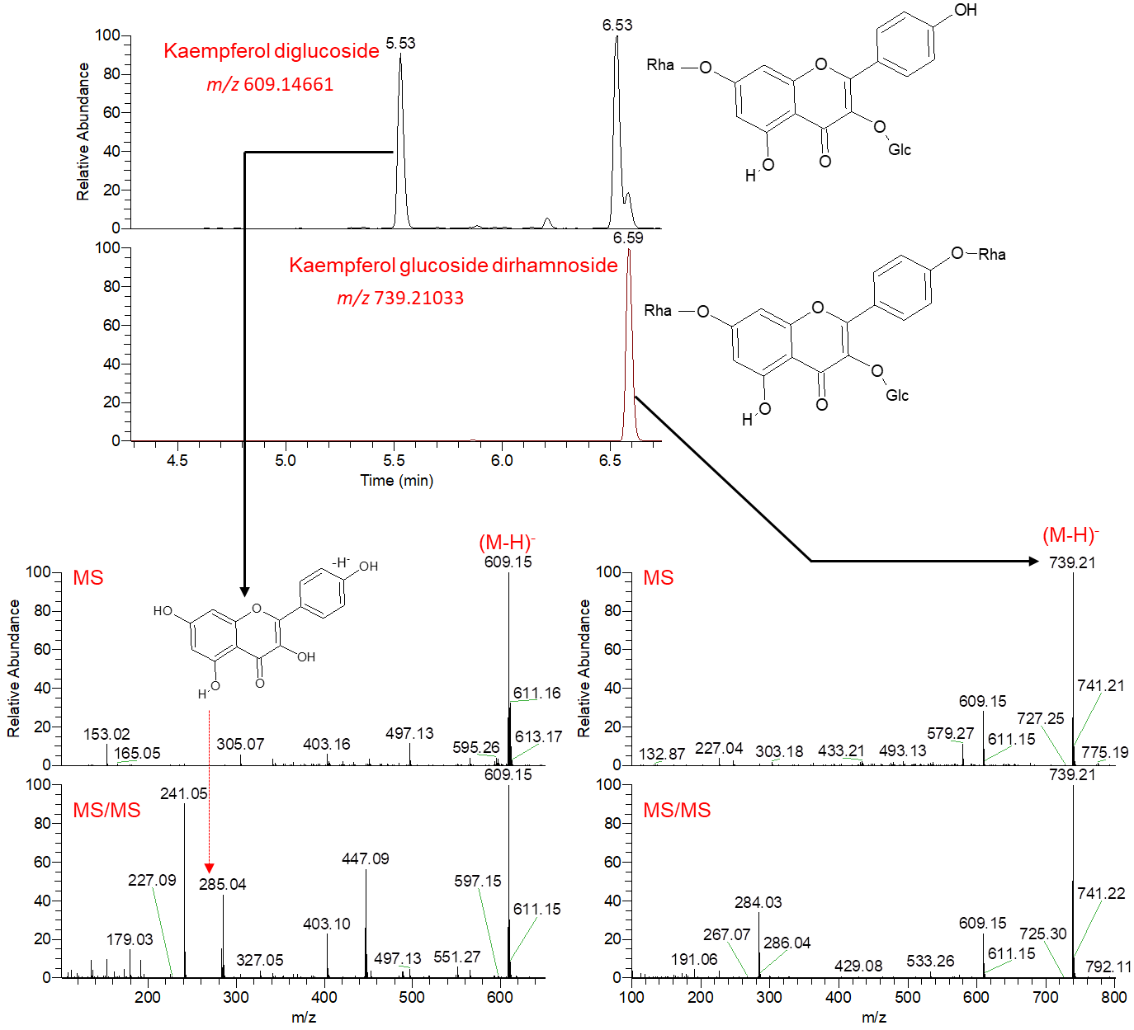
Figure S3. Annotation of kaempferol glycosides of the polyphenol-rich extracts from different Morus leaves as analyzed by UPLC–HR–ESI–MS/MS in negative ionization mode.
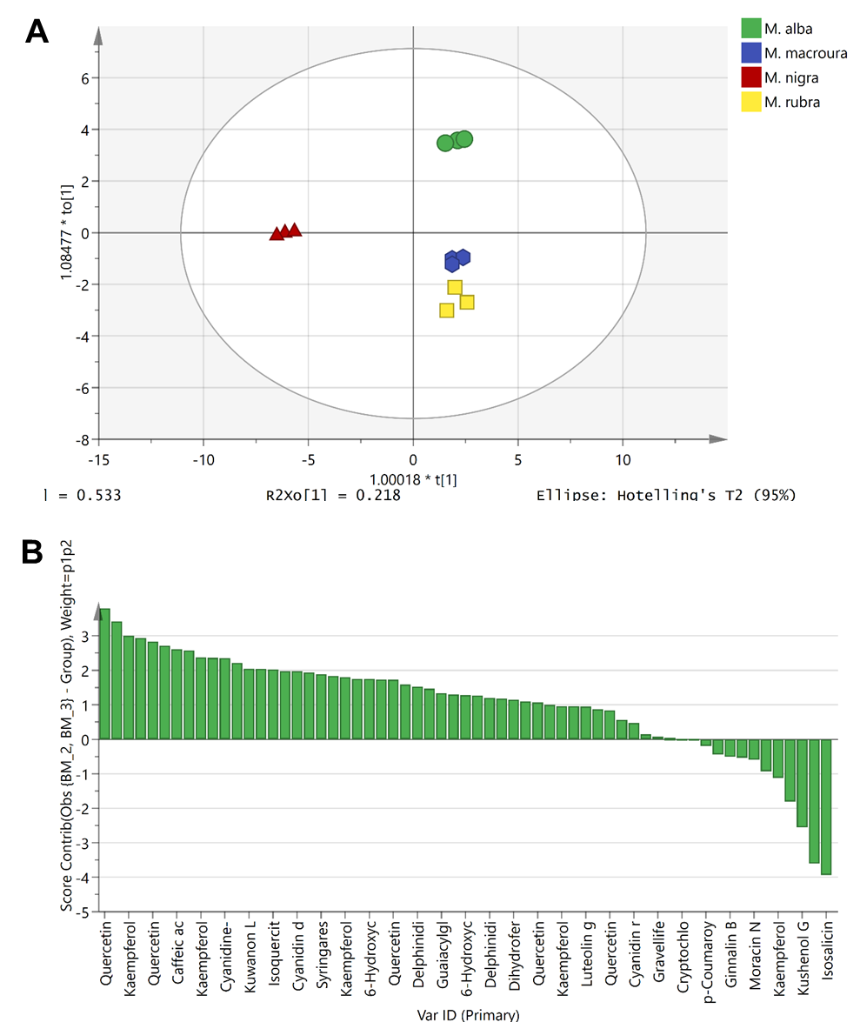
Figure S4. Orthogonal Projections to Latent Structures Discriminant Analysis (OPLS-DA) score plot (A) and Contribution plot (B) based on the identified metabolites from the polyphenol-rich extracts of different Morus leaves.

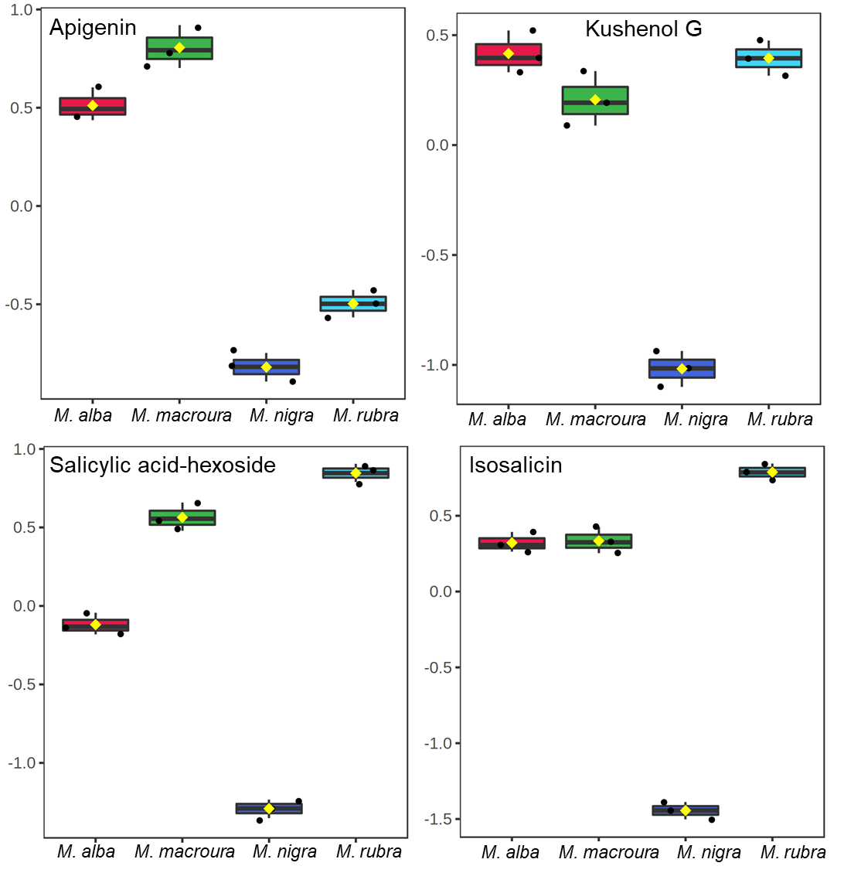
Figure S5. Metabolites with low abundance in the polyphenol-rich extracts extract from Morus nigra leaves. The y-axis represents the log₁₀-scaled values of metabolite abundance.

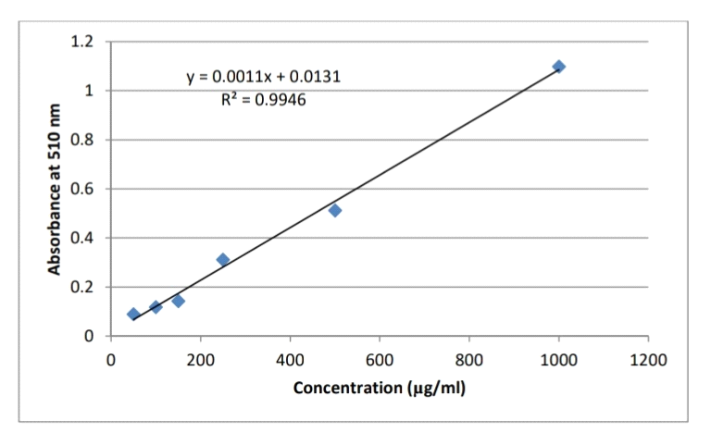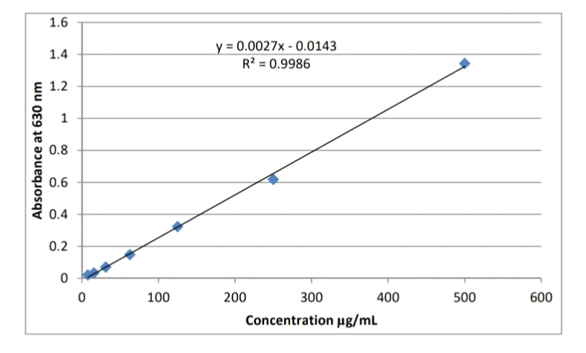
b
a
Figure S6. Representative standard curves: (a) gallic acid, (b) rutin (The average of the readings of the 6 replicates was taken)
b
a

Figure S7. Total phenolics (A) and total Flavonoids (B) of the four Morus species calculated as gallic acid equivalent (GAE) and rutin equivalent, respectively.

Table S1. Fold change (FC) analysis of metabolites that were significantly changed in Morus nigra leaves relative to other Morus species.
Metabolites | FC | log₂(FC) | p-value | -log₁₀(p)
Cyanidin sambubioside | 40.968 | 5.3564 | 2.00E-05 | 4.6988
Quercetin | 21.184 | 4.4049 | 0.0051951 | 2.2844
Kaempferol | 14.544 | 3.8623 | 0.004698 | 2.3281
Kaempferol galactosyl dirhamnoside | 11.025 | 3.4627 | 4.84E-07 | 6.3149
Quercetin 3-rhamninoside | 10.124 | 3.3397 | 1.53E-09 | 8.8148
Naringenin glucoside | 8.5651 | 3.0985 | 3.44E-08 | 7.4633
Kaempferol diglucoside | 7.0016 | 2.8077 | 0.0026091 | 2.5835
Luteolin | 6.3379 | 2.664 | 2.52E-05 | 4.5989
Caffeic acid | 6.1743 | 2.6263 | 0.0016105 | 2.793
4,7-Dihydroxy coumarin | 5.7097 | 2.5134 | 0.00074817 | 3.126
Kushenol G | 0.14027 | -2.8338 | 1.57E-08 | 7.8033
Apigenin | 0.12055 | -3.0523 | 0.011923 | 1.9236
Salicylic acid-hexoside | 0.024961 | -5.3242 | 5.87E-05 | 4.2314
Isosalicin | 0.017007 | -5.8778 | 9.77E-08 | 7.0099

