Supplementary Material

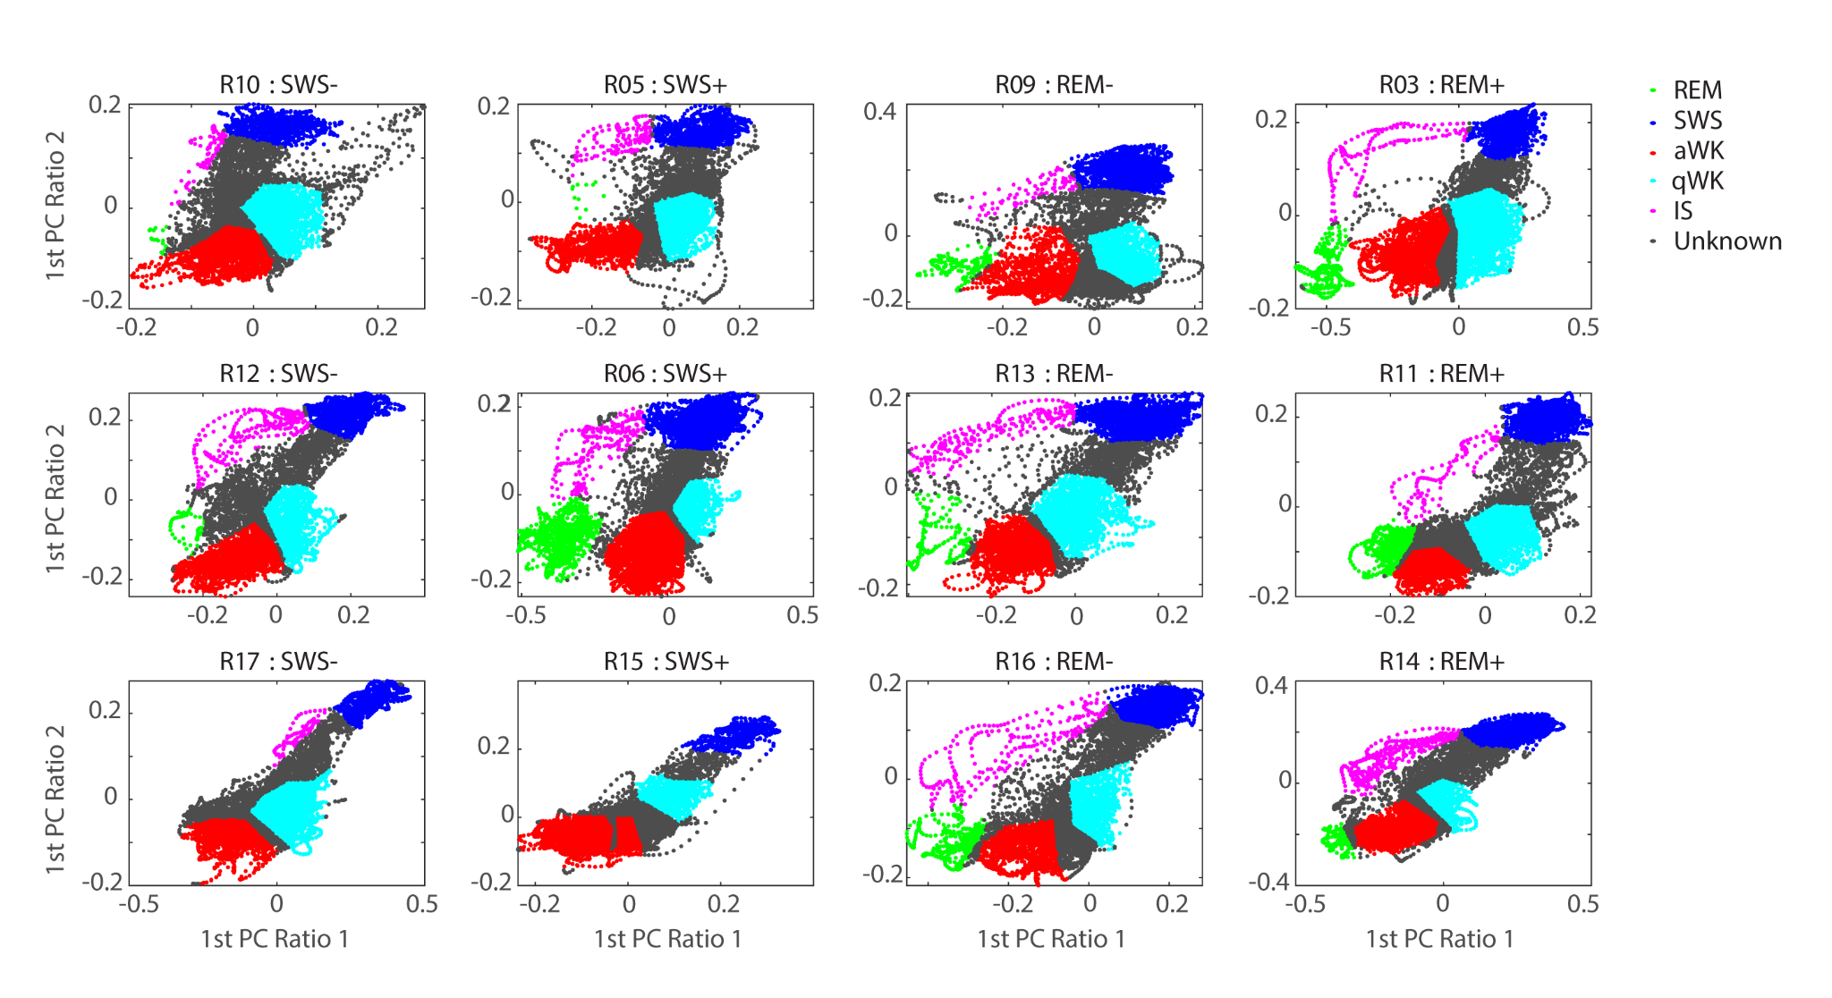
Supplementary Figure S1. Manual annotations of sleep states from the 2D spectral map.

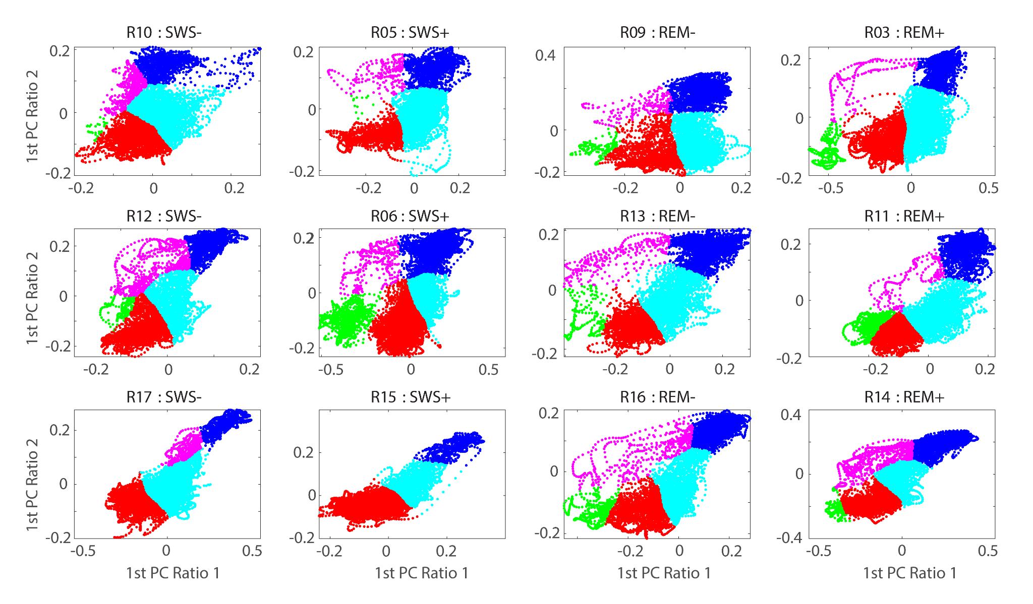
Supplementary Figure S2. Sleep states from 2D spectral maps after KNN classification of non-annotated points. The parameters used for KKN classifier, K = 11 and Euclidean distance metric.

Shuffling groups

The original groups are considered the animals in the experimental conditions, those groups are references with letters for better comprehension:
• SWS-: A
• SWS-: B
• REM-: C
• REM+: D

The shuffling procedure allows to obtain 'random' groups (1296), which contains 3 subjects, always from different original groups, e.g. 'A1 B2 C1' is a possible random group, but 'A1 A2 C1' it is not. 10 random groups resulting from shuffling are illustrated in Supp. Figure S3.

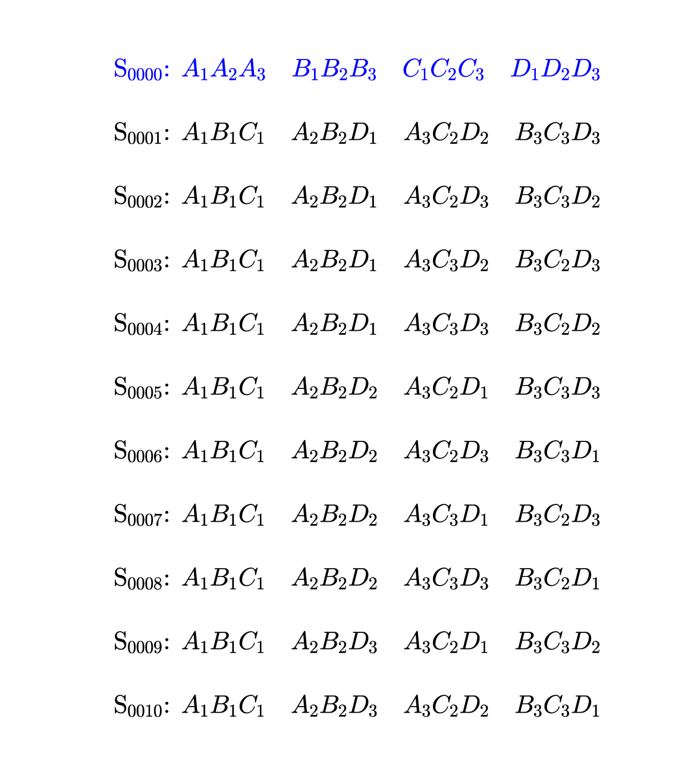
Supplementary Figure S3. Original group ordering and the first 10 shuffling cases.

Clustering metric
To quantify the clustering quality for each shuffling iteration we computed the compactness/separability ratio. For each group, the intra-group compactness is computed as the Euclidean distance between the group centroid and the most distant group element. The inter-group separability was computed as Euclidean distance between group centroids. The clustering quality metric was computed as the (mean intra-group compactness)/(mean inter group separability), see Suppl. Figure S4.

For each iteration, the following steps were performed:

- Rank proteins by its discriminative power based on fisher score. Proteins were ranked based on its capacity to discriminate the groups for the current shuffling.
- Compute clustering metric in 2D Principal Component Analysis space. The N* higher ranked proteins were selected. By using these N proteins, we performed a 2D PCA dimensionality reduction. By using the resulting 2D space we computed the clustering metric, but only for the cases in which it was possible to identify clustering that agreed with the current shuffled order.
- The parameter N ranges from 10, 11, 12, ... 291.

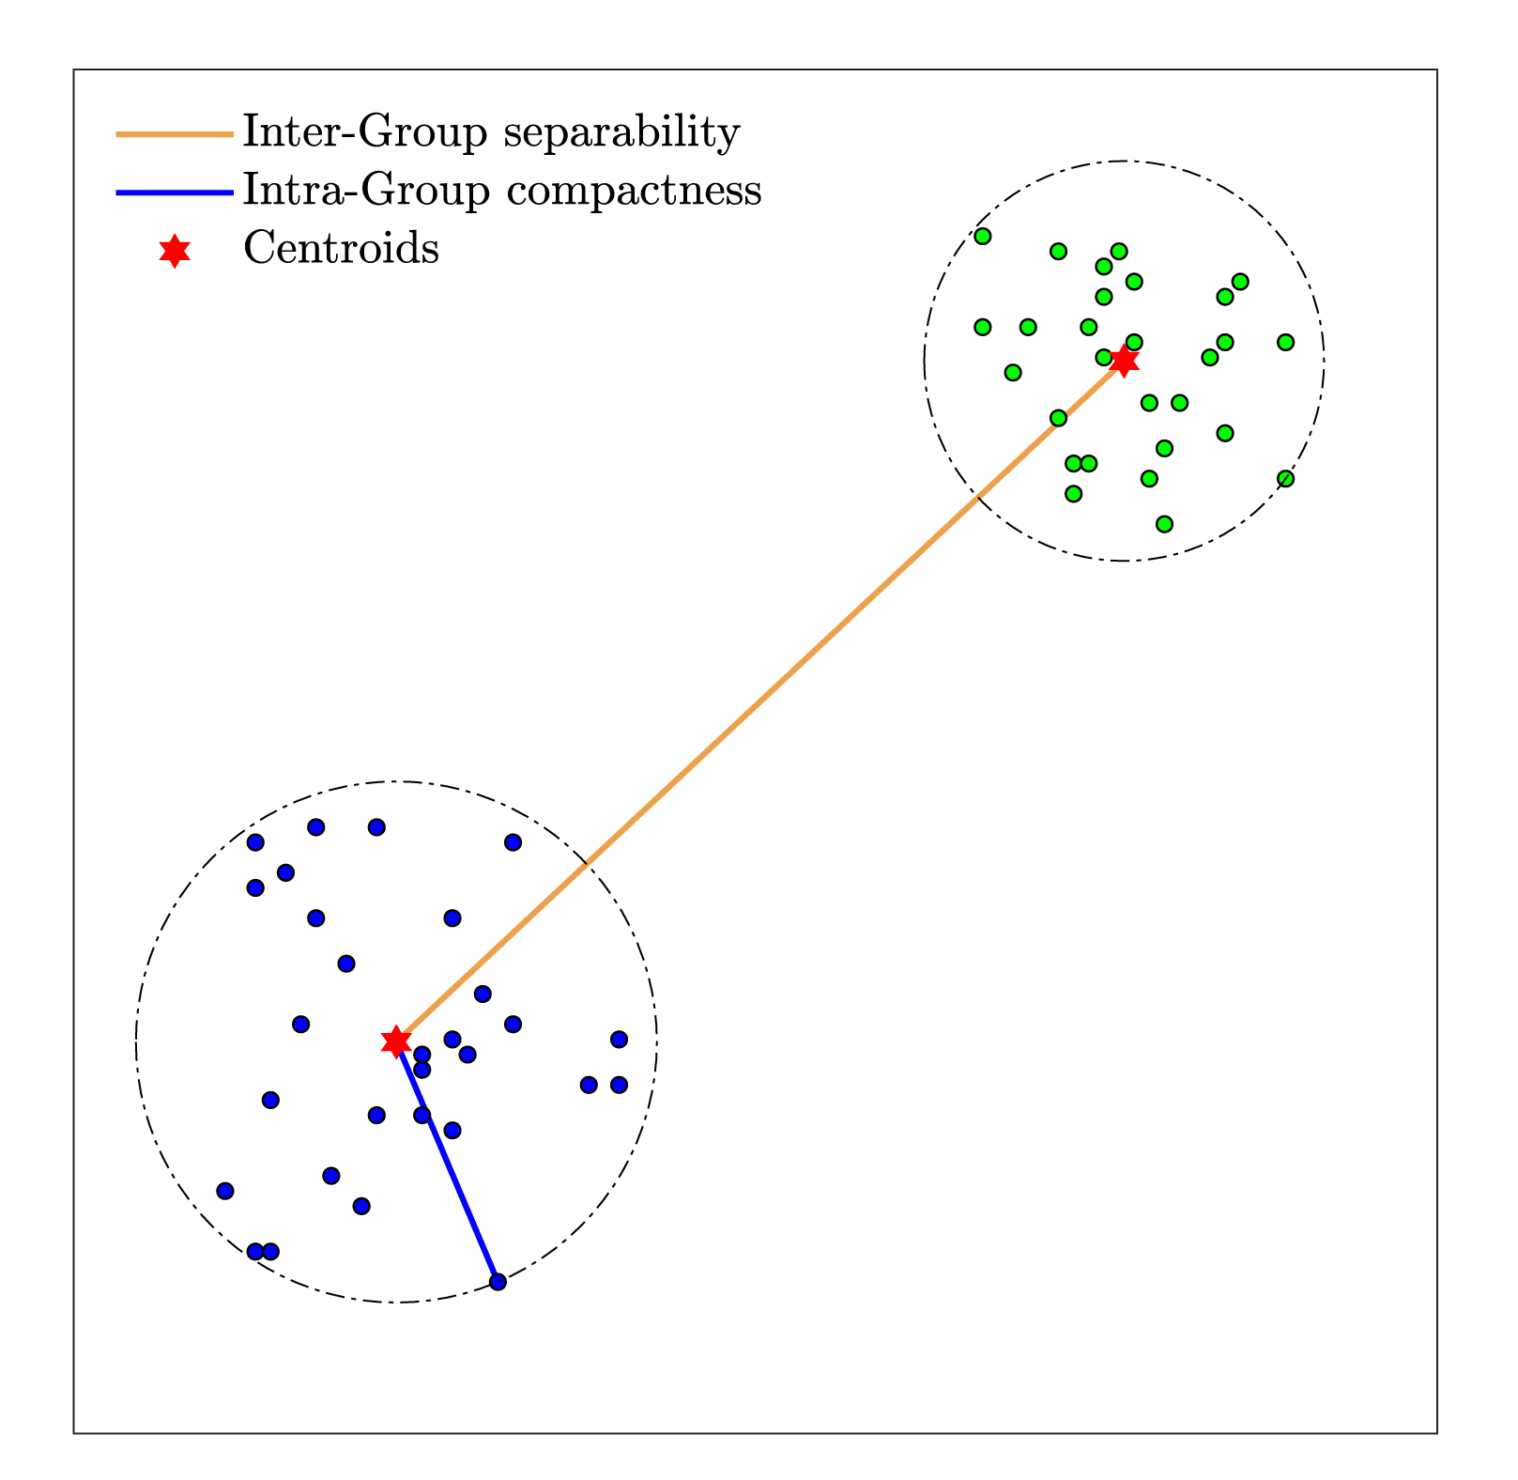
Supplementary Figure S4. Visualization of the procedure used to compute the intra-group compactness and inter-group separability.

As result we obtained a sparse matrix, which values different from zero indicate clustering metric. The rows of the matrix point to shuffling iteration and the columns represent the number of proteins used for 2D PCA dimensionality reduction.

Evaluating the clustering quality: original grouping vs shuffled ordering

The clustering metric does not follow a normal distribution (kstest, Lilliefors test) but has a Gaussian-like shape. The best clustering was estimated for the case of the subjects grouped by experimental conditions. Additionally, by accepting normality for the clustering metric, the range of values with a probability of occurrence below 0.01 are represented by the 62.5 % (15/24) of cases for the original grouping.
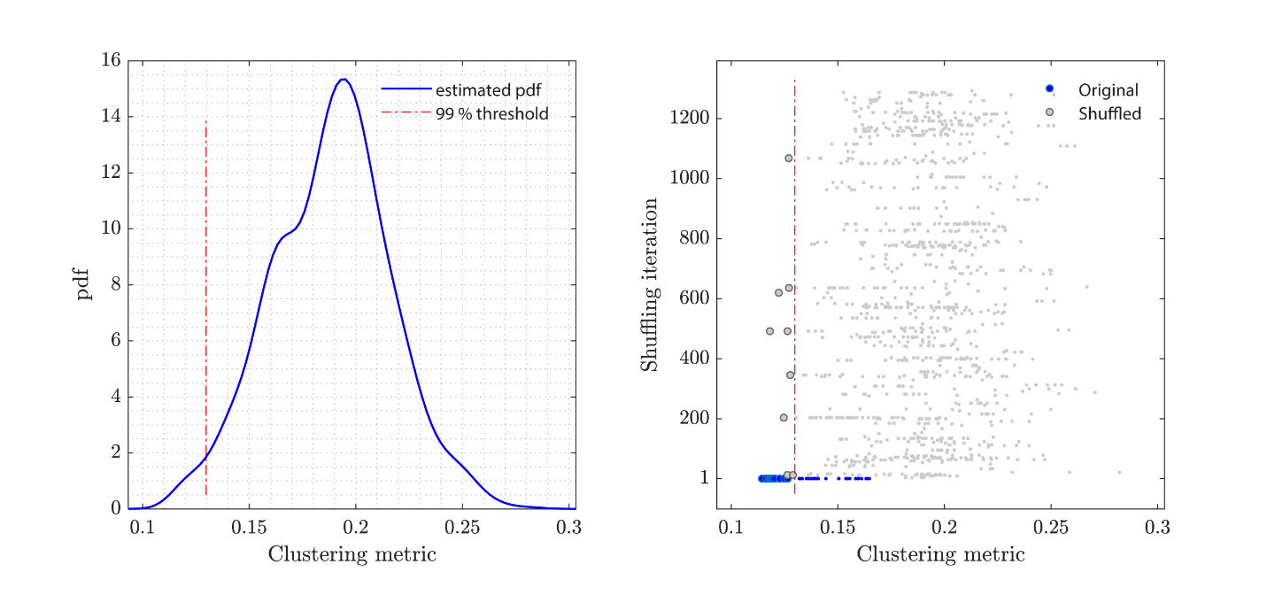
Supplementary Figure S5. Cluster metric probability density function (pdf) and its values for each shuffling iteration.

Considering the cluster metric matrix, from the 11 best results 10 are from original order (without shuffling). The single shuffling result included in this list is shown below.
Original Subject Order:
SWS- SWS- SWS- SWS+ SWS+ SWS+ REM- REM- REM- REM+ REM+ REM+
R10 R12 R17 R05 R06 R15 R09 R13 R16 R03 R11 R14
The best clustering in 2D PCA was for original order, NProteins: 51

Subject with random order that shows best clustering metric for all shuffling:
SWS- SWS+ REM- SWS- SWS+ REM+ SWS- REM- REM+ SWS+ REM- REM+
R12 R05 R13 R10 R06 R14 R17 R16 R03 R15 R09 R11
The best clustering in 2D PCA was for shuffled order, NProteins: 47

Plot Heat Map for selected proteins

The figure below represents the hierarchical clustering in both 2D PCA space and N-dimensional space (Supp. Figure S6).
For the panel of PCA clustering, k proteins representing dimension (k = 51 for S1 and k = 37 for Hp) were projected on 2D PCA space. In that sense, k proteins represent features and subjects (n = 12) represent the observations. The lines in the PCA clustering illustrate boundaries for the clusters.
The protein rank values for the selected k proteins are illustrated as a heat map. For each column (protein), the color in the heat map represents the rank (position from 0 to 11) that the protein abundance occupies for each animal (rows). Vertical and horizontal dendrograms represent hierarchical clustering of animals and proteins, respectively, and are associated with the heat map.

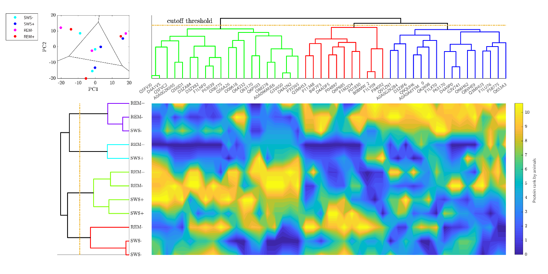
Supplementary. Figure S6. Heat Map for protein abundance data for the top proteins selected for the animals grouped in the ‘best shuffling case’.

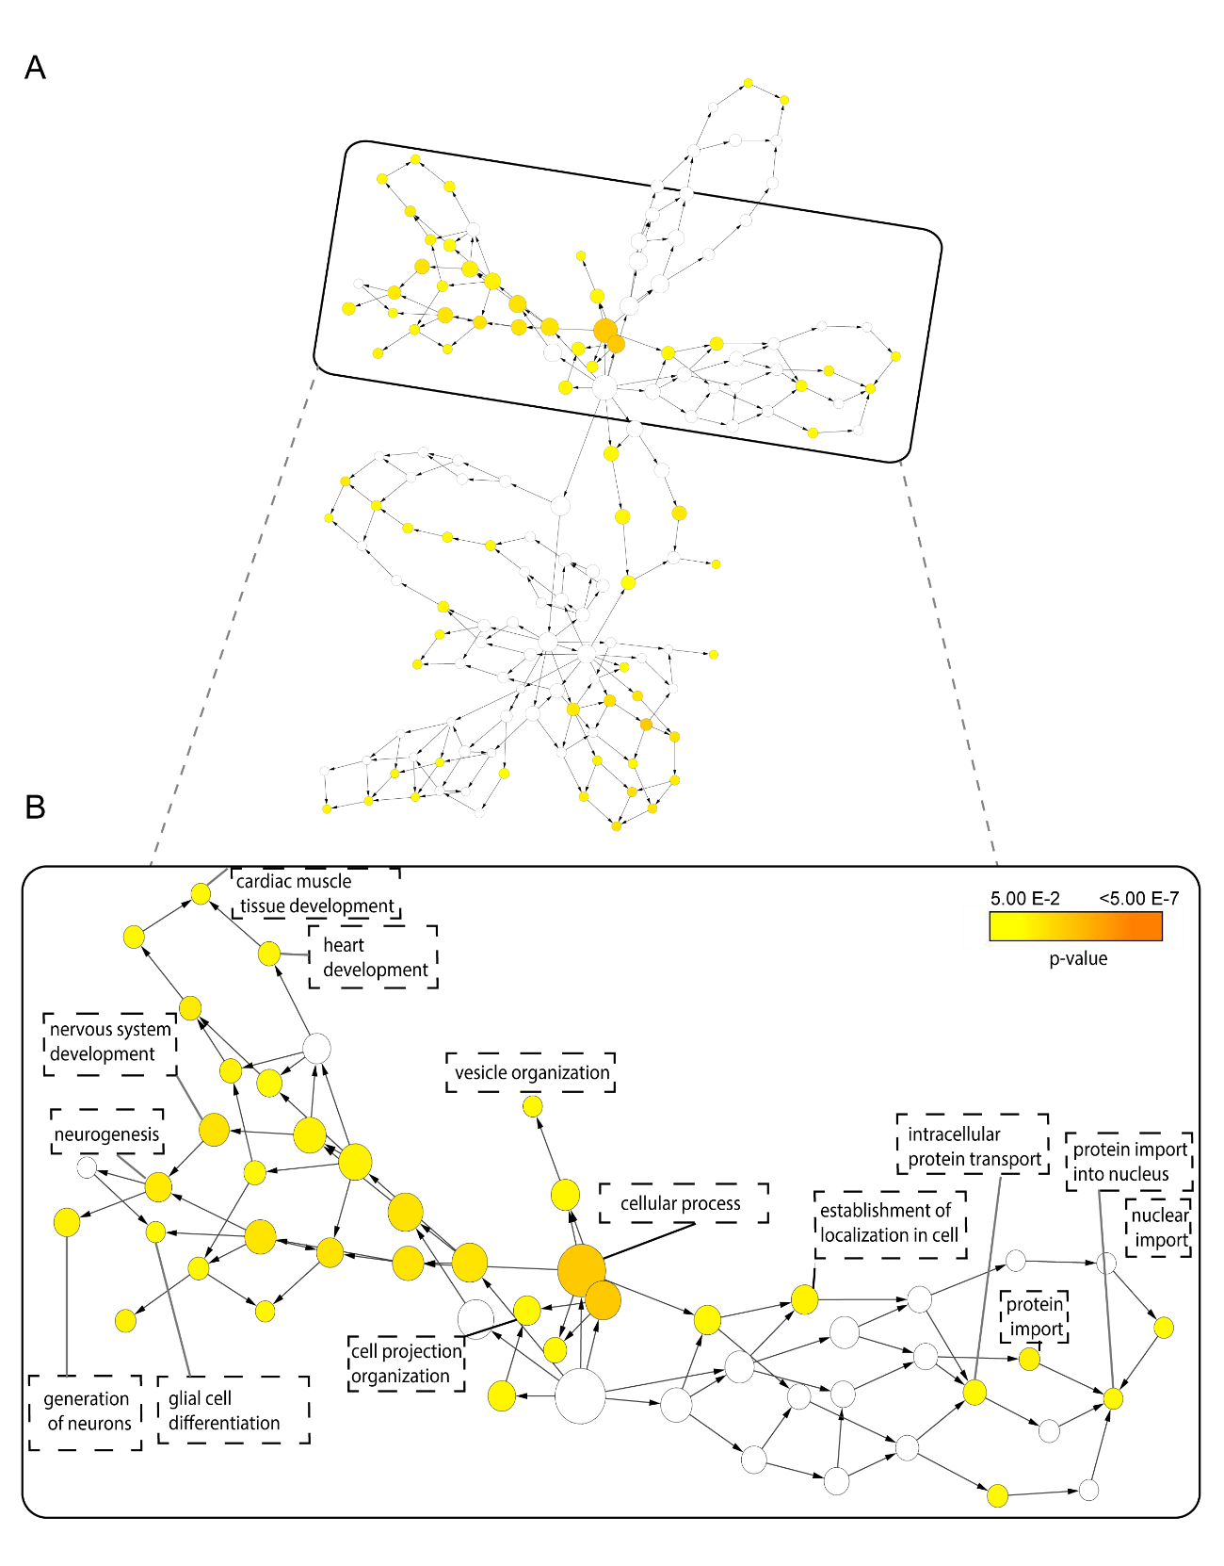Supplementary Figure S7. Overrepresentation of gene ontology categories in biological networks. A) Enrichment network using genes from modulated phosphoproteins in both hippocampus and cortex based on biological processes. Significantly overrepresented biological processes based on GO terms were visualized in Cytoscape. B) Subnetwork of brain biological processes. The size of a node is proportional to the number of targets in the GO category. The color represents enrichment significance - the deeper the color on a color scale, the higher the enrichment significance, while white nodes did not have significant representation. The size of the nodes is proportional to the number of genes in the test set which are annotated to that node. To identify the network of genes related to the biological process we performed a Hypergeometric Test to identify over-represented sets of genes. p-values were adjusted using a Benjamini and Hochberg False Discovery Rate (FDR) correction.

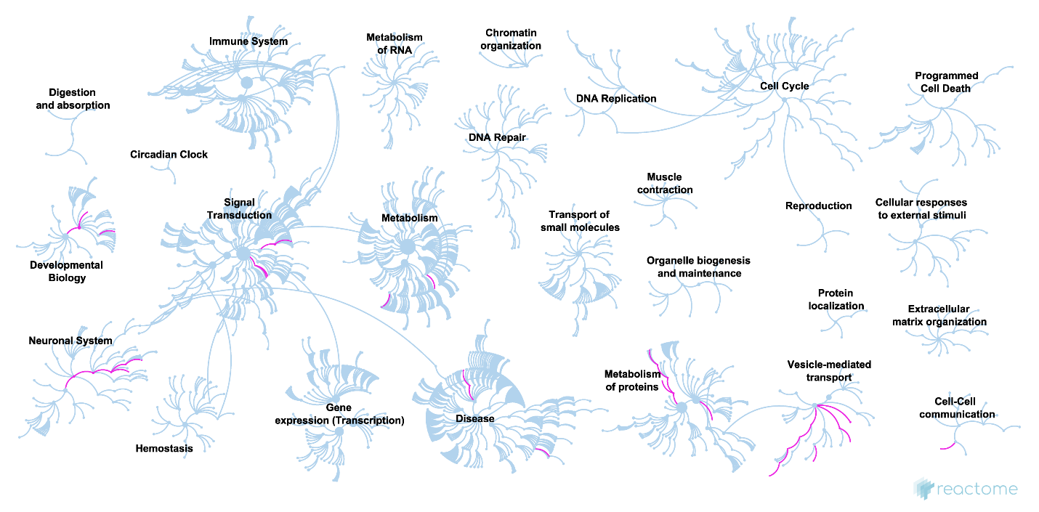
Supplementary Figure S8. Network representations of the enriched biological pathway. Phosphoprotein list of 90 significantly modulated from the hippocampus and primary somatosensory cortex were considered in this analysis using Reactome Knowledgebase. The biological processes enriched using our data are indicated in pink.

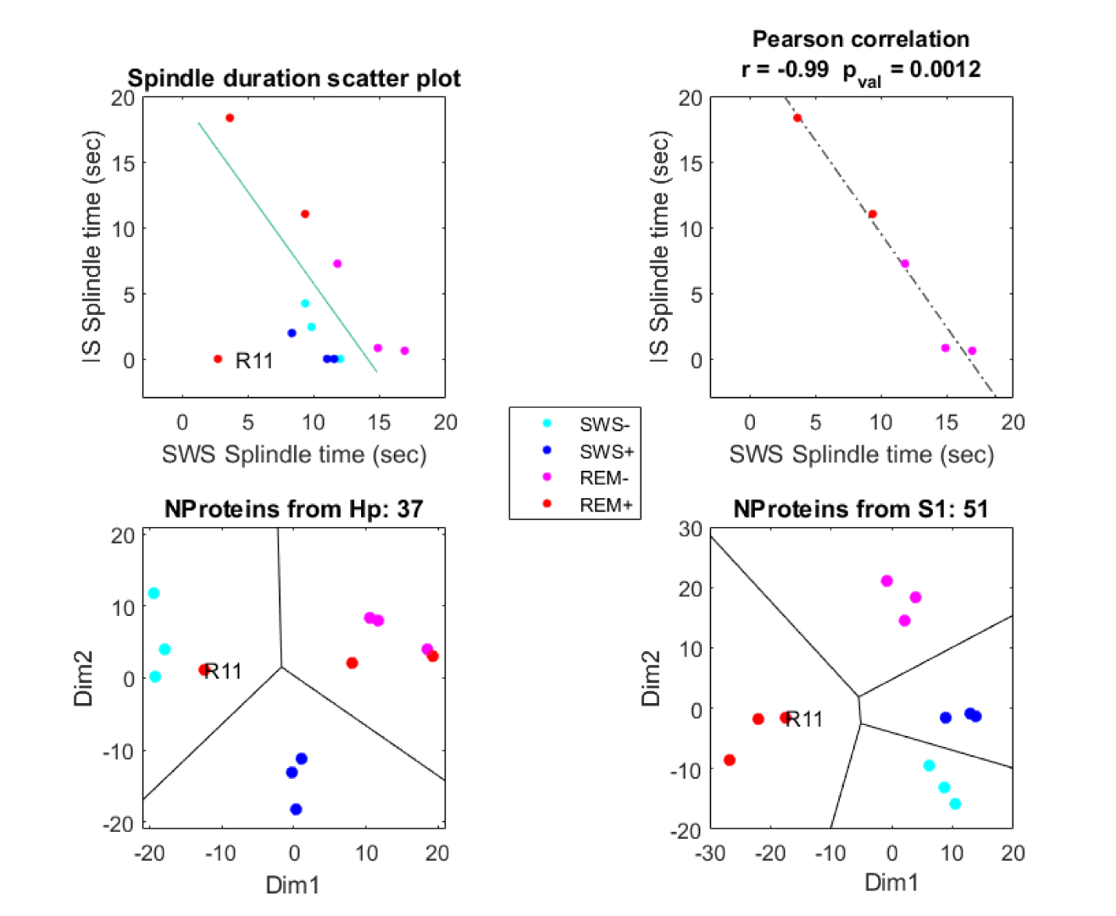
Supplementary Figure S9. Relationship between SWS and IS spindle duration across groups. Scatter plots of IS versus SWS spindle duration and Pearson’s correlation between IS and SWS spindle duration for the four different experimental conditions (SWS-, SWS+, REM-, REM+).
Group | Objects | Animal ID | Total SWS time | Total REM time | Total sleep time
SWS | Yes | Rat 5 | 8min | - | 8min
SWS | Yes | Rat 6 | 9min06s | - | 9min06s
SWS | Yes | Rat15 | 11min04s | - | 11min04s
SWS | No | Rat 10 | 10min11s | - | 10min11s
SWS | No | Rat 12 | 11min06s | - | 11min06s
SWS | No | Rat 17 | 10min47s | - | 10min47s
REM | Yes | Rat 3 | 8min50s | 4min10s | 13min
REM | Yes | Rat 11 | 22min02s | 3min5s | 25min7s
REM | Yes | Rat14 | 35min28s | 4min31s | 39min59s
REM | No | Rat 9 | 21min43s | 3min | 24min
REM | No | Rat 13 | 22min13s | 3min21s | 25min34s
REM | No | Rat 16 | 20min54s | 4min55s | 25min49s

Supplementary Table S1. Characteristics of individual subjects. The animals were grouped into two subgroups according to sleep phase identification, further separated by presence or absence of objects related to the behavioral task.

Region | Group | Anova | FChange | Accession | Gene | Up/  Down | Protein function
HP | REM-/SWS- | 0,036344062 | 1,09063402 | F1MAF8 | Atg2b | Up | Autophagosome biogenesis
HP | REM+/REM- | 0,045460583 | 1,243664521 | Q6AYK1 | Rnps1 | Up | mRNA nuclear export and surveillance. Its knockdown exacerbated ischemia induced neuronal apoptosis
HP | REM+/SWS+ | 0,018538222 | 1,017218569 | A0A096MIZ1 | Palm2 | Up | Regulation of cell shape, filopodia outgrowth and the branching of dendrites and axons in neurons
HP | REM+/SWS+ | 0,030942642 | 1,018665794 | Q05096 | Myo1b | Up | Neuronal development and function
HP | REM+/SWS+ | 0,043397002 | 1,28548371 | A0A0G2K7D4 | Dnah12 | Up | Produces force towards microtubules
HP | SWS+/SWS- | 0,00527662 | 1,269137616 | A0A0G2K7M1 | Gapdh | Up | Involved in synthesis of pyruvate
HP | SWS+/SWS- | 0,007570593 | 1,188112513 | Q6AY56 | Tuba8 | Up | Constituent of microtubules
HP | SWS+/SWS- | 0,01120809 | 1,169316019 | D3ZY40 | Pcf11 | Up | Component of pre-mRNA cleavage complex
HP | SWS+/SWS- | 0,013053918 | 1,326191059 | P70541 | Eif2b3 | Up | Catalyzes eukaryotic initiation factor
HP | SWS+/SWS- | 0,018593747 | 1,170819189 | A0A0G2K5Z0 | Uncharacterized protein | Up | NA
HP | SWS+/SWS- | 0,042807648 | 1,129963731 | P49793 | Nup98 | Up | Plays a role in nuclear pore complex (NPC), influencing the transport across NPC
HP | SWS+/SWS- | 0,047879796 | 1,461196502 | A0A096MKF8 | Med12 | Up | Participates as part of preinitiation transcription complex, activating CDK8 kinase
HP | REM-/SWS- | 0,020765572 | -1,158704124 | A0A0G2K0S6 | Sema3f | Down | A secreted and transmembrane protein. In the brain, acts as an axon guidance factor
HP | REM+/REM- | 0,003251594 | -2,137981693 | P34926 | Map1a | Down | Constituent of microtubules, and it is critical for the organization of neuronal microtubules
HP | REM+/REM- | 0,005939172 | -1,455365523 | A0A0G2JUB3 | Optn | Down | Plays role in inflammatory response, autophagy, vesicular transport and its disfunction implicates in neurodegenerative disorders
HP | REM+/SWS+ | 0,004311176 | -1,557479501 | D3ZKP9 | Cacna2d1 | Down | Voltage-dependent calcium channel implicated in calcium channelopathies, and intellectual disability
HP | REM+/SWS+ | 0,004981229 | -2,738646586 | P34926 | Map1a | Down | Constituent of microtubules, and it is critical for the organization of neuronal microtubules
HP | REM+/SWS+ | 0,028738617 | -1,27296667 | P49793 | Nup98 | Down | Plays a role in nuclear pore complex (NPC), influencing the transport across NPC
HP | REM+/SWS+ | 0,029354363 | -1,649388177 | A0A0G2K0S6 | Sema3f | Down | A secreted and transmembrane protein. In the brain, acts as an axon guidance factor
HP | SWS+/SWS- | 0,006545512 | -1,082494369 | A0A0G2K7D4 | Dnah12 | Down | Produces force towards microtubules
HP | SWS+/SWS- | 0,026493866 | -1,079338011 | Q5BJT7 | Ccdc93 | Down | Regulation of endosomal recycling of surface protein
S1 | REM-/SWS- | 0,007276054 | 2,074343194 | D3ZRJ7 | Lrrk1 | Up | Serine/threonine protein kinase whose mutations is linked to Parkinson’s disease
S1 | REM-/SWS- | 0,007929819 | 1,120524823 | F1LU76 | Nhs | Up | Actin-remodeling regulator linked to regressive brain development in the Nance-Horan Syndrome
S1 | REM-/SWS- | 0,009701368 | 1,881778487 | D3ZYP9 | Nlrc3 | Up | Anti-inflammatory cytosolic protein which delays the progression of Alsheimer’s disease
S1 | REM-/SWS- | 0,012805175 | 1,574653752 | Q56A26 | Opalin | Up | Membrane protein that plays a role in increasing myelin genes expression during oligodendrocyte differentiation
S1 | REM-/SWS- | 0,0175153 | 1,822553372 | D4A164 | Nebl | Up | Binds to actin and when overexpressed has a role in Parkinson’s disease neurodegeneration
S1 | REM-/SWS- | 0,017673369 | 1,515419272 | Q3MHU3 | Tdrd9 | Up | ATP-dependent RNA helicase
S1 | REM-/SWS- | 0,019440371 | 1,912693641 | Q5RJQ4 | Sirt2 | Up | Histone deacetylase that plays a pivotal role in neuroprotection and cellular senescence
S1 | REM-/SWS- | 0,019608468 | 1,00828886 | Q64232 | Tecr | Up | Involved in sphingolipid synthesis
S1 | REM-/SWS- | 0,020423431 | 2,020061192 | F1LW90 | Fam184a | Up | NA
S1 | REM-/SWS- | 0,023783945 | 1,251662959 | P58751 | Reln | Up | Extracellular matrix serine protease that plays a role in layering of neurons in the cerebral cortex and cerebellum. Regulates microtubule function in neurons and neuronal migration
S1 | REM-/SWS- | 0,027706924 | 1,315903668 | F1LXT0 | Exph5 | Up | Involved in exosome secretion and intracellular vesicle trafficking
S1 | REM-/SWS- | 0,031253439 | 1,58810364 | P48679 | Lmna | Up | Components of nuclear lamina acting at chromatin level. Required for normal development of peripheral nervous system
S1 | REM-/SWS- | 0,031346026 | 1,038362524 | Q6S3A3 | Plec | Up | Key cytoskeleton interlinking molecule abundantly expressed in the central nervous system
S1 | REM-/SWS- | 0,035383321 | 2,308868143 | B5DF41 | Snph | Up | Controls mitochondrial transport for axonal morphogenesis and function
S1 | REM-/SWS- | 0,037514679 | 3,553794376 | A0A0G2K8D7 | Tbx3 | Up | It is expressed in hypothalamic neurons sensing and governing energy status
S1 | REM-/SWS- | 0,040164964 | 2,095906638 | P49816 | Tsc2 | Up | In complex with TSC1, negatively regulates mTORC1 signaling
S1 | REM-/SWS- | 0,047712394 | 1,629762936 | Q7TP36 | Shroom2 | Up | In the retinal pigment epithelium, may regulate the biogenesis of melanosomes
S1 | REM-/SWS- | 0,04807759 | 1,447656144 | P21818 | Stmn2 | Up | Regulator of microtubule stability and essential protein for axonal growth and maintenance
S1 | REM-/SWS- | 0,049921598 | 1,710790331 | F1LW22 | Pard3b | Up | Putative adapter protein involved in asymmetrical cell division and cell polarization processes
S1 | SWS+/SWS- | 0,002471495 | 1,880349527 | D4A1J7 | Nin | Up | Centrosomal protein connecting microtubules to the centrosome
S1 | SWS+/SWS- | 0,005947274 | 1,536783101 | F1LSX1 | RGD1307929 | Up | NA
S1 | SWS+/SWS- | 0,006306491 | 3,232282637 | D3ZVS2 | L2hgdh | Up | It participates in the neurometabolic disorder l-2-hydroxyglutaric aciduria
S1 | SWS+/SWS- | 0,012217487 | 1,090914093 | Q9WVC0 | Sept7 | Up | GTP-binding proteins that in a component of the cytoskeleton involved in dendrite morphogenesis
S1 | SWS+/SWS- | 0,01431956 | 1,888989318 | A0A0G2JX62 | Srpk2 | Up | Serine/arginine-rich protein-specific kinase that promotes neuronal apoptosis by up-regulating cyclin-D1 (CCND1) expression
S1 | SWS+/SWS- | 0,01769578 | 1,018791955 | Q62696 | Dlg1 | Up | Essential multidomain scaffolding protein that regulates myelination
S1 | SWS+/SWS- | 0,021234917 | 1,062065661 | Q68FR6 | Eef1g | Up | Translation elongation factor
S1 | SWS+/SWS- | 0,025083014 | 1,571713805 | A0A0G2K0B6 | Snap91 | Up | Synapse-associated protein that is expressed highest in the brain. It is 1-phosphatidylinositol and clathrin binding
S1 | SWS+/SWS- | 0,029378679 | 1,609881415 | Q8VIL3 | Zwint | Up | ZW10 interacting kinetochore protein that presents role in glioblastoma growth
S1 | SWS+/SWS- | 0,031747737 | 1,633138074 | A0A0G2JZB8 | Gpm6b | Up | Neuronal membrane glycoprotein M6-b playing important roles in the development of a variety of neural cell types
S1 | SWS+/SWS- | 0,035112356 | 1,522345316 | D3Z9L5 | Wdr11 | Up | WDR11 has been associated with various human diseases including neurological disorders, ciliopathies, endocrine disorders and cancer
S1 | SWS+/SWS- | 0,038936907 | 1,252211496 | P97526 | Nf1 | Up | Negative regulator of the Ras proto-oncogene, responsible for neurofibromatosis type 1
S1 | SWS+/SWS- | 0,039200031 | 1,953708651 | D3ZVN8 | cap-1 | Up | F-actin-capping proteins bind in a Ca²⁺-independent manner to the fast growing ends of actin filaments
S1 | SWS+/SWS- | 0,048370389 | 1,316391335 | D4A7S4 | Urb1 | Up | Ribosome biogenesis
S1 | REM-/SWS- | 0,001684486 | -2,207727539 | D3ZZ54 | Gnb5 | Down | Guanine nucleotide-binding protein subunit beta-5 linked to GNB5-related neurodevelopmental disorder
S1 | REM-/SWS- | 0,002648582 | -1,166233961 | D3ZDU5 | Pfn2 | Down | Function in actin polymerization. It plays a role in neuronal precursor expansion and differentiation, as well as in the maintenance of pyramidal neuron dendritic arborization.
S1 | REM-/SWS- | 0,006754214 | -1,003721039 | Q66H62 | Cyld | Down | Deubiquitinase
S1 | REM-/SWS- | 0,007840268 | -1,048848521 | P15146 | Map2 | Down | Performs the nucleation and stabilization of microtubules, the regulation of organelle transport within axons and dendrites, as well as the anchorage of regulatory proteins such as protein kinases which may be important for signal transduction
S1 | REM-/SWS- | 0,008636243 | -1,172943175 | Q6S396 | Plec | Down | Key cytoskeleton interlinking molecule abundantly expressed in the central nervous system
S1 | REM-/SWS- | 0,009218502 | -1,427444399 | D3ZTF6 | Pik3c2a | Down | C2 domains act as calcium-dependent phospholipid binding motifs that mediate translocation of proteins to membranes
S1 | REM-/SWS- | 0,018419333 | -1,090547444 | P39069 | Ak1 | Down | Adenylate kinase may function in promoting energy homeostasis and in translating cellular energetic signals to membrane metabolic sensors in the mouse brain
S1 | REM-/SWS- | 0,018598817 | -1,390478857 | Q9Z1K2 | Spa17 | Down | Sperm protein 17 is a cancer-testis (CT) tumour-associated antigens expressed in nervous system (NS) malignancies
S1 | REM-/SWS- | 0,021880828 | -1,329647441 | Q8VHE9 | Retsat | Down | Retinol saturase is an oxidoreductase
S1 | REM-/SWS- | 0,023666645 | -2,22929283 | P20760 | Igg-2a | Down | It plays a role in protection against protein antigens
S1 | REM-/SWS- | 0,028829434 | -2,411965436 | Q3KR59 | Usp10 | Down | Ubiquitin carboxyl-terminal hydrolase 10 plays a role in Tau aggregation during Alzheimer’s disease development
S1 | REM-/SWS- | 0,031740909 | -1,017413419 | A0A0G2JX74 | Mtor | Down | Serine/threonine-protein kinase mTOR that regulates the neuronal development, synaptic plasticity, memory storage, and cognition
S1 | REM-/SWS- | 0,031807931 | -1,001829834 | P09330 | Prps2 | Down | Ribose-phosphate pyrophosphokinase 2 integrates physiological function in the nervous system
S1 | REM-/SWS- | 0,032271896 | -1,092293168 | D4ADC2 | Helz2 | Down | Helicase that potentially is controlling neurodegeneration and progression of sporadic Alzheimer's disease
S1 | REM-/SWS- | 0,036436771 | -1,004079214 | P0C5Y8 | Als2 | Down | Guanine-nucleotide exchange factor for the small GTPase Rab5 with regulatory roles in endosomal trafficking, synaptic development, and neuronal survival
S1 | REM-/SWS- | 0,037917828 | -1,038142683 | F1M0Z1 | Trio | Down | Regulator of actin dynamics at the synapse
S1 | REM-/SWS- | 0,038071631 | -1,088739423 | E9PTU4 | Myh11 | Down | Actin filament binding
S1 | REM-/SWS- | 0,038421169 | -1,106326303 | P97846 | Cntnap1 | Down | Required for radial and longitudinal organization of myelinated axons
S1 | REM-/SWS- | 0,03895926 | -1,018528204 | D4ADF5 | Pdcd5 | Down | Programmed cell death 5 (PDCD5) has a major role in cellular apoptosis. It is a promising target for the diagnosis and treatment of glioma.
S1 | REM-/SWS- | 0,042740635 | -1,053555271 | A0A0G2KB86 | Uncharacterized protein | Down | RNA-directed DNA polymerase
S1 | REM-/SWS- | 0,043970238 | -1,128241719 | D3ZTG3 | Fam171b | Down | Protein containing polyglutamine possibly related to neurodegenerative disease
S1 | REM+/REM- | 0,013277483 | -1,265540188 | Q5FVF3 | Gga1 | Down | Golgi associated protein affecting the generation of amyloid beta-peptide that might be involved in the pathogenesis of Alzheimer’s disease
S1 | REM+/REM- | 0,013302333 | -1,405028422 | D3ZYP9 | Nlrc3 | Down | Nucleotide-oligomerization domain (NOD)-like receptor subfamily C3 that inhibits inflammatory responses and may play an important role in the development and progression of Alzheimer’s disease
S1 | REM+/REM- | 0,044517016 | -1,339467215 | A0A0G2JT63 | Cyfip2 | Down | Cytoplasmic FMR1-interacting protein family regulator of neuronal actin dynamics and implicated in neurological disorders
S1 | REM+/SWS+ | 0,003239931 | -1,04927124 | F1LMK8 | Jmjd1c | Down | Involved in histone demethylation that is expressed in the brain and associated with intellectual disability
S1 | REM+/SWS+ | 0,03855476 | -1,571113053 | P48675 | Des | Down | May act as a sarcomeric microtubule-anchoring protein, important in regulating cerebral blood flow and blood-brain barrier integrity
S1 | REM+/SWS+ | 0,047063163 | -2,354958938 | P19945 | Rplp0 | Down | 60S acidic ribosomal protein P0
S1 | SWS+/SWS- | 0,001333462 | -2,159517679 | Q6MG75 | Nelfe | Down | Chromatin binding protein acting as a Negative elongation factor E
S1 | SWS+/SWS- | 0,006806403 | -1,26625136 | O70244 | Cubn | Down | Cubilin is an endocytic receptor strongly expressed in the sensory organs and central nervous system
S1 | SWS+/SWS- | 0,015543359 | -1,416484941 | F1LRZ7 | Nefh | Down | Neurofilament heavy polypeptide pathological hallmarks of amyotrophic lateral sclerosis
S1 | SWS+/SWS- | 0,016428106 | -2,091469017 | Q9Z1K2 | Spa17 | Down | Sperm protein 17 is a cancer-testis (CT) tumour-associated antigens expressed in nervous system (NS) malignancies
S1 | SWS+/SWS- | 0,02485172 | -1,294920201 | Q56A26 | Opalin | Down | Membrane protein that plays a role in increasing myelin genes expression during oligodendrocyte differentiation
S1 | SWS+/SWS- | 0,025685637 | -1,384147707 | O88954 | Mpp3 | Down | Membrane palmitoylated protein required for maintenance of the apical protein complex and adherens junctions and for stratification and proper migration of neurons during the development of the cortex
S1 | SWS+/SWS- | 0,034074661 | -1,000973779 | D3ZPX4 | Plxna3 | Down | Necessary for signaling by SEMA3 and subsequent remodeling of the cytoskeleton. Plays a role in axon guidance in the developing nervous system
S1 | SWS+/SWS- | 0,03546956 | -1,566603976 | Q6P503 | Atp6v1d | Down | V-type proton ATPase subunit D with proton-transporting ATPase activity
S1 | SWS+/SWS- | 0,037215979 | -1,260584923 | D3ZN21 | Ddx3y | Down | RNA helicase

Supplementary Table S2. Modulated phosphoproteins. List of proteins containing STY phosphorylation tag which expression was up or down modulated for each experimental condition and brain region.

Brain region | Accession | Gene name | Protein description | Hierarchical cluster | Spindle correlation
HP | A0A096MIZ1 | Palm2 | Paralemmin 2 | Green protein cluster in hierarchical clustering
HP | F1LQU9 | Sgsm3 | Small G protein-signalling modulator 3 | Green protein cluster in hierarchical clustering
HP | A0A0G2K7D4 | Dnah12 | Dynein heavy chain 12, axonemal | Blue protein cluster in hierarchical clustering | Positive (IS)
HP | P13086 | Suclg1 | Succinate--CoA ligase [ADP/GDP-forming] subunit alpha, mitochondrial | Blue protein cluster in hierarchical clustering
HP | F1M0R1 | Rnf213 | Ring finger protein 213 - ubiquitin ligase | Blue protein cluster in hierarchical clustering | Positive (SWS+IS)
HP | A0A0G2K0W6 | Gon4l | GON-4-like protein | Blue protein cluster in hierarchical clustering | Positive (SWS+IS)
HP | B4F7C2 | Tubb4a | Tubulin beta chain | Blue protein cluster in hierarchical clustering | Positive (SWS+IS)
HP | D4A3A1 | Loxhd1 | Lipoxygenase homology domains 1 | Red protein cluster in hierarchical clustering
HP | P21708 | Mapk3 | Mitogen-activated protein kinase 3 | Red protein cluster in hierarchical clustering
HP | P98158 | Lrp2 | Low-density lipoprotein receptor-related protein 2 | Red protein cluster in hierarchical clustering
HP | P62804 | H4c2 | Histone H4 | Red protein cluster in hierarchical clustering
HP | P62268 | Rps23 | 40S ribosomal protein S23 | Red protein cluster in hierarchical clustering
HP | P51635 | Akr1a1 | Aldo-keto reductase family 1 member A1 | Red protein cluster in hierarchical clustering
HP | F1LUE2 | Camk2b | Calcium/calmodulin-dependent protein kinase II, beta, isoform CRA_c | Red protein cluster in hierarchical clustering
HP | D4A628 | Polq | DNA polymerase theta | Red protein cluster in hierarchical clustering
HP | Q05982 | Nme1 | Nucleoside diphosphate kinase A | Red protein cluster in hierarchical clustering
HP | F1LS79 | Cspg4 | Chondroitin sulfate proteoglycan 4 | Red protein cluster in hierarchical clustering | Positive (IS)
HP | Q63615 | Vps33a | Vacuolar protein sorting-associated protein 33A | Red protein cluster in hierarchical clustering
HP | A0A0G2JT93 | Ctnnb1 | Catenin, beta 1 | Red protein cluster in hierarchical clustering
HP | Q6AY56 | Tuba8 | Tubulin alpha-8 chain | Red protein cluster in hierarchical clustering
HP | Q99041 | Tgm4 | Protein-glutamine gamma-glutamyltransferase 4 | Red protein cluster in hierarchical clustering | Positive (SWS+IS)
HP | D3ZCG3 | Mon2 | MON2 homolog, a regulator of endosome-to-Golgi-trafficking | Red protein cluster in hierarchical clustering | Positive (SWS+IS)
HP | A0A0G2K5S3 | Cd101 | CD101 molecule | Red protein cluster in hierarchical clustering | Positive (SWS+IS)
HP | Q5PQJ9 | Ccdc175 | Coiled-coil domain-containing protein 175 | Red protein cluster in hierarchical clustering
HP | Q499N5 | Acsf2 | Medium-chain acyl-CoA ligase ACSF2, mitochondrial | Red protein cluster in hierarchical clustering
HP | D3ZY40 | Pcf11 | PCF11 cleavage and polyadenylation factor subunit | Red protein cluster in hierarchical clustering
HP | G3V7S0 | Folh1 | Folate hydrolase | Red protein cluster in hierarchical clustering
HP | A0A0G2K9J8 | Armc9 | LisH domain-containing protein ARMC9 | Red protein cluster in hierarchical clustering | Positive (SWS+IS)
HP | P70567 | Tmod1 | Tropomodulin-1 | Red protein cluster in hierarchical clustering | Positive (SWS+IS)
HP | A0A0G2JYT1 | Erc1 | ELKS/Rab6-interacting/CAST family member 1 | Red protein cluster in hierarchical clustering | Positive (SWS+IS)
HP | D3ZXU0 | Zkscan2 | Zinc finger with KRAB and SCAN domains 2 | Red protein cluster in hierarchical clustering | Positive (SWS+IS)
HP | E9PSJ0 | Cyp2j10 | Cytochrome P450, family 2, subfamily j, polypeptide 10 | Red protein cluster in hierarchical clustering
HP | F1LPG3 | Pacs1 | Phosphofurin acidic cluster sorting protein 1 | Red protein cluster in hierarchical clustering
HP | D4ADG4 | Mlh3 | MutL homolog 3 | Red protein cluster in hierarchical clustering
HP | Q9JKB7 | Gda | Guanine deaminase | Red protein cluster in hierarchical clustering
HP | A0A0G2K3Z9 | N/A | Thioredoxin domain-containing protein | Red protein cluster in hierarchical clustering
HP | O08875 | Dclk1 | Serine/threonine-protein kinase DCLK1 | Red protein cluster in hierarchical clustering
S1 | F1LN42 | Tns1 | Tensin 1 | Red protein cluster in hierarchical clustering | Positive (SWS+IS)
S1 | D4ABP4 | Rab3gap2 | Rab3 GTPase-activating protein | Red protein cluster in hierarchical clustering | Positive (SWS+IS)
S1 | F1M446 | Ecpas | Ecm29 proteasome adaptor and scaffold | Red protein cluster in hierarchical clustering | Positive (SWS+IS)
S1 | P58751 | Reln | Reelin | Red protein cluster in hierarchical clustering | Positive (SWS+IS)
S1 | A0A0G2JVW6 | Samd9 | Sterile alpha motif domain-containing 9 | Red protein cluster in hierarchical clustering
S1 | D4A6L0 | Gpr158 | Probable G-protein coupled receptor 158 | Red protein cluster in hierarchical clustering
S1 | Q4V8B0 | Oxr1 | Oxidation resistance protein 1 | Red protein cluster in hierarchical clustering
S1 | G3V6P7 | Myh9 | Myosin heavy chain 9-like 1 | Red protein cluster in hierarchical clustering
S1 | P13264 | Gls | Glutaminase kidney isoform, mitochondrial | Red protein cluster in hierarchical clustering
S1 | F1LU76 | Nhs | NHS actin-remodeling regulator | Red protein cluster in hierarchical clustering | Positive (SWS+IS)
S1 | A0A0G2K657 | Opcml | Opioid-binding protein | Red protein cluster in hierarchical clustering
S1 | Q5XI06 | Kat8 | Histone acetyltransferase KAT8 | Red protein cluster in hierarchical clustering
S1 | P26284 | Pdha1 | Pyruvate dehydrogenase E1 | Red protein cluster in hierarchical clustering
S1 | Q5U2Z5 | Cmtr1 | Cap-specific mRNA (nucleoside-2'-O-)-methyltransferase 1 | Red protein cluster in hierarchical clustering
S1 | D4ABT8 | Hnrnpul2 | Heterogeneous nuclear ribonucleoprotein U-like 2 | Red protein cluster in hierarchical clustering
S1 | P35565 | Canx | Calnexin | Red protein cluster in hierarchical clustering
S1 | Q9R1Z0 | Vdac3 | Voltage-dependent anion-selective channel protein 3 | Green protein cluster in hierarchical clustering | Negative (SWS+IS)
S1 | P42123 | Ldhb | L-lactate dehydrogenase B chain | Green protein cluster in hierarchical clustering | Negative (SWS+IS)
S1 | B4F7C2 | Tubb4a | Tubulin beta chain | Green protein cluster in hierarchical clustering
S1 | Q5U2U2 | Crkl | Crk-like protein | Green protein cluster in hierarchical clustering
S1 | P04182 | Oat | Ornithine aminotransferase, mitochondrial | Green protein cluster in hierarchical clustering
S1 | Q9QUR2 | Dctn4 | Dynactin subunit 4 | Green protein cluster in hierarchical clustering
S1 | P20651 | Ppp3cb | Serine/threonine-protein phosphatase 2B catalytic subunit beta isoform | Green protein cluster in hierarchical clustering | Negative (SWS+IS)
S1 | P61107 | Rab14 | Ras-related protein Rab-14 | Green protein cluster in hierarchical clustering
S1 | A0A0G2K677 | Sptbn4 | Spectrin beta chain | Green protein cluster in hierarchical clustering
S1 | P09606 | Glul | Glutamine synthetase | Green protein cluster in hierarchical clustering | Negative (SWS+IS)
S1 | P04256 | Hnrnpa1 | Heterogeneous nuclear ribonucleoprotein A1 | Green protein cluster in hierarchical clustering | Negative (IS)
S1 | D3ZRN3 | Actbl2 | Actin, beta-like 2 | Green protein cluster in hierarchical clustering | Negative (IS)
S1 | B0K031 | Rpl7 | 60S ribosomal protein L7 | Green protein cluster in hierarchical clustering | Negative (SWS+IS) and Negative (IS)
S1 | P23965 | Eci1 | Enoyl-CoA delta isomerase 1, mitochondrial | Green protein cluster in hierarchical clustering | Negative (SWS+IS) and Negative (IS)
S1 | P00507 | Got2 | Aspartate aminotransferase, mitochondrial | Green protein cluster in hierarchical clustering | Negative (SWS+IS)
S1 | G3V826 | Tkt | Transketolase | Green protein cluster in hierarchical clustering | Negative (SWS+IS) and Negative (IS)
S1 | Q9Z2L0 | Vdac1 | Voltage-dependent anion-selective channel protein 1 | Green protein cluster in hierarchical clustering | Negative (SWS+IS) and Negative (IS)
S1 | Q68FQ0 | Cct5 | chaperonin-containing T-complex protein 1 subunit epsilon | Green protein cluster in hierarchical clustering | Negative (SWS+IS) and Negative (IS)
S1 | D4ACD3 | D4ACD3 | Ubiquitin specific protease 25 | Green protein cluster in hierarchical clustering | Negative (IS)
S1 | A0A0G2K8V2 | Vcl | Vinculin | Blue protein cluster in hierarchical clustering | Positive (SWS)
S1 | B6RK61 | Myh7b | Myosin heavy chain 7B | Blue protein cluster in hierarchical clustering
S1 | A0A0G2K1P8 | Triobp | TRIO and F-actin-binding protein | Blue protein cluster in hierarchical clustering | Positive (SWS)
S1 | Q4QQT4 | Ppp2r1b | Serine/threonine-protein phosphatase 2A | Blue protein cluster in hierarchical clustering
S1 | P48679 | Lmna | Prelamin-A/C | Blue protein cluster in hierarchical clustering
S1 | P67779 | Phb | Prohibitin | Blue protein cluster in hierarchical clustering
S1 | P01830 | Thy1 | Thy-1 membrane glycoprotein | Blue protein cluster in hierarchical clustering
S1 | Q9Z1K2 | Spa17 | Sperm surface protein Sp17 | Blue protein cluster in hierarchical clustering
S1 | A0A0G2K6P7 | Krt4 | Keratin, type II cytoskeletal 4 | Blue protein cluster in hierarchical clustering
S1 | P04905 | Gstm1 | Glutathione S-transferase Mu 1 | Blue protein cluster in hierarchical clustering | Positive (SWS)
S1 | A0A096MJB8 | Frmd7 | FERM domain-containing 7 | Blue protein cluster in hierarchical clustering | Positive (SWS)
S1 | Q29RW1 | Myh4 | Myosin-4 | Blue protein cluster in hierarchical clustering
S1 | D3ZC07 | Pkn3 | Protein kinase N3 | Blue protein cluster in hierarchical clustering
S1 | Q4V7C7 | Actr3 | Actin-related protein 3 | Blue protein cluster in hierarchical clustering
S1 | F1LN88 | Aldh2 | Aldehyde dehydrogenase, mitochondrial | Blue protein cluster in hierarchical clustering | Positive (SWS)
S1 | D4AAG8 | Smchd1 | Structural maintenance of chromosomes flexible hinge domain-1 | Blue protein cluster in hierarchical clustering | Positive (SWS)

Supplementary Table S3. Protein markers that allowed group separation through clustering analysis. The table lists the proteins whose abundance allowed the identification/separation of the groups (SWS-, SWS+, REM-, REM+) for each region (HP and S1). The accession number from Uniprot, gene name from NCBI Gene and protein description are provided. Protein hierarchical groups/clusters shown in the heatmaps (Figure 6) and information about protein correlation to spindles (Figure 7) are also provided in the table.

Region | Accession | Gene name | Protein description | Protein function | SWS Spindle correlation | IS Spindle correlation | SWS+IS Spindle correlation
HP | P38983 | Rpsa | 40S ribosomal protein SA | Required for the assembly and/or stability of the 40S ribosomal subunit | no
HP | Q80ZG5 | Slu7 | Pre-mRNA-splicing factor SLU7 | Required for pre-mRNA splicing as component of the spliceosome | no
HP | Q6AYK1 | Rnps1 | RNA-binding protein with serine-rich domain 1 | Auxiliary component of the splicing-dependent multiprotein exon junction complex | no
HP | D4ABT8 | Hnrnpul2 | Heterogeneous nuclear ribonucleoprotein U-like 2 | RNA binding | no
HP | D3ZUC6 | Topaz1 | Protein TOPAZ1 | Specifically required for progression to the post-meiotic stages of spermatocyte development | no | no | Positive
HP | G3V7C6 | Tubb4b | Tubulin beta chain | Constituent of microtubules | no
HP | D3ZUT0 | Kif26a | Kinesin family member 26A | Plays a key role in enteric neuron development | no | Positive
HP | Q91Z79 | Ppfia3 | Liprin-alpha-3 | May regulate the disassembly of focal adhesions and the formation and structure of synapses | no | Positive
HP | Q8VHV7 | Hnrnph1 | Heterogeneous nuclear ribonucleoprotein H | Mediates pre-mRNA alternative splicing regulation | no
HP | Q6AY09 | Hnrnph2 | Heterogeneous nuclear ribonucleoprotein H2 | Participates in processing events that pre-mRNAs undergo before becoming functional | no
HP | P60892 | Prps1 | Ribose-phosphate pyrophosphokinase 1 | Catalyzes the synthesis of phosphoribosylpyrophosphate that is essential for nucleotide synthesis | no
HP | P36972 | Aprt | Adenine phosphoribosyltransferase | Catalyzes a salvage reaction resulting in the formation of AMP | no
HP | D4ACD3 | Usp25 | Ubiquitin specific protease 25 | Hydrolyzes ubiquitin moieties conjugated to substrates | no
HP | A0A0G2JV04 | Gga3 | ADP-ribosylation factor-binding protein GGA3 | Plays a role in protein sorting and trafficking between the trans-Golgi network and endosomes | no
HP | F1lW77 | Rab33b | RAB33B, member RAS oncogene family | Protein transport. Acts, in coordination with RAB6A, to regulate intra-Golgi retrograde trafficking | Negative | no | no
HP | A0A0G2K5J1 | Ryr1 | Ryanodine receptor 1 | Calcium channel that mediates the release of Ca2+ from the sarcoplasmic reticulum the cytoplasm | no
HP | A0A0G2JUB3 | Optn | Optineurin | Maintenance of the Golgi complex, membrane trafficking, and exocytosis | no | Positive | no
HP | P0C5Y8 | Als2 | Alsin | May act as a GTPase regulator | no
HP | P04905 | Gstm1 | Glutathione S-transferase Mu 1 | Conjugation of reduced glutathione to a wide number of hydrophobic electrophiles | no | Positive | no
HP | A0A096MJJ4 | Cfap58 | Cilia and flagella-associated protein 58 | No data available | no
HP | D3ZKP9 | Cacna2d1 | Voltage-dependent calcium channel subunit alpha-2/delta-1 | Regulates calcium current density and activation/inactivation kinetics of the calcium channel | no
HP | F1MAF8 | Atg2b | Autophagy related 2B | Required for both autophagosome formation and regulation of lipid droplet morphology and dispersion | no | no | Positive
HP | F1LS79 | Cspg4 | Chondroitin sulfate proteoglycan 4 | Proteoglycan playing a role in cell proliferation and migration | no | Positive | no
HP | A0A0G2K5S3 | Cd101 | CD101 molecule | Plays a role as inhibitor of T-cells proliferation induced by CD3 | no | no | Positive
HP | F1M0R1 | Rnf213 | Ring finger protein 213 | E3 ubiquitin-protein ligase | no | no | Positive
HP | A0A0G2K0W6 | Gon4l | GON-4-like protein | Transcriptional repressor activity | no | no | Positive
HP | Q99041 | Tgm4 | Protein-glutamine gamma-glutamyltransferase 4 | Associated with the mammalian reproductive process | no | no | Positive
HP | A0A0G2K7D4 | Dnah12 | Dynein heavy chain 12, axonemal | Produces force towards the minus ends of microtubules | no | Positive | no
HP | P70567 | Tmod1 | Tropomodulin-1 | Blocks the elongation and depolymerization of the actin filaments at the pointed end | no | no | Positive
HP | A0A0G2JYT1 | Erc1 | ELKS/Rab6-interacting/CAST family member 1 | I-kappaB kinase/NF-kappaB signaling. May be involved in Rab-6 regulated endosomes to Golgi transport | no | no | Positive
HP | D3ZXU0 | Zkscan2 | Zinc finger with KRAB and SCAN domains 2 | Transcriptional regulation | no | no | Positive
HP | D3ZCG3 | Mon2 | MON2 homolog, regulator of endosome-to-Golgi-trafficking | May be required for traffic between late Golgi and early endosomes | no | no | Positive
HP | A0A0G2K9J8 | Armc9 | LisH domain-containing protein ARMC9 | Acts as a positive regulator of hedgehog (Hh)signaling | no | no | Positive
HP | B4F7C2 | Tubb4a | Tubulin beta chain | Major constituent of microtubules, and binds to GTP | no | no | Positive
S1 | F1M7G0 | Trpm6 | Transient receptor potential cation channel, subfamily M, member 6 | Ion channel and serine/threonine-protein kinase, crucial for magnesium homeostasis | Positive | no | no
S1 | Q64303 | Pak2 | Serine/threonine-protein kinase PAK 2 | Cytoskeleton regulation, cell motility, cell cycle progression, apoptosis or proliferation | no | no | Negative
S1 | P14480 | Fbg | Fibrinogen beta chain | Function in hemostasis as one of the primary components of blood clots | no | Positive | no
S1 | Q5FVC2 | Arhgef2 | Rho guanine nucleotide exchange factor 2 | Activates Rho-GTPases by promoting the exchange of GDP for GTP | no | Negative | Negative
S1 | D3ZM69 | Epb41l2 | Erythrocyte membrane protein band 4.1-like 2 | Required for dynein-dynactin complex | Positive | Negative | no
S1 | F1LW22 | Pard3b | Par-3 family cell polarity regulator beta | Involved in asymmetrical cell division and cell polarization processes | no | Positive | no
S1 | P17077 | Rpl9 | 60S ribosomal protein L9 | Structutral constituint of ribosome | Positive | Negative | no
S1 | Q1WIM2 | Cadm2 | Cell adhesion molecule 2 | Engages in cell aggregation, being important for synapse organization | no | Positive | no
S1 | F1LXT0 | Exph5 | Exophilin 5 | May act as Rab effector protein and play a role in vesicle trafficking | Positive | no | no
S1 | Q5FVM4 | Nono | Non-POU domain-containing octamer-binding protein | DNA- and RNA binding protein, involved in several nuclear processes | Positive | Negative | no
S1 | D3ZD71 | Efhc1 | EF-hand domain-containing 1 | Microtubule-associated protein which regulates cell division and neuronal migration | no | Positive | no
S1 | P14408 | Fh | Fumarate hydratase, mitochondrial | Catalyzes the reversible stereospecific interconversion of fumarate to L-malate | no | no | Negative
S1 | Q8VHE9 | Retsat | All-trans-retinol 13,14-reductase | Catalyzation of retinol | Positive | no | no
S1 | A0A0A6YYM0 | Acsl6 | Long-chain-fatty-acid-CoA ligase 6 | Catalyzes the conversion of acyl-CoA for synthesis and degradation of cellular lipids | no | no | Positive
S1 | B4F7F3 | Arvcf | ARVCF, delta catenin family member | Protein-protein interactions at adherens junctions via cadherin binding | Positive | no | no
S1 | D3ZB66 | Vom2r29 | Vomeronasal 2 receptor, 29 | G-protein-coupled receptors likely to mediators of pheromone responses | Positive | Negative | no
S1 | Q5I0G4 | Gars1 | Glycine--tRNA ligase | Catalyzes the ATP-dependent ligation of glycine to the 3'-end of its cognate tRNA | no | no | Positive
S1 | P19945 | Rplp0 | 60S acidic ribosomal protein P0 | Ribosomal protein component | no | Negative | no
S1 | M0R887 | Stap2 | Signal transducing adaptor family member 2 | Substrate of protein kinase PTK6, may modulate STAT3 | no | no | Positive
S1 | F1LUM5 | Tubal3 | Tubulin alpha chain | Constituent of microtubules, binding two moles of GTP | Positive | Negative | no
S1 | D3ZU57 | Riox1 | Ribosomal oxygenase 1 | Act as both a histone lysine demethylase and a ribosomal histidine hydroxylase | no | Negative | no
S1 | P15146 | Map2 | Microtubule-associated protein 2 | May stabilize the microtubules against depolymerization | Positive | Negative | no
S1 | P19234 | Ndufv2 | NADH dehydrogenase flavoprotein 2, mitochondrial | Core subunit of the mitochondrial membrane respiratory chain | Positive | no | no
S1 | F1M8A4 | Ppfia2 | PTPRF-interacting protein alpha 2 | May regulate the disassembly of focal adhesions, in the dendritic spines acts as immobile postsynapti | Positive | Negative | no
S1 | M0R660 | Gapdh | Glyceraldehyde-3-phosphate dehydrogenase | Involved in synthesis of pyruvate from D-glyceraldehyde 3-phosphate | no | no | Positive
S1 | P81155 | Vdac2 | Voltage-dependent anion-selective channel protein 2 | Forms a channel through the mitochondrial outer membrane and in brain postsynaptic membranes | no | Negative | no
S1 | P09330 | Prps2 | Ribose-phosphate pyrophosphokinase 2 | Catalyzes the synthesis of phosphoribosylpyrophosphate that is essential for nucleotide synthesis | Positive | no | no
S1 | D4ADC2 | Helz2 | Helicase with zinc finger 2 | Helicase that acts as a transcriptional coactivator | no | Negative | Negative
S1 | A0A0G2JX74 | Mtor | Serine/threonine-protein kinase mTOR | Central regulator of cellular metabolism, growth and survival | no | no | Negative
S1 | P18910 | Npr1 | Atrial natriuretic peptide receptor 1 | Receptor for the atrial and brain natriuretic peptide | Positive | Negative | no
S1 | P13233 | Cnp | 2',3'-cyclic-nucleotide 3'-phosphodiesterase | May participate in RNA metabolism in the myelinating cell | no | Negative | no
S1 | A0A0G2JVG3 | Pkm | Pyruvate kinase | Glycolytic enzyme that catalyzes the generation of ATP | Positive | Negative | no
S1 | P61980 | Hnrnpk | Heterogeneous nuclear ribonucleoprotein K | Binds tenaciously to poly(C) sequences. Likely to play a role in the nuclear metabolism of hnRNAs | no | no | Negative
S1 | B0BN00 | Lrrc27 | Leucine-rich repeat-containing 27 | No data available | no | Negative | Negative
S1 | E9PTU4 | Myh11 | Myosin-11 | Actin filament binding and motor activity | Positive | no | no
S1 | P69897 | Tubb5 | Tubulin beta-5 chain | Major constituent of microtubules, and also binds to moles of GTP | no | no | Negative
S1 | Q7TP36 | Shroom2 | Protein Shroom2 | May be involved in endothelial cell morphology changes during cell spreading | no | no | Positive
S1 | B0K031 | Rpl17 | 60S ribosomal protein L7 | Ribosomal protein component | no | Negative | Negative
S1 | Q68FQ0 | Cct5 | T-complex protein 1 subunit epsilon | Chaperone complex that assists the folding of proteins upon ATP hydrolysis | no | no | Negative
S1 | P09606 | Glul | Glutamine synthetase | in the brain, it regulates the levels of toxic ammonia and converts neurotoxic glutamate to harmless glutamine | no | no | Negative
S1 | P04905 | Gstm1 | Glutathione S-transferase Mu 1 | Conjugation of reduced glutathione to a wide number of hydrophobic electrophiles | Positive | no | no
S1 | Q9R1Z0 | Vdac3 | Voltage-dependent anion-selective channel protein 3 | neuron-neuron synaptic transmission, chemical synapse, learning, | no | no | Negative
S1 | P04256 | Hnrnpa1 | Heterogeneous nuclear ribonucleoprotein A1 | Involved in processes of pre-mRNA, mRNA, and miRNA, as packing, transport and binding | no | Negative | no
S1 | F1LU76 | Nhs | NHS actin-remodeling regulator | lens development in camera-type eye, cell differentiation | no | no | Positive
S1 | P42123 | Ldhb | L-lactate dehydrogenase B chain | involved in step 1 of the subpathway that synthesizes (S)-lactate from pyruvate. | no | no | Negative
S1 | P00507 | Got2 | Aspartate aminotransferase, mitochondrial | Catalyzes the irreversible transamination of the L-tryptophan metabolite L-kynurenine to form kynurenic acid (KA). Plays a key role in amino acid metabolism. I | no | no | Negative
S1 | A0A0G2K8V2 | Vcl | Vinculin | Actin filament (F-actin)-binding protein involved in cell-matrix adhesion and cell-cell adhesion | Positive | no | no
S1 | D3ZRN3 | Actbl2 | Actin, beta-like 2 | Involved in various types of cell motility and are ubiquitously expressed in all eukaryotic cells | no | Negative | no
S1 | P20651 | Ppp3cb | Serine/threonine-protein phosphatase 2B catalytic subunit beta isoform | Calcium-dependent, calmodulin-stimulated protein phosphatase which plays an essential role in the transduction of intracellular Ca²⁺-mediated signals. Dephosphorylates and activates transcription factor NFATC1. Dephosphorylates and inactivates transcription factor ELK1. Dephosphorylates DARPP32. | no | no | Negative
S1 | P23965 | Eci1 | Enoyl-CoA delta isomerase 1, mitochondrial | Able to isomerize both 3-cis and 3-trans double bonds into the 2-trans form in a range of enoyl-CoA species. | no | Negative | Negative
S1 | G3V826 | Tkt | Transketolase | Catalyzes the transfer of a two-carbon ketol group from a ketose to an aldose acceptor | no | Negative | Negative
S1 | P58751 | Reln | Reelin | Serine protease that plays a role in layering of neurons in the cerebral cortex and cerebellum | no | no | Positive
S1 | A0A0G2K1P8 | Triobp | TRIO and F-actin-binding protein | May regulate actin cytoskeletal organization | Positive | no | no
S1 | Q9Z2L0 | Vdac1 | Voltage-dependent anion-selective channel protein 1 | Forms a channel through the mitochondrial outer membrane and also the plasma membrane, neuron-neuron synaptic transmission, chemical synapse, learning, | no | Negative | Negative
S1 | F1M446 | Ecpas | Ecm29 proteasome adaptor and scaffold | molecular adaptor activity , proteasome binding, multivesicular body | no | no | Positive
S1 | A0A096MJB8 | Frmd7 | FERM domain-containing 7 | Plays a role in neurite development | Positive | no | no
S1 | D4ABP4 | Rab3gap2 | Rab3 GTPase-activating protein non-catalytic subunit | Rab guanyl-nucleotide exchange factor activity | no | no | Positive
S1 | F1LN42 | Tns1 | Tensin 1 | metal ion binding, cell-substrate junction assembly, intracellular signal transduction, fibroblast migration | no | no | Positive
S1 | D4ACD3 | Usp25 | Ubiquitin specific protease 25 | Hydrolyzes ubiquitin moieties conjugated to substrates | no | Negative | no
S1 | F1LN88 | Aldh2 | Aldehyde dehydrogenase, mitochondrial | Involved in synthesis of acetate from ethanol | Positive | no | no
S1 | D4AAG8 | Smchd1 | Structural maintenance of chromosomes | Plays a key role in epigenetic silencing by regulating chromatin architecture | Positive | no | no

Supplementary Table S4. Proteins that correlated to spindles count and were relevant for cluster separation (marked in green). Proteins that correlated to sleep spindles (all listed) and a subset of those that also were relevant (protein markers) for group separation through clustering analysis.

