Meta-analysis of Statin for patients with aneurysmal subarachnoid hemorrhage (aSAH): A systematic review and meta-analysis

List of Figures:
No. | Label
1 | Figure 1. Forest plot of comparison: vasospasm .
2 | Figure 2. Forest plot of comparison: DIND .
3 | Figure 3. Forest plot of comparison: DCI .
4 | Figure 4. Forest plot of comparison: Functional Outcome, outcome: Poor Outcome.
5 | Figure 5. Forest plot of comparison: Mortality (all-causes) .
6 | Figure 6. Forest plot of non-neurological causes of deterioration.
7 | Figure 7. Forest plot of adverse effects.
8 | Figure 8. Forest plot of comparison vasospasm: severe vasospasm
9 | Figure 9. Forest plot of comparison vasospasm: moderate vasospasm
10 | Figure 10. Forest plot of comparison vasospasm: subgroup of simvastatin.
11 | Figure 11. Forest plot of comparison vasospasm: subgroup of pravastatin.
12 | Figure 12. Forest plot of comparison vasospasm: subgroup of pitavastatin.
13 | Figure 13. Forest plot of comparison vasospasm: subgroup of atorvastatin.
14 | Figure 14. Forest plot of comparison vasospasm: subgroup of simvastatin 80 mg/day.
15 | Figure 15. Forest plot of comparison vasospasm: subgroup of equivalent dose to simvastatin 40mg/day.
16 | Figure 16. Forest plot of comparison vasospasm: subgroup of equivalent dose to simvastatin 80mg/day.
17 | Figure 17. Forest plot of comparison vasospasm: subgroup 48h from onset to administration of statin.
18 | Figure 18. Forest plot of comparison vasospasm: subgroup 72h from onset to administration of statin.
19 | Figure 19. Forest plot of comparison vasospasm: subgroup 48-72h from onset to administration of statin.
20 | Figure 20. Forest plot of comparison vasospasm: subgroup 96h from onset to administration of statin.
21 | Figure 21. Forest plot of comparison vasospasm: subgroup a duration of 14 day of therapy.
22 | Figure 22. Forest plot of comparison vasospasm: subgroup a duration of 21 day of therapy.
23 | Figure 23. Forest plot of comparison vasospasm: subgroup TCD assessment.
24 | Figure 24. Forest plot of comparison vasospasm: subgroup of conventional angiography assessment.
25 | Figure 25. Forest plot of comparison DIND: subgroup of simvastatin.
26 | Figure 26. Forest plot of comparison DIND: subgroup of pitavastatin.
27 | Figure 27. Forest plot of comparison DIND: subgroup of pravastatin.
28 | Figure 28. Forest plot of comparison DIND: subgroup of atorvastatin.
29 | Figure 29. Forest plot of comparison DIND: subgroup of simvastatin 40mg/day.
30 | Figure 30. Forest plot of comparison DIND: subgroup of simvastatin 80mg/day.
31 | Figure 31. Forest plot of comparison DIND: subgroup of equivalent to 40mg simvastatin.
32 | Figure 32. Forest plot of comparison DIND: subgroup of equivalent to 80mg simvastatin.
33 | Figure 33. Forest plot of comparison DIND: subgroup of 48h from onset to administration of statin.
34 | Figure 34. Forest plot of comparison DIND: subgroup of 72h from onset to administration of statin.
35 | Figure 35. Forest plot of comparison DIND: subgroup of 48-72h from onset to administration of statin.
36 | Figure 36. Forest plot of comparison DIND: subgroup of 96h from onset to administration of statin.
37 | Figure 37. Forest plot of comparison DIND: subgroup of a duration of 14 day of therapy.
38 | Figure 38. Forest plot of comparison DIND: subgroup of a duration of 21 day of therapy.
39 | Figure 39. Forest plot of comparison DCI: subgroup of simvastatin.
40 | Figure 40. Forest plot of comparison DCI: subgroup of pitavastatin.
41 | Figure 41. Forest plot of comparison DCI: subgroup of atorvastatin.
42 | Figure 42. Forest plot of comparison DCI: subgroup of simvastatin 40mg/day.
43 | Figure 43. Forest plot of comparison DCI: subgroup of simvastatin 80 mg/day.
44 | Figure 44. Forest plot of comparison DCI: subgroup of equivalent dose to 40 mg simvastatin.
45 | Figure 45. Forest plot of comparison DCI: subgroup of equivalent dose to 80 mg simvastatin.
46 | Figure 46. Forest plot of comparison DCI: subgroup of 48h from onset to administration of statin.
47 | Figure 47. Forest plot of comparison DCI: subgroup of 72h from onset to administration of statin.
48 | Figure 48. Forest plot of comparison DCI: subgroup of 48-72h from onset to administration of statin.
49 | Figure 49. Forest plot of comparison DCI: subgroup of 96h from onset to administration of statin.
50 | Figure 50. Forest plot of comparison DCI: subgroup of a duration of 14 day of therapy.
51 | Figure 51. Forest plot of comparison DCI: subgroup of a duration of 21 day of therapy.
52 | Figure 52. Forest plot of comparison Functional outcome: poor outcome; subgroup of simvastatin.
53 | Figure 53. Forest plot of comparison Functional outcome: poor outcome; subgroup of pitavastatin.
54 | Figure 54. Forest plot of comparison Functional outcome: poor outcome; subgroup of pravastatin.
55 | Figure 55. Forest plot of comparison Functional outcome: poor outcome; subgroup of atorvastatin.
56 | Figure 56. Forest plot of comparison Functional outcome: poor outcome; subgroup of simvastatin 40mg/day.
57 | Figure 57. Forest plot of comparison Functional outcome: poor outcome; subgroup of simvastatin 80mg/day.
58 | Figure 58. Forest plot of comparison Functional outcome: poor outcome; subgroup of equivalent to 40mg simvastatin.
59 | Figure 59. Forest plot of comparison Functional outcome: poor outcome; subgroup of equivalent to 80mg simvastatin.
60 | Figure 60. Forest plot of comparison Functional outcome: poor outcome; subgroup of 48h from onset to administration of statin.
61 | Figure 61. Forest plot of comparison Functional outcome: poor outcome; subgroup of 72h from onset to administration of statin.
62 | Figure 62. Forest plot of comparison Functional outcome: poor outcome; subgroup of 48-72h from onset to administration of statin.
63 | Figure 63. Forest plot of comparison Functional outcome: poor outcome; subgroup of 96h from onset to administration of statin.
64 | Figure 64. Forest plot of comparison Functional outcome: poor outcome; subgroup of a duration of 14 day of therapy.
65 | Figure 65. Forest plot of comparison Functional outcome: poor outcome; subgroup of a duration of 21 day of therapy.
66 | Figure 66. Forest plot of comparison Functional outcome: poor outcome; subgroup of mRS assessment.
67 | Figure 67. Forest plot of comparison Functional outcome: poor outcome; subgroup of GOS assessment.
68 | Figure 68. Forest plot of mortality: subgroup of simvastatin.
69 | Figure 69. Forest plot of mortality: subgroup of pravastatin.
70 | Figure 70. Forest plot of mortality: subgroup of atorvastatin.
71 | Figure 71. Forest plot of mortality: subgroup of simvastatin 40mg/day.
72 | Figure 72. Forest plot of mortality: subgroup of simvastatin 80mg/day.
73 | Figure 73. Forest plot of mortality: subgroup of equivalent dose of 40mg simvastatin.
74 | Figure 74. Forest plot of mortality: subgroup of equivalent dose of 80mg simvastatin.
75 | Figure 75. Forest plot of mortality: subgroup of 72h from onset to administration of statin.
76 | Figure 76. Forest plot of mortality: subgroup of 48-72h from onset to administration of statin.
77 | Figure 77. Forest plot of mortality: subgroup of 96h from onset to administration of statin.
78 | Figure 78. Forest plot of mortality: subgroup of a duration of 14 day of therapy.
79 | Figure 79. Forest plot of mortality: subgroup of a duration of 21 day of therapy.
80 | Figure 80. Forest plot of adverse effects: subgroup of simvastatin.
81 | Figure 81. Forest plot of adverse effects: subgroup of pitavastatin.
82 | Figure 82. Forest plot of adverse effects: subgroup of a dose of simvastatin 40 mg/day.
83 | Figure 83. Forest plot of adverse effects: subgroup of a dose of simvastatin 80mg/day.
84 | Figure 84. Forest plot of adverse effects: subgroup of equivalent dose of 40mg simvastatin.
85 | Figure 85. Forest plot of adverse effects: subgroup of a duration of 14 day of therapy.
86 | Figure 86. Forest plot of adverse effects: subgroup of a duration of 21 day of therapy.

- Vasospasm
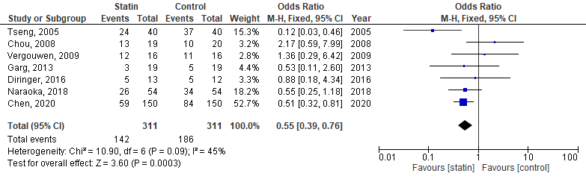
Figure 1. Forest plot of comparison: Vasospasm.
- Delayed Neurological Ischemic Deficits
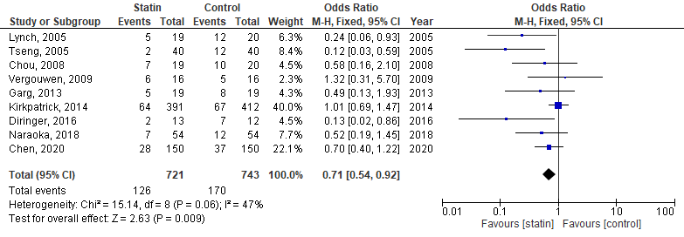
Figure 2. Forest plot of comparison: Delayed Ischemic Neurological Deficits, DIND.
- Delayed Cerebral Ischemia
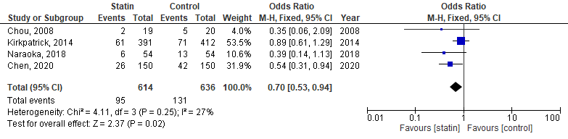
Figure 3. Forest plot of comparison: Radiological Delayed Cerebral Infraction, DCI.
- Functional Outcomes

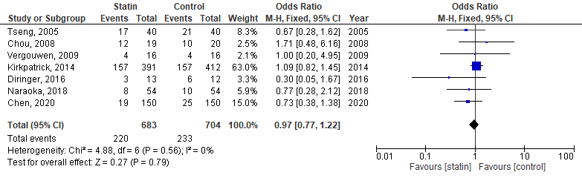
Figure 4. Forest plot of comparison: Functional Outcome, outcome: Poor Outcome.
- Mortality
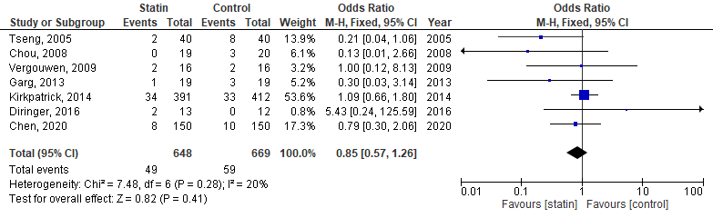
Figure 5. Forest plot of Mortality, all- cause.
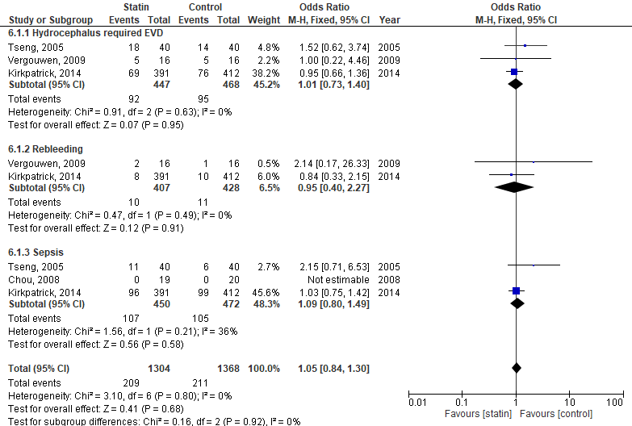
Figure 6. Forest plot of comparison: Non neurological causes of deterioration, outcome: Hydrocephalous, Rebleeding, Sepsis.
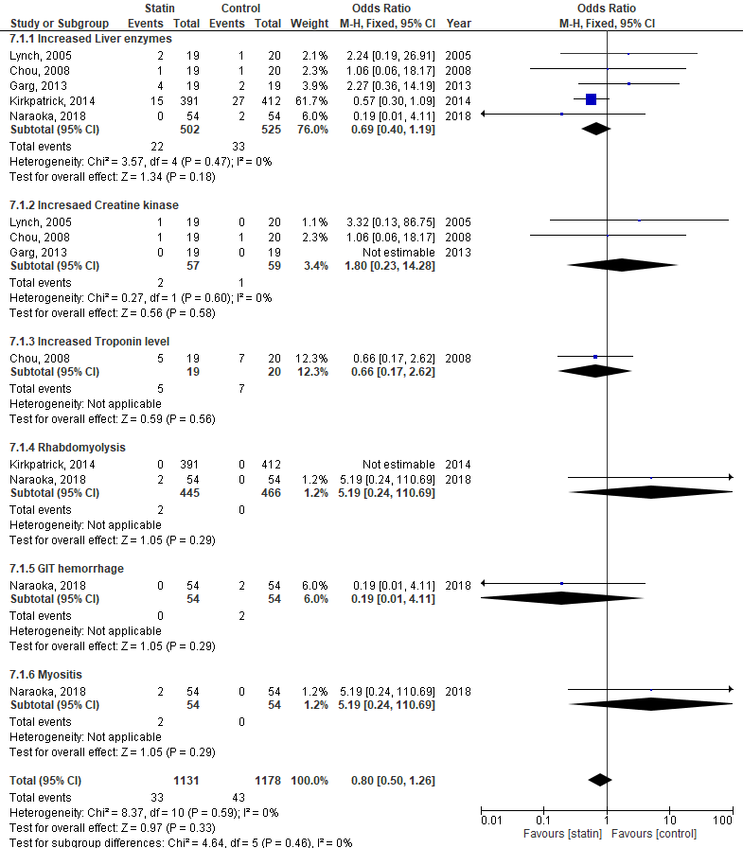
Figure 7. Forest plot of comparison: Adverse effects, outcome: increased liver enzymes, increased Troponin level, Rhabdomyolysis, Gastrointestinal tract Hemorrhage (GIT), Myositis.

Subgrouping meta-analysis

- Vasospasm
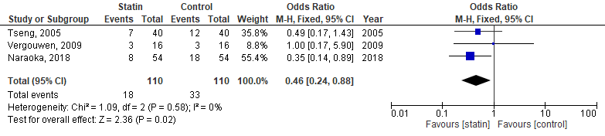
Figure 8. Forest plot of comparison vasospasm: severe vasospasm

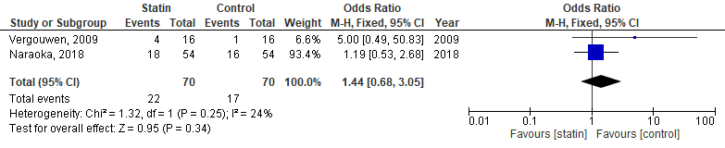
Figure 9. Forest plot of comparison vasospasm: moderate vasospasm

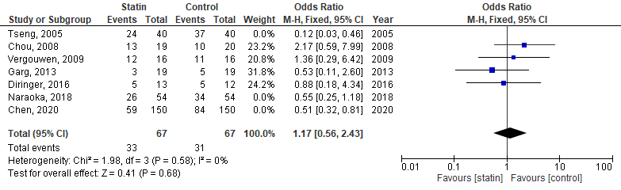
Figure 10. Forest plot of comparison vasospasm: subgroup of simvastatin.
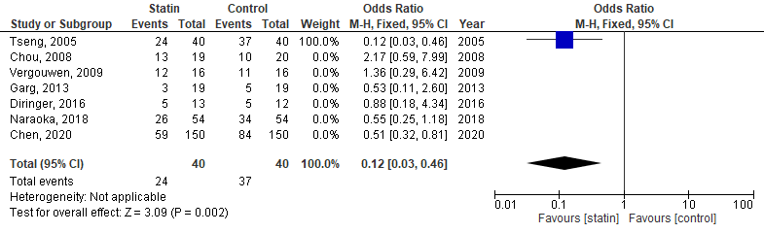
Figure 11. Forest plot of comparison vasospasm: subgroup of pravastatin.

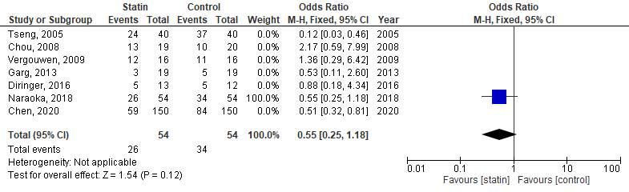
Figure 12. Forest plot of comparison vasospasm: subgroup of pitavastatin.

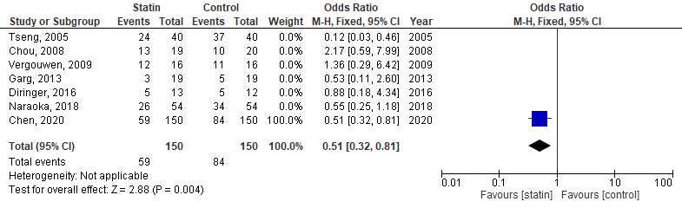
Figure 13. Forest plot of comparison vasospasm: subgroup of atorvastatin.

Figure 14. Forest plot of comparison vasospasm: subgroup of simvastatin 80 mg/day.

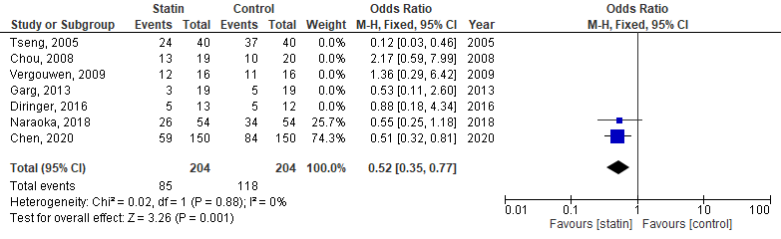
Figure 15. Forest plot of comparison vasospasm: subgroup of equivalent dose to simvastatin 40mg/day.
Figure 16. Forest plot of comparison vasospasm: subgroup of equivalent dose to simvastatin 80mg/day.
Figure 17. Forest plot of comparison vasospasm: subgroup 48h from onset to administration of statin.

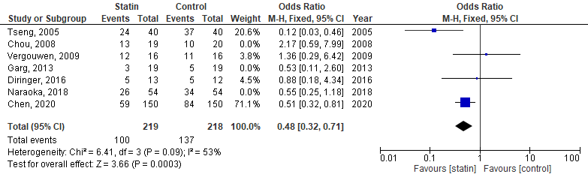
Figure 18. Forest plot of comparison vasospasm: subgroup 72h from onset to administration of statin.
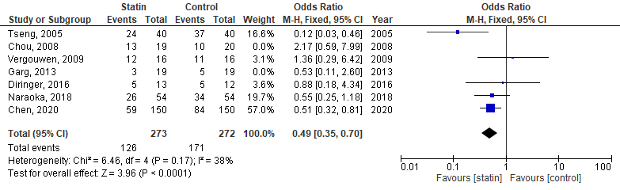
Figure 19. Forest plot of comparison vasospasm: subgroup 48-72h from onset to administration of statin.
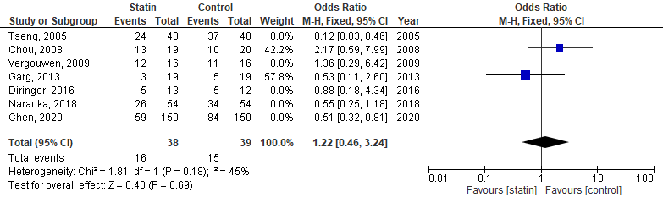
Figure 20. Forest plot of comparison vasospasm: subgroup 96h from onset to administration of statin.

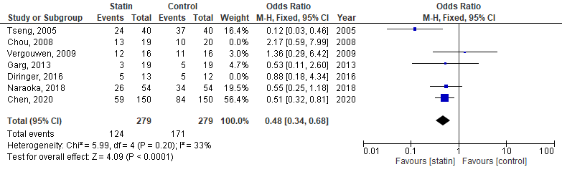
Figure 21. Forest plot of comparison vasospasm: subgroup a duration of 14 day of therapy.

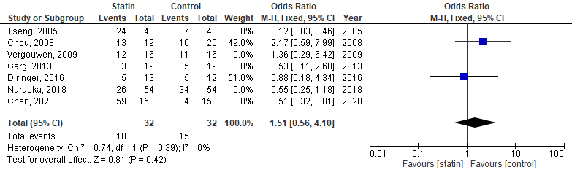
Figure 22. Forest plot of comparison vasospasm: subgroup a duration of 21 day of therapy.
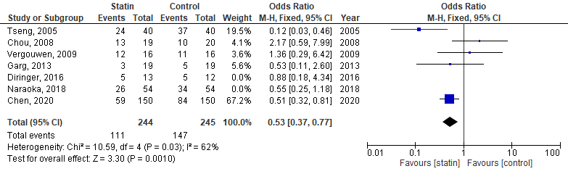
Figure 23. Forest plot of comparison vasospasm: subgroup TCD assessment.
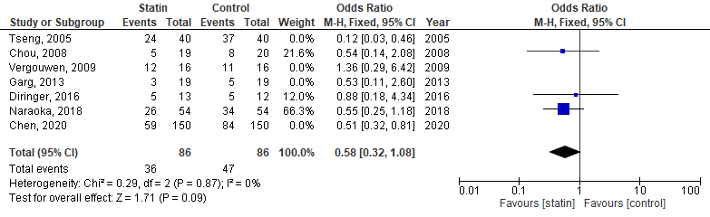
Figure 24. Forest plot of comparison vasospasm: subgroup of conventional angiography assessment.

- DIND
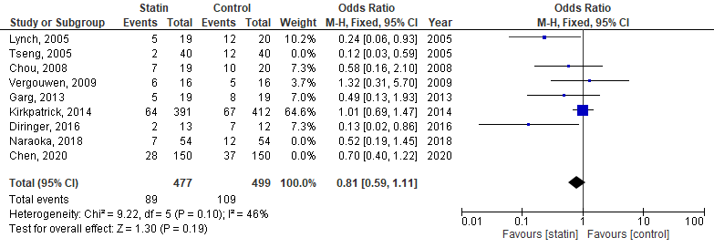
Figure 25. Forest plot of comparison DIND: subgroup of simvastatin.

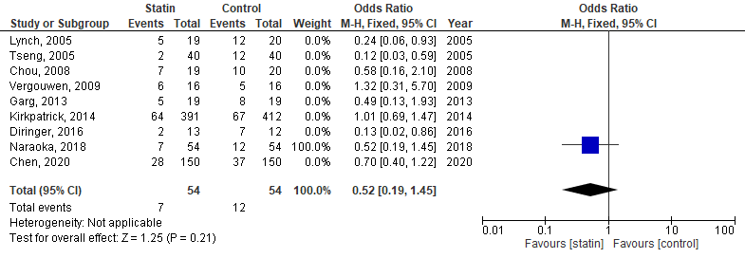
Figure 26. Forest plot of comparison DIND: subgroup of pitavastatin.

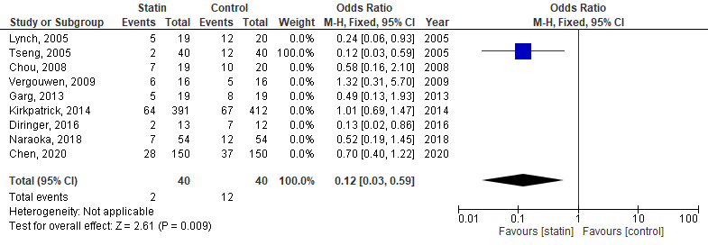
Figure 27. Forest plot of comparison DIND: subgroup of pravastatin.

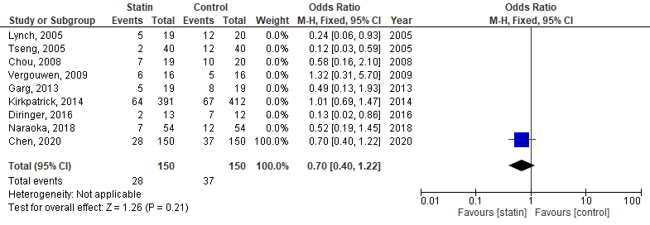
Figure 28. Forest plot of comparison DIND: subgroup of atorvastatin.

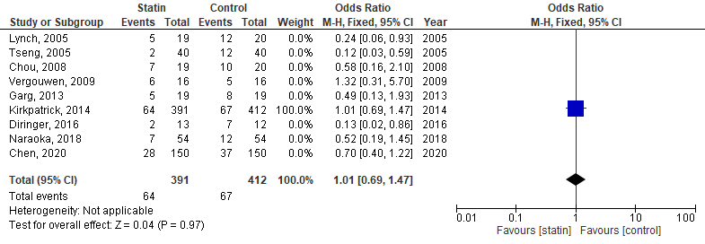
Figure 29. Forest plot of comparison DIND: subgroup of simvastatin 40mg/day.

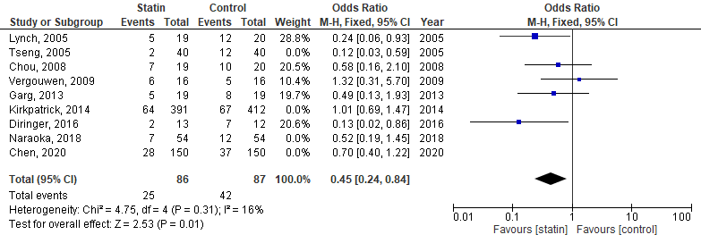
Figure 30. Forest plot of comparison DIND: subgroup of simvastatin 80mg/day.
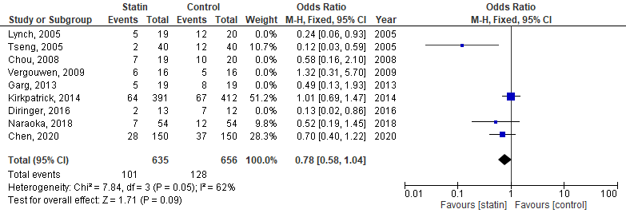
Figure 31. Forest plot of comparison DIND: subgroup of equivalent to 40mg simvastatin.

Figure 32. Forest plot of comparison DIND: subgroup of equivalent to 80mg simvastatin.

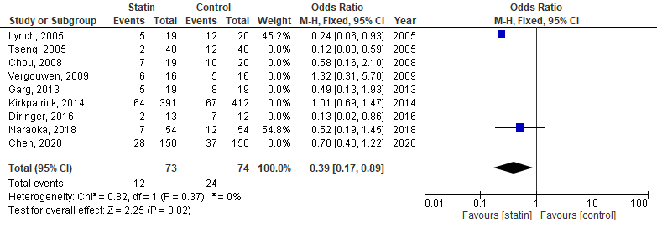
Figure 33. Forest plot of comparison DIND: subgroup of 48h from onset to administration of statin.
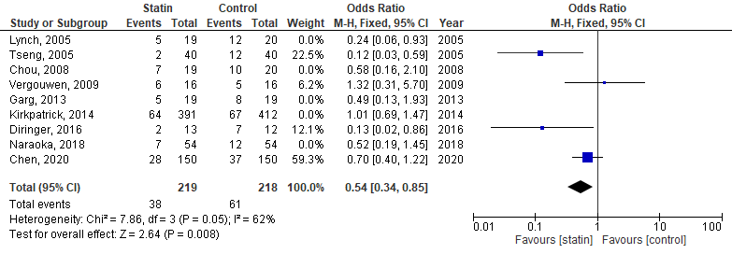
Figure 34. Forest plot of comparison DIND: subgroup of 72h from onset to administration of statin.
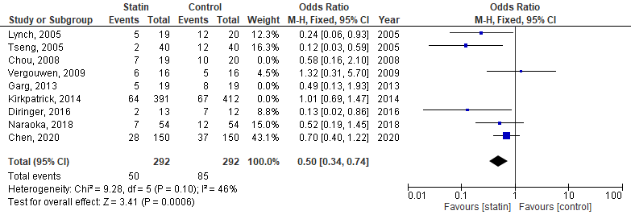
Figure 35. Forest plot of comparison DIND: subgroup of 48-72h from onset to administration of statin.

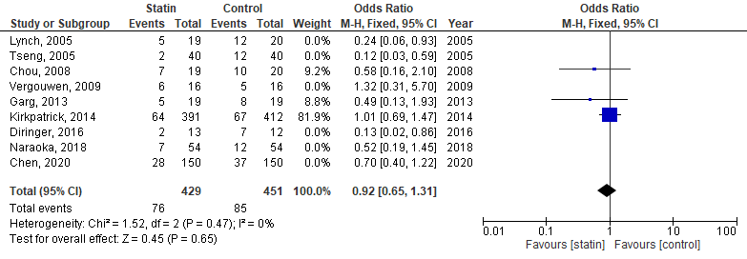
Figure 36. Forest plot of comparison DIND: subgroup of 96h from onset to administration of statin.
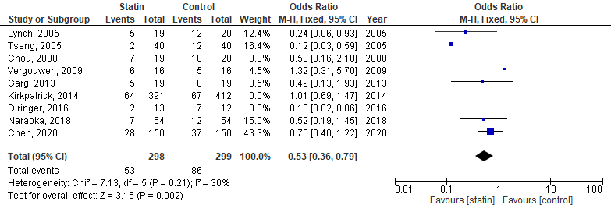
Figure 37. Forest plot of comparison DIND: subgroup of a duration of 14 day of therapy.

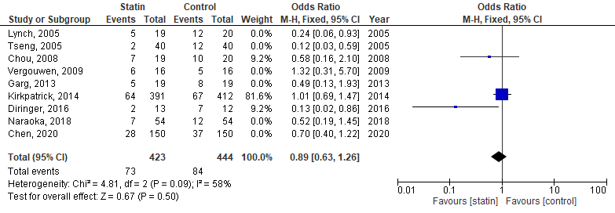
Figure 38. Forest plot of comparison DIND: subgroup of a duration of 21 day of therapy.

- Delayed cerebral Ischemia, DCI

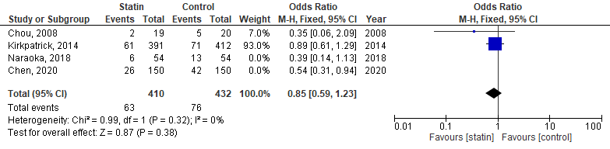
Figure 39. Forest plot of comparison DCI: subgroup of simvastatin.
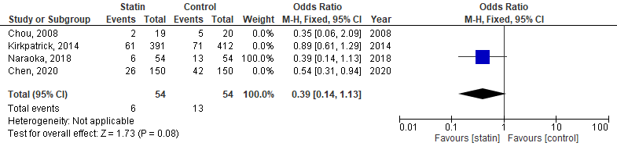
Figure 40. Forest plot of comparison DCI: subgroup of pitavastatin.
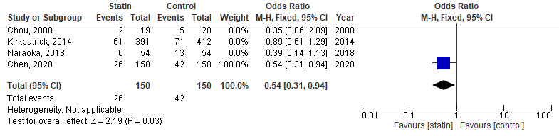
Figure 41. Forest plot of comparison DCI: subgroup of atorvastatin.

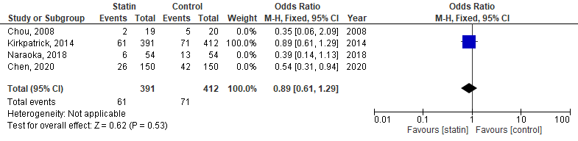
Figure 42. Forest plot of comparison DCI: subgroup of simvastatin 40mg/day.

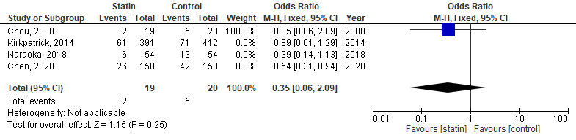
Figure 43. Forest plot of comparison DCI: subgroup of simvastatin 80 mg/day.
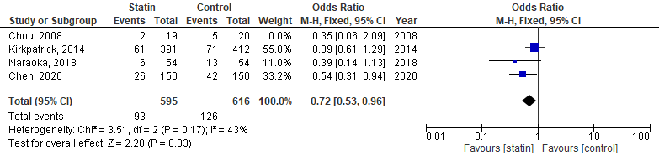
Figure 44. Forest plot of comparison DCI: subgroup of equivalent dose to 40 mg simvastatin.

Figure 45. Forest plot of comparison DCI: subgroup of equivalent dose to 80 mg simvastatin.

Figure 46. Forest plot of comparison DCI: subgroup of 48h from onset to administration of statin.
.
Figure 47. Forest plot of comparison DCI: subgroup of 72h from onset to administration of statin.
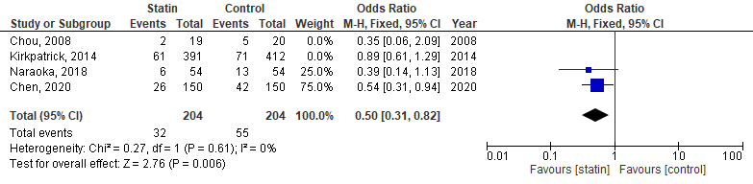
Figure 48. Forest plot of comparison DCI: subgroup of 48-72h from onset to administration of statin.

Figure 49. Forest plot of comparison DCI: subgroup of 96h from onset to administration of statin.

Figure 50. Forest plot of comparison DCI: subgroup of a duration of 14 day of therapy.
Figure 51. Forest plot of comparison DCI: subgroup of a duration of 21 day of therapy.

- Poor outcome
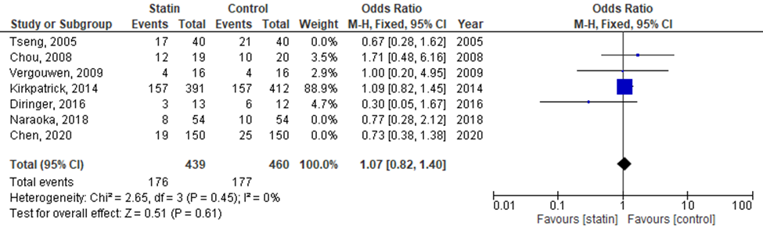
Figure 52. Forest plot of comparison Functional outcome: poor outcome; subgroup of simvastatin.
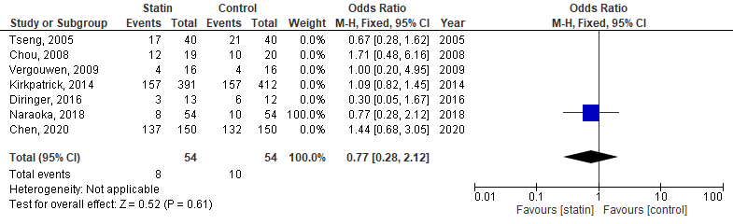
Figure 53. Forest plot of comparison Functional outcome: poor outcome; subgroup of pitavastatin.
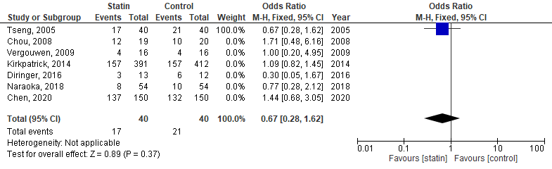
Figure 54. Forest plot of comparison Functional outcome: poor outcome; subgroup of pravastatin.
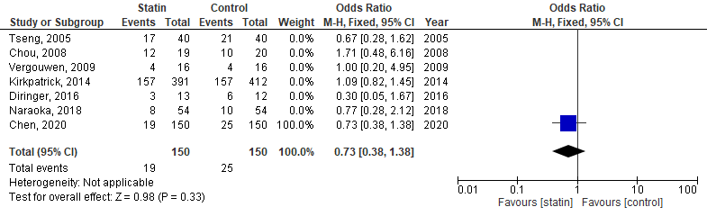
Figure 55. Forest plot of comparison Functional outcome: poor outcome; subgroup of atorvastatin.
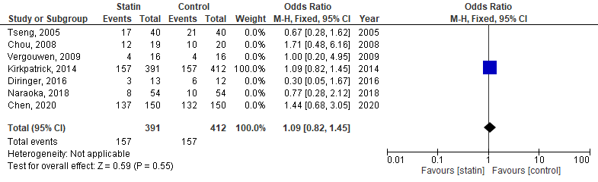
Figure 56. Forest plot of comparison Functional outcome: poor outcome; subgroup of simvastatin 40mg/day.
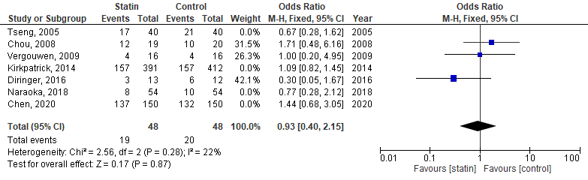
Figure 57. Forest plot of comparison Functional outcome: poor outcome; subgroup of simvastatin 80mg/day.
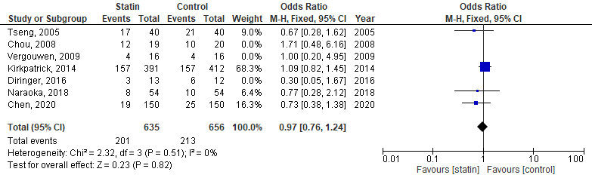
Figure 58. Forest plot of comparison Functional outcome: poor outcome; subgroup of equivalent to 40mg simvastatin.
Figure 59. Forest plot of comparison Functional outcome: poor outcome; subgroup of equivalent to 80mg simvastatin.

Figure 60. Forest plot of comparison Functional outcome: poor outcome; subgroup of 48h from onset to administration of statin.

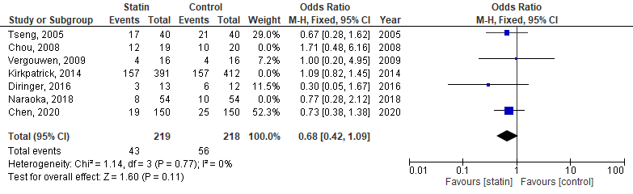
Figure 61. Forest plot of comparison Functional outcome: poor outcome; subgroup of 72h from onset to administration of statin.
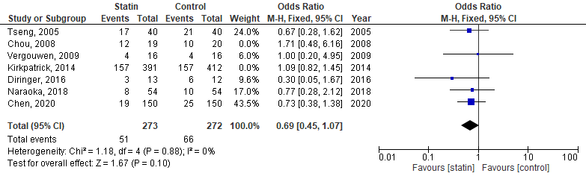
Figure 62. Forest plot of comparison Functional outcome: poor outcome; subgroup of 48-72h from onset to administration of statin.
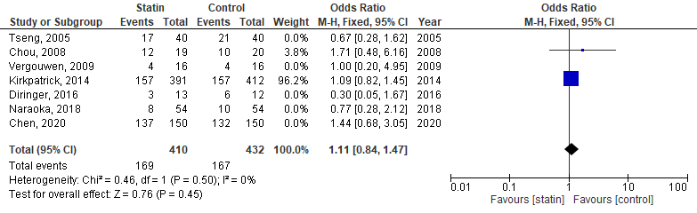
Figure 63. Forest plot of comparison Functional outcome: poor outcome; subgroup of 96h from onset to administration of statin.
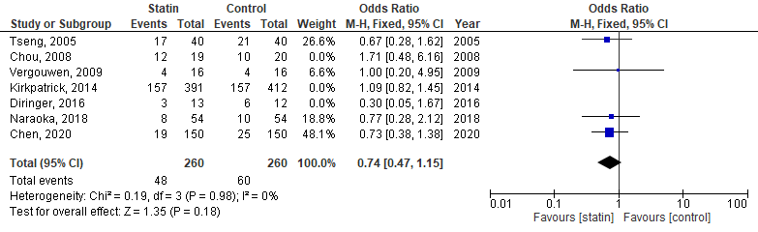
Figure 64. Forest plot of comparison Functional outcome: poor outcome; subgroup of a duration of 14 day of therapy.
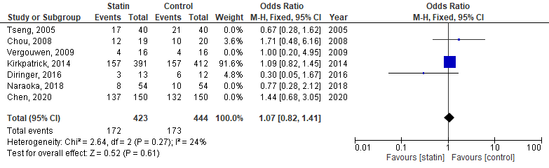
Figure 65. Forest plot of comparison Functional outcome: poor outcome; subgroup of a duration of 21 day of therapy.
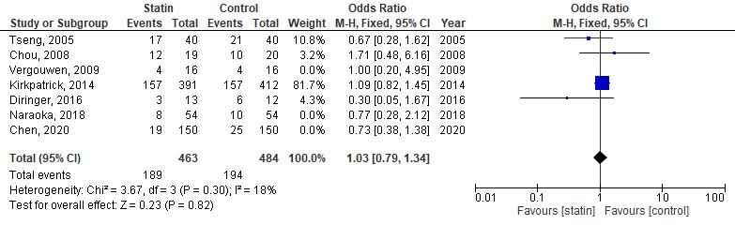
Figure 66. Forest plot of comparison Functional outcome: poor outcome; subgroup of mRS assessment.
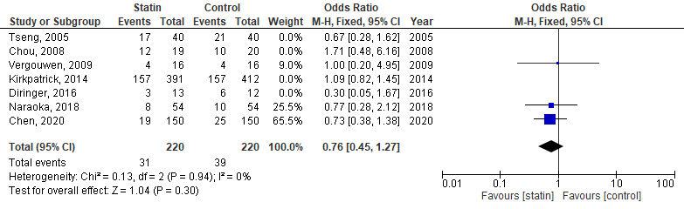
Figure 67. Forest plot of comparison Functional outcome: poor outcome; subgroup of GOS assessment.

- Mortality
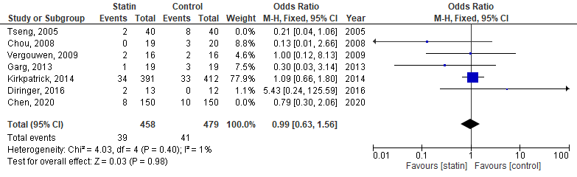
Figure 68. Forest plot of mortality: subgroup of simvastatin.

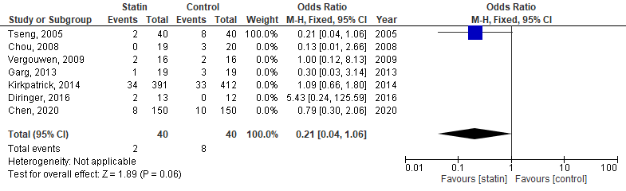
Figure 69. Forest plot of mortality: subgroup of pravastatin.
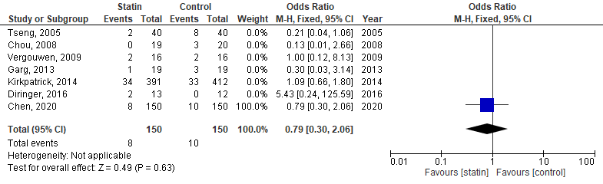
Figure 70. Forest plot of mortality: subgroup of atorvastatin.
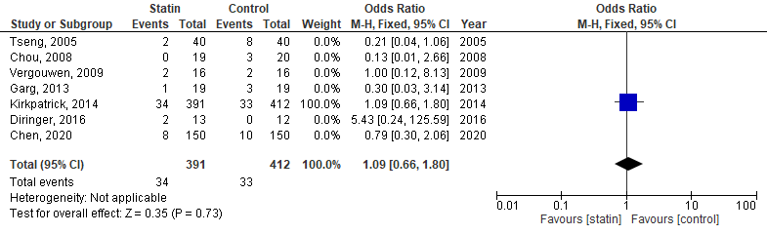
Figure 71. Forest plot of mortality: subgroup of simvastatin 40mg/day.
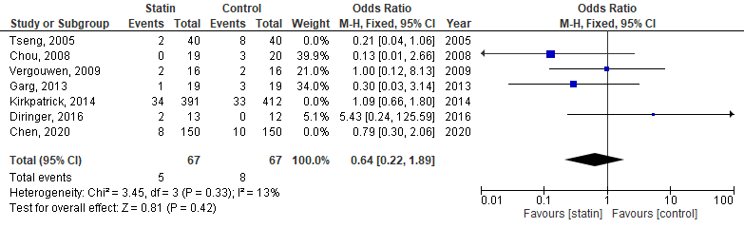
Figure 72. Forest plot of mortality: subgroup of simvastatin 80mg/day.
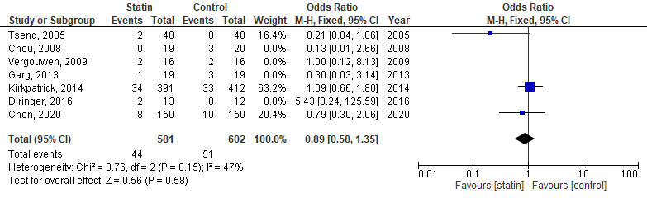
Figure 73. Forest plot of mortality: subgroup of equivalent dose of 40mg simvastatin.
Figure 74. Forest plot of mortality: subgroup of equivalent dose of 80mg simvastatin.

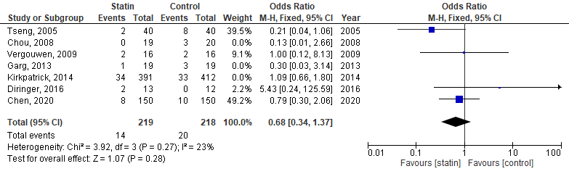
Figure 75. Forest plot of mortality: subgroup of 72h from onset to administration of statin.
Figure 76. Forest plot of mortality: subgroup of 48-72h from onset to administration of statin.

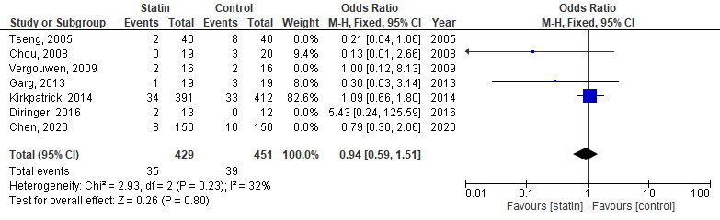
Figure 77. Forest plot of mortality: subgroup of 96h from onset to administration of statin.

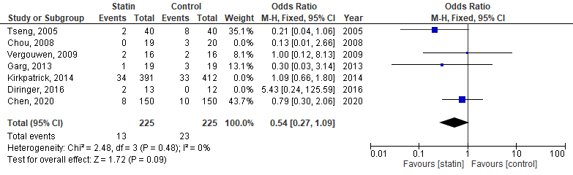
Figure 78. Forest plot of mortality: subgroup of a duration of 14 day of therapy.
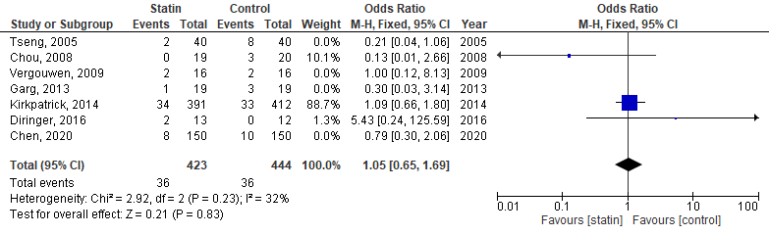
Figure 79. Forest plot of mortality: subgroup of a duration of 21 day of therapy.

- Adverse effects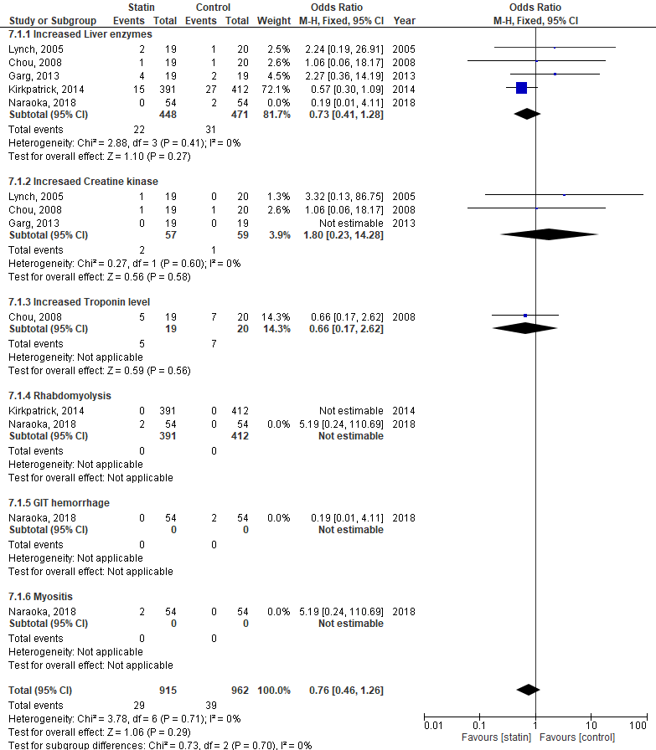
Figure 80. Forest plot of adverse effects: subgroup of simvastatin.
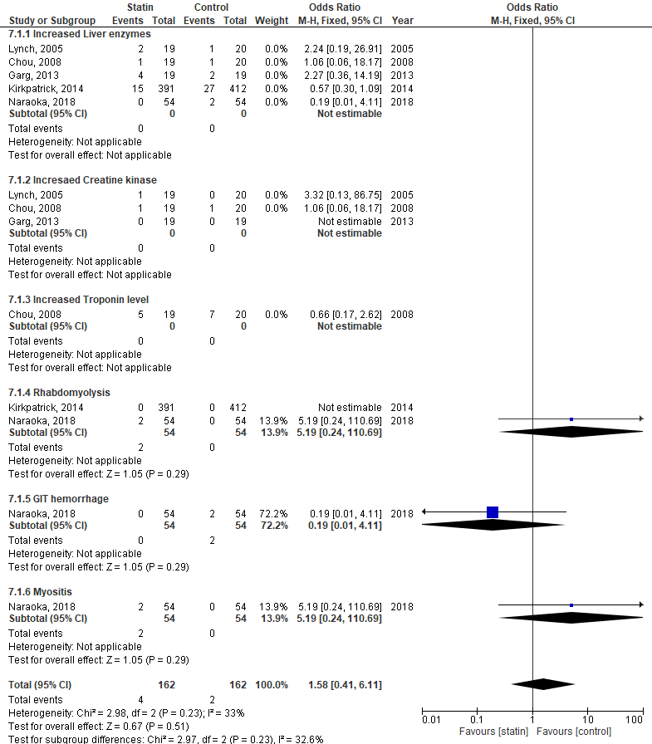
Figure 81. Forest plot of adverse effects: subgroup of pitavastatin.
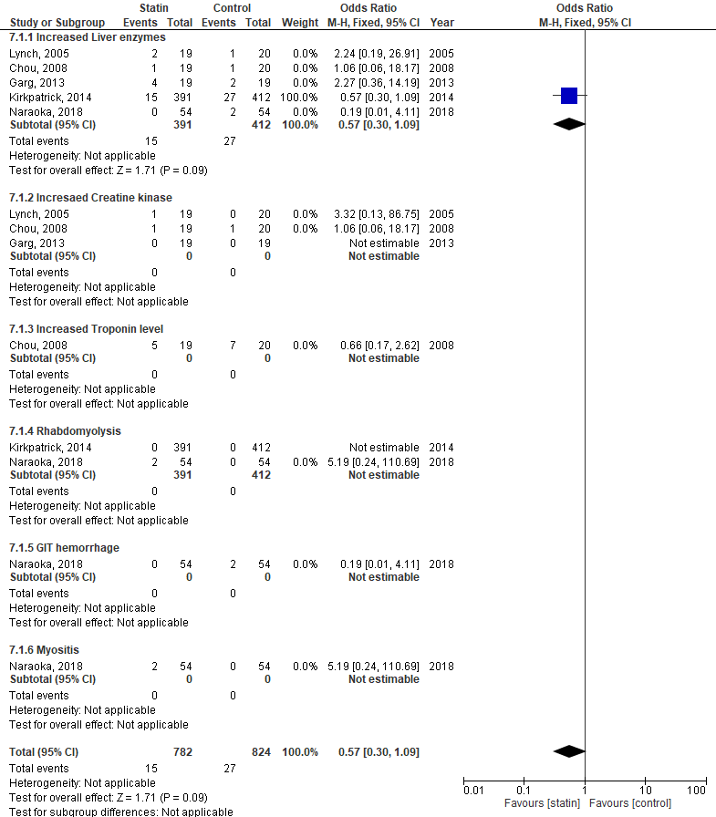
Figure 82. Forest plot of adverse effects: subgroup of a dose of simvastatin 40 mg/day.

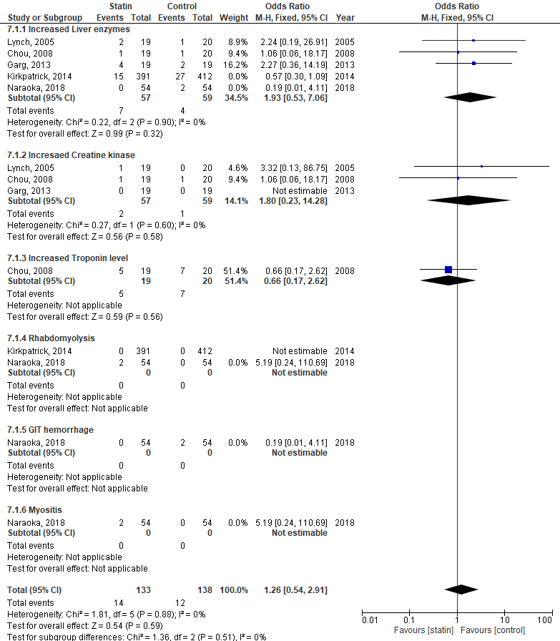
Figure 83. Forest plot of adverse effects: subgroup of a dose of simvastatin 80mg/day.
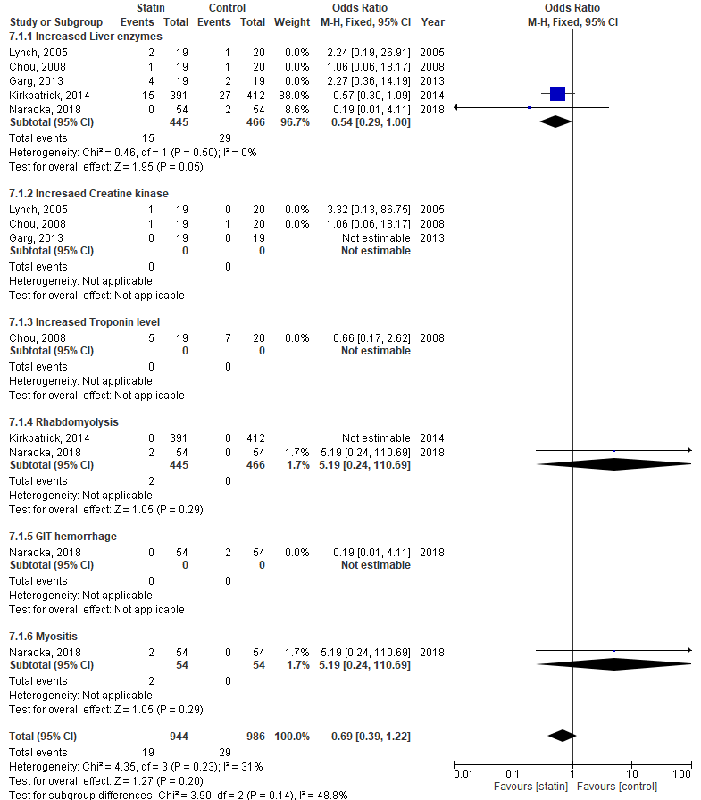
Figure 84. Forest plot of adverse effects: subgroup of equivalent dose of 40mg simvastatin.

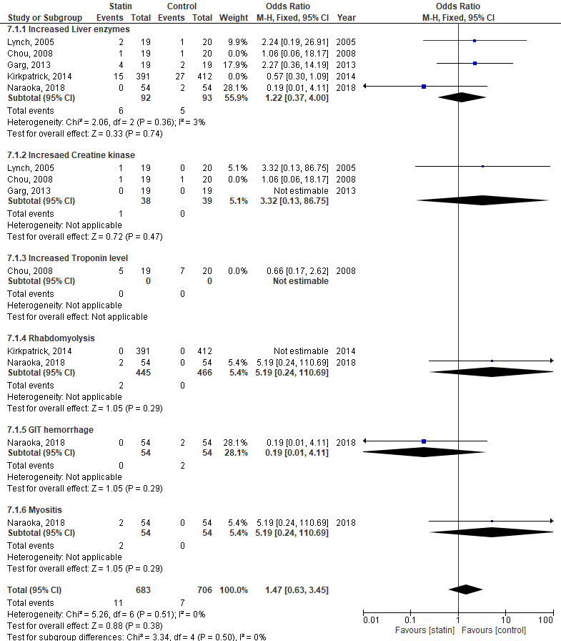
Figure 85. Forest plot of adverse effects: subgroup of a duration of 14 day of therapy.
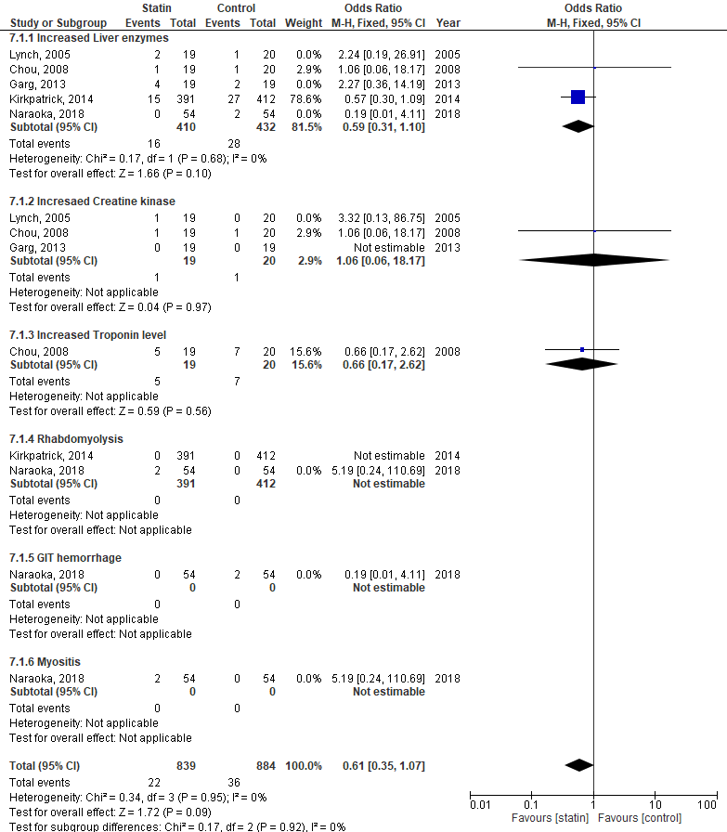
Figure 86. Forest plot of adverse effects: subgroup of a duration of 21 day of therapy.

