Supplementary Figures
Figure S1. Pathway of tobacco smoke metabolism and damage repair involved in tobacco smoke-induced lung carcinogenesis. The impaired function of xenobiotic metabolism and DNA repair genes leads to carcinogenic potentiation.

Figure S2. A box plot representation depicts genotype to tissue expression of significant cis-eQTLs (p < 0.05*) in healthy lung tissue (A-E). Data obtained from the GTEx portal. ‘N’ represents a number of individuals.

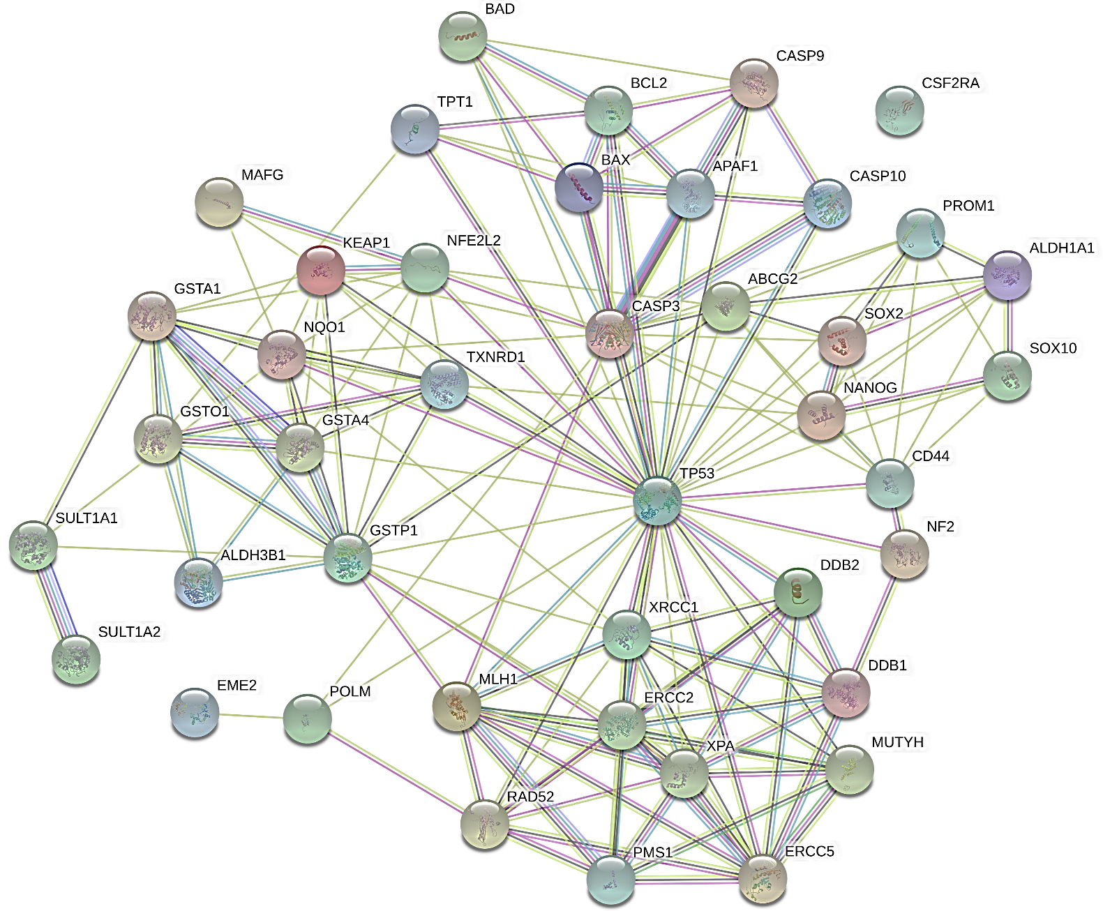
Figure S3. A Protein-Protein Interactome for the final set of prioritized genes in STRING v10.5. The interaction was expanded to view more interactors and identify potential candidate protein-coding genes. Red arrows indicate our input protein-coding genes.

Figure S4. A comparative box plot representation depicting the genotype-specific expression of 4 cis-eQTL rSNPs from 3 genes in lung cancer and healthy individuals. Data for lung cancer, both lung adenocarcinoma, and lung squamous cell carcinoma were taken from TCGA in PancanQTL web server and for healthy lung tissue, the data was analyzed through the GTEx portal. ‘N’ represents a number of individuals. FDR corrected P<0.05* is considered as significant.

