Endogenous circadian reporters reveal critical consequences of diverse novel mutations in clock genes

Jiyoung Park, Kwangjun Lee, Hyeongseok Kim, Heungsop Shin and Choogon Lee

List of Supplementary Information:

Supplementary Figures 1-9
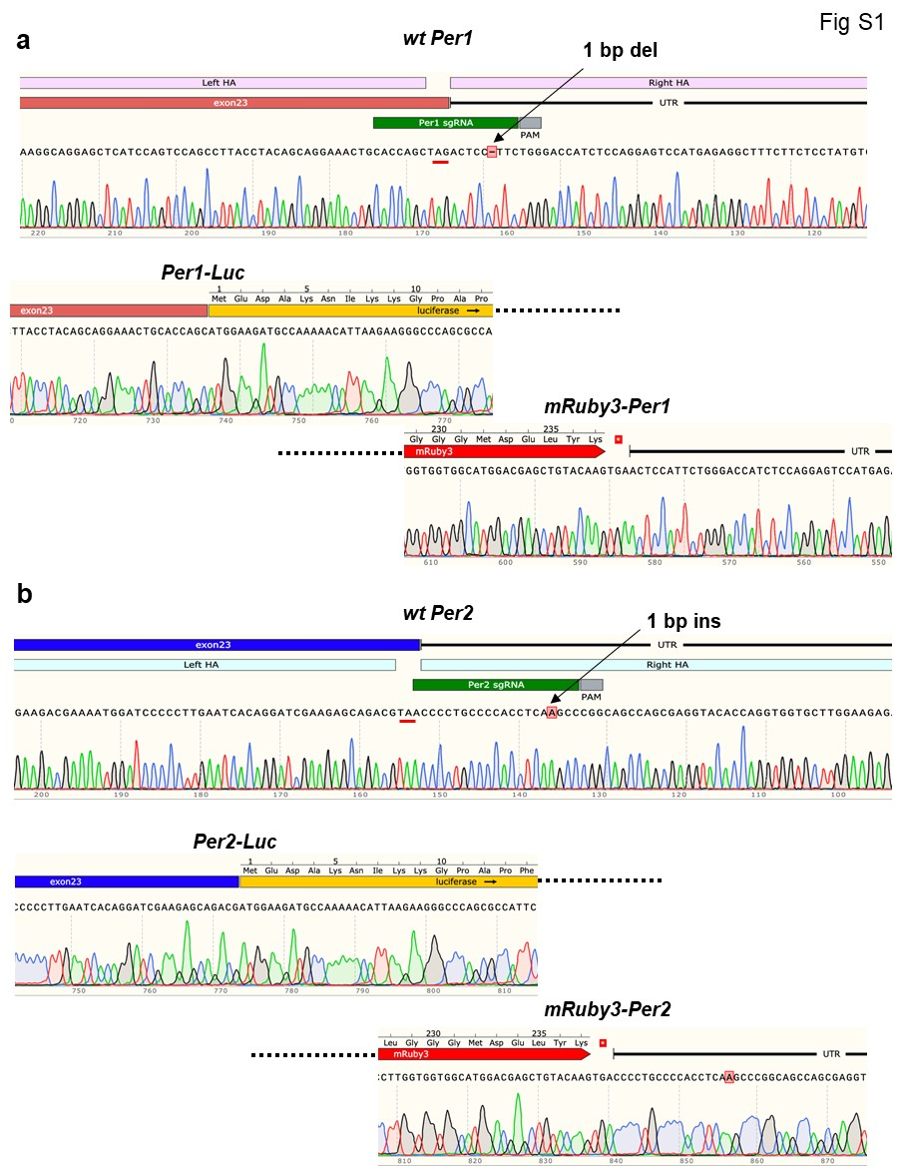
Figure S1. Sanger sequencing of the KI alleles confirms on-target KI. One each of Per1 (H3) and Per2 (LH1) heterozygous KI clones used throughout the studies are shown. Stop codons are underlined with red. Note that a base pair (bp) was deleted in the non-KI allele in the Per1 clone and 1 bp insertion in the Per2 clone. There are no mutations in the KI alleles. Related to Fig. 1.

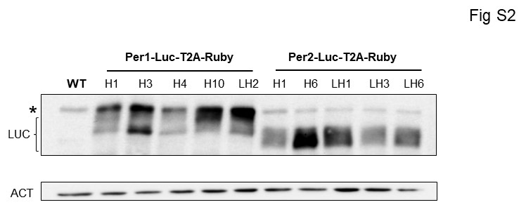

Figure S2. Immunoblotting with anti-Luc antibody confirms specific KI. * nonspecific band. Related to Fig. 1.
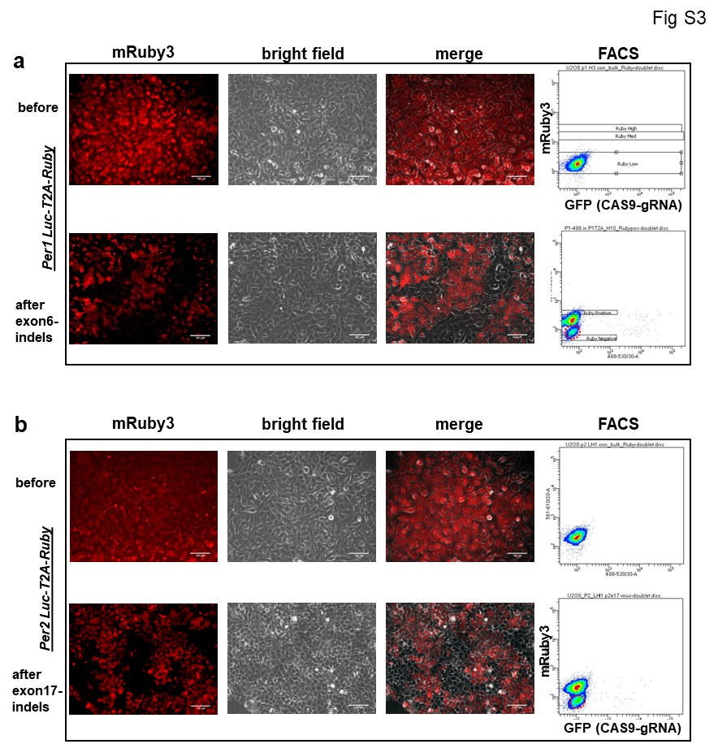
Figure S3. mRuby3 and Luc signals disappear due to indels in early exons in Per-Luc reporter clones. Representative Per1 and Per2 clones are shown. Indels were induced using all-in-one adenoviruses targeting exon 17 in Per2 and exon 6 in Per1. To ensure 100% infection in U2OS cells with the all-in-one adenoviruses, the cells were infected at MOI of 50 twice, two days apart.
Note that a group of mRuby3-negative cells appeared after the treatment in the bottom FACS graph. These negative cells also lost bioluminescence signal. Related to Fig. 1.
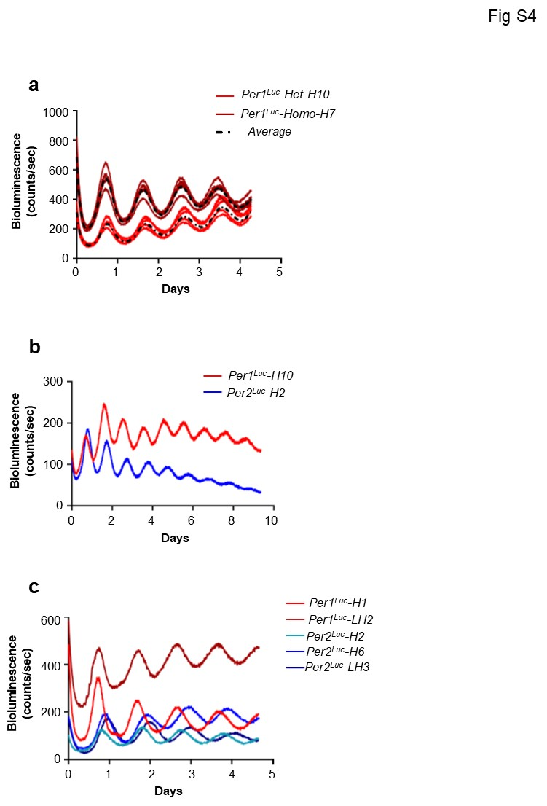
Figure S4. Bioluminescence circadian reporters are highly quantitative and robust. a. A heterozygous Per1^{Luc} was compared with a homozygous Per1^{Luc} clone. b. Bioluminescence rhythms were robust over 10 days. Representative Per1^{Luc} and Per2^{Luc} reporters are shown. c. Circadian period was not significantly different between Per1^{Luc} and Per2^{Luc} reporter clones. Representative of three traces per clone is shown.
Related to Fig. 2.
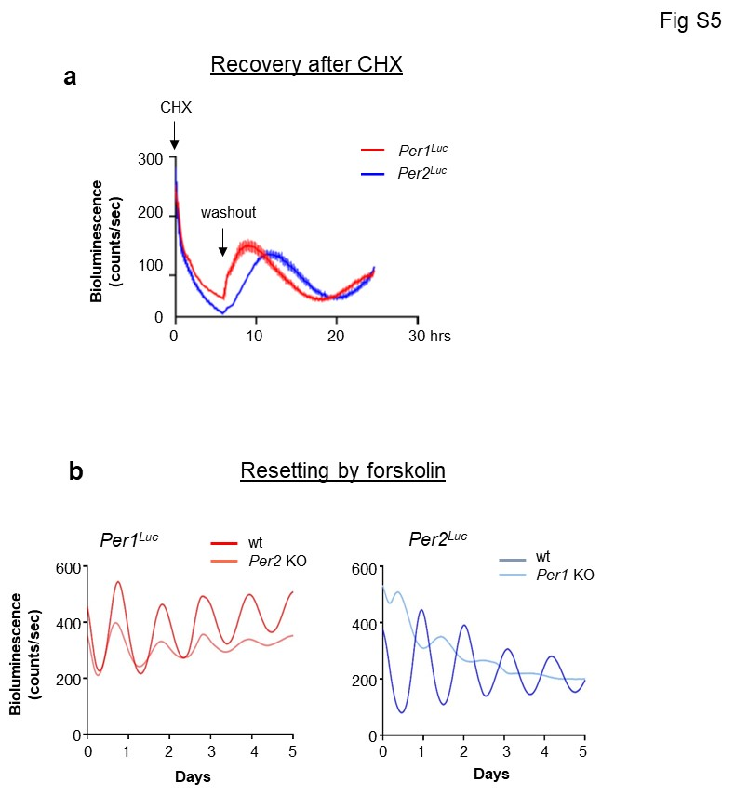
Figure S5. PER1 and PER2 are different in key parameters. a. De novo PER1 accumulated faster than PER2. Existing PER was depleted by CHX treatment for 8 hrs. Mean+/-SEM (n=3, two-tailed t-test). p<0.001. b. Antiphase oscillation of PER2-Luc in Per1 KO cells was reproduced by forskolin treatment. Related to Fig. 3 and 4.
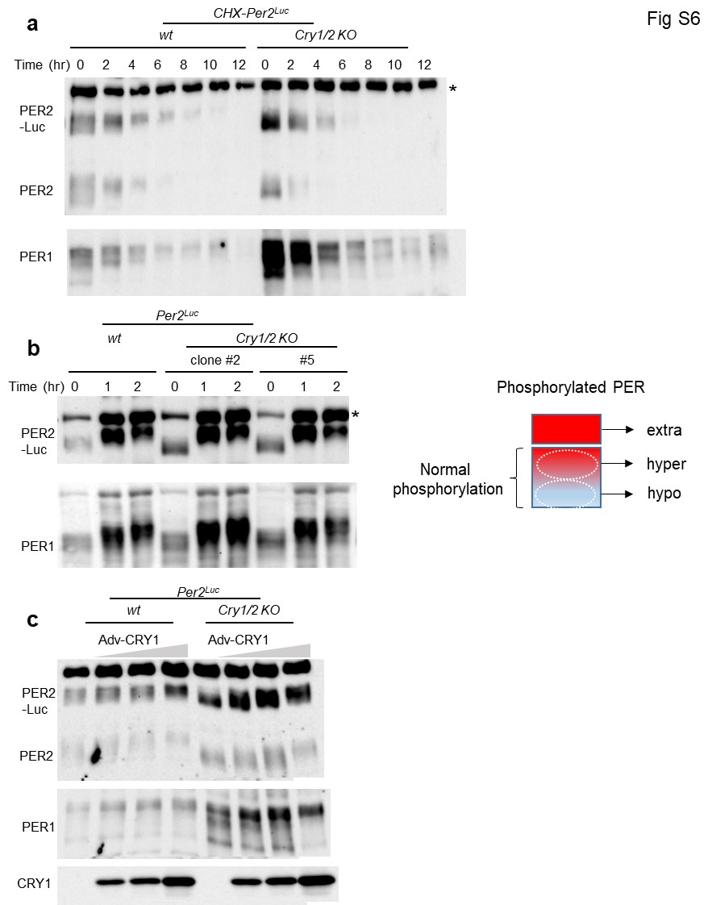
Figure S6. CRY protects hyperphosphorylated PER from rapid degradation. a. PER proteins were degraded before reaching a hyperphosphorylated state in Cry1/2 KO cells. b. PER can be hyperphosphorylated in Cry1/2 KO cells as much as PER in wt cells. This suggests that hyperphosphorylated PER species are unstable without CRY. Three stages of PER phosphorylation are illustrated in the left panel. Extra hyperphosphorylated species are not detected in a steady state because they are very unstable but can be detected in β-Trcp1/2 KO cells. c. Hyperphosphorylated PER species accumulated in Cry1/2 KO cells when transgenic CRY1 was expressed. Related to Fig. 5.
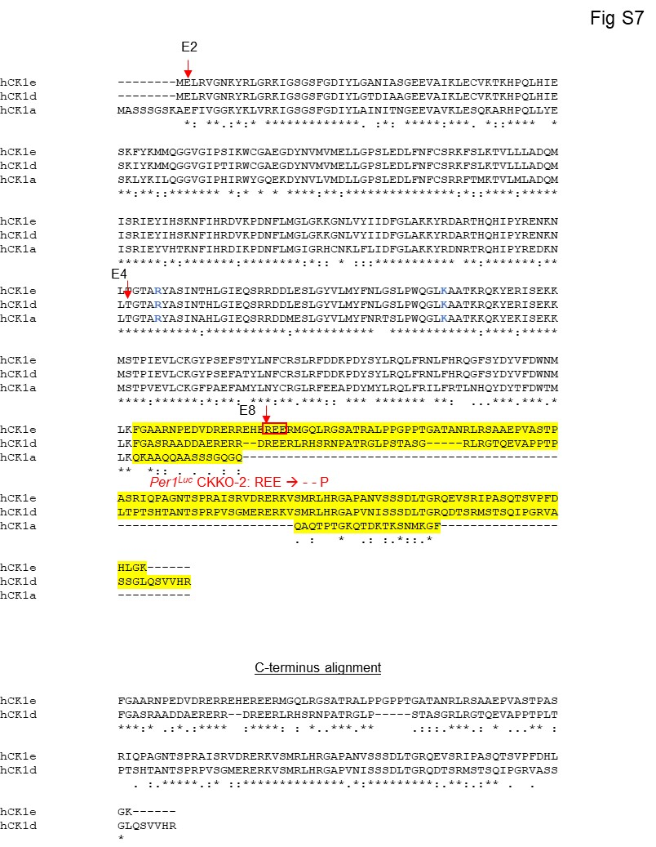
Figure S7. Catalytic domains of CK1 isoforms are well conserved. Three most conserved human CK1 isoforms are aligned. CRISPR target sites are represented by red arrows; E2 and E8 for CK1ε, E4 for CK1δ. C-termini are highlighted in yellow. The red boxed sequence was mutated from Arg Glu Glu to del del Pro in the Per1^{Luc}-CKKO-2 clone. Related to Fig. 6.

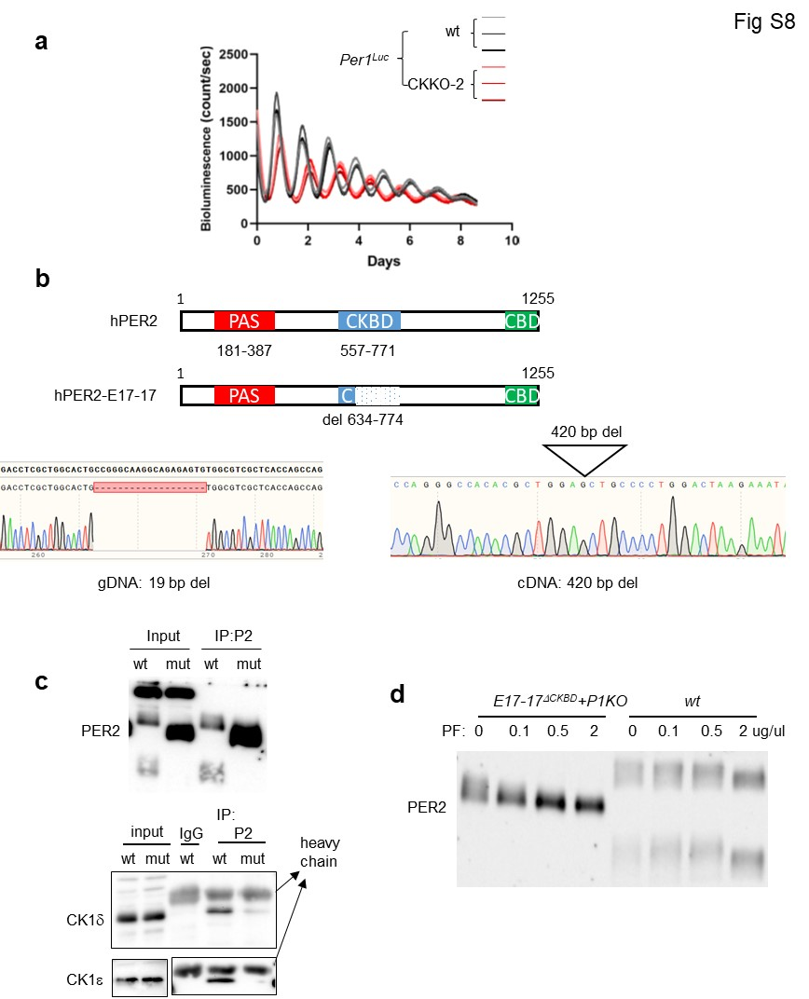
Figure S8. Robust interaction between PER-CKBD and CK1δ/ε is critical for the phosphotimer. a. Per1^{Luc}-CKKO-2 clone showed a ~28.5 hr period which is comparable to other CK1 double mutant clones and much longer than CK1δ or ε single mutant clones. Another bioluminescence rhythm plot is shown. Three replicates of wt and the mutant are shown. b,c. A PER2^{ΔCKBD} mutant is defective in binding to PER. One allele had a frame-shifting mutation while the other allele had a large deletion. Sequencing of cDNA revealed that the deletion-mutant allele had an in-frame deletion missing 2/3 of CKBD. CoIP is representative of two experiments. d. Hyperphosphorylation of the mutant PER2 was more sensitive to the CK1δ/ε inhibitor. Related to Fig. 6 and 7.
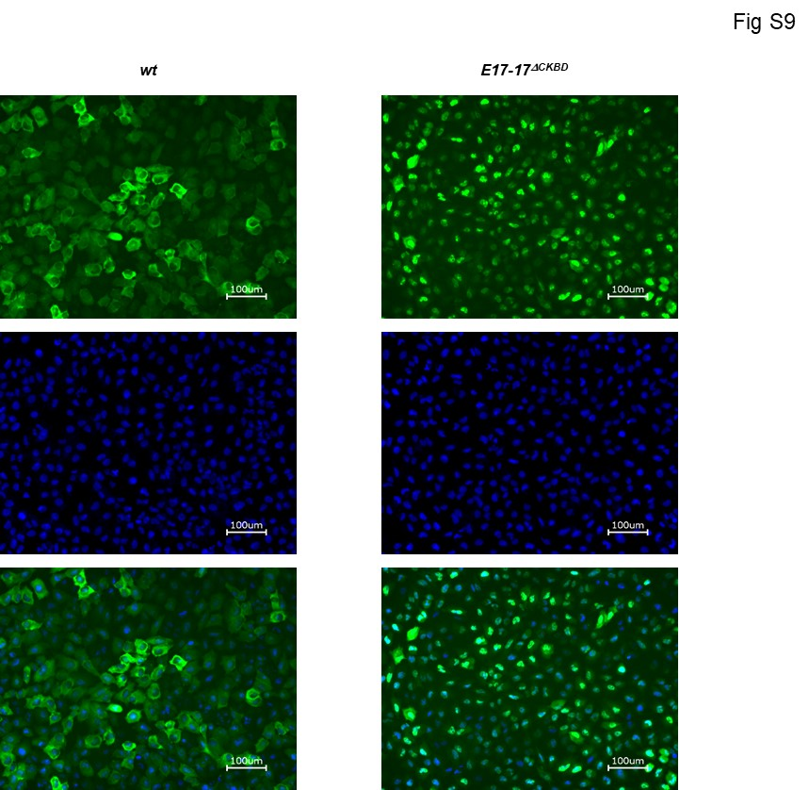
Figure S9. PER2^{ΔCKBD} is predominantly nuclear. PER2-Venus and PER2^{ΔCKBD}-Venus fusion proteins were expressed using the adenoviral vector. Venus fluorescence was visualized using confocal microscopy. Related to Fig. 7.

