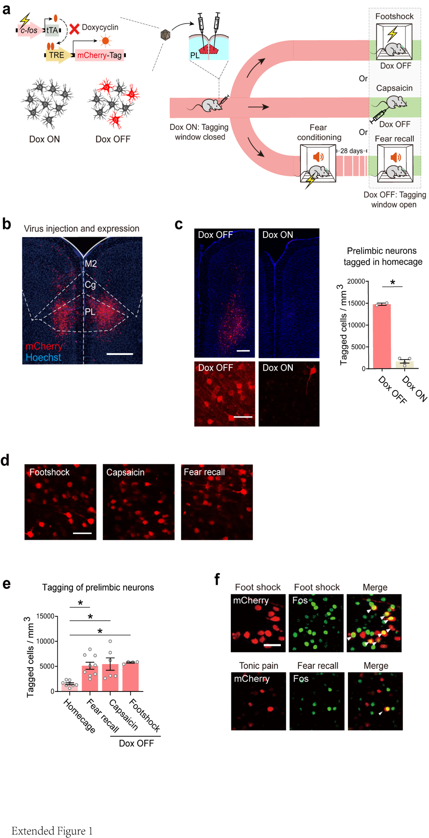
Extended Data (ED) Figures:

ED Fig. 1: Activity labeling system for labelling prefrontal engrams for long term fear recall and neurons responsive to foot shock stimulation and tonic pain.
(a, b) Doxycycline-controlled, activity-evoked expression of protein tags under c-fos promoter following viral injection of tagging constructs in the murine prelimbic cortex. Shown are the experimental scheme for activity-dependent tagging of prelimbic cortical neurons with a marker tag, such as mCherry, upon paw exposure to painful intensities of foot shock or capsaicin or during recall of fear memory 28 days after cued fear-conditioning (panel a) and an example of neurons tagged with mCherry expression in an activity-dependent manner (panel b). (c) Control of tagging by presence of Doxycyline (Dox ON, 1 mg/mL Dox for 16 days) in comparison to Doxycline-free time window (Dox OFF) is demonstrated in baseline home-cage conditions. Example images show mCherry reporter expression (red) on the background of Hoechst-stained cell nuclei (blue). Magnified images are shown in lower panels. Quantitative summary is shown on the right; unpaired t-test; * p < 0.05; p < 0.0001; Dox OFF n = 4 mice/group, Dox ON n = 2 mice/group. (d, e) Examples (panel d) and quantitative summary (panel e) of prelimbic neuronal labeling upon foot shock, fear memory recall at 28 days post-conditioning or paw injection of capsaicin. For panel e, One-way ANOVA with Dunnet's multiple comparisons; * p < 0.05; Homecage vs Fear memory, p = 0.012; Homecage vs. Capsaicin, p = 0.018; Homecage vs. Footshock, p = 0.020; n = 4-9 mice/group. (f) Typical examples showing dual labeling of neuronal activity over two discrete events of the same behavioral state or two distinct behavioral states via mCherry and Fos immunohistochemistry. Arrow-heads: double-labelled neurons. Scale bars represent 0.5 mm in panel b, 250 µm in upper images in panel c and 50 µm lower images in panel c, 100 µm in panel d and 50 µm in panel e. All data are shown as mean +/- S.E.M.

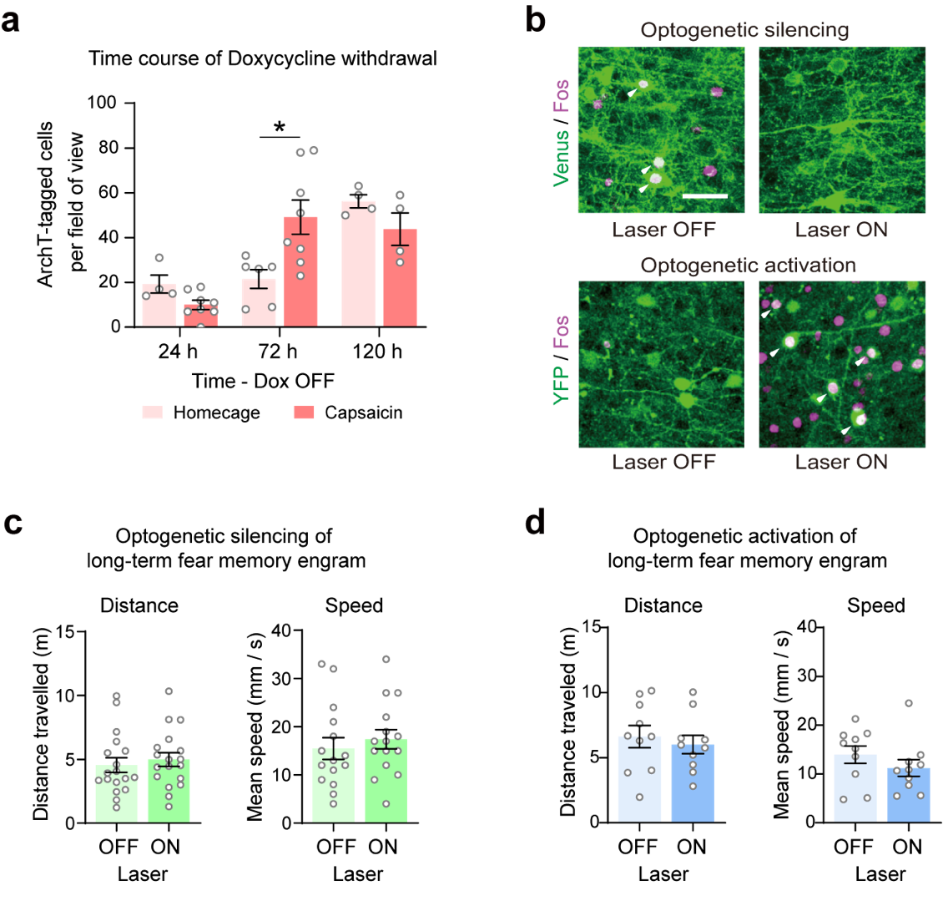
ED Fig. 2: Control experiments for optogenetic activation or silencing of prefrontal fear memory engram.
(a) Optimization of the time course of Doxycycline (Dox) withdrawal (n = 8 brain sections) to uncover conditions yielding a significant increase (* p < 0.05, p = 0.002) in the number of cells labelled with optogenetic actuators, when compared to homecage controls (two-way ANOVA with Sidak’s test for multiple comparisons, n = 4-8 sections per group). (b) Typical examples of labeling prefrontal remote fear memory engram neurons with Channelrhodopsin (ChR2-YFP) or Archeorhodopsin (ArchT-Venus) and validation of optogenetic activation or silencing, respectively, via increase or decrease in immunohistochemical detection of expression of activity marker Fos respectively, upon laser light stimulation in vivo; arrowheads indicate double-labelled neurons and scale bars represent 50 µm. (c, d) Behavior associated with locomotion in open field (in the same cohort of mice with (Laser ON) or without (Laser OFF) optogenetic silencing (c) or activation (d) of the prefrontal fear memory engram; paired t-test; for c panel, n = 17-18 mice /group; for panel d, n = 10 mice/group. All data are shown as mean +/- S.E.M.

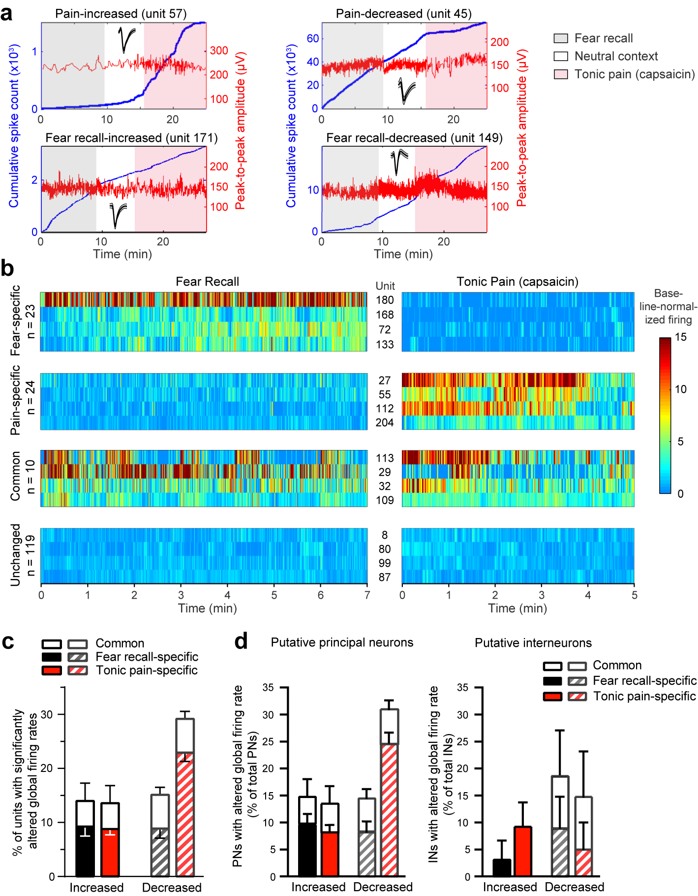

ED Fig. 3: In vivo tetrode recordings to study encoding of fear recall and tonic pain in prefrontal excitatory neurons and inhibitory neurons.
(a) Example plots showing state-specific changes in firing rates of units. Insets show spike waveforms (mean ± SD, 1.2 ms) for each unit. (b) Example heat map illustration of binned firing rates normalized to activity in neutral context for units showing increased activity during fear recall or tonic pain. (c) Summary of prelimbic units demonstrating significant rate changes during fear recall or tonic pain over neutral context (total n = 261 units from 7 mice). (d) Delineation of global rate coding units for fear recall and tonic pain into putative principal (excitatory) neurons (PN, left; n = 231 units) and interneurons (IN, right; n = 30 units). Permutation test for mean difference between binned firing rates, p < 0.05, effect size > 0.5; n = 261 units over 7 mice. Data are shown as mean +/- S.E.M.
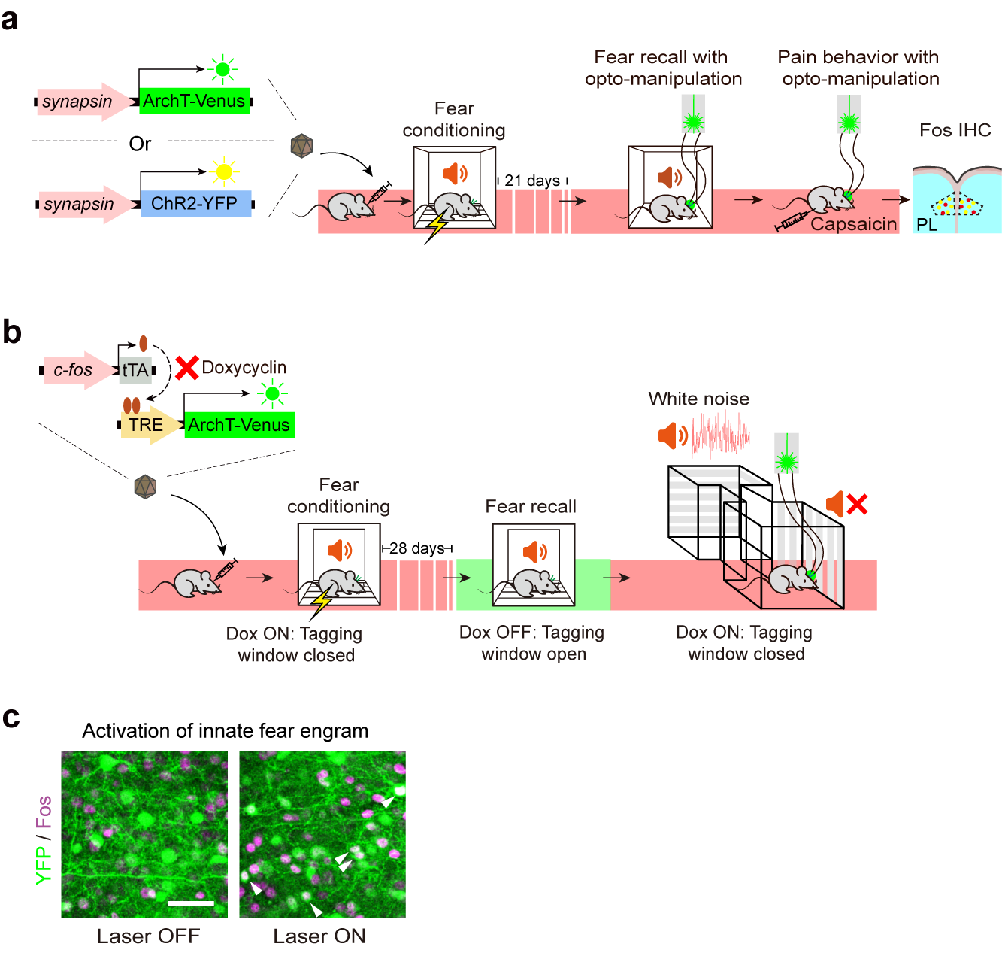

ED Fig. 4: Experiments for testing specificity of interaction between fear memory and pain.
(a) Experimental scheme for labelling of a random population of prelimbic neurons with optogenetic actuators ArchT and ChR2 using the murine synapsin promoter to drive expression, and scheme for testing effect of their activation or silencing on remote fear recall and capsaicin-induced pain behaviors. (b) Experimental scheme for testing impact of optogenetic silencing of the prefrontal fear memory engram on pain-unrelated aversion to white noise. (c) Typical examples of labeling prefrontal neurons responding to innate fear upon exposure to compound TMT from fox urine with Channelrhodopsin (ChR2-YFP) and validation of optogenetic activation via increase in immunohistochemical detection of Fos upon laser light stimulation in vivo; arrowheads indicate double-labelled neurons and scale bars represent 50 µm.

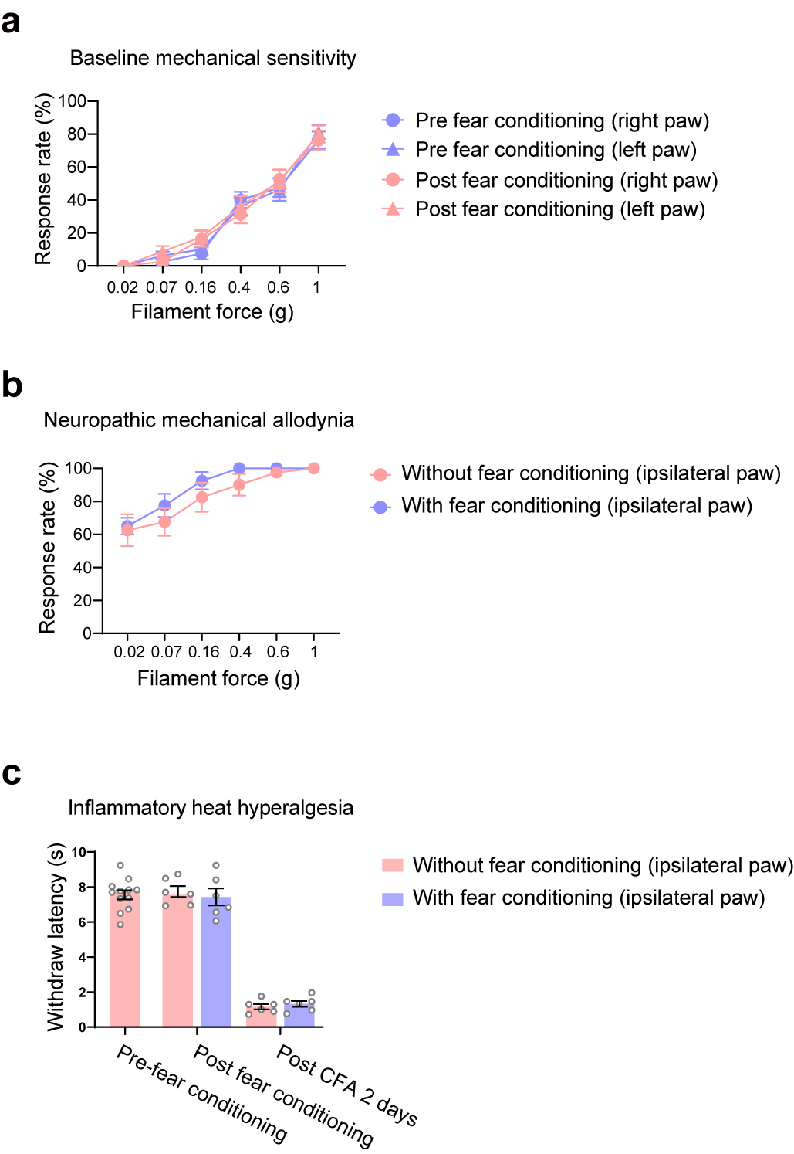

ED Fig. 5: Impact of cued fear conditioning on nociceptive and tactile sensitivity in baseline and inflammatory or neuropathic pain conditions.
(a) Impact of fear conditioning on paw withdrawal responses to graded mechanical von Frey force across noxious and non-noxious intensities in naïve mice (baseline); n = 16 mice/group. (b) Impact of fear conditioning on withdrawal responses to von Frey hairs after nerve injury; shown are data from the ipsilateral paw; n = 8 mice/group. (c) Impact of fear conditioning on withdrawal responses to thermal nociceptive stimuli (Hargreaves plantar test) in baseline condition and longitudinally after induction of unilateral paw inflammation (CFA); shown are data from the ipsilateral paw; n = 6 mice/group. (In all panels, two-way ANOVA with Tukey’s multiple comparisons test was performed. Data are shown as mean +/- S.E.M.

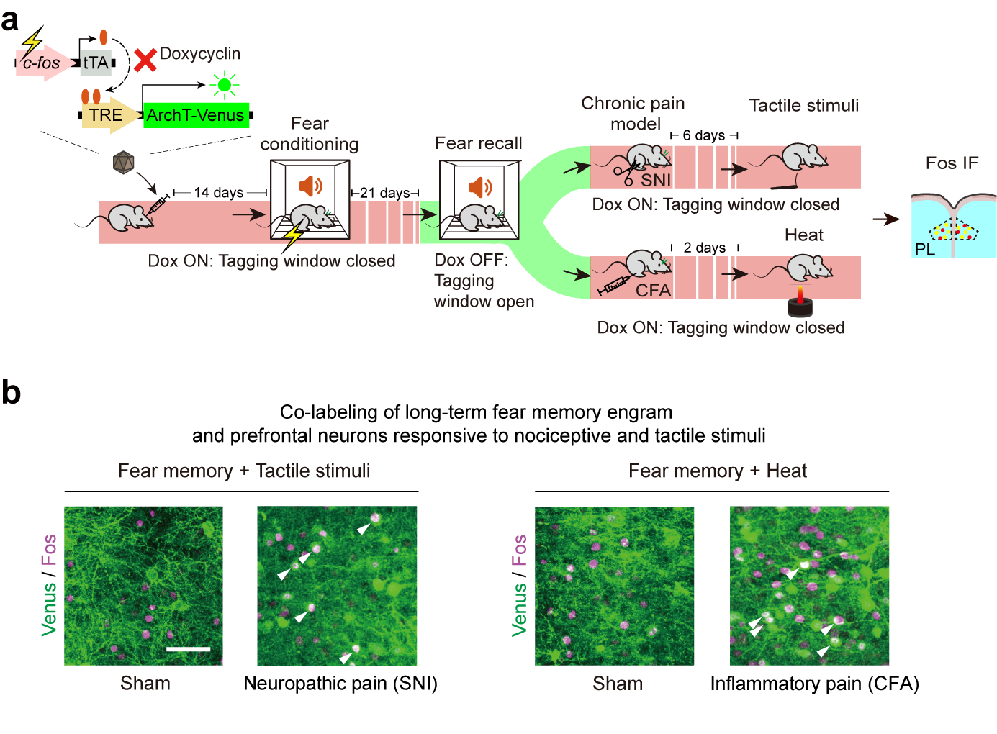
ED Fig. 6: Analysis of prefrontal basis of interplay between fear memory, nociception and touch in naïve mice and inflammatory or neuropathic pain conditions
(a) Experimental scheme for labelling prefrontal long-term fear memory engram and testing its overlap with prefrontal neurons responsive to a heat ramp or tactile von Frey stimulation in baseline conditions and changes thereof after induction of paw inflammation (CFA) or nerve injury (SNI). (b) Typical examples fear engram-labelled neurons (Venus) and overlap (arrows) with neurons activated by light touch or heat (Fos+Venus); scale bars represent 50 µm.

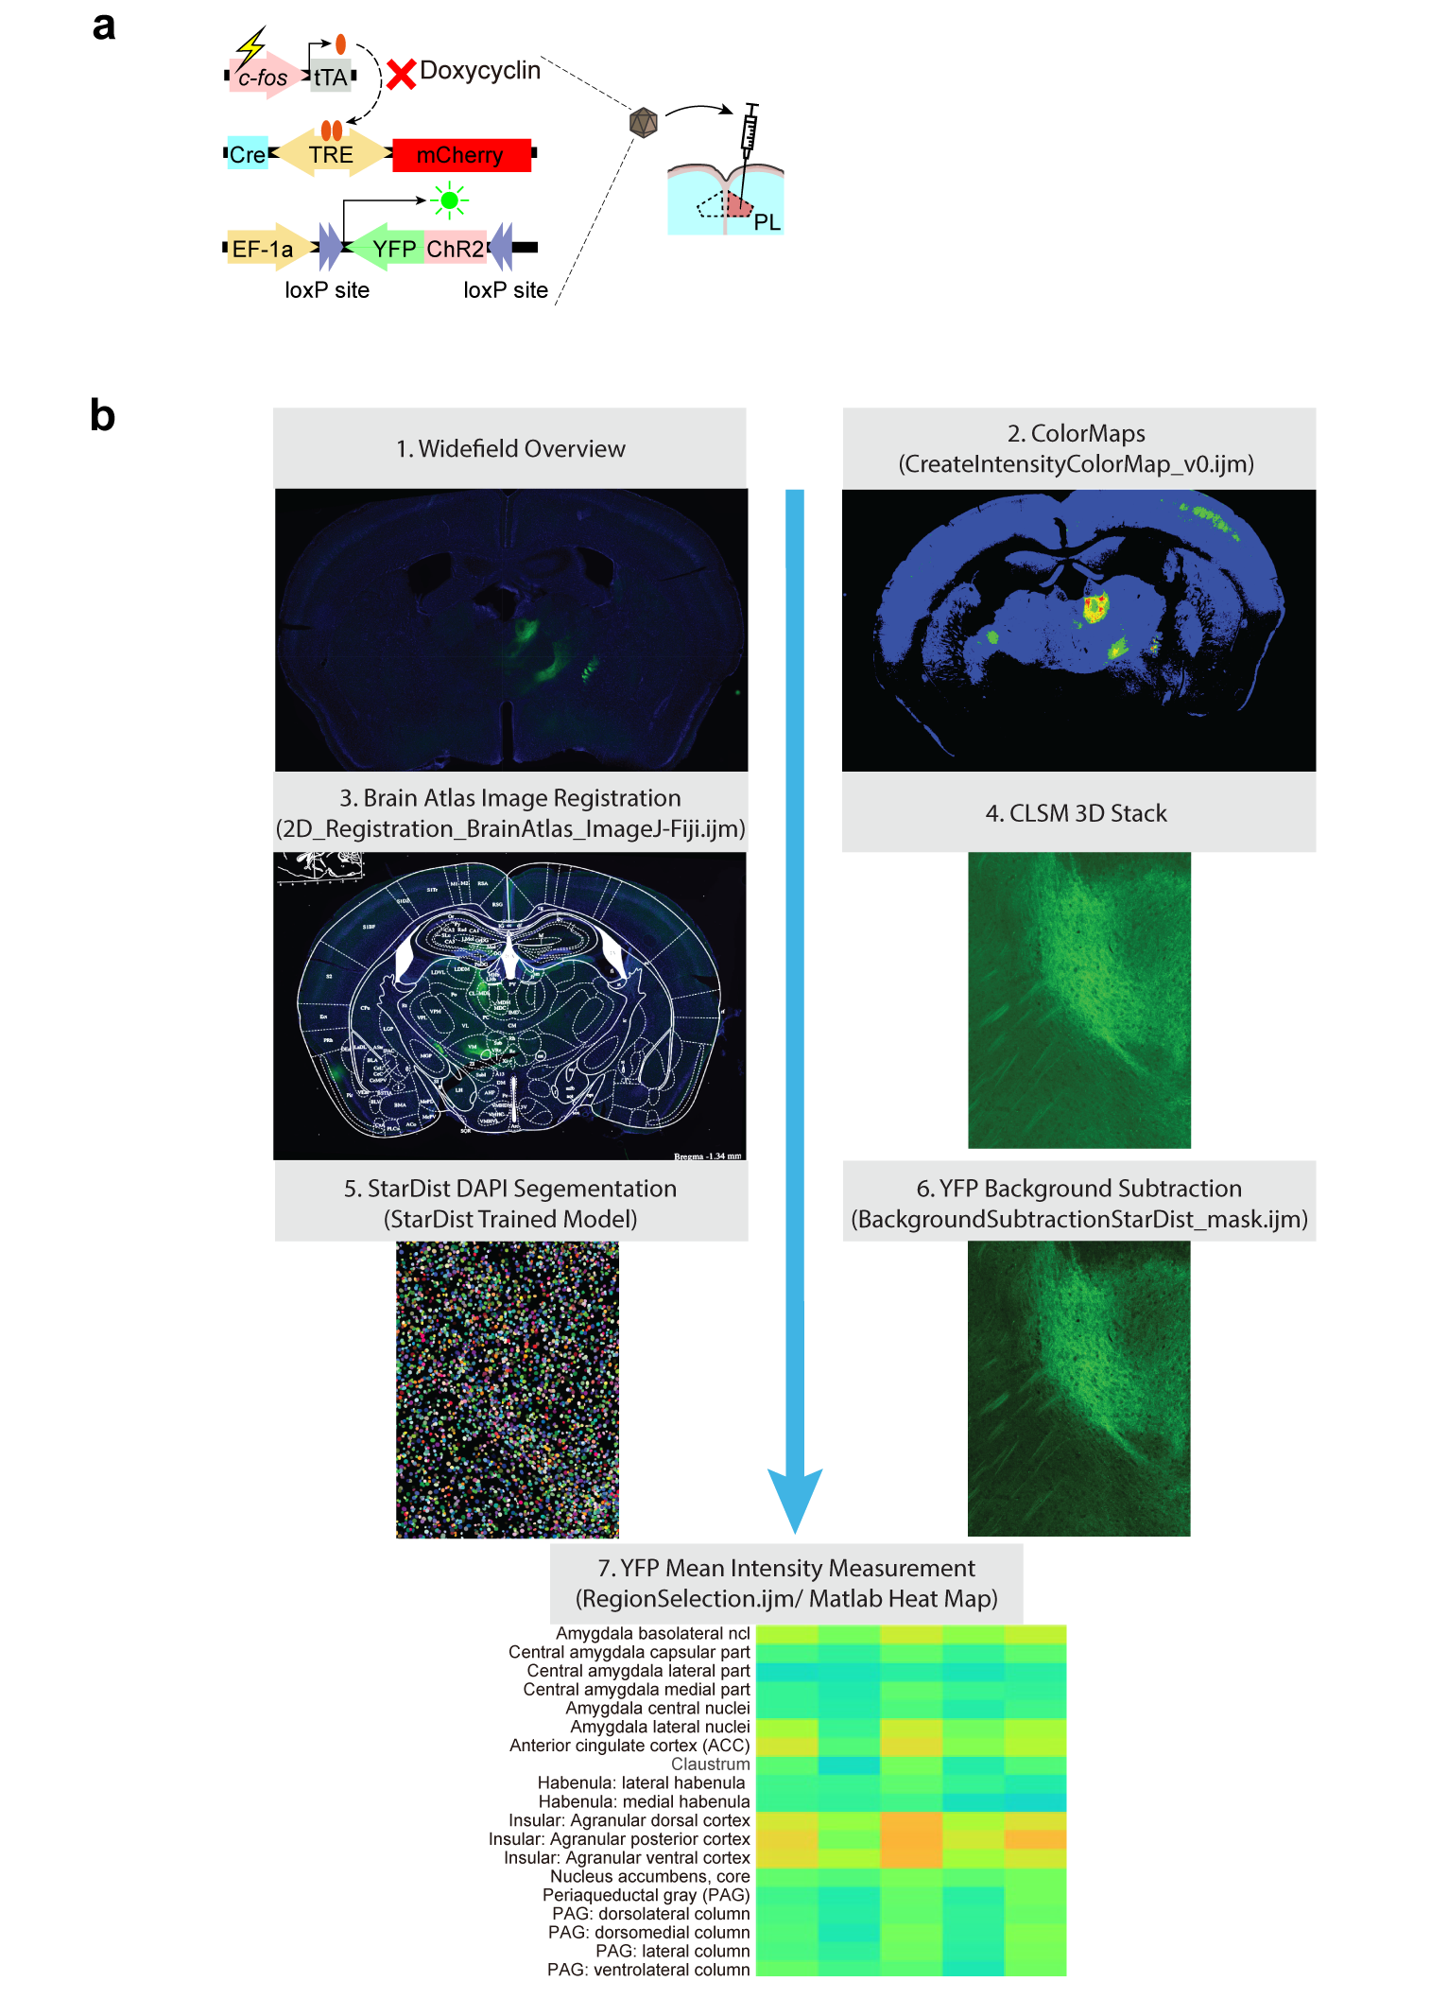
ED Fig. 7: Experimental scheme and analysis strategy for connectivity analysis of specific functional groups of prefrontal neurons
(A) Details of viral constructs employed for activity-dependent labeling of prefrontal neurons and their projections. (B) Steps undertaken for measuring intensity of projections of labelled neurons to specific brain areas and conversion to heat maps for representation.

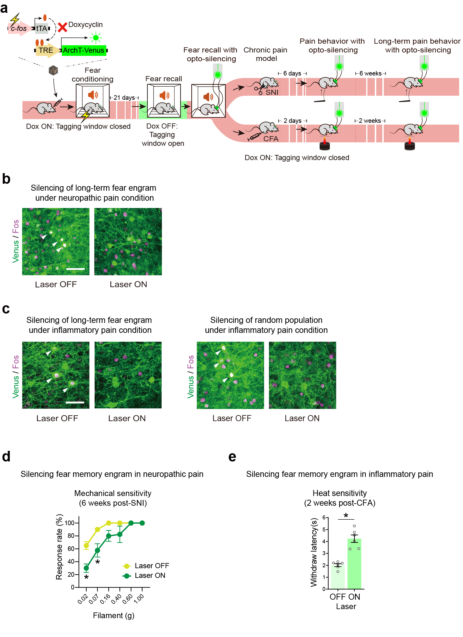
ED Fig. 8: Controls for optogenetic manipulations and testing impact on pain-unrelated aversion in pathological pain
(a) Scheme of tagging prefrontal long term fear memory engram neurons with ArchT and optogenetic silencing of fear memory engram in mice with CFA-induced inflammatory pain and SNI-induced neuropathic pain. (b, c) Typical examples of Fos immunohistochemistry showing validation of optogenetic silencing of prefrontal fear memory engram in mice with nerve injury (b) or inflammatory pain (c, left panel) and silencing of random neurons by synapsin promoter-mediated expression of ArchT in a random population (c, right panel); arrowheads indicate double-labelled neurons and scale bars represent 50 µm. (d, e) Impact of optogenetic silencing of prefrontal long-term fear memory engram on chronic stages of neuropathic mechanical hypersensitivity (6 weeks post-SNI) and inflammatory heat hyperalgesia (2 weeks post-CFA); two-way ANOVA with Tukey’s multiple comparisons test for von Frey behavior and paired t-test for heat sensitivity; * p < 0.05; p < 0.0001 for 0.02 g filament, p = 0.0003 for 0.07 g filament; n = 4 mice/group for SNI. p < 0.0001 for heat sensitivity; n = 6 mice/group for CFA experiments. All data are shown as mean +/- S.E.M.

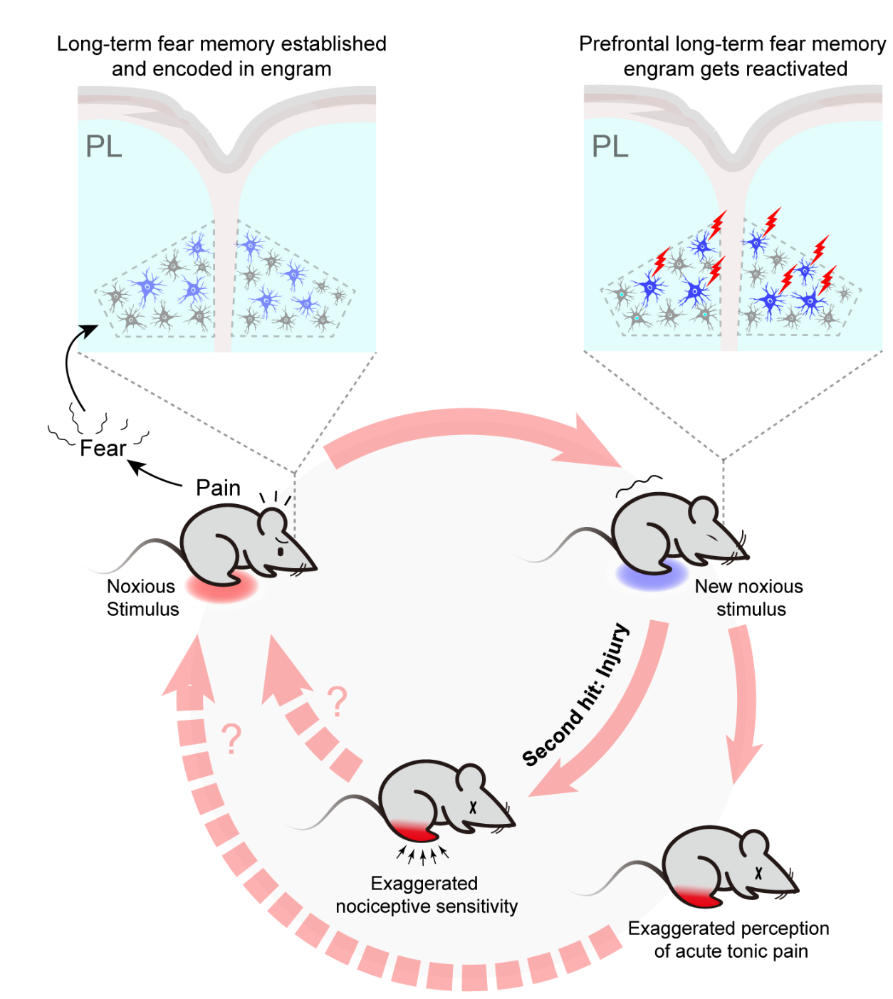

ED Fig. 9: Model based on results of this study to explain the cellular basis of how long-term fear memory induced by a painful episode can alter the perception of tonic pain as well as nociceptive hypersensitivity in chronic neuropathic or inflammatory pain conditions at a remote point in life.

