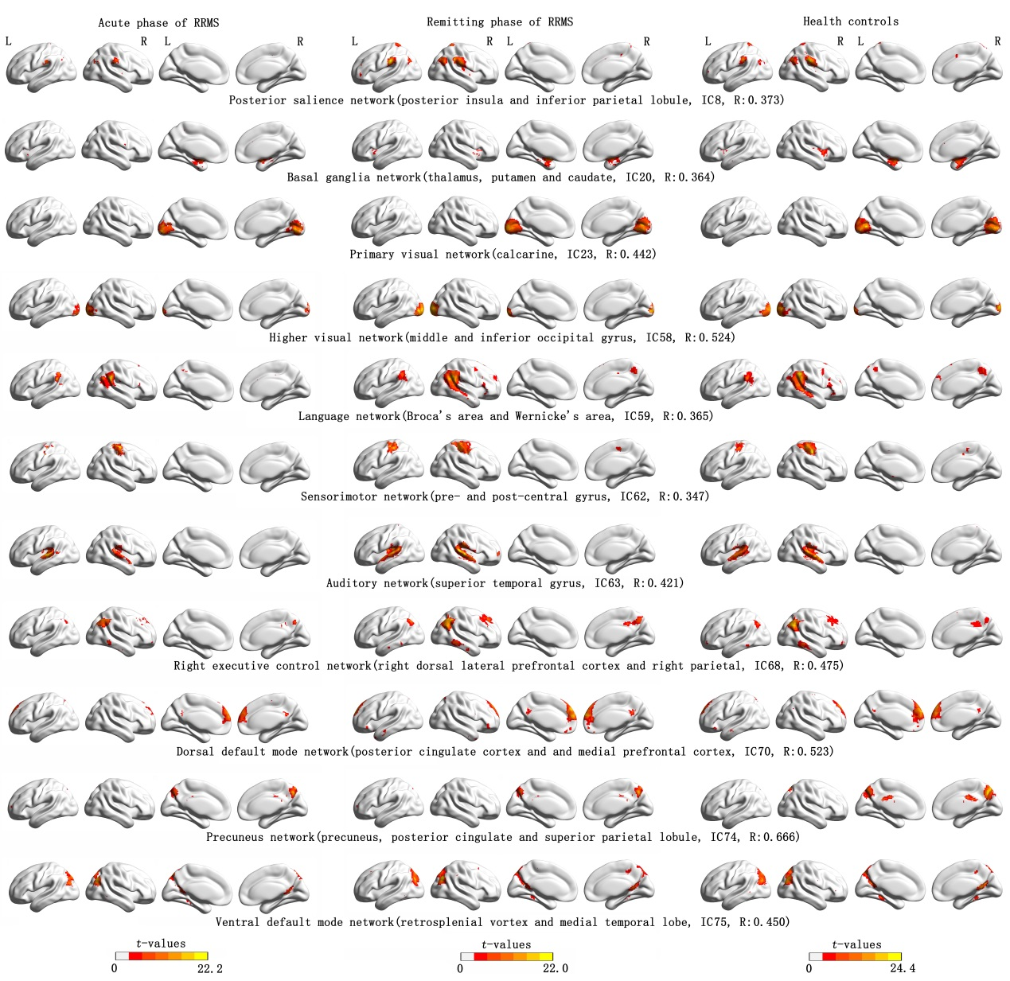
Supplementary Fig. 1 Spatial map of the eleven resting state networks from relapsing-remitting multiple sclerosis and health controls. (one-sample t-test, P = 0.001, FDR correction).
Note: IC x: independent component x obtained by group independent components analysis. R is the highest correlation coefficient which results from the spatial match of the independent components with the offering templates.

Supplementary Fig. 2 Group differences in the GCT between the acute phase RRMS patient and HCs. (P < 0.05, FDR correction).
Note: A> B means component A is larger than component B, eg, in the bar of 10-68, cold-toned (blue) means component 10 is larger than component 68, and warm-toned (red) means component 68 is larger than component 10 in frequency (Hz) of GCT analyses.
Supplementary Fig. 3 Group differences in the GCT between the remitting phase RRMS patient and HCs. (P < 0.05, FDR correction)

