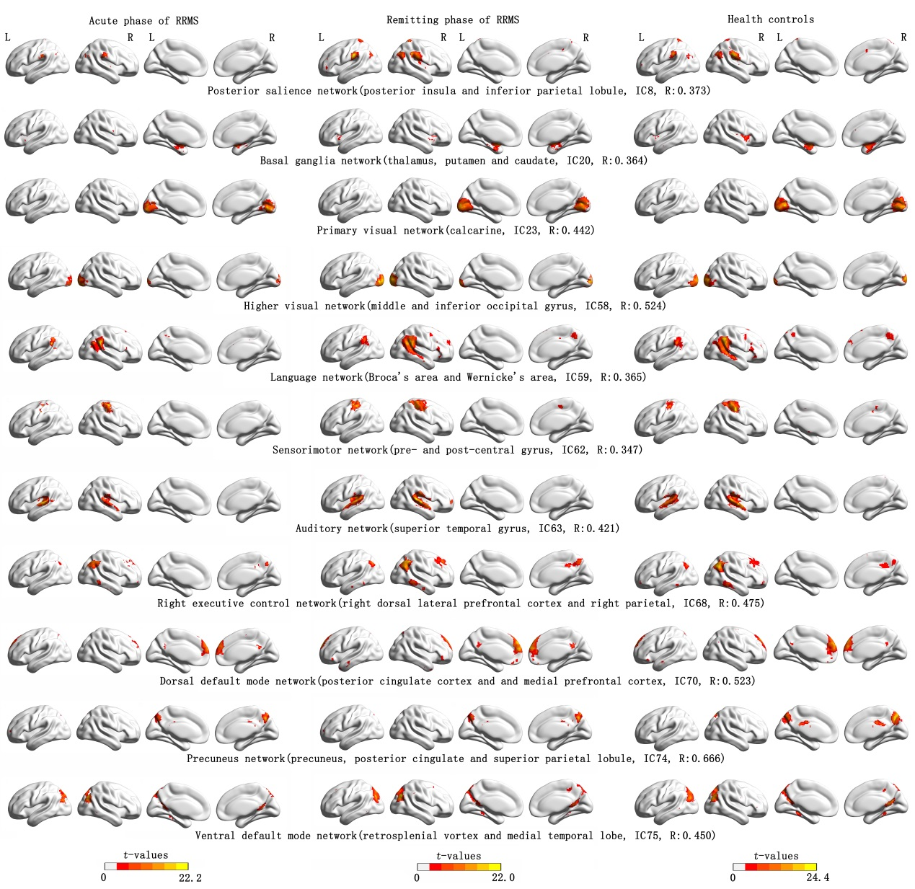
Supplementary Fig. 1 Spatial map of the eleven resting state networks from relapsing-remitting multiple sclerosis and health controls. (one-sample t-test, P = 0.001, FDR correction).
Note: IC x: independent component x obtained by group independent components analysis. R is the highest correlation coefficient which results from the spatial match of the independent components with the offering templates.

