Supplemental materials
Supplemental Figure 1. The overview of study procedure.

Supplemental Figure 2.
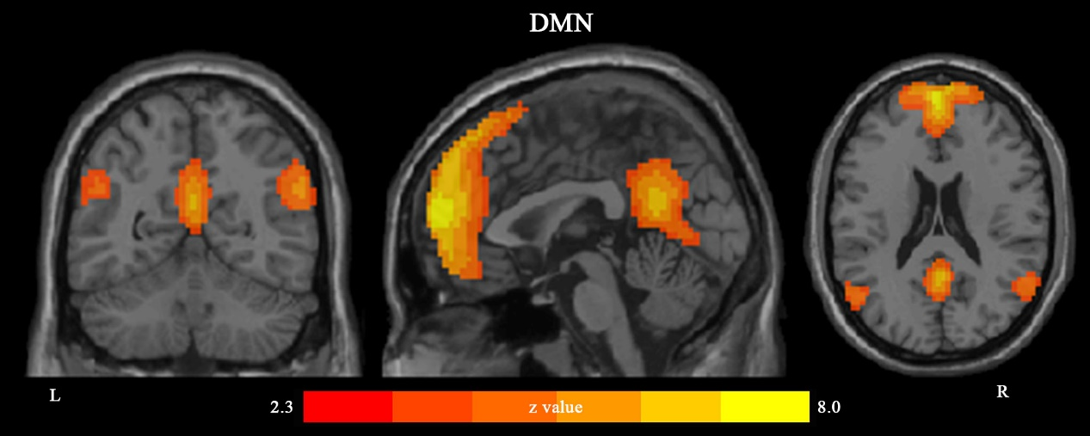
ROIs of the default mode network
ROI | x | y | z | Voxels
MPFC | 0 | 39 | -18 | 2421
PCC | 3 | -75 | 0 | 442
Left-IPL | -51 | -69 | 18 | 281
Right-IPL | 57 | -60 | 15 | 219
MPFC, medial prefrontal cortex; PCC, posterior cingulate cortex; IPL, inferior parietal lobe; ROI, region of interest.
The default mode network (DMN)
The DMN derived from group independent component analyses. Spatial maps for the DMN were converted to z-score images, then thresholded at z > 2.3 and were shown in axial, coronal and sagittal views. The x, y and z refer to the coordinates of peak t statistic value for each cluster in Montreal Neurological Institute space. The right side of the image corresponds to the right hemisphere of the brain. The key DMN regions consisted of the medial prefrontal cortex, posterior cingulate cortex and bilateral inferior parietal lobe.
Supplemental Table 1.
Differences in functional connectivity based on the PCC
Cluster | BA | x | y | z | t | Voxels
HD (pre-rTMS) – HC
left inferior frontal gyrus | 44 | -45 | 6 | 27 | 6.06 | 1311
right precentral gyrus | 6 | 54 | 3 | 27 | 4.29 | 341
HD (post-rTMS) – HC
left precentral gyrus | 6 | -42 | -3 | 33 | 5.71 | 1203
right inferior frontal gyrus | 48 | 36 | 3 | 9 | 5.03 | 1188
HD (post-rTMS) – HD (pre-rTMS)
No significant effects
HD, heroin dependent individuals; HC, healthy controls; BA, Brodmann area; PPC, posterior parietal cortex; rTMS, repeated transcranial magnetic stimulation.
Data accompanies Figure 2. x, y and z refer to the coordinates of peak t statistic for each cluster in Montreal Neurological Institute space.

Supplemental Table 2.
Differences in functional connectivity based on the left IPL
Cluster | BA | x | y | z | t | Voxels
HD (pre-rTMS) – HC
left precentral gyrus | 6 | -45 | -3 | 33 | 5.06 | 681
right inferior frontal gyrus | 44 | 60 | 15 | 15 | 3.98 | 274
HD (post-rTMS) – HC
left precentral gyrus | 4 | -45 | -6 | 30 | 4.53 | 278
right inferior frontal gyrus | 43 | 63 | 0 | 24 | 4.59 | 393
HD (post-rTMS) – HD (pre-rTMS)
left middle frontal gyrus | 8 | -27 | 9 | 60 | -4.78 | 172
right inferior occipital gyrus | 19 | 36 | -90 | -3 | -5.39 | 161
HD, heroin dependent individuals; HC, healthy controls; BA, Brodmann area; IPL, inferior parietal lobe; rTMS, repeated transcranial magnetic stimulation.
Data accompanies Figure 3. The x, y and z refer to the coordinates of peak t statistic for each cluster in Montreal Neurological Institute space.

Supplemental Table 3.
Differences in functional connectivity based on the right IPL
Cluster | BA | x | y | z | t | Voxels
HD (pre-rTMS) – HC
left precentral gyrus | 6 | -39 | 0 | 33 | 5.88 | 251
right precentral gyrus | 6 | 42 | 0 | 39 | 4.48 | 364
HD (post-rTMS) – HC
No significant effects
HD (post-rTMS) – HD (pre-TMS)
No significant effects
HD, heroin dependent individuals; HC, healthy controls; BA, Brodmann area; IPL, inferior parietal lobe; rTMS, repeated transcranial magnetic stimulation.
Data accompanies Figure 4. The x, y and z refer to the coordinates of peak t statistic for each cluster in Montreal Neurological Institute space.

