Supporting Information
In-situ Synthesis of Flexible Nanocellulose/Carbon Nanotube/Polypyrrole Hydrogels for High-performance Solid-state Supercapacitors

Yang Zhan^{a,1}, Yang Hu^{a,1}, Yu Chenª, Quanling Yang^{a,}*, Zhuqun Shi^{b,}*, Chuanxi Xiong^{a,}*
ª School of Materials Science and Engineering, Wuhan University of Technology, Luoshi Road 122, Wuhan 430070, China.
^{b} School of Chemistry, Chemical Engineering and Life Sciences, Wuhan University of Technology, Luoshi Road 122, Wuhan 430070, China.

*Corresponding author. E-mail: yangql@whut.edu.cn (Q.Y.); zqshi2016@whut.edu.cn (Z.S.); cxiong@whut.edu.cn (C.X.).

¹These authors contribute equally.
Number of pages: 3; Number of tables: 0; Number of figures: 5
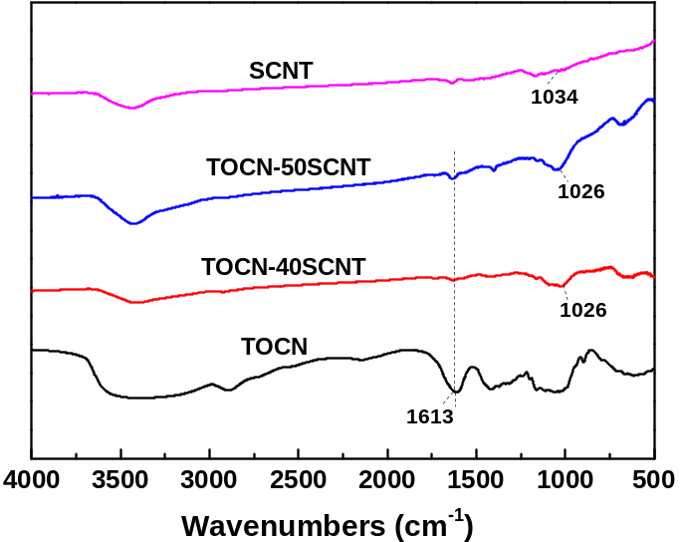
Fig. S1 FT-IR spectra of TOCN, SCNT, PPy and TOCN/SCNT aerogels.
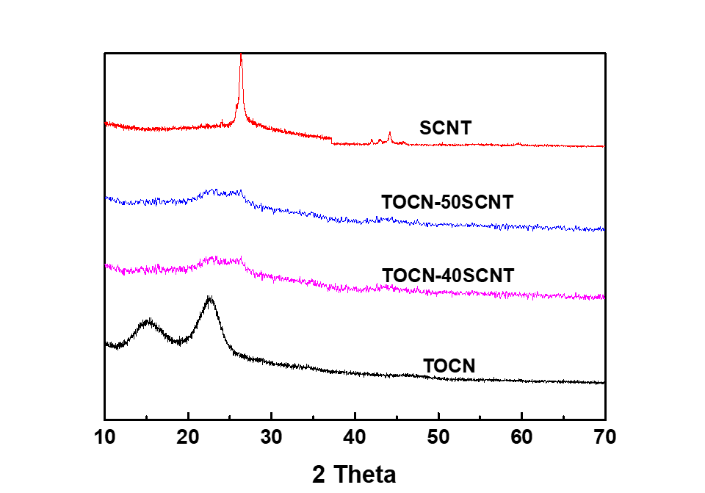
Fig. S2 XRD patterns of TOCN, SCNT and TOCN/SCNT aerogels.

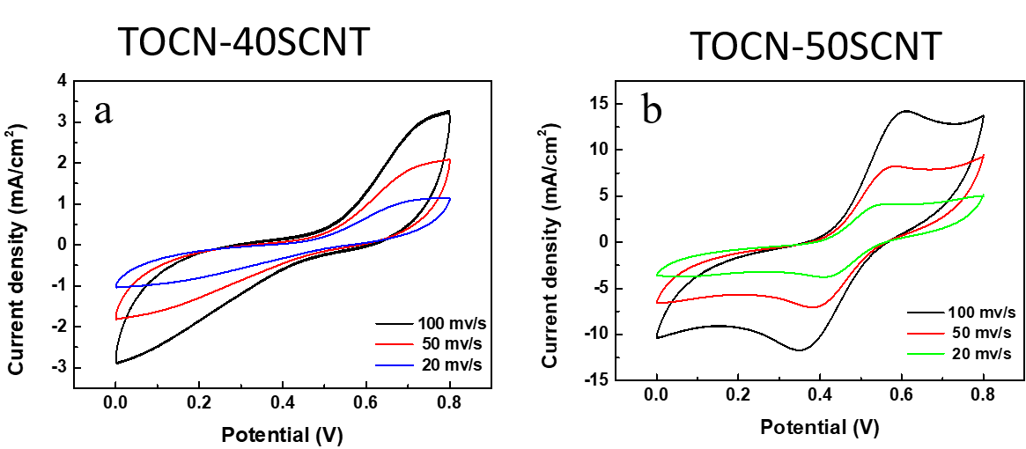
Fig. S3 CV curves of (a) TOCN-40SCNT-PPy and (b) TOCN-50SCNT-PPy hydrogel electrodes.
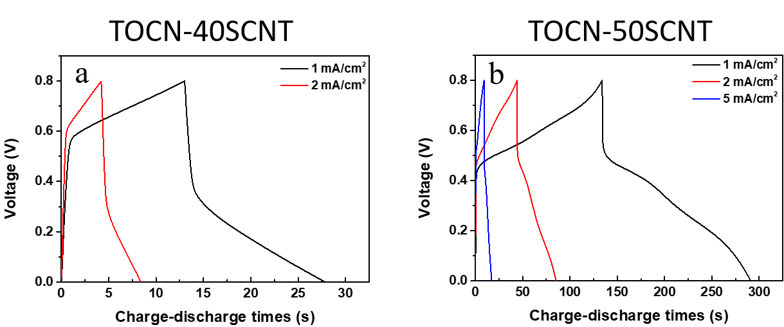
Fig. S4 Galvanostatic charge-discharge (GCD) curves of (a) TOCN-40SCNT and (b) TOCN-50SCNT at different current densities.

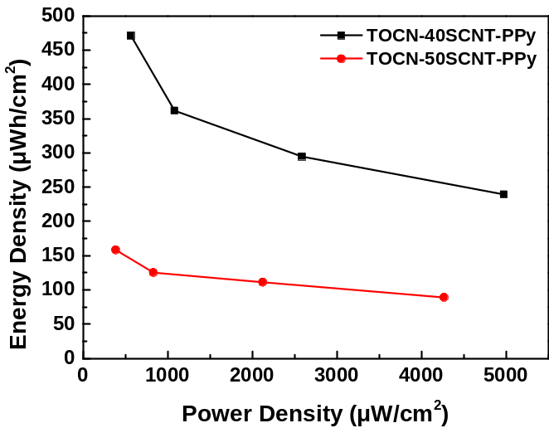
Fig. S5 The ragone plots of various TOCN/SCNT/PPy.
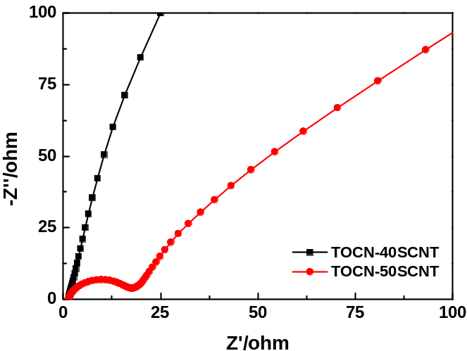
Fig. S6 Nyquist impedance spectra of TOCN-40SCNT and TOCN-50SCNT hydrogels.

