Supplementary information

Surface curvature dominated guest-induced nonequilibrium deformations of single covalent organic framework-300 particles

Guihua Zhang⁺, Xinyi Zou⁺, Qianxi Wang, Yi He*

National Collaborative Innovation Center for Nuclear Waste and Environmental Safety, School of National Defence Science & Technology, Southwest University of Science and Technology, Mianyang 621010, P. R. China.
⁺These authors contributed equally.
*Corresponding author: Prof. Dr. Yi He, Tel: +86-816-6089885, Fax: +86-816-6089889, Email: yhe2014@126.com.

Characterizations
PXRD patterns are recorded on a PANalytical X' Pert Pro diffractometer. X-ray photoelectron spectroscopy measurements are performed on an ESCALAB 250Xi spectrometer. Scanning electron microscope images are conducted on a Zeiss Ultra 55 field-emission electron microscope. Fourier transformation infrared absorption spectra are collected from a Spectrum One Autoima spectrometer. The solid-state ¹³C nuclear magnetic resonance spectroscopy is carried out on a Bruker AVANCE III HD 400MHz spectrometer with cross polarization and magic-angle spinning.
Theoretical calculations
First-principles calculations are carried out on Forcite and Gaussian 09 software packages. The geometries of COF-300 and curved COF-300 with adsorbed dichloromethane are optimized by using the COMPASS (version 2.8) forcefield. The cutoff distances is set as 15.5 Å. The convergence tolerance of energy and force is selected as 10⁻⁴ kcal/mol and 5 ×10⁻³ kcal/mol/Å, respectively. The adsorption energy of dichloromethane on COF-300 crystal (E_{adsorption}) is calculated by the equation S1:
E_{adsorption} = E_{total} – E_{COF-300} – E_{dichloromethane} (S1)
Where E_{total} is the total energy of this system, E_{COF-300} and E_{dichloromethane} stand for the energy of COF-300 and dichloromethane.
To calculate the noncovalent interaction of COF-300 and dichloromethane, the COF-300-dichloromethane complex is geometrically optimized by Gaussian 09 at the B3LYP-6-311G level of the theory for the density functional theory part. The optimized structure is then analyzed with Multiwfn.
Movies
Movie 1 and 2 are quickly displayed by 5 times.

Figure S1. SEM image of COF-300 crystals with an average longitudinal size of 1.1 μm.

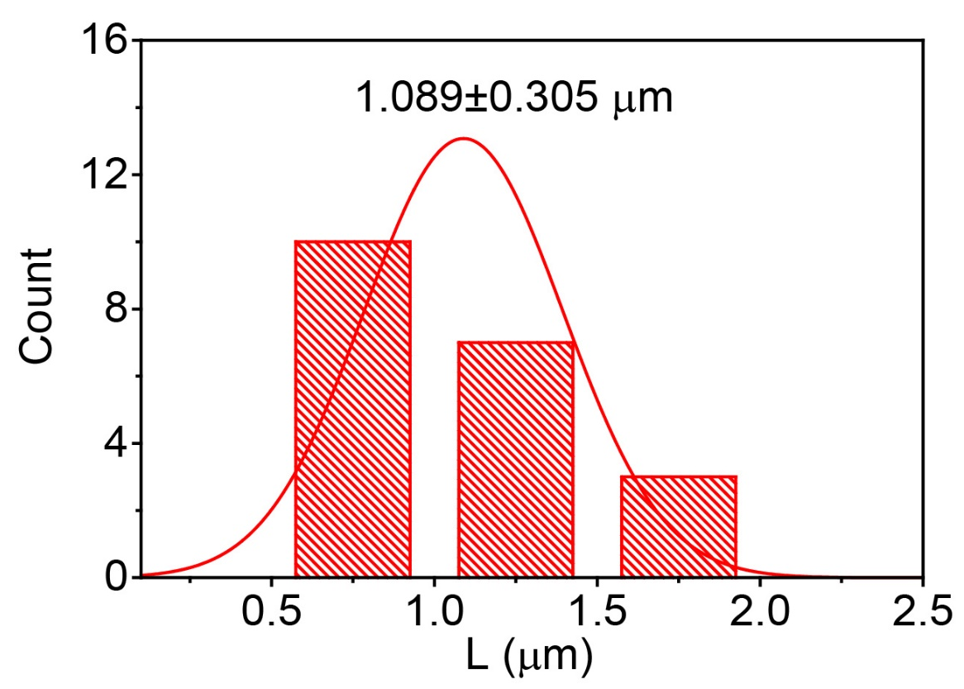
Figure S2. Particle size distribution for COF-300 crystals in Figure S1.

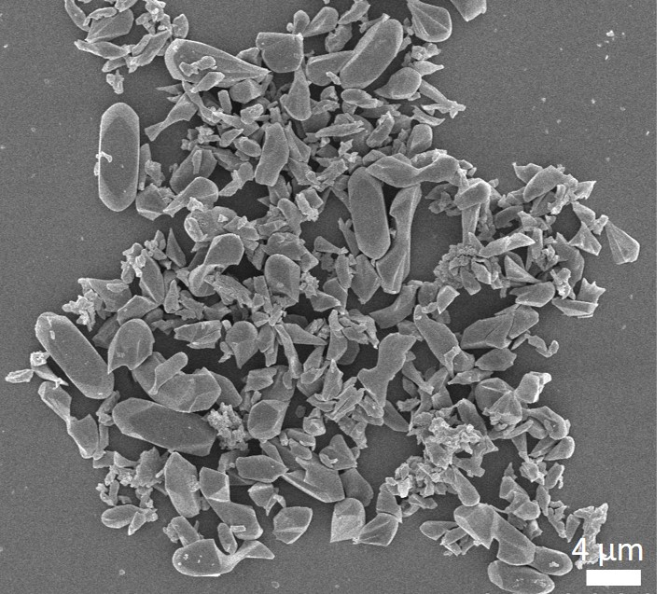
Figure S3. SEM image of COF-300 crystals with an average longitudinal size of 7.3 μm.

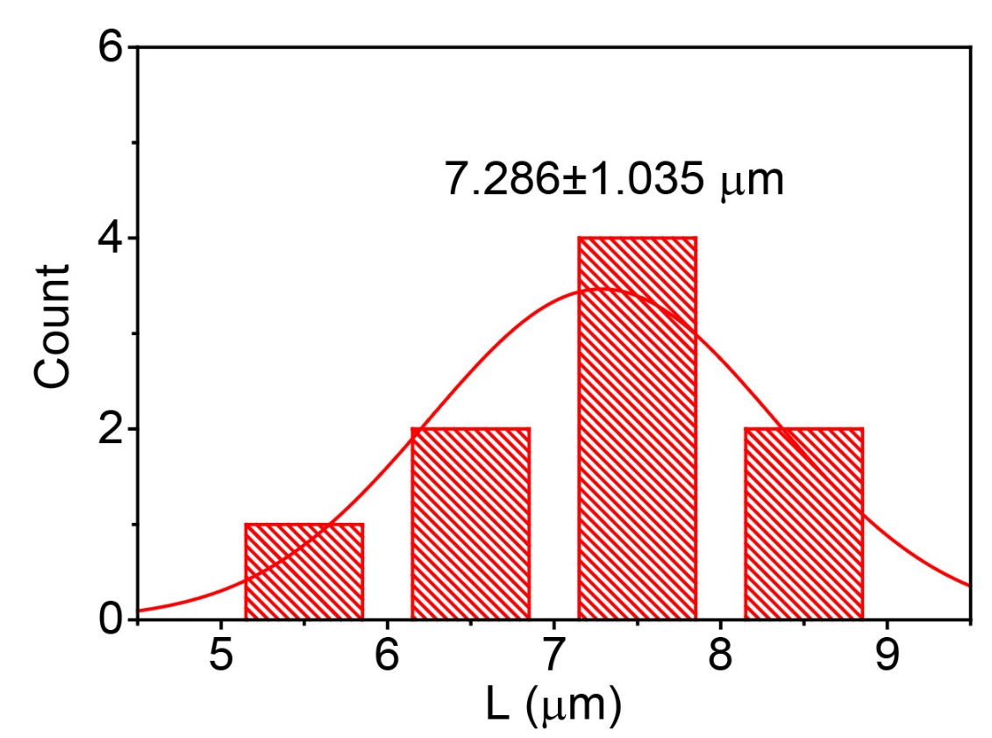
Figure S4. Particle size distribution for COF-300 crystals in Figure S3.

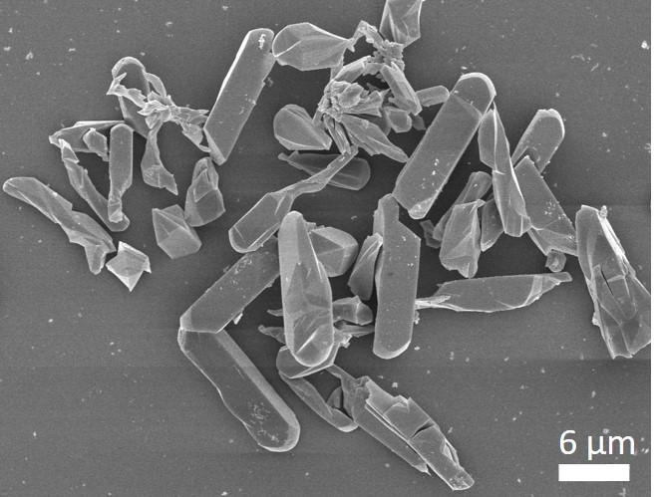
Figure S5. SEM image of COF-300 crystals with an average longitudinal size of 13.9 μm.

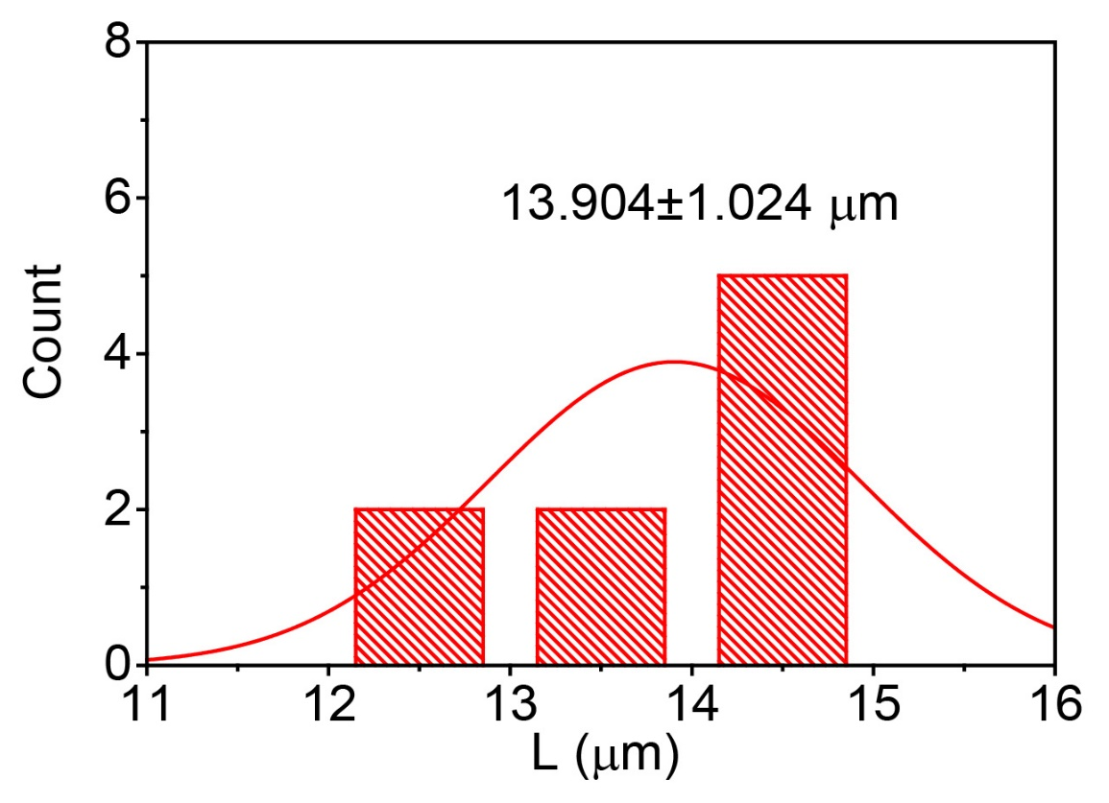
Figure S6. Particle size distribution for COF-300 crystals in Figure S5.

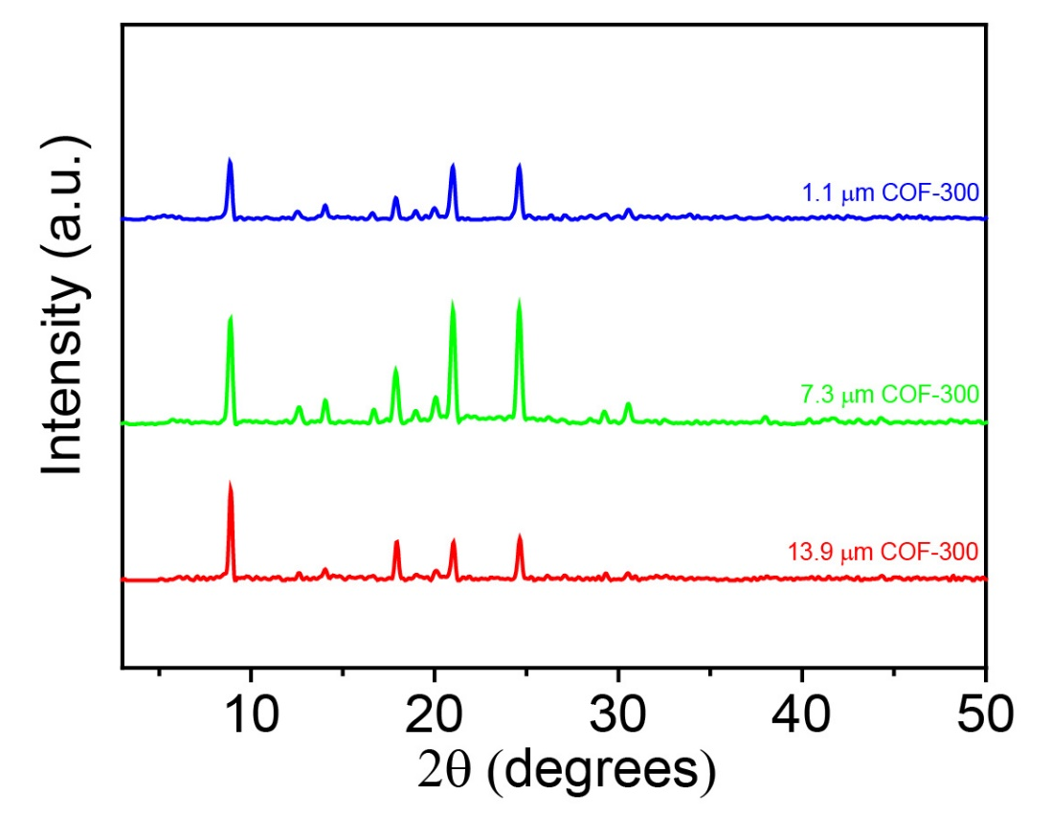
Figure S7. PXRD patterns of COF-300 crystals with different longitudinal lengths.

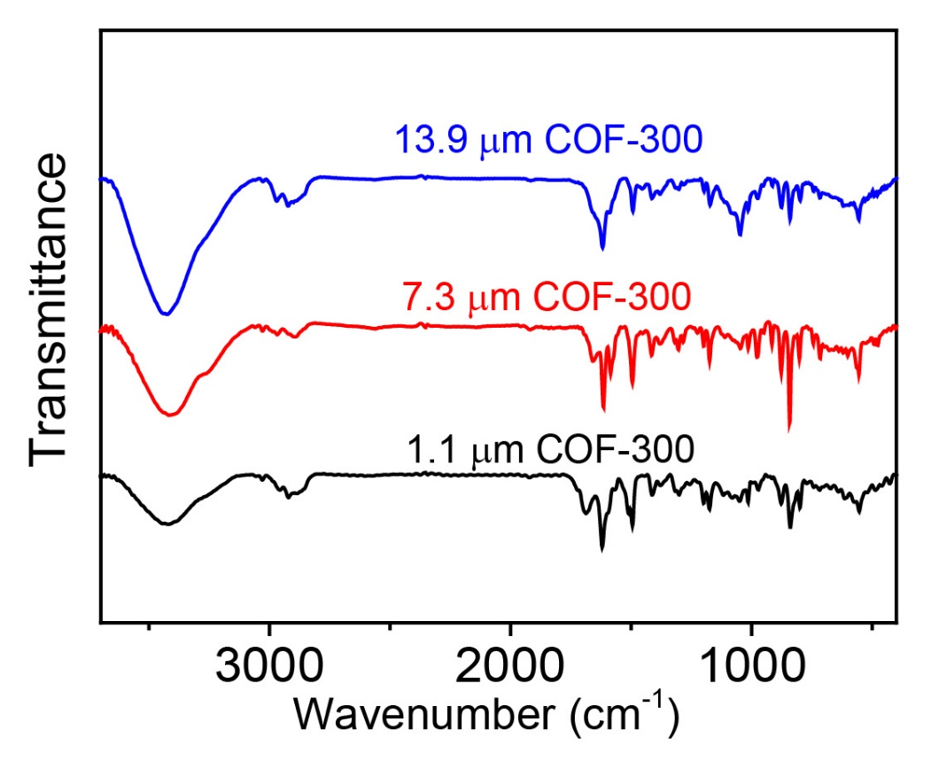
Figure S8. FT-IR absorption spectra of COF-300 crystals with different longitudinal lengths.

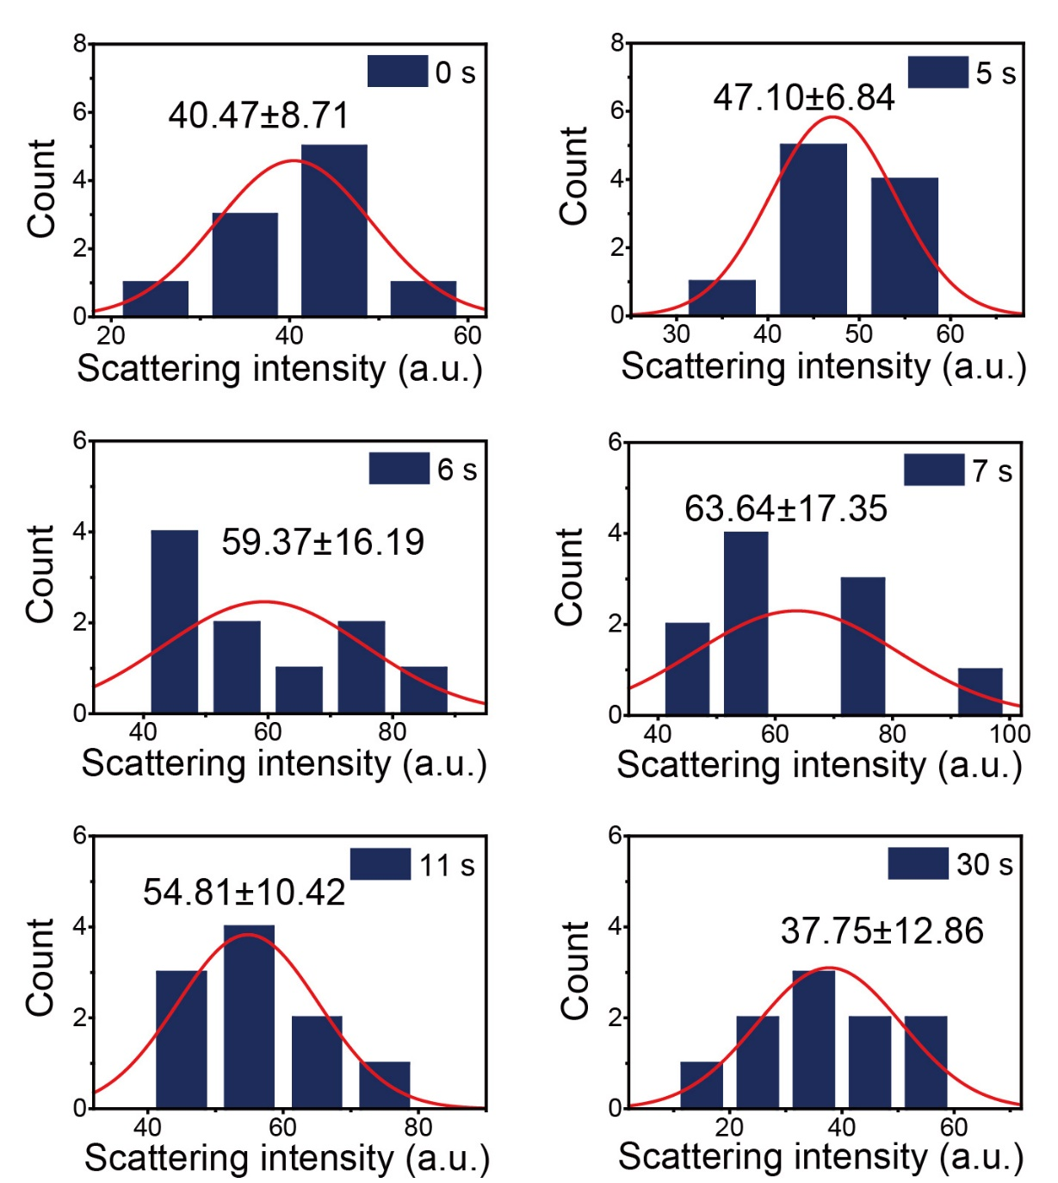
Figure S9. Statistical analysis of the scattering intensity for COF-300 crystals upon exposure to 0.71 bar dichloromethane with one expansion-contraction process at different reaction time.

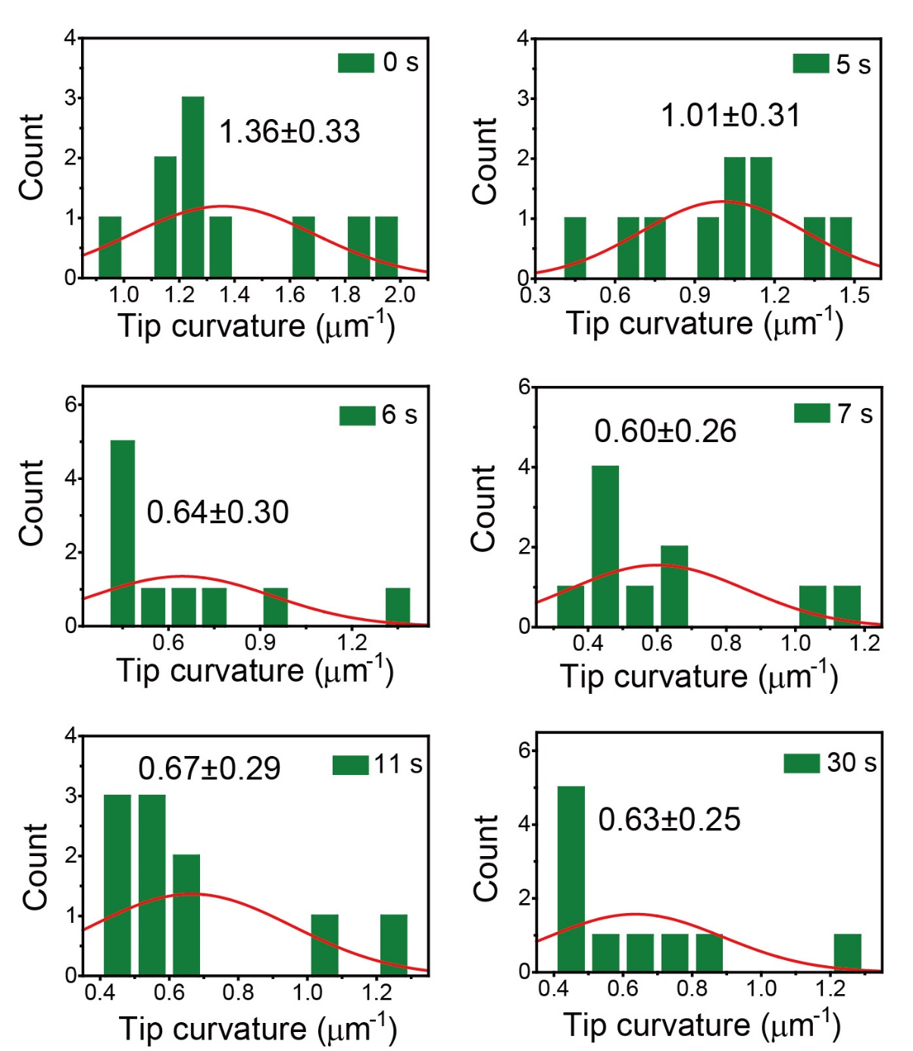
Figure S10. Statistical analysis of the tip curvature for COF-300 crystals upon exposure to 0.71 bar dichloromethane with one expansion-contraction process at different reaction time.

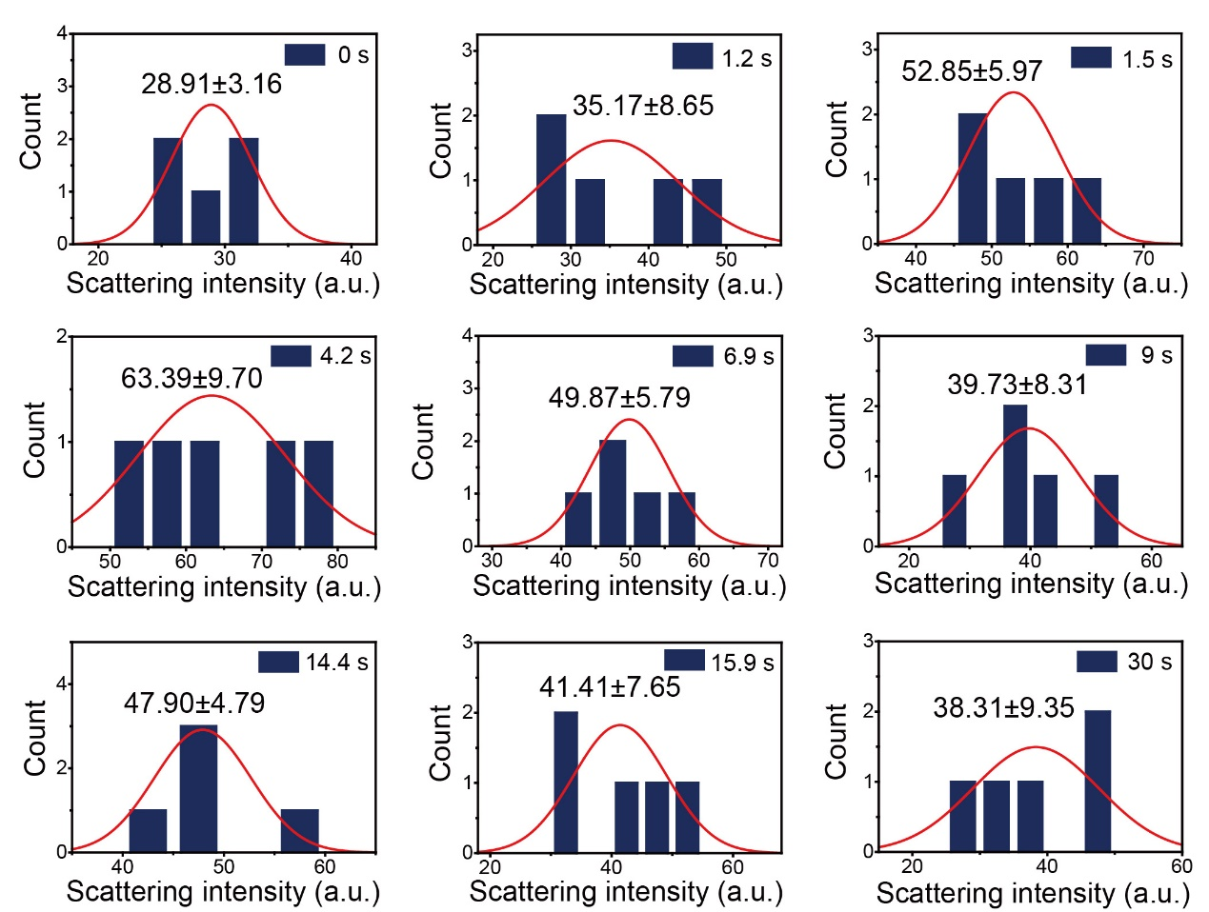
Figure S11. Statistical analysis of the scattering intensity for COF-300 crystals upon exposure to 0.71 bar dichloromethane with two expansion-contraction processes at different reaction time.

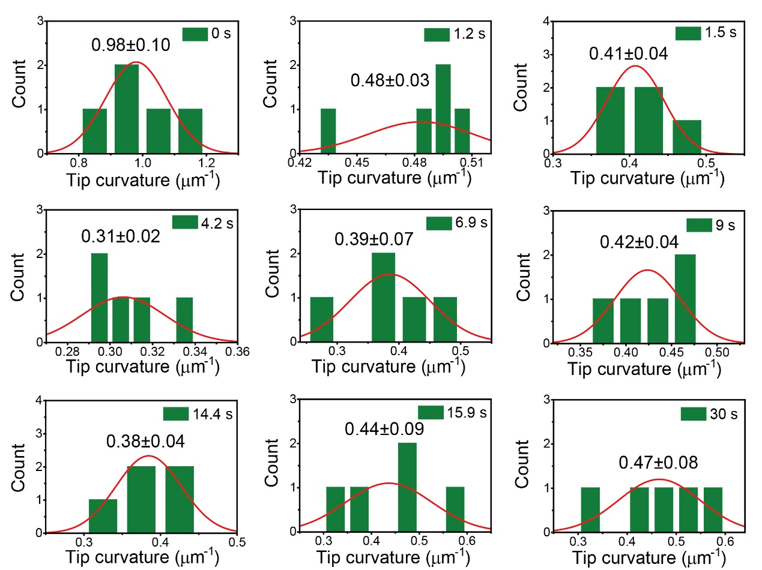
Figure S12. Statistical analysis of the tip curvature for COF-300 crystals upon exposure to 0.71 bar dichloromethane with two expansion-contraction processes at different reaction time.

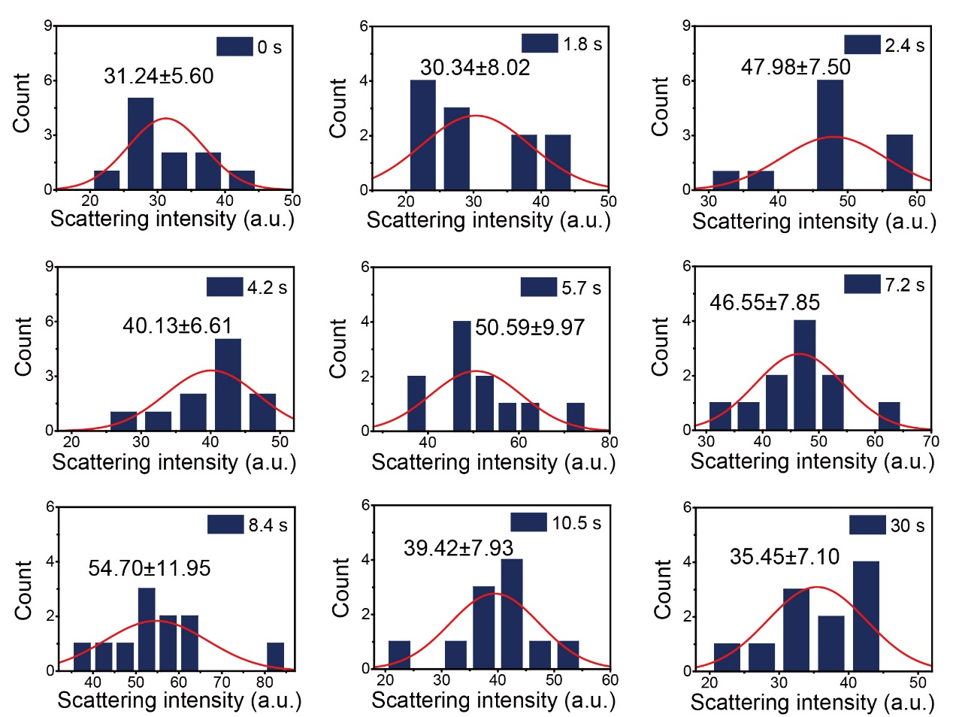
Figure S13. Statistical analysis of the scattering intensity for COF-300 crystals upon exposure to 0.71 bar dichloromethane with multiple expansion-contraction processes at different reaction time.

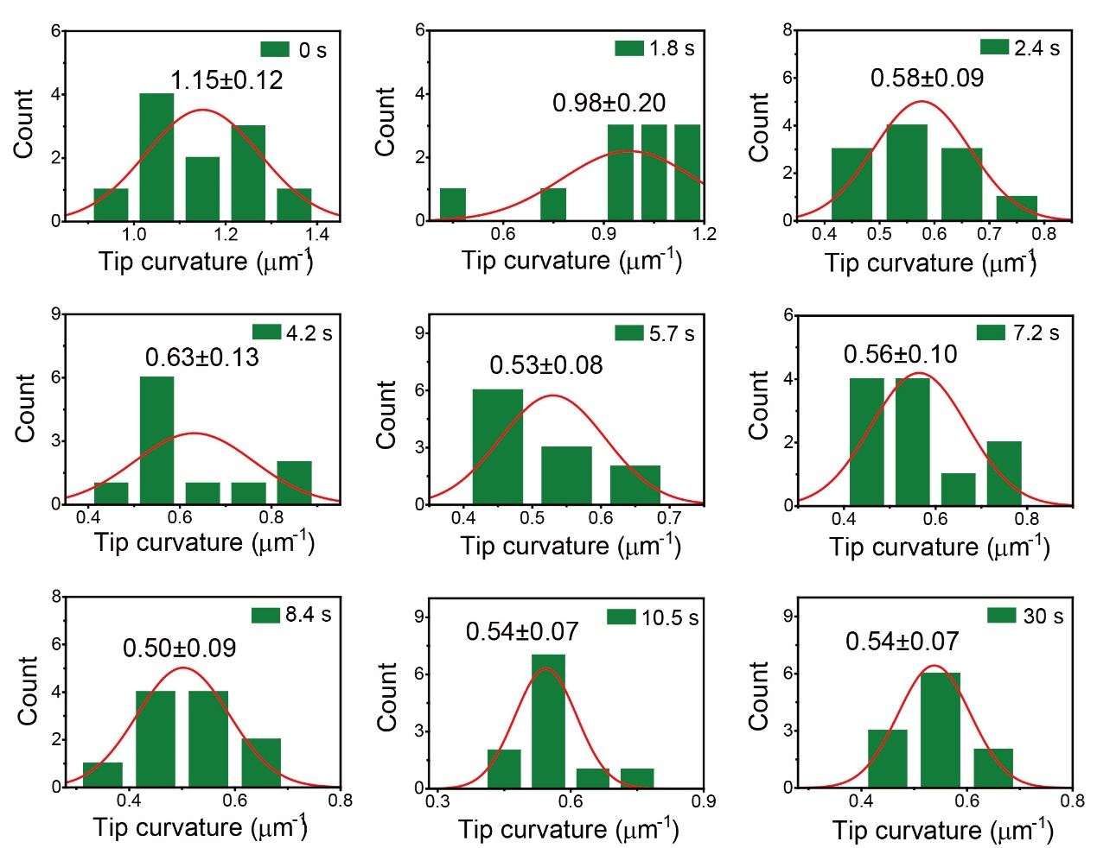
Figure S14. Statistical analysis of the tip curvature for COF-300 crystals upon exposure to 0.71 bar dichloromethane with multiple expansion-contraction processes at different reaction time.

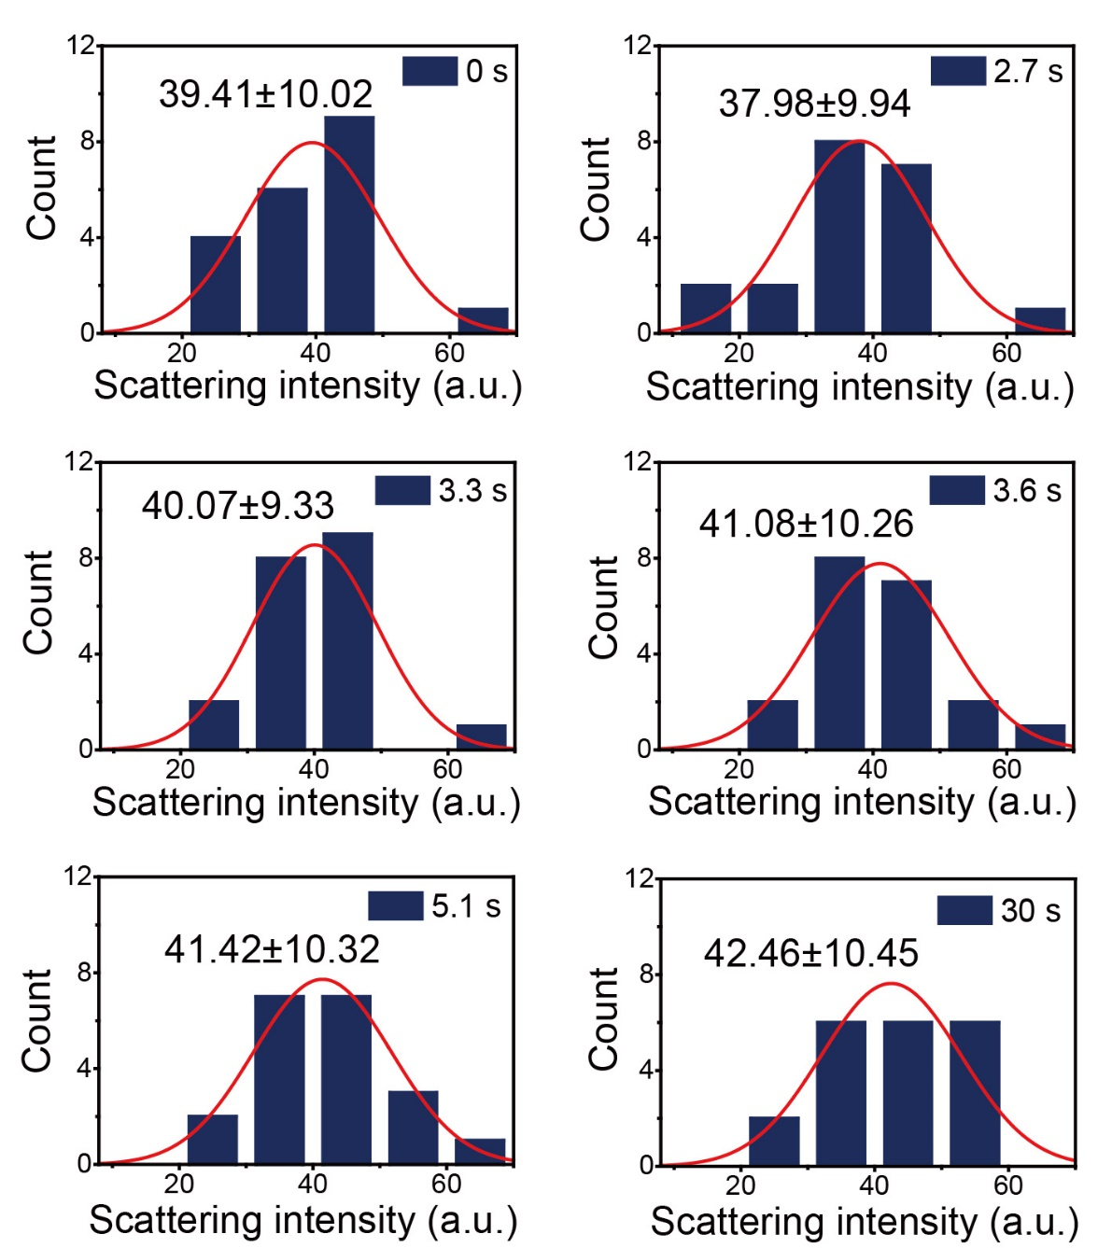
Figure S15. Statistical analysis of the scattering intensity for COF-300 crystals upon exposure to 0.71 bar dichloromethane with a contraction-expansion process at different reaction time.

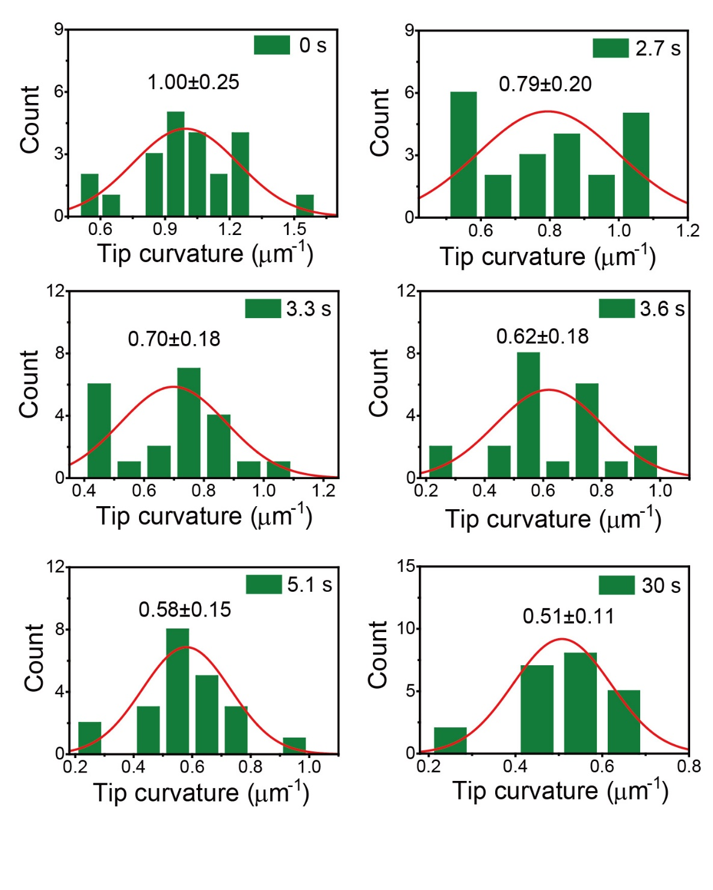
Figure S16. Statistical analysis of the tip curvature for COF-300 crystals upon exposure to 0.71 bar dichloromethane with a contraction-expansion process at different reaction time.

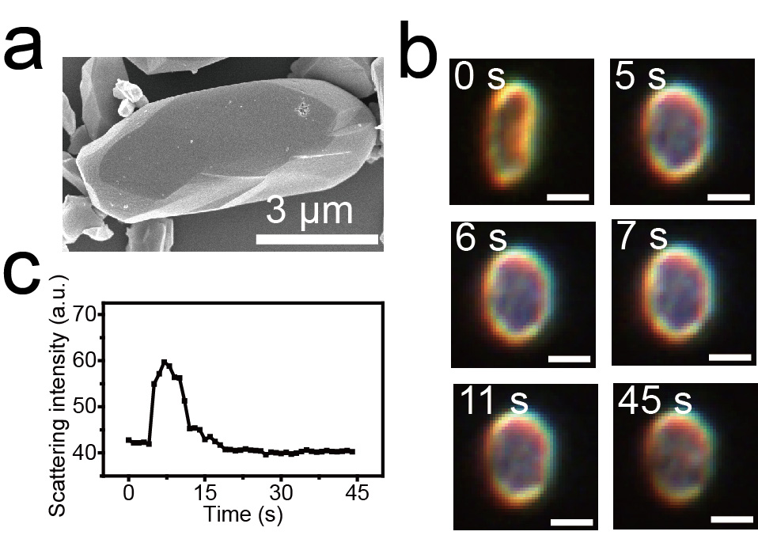
Figure S17. (a) SEM image, (b) time-sequential DFM images and (c) scattering intensity of an irregular COF-300 crystal with a longitudinal size of 7.7 μm upon exposure to 0.71 bar dichloromethane. Scale bar: 5 μm.

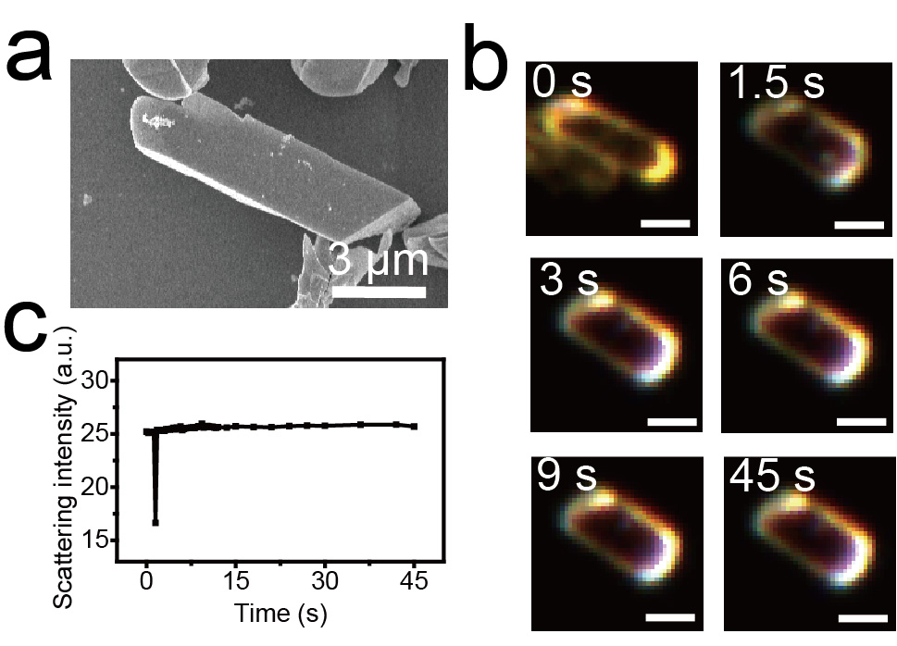
Figure S18. (a) SEM image, (b) time-sequential DFM images and (c) scattering intensity of an irregular COF-300 crystal with a longitudinal size of 13.3 μm upon exposure to 0.71 bar dichloromethane. Scale bar: 5 μm.

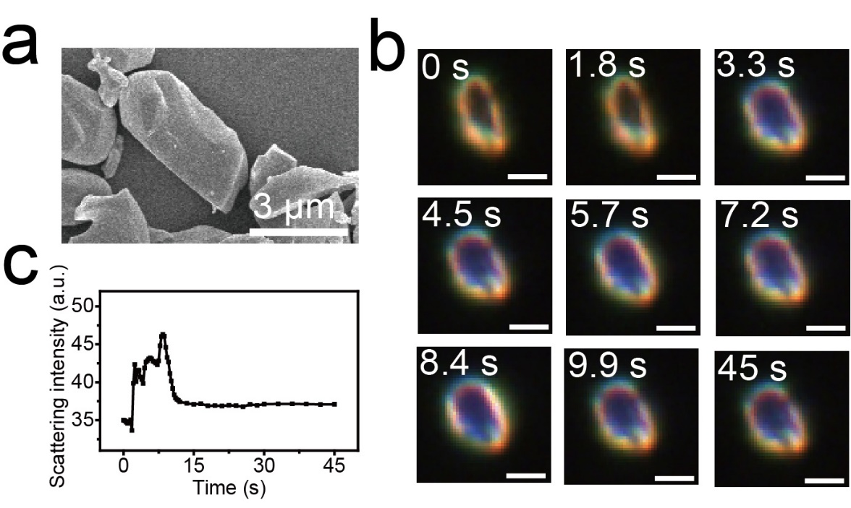
Figure S19. (a) SEM image, (b) time-sequential DFM images and (c) scattering intensity of an irregular COF-300 crystal with a longitudinal size of 5.5 μm upon exposure to 0.71 bar dichloromethane. Scale bar: 5 μm.

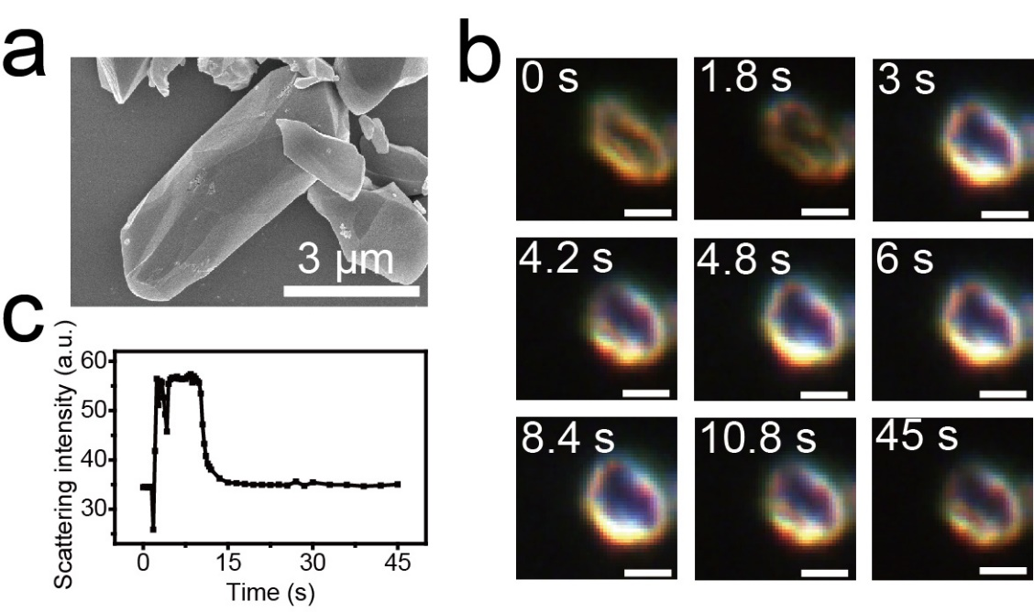
Figure S20. (a) SEM image, (b) time-sequential DFM images and (c) scattering intensity of an irregular COF-300 crystal with a longitudinal size of 6.3 μm upon exposure to 0.71 bar dichloromethane. Scale bar: 5 μm.

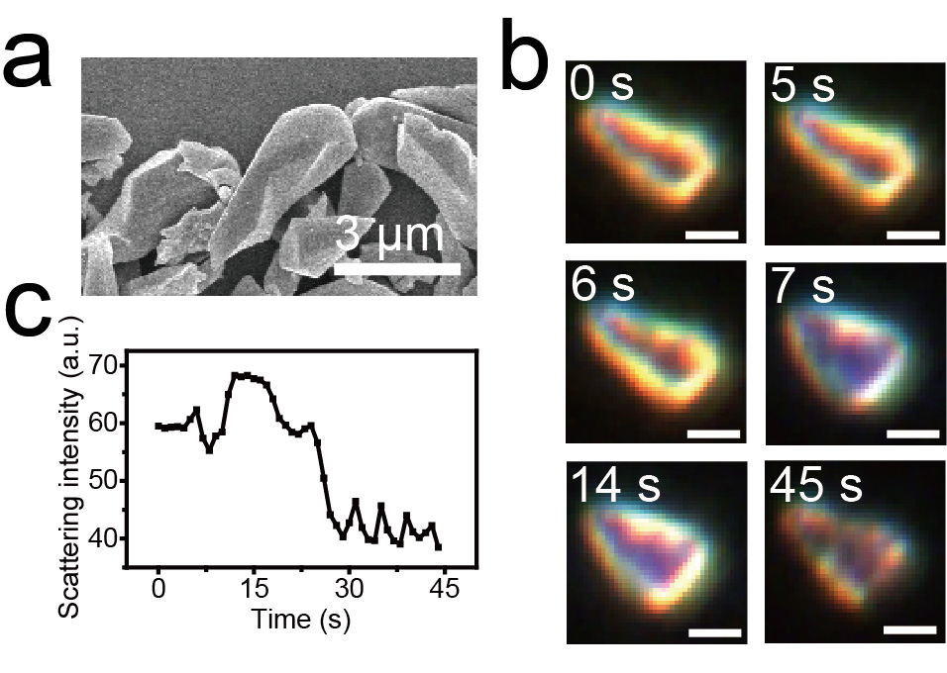
Figure S21. (a) SEM image, (b) time-sequential DFM images and (c) scattering intensity of an irregular COF-300 crystal with a longitudinal size of 5.4 μm upon exposure to 0.71 bar dichloromethane. Scale bar: 5 μm.

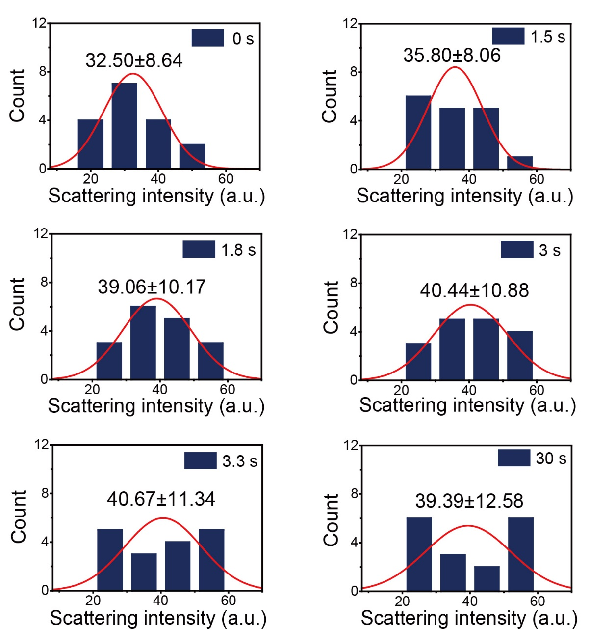
Figure S22. Statistical analysis of the scattering intensity for COF-300 crystals upon exposure to 0.69 bar trichlormethane at different reaction time.

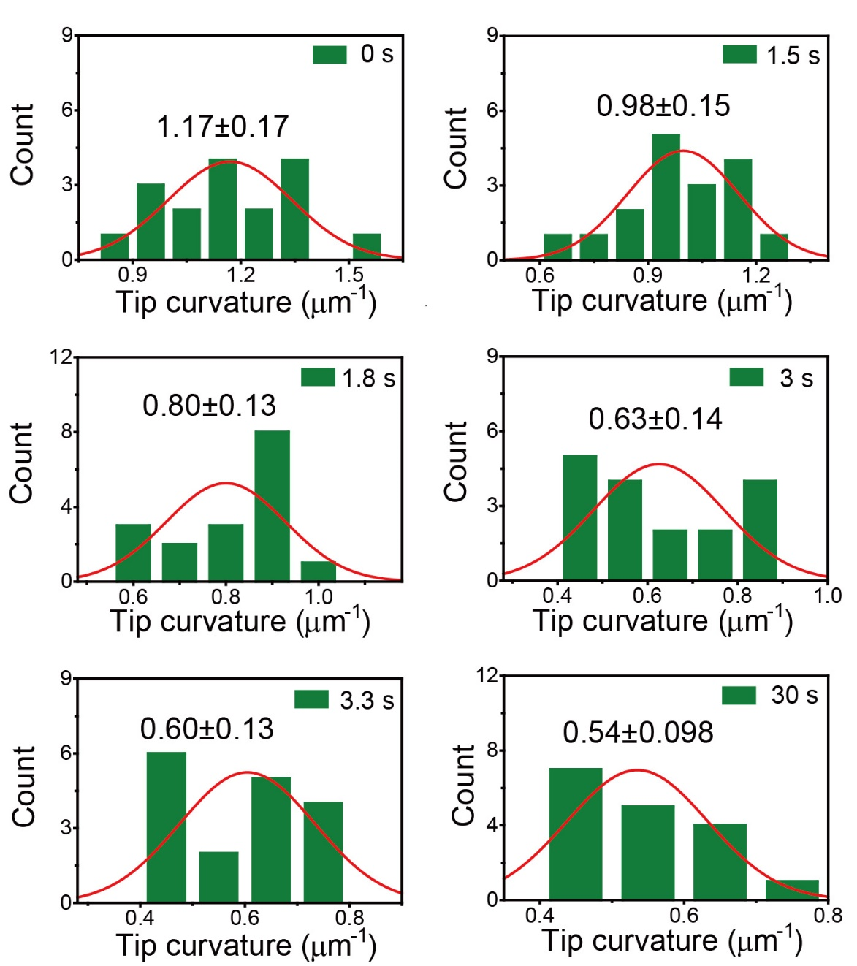
Figure S23. Statistical analysis of the tip curvature for COF-300 crystals upon exposure to 0.69 bar trichlormethane at different reaction time.

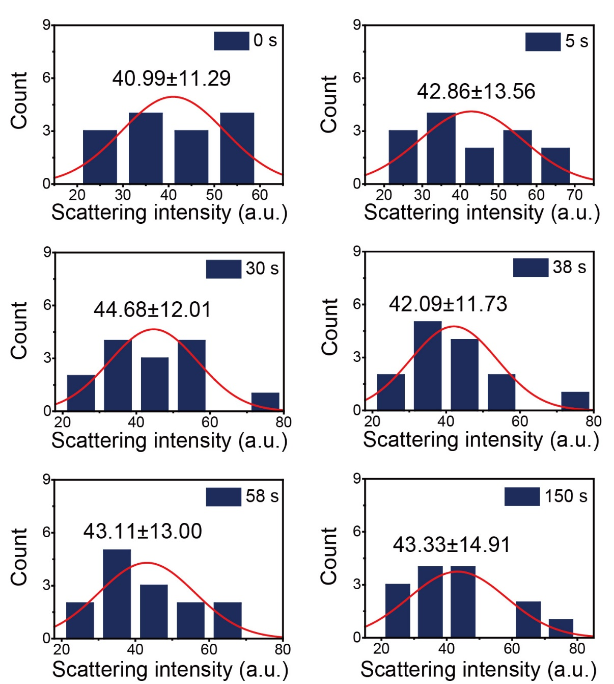
Figure S24. Statistical analysis of the scattering intensity for COF-300 crystals upon exposure to 1.1 bar tetrachloromethane at different reaction time.

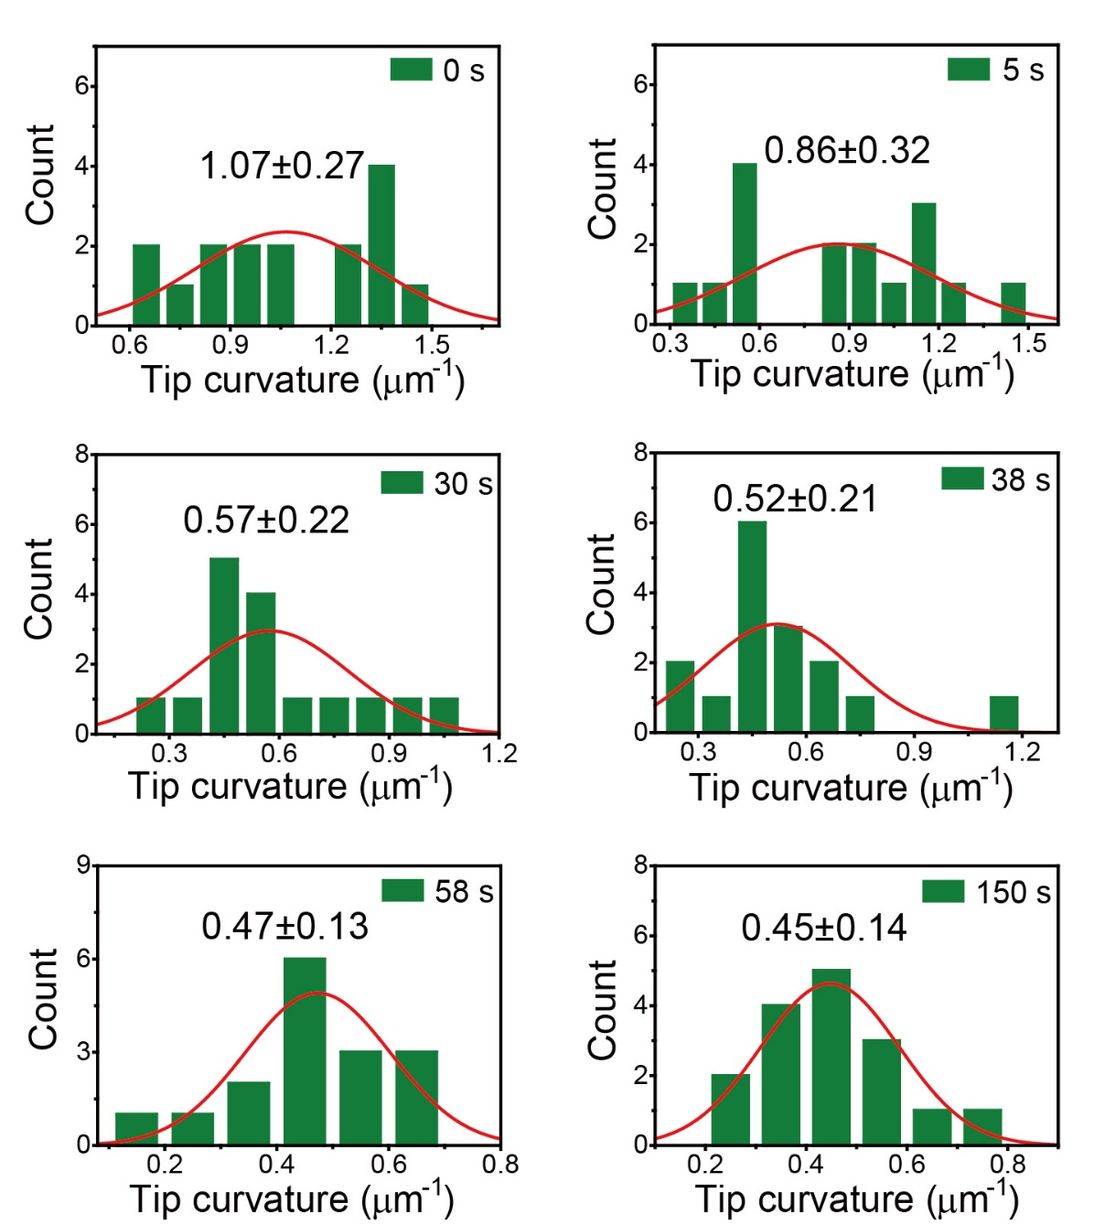
Figure S25. Statistical analysis of the tip curvature for COF-300 crystals upon exposure to 1.1 bar tetrachloromethane at different reaction time.

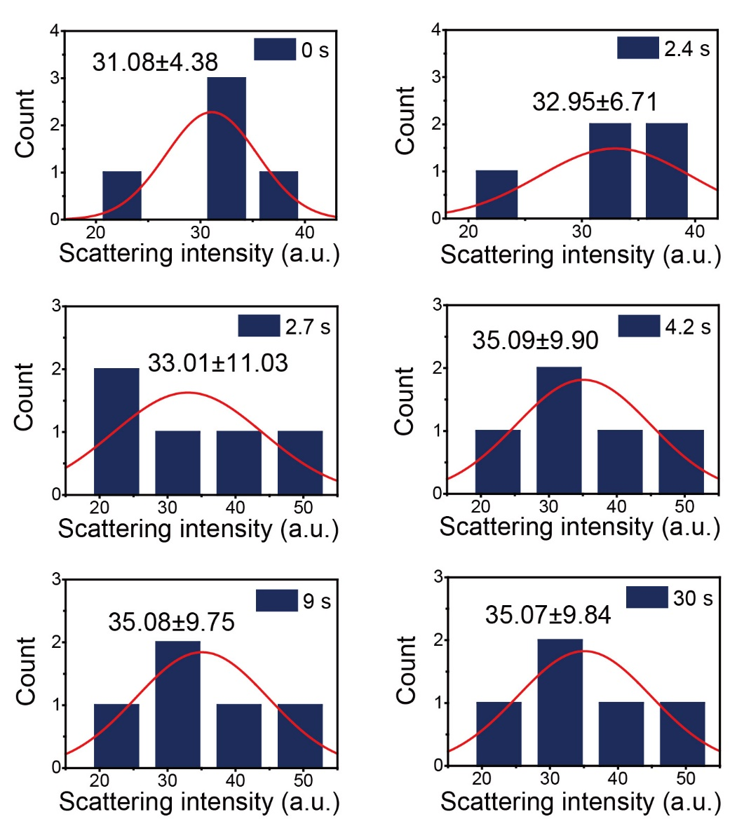
Figure S26. Statistical analysis of the scattering intensity for COF-300 crystals with an average longitudinal size of 7.3 μm upon exposure to 0.76 bar n-hexane.

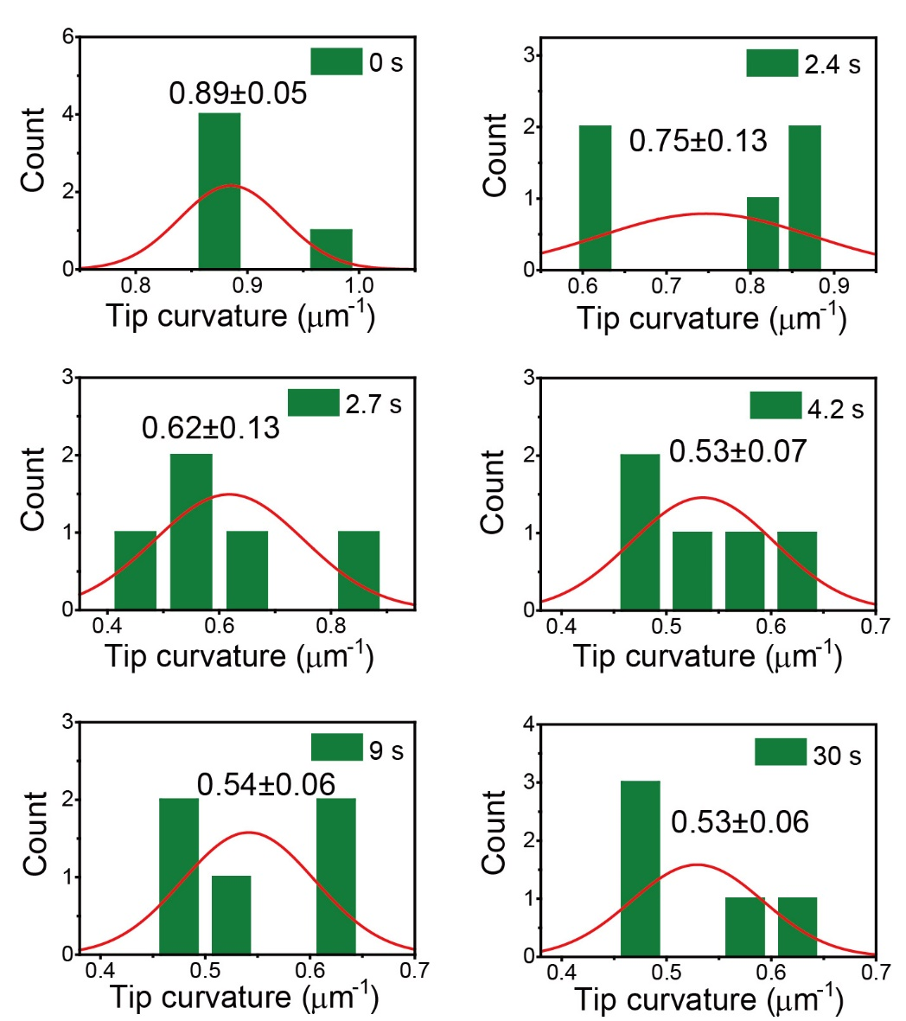
Figure S27. Statistical analysis of the tip curvature for COF-300 crystals with an average longitudinal size of 7.3 μm upon exposure to 0.76 bar n-hexane.

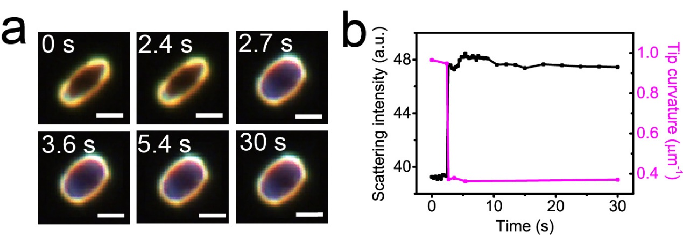
Figure S28. (a) Time-sequential DFM image, (b) scattering intensity and tip curvature of a single COF-300 crystal upon exposure to 0.6 bar methanol. Scale bar: 5 μm.

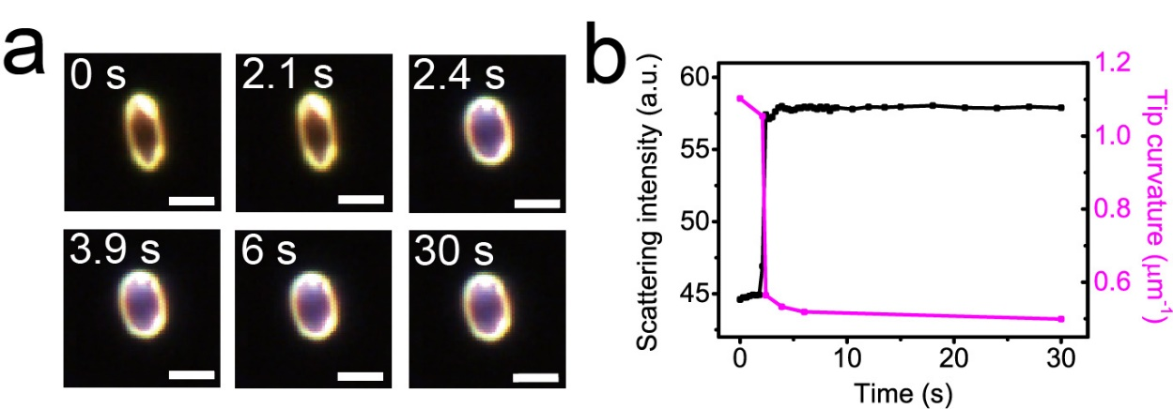
Figure S29. (a) Time-sequential DFM image, (b) scattering intensity and tip curvature of a single COF-300 crystal upon exposure to 0.6 bar ethanol. Scale bar: 5 μm.

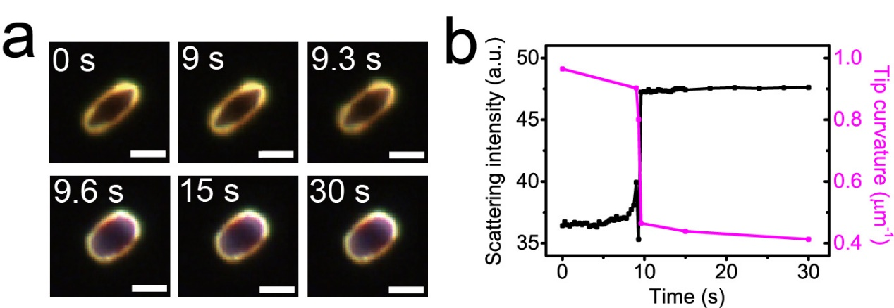
Figure S30. (a) Time-sequential DFM image, (b) scattering intensity and tip curvature of a single COF-300 crystal upon exposure to 0.6 bar isopropyl alcohol. Scale bar: 5 μm.

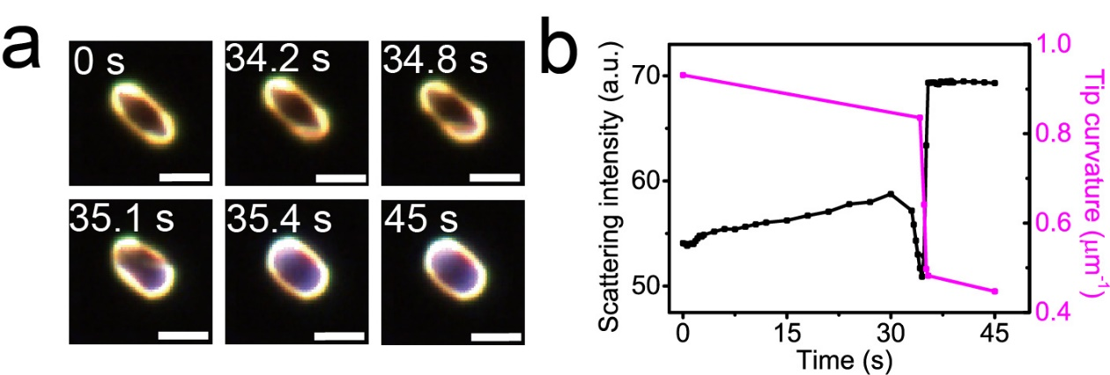
Figure S31. (a) Time-sequential DFM image, (b) scattering intensity and tip curvature of a single COF-300 crystal upon exposure to 0.68 bar dioxane. Scale bar: 5 μm.

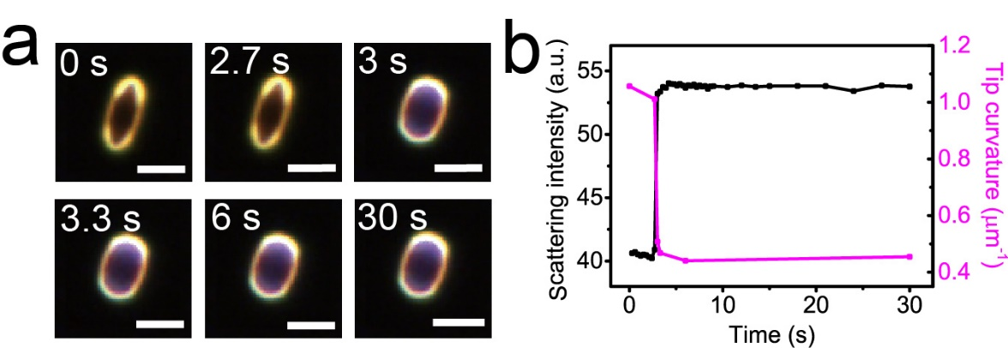
Figure S32. (a) Time-sequential DFM image, (b) scattering intensity and tip curvature of a single COF-300 crystal upon exposure to 0.73 bar tetrahydrofuran. Scale bar: 5 μm.

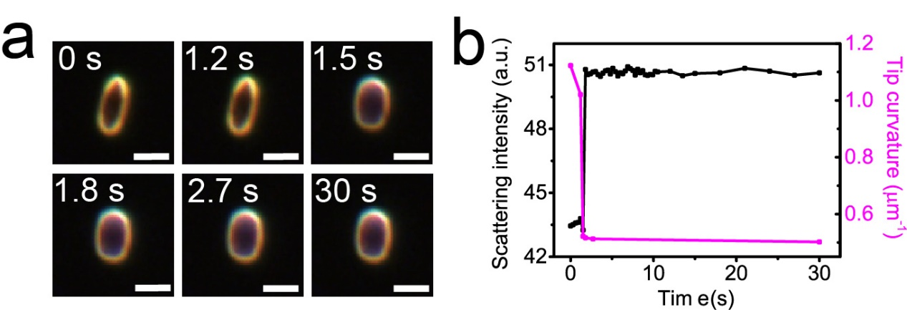
Figure S33. (a) Time-sequential DFM image, (b) scattering intensity and tip curvature of a single COF-300 crystal upon exposure to 0.73 bar acetonitrile. Scale bar: 5 μm.

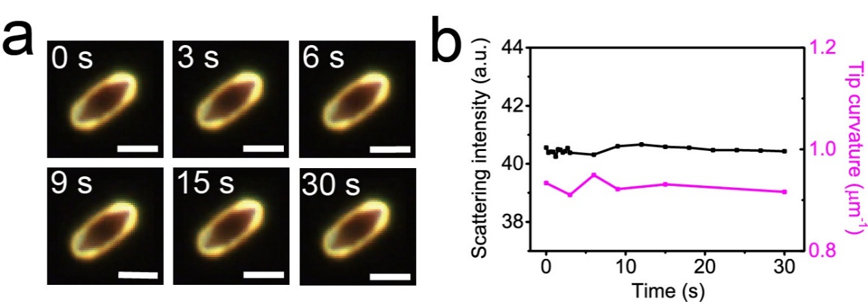
Figure S34. (a) Time-sequential DFM image, (b) scattering intensity and tip curvature of a single COF-300 crystal upon exposure to 0.7 bar water vapor. Scale bar: 5 μm.

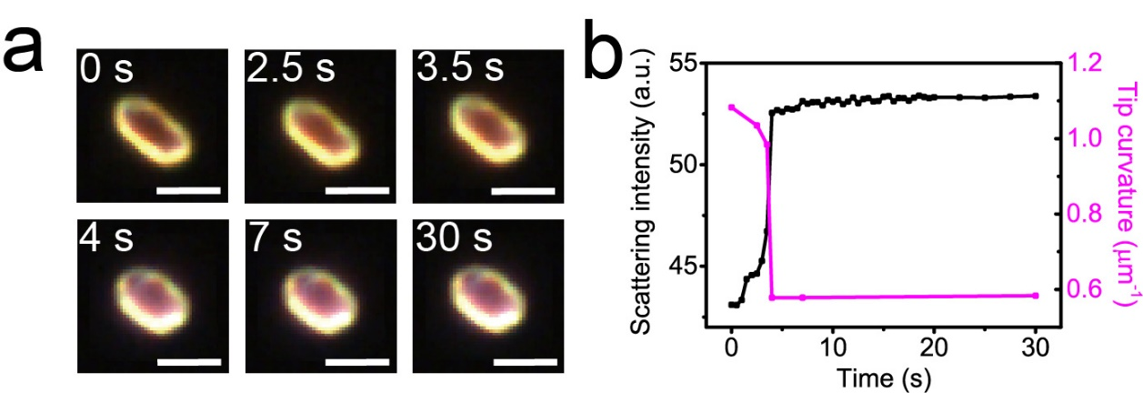
Figure S35. Time-sequential DFM image, (b) scattering intensity and tip curvature of a single COF-300 crystal upon exposure to 0.59 bar dichloromethane. Scale bar: 5 μm.

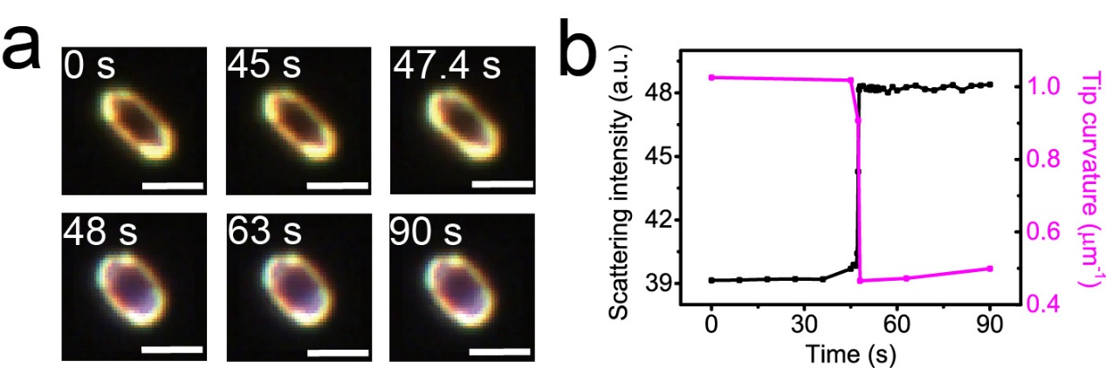
Figure S36. (a) Time-sequential DFM image, (b) scattering intensity and tip curvature of a single COF-300 crystal upon exposure to 0.34 bar dichloromethane. Scale bar: 5 μm.

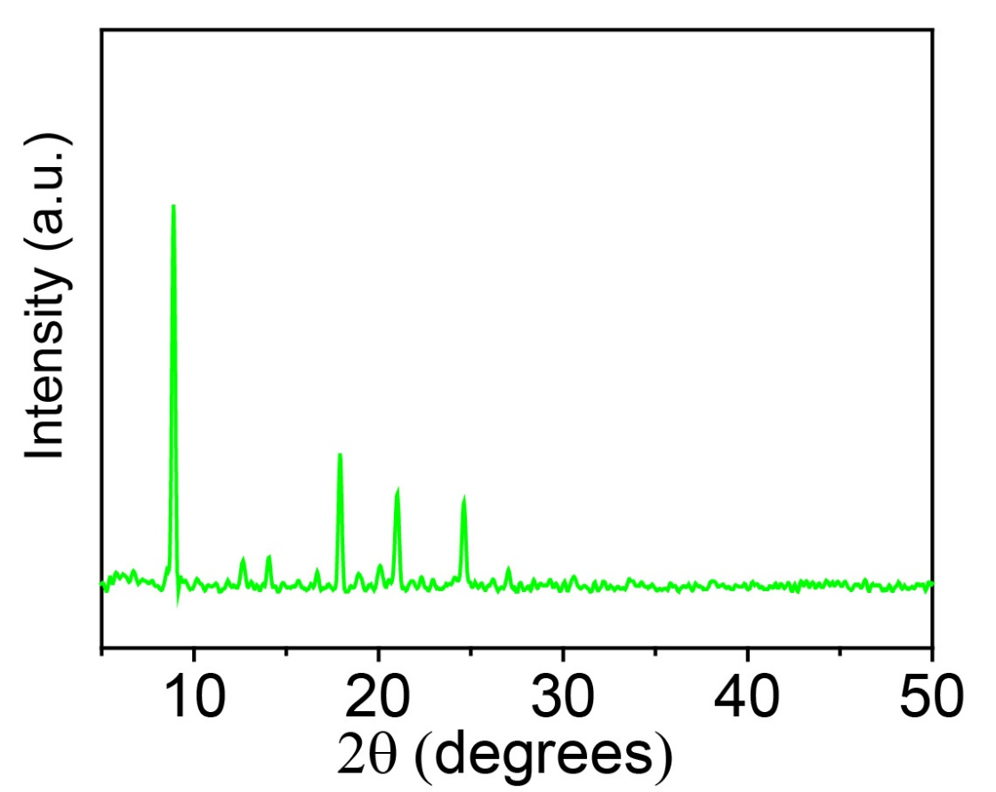
Figure S37. PXRD pattern of COF-300 crystals after interaction with dichloromethane.

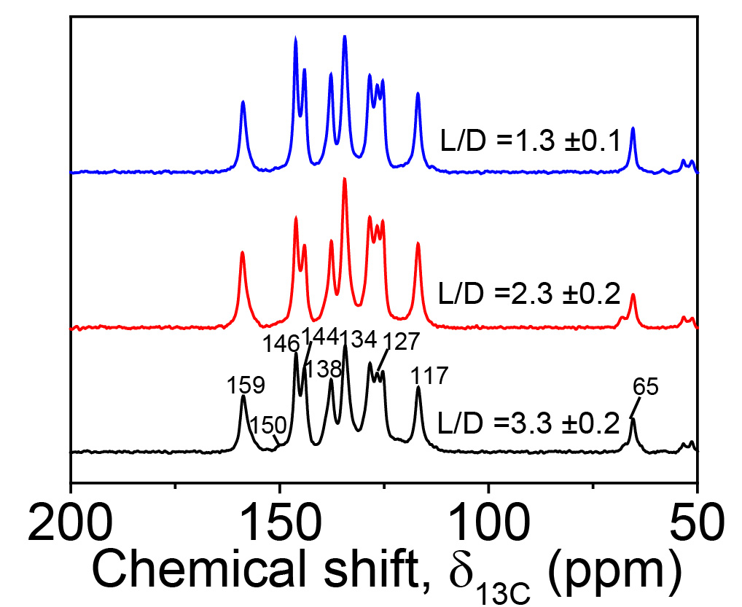
Figure S38. ¹³C CP/MAS spectra of COF-300 crystals with different longitudinal length-to-diameter ratios.

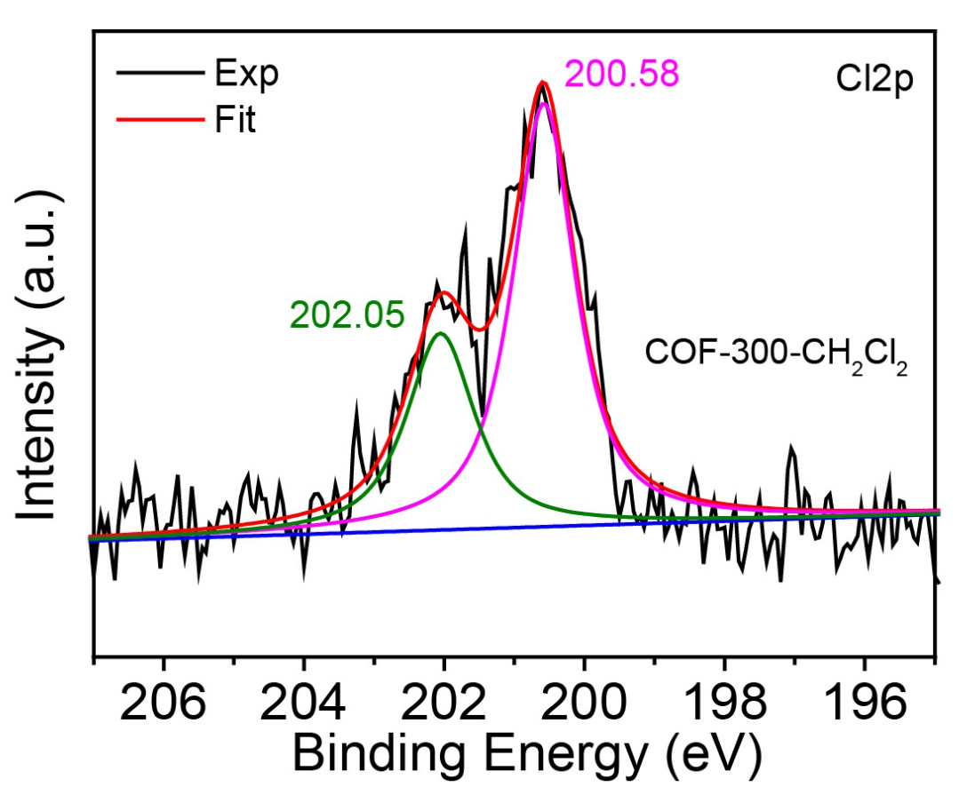
Figure S39. Cl2p XPS spectra of COF-300 crystals after interaction with dichloromethane.

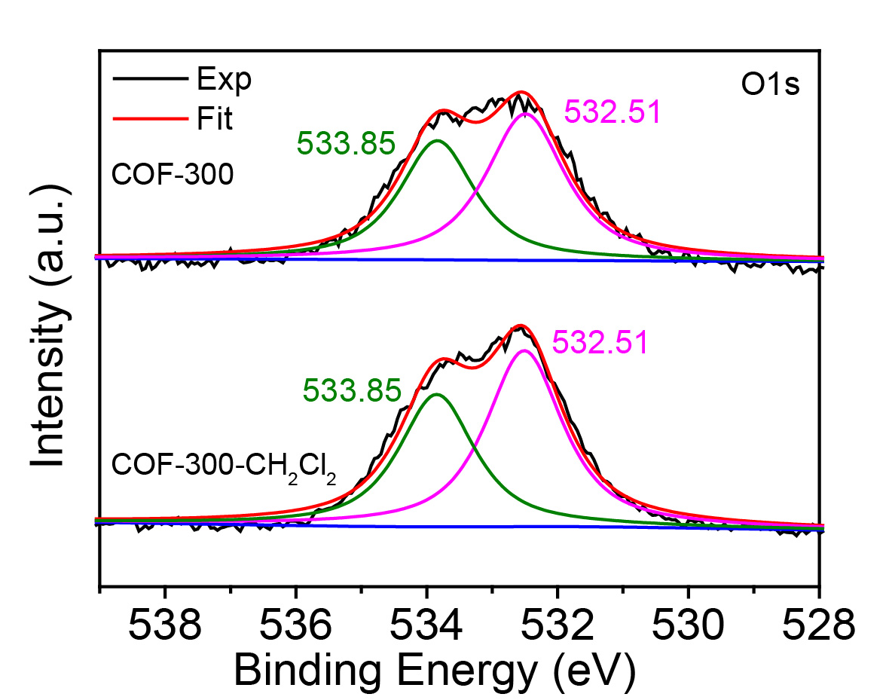
Figure S40. O1s XPS spectra of COF-300 before and after interaction with dichloromethane.

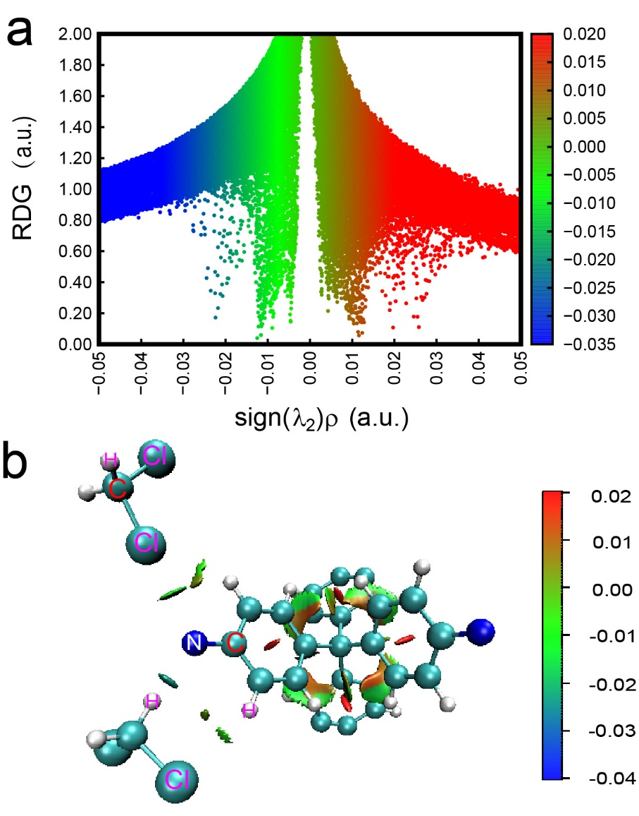
Figure S41. RDG scatter and non-covalent interactions plots for the COF-300- dichloromethane complex. Color code: blue = strong attractive interactions, green = weak attractive interaction (hydrogen bonding, halogen bonding)/van der Waals attraction.
As illustrated in Figure S41a, the scatterplots of reduced density gradient (RDG) versus sign(λ ₂)ρ produces spikes of data points with negative sign(λ ₂)ρ and slightly positive RGD, demonstrating the attractive intermolecular interactions between COF-300 and dichloromethane. Meanwhile, the non-covalent interaction (NCI) plots clearly show the weak attractive interaction of COF-300 with dichloromethane according to the hydrogen bonding and halogen bonding.

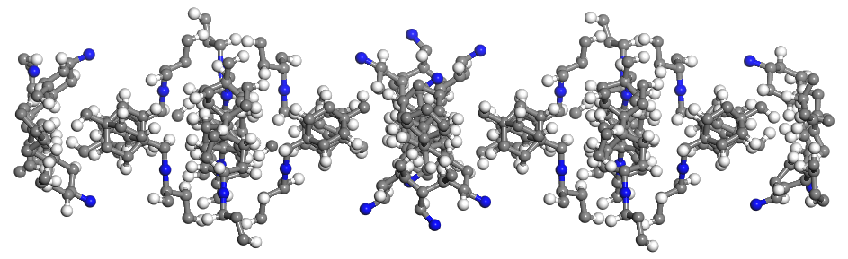
Figure S42. The structural model of COF-300 crystal with a curvature of 0.0008 Å⁻¹.

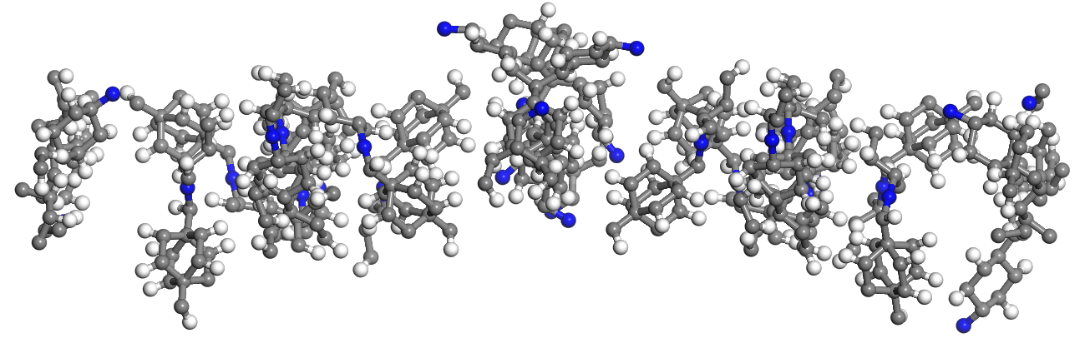
Figure S43. The structural model of curved COF-300 crystal with a curvature of 0.007 Å⁻¹.

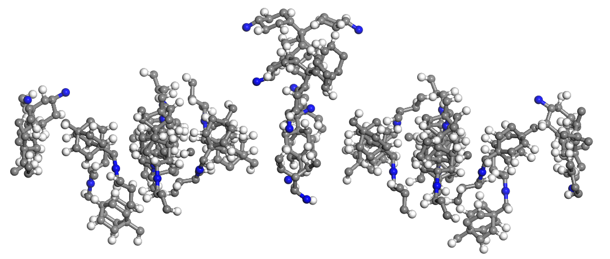
Figure S44. The structural model of curved COF-300 crystal with a curvature of 0.0216 Å⁻¹.

