Supplementary Information for

Complex day-to-day movements of an alpine passerine may act as an insurance against environmental variability

Arnaud G. Barras¹*, Felix Liechti², Raphaël Arlettaz¹
1 Division of Conservation Biology, Institute of Ecology and Evolution, University of Bern, Baltzerstrasse 6, CH-3012 Bern, Switzerland
2 Swiss Ornithological Institute, Department of Bird Migration, Seerose 1, CH-6204 Sempach, Switzerland

Table S1: Details on the type and number of tracking devices fitted on ring ouzels in the Swiss Alps over the period 2015–2019.
 |  | Simple geolocator | Remote-download geolocator | Multi-sensor logger | GPS logger
 | Abbreviation | GL | GL | MSL | GPS
 | Model | GDL2 | GDL-uTag | GDL3-PAM | nanoFix-GEO
 | Producer | Swiss Ornithological Institute | Swiss Ornithological Institute | Swiss Ornithological Institute | PathTrack Ltd.
 | Weight with harness (g) | 0.6 | 1.2 | 1.5 | 2.5
 | Material of harness | Threaded nylon | Elastic rubber | Elastic rubber or threaded nylon | Teflon ribbon
 | Number fitted
 | 2015 | 6 | 0 | 0 | 0
 | 2016 | 0 | 0 | 0 | 15
 | 2017 | 0 | 0 | 12 | 0
 | 2018 | 0 | 0 | 19 | 0
 | 2019 | 0 | 13 | 12 | 0
 | Total | 6 | 13 | 43 | 15
 | Number retrieved | 2 | 4 | 5 | 2
 | Exploitable data | 0 | 4 | 5 | 1

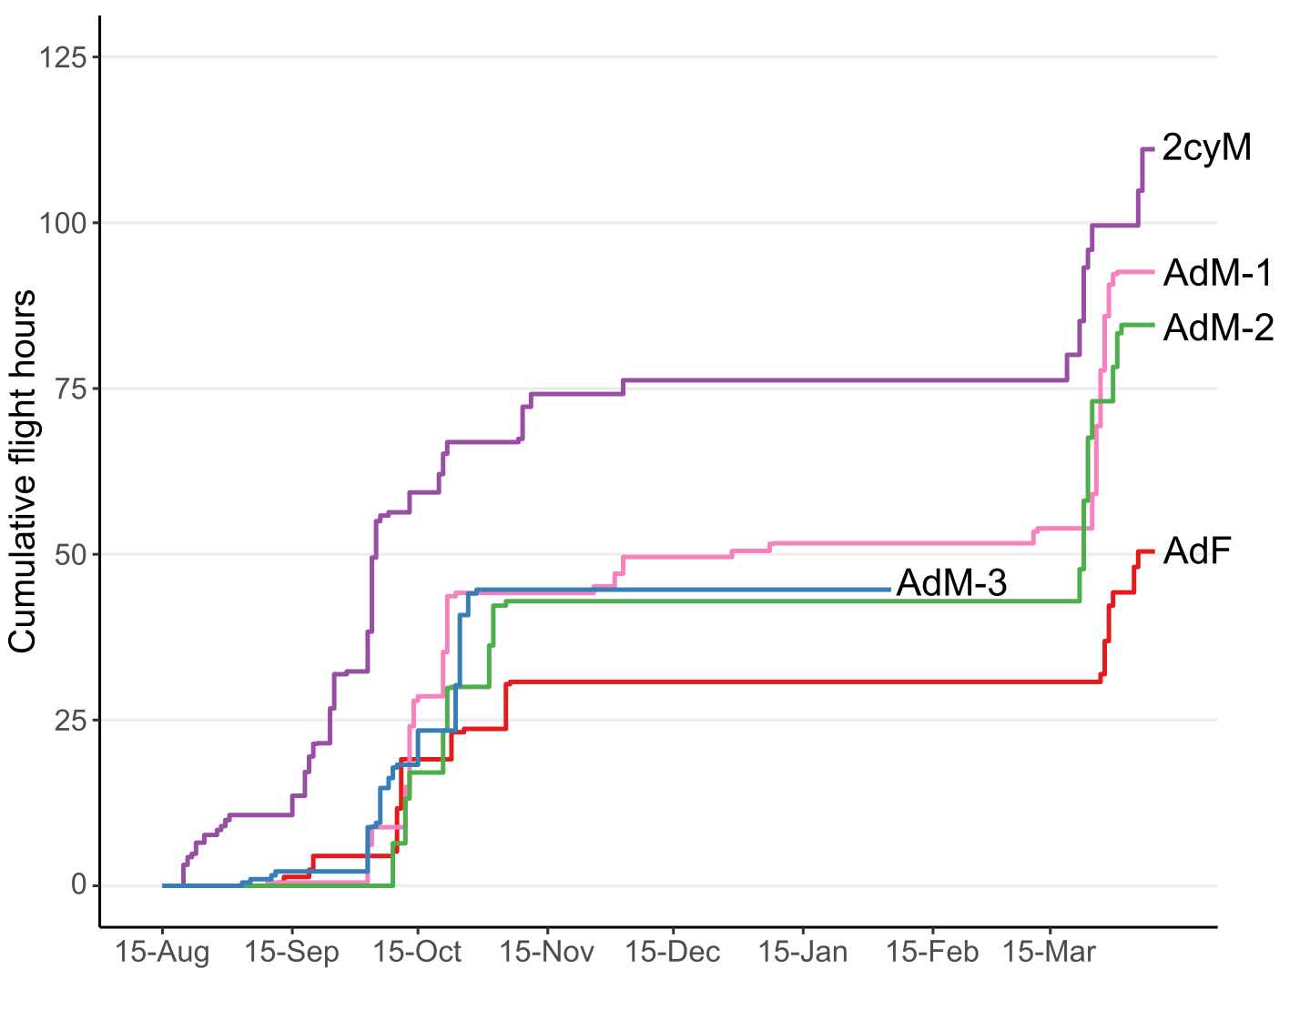
Figure S1: Cumulative flight hours of five ring ouzel individuals during the autumn migration, non-breeding and spring migration periods (August 15th to April 10th).

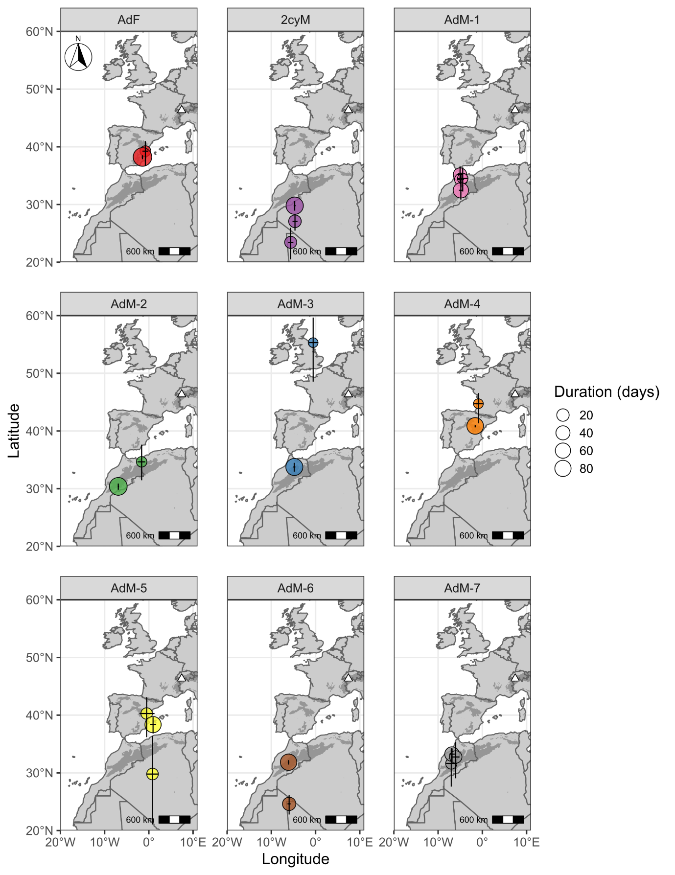
Figure S2: Estimated locations (± 95% CI bars) of the non-breeding residency periods (between October 15th and March 1st) for all nine ring ouzel individuals tracked with geolocators.

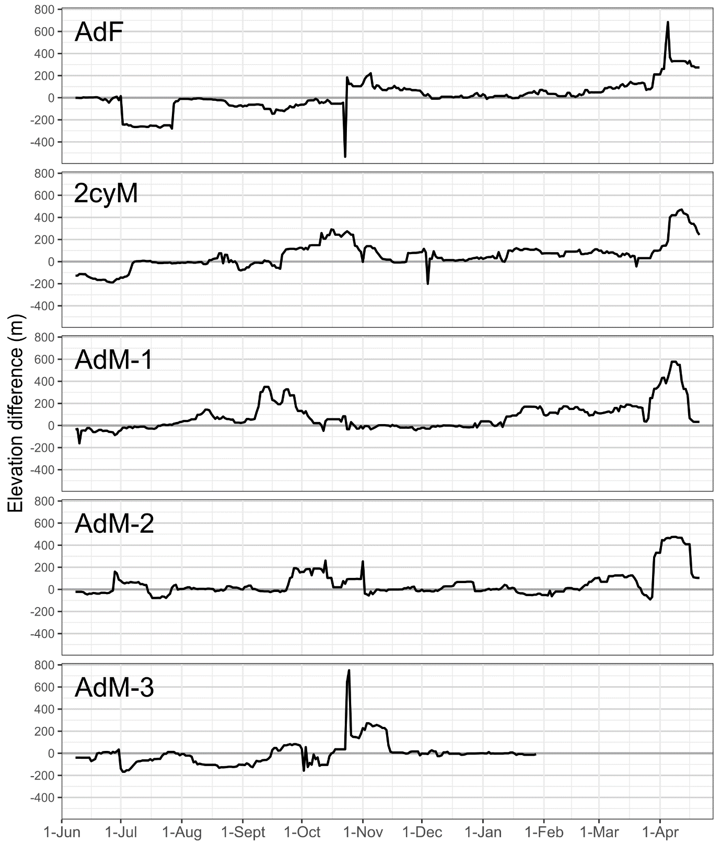Figure S3: Difference in elevation (in meters) between night and day readings for five ring ouzel individuals equipped with multi-sensor loggers. A 15-days moving average has been applied to smooth peaks following migration flights at high or low elevations.

