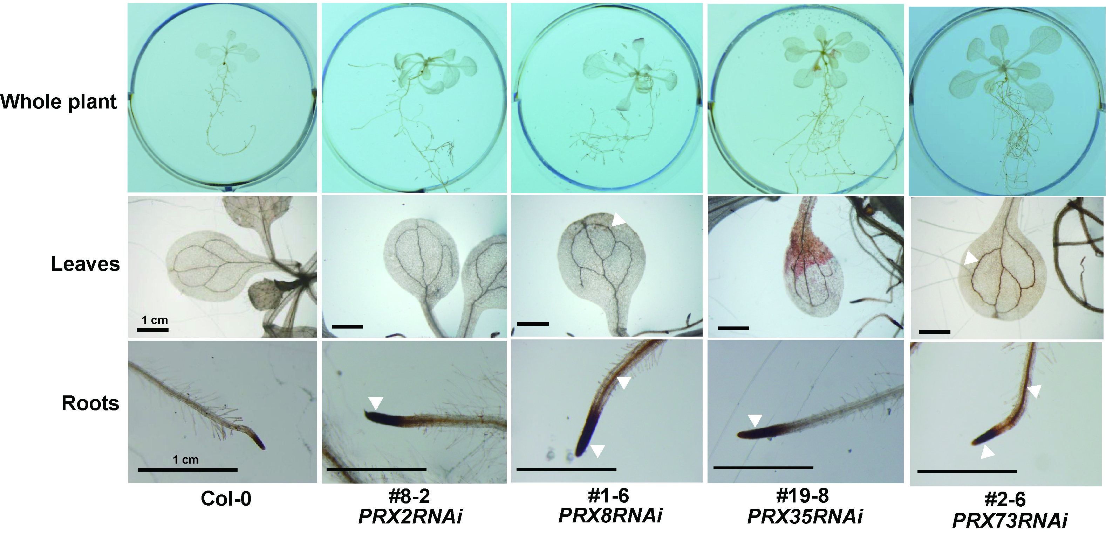

Figure S1. Localization patterns of H₂O₂ accumulation in 2-week-old wild-type (Col-0) and respective PRXRNAi plants by DAB histochemical staining. Images of H₂O₂ signals in leaves and roots were enlarged. The photos shown in wild-type (Col-0) plants were identical with those in Fig. 3. Strong H₂O₂ signals in enlarged leaves and roots of respective PRXRNAi plants are indicated by filled triangles. Scale bars are presented in photos.

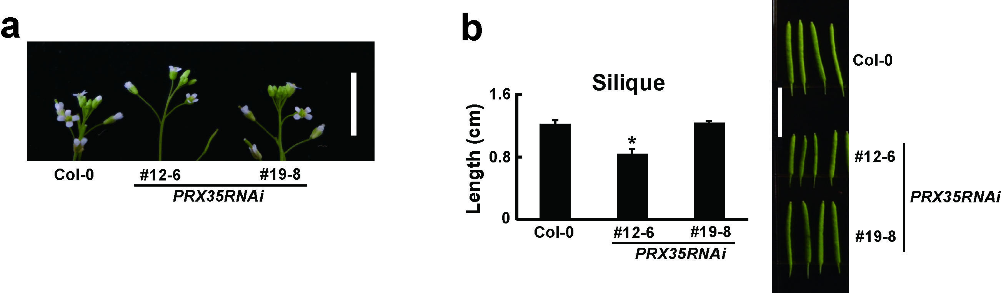

Figure S2. Morphological changes in reproductive organs of PRX35RNAi plants. a Inflorescence patterns of wild-type (Col-0) and PRX35RNAi plants grown for 6 weeks. Scale bar, 1 cm. b Silique lengths of 6-week-old soil-grown wild-type (Col-0) and PRX35RNAi plants (n ≥ 10). Scale bar, 1 cm. Asterisks indicate significant differences (p < 0.005, Student’s t-test).

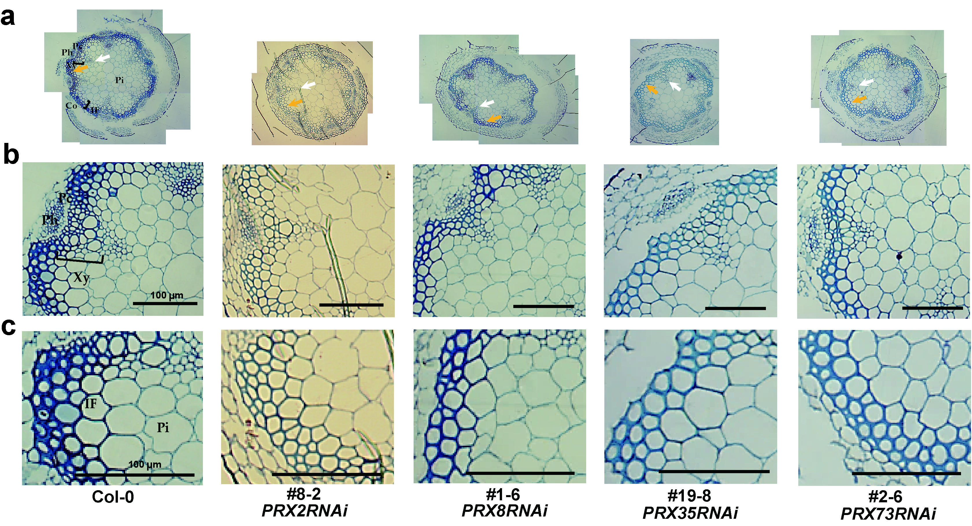

Figure S3. Transverse sections of basal main stems of wild-type (Col-0) plants and the independent PRXsRNAi lines for each RNAi construct. a, b, c Full (a) and enlarged photos (b, c) of the xylem and interfascicular fiber parts in toluidine blue-stained sections of resin-embedded stems of soil-grown 6-week-old wild-type (Col-0) and respective PRXRNAi plants. White and yellow arrows indicate the xylem and interfascicular fibers, respectively. The cortex (Co), phloem (Ph), xylem (Xy), pith (Pi), and interfascicular fiber (IF) are indicated. Scale bars, 100 μm.

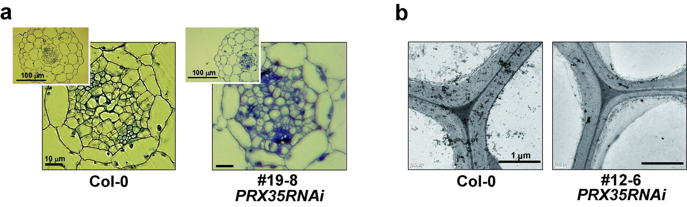
Figure S4. Transverse sections of hypocotyl and root regions in wild-type (Col-0) and PRX35RNAi seedlings. a The photos of vascular bundles (upper left corner) in toluidine blue-stained sections of resin-embedded upper hypocotyls in wild-type (Col-0) and PRX35RNAi #19-8 seedlings. b Comparison of the cell wall thickness of cortex between wild-type (Col-0) and PRX35RNAi #12-6 lines. The photo was another TEM image, which were the same plants shown in Fig. 6e.

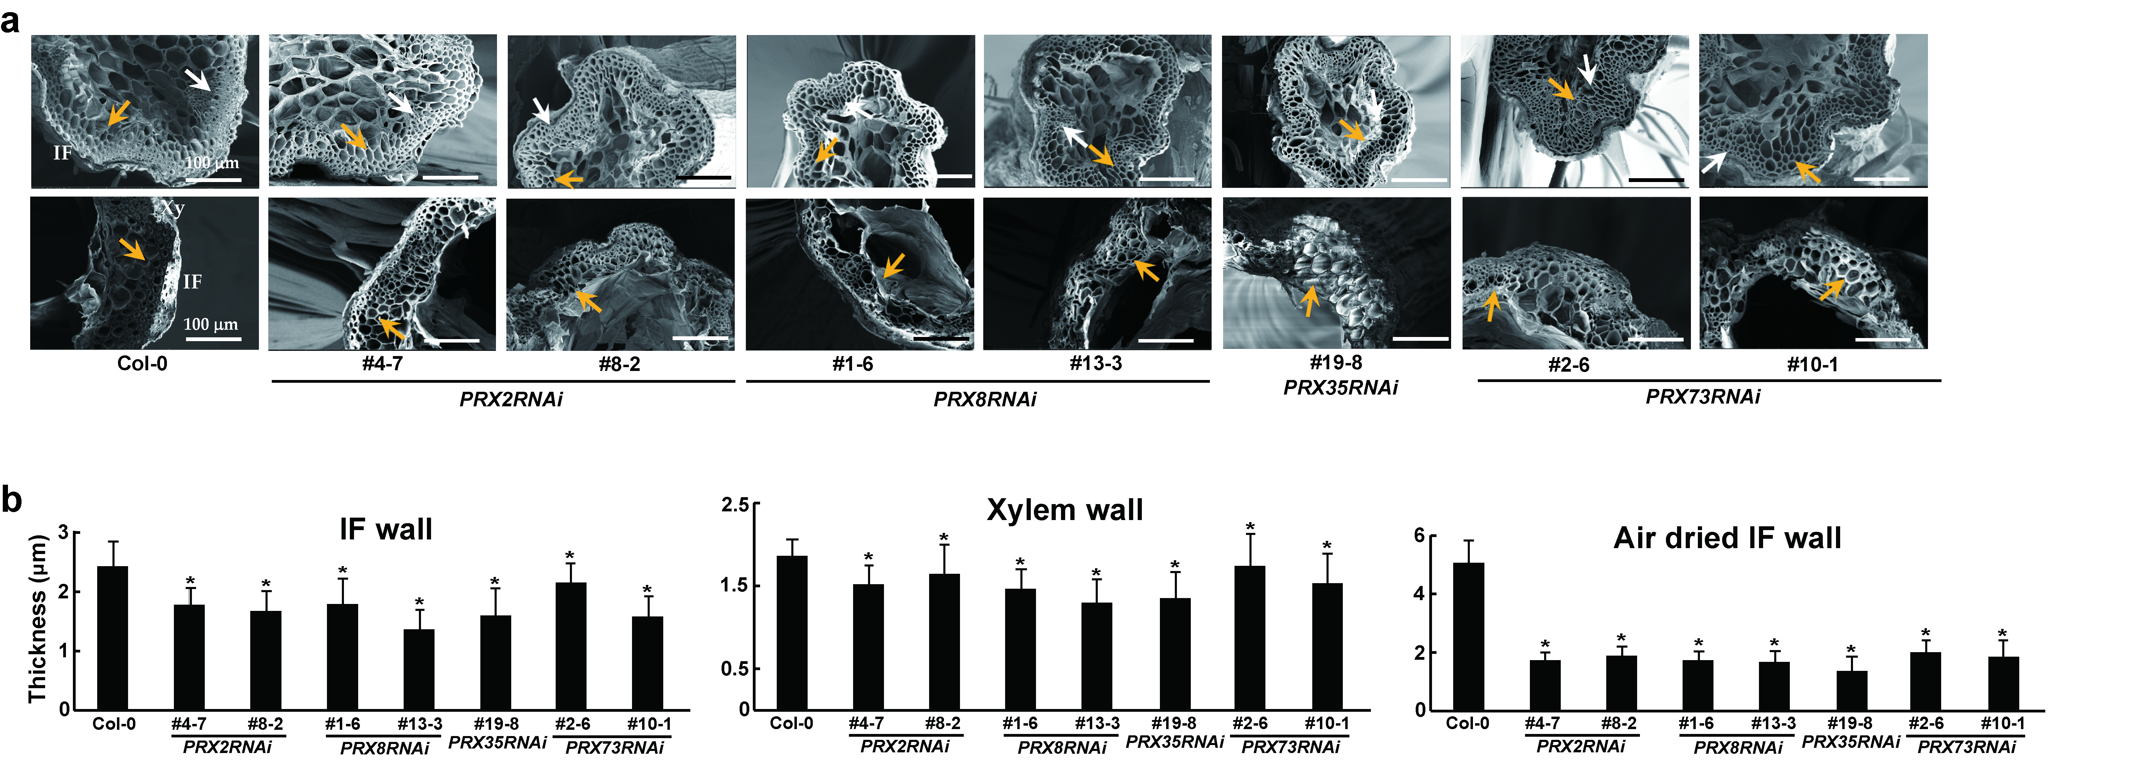

Figure S5. Scanning electron microscopic (SEM) images of stems of wild-type (Col-0) plants and the independent PRXsRNAi lines for each RNAi construct. a SEM images of cross sections of freshly harvested stems (top) and air-dried basal stems (bottom) of 6-week-old soil-grown wild-type (Col-0) and respective PRXRNAi plants. A SEM image of wild-type (Col-0) was the same shown in Fig. 8. The xylem (Xy) and interfascicular fiber (IF) parts are indicated. White and yellow arrows indicate the xylem and interfascicular fiber, respectively. b Cell wall thickness of xylem and interfascicular fiber in freshly harvested or air-dried basal stems of 6-week-old soil-grown plants. Wall thickness was measured from three SEM micrographs of xylem and interfascicular fiber (n = 30 cells; each 10 cell from three individual plants for each PRXRNAi lines). Error bars indicate the standard error of the mean. Asterisks indicate significant differences (p < 0.005, Student’s t-test).

Table S1. Primers used for cloning of each PRX gene into the RNAi silencing Gateway vector
Gene ID | Name | Primer sequence (5′- 3′)
AT1G05250 | PRX2/  ATPRX1 | Prx2-F: CACCATGGCGATCAAGAACATTCTCGC
AT1G05250 | PRX2/  ATPRX1 | Prx2-R: GTTAGGGAAGGCGCATCTCTTC
AT1G34510 | PRX8 | Prx8-F: CACCATGAGGGCAATCGCAGCTTGG
AT1G34510 | PRX8 | Prx8-R: GTTGTTGAAGGCTCTGCAGTTTGT
AT3G49960 | PRX35 | Prx35-F: CACCATGGCTCGCTTCGATATTGTTC
AT3G49960 | PRX35 | Prx35-R: GTTAAACGCACCACAATCACGACG
AT5G67400 | PRX73 | Prx73-F: CACCATGGCGCGGTTCAGTCTGGTT
AT5G67400 | PRX73 | Prx73-R: GTTAAAGGCACCACAGTCACGAC

Table S2. Primers used for RT-qPCR amplification of four PRX genes
Gene ID | Name | Primer sequence (5′- 3′)
AT1G05250 | PRX2/  ATPRX1 | prx2R-F: CGAAATTGAACGATGCATTGCTAAA
AT1G05250 | PRX2/  ATPRX1 | prx2R-R: CCATGTTCAGTGAGGTTCTGAAAT
AT1G34510 | PRX8 | prx8R-F: GGATCCTAAAATGGACAGCAAACTGA
AT1G34510 | PRX8 | prx8R-R: AAATCTGACACAATCGACCTGGTTGAT
AT3G49960 | PRX35 | prx35R-F: CGAAGGGAACTTACCAGGACCTT
AT3G49960 | PRX35 | prx35R-R: TTGTCAAACGTCTTGGGCGTGAC
AT5G67400 | PRX73 | prx73-F: CCGGACCAAATAACAAAGTTACAGAA
AT5G67400 | PRX73 | prx73-R: GCGGTTACGAAAGCCTTGTTGAAA
AT4G05320 | UBQ10 | UBQ10-F: CCACCAAAGTTTTACATGAAACGAA
AT4G05320 | UBQ10 | UBQ10-R: TCCAGGACAAGGAAGGTATTCC

Table S3. Primers used for RT-qPCR amplification of lignin biosynthesis genes
Gene ID | Name | Primer sequence (5′- 3′)
AT2G37040 | PAL1 | PAL1-F: AAGATTGGAGCTTTCGAGGA
AT2G37040 | PAL1 | PAL1-R: TCTGTTCCAAGCTCTTCCCT
AT2G30490 | C4H | C4H-F: ACTGGCTTCAAGTCGGAGAT
AT2G30490 | C4H | C4H-R: ACACGACGTTTCTCGTTCTG
AT1G51680 | 4CL1 | 4CL-F: TCAACCCGGTGAGATTTGTA
AT1G51680 | 4CL1 | 4CL-R: TCGTCATCGATCAATCCAAT
AT5G48930 | HCT | HCT-F: GCCTGCACCAAGTATGAAGA
AT5G48930 | HCT | HCT-R: GACAGTGTTCCCATCCTCCT
AT2G40890 | C3H1 | C3H1-F: GTTGGACTTGACCGGATCTT
AT2G40890 | C3H1 | C3H1-R: ATTAGAGGCGTTGGAGGATG
AT4G34050 | CCoAOMT1 | CCOAMT-F: CTCAGGGAAGTGACAGCAAA
AT4G34050 | CCoAOMT1 | CCOAMT-F: GTGGCGAGAAGAGAGTAGCC
AT4G36220 | F5H1 | F5H-F: CTTCAACGTAGCGGATTTCA
AT4G36220 | F5H1 | F5H-R: AGATCATTACGGGCCTTCAC
AT5G54160 | COMT | COMT-F: TTCCATTGCTGCTCTTTGTC
AT5G54160 | COMT | COMT-R: CATGGTGATTGTGGAATGGT
AT4G34230 | CAD | CAD-F: TTGGCTGATTCGTTGGATTA
AT4G34230 | CAD | CAD-R: ATCACTTTCCTCCCAAGCAT
AT4G05320 | UBQ10 | UBQ10-F: CCACCAAAGTTTTACATGAAACGAA
AT4G05320 | UBQ10 | UBQ10-R: TCCAGGACAAGGAAGGTATTCC

Table S4. Primers used for RT-qPCR amplification of lignin biosynthesis regulated genes
Gene ID | Name | Primer sequence (5′ - 3′)
AT1G16490 | MYB58 | MYB58-F: CCAGAGAACAGAGCTCTTCAAGAG
AT1G16490 | MYB58 | MYB58-R: ATGTATGAGGAGCTCGTAACTCTC
AT1G79180 | MYB63 | MYB63-F: GAACAGCTCAGGCTCAAGAGCAAC
AT1G79180 | MYB63 | MYB63-R: ATGTATCATGAGCTCGTAGTTCTT
AT4G05320 | UBQ10 | UBQ10-F: CCACCAAAGTTTTACATGAAACGAA
AT4G05320 | UBQ10 | UBQ10-R: TCCAGGACAAGGAAGGTATTCC

Table S5. Comparison of nucleotide sequences within coding regions among PRX2/ATPRX1, PRX8, PRX35, PRX44, and PRX73
 | PRX2/ATPRX1 | PRX8 | PRX35 | PRX44 | PRX73
PRX2/ATPRX1 | - | * | 76 | * | *
PRX8 | * | - | 75 | 76 | *
PRX35 | 76 | 75 | - | 80 | 80
PRX44 | * | 76 | 80 | - | *
PRX73 | * | * | 80 | * | -
*No significant identity found.

