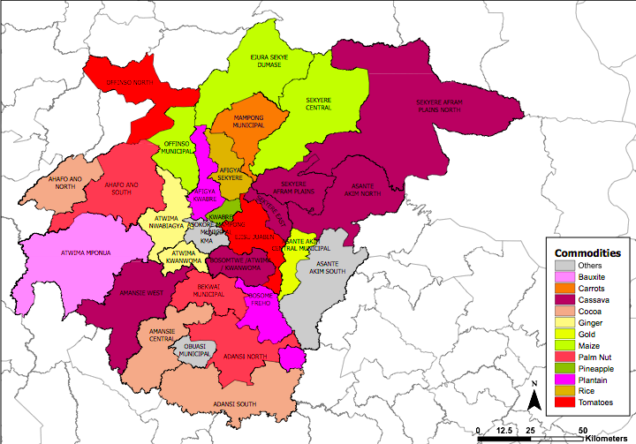
Figure S1: Map of the Ashanti Region indicating division of Ashanti region into northern and southern sectors. Photo credit: Dwamena, H. A., Tawiah, K., & Akuoko Kodua, A. S. (2022). The Effect of Rainfall, Temperature, and Relative Humidity on the Yield of Cassava, Yam, and Maize in the Ashanti Region of Ghana.

Supplementary file (S) 2: Cervical cancer survey

Participant ID:

SHiNE
The
project

Cervical Cancer Survey
Version 3, dated 18032021

SECTION A: Knowledge of cervical cancer
The following questions are about your knowledge of things or activities that can lead to cervical cancer. For each question, please tick the box () which best describes your answer. If you are unsure about a question, please give the best answer that you can.

- Which of the following can increase chances of getting cervical cancer? Cervical cancer is a disease that can affect the tip of the womb. | Yes | No
- Smoking cigarettes | ₁ | ₂
- Having sexually transmitted infections e.g., Human Papillomavirus, HIV/AIDS | ₁ | ₂
- Using oral contraceptives | ₁ | ₂
- Having one or more abortions | ₁ | ₂
- Having sex before 18 years of age | ₁ | ₂
- Applying Dettol or strong soaps into the vagina during bathing | ₁ | ₂
- Having had more than one sexual partner over a lifetime | ₁ | ₂
- Spiritual forces (e.g. witchcraft) | ₁ | ₂
- Inserting herbs into the vagina | ₁ | ₂
- Having a family history of cervical cancer | ₁ | ₂
- Poor personal hygiene | ₁ | ₂
- Contact with blood of a person with cervical cancer | ₁ | ₂
- Which of the following can reduce a woman’s chance of getting cervical cancer? | True | False
- Praying to God | ₁ | ₂
- Fasting to God | ₁ | ₂
- Using a condom during sexual intercourse | ₁ | ₂
- Having regular cervical check ups | ₁ | ₂
- Getting vaccinated with HPV vaccines to prevent cervical cancer  (A vaccine is a liquid often injected into the arm) | ₁ | ₂

SECTION B: Your thoughts and view about HPV and cervical cancer
The following questions explore your thoughts and views about HPV and cervical cancer. For each question, please tick the box () that describes your answer to each question. If you are unsure about a question, please give the best answer that you can. Remember that the answers you give will remain confidential.

Please rate your chances of getting HPV infection and cervical cancer.
About HPV | Very unlikely | Unlikely | Not sure | Likely | Very Likely
- How likely are you to get HPV infection in your life? | 1 | 2 | 3 | 4 | 5
- How likely is it that your sexual activities will lead you to getting HPV infection? | 1 | 2 | 3 | 4 | 5
About cervical cancer | Very unlikely | Unlikely | Not sure | Likely | Very Likely
- How likely are you to develop cervical cancer? | 1 | 2 | 3 | 4 | 5
- How likely is it that your family background will lead you to get cervical cancer? | 1 | 2 | 3 | 4 | 5
- How likely is it that your physical fitness will lead you to get cervical cancer? | 1 | 2 | 3 | 4 | 5
- How likely is it that your spirituality protects you from getting cervical cancer? | 1? | 2 | 3 | 4 | 5

Please rate your views about the impact of having HPV infection and cervical cancer
Getting HPV would: | Strongly disagree | Disagree | Not sure | Agree | Strongly agree
- Make it difficult to get pregnant. | 1 | 2 | 3 | 4 | 5
- Interfere with my learning at school. | 1 | 2 | 3 | 4 | 5
- Affect my relationship with my boyfriend/girlfriend or husband | 1 | 2 | 3 | 4 | 5
- Result in serious health challenges. | 1 | 2 | 3 | 4 | 5
The thought of cervical cancer: | Strongly disagree | Disagree | Not sure | Agree | Strongly agree
- Makes me scared. | 1 | 2 | 3 | 4 | 5
- Makes me panic. | 1 | 2 | 3 | 4 | 5
- Makes me sad | 1 | 2 | 3 | 4 | 5
- Makes me worry | 1 | 2 | 3 | 4 | 5
Getting cervical cancer would: | Strongly disagree | Disagree | Not sure | Agree | Strongly agree
- Reduce the number years I live | 1 | 2 | 3 | 4 | 5
- Affect my relationships with the people close to me. | 1 | 2 | 3 | 4 | 5
- Make me die | 1 | 2 | 3 | 4 | 5

SECTION C: Sexual behavior
The following questions are about your sexual behavior. For each question, please tick the box () which best describes your answer. If you are unsure about a question, please give the best answer that you can. Remember that the answers you give will remain confidential. Note: these questions are optional.

- Have you had sexual intercourse before? | ₁ Yes  ₂ No  ₃ Prefer not to answer
- How old were you the first time you had sexual intercourse? | ₁ I have never had sexual intercourse before  ₂ 16 years of age or younger  ₃ 17 years of age or older  ₄ Prefer not to answer
- During your life, how many people have you had sexual intercourse with? | ₁ I have never had sexual intercourse before  ₂ one person  ₃ two or more people  ₄ Prefer not to answer
- The last time you had sexual intercourse, did you or your partner use a condom? | ₁ I have never had sexual intercourse before  ₂ Yes  ₃ No  ₄ Prefer not to answer
- During the past 12 months, have you been tested with a sexually transmitted infection e.g. gonorrhoea, syphilis, chlamydia, HIV e.t.c,? | ₁ Yes  ₂ No  ₃Prefer not to answer
- The last time you had sexual intercourse, did you use birth control pills to prevent pregnancy? | ₁ I have never had sexual intercourse before  ₂ Yes  ₃ No  ₄ Prefer not to answer

SECTION D: Information about you
The following questions are about you. For each question, please tick the box () which best describes your answer or write your answer in the space provided. If you are unsure about a question, please give the best answer that you can. Remember that the answers you give will remain confidential.

- What is your age? | ………………years
- What is your ethnicity? | ₁ Akan  ₂ Northner  ₃ Ewe/Guans  ₄ Ga – Adangbe  ₅Other (please specify)………………………
- What is your relationship status? | ₁ Single  ₂ Dating  ₃ Other (please specify)………………………
- What program are you studying at school? | ₁Science  ₂General arts  ₃Visual arts  ₄Business  ₅Home economics  ₆Agric
- What is your enrolment status at school? | ₁ Boarding student  ₂ Day student
- Who do you live with most of the time during school holidays? | ₁ Both parents  ₂ One parent  ₃ Grandparent (s)  ₄ Guardian  ₅ Friend(s)  ₆ On my own
- What is the occupation of your father or male guardian? | ₁ Unemployed  ₂Employed…………………..please specify
- What is the occupation of your mother or female guardian? | ₁ Unemployed  ₂ Employed…………………. please specify
- Have you smoked cigarettes, marijuana “weed?”, or shisha in the before? | ₁ Yes  ₂ No
Thank you for completing this survey. Your time is greatly appreciated.

If you have any comments, please write them in the space below.

………………………………………………………………………………………………………………………………………………………………………………………………………………………………………………………………………………………………………………………………………………………………………………………………………………………………………………………………

