Supplementary Figures
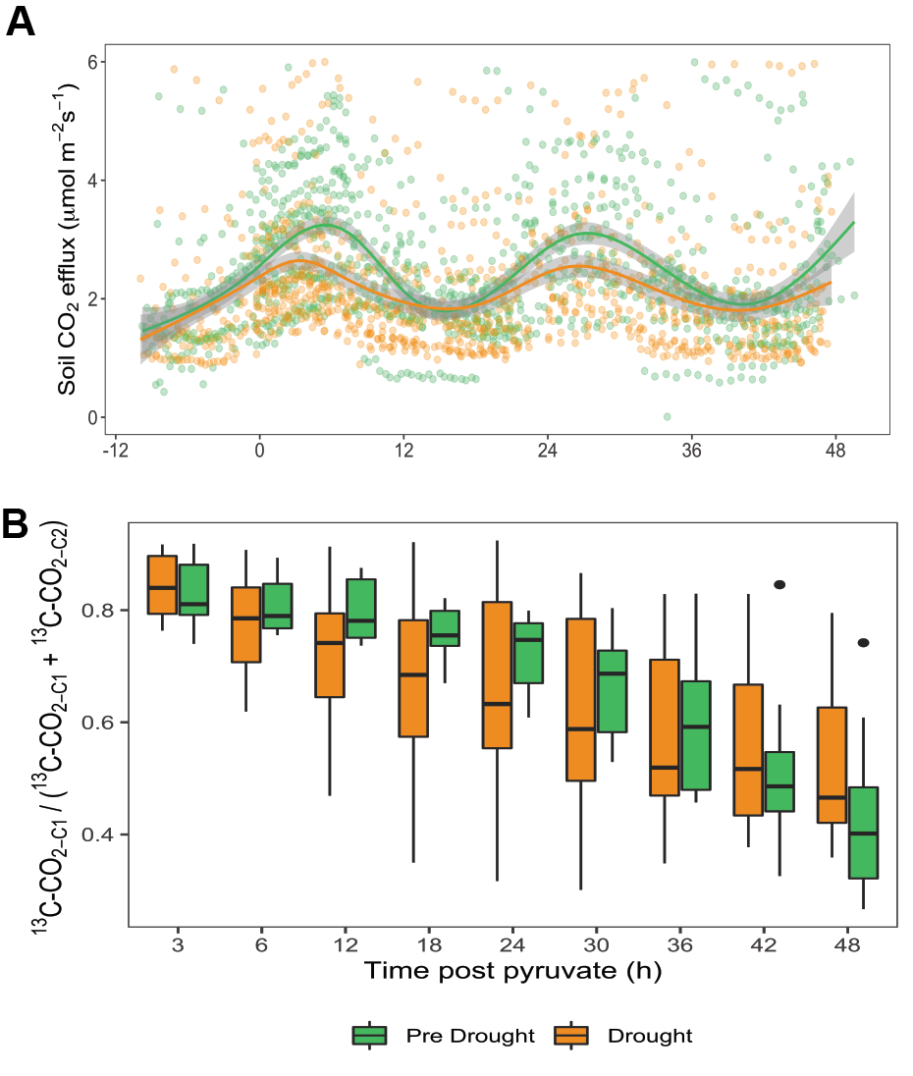
Figure S1. Continuous CO₂ emissions and proportion of C from pyruvate allocated to biosynthesis. A) Total flux of CO₂ during pre-drought and drought conditions. Data includes triplicate replicates of chambers receiving C1 or C2-¹³C-pyruvate across three sites (n=18). B) C1/(C1 + C2) efflux over time. B) Proportion of C from pyruvate allocated to biosynthesis (calculated as C1/(C1 + C2) of ¹³C-CO₂) from 0 to 48 hr post pyruvate injection, with significant increases during pre-drought from 3 - 24 h. Continuous emission data was binned to 3 or 6 h intervals.

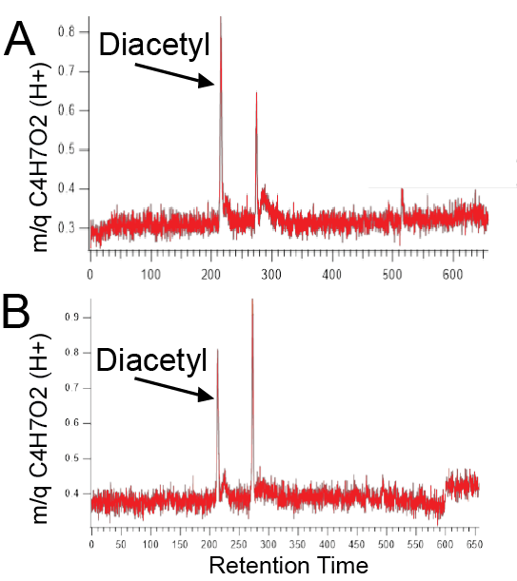
Figure S2. GC-PTR-TOF data to identify C₄H₆O₂. Two nearby locations A) and B) had two peaks with retention times 217 s and 275 s, where 217 s matched the expected retention time for Diacetyl, but 275 s was unidentified. The diacetyl peak is indicated with an arrow.

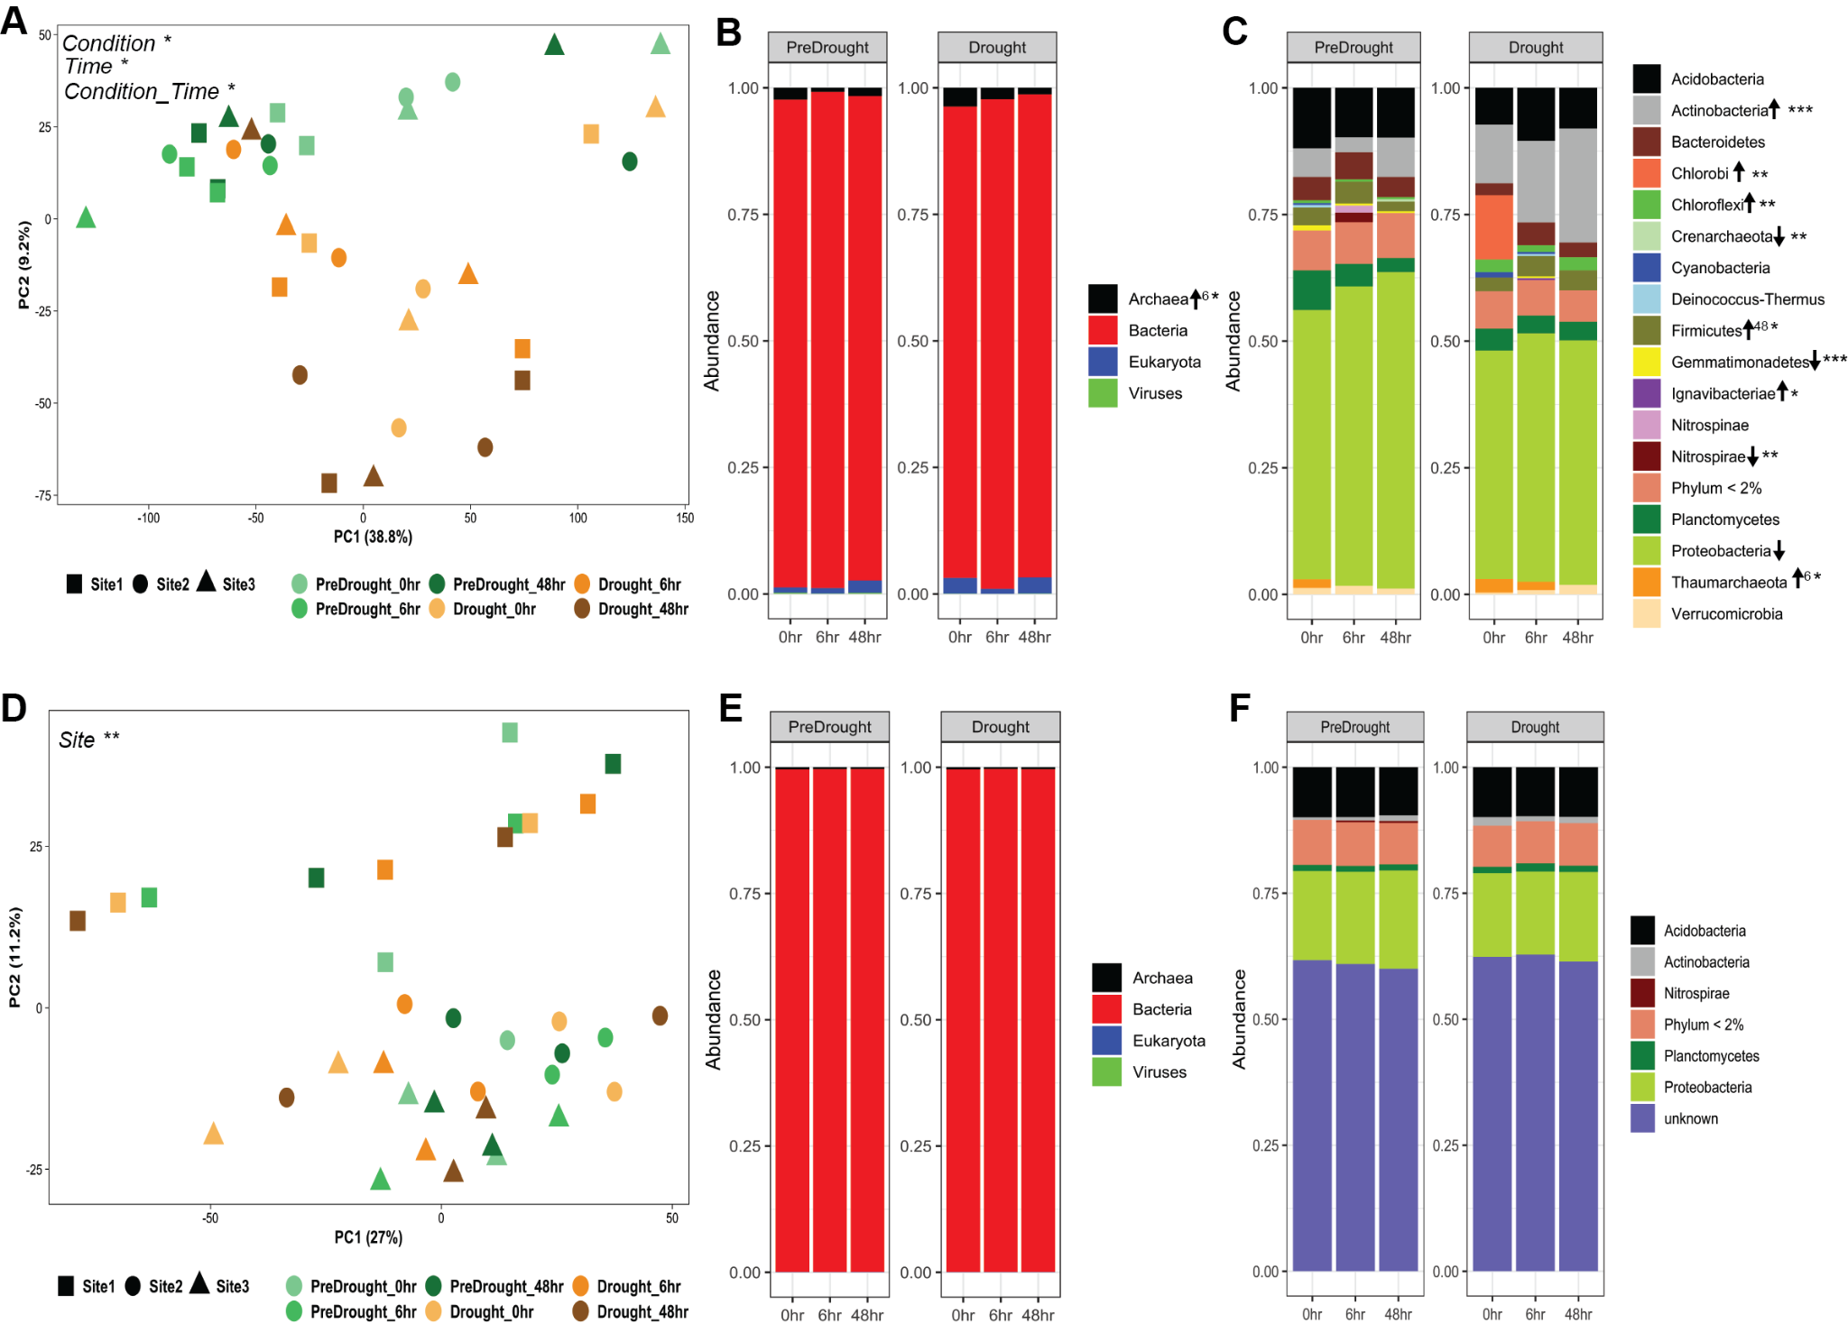
Figure S3. Metatranscriptomic and metagenomic functional and taxonomic diversity shows shifts in active microbial functional profiles and taxonomic diversity, but not in functional potential and total (active and inactive) taxonomic diversity. A) PCA of metatranscriptomic data. B) Taxonomic profiles at the kingdom-level of active archaea, bacteria, eukaryota, and viruses, as inferred from metatranscriptomes. C) Taxonomic profiles of microbial phyla, as inferred from metatranscriptomes. D) PCA of metagenomic data. E) Taxonomic profiles at the kingdom-level of total DNA present, as inferred by metagenomics. F) Taxonomic profiles at the phylum-level of total DNA present, as inferred by metagenomics. For PCA plots, color represents condition (pre-drought, red and drought, green) and color intensity represents increased time post pyruvate addition (0, 6, or 48 hr). Sites are represented by shapes. Significance between clusters in PCA is determined by PERMANOVA on Bray-Curtis distance matrices. For taxonomic profiles, significance in relative abundance is indicated by arrows (up for increased, and down for decreased relative abundance in drought compared to pre-drought conditions). A number next to the arrow indicates that significant difference was only during that time point. *, p < 0.05; **, p < 0.01; ***, p < 0.001

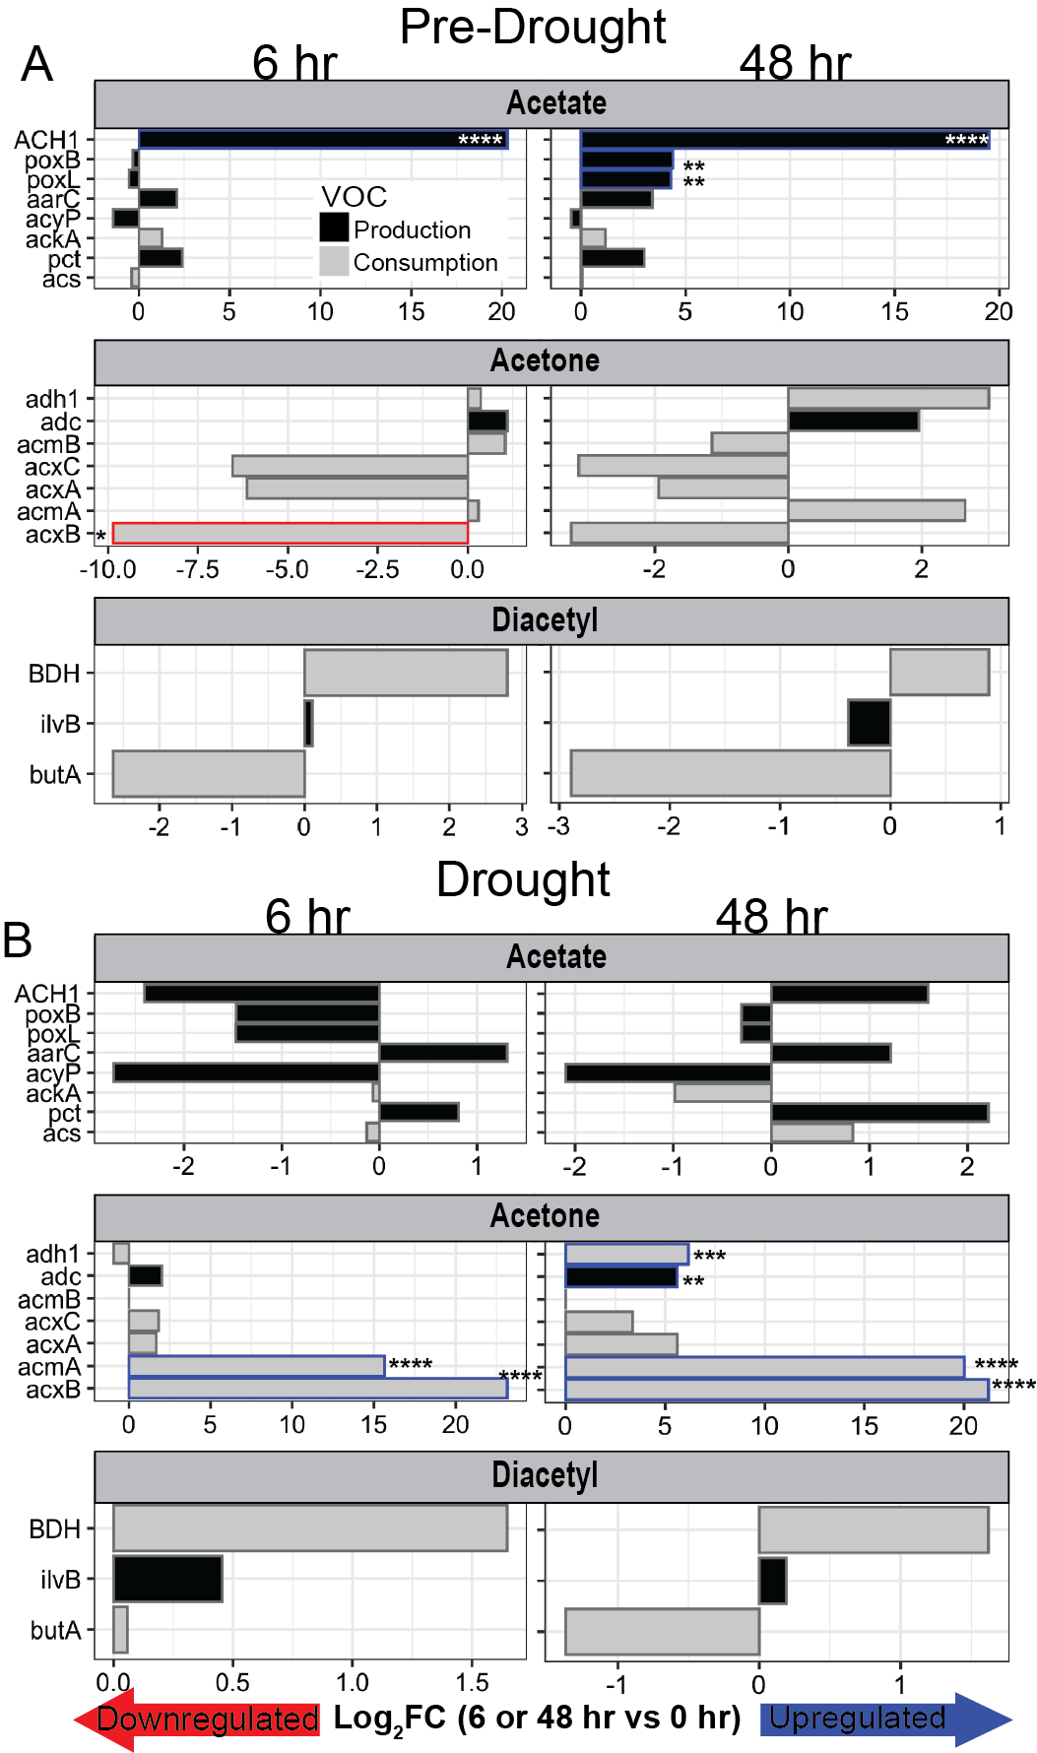

Figure S4. Up- or down-regulation of genes encoding for enzymes that cycle ¹³C-enriched VOCs shift with pyruvate addition. Log₂-fold change (FC) of genes involved in cycling of acetate, acetone, and diacetyl at 6 and 48 hrs in relation to 0 hr to show effect of pyruvate addition on microbial activity during A) pre-drought and B) drought conditions. Log₂-FC values to indicate up-or down-regulation calculated with Deseq2. Production vs. consumption indicated by black and gray bars, respectively. Significantly up- or down-regulated genes are outlined in color (blue = upregulated, red = downregulated). *, p<0.1; **, p<0.05; ***, p<0.01, ****, p < 0.001.

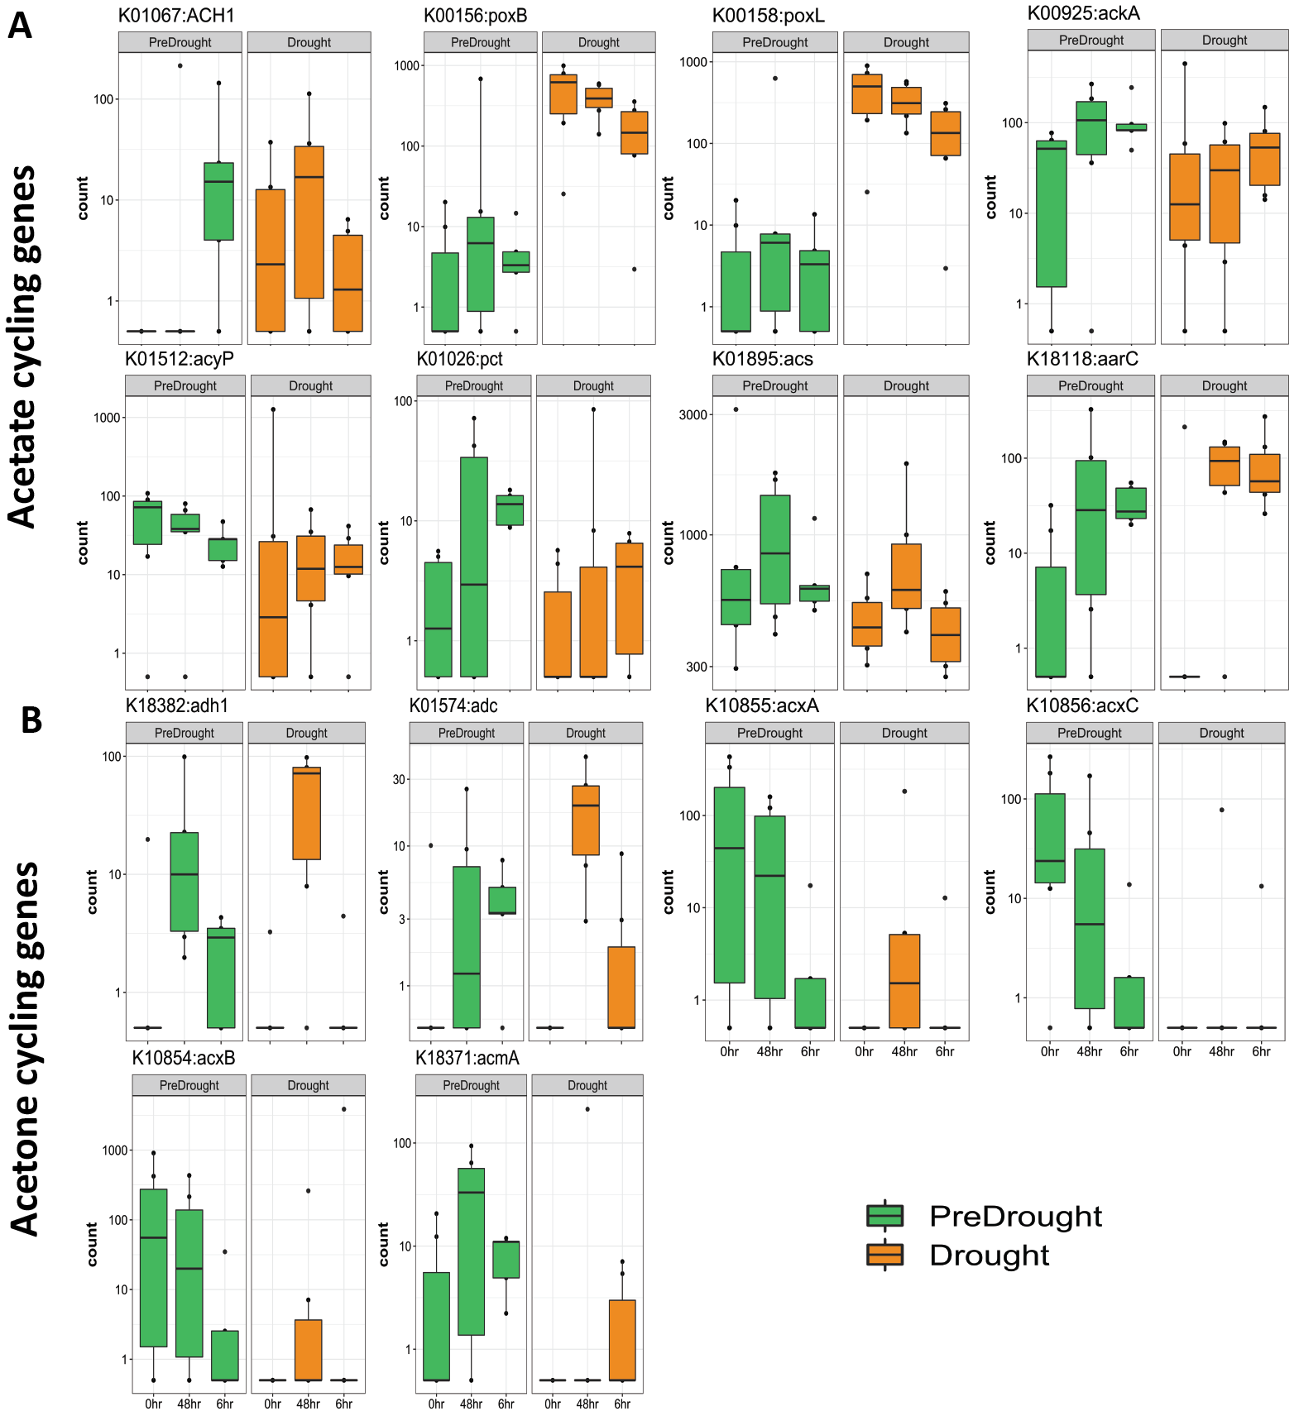
Figure S5. Acetone and acetate cycling gene transcripts. DeSEQ2-normalized transcript copies of A) acetate- and B) acetone-cycling genes at 0, 6, and 48 hr post pyruvate injection. Each time point represents an average across all sites for each condition (n=9).

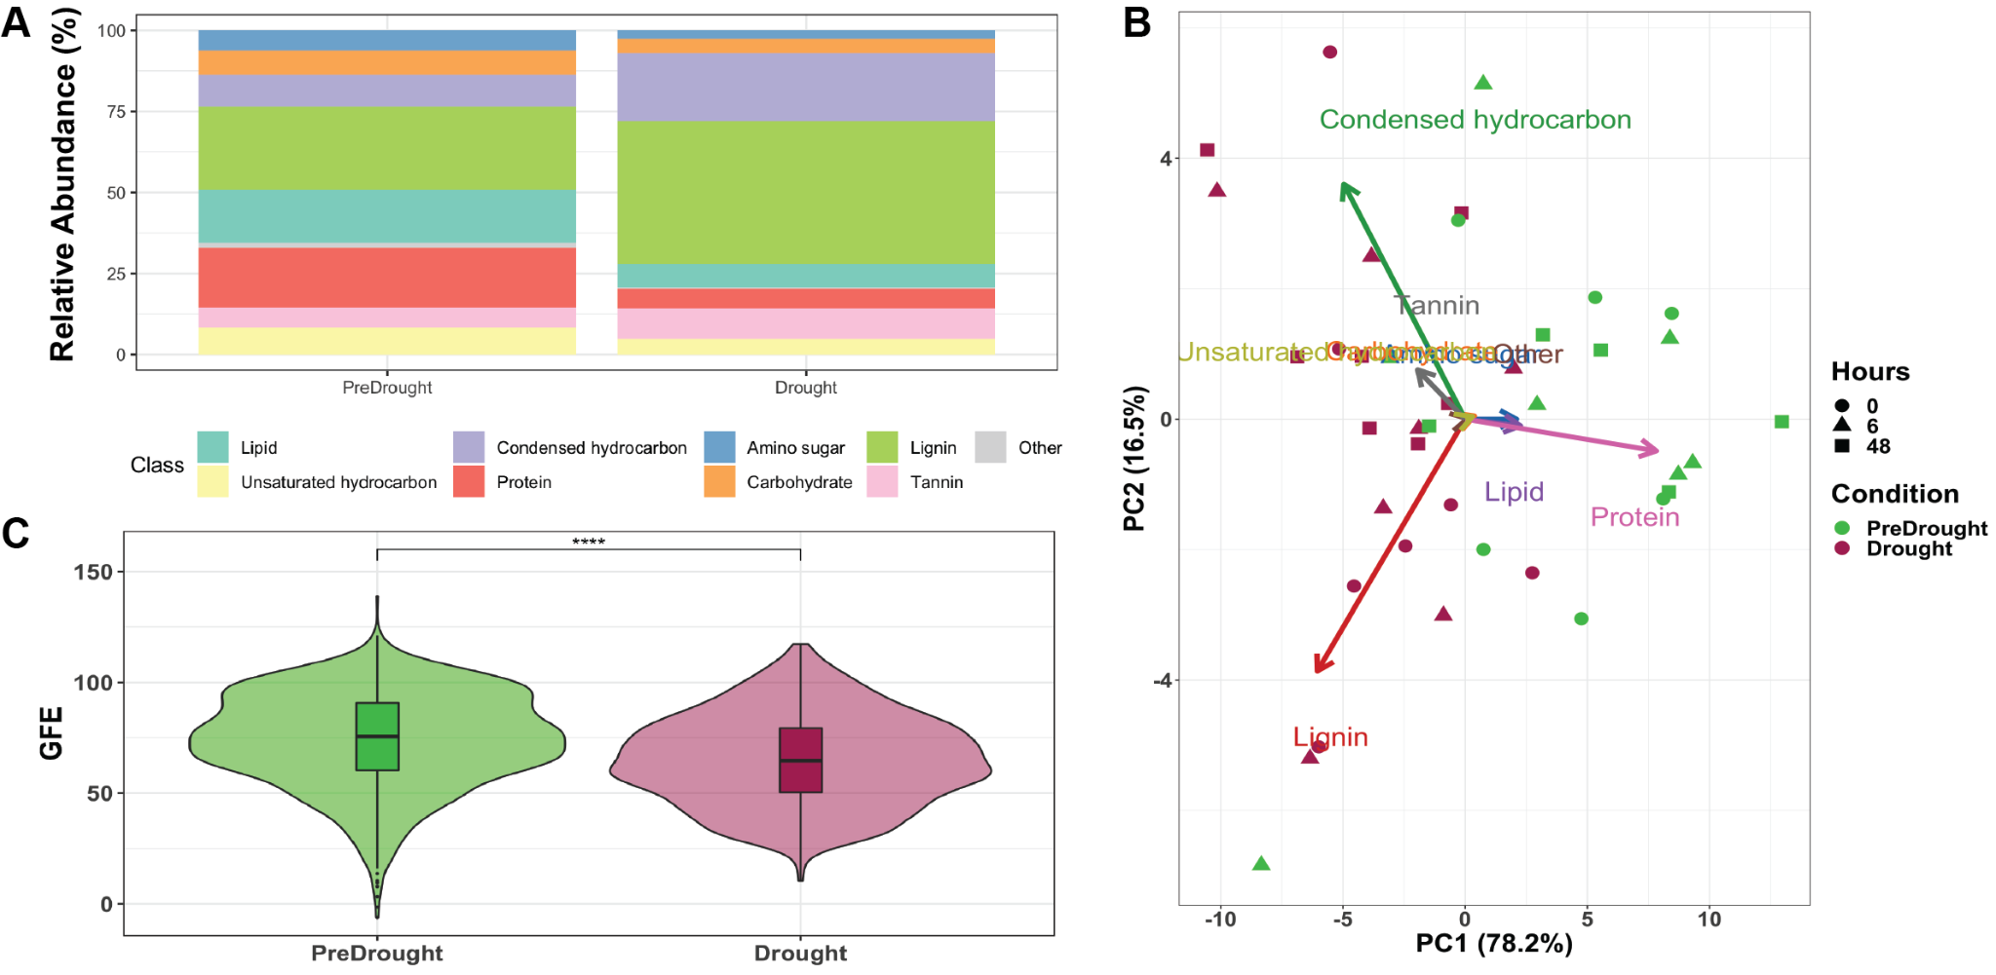
Figure S6. Profile of FTICR-detected compounds at class-level. Each bar at pre-drought and drought represents an average across all sites and time points (0, 6, and 48 hr post pyruvate injection) (n=54).

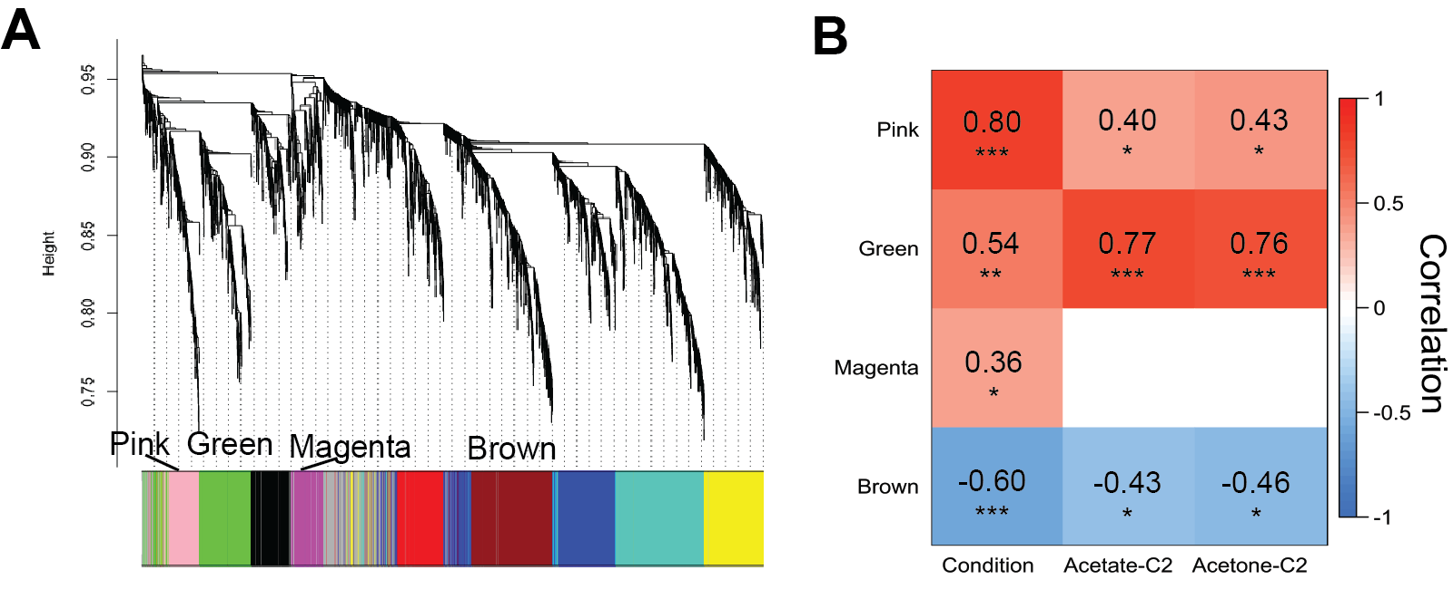

Figure S7. Modules of co-expressed genes that are associated with pre-drought or drought conditions and ¹³C-enrichment of VOCs. A) WGCNA cluster dendrogram reveals 9 clusters of co-expressed genes, or modules. The four modules with significant correlations to drought or pre-drought (pink, green, magenta, and brown) are indicated. B) Correlations of the pink, green, magenta, and brown module eigengenes with environmental conditions (pre-drought = -1, drought = 1) and efflux of ¹³C-enriched (¹³C/ (¹²C + ¹³C)) acetate and acetone from chambers receiving ¹³C2-pyruvate (acetate-C2 and acetone-C2, respectively). Significant Pearson correlation coefficients are shown. *, p < 0.05; **, p < 0.01; ***, p < 0.001

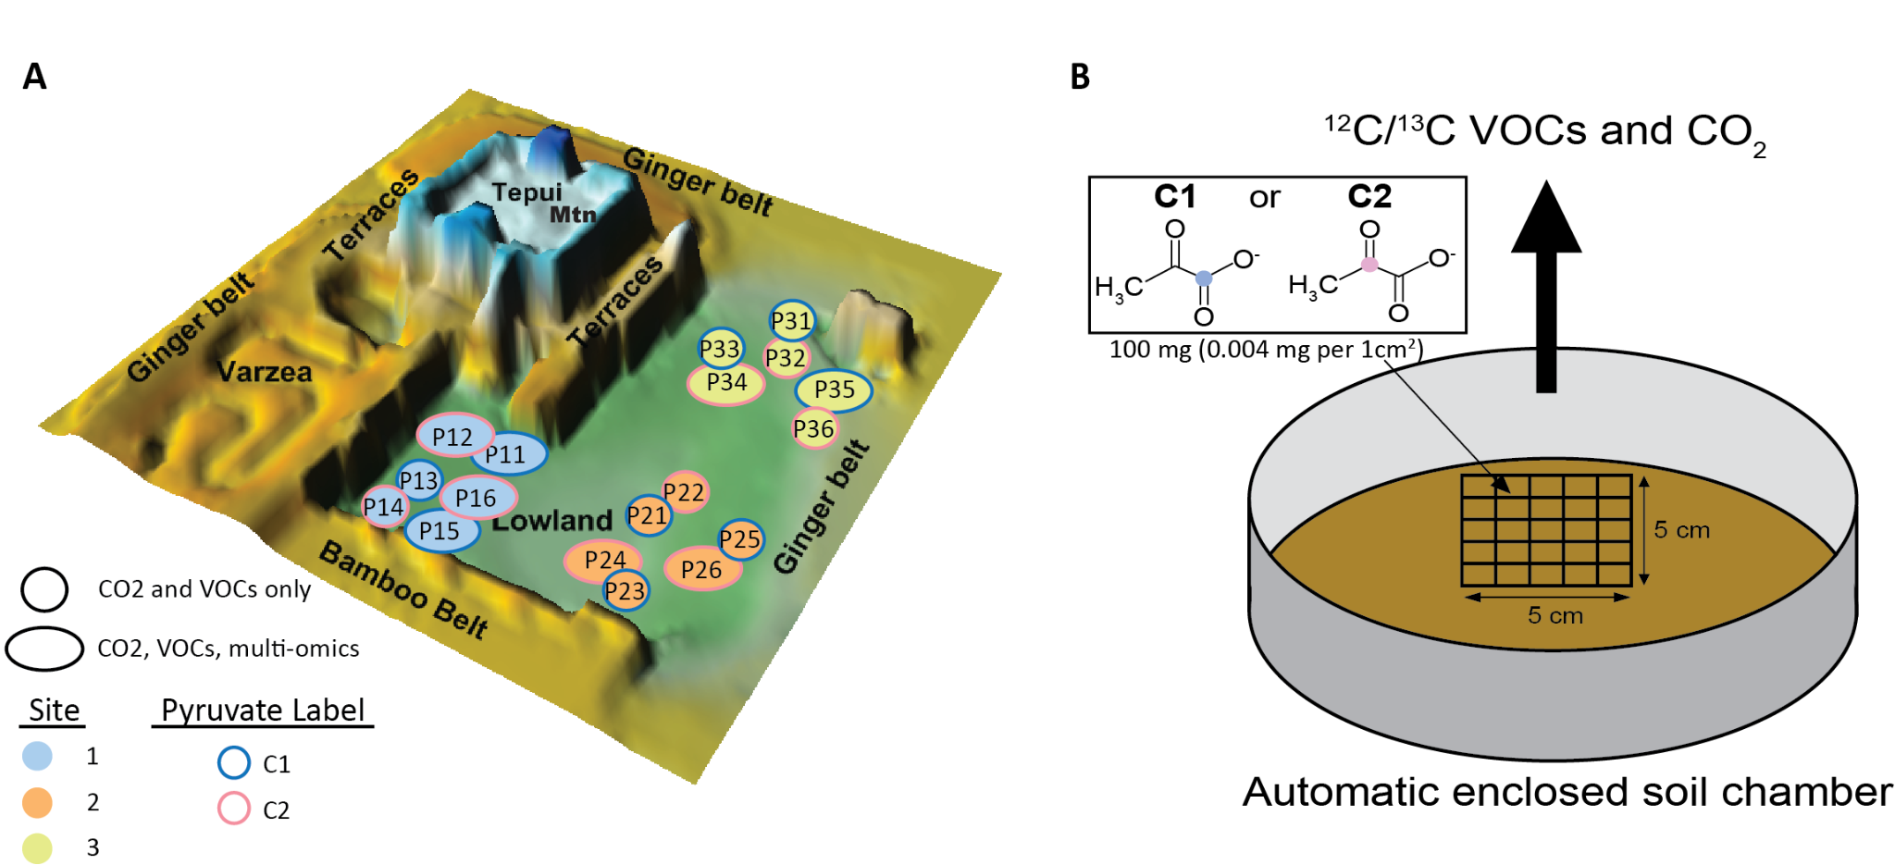Figure S8. A) Topological map of Biosphere 2 Tropical Rainforest, with locations of Sites 1 - 3. All circles represent collar locations where CO2 and VOC data were collected and large circles represent a sub selection of sites collars additional samples for metatranscriptomics, metagenomics, and metabolomics were collected. B) Diagram showing soil pyruvate experimental setup with stencil placed inside a soil collar where ¹³C1 or ¹³C2-pyruvate was added within each 1 cm x 1 cm square. An automatic soil chamber was placed over the soil collar during the experiment and continuous measurements of ¹²C and ¹³C-CO₂ and VOCs were measured.

Table S1. Metabolic concentrations (μM) detected using NMR. Samples displayed are a subset of total samples based on the quality of NMR data. Most samples are from 0 h, except for P24 during drought which is from 6 h post pyruvate injection.
Compound |  |  | Pre-drought |  |  |  |  |  | Drought
Name | Formula |  | P15-0hr | P24-0hr | P26-0hr | P34-0hr | P35-0hr |  | P12-Ctrl | P15-0hr | P24-6hr | P26-0hr | P34-0hr | P34-0hr
2-Oxoisocaproate*^{P} | C6H10O3 |  | 6 | 5 | D | 5 | D |  | ND | ND | ND | ND | ND | D
3-Hydroxybutyrate | C4H8O3 |  | ND | ND | ND | ND | D |  | ND | ND | ND | ND | ND | ND
Acetate | C2H4O2 |  | 22 | 38 | 30 | 55 | 26 |  | 19 | 35 | 31 | 31 | 24 | 11
Acetone | C3H6O |  | ND | D | D | ND | ND |  | D | ND | ND | ND | ND | D
Alanine*^{P} | C3H7NO2 |  | 24 | 21 | 15 | 20 | 17 |  | 18 | 9 | 13 | 9 | 7 | 9
Benzoate | C7H6O2 |  | ND | ND | ND | D | ND |  | ND | ND | ND | ND | ND | ND
Betaine | C5H11NO2 |  | ND | ND | ND | ND | ND |  | D | D | ND | ND | ND | ND
Ethanol | C2H6O |  | 12 | 17 | 21 | 19 | 18 |  | 28 | 24 | 12 | 22 | 22 | 12
Formate*^{P} | CH2O2 |  | 17 | 38 | 40 | 23 | 31 |  | ND | D | 6 | 16 | D | 11
Glutamate | C5H9NO4 |  | 12 | 12 | 8 | 6 | 10 |  | 11 | 7 | 10 | 10 | 10 | 6
Glycerol | C3H8O3 |  | 6 | 8 | 8 | 6 | 7 |  | 5 | 6 | 7 | 5 | 8 | 6
Glycine*^{P} | C2H5NO2 |  | 12 | 9 | 6 | 8 | 7 |  | 5 | D | 7 | 6 | D | D
Isoleucine | C6H13NO2 |  | 7 | 7 | D | D | D |  | D | D | D | D | D | D
Lactate | C3H6O3 |  | 6 | 7 | D | 12 | 7 |  | D | D | 11 | D | D | 7
Leucine*^{P} | C6H13NO2 |  | 12 | 11 | 7 | 7 | 6 |  | 7 | 6 | 6 | 6 | D | D
Methanol | CH4O |  | 150 | 375 | 367 | 222 | 326 |  | 508 | 329 | 203 | 370 | 372 | 322
Phenylalanine*^{P} | C9H11NO2 |  | D | D | ND | D | ND |  | ND | ND | ND | ND | ND | ND
Pyroglutamate*^{P} | C5H7NO3 |  | 22 | 19 | 10 | 16 | 9 |  | 8 | 5 | 12 | 8 | D | D
Pyruvate*^{P} | C3H4O3 |  | 11 | 13 | 10 | 11 | 10 |  | D | 5 | 9 | 5 | D | 7
Succinate | C4H6O4 |  | ND | ND | ND | ND | ND |  | ND | D | D | ND | ND | ND
Threonine | C4H9NO3 |  | 6 | 7 | D | D | D |  | D | D | D | D | D | D
Trehalose*^{D} | C12H22O11 |  | ND | ND | ND | ND | ND |  | 18 | D | 7 | 6 | 13 | D
Uracil*^{P} | C4H4N2O2 |  | D | 5 | D | D | D |  | ND | ND | D | ND | ND | D
Valine*^{P} | C5H11NO2 |  | 15 | 13 | 8 | 9 | 8 |  | 8 | 6 | 8 | 6 | 5 | 5
ND, not detected (below the level of detection where concentration < 1.9 μM); D, detected (below level of quantification, where concentration 2 - 5 μM)
*^{P}, Compound higher during pre-drought (p < 0.05; Wilcoxan t-test, where ND and D were given values of 1 and 4 μM respectively)
*^{D}, Compound higher during drought (p < 0.05)

Table S2. Sequence coverage for metagenomics and metatranscriptomics. Read counts are post-filtering (as described in the methods section).
 | Metagenomics |  |  |  | Metatranscriptomics
Sample | Reads | Bases (Gb) | Mapped to assembly (%) |  | Reads | Bases (Gb) | Mapped to assembly (%)
P11SSC1_190916_c | 142713986 | 21.4 | 49.1 |  | 124166928 | 18.0 | 77.9
P11SSC1_190916_f | 224647504 | 33.6 | 60.0 |  | 134601358 | 19.5 | 81.2
P11SSC1_190916_i | 155786656 | 23.3 | 53.4 |  | 101082054 | 14.5 | 77.6
P11SSC1_191110_c | 227806600 | 34.1 | 64.9 |  | 82931902 | 12.0 | 81.1
P11SSC1_191119_f | 132381506 | 19.8 | 55.9 |  | 107176982 | 15.4 | 82.3
P11SSC1_191119_i | 257335184 | 38.5 | 64.8 |  | 76710842 | 11.0 | 81.1
P12SS_CTRL_191116_c | 135568486 | 20.3 | 52.9 |  | 92715120 | 13.2 | 77.0
P12SS_CTRL_191116_f | 103105310 | 15.4 | 48.0 |  | 146171918 | 20.8 | 73.4
P12SS_CTRL_191116_i | 89432070 | 13.4 | 45.8 |  | 85117324 | 12.1 | 81.9
P15SSC1_190912_c | 141457632 | 21.2 | 44.5 |  | 95565802 | 13.6 | 77.1
P15SSC1_190913_f | 136093864 | 20.4 | 41.0 |  | 102381422 | 14.5 | 73.1
P15SSC1_190915_i | 116566008 | 17.5 | 39.7 |  | 105544744 | 15.0 | 67.5
P15SSC1_191107_f | 126857110 | 19.0 | 43.0 |  | 22699542 | 3.2 | 68.0
P15SSC1_191107_i | 141678932 | 21.2 | 43.5 |  | 104936440 | 14.9 | 75.1
P15SSCI_191107_c | 131734810 | 19.7 | 45.6 |  | 106270712 | 15.0 | 78.9
P24SSC2_190915_c | 131640432 | 19.7 | 54.6 |  | 93137922 | 13.3 | 80.2
P24SSC2_190915_f | 108754462 | 16.3 | 50.0 |  | 145088652 | 20.6 | 77.5
P24SSC2_190915_i | 143103050 | 21.4 | 55.0 |  | 120662996 | 17.1 | 73.7
P24SSC2_191109_c | 122604752 | 18.4 | 49.7 |  | 124732280 | 17.6 | 74.2
P24SSC2_191109_f | 145461884 | 21.8 | 59.2 |  | 79879116 | 11.5 | 74.6
P24SSC2_191109_i | 101194304 | 15.2 | 44.3 |  | 72649070 | 10.2 | 77.6
P26SSC2_190918_c | 138246448 | 20.7 | 58.3 |  | 76395558 | 10.8 | 63.8
P26SSC2_190918_f | 110179686 | 16.5 | 54.9 |  | 94868962 | 13.4 | 65.5
P26SSC2_190918_i | 112067984 | 16.8 | 49.2 |  | 116842828 | 16.7 | 76.7
P26SSC2_191112_c | 98449944 | 14.7 | 50.9 |  | 85137010 | 12.0 | 72.2
P26SSC2_191112_f | 119958450 | 18.0 | 58.9 |  | 78330638 | 10.9 | 68.4
P26SSC2_191112_i | 175881098 | 26.3 | 62.4 |  | 97683038 | 13.7 | 68.9
P34SSC2_190917_c | 132462676 | 19.8 | 55.5 |  | 71554676 | 10.2 | 77.8
P34SSC2_190917_f | 101846050 | 15.3 | 48.6 |  | 183218676 | 25.8 | 78.6
P34SSC2_190917_i | 127521864 | 19.1 | 51.5 |  | 85630146 | 12.0 | 69.7
P34SSC2_191111_c | 154773318 | 23.2 | 57.8 |  | 83204978 | 12.0 | 84.2
P34SSC2_191111_f | 134298460 | 20.1 | 56.9 |  | 78791904 | 10.8 | 72.9
P34SSC2_191111_i | 112046872 | 16.8 | 53.5 |  | 68499682 | 9.9 | 80.1
P35SSC1_190914_c | 112270418 | 16.8 | 56.0 |  | 16633060 | 2.3 | 65.2
P35SSC1_190914_f | 112035746 | 16.8 | 55.5 |  | na | na | na
P35SSC1_190914_i | 128627610 | 19.3 | 60.0 |  | 14394504 | 2.0 | 37.3
P35SSC1_191108_c | 195950226 | 29.3 | 64.4 |  | 13623088 | 1.9 | 59.7
P35SSC1_191108_f | 128984880 | 19.3 | 56.8 |  | 97460190 | 13.5 | 72.1
P35SSC1_191108_i | 109718370 | 16.4 | 55.1 |  | 86907854 | 12.1 | 74.3
a, 0 h; f, 6 hr; i, 48 h
na, Metatranscriptomics of sample P35SSC1_191108_c were not completed due to sequencing issues

