Supplementary Material for
Potent and Selective Covalent Inhibition of the Papain-like Protease from SARS-CoV-2
Brian C. Sanders,^{a,†,*} Suman Pohkrel,^{b,c,†} Audrey D. Labbe,ª Irimpan I. Mathews,^{d} Connor J. Cooper,ª Russell B. Davidson,ª Gwyndalyn Phillips,^{e} Kevin L. Weiss,^{e} Qiu Zhang,^{e} Hugh O’Neill,^{e} Manat Kaur,^{f} Lori Ferrins,^{g} Jurgen G. Schmidt,^{h} Walter Reichard,^{i} Surekha Surendranathan,^{j} Jyothi Parvathareddy,^{j} Lexi Phillips,^{k} Christopher Rainville,^{l} David E. Sterner,^{l} Desigan Kumaran,^{m} Babak Andi,^{n} Gyorgy Babnigg,^{o,p} Nigel W. Moriarty,^{q} Paul D. Adams,^{q,r} Andrzej Joachimiak,^{o,s} Brett L. Hurst,^{k} Suresh Kumar,^{l} Tauseef R. Butt,^{l} Colleen B. Jonsson,^{i} Soichi Wakatsuki,^{b,c,*} Stephanie Galanie,ª Martha S. Head,^{t,u} and Jerry M. Parks^{a,*}

ª Biosciences Division, Oak Ridge National Laboratory, Oak Ridge, Tennessee, USA
^{b} Department of Chemical and Systems Biology, Stanford University School of Medicine, Stanford, California, USA
^{c} Biological Sciences Division, SLAC National Accelerator Laboratory, Menlo Park, California, USA
^{d} Stanford Synchrotron Radiation Lightsource, Menlo Park, California, USA
^{e} Neutron Scattering Division, Oak Ridge National Laboratory, Oak Ridge, Tennessee, USA
^{f} Department of Structural Biology, Stanford University School of Medicine, Stanford, California, USA
^{g} Department of Chemistry and Chemical Biology, Northeastern University, Boston, Massachusetts, USA
^{h} B-11 Bioenergy and Biome Sciences, Bioscience Division, Los Alamos National Laboratory, Los Alamos, New Mexico, USA
^{i} Department of Microbiology, Immunology and Biochemistry, University of Tennessee Health Science Center, Memphis, Tennessee, USA
^{j} Regional Biocontainment Laboratory, University of Tennessee Health Science Center, Memphis, TN, USA
^{k} Institute for Antiviral Research, Department of Animal, Dairy, and Veterinary Sciences, Utah State University; Logan, UT, USA
^{l} Progenra Inc., Malvern, Pennsylvania, USA
^{m} Biology Department, Brookhaven National Laboratory, Upton, New York, USA
^{n} Center for BioMolecular Structure, National Synchrotron Light Source II, Brookhaven National Laboratory, Upton, New York, USA
º Center for Structural Genomics of Infectious Diseases, Consortium for Advanced Science and Engineering, University of Chicago, Chicago, Illinois, USA
^{p} Biosciences Division, Argonne National Laboratory, Argonne, Illinois, USA
^{q} Molecular Biosciences and Integrated Bioimaging, Lawrence Berkeley National Laboratory, Berkeley, California, USA
^{r} Department of Bioengineering, University of California, Berkeley, CA, USA
^{s} Structural Biology Center, X-ray Science Division, Argonne National Laboratory, Argonne, IL, USA. Department of Chemistry, University of Chicago, Chicago, Illinois, USA
^{t} Joint Institute for Biological Sciences, Oak Ridge National Laboratory, Oak Ridge, Tennessee USA
^{u} Computing and Computational Sciences Directorate, Oak Ridge National Laboratory, Oak Ridge, Tennessee USA

† These authors contributed equally to this work.
*Correspondence and requests for materials should be addressed to sandersbc@ornl.gov, soichi.wakatsuki@stanford.edu, or parksjm@ornl.gov.
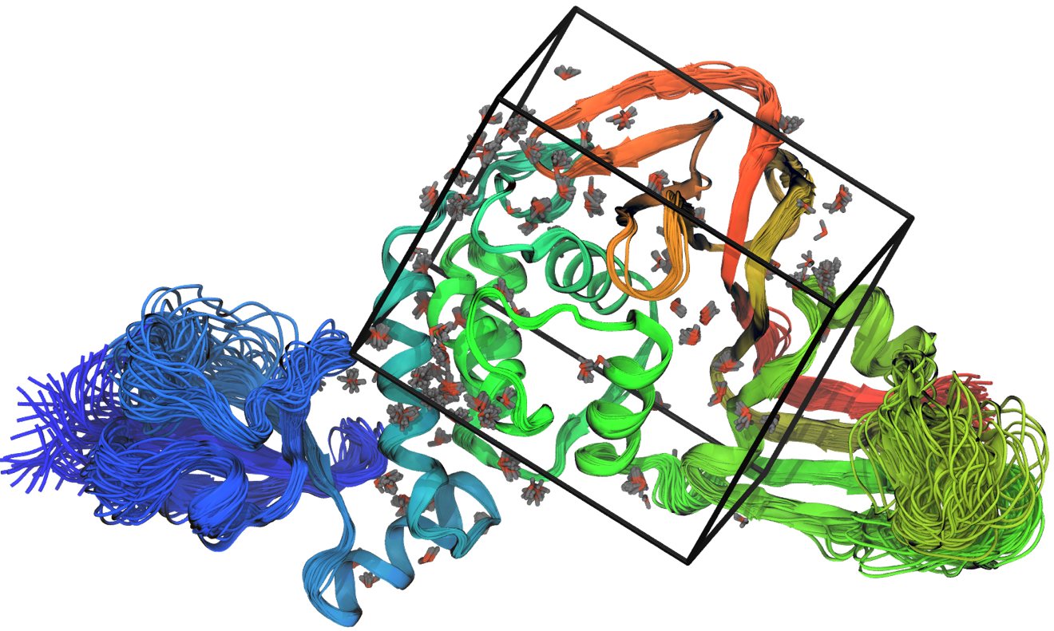
Figure S1. Superposition of 50 ensemble models generated from crystallographic data for PDB entry 7JIR.¹⁴ The protein is shown in spectrum coloring (blue = N-terminus, red = C-terminus). The docking box is shown in thick black lines. Conserved water molecules are shown in stick representation.

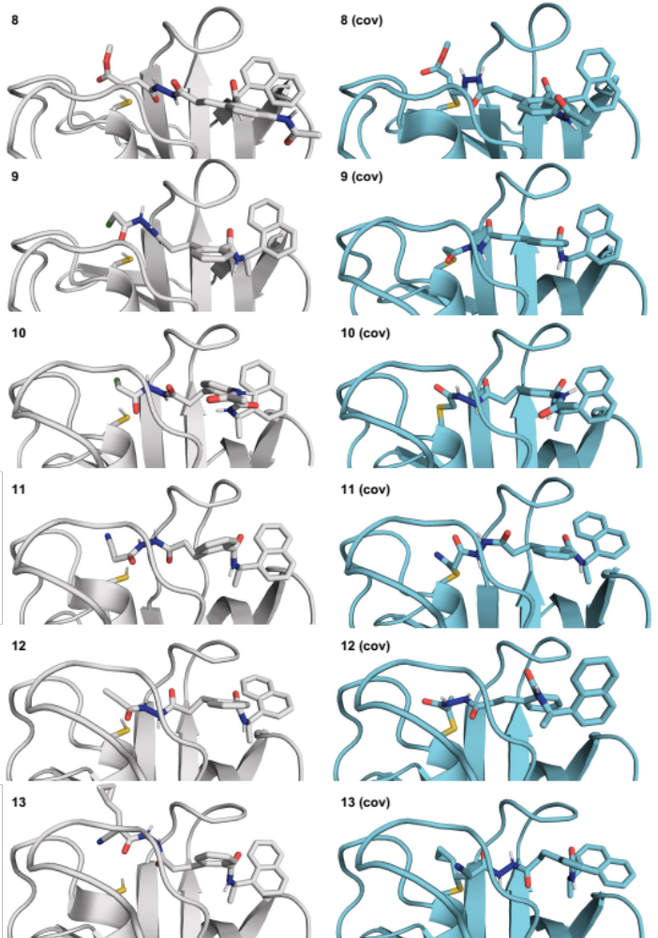
Figure S2. Docked poses of compounds 8-13. Left: noncovalent, right: covalent.

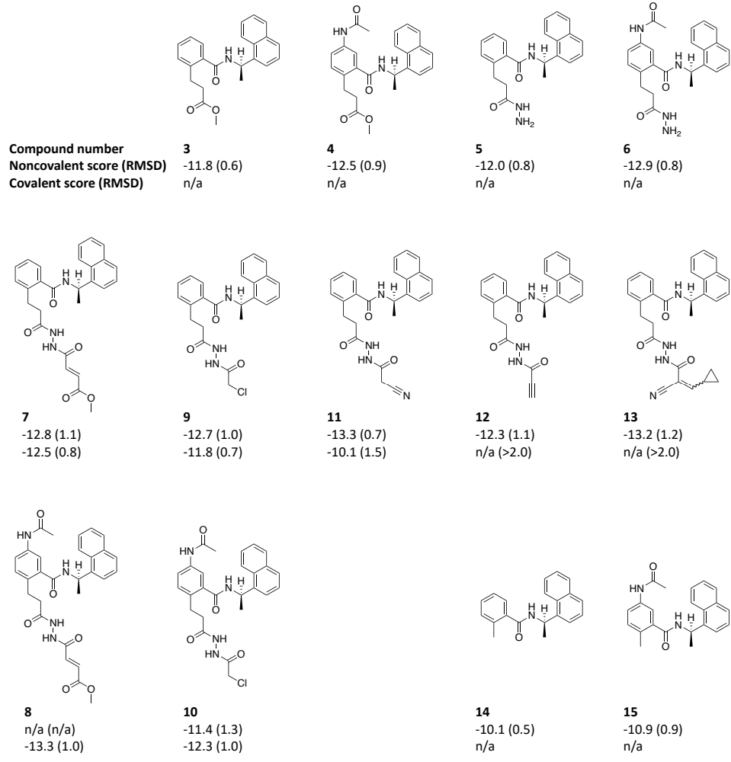
Figure S3. Summary of docking results for experimentally tested compounds. Docking scores are in kcal/mol and MCS-RMSD values are in Å. Additional docking data for all candidate inhibitors are provided in Supplementary Data File 1.

Figure S4. Michaelis-Menten kinetics data for Z-RLRGG-AMC and Z-LRGG-AMC substrates. Data points represent the average initial rate for n = 2 independent experiments performed with n = 3 replicates, ± s.d.

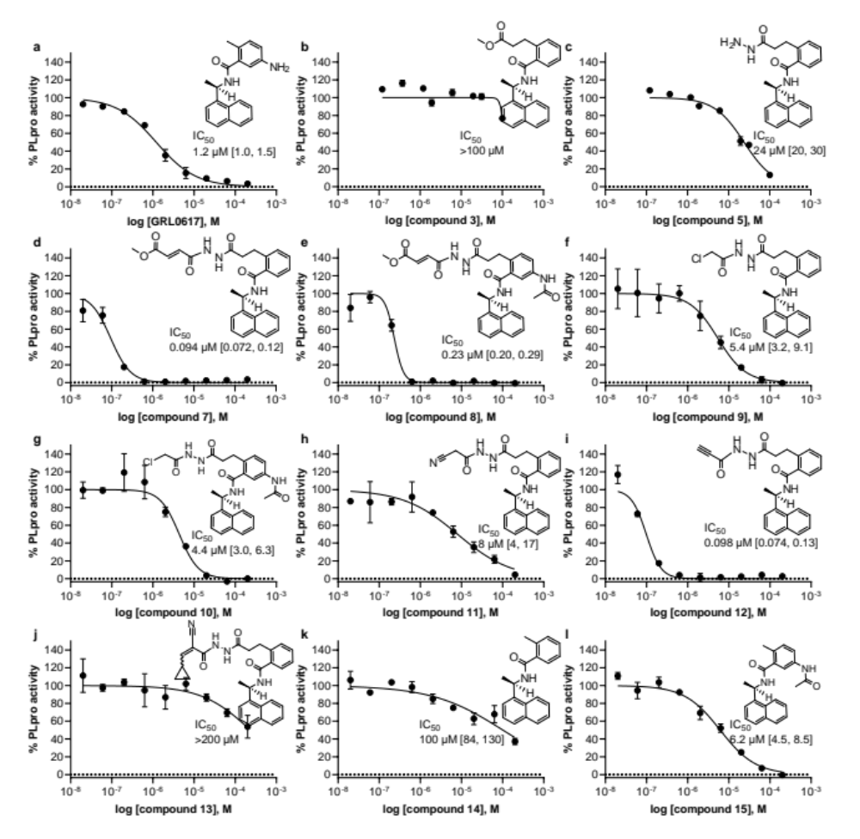
Figure S5. Fluorogenic peptide activity assay after 30 min preincubation with inhibitor candidates. Data points are the average of n = 2 independent samples ± range and are representative of n ≥ 1 independent experiments. IC₅₀ is the concentration at which 50% inhibition was observed, and bracketed values are the 95% confidence interval. Curve is the nonlinear regression to the normalized inhibitor dose response equation.

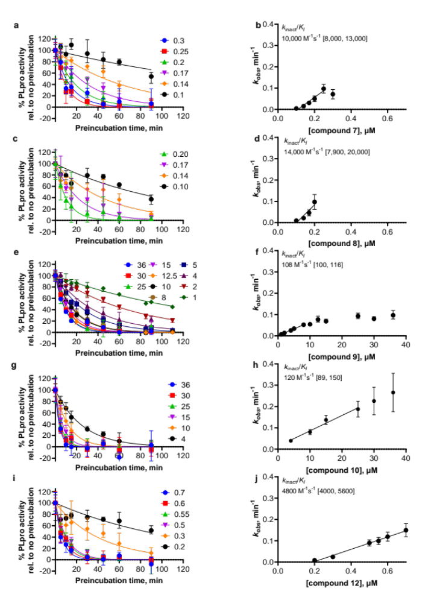
Figure S6. Time-dependent characterization with fluorogenic peptide assay. a, c, e, g, and i are initial rates determined at various inhibitor concentrations (concentrations in μM, inhibitor in x-axis of right panels) and preincubation times, normalized to no preincubation. Data points are from n ≥ 2 independent experiments with n = 2 independent samples each, ± range. Curves are nonlinear regressions of the exponential decay equation to the data. b, d, f, h, and j, Data points are the k_{obs} values determined from a, c, e, g, and i ± 95% confidence interval of the nonlinear regression. Line represents the linear regression yielding as its slope the second-order rate constant (k_{inact}/K_{I}), with bracketed values representing 95% confidence interval of the slope.

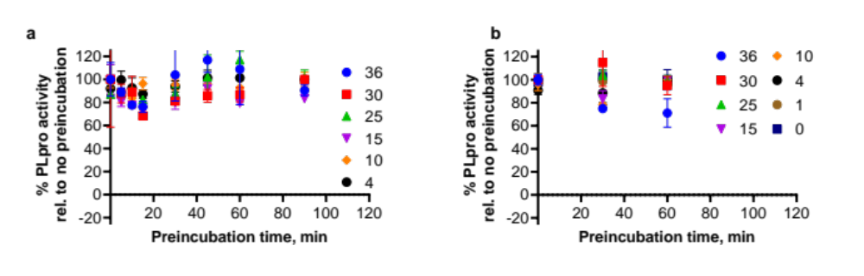
Figure S7. Time-dependent characterization with fluorogenic peptide assay. (a) compound 11, (b) compound 13. Data points are from an experiment with n = 2 independent samples, ± range.
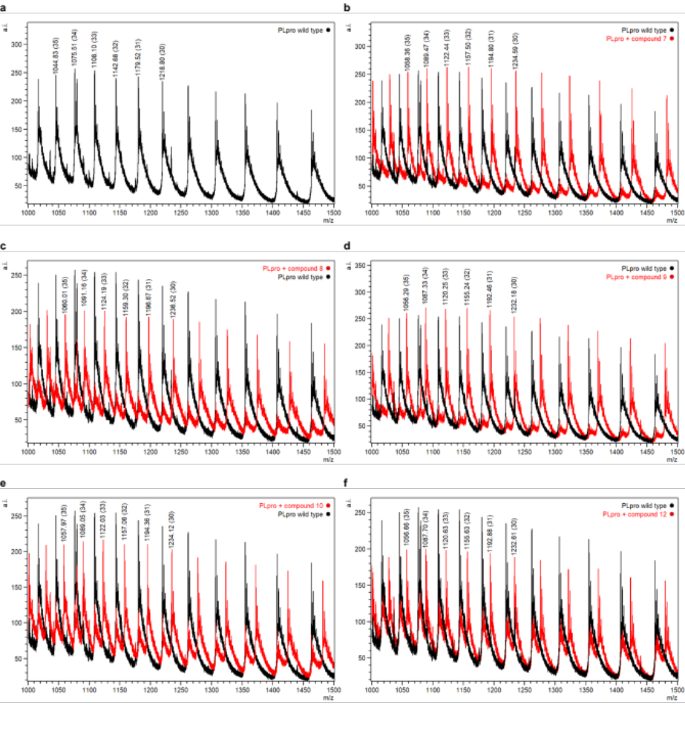
Figure S8. Intact protein ESI-MS spectra of (a) PLpro (black), and (b-f), PLpro incubated with compounds indicated in the figure legends (red). a.i., arbitrary intensity; m/z, mass-to-charge ratio. Spectral peaks used for protein monoisotopic mass deconvolution are annotated with their monoisotopic masses and, in parentheses, charge states. A,
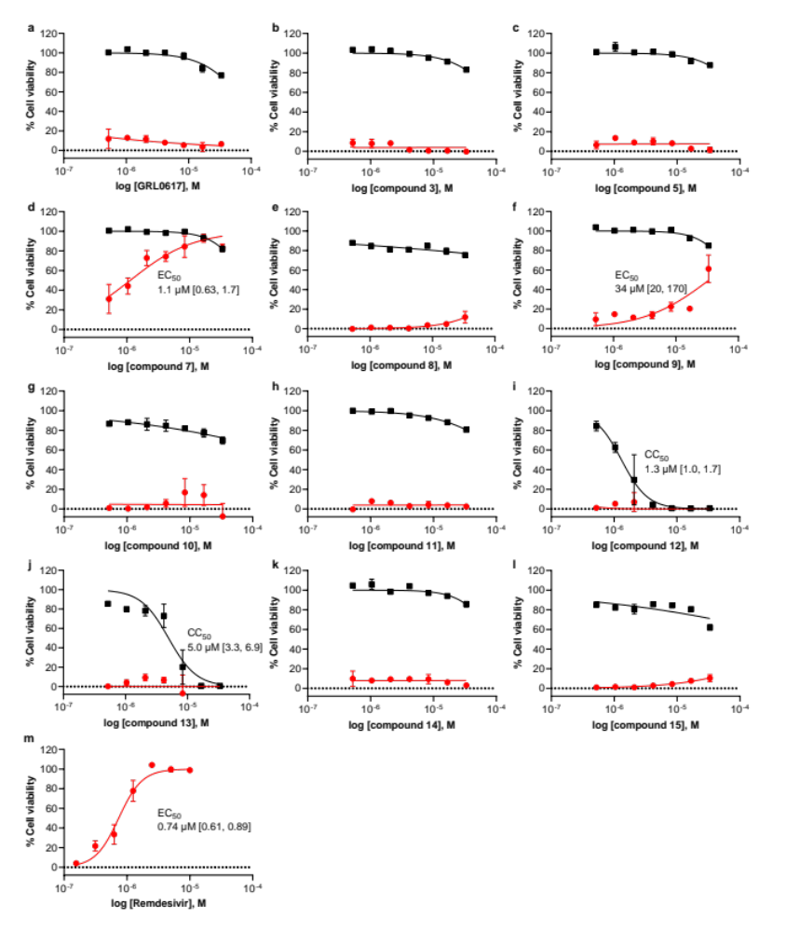
Figure S9. Cell viability in Vero E6 cells for uninfected cells pretreated with indicated compound (black) and SARS-CoV-2-infected cells pretreated with indicated compound (red). Data points are the average of n = 2 independent samples ± range and are representative of n ≥ 1 independent experiments. EC₅₀ is the concentration at which 50% effect was observed, CC₅₀ is the concentration at which 50% cytotoxicity was observed, and bracketed values are the 95% confidence intervals. Curves are nonlinear regression to the normalized dose response equation.

Figure S10. MetaSite site-of-metabolism prediction for compound 7. The shade of the red circles indicates relative liability (darker = greater liability).

Table S1. PLpro intact protein ESI-MS analysis.
Compound | Deconvoluted monoisotopic  PLpro + compound mass | Measured  adduct  mass | Predicted  adduct  mass
- (wild-type PLpro) | 36535 (FWHM 16) | - | -
7 | 37009 (FWHM 16) | 474 | 473
8 | 37066 (FWHM 16) | 531 | 530
9 | 36936 (FWHM 15) | 401 | 401
10 | 36995 (FWHM 15) | 460 | 458
FWHM = full-width half maximum

Table S2. Deubiquitinase selectivity assay data.
DUB, enzyme conc.  (substrate) | Compound
DUB, enzyme conc.  (substrate) | 15 |  |  | 9 |  |  | 7
DUB, enzyme conc.  (substrate) | IC₅₀  (μM) | Hill slope | SIª | IC₅₀  (μM) | Hill slope | SIª | IC₅₀  (μM) | Hill slope | SIª
PLpro, 50 nM  (Ub-rhodamine110) | >30 | 0.376 | N/A | 1.96 | 0.705 | N/A | 0.076 | 1.06 | N/A
PLpro, 10 nM  (ISG15-CHOP2) | >30 | 0.969 | N/A | 20.2 | 0.817 | N/A | 0.037 | 1.34 | N/A
USP30, 10 nM  (Ub-rhodamine110) | >30 | N/A | 1 | >30 | N/A | 15.3 | >30 | N/A | 394.7
USP15, 1 nM  (Ub-rhodamine110) | >30 | N/A | 1 | >30 | N/A | 15.3 | >30 | N/A | 394.7
USP8, 10 nM  (Ub-rhodamine110) | >30 | N/A | 1 | >30 | N/A | 15.3 | >30 | N/A | 394.7
USP7, 5 nM  (Ub-CHOP2) | >30 | N/A | 1 | >30 | N/A | 15.3 | >30 | N/A | 394.7
USP4, 10 nM  (Ub-rhodamine110) | >30 | N/A | 1 | >30 | N/A | 15.3 | >30 | N/A | 394.7
USP2, 10 nM  (Ub-rhodamine110) | >30 | N/A | 1 | >30 | N/A | 15.3 | >30 | N/A | 394.7
UCHL1, 10 nM  (Ub-rhodamine110) | >30 | N/A | 1 | >30 | N/A | 15.3 | >30 | N/A | 394.7
ª Selectivity index (SI) is represented as the fold change in selectivity for PLpro compared to DUB inhibition activity of other DUBs in the selectivity panel.

Table S3. Summary of X-ray crystallography data collection and refinement
 | PLpro compound 7
Crystallographic parameters  Space group  Unit-cell dimensions | I4₁22  112.33 Å, 112.33 Å, 217.33 Å  90.0˚, 90.0˚, 90.0˚
Data collection statistics  Resolution limits (Å)  No. of observed reflections  No. of unique reflections  Completeness  overall/outer shell  CC1/2 (overall/outer shell)  R_{sym}ª (%)  overall/outer shell & os I/σ | 39.1 – 3.10  333876  13010  99.8/99.8  99.8/75.2  44.5/720.0 & 1.3
Refinement statistics  Resolution limits (Å)  Number of reflections/%  (|F| > 2σ|F|)  Reflections used for R_{free}  R_{factor}^{b} (%)  R_{free} (%)  Model contents/average B (Å²)  Protein atoms  Ligand  Ions  Water molecules  RMS deviations  Bond length (Å)  Bond angle (°)  Ramachandran (analyzed/outliers) | 39.1-3.10  12359/99.8  651  19.1  25.3  2468/97.4  35/81.7  8/101.9  42/71.6  0.008  1.79  311/5

Table S4. Metabolic stability in liver microsomes
 | human |  | rat |  | mouse
 | half-life  (min)ª | Cl_{int}  (μL/min/mg) | half-life  (min)ª | Cl_{int}  (μL/min/mg) | half-life  (min)ª | Cl_{int}  (μL/min/mg)
7 | 50 | 138.8 | 46 | 151.2 | 13 | 539.7
9 | 7 | 974.9 | 13 | 514.7 | 5 | 1333.3
14 | 41 | 171.0 | 21 | 329.7 | 16 | 434.6
imipramine | >60 | <115.5 | 5 | 1420.5 | 16 | 435.5
propranolol | >60 | <115.5 | 3 | 2387.8 | 20 | 373.2
terfenadine | 11 | 615.1 | 7 | 1053.6 | 8 | 851.4
verapamil | 38 | 183.0 | 35 | 195.7 | 18 | 374.8
ª mean of two replicates

Table S5. Metabolic stability in liver S9 fractions
 | human |  | rat |  | mouse
 | half-life  (min)ª | Cl_{int}  (μL/min/mg) | half-life  (min)ª | Cl_{int}  (μL/min/mg) | half-life  (min)ª | Cl_{int}  (μL/min/mg)
7 | 60 | 38.9 | 31 | 75.5 | 9 | 266.4
9 | 3 | 689.4 | 16 | 140.4 | 4 | 544.0
14 | >60 | <38.5 | 17 | 137.5 | 18 | 128.4
imipramine | >60 | <38.5 | 3 | 886.4 | 15 | 153.3
propranolol | >60 | <38.5 | 3 | 765.7 | 6 | 356.6
terfenadine | 16.0 | 144.5 | 8 | 290.8 | 14 | 160.1
verapamil | >60 | <38.5 | 31 | 76.1 | 18 | 127.0
ª mean of two replicates

Table S6. Pharmacokinetic parameters for compound 7 in mouse plasma following a single IV administration in male ICR mice (dose: 3 mg/kg).
t_{1/2}  (h) | C₀  (ng/mL) | AUC_{last}  (ng*hr/mL) | AUC_{inf}  (ng*hr/mL) | V_{ss} (L/kg) | Cl  (mL/min/kg)
0.06 | 63 | 4 | 5 | 35.21 | 11047.18

