Table 1 – Dimension parameters and failure criteria of the geared pair.
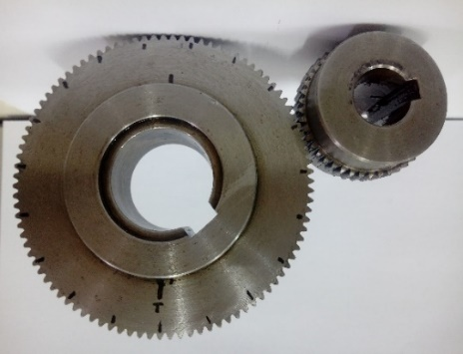 | Parameter | Pinion | Crown
 | Nominal diameter | 44 mm | 95 mm
 | Teeth number | 44 | 95
 | Face width | 10 mm | 10 mm
 | Superficial hardness | 230 HB | 230 HB
 | Bending factor | 0.925 | 1.0063
 | Wear factor | 1.497 | 2.2961
Source: Elaborated by the authors.

