Table 1: Changes in partnership quality and symptoms of depression from the pre- to the postnatal period
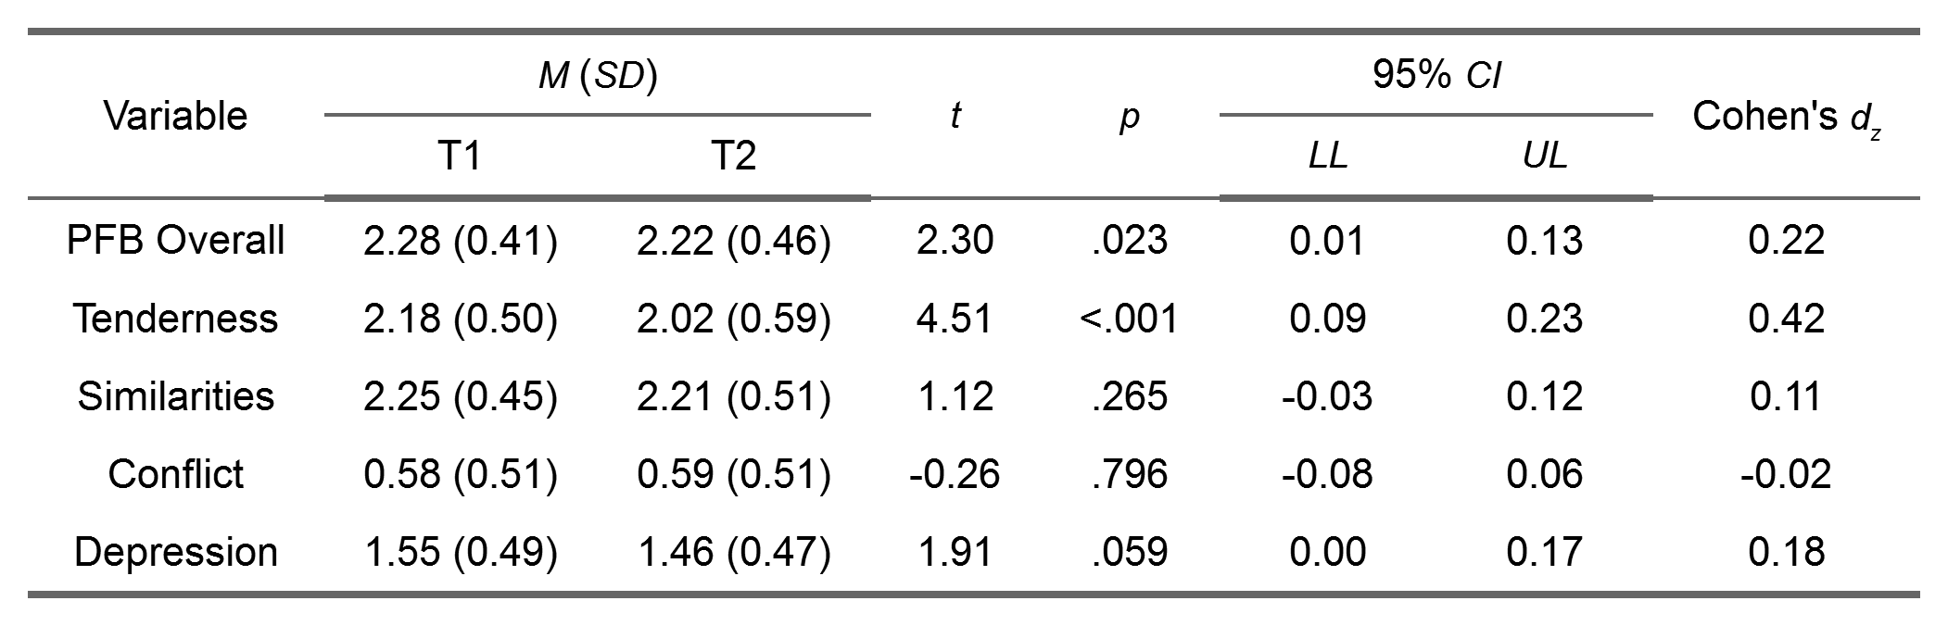
Note: CI confidence interval, LL lower limit, UL upper limit. The sample size (N = 113) is based on women who filled in at least 50% of the items of each of the two questionnaires (i.e., PFB and EPDS) at both time points.

Table 2: Associations between relationship quality and maternal symptoms of depression.
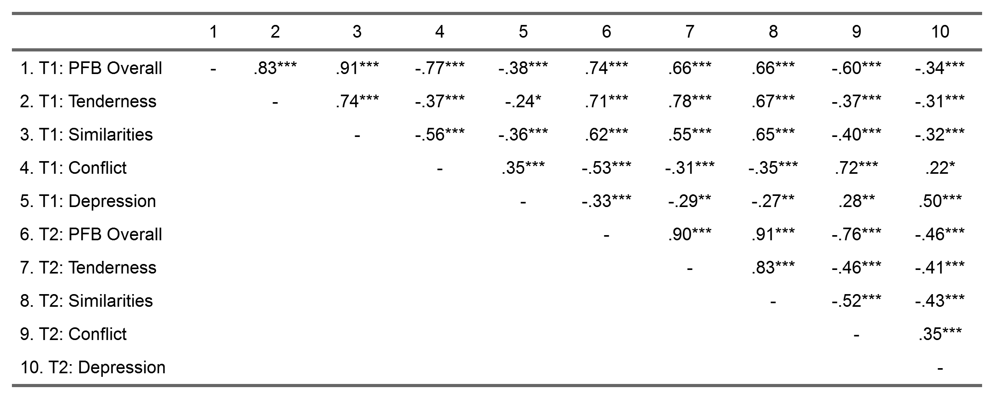
Note: The sample size (N = 113) is based on women who filled in at least 50% of the items of each of the two questionnaires (i.e., PFB and EPDS) at both time points. * p < .05. ** p < .01. *** p < .001.

Table 3: Summary of model fit indices for competing cross-lagged models
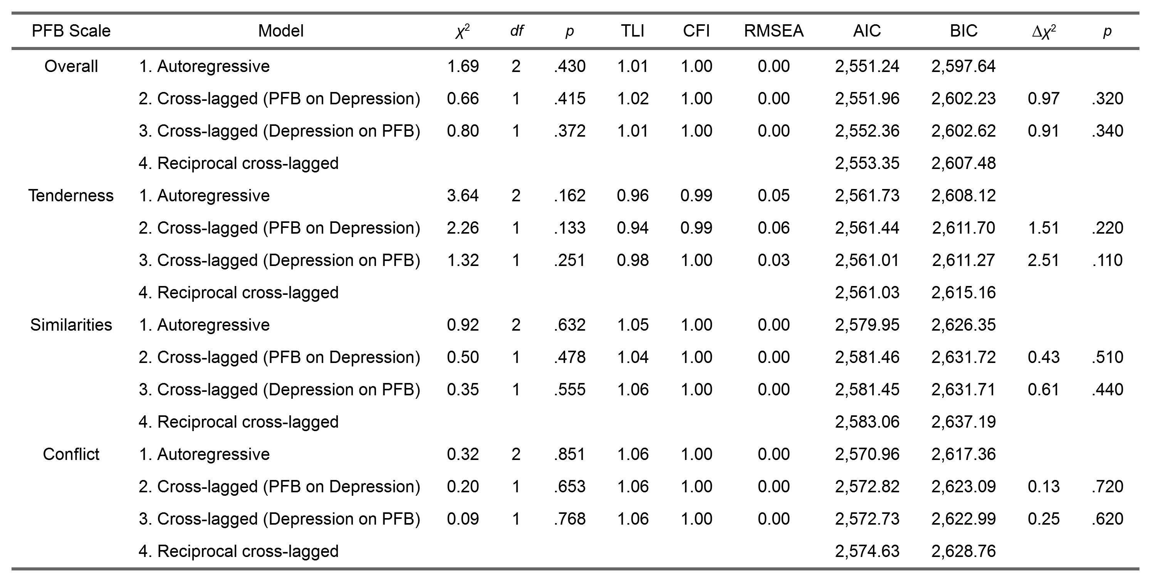
Note: TLI = Tucker-Lewis index; CFI = comparative fit index; RMSEA = root mean square error of approximation; AIC = Akaike’s information criterion; BIC = Bayesian information criterion. The two rightmost columns show the results of the comparison of Models 2 and 3 with Model 1. Note that Model 4 is a fully saturated model without any degrees of freedom. Accordingly, for Model 4 the fit indices TLI, CFI, and RMSEA are not reported.

Table 4: Parameter estimates of the best-fitting cross-lagged panel models (always Model 1)
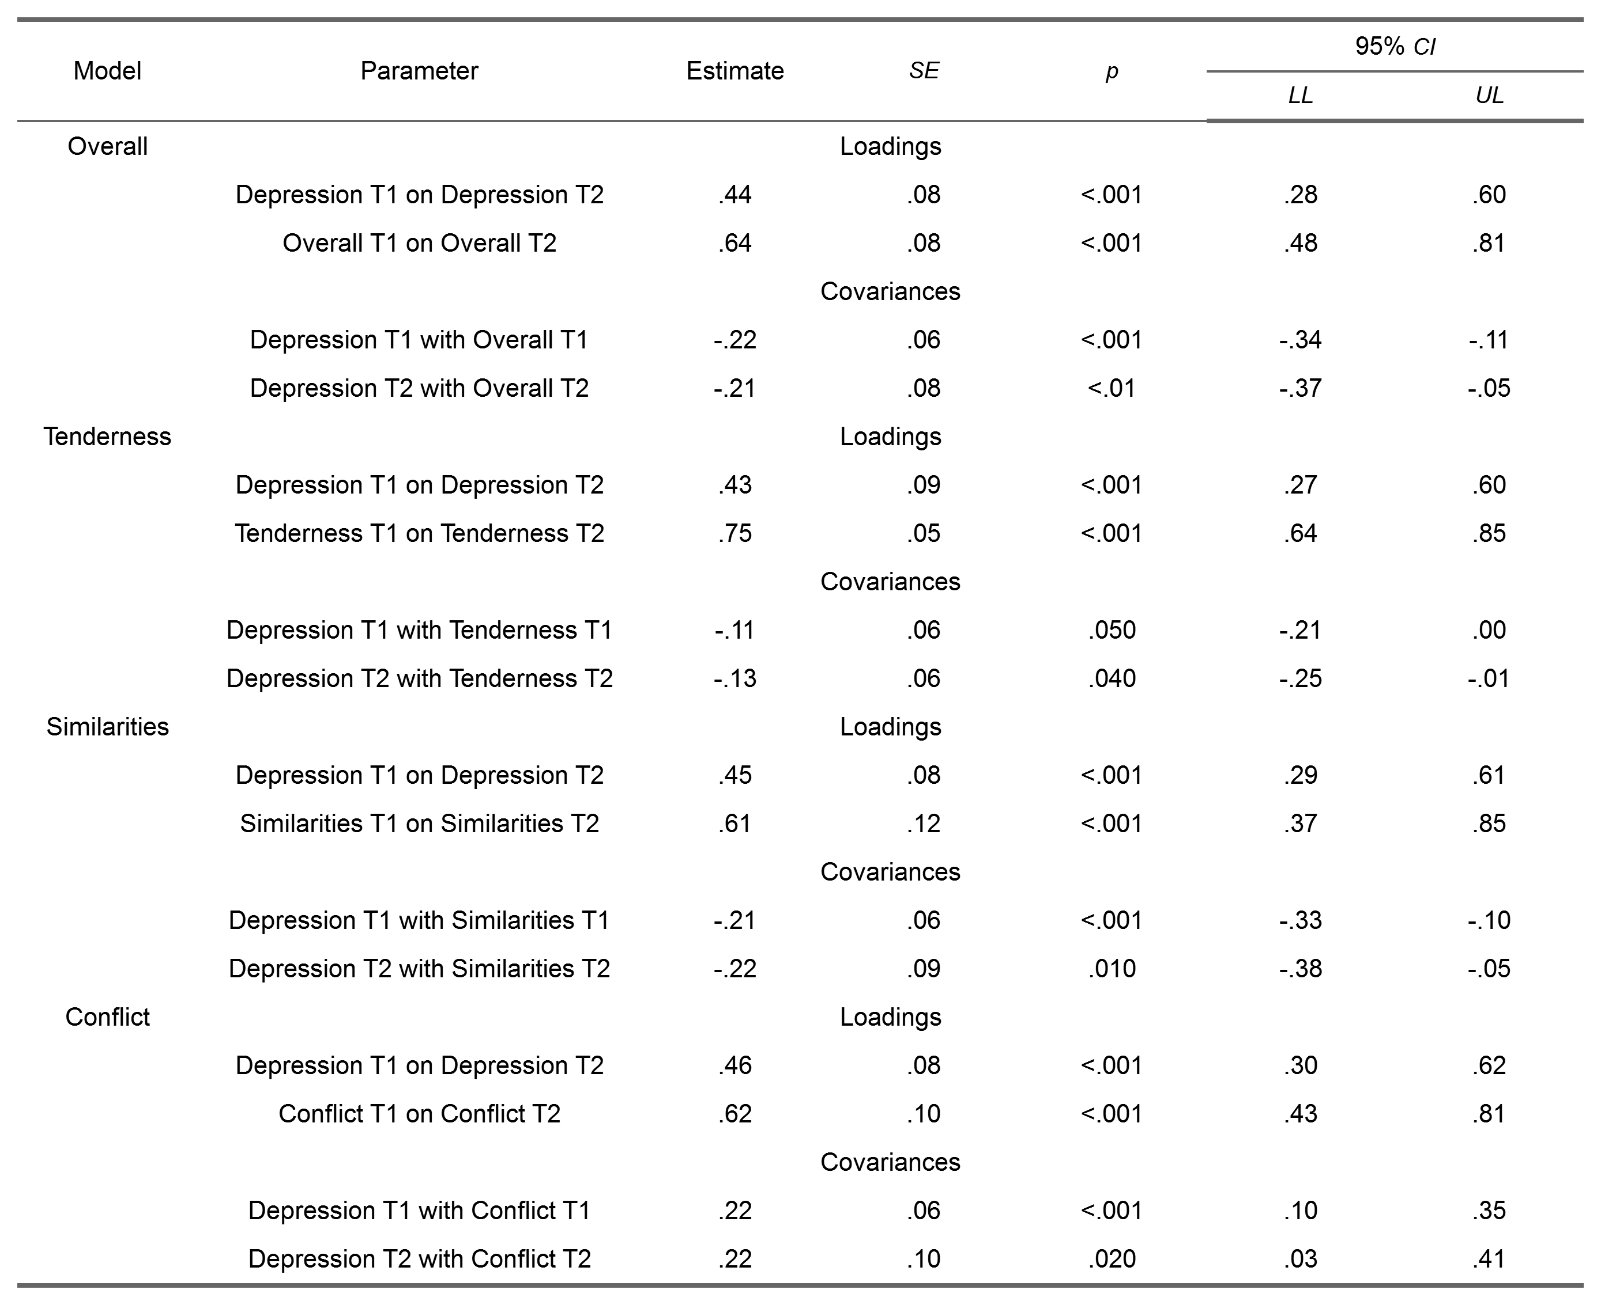
Note: We report standardized path coefficients. SE standard error, CI confidence interval, LL lower limit, UL upper limit.

