Electronic Supplementary Materials
Sorption-photocatalysis of structurally distinct pesticides using polythiophene/TiO₂ composites: Kinetics, equilibrium, reusability and operational economics
Pareshkumar G Moradeeya^{1,3}, Madhava Anil Kumar², Archana Sharma¹, Shaik Basha³*
¹Department of Environmental Science & Engineering, Marwadi University, Rajkot-360 003, Gujarat (India).
²Analytical and Environmental Science Division & Centralized Instrument Facility, CSIR-Central Salt & Marine Chemicals Research Institute, Bhavnagar-364 002, Gujarat (India).
³Hyderabad Zonal Centre, CSIR-National Environmental Engineering Research Institute, IICT Campus, Tarnaka, Hyderabad-500 007, Telangana (India).
*Corresponding Author: s_basha@neeri.res.in

Supplementary Experimental
S1. Instrumental analyses
Analysis of TCP, 4-CPA and 2,4-D in water were carried out using a high-performance liquid chromatograph coupled with a diode array detector (HPLC-DAD) of Shimadzu, and a diode array detector (SPD-M20A prominence-i-DAD). LAB Solution LC Software System® controlled the instrument. All data were obtained using a Shim-pack GIST C18, 5 µm column (4.6×250 mm), at 30°C with different conditions as per below conditions (isocratic method).

Pesticides name | Mobile phase (Methanol/Water) | Injection volume | Wave length (nm)
TCP | (700 mL)/Water (300 mL)  + (0.5 mL H₃PO₄) | 20 µL | 230
2,4-D | Methanol (700 mL)/Water  (300 mL) + (0.5 mL Acetic Acid) | 20 µL | 280
4-CPA | Methanol (700 mL)/Water  (300 mL)+ (1 mL Acetic Acid) | 50 µL | 275

S2. Material characterization tools
The morphologies of synthesized composites were characterized by (FE-SEM) Gemini 500 (M/s Carl Zeiss), for studying sample surfaces at high magnifications (> 200000x) due to the presence of a hot Schottky field emission (FE) gun. Powered X-ray diffraction (XRD) patterns were obtained on a Philips X’Pert system Cu-K α radiation, measurement conditions: (λ= 1.5406 A),(voltage=40.0 (kV), (current= 30.0 mA), (Auto Slit=not used). Fourier transform-infrared (FT-IR) absorption spectra were recorded using a Perkin-Elmer FT-IR spectrometer (FTIR-8400S, Shimadzu) equipped with a KBr beam splitter (KBr, FTIR grade) at room temperature. UV-Visible Spectrum (T90+UV/VIS Spectrophotometer, PG Instruments Ltd)
S3. Electrical energy determination and cost analysis
- UV lamp intensity used in all the experiments was same (the value is 125 W)
- Working volume of reactor 1.5 L (used reactor having maximum capacity 1.5 L, for the determination of optimum condition, used volume was 50 mL)
- Total energy consumed (P) 136 W (includes energy for electronic over-head stirrer)
- Unit cost of power: ₹2.6/kWh
- Time: 120 min

Supplementary Figures
Figure S1. The diffraction patterns of (a) TiO₂ and (b) pTh-TiO₂
Figure S2. FE-SEM images showing the surface morphology of (a&b) TiO₂ and (c&d) pTh-1
Figure S3. FT-IR spectra of pure (a) TiO₂ (a) and (b) pTh-1
Figure S4. Regeneration of (a) pTh-1, (b) 2,4-D and (c) 4-CPA

Figure S1.
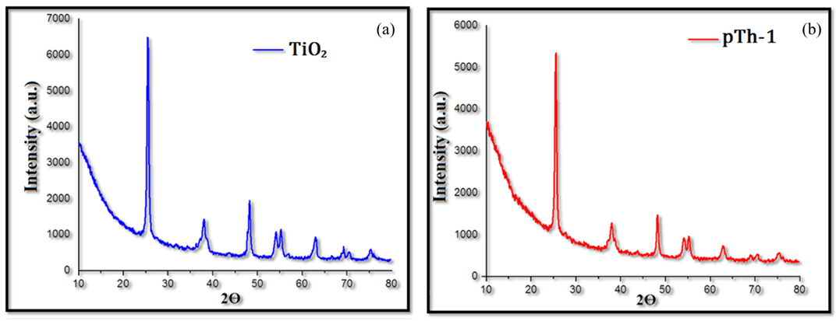

Figure S2.
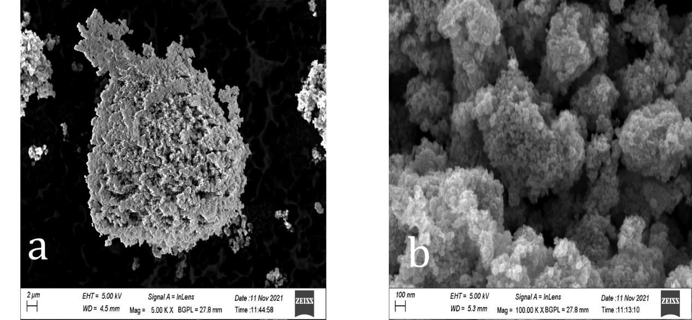
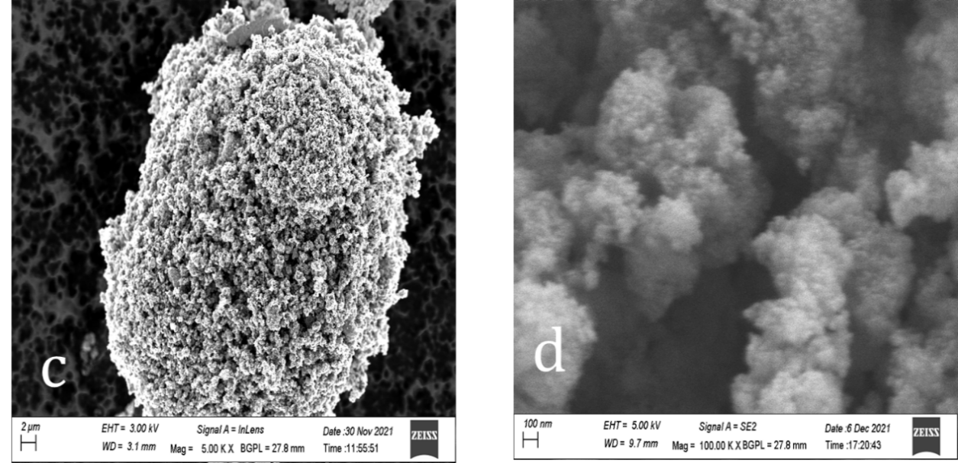

Figure S3.

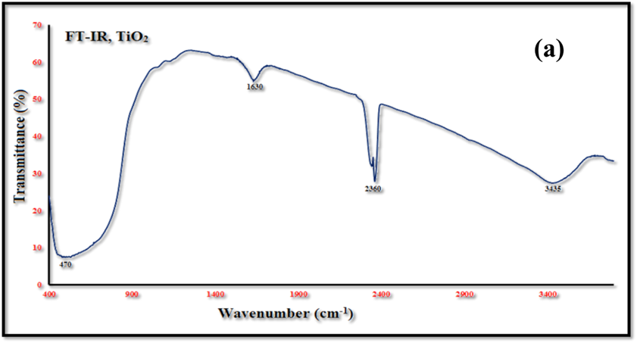
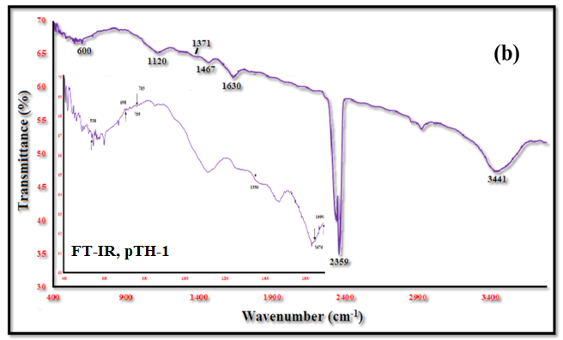

Figure S4.
