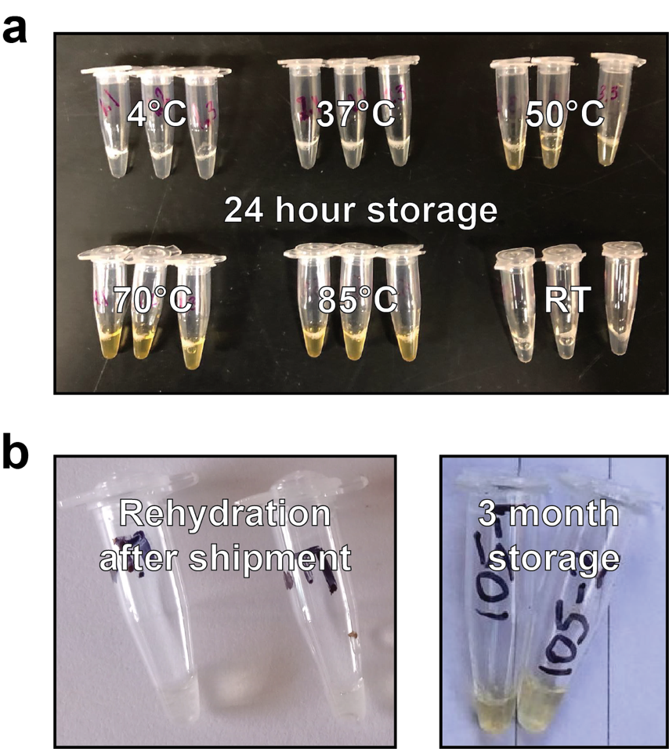

Supplemental Figure 1. Cell-free reactions degrade after storage at high temperatures. (a) Lyophilized reactions rehydrated with purified water after 24-hour storage at 4°C, 37°C, 50°C, 70°C, 85°C, and room temperature (RT, ~20°C). As temperatures increased, rehydration resulted in a yellow color due to component degradation and thus loss of function. This yellow color change confounds the interpretation of the intended yellow color change of the tests in the presence of fluoride causing false positives. (b) Tests from the first batch shipped to Kenya rehydrated immediately after arrival (left) and after three-month storage at ambient temperatures (right). Color change in the stored reactions resembles color change from 24-hour storage at high temperatures and was similarly reflective of loss of function.
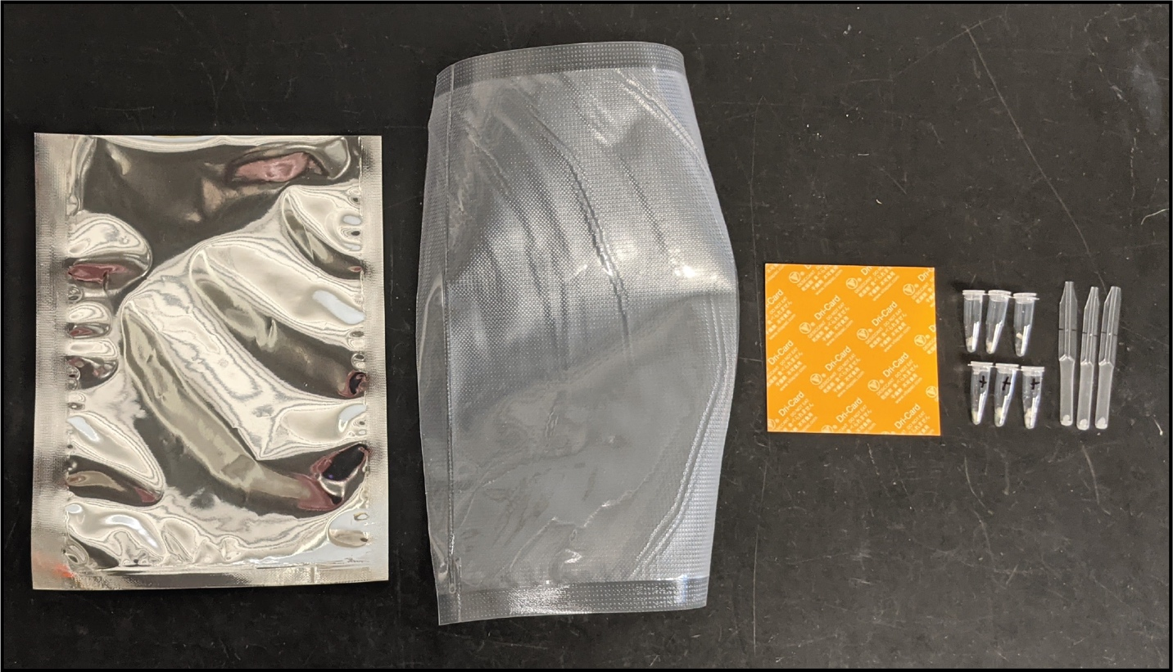

Supplemental Figure 2. Fluoride testing field kit. Pictured from left to right: foil pouch, vacuum bag, desiccant card, freeze-dried reactions in PCR tubes, and disposable micropipettes. Reactions and desiccant card are placed in the vacuum bag and sealed, then stored in the foil pouch to prevent photodegradation. Pipettes were packaged separately during testing but could also be stored in the foil pouch.
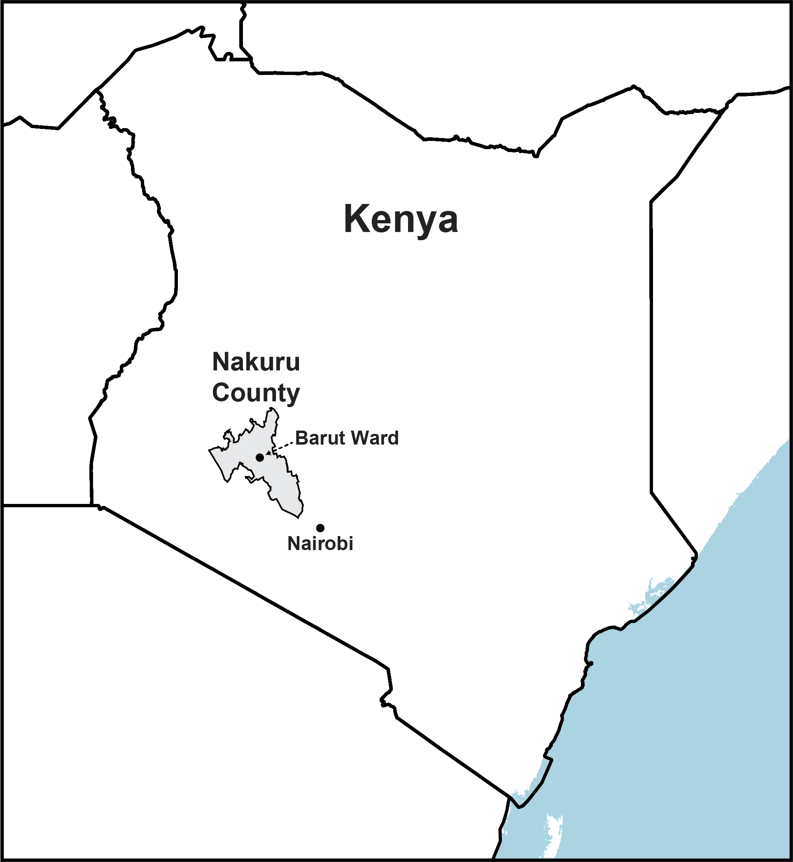

Supplemental Figure 3. Geographic location of the study site. Samples were collected in Barut Ward, one of 55 wards in Nakuru County. Nakuru County is located in the Great Rift Valley, where geogenic fluoride is common. Geographical data © OpenStreetMap contributors.

