Supplementary Data
Supplementary Table 1a – Summary of apatite (U-Th)/He ages (AHe) around the Mont Baker, Cascade Range (data inside the inset of Fig. 1a, plotted in the central panel of Fig. 1b). W-E distance corresponds to the horizontal distance between each sample and the western boundary of the inset in Fig. 1a. In the field “Type”, I = intrusive, V = volcanic, M = metamorphic. Geographic Coordinate System WGS 1984.

Method | Name | Longitude | Latitude | Elevation | W-E distance (km) | Age (Ma) | Error (Ma) | Type | Place of sampling | Reference
AHe | 01-1 | -121.1975 | 48.7287 | 1953 | 112 | 12.4 | 2.7 | I | Skagit Gorge Profile | Simon-Labric et al., 2014
AHe | 01-2 | -121.1981 | 48.7234 | 1758 | 112 | 14.5 | 2.1 | I | Skagit Gorge Profile | Simon-Labric et al., 2014
AHe | 01-4 | -121.2005 | 48.7123 | 1347 | 111 | 9.1 | 1.3 | I | Skagit Gorge Profile | Simon-Labric et al., 2014
AHe | 01-5 | -121.2041 | 48.7112 | 1155 | 111 | 10.1 | 1.4 | I | Skagit Gorge Profile | Simon-Labric et al., 2014
AHe | 01-6 | -121.2072 | 48.7076 | 904 | 111 | 6.4 | 0.6 | I | Skagit Gorge Profile | Simon-Labric et al., 2014
AHe | 01-7 | -121.2083 | 48.70667 | 680 | 111 | 5.9 | 0.6 | I | Skagit Gorge Profile | Simon-Labric et al., 2014
AHe | 02-1 | -121.2092 | 48.6999 | 345 | 110 | 4.3 | 1.0 | I | Skagit Gorge Profile | Simon-Labric et al., 2014
AHe | 02-2 | -121.2116 | 48.6973 | 241 | 110 | 3.5 | 0.8 | I | Skagit Gorge Profile | Simon-Labric et al., 2014
AHe | 03-1 | -121.0988 | 48.8223 | 1967 | 123 | 18.1 | 1.8 | I | Ross Lake Profile | Simon-Labric et al., 2014
AHe | 03-2 | -121.0914 | 48.8182 | 1778 | 124 | 14.3 | 1.4 | I | Ross Lake Profile | Simon-Labric et al., 2014
AHe | 03-3 | -121.0828 | 48.8095 | 1617 | 124 | 15.1 | 1.5 | I | Ross Lake Profile | Simon-Labric et al., 2014
AHe | 03-5 | -121.0703 | 48.7943 | 1181 | 126 | 15.3 | 4.7 | I | Ross Lake Profile | Simon-Labric et al., 2014
AHe | 04-1 | -121.0595 | 48.7793 | 692 | 127 | 11.0 | 2.2 | I | Ross Lake Profile | Simon-Labric et al., 2014
AHe | 04-2 | -121.0612 | 48.7818 | 916 | 127 | 11.3 | 2.0 | I | Ross Lake Profile | Simon-Labric et al., 2014
AHe | 013D25 | -120.6298 | 48.5743 | 1173 | 175 | 38.8 | 7.8 | I | North Washington Cascades | Simon-Labric et al., 2014
AHe | 013D27 | -120.8371 | 48.6243 | 1033 | 152 | 43.7 | 6.9 | I | North Washington Cascades | Simon-Labric et al., 2014
AHe | 013D28 | -121.0771 | 48.7167 | 628 | 125 | 15.6 | 3.3 | I | North Washington Cascades | Simon-Labric et al., 2014
AHe | 09CAS16 | -121.9142 | 48.8797 | 350 | 32 | 3.4 | 0.7 | I | North Washington Cascades | Simon-Labric et al., 2014
AHe | 09CAS18 | -121.9264 | 48.8639 | 854 | 31 | 4.8 | 1.8 | I | North Washington Cascades | Simon-Labric et al., 2014
AHe | 12Cas14 | -121.32201 | 48.63378 | 142 | 98 | 2.4 | 0.6 | I | North Washington Cascades | Simon-Labric et al., 2014
AHe | 12Cas25 | -121.39841 | 48.58596 | 116 | 89 | 2.7 | 0.2 | I | North Washington Cascades | Simon-Labric et al., 2014
AHe | 12Cas26 | -122.20283 | 48.81322 | 73 | 0 | 8.7 | 2.7 | I | North Washington Cascades | Simon-Labric et al., 2014
AHe | 12Cas10 | -121.17249 | 48.70697 | 280 | 115 | 5.9 | 0.8 | I | North Washington Cascades | Simon-Labric et al., 2014
AHe | WC95-32 | -121.5 | 48.67 | 300 | 78 | 8.6 | 0.5 | I | Yellow Aster | Reiners et al., 2002
AHe | LA01A | -121.641 | 48.835 | 1651 | 62 | 1.4 | 0.1 | I | Lake Ann pluton | Reiners et al., 2002
AHe | LA01B | -121.641 | 48.835 | 1651 | 62 | 1.4 | 0.1 | I | Lake Ann pluton | Reiners et al., 2002
AHe | LA01C | -121.641 | 48.835 | 1651 | 62 | 1.2 | 0.1 | I | Lake Ann pluton | Reiners et al., 2002
AHe | LA02A | -121.645 | 48.831 | 1471 | 62 | 2.2 | 0.1 | I | Lake Ann pluton | Reiners et al., 2002
AHe | LA02B | -121.645 | 48.831 | 1471 | 62 | 2.0 | 0.1 | I | Lake Ann pluton | Reiners et al., 2002

Supplementary Table 1b – Summary of isotopic ages <4 Ma of rocks around the Mount Baker, Cascade Range (data inside the inset of Fig. 1a, plotted in the bottom panel of Fig. 1b). In the field “Method”, Wr K-Ar: ⁴⁰K/⁴⁰Ar in whole rock, Pl Ar-Ar: ⁴⁰Ar/³⁹Ar in plagioclase, Bt K-Ar: ⁴⁰K/⁴⁰Ar in biotite, Hb K-Ar: ⁴⁰K/⁴⁰Ar in hornblende; Active volcano: 0.01 Ma is an arbitrary recent age and the position is according to Venzke (2013). Other columns like in Table 1a.

Method | Name | Longitude | Latitude | W-E distance (km) | Age (Ma) | Error (Ma) | Rock | Type | Place of sampling | Reference
Wr K-Ar | MB-493 | -121.736092 | 48.85944238 | 51.89168666 | 1.191 | 0.094 | Dacite | V | Kulshan caldera suite | Hildreth et al., 2003
Wr K-Ar | MB-500 | -121.840496 | 48.82545378 | 40.28829116 | 1.156 | 0.130 | Andesite | V | Kulshan caldera suite | Hildreth et al., 2003
Wr K-Ar | MB-316 | -121.694892 | 48.81849939 | 56.47058367 | 1.155 | 0.038 | Rhyodacite | V | Kulshan caldera suite | Hildreth et al., 2003
Wr K-Ar | MB-145 | -121.83771 | 48.82812465 | 40.59801732 | 1.060 | 0.010 | Rhyodacite | V | Kulshan caldera suite | Hildreth et al., 2003
Wr K-Ar | MB-212 | -121.70544 | 48.83211299 | 55.29837474 | 1.032 | 0.011 | Rhyodacite | V | Kulshan caldera suite | Hildreth et al., 2003
Wr K-Ar | MB-276B | -121.710335 | 48.8006803 | 54.7542751 | 1.005 | 0.017 | Andesite | V | Kulshan caldera suite | Hildreth et al., 2003
Wr K-Ar | MB-93 | -121.871016 | 48.86174231 | 36.89636533 | 0.878 | 0.018 | Andesite | V | Early extracaldera lava flows from Mt Baker | Hildreth et al., 2003
Wr K-Ar | MB-91 | -121.944213 | 48.81745383 | 28.76138252 | 0.859 | 0.014 | Andesite | V | Early extracaldera lava flows from Mt Baker | Hildreth et al., 2003
Wr K-Ar | MB-81 | -121.722576 | 48.8547952 | 53.39378926 | 0.743 | 0.034 | Andesite | V | Early extracaldera lava flows from Mt Baker | Hildreth et al., 2003
Wr K-Ar | MB-640 | -121.751692 | 48.7804437 | 50.15788814 | 0.743 | 0.072 | Andesite | V | Early extracaldera lava flows from Mt Baker | Hildreth et al., 2003
Wr K-Ar | MB-52 | -121.851179 | 48.71580346 | 39.10098866 | 0.716 | 0.045 | Basalt | V | Early extracaldera lava flows from Mt Baker | Hildreth et al., 2003
Wr K-Ar | MB-225 | -121.810782 | 48.87193235 | 43.59068974 | 0.613 | 0.008 | Dacite | V | Early extracaldera lava flows from Mt Baker | Hildreth et al., 2003
Wr K-Ar | MB-99 | -121.748943 | 48.83619194 | 50.46346304 | 0.515 | 0.008 | Andesite | V | Oldest unaltered intracaldera andesitic lava flow | Hildreth et al., 2003
Wr K-Ar | MB-135 | -121.756022 | 48.82547284 | 49.67663871 | 0.457 | 0.040 | Andesite | V | Oldest unaltered intracaldera andesitic lava flow | Hildreth et al., 2003
Wr K-Ar | MB-67 | -121.895581 | 48.73692941 | 34.16627492 | 0.495 | 0.018 | Andesite | V | Black Buttes stratovolcano | Hildreth et al., 2003
Wr K-Ar | MB-63 | -121.892822 | 48.73870224 | 34.47292075 | 0.296 | 0.020 | Andesite | V | Black Buttes stratovolcano | Hildreth et al., 2003
Wr K-Ar | MB-116 | -121.884404 | 48.75031652 | 35.40848586 | 0.374 | 0.010 | Andesite | V | Black Buttes stratovolcano | Hildreth et al., 2003
Wr K-Ar | MB-246 | -121.882644 | 48.76829254 | 35.60408894 | 0.346 | 0.009 | Andesite | V | Black Buttes stratovolcano | Hildreth et al., 2003
Wr K-Ar | MB-603 | -121.881443 | 48.76108368 | 35.73750709 | 0.343 | 0.005 | Andesite | V | Black Buttes stratovolcano | Hildreth et al., 2003
Wr K-Ar | MB-249 | -121.908457 | 48.77033914 | 32.73523793 | 0.339 | 0.011 | Andesite | V | Black Buttes stratovolcano | Hildreth et al., 2003
Wr K-Ar | MB-49 | -121.807494 | 48.72345666 | 43.95615923 | 0.336 | 0.015 | Andesite | V | Black Buttes stratovolcano | Hildreth et al., 2003
Wr K-Ar | MB-119 | -121.92406 | 48.74079732 | 31.00112922 | 0.334 | 0.015 | Andesite | V | Black Buttes stratovolcano | Hildreth et al., 2003
Wr K-Ar | MB-238 | -121.872897 | 48.77809383 | 36.68729064 | 0.334 | 0.011 | Andesite | V | Black Buttes stratovolcano | Hildreth et al., 2003
Wr K-Ar | MB-16 | -121.882363 | 48.78088494 | 35.63522097 | 0.306 | 0.013 | Andesite | V | Black Buttes stratovolcano | Hildreth et al., 2003
Wr K-Ar | MB-110 | -121.874701 | 48.75831911 | 36.48678255 | 0.288 | 0.015 | Andesite | V | Black Buttes stratovolcano | Hildreth et al., 2003
Wr K-Ar | MB-615 | -121.733933 | 48.78294894 | 52.13166032 | 0.460 | 0.013 | Andesite | V | Satellite centers contemporaneous with Black Buttes | Hildreth et al., 2003
Wr K-Ar | MB-61 | -121.744933 | 48.77857099 | 50.90913676 | 0.296 | 0.015 | Andesite | V | Satellite centers contemporaneous with Black Buttes | Hildreth et al., 2003
Wr K-Ar | MB-22 | -121.722492 | 48.69735533 | 53.40315038 | 0.455 | 0.009 | Andesite | V | Satellite centers contemporaneous with Black Buttes | Hildreth et al., 2003
Wr K-Ar | MB-222 | -121.773225 | 48.73479255 | 47.76478584 | 0.366 | 0.010 | Andesite | V | Satellite centers contemporaneous with Black Buttes | Hildreth et al., 2003
Wr K-Ar | MB-151 | -121.847679 | 48.8093322 | 39.49001295 | 0.322 | 0.012 | Andesite | V | Satellite centers contemporaneous with Black Buttes | Hildreth et al., 2003
Wr K-Ar | MB-589 | -121.839592 | 48.8056525 | 40.38881016 | 0.322 | 0.009 | Andesite | V | Satellite centers contemporaneous with Black Buttes | Hildreth et al., 2003
Wr K-Ar | MB-223 | -121.786263 | 48.87077718 | 46.31572544 | 0.334 | 0.009 | Andesite | V | Satellite centers contemporaneous with Black Buttes | Hildreth et al., 2003
Wr K-Ar | MB-59 | -121.846814 | 48.72835501 | 39.58617675 | 0.333 | 0.012 | Andesite | V | Satellite centers contemporaneous with Black Buttes | Hildreth et al., 2003
Wr K-Ar | MB-50 | -121.846958 | 48.72205888 | 39.57017129 | 0.331 | 0.018 | Basalt | V | Satellite centers contemporaneous with Black Buttes | Hildreth et al., 2003
Wr K-Ar | MB-89 | -121.741175 | 48.81991379 | 51.32680857 | 0.305 | 0.006 | Andesite | V | Ptarmigan Ridge and Table Mountain lavas | Hildreth et al., 2003
Wr K-Ar | MB-89 | -121.738428 | 48.8207834 | 51.63205273 | 0.306 | 0.013 | Andesite | V | Ptarmigan Ridge and Table Mountain lavas | Hildreth et al., 2003
Wr K-Ar | MB-391 | -121.682982 | 48.85704853 | 57.79423382 | 0.301 | 0.005 | Andesite | V | Ptarmigan Ridge and Table Mountain lavas | Hildreth et al., 2003
Wr K-Ar | MB-10 | -121.698185 | 48.84912447 | 56.10465285 | 0.309 | 0.013 | Andesite | V | Ptarmigan Ridge and Table Mountain lavas | Hildreth et al., 2003
Wr K-Ar | MB-488 | -121.717401 | 48.84394205 | 53.96898404 | 0.189 | 0.011 | Andesite | V | Ptarmigan Ridge and Table Mountain lavas | Hildreth et al., 2003
Wr K-Ar | MB-262 | -121.816703 | 48.85220125 | 42.93263205 | 0.192 | 0.008 | Andesite | V | Younger lavas inset along Cougar Divide | Hildreth et al., 2003
Wr K-Ar | MB-260 | -121.818448 | 48.83602562 | 42.73874985 | 0.119 | 0.023 | Andesite | V | Younger lavas inset along Cougar Divide | Hildreth et al., 2003
Wr K-Ar | MB-335 | -121.810038 | 48.84583517 | 43.67335604 | 0.105 | 0.008 | Andesite | V | Younger lavas inset along Cougar Divide | Hildreth et al., 2003
Wr K-Ar | MB-53 | -121.848482 | 48.71487688 | 39.40082802 | 0.203 | 0.025 | Andesite | V | Younger mafic outliers | Hildreth et al., 2003
Wr K-Ar | MB-175B | -121.729466 | 48.63625504 | 52.62810201 | 0.094 | 0.021 | Basalt | V | Younger mafic outliers | Hildreth et al., 2003
Wr K-Ar | MB-193 | -121.695911 | 48.72674642 | 56.35735248 | 0.199 | 0.005 | Rhyodacite | V | Boulder Ridge lavas | Hildreth et al., 2003
Wr K-Ar | MB-645 | -121.762823 | 48.77066753 | 48.92082738 | 0.140 | 0.055 | Andesite | V | Boulder Ridge lavas | Hildreth et al., 2003
Wr K-Ar | MB-39 | -121.764405 | 48.76168797 | 48.74504171 | 0.090 | 0.052 | Andesite | V | Boulder Ridge lavas | Hildreth et al., 2003
Wr K-Ar | MB-402 | -121.761529 | 48.76795468 | 49.0646607 | 0.080 | 0.014 | Andesite | V | Boulder Ridge lavas | Hildreth et al., 2003
Wr K-Ar | MB-12 | -121.793685 | 48.90234227 | 45.49086856 | 0.202 | 0.009 | Andesite | V | Intracanyon lava flows | Hildreth et al., 2003
Wr K-Ar | MB-332A | -121.792169 | 48.90862381 | 45.65937696 | 0.149 | 0.005 | Dacite | V | Intracanyon lava flows | Hildreth et al., 2003
Wr K-Ar | MB-92 | -121.810141 | 48.89891476 | 43.66194695 | 0.114 | 0.009 | Andesite | V | Intracanyon lava flows | Hildreth et al., 2003
Wr K-Ar | MB-168 | -121.784605 | 48.82667737 | 46.49996979 | 0.076 | 0.007 | Andesite | V | Intracanyon lava flows | Hildreth et al., 2003
Wr K-Ar | MB-232 | -121.755107 | 48.80747006 | 49.77843325 | 0.070 | 0.007 | Andesite | V | Intracanyon lava flows | Hildreth et al., 2003
Wr K-Ar | MB-572 | -121.677945 | 48.78951755 | 58.35403441 | 0.048 | 0.018 | Andesite | V | Intracanyon lava flows | Hildreth et al., 2003
Wr K-Ar | MB-507 | -121.86605 | 48.71954932 | 37.44830161 | 0.043 | 0.005 | Andesite | V | Mount Baker Stratovolcano | Hildreth et al., 2003
Wr K-Ar | MB-520 | -121.815861 | 48.71454637 | 43.02619053 | 0.036 | 0.014 | Andesite | V | Mount Baker Stratovolcano | Hildreth et al., 2003
Wr K-Ar | MB-524 | -121.841644 | 48.71660768 | 40.16070948 | 0.032 | 0.014 | Andesite | V | Mount Baker Stratovolcano | Hildreth et al., 2003
Wr K-Ar | MB-458 | -121.869629 | 48.80235234 | 37.05053313 | 0.024 | 0.016 | Andesite | V | Mount Baker Stratovolcano | Hildreth et al., 2003
Wr K-Ar | MB-632 | -121.888571 | 48.80793439 | 34.94531285 | 0.014 | 0.009 | Andesite | V | Mount Baker Stratovolcano | Hildreth et al., 2003
Wr K-Ar | MB-46 | -121.815227 | 48.74152949 | 43.09665621 | 0.011 | 0.009 | Andesite | V | Mount Baker Stratovolcano | Hildreth et al., 2003
Wr K-Ar | MB-43 | -121.849204 | 48.74277333 | 39.3204983 | 0.009 | 0.011 | Andesite | V | Mount Baker Stratovolcano | Hildreth et al., 2003
Wr K-Ar | MB-294 | -121.853373 | 48.79859321 | 38.85724294 | 0.009 | 0.007 | Andesite of Roosevelt Glacier | V | Mount Baker Stratovolcano | Hildreth et al., 2003
Hb K-Ar | RWT 469A-67 | -121.524993 | 48.86413266 | 75.35299663 | 3.6 | 1.0 | Andesite | V | Hannegan Pass | Engels et al., 1976
Hb K-Ar | RWT 469B-67 | -121.524964 | 48.86512286 | 75.35623356 | 3.3 | 1.0 | Andesite | V | Hannegan Pass | Engels et al., 1976
Pl Ar-Ar | MB-618 | -121.742559 | 48.81902926 | 51.1729383 | 0.992 | 0.014 | Rhyodacite | V | Mount Baker Volcanic Field | Hildreth et al., 2003
Pl Ar-Ar | MB-628 | -121.813914 | 48.8548715 | 43.24266407 | 1.015 | 0.018 | Rhyodacite | V | Mount Baker Volcanic Field | Hildreth et al., 2003
Pl Ar-Ar | MB-212 | -121.705416 | 48.83301237 | 55.30095361 | 1.012 | 0.008 | Rhyodacite | V | Mount Baker Volcanic Field | Hildreth et al., 2003
Pl Ar-Ar | MB-212 | -121.705416 | 48.83301237 | 55.30095361 | 0.994 | 0.015 | Rhyodacite | V | Mount Baker Volcanic Field | Hildreth et al., 2003
Pl Ar-Ar | MB-212 mean | -121.705416 | 48.83301237 | 55.30095361 | 1.008 | 0.007 | Rhyodacite | V | Mount Baker Volcanic Field | Hildreth et al., 2003
Pl Ar-Ar | MB-145 | -121.836368 | 48.82721147 | 40.74709451 | 1.018 | 0.008 | Rhyodacite | V | Mount Baker Volcanic Field | Hildreth et al., 2003
Pl Ar-Ar | MB-82-2 | -121.71858 | 48.85115228 | 53.83797894 | 1.063 | 0.012 | Rhyodacite | V | Mount Baker Volcanic Field | Hildreth et al., 2003
Pl Ar-Ar | MB-630 | -121.727076 | 48.83865146 | 52.8937021 | 1.041 | 0.011 | Rhyodacite | V | Mount Baker Volcanic Field | Hildreth et al., 2003
Pl Ar-Ar | MB-630 | -121.727076 | 48.83865146 | 52.8937021 | 1.073 | 0.016 | Rhyodacite | V | Mount Baker Volcanic Field | Hildreth et al., 2003
Pl Ar-Ar | MB-630 mean | -121.705416 | 48.83301237 | 55.30095361 | 1.008 | 0.007 | Rhyodacite | V | Mount Baker Volcanic Field | Hildreth et al., 2003
Pl Ar-Ar | MB-287 | -121.723401 | 48.82241724 | 53.30218327 | 1.109 | 0.019 | Rhyodacite | V | Mount Baker Volcanic Field | Hildreth et al., 2003
Pl Ar-Ar | MB-287 | -121.723401 | 48.82241724 | 53.30218327 | 1.111 | 0.015 | Rhyodacite | V | Mount Baker Volcanic Field | Hildreth et al., 2003
Pl Ar-Ar | MB-287 mean | -121.727076 | 48.83865146 | 52.8937021 | 1.052 | 0.016 | Rhyodacite | V | Mount Baker Volcanic Field | Hildreth et al., 2003
Pl Ar-Ar | MB-227 | -121.730484 | 48.81169973 | 52.51498173 | 1.114 | 0.011 | Rhyodacite | V | Mount Baker Volcanic Field | Hildreth et al., 2003
Pl Ar-Ar | MB-227 | -121.730484 | 48.81169973 | 52.51498173 | 1.138 | 0.010 | Rhyodacite | V | Mount Baker Volcanic Field | Hildreth et al., 2003
Pl Ar-Ar | MB-227 mean | -121.723401 | 48.82241724 | 53.30218327 | 1.110 | 0.012 | Rhyodacite | V | Mount Baker Volcanic Field | Hildreth et al., 2003
Pl Ar-Ar | MB-188 | -121.696986 | 48.84281344 | 56.23792518 | 1.149 | 0.010 | Rhyodacite | V | Mount Baker Volcanic Field | Hildreth et al., 2003
Pl Ar-Ar | MB-583 | -121.813637 | 48.86656395 | 43.27343013 | 1.151 | 0.016 | Rhyodacite | V | Mount Baker Volcanic Field | Hildreth et al., 2003
Pl Ar-Ar | MB-275C | -121.71435 | 48.80342409 | 54.30803001 | 1.180 | 0.017 | Rhyodacite | V | Mount Baker Volcanic Field | Hildreth et al., 2003
Pl Ar-Ar | MB-626 | -121.827901 | 48.83972068 | 41.68815988 | 1.293 | 0.016 | Rhyodacite | V | Mount Baker Volcanic Field | Hildreth et al., 2003
Pl Ar-Ar | MB-380 | -121.536133 | 48.89036302 | 74.11497719 | 3.722 | 0.020 | Ignimbrite | V | Mount Baker Volcanic Field | Hildreth et al., 2003
Pl Ar-Ar | MB-201 | -121.789859 | 48.83482942 | 45.91611361 | 0.969 | 0.029 | Felsite breccia | V | Mount Baker Volcanic Field | Hildreth et al., 2003
Active volcano | - | -121.81 | 48.77 | 43.677627 | 0.010 | - | - | - | Mount Baker Volcano | -
Pl Ar-Ar | MB-636A | -121.79293 | 48.82046733 | 45.57479774 | 0.674 | 0.023 | Granodiorite | I | Mount Baker Volcanic Field | Hildreth et al., 2003
Bt Ar-Ar | MB-333 | -121.642704 | 48.83409025 | 62.27077326 | 2.750 | 0.130 | Lake Ann stock | I | Mount Baker Volcanic Field | Hildreth et al., 2003
Bt K-Ar | RWT 480-67 | -121.631287 | 48.82913807 | 63.53957821 | 2.7 | 0.3 | Lake Ann stock | I | Chilliwack Composite Batholith | Engels et al., 1976
Bt K-Ar | DFC 1-69 | -121.633725 | 48.83610637 | 63.26863455 | 2.5 | 0.1 | Hornfels | I | Chilliwack Composite Batholith | Engels et al., 1976
Wr K-Ar | MB-356 | -121.794313 | 48.81958217 | 45.42102482 | 0.764 | 0.163 | Granodiorite | I | Kulshan caldera suite | Hildreth et al., 2003

Supplementary Table 1c – Summary of apatite fission tracks (AFT) ages around the Osorno and Tronador volcanoes, Southern Andes (data inside the inset of Fig. 1c, plotted in the central panel of Fig. 1d). W-E distance corresponds to the horizontal distance between each sample and the western boundary of the inset in Fig. 1c. Other columns like in Table 1a.

Method | Name | Longitude | Latitude | Elevation | W-E distance (km) | Age (Ma) | Error (Ma) | Rock | Type | Place of sampling | Reference
AFT | AA1 | -72.6812 | -41.2194 | 80 | 19.5 | 24.9 | 4.7 | Granodiorite | I | Lago Llanquihue | Adriasola et al., 2006
AFT | AA102 | -72.4267 | -41.154 | 50 | 47.8 | 6.3 | 2.2 | Tonalite | I | Petrohué | Adriasola et al., 2006
AFT | AA106 | -72.4710 | -42.039 | 5 | 42.9 | 4.3 | 1.5 | Tonalite | I | Isla Pelada | Adriasola et al., 2006
AFT | AA11 | -72.3328 | -41.461 | 150 | 58.3 | 3.3 | 1.2 | Granodiorite | I | Estancia Reloncaví | Adriasola et al., 2006
AFT | AA111 | -72.4903 | -42.022 | 5 | 40.8 | 4.4 | 1.2 | Aplite | I | Isla Pelada | Adriasola et al., 2006
AFT | AA112 | -72.0054 | -41.0885 | 850 | 94.6 | 10.6 | 1.3 | Tonalite | I | Volcan Casablanca | Adriasola et al., 2006
AFT | AA119 | -72.4939 | -42.1683 | 5 | 40.4 | 4.9 | 1.7 | Mica-schist | M | Isla Llancahué | Adriasola et al., 2006
AFT | AA12 | -72.3493 | -41.488 | 180 | 56.4 | 4 | 1.3 | Tonalite | I | Canutillar | Adriasola et al., 2006
AFT | AA125 | -72.3946 | -41.9462 | 100 | 51.4 | 6.5 | 1.2 | Granite | I | Rio Blanco | Adriasola et al., 2006
AFT | AA129 | -72.2897 | -41.11 | 5 | 63.0 | 4.4 | 0.6 | Granite | I | Lago Todos Los Santos | Adriasola et al., 2006
AFT | AA13 | -72.4092 | -41.501 | 300 | 49.8 | 4.8 | 0.8 | Tonalite | I | Lago Chapo | Adriasola et al., 2006
AFT | AA130 | -72.1242 | -41.0738 | 5 | 81.4 | 6.1 | 0.8 | Granite | I | Lago Todos Los Santos | Adriasola et al., 2006
AFT | AA131 | -72.0718 | -41.148 | 20 | 87.3 | 6.9 | 1.3 | Tonalite | I | Lago Todos Los Santos | Adriasola et al., 2006
AFT | AA132 | -72.1755 | -41.0975 | 10 | 75.7 | 7.2 | 1.8 | Tonalite | I | Lago Todos Los Santos | Adriasola et al., 2006
AFT | AA2 | -72.3042 | -41.3782 | 30 | 61.4 | 4.4 | 0.5 | Tonalite | I | Ralún | Adriasola et al., 2006
AFT | AA20 | -72.6417 | -41.4456 | 200 | 23.9 | 11.1 | 1.8 | Granodiorite | I | Correntoso | Adriasola et al., 2006
AFT | AA21 | -72.6331 | -41.4102 | 250 | 24.9 | 11.4 | 1.5 | Granodiorite | I | Lago Chapo | Adriasola et al., 2006
AFT | AA22 | -72.5813 | -41.4383 | 300 | 30.6 | 10.9 | 1.1 | Granodiorite | I | Lago Chapo | Adriasola et al., 2006
AFT | AA23 | -72.6090 | -41.514 | 450 | 27.6 | 8 | 1 | Gneiss | M | Lago Chaiquenes | Adriasola et al., 2006
AFT | AA24 | -72.6998 | -41.5955 | 10 | 17.5 | 9.4 | 2 | Granodiorite | I | Punta Metri | Adriasola et al., 2006
AFT | AA25 | -72.7230 | -41.566 | 20 | 14.9 | 12.5 | 1.6 | Tonalite | I | Punta Metri | Adriasola et al., 2006
AFT | AA26 | -72.668 | -41.637 | 10 | 21.0 | 7.8 | 0.9 | Tonalite | I | Caleta Larenas | Adriasola et al., 2006
AFT | AA27 | -72.626 | -41.692 | 200 | 25.7 | 9.3 | 0.8 | Tonalite | I | Caleta Larenas | Adriasola et al., 2006
AFT | AA29 | -72.2369 | -41.4594 | 150 | 68.9 | 5.5 | 0.9 | Granite | I | Rio Cochamo | Adriasola et al., 2006
AFT | AA3 | -72.349 | -41.5049 | 60 | 56.5 | 5.6 | 2 | Tonalite | I | Estancia Reloncaví | Adriasola et al., 2006
AFT | AA30 | -72.311 | -41.6492 | 100 | 60.7 | 4 | 0.9 | Tonalite | I | Balseo | Adriasola et al., 2006
AFT | AA31 | -72.3008 | -41.6667 | 250 | 61.8 | 4 | 0.9 | Granite | I | Puelo Chico | Adriasola et al., 2006
AFT | AA33 | -72.4672 | -41.728 | 20 | 43.3 | 5.8 | 0.5 | Granodiorite | I | Volcán Yates | Adriasola et al., 2006
AFT | AA34 | -72.4010 | -41.705 | 30 | 50.7 | 4.2 | 0.5 | Tonalite | I | Volcán Yates | Adriasola et al., 2006
AFT | AA35 | -72.363 | -41.354 | 150 | 54.9 | 6.2 | 0.8 | Tonalite | I | Termas de Ralún | Adriasola et al., 2006
AFT | AA36 | -72.5890 | -41.589 | 200 | 2.8 | 8.2 | 1.3 | Gneiss | M | Parque Alerce Andino | Adriasola et al., 2006
AFT | AA37 | -72.5726 | -41.747 | 30 | 31.6 | 6.8 | 1 | Tonalite | I | Chaparrano | Adriasola et al., 2006
AFT | AA39 | -72.4346 | -42.02 | 150 | 46.9 | 5.7 | 1.9 | Tonalite | I | Rio Mariquita | Adriasola et al., 2006
AFT | AA4 | -72.4022 | -41.647 | 20 | 50.6 | 3.8 | 0.9 | Tonalite | I | Estancia Reloncaví | Adriasola et al., 2006
AFT | AA40 | -72.4484 | -42.076 | 40 | 45.4 | 4.3 | 0.7 | Granodiorite | I | Pichanco | Adriasola et al., 2006
AFT | AA42 | -72.4027 | -41.907 | 200 | 50.5 | 4.2 | 2.7 | Tonalite | I | Rio Negro | Adriasola et al., 2006
AFT | AA43 | -72.601 | -41.9908 | 100 | 28.5 | 15.5 | 2.7 | Dacite | I | Pichicolo | Adriasola et al., 2006
AFT | AA44 | -72.3689 | -42.18 | 10 | 54.2 | 3.3 | 0.5 | Tonalite | I | F. Quintupeu | Adriasola et al., 2006
AFT | AA45 | -72.4821 | -42.091 | 5 | 41.7 | 4.3 | 1.2 | Mica-schist | M | Isla Llancahué | Adriasola et al., 2006
AFT | AA6 | -72.3424 | -41.5378 | 20 | 57.2 | 3.8 | 0.9 | Tonalite | I | Estancia Reloncaví | Adriasola et al., 2006
AFT | AA8 | -72.3201 | -41.6024 | 80 | 59.7 | 3.3 | 0.6 | Granodiorite | I | Estancia Reloncaví | Adriasola et al., 2006
AFT | AA9 | -72.3003 | -41.5672 | 110 | 61.9 | 3.5 | 0.7 | Granite | I | Estancia Reloncaví | Adriasola et al., 2006
AFT | AL122 | -72.0588 | -41.3606 | 1600 | 88.7 | 6.7 | 1.6 | Tonalite | I | Rio Cochamo | Adriasola et al., 2006
AFT | AL137 | -72.46 | -41.5885 | 1200 | 44.1 | 9.8 | 1.9 | Granodiorite | I | Puelo | Adriasola et al., 2006
AFT | AL152 | -72.0588 | -41.3606 | 1550 | 88.7 | 6.7 | 1.7 | Tonalite | I | Llanada Grande | Adriasola et al., 2006
AFT | SP06b | -72.415 | -41.4933 | 400 | 49.1 | 5.9 | 0.6 | - | - | - | Thomson et al., 2010
AFT | SP11 | -72.6 | -41.73 | 25 | 28.6 | 5.1 | 1 | - | - | - | Thomson et al., 2010
AFT | SP040 | -71.898 | -41.8 | 1675 | 106.5 | 13 | 2.2 | - | - | - | Thomson et al., 2010
AFT | SP041 | -71.888 | -41.862 | 1525 | 107.7 | 14.2 | 3.3 | - | - | - | Thomson et al., 2010
AFT | SP046 | -72.13 | -42.062 | 1450 | 80.8 | 3.4 | 0.5 | - | - | - | Thomson et al., 2010
AFT | SP048 | -71.928 | -41.903 | 275 | 103.2 | 14.1 | 2.7 | - | - | - | Thomson et al., 2010
AFT | SP057 | -72.03 | -41.395 | 1325 | 91.9 | 3.5 | 1.1 | - | - | - | Thomson et al., 2010
AFT | SP061 | -72.337 | -41.995 | 1650 | 57.8 | 3.9 | 0.7 | - | - | - | Thomson et al., 2010
AFT | SP062 | -72.33 | -42.072 | 1325 | 58.6 | 5.1 | 0.6 | - | - | - | Thomson et al., 2010
AFT | SP066 | -72.373 | -41.947 | 125 | 53.8 | 2 | 0.8 | - | - | - | Thomson et al., 2010
AFT | SP067 | -72.647 | -41.408 | 250 | 23.4 | 10.2 | 1.5 | - | - | - | Thomson et al., 2010
AFT | SP128 | -71.568 | -42.03 | 300 | 143.2 | 21 | 2 | - | - | - | Thomson et al., 2010
AFT | SP133 | -71.43 | -41.098 | 250 | 158.6 | 14 | 1.7 | - | - | - | Thomson et al., 2010
AFT | SP137 | -71.777 | -41.578 | 450 | 120.1 | 12.5 | 3.9 | - | - | - | Thomson et al., 2010
AFT | SP139 | -71.612 | -41.593 | 300 | 138.4 | 28.1 | 5.2 | - | - | - | Thomson et al., 2010

Supplementary Table 1d – Summary of isotopic ages < 4 Ma of rocks around the Osorno and Tronador volcanoes, Southern Andes (data inside the inset of Fig. 1c, plotted in the bottom panel of Fig. 1d). In the field “Method”, ZFT: zircon fission tracks, Wr K-Ar: ⁴⁰K/⁴⁰Ar in whole rock, Wr Ar-Ar: ⁴⁰Ar/³⁹Ar in whole rock, Active volcano: 0.1 Ma is an arbitrary recent age and the position is according to Venzke (2013). Other columns like in Table 1a.

Method | Name | Longitude | Latitude | Elevation | W-E Horizontal distance (km) | Age (Ma) | Error (Ma) | Rock | Type | Place of sampling | Reference
ZFT | AA106 | -72.4710 | -42.0391 | 5 | 42.895 | 3.4 | 0.3 | Tonalite | I | Isla Pelada | Adriasola et al., 2006
ZFT | AA111 | -72.4903 | -42.02187 | 5 | 40.754 | 3.9 | 0.3 | Aplite | I | Isla Pelada | Adriasola et al., 2006
ZFT | AA129 | -72.2897 | -41.11029 | 5 | 63.049 | 3.8 | 0.2 | Granite | I | Lago Todos los Santos | Adriasola et al., 2006
ZFT | AA40 | -72.4484 | -42.07639 | 40 | 45.412 | 3.8 | 0.3 | Granodiorite | I | Pichanco | Adriasola et al., 2006
ZFT | AA45 | -72.4821 | -42.09051 | 5 | 41.670 | 3.2 | 0.5 | Mica-schist | M | Isla Llancahué | Adriasola et al., 2006
ZFT | BR409 | -72.2795 | -41.41409 | 200 | 64.183 | 3.4 | 0.8 | Granite | I | Puente Las Trancas, Ralún | Adriasola et al., 2006
Wr K-Ar | XC-288 | -72.3970 | -40.91695 |  | 51.122 | 0.4 | 0.1 | Basalt | V | Estratos de Chapuco | Lara et al., 2001
Wr K-Ar | XC-289 | -72.3954 | -40.95834 |  | 51.302 | 0.6 | 0.5 | Basalt | V | Estratos de Chapuco | Lara et al., 2001
Wr K-Ar | HO-46 | -72.4952 | -40.95695 |  | 40.205 | 1 | 0.3 | Basalt | V | Estratos de Chapuco | SNGM-BRGM,1995
Wr K-Ar | HO-46 | -72.4952 | -40.95695 |  | 40.205 | 0.9 | 0.3 | Basalt | V | Estratos de Chapuco | Lara et al., 2001
Wr K-Ar | 60385 | -72.5391 | -41.30917 |  | 35.326 | 1.4 | 0.2 | Basalt | V | Estratos de Hueñu Hueñu | Moreno et al.,1985
Wr K-Ar | 090185-3 | -72.2970 | -41.44603 |  | 62.241 | 0.27 | 0.14 | Basalt | V | Estratos de Reloncavi | Moreno et al., 1985
Wr K-Ar | P273b | -72.0661 | -41.3359 |  | 87.897 | 0.7 | 0.4 | basalt | V | Volcán Cuernos del Diablo | SNGM-BRGM, 1995
Wr Ar-Ar | XB-29 | -72.0033 | -41.22027 |  | 94.880 | 0.53 | 0.127 | basalt | V | Tronador Volcanic Group | Mella et al., 2005
Wr Ar-Ar | XB-32 | -71.9675 | -41.18701 |  | 98.860 | 0.47 | 0.036 | basalt | V | Tronador Volcanic Group | Mella et al., 2005
Wr Ar-Ar | XM-7 | -71.8432 | -41.14895 |  | 112.674 | 0.36 | 0.05 | basalt | V | Tronador Volcanic Group | Mella et al., 2005
Wr Ar-Ar | XM-22 | -71.8877 | -41.20374 |  | 107.730 | 0.34 | 0.041 | basalt | V | Tronador Volcanic Group | Mella et al., 2005
Wr K-Ar | XM-23 | -71.8327 | -41.18705 |  | 113.838 | 1.3 | 0.3 | dacite | V | Tronador Volcanic Group | Mella et al., 2005
Active volcano | - | -72,2667 | -40.98333 | 2493 | 65.609 | 0.1 | - | - | - | Puntiagudo Cordon Cenizos | -
Active volcano | - | -72,4333 | -41.05 | 1715 | 47.086 | 0.1 | - | - | - | Osorno | -
Active volcano | - | -72,5 | -41.1 | 2652 | 39.677 | 0.1 | - | - | - | Osorno | -
Active volcano | - | -72,5333 | -41.13333 | 1082 | 35.972 | 0.1 | - | - | - | Osorno | -
Active volcano | - | -72,2667 | -41.18333 | 260 | 65.609 | 0.1 | - | - | - | Cayutue La Vigueria | -
Active volcano | - | -72,2833 | -41.28333 | 500 | 63.757 | 0.1 | - | - | - | Cayutue La Vigueria | -
Active volcano | - | -72,6167 | -41.33333 | 2015 | 26.710 | 0.1 | - | - | - | Cabulco | -
Active volcano | - | -72,3833 | -41.78333 | 2111 | 52.643 | 0.1 | - | - | - | Yate | -
Active volcano | - | -72,45 | -41.86667 | 1572 | 45.234 | 0.1 | - | - | - | Hornopirén | -
Active volcano | - | -72,6167 | -41.88333 | 1670 | 26.710 | 0.1 | - | - | - | Apagado | -

Supplementary Table 2 – Material properties used in the numerical experiments.

 | Ρ₀^{s}, ρ₀^{l} | E_{a} | V_{a} | n | C | Visc. | Sin | c | µ | C_{p} | Hr | H_{l} | α | β | T_{solidus} | T_{liquidus}
 | (km/m³) | (kJ/mol) | (m³/mol) |  | (Mpa) | flow law | (ϕ_{eff}) | (W/m/K) | (Gpa) | (J/kg/K) | (µW/m³) | (kJ/kg) | (1/k) | (1/Pa) | (K) | (K)
Crust | 2800 (solidus) 2400 (liquidus) | 154 | 0 | 2.3 | 10 | Wet Qz. | 0.2 | 0.64+807/(T+77) | 10 | 1000 | 1 | 300 | 3x10⁻⁵ | 1x10⁻¹¹ | 889 + 17900 /(P+54)+ 20200/(P+54)²  at P <1200 Mpa;  831 + 0.06 P  at P > 1200 Mpa | 1262 + 0.09 P
Lithospheric mantle | 3250 (solidus)  2200 (liquidus) | 532 | 10 | 3.5 | 10 | Dry  Ol. | 0.6 | 0.73+1293/(T+77) | 67 | 1000 | 0.022 | 400 | 3x10⁻⁵ | 1x10⁻¹¹ | 1394 + 0.132899 P-0.000005104P²  at P < 1000 Mpa,  2212 + 0.030819 (P-10000)  at P >1000 Mpa | 2073 + 0.114 P
Asthenospheric mantle | 3250 (solidus) 2200 (liquidus) | 532 | 10 | 3.5 | 10 | Dry  Ol. | 0.6 | 0.73+1293/(T+77) | 67 | 1000 | 0.022 | 400 | 3x10⁻⁵ | 1x10⁻¹¹ | 1394 + 0.132899 P-0.000005104 P²  at P < 1000 Mpa,  2212 + 0.030819 (P-1000)  at P>10000 Mpa | 2073 + 0.114 P
MMZ and 75% of the magma  channel | 3250 (solidus)  1800 (liquidus) | 471 | 0 | 4.0 | 10 | Wet Ol. | 0 | 0.73+1293/(T+77) | 67 | 1000 | 0.022 | 400 | 3x10⁻⁵ | 1x10⁻¹¹ | 1240 + 49800/(P+323)  at P<2400 Mpa,  1266 + 0.114 P + 0.000005 P²  at P>2400 Mpa | 2073 + 0.114 P
Basalt 25% of the magma channel | 3100 (solidus), 1800 (liquidus) | 154 | 0 | 2.3 | 10 | Wet Qz. | 0 | 1.18+474/(T+77) | 25 | 1000 | 0.25 | 380 | 3x10⁻⁵ | 1x10⁻¹¹ | 973-70400/(P+354)+77800000  at P<1600  935+0.0035 P + 0.0000062 P²  at P>1600 | 1423 + 0.105 P
$ρ_{l}^{0}$ and $ρ_{s}^{0}$ are the standard densities of solid and molten rocks, respectively; $E_{a}$ is the activation energy; $V_{a}$ is the activation volume; n is the stress exponent; C is cohesion; $φ$ is the effective internal friction angle; C_{p} is the specific heat capacity; c is thermal conductivity; $μ$ is the shear modulus; H_{r} and H_{l} are the radiogenic and latent heat productions, respectively; $α$ is thermal expansion; $β$ is compressibility; $T_{s}$ and $T_{l}$ are the solidus and liquidus temperatures, respectively. Qz and Ol are quartzite and olivine, respectively. All rheological and partial melting laws/parameters are based on experimental rock mechanics and petrology (Ranalli, 1995; Hirschmann, 2000; Johannes, 1985; Turcotte, 2002).

References
Adriasola, A. C., Thomson, S. N., Brix, M. R., Hervé, F. & Stöckhert, B. Postmagmatic cooling and late Cenozoic denudation of the North Patagonian Batholith in the Los Lagos region of Chile, 41°-42°15′S. Int. J. Earth Sci. 95, 504–528 (2006).
Engels, J.C., Tabor, R. W., Miller, F.K., Obradovich, J. D. Summary of K-Ar, Rb-Sr, U-Pb, Pba, and fission-track ages of rocks from Washington State prior to 1975 (exclusive of Columbia Plateau basalts). Miscellaneous Field Studies Map 710 (1976).
Hildreth, W., Fierstein, J. & Lanphere, M. Eruptive history and geochronology of the Mount Baker volcanic field, Washington. Bull. Geol. Soc. Am. 115, 729–764 (2003).
Hirschmann, M. M. Mantle solidus: Experimental constraints and the effects of peridotite composition. Geochemistry, Geophys. Geosystems 1, (2000).
Johannes, W. The significance of experimental studies for the formation of migmatites. in Migmatites (ed. Ashworth, J. R.) (Blackie & Son Ltd, USA Chapman & Hall, 1985).
Lara, L. ., Rodríguez, C. ., Moreno, H. . & Pérez de Arce, C. Geocronología K-Ar y geoquímica del volcanismo plioceno superior-pleistoceno de los Andes del sur (39-42°S). Rev. Geol. Chile 28, (2001).
Mella, M. et al. Petrogenesis of the Pleistocene Tronador Volcanic Group, Andean Southern Volcanic Zone. Rev. Geol. Chile 32, 131–154 (2005).
Moreno, H., Varela, J., López, L., Munizaga, F., and Lahsen, A. Geología y riesgo volcánico del volcán Osorno y centros eruptivos menores: Unpublished report No. OICB-06C to ENDESA-CORFO, 212 p. (1985).
Ranalli, G. Rheology of Earth. (Springer Sciences and Business Media, 1995).
Reiners, P. W. et al. Late Miocene exhumation and uplift of the Washington Cascade Range. Geology 30, 767–770 (2002).
SERNAGEOMIN-BGRM. Carta metalogénica X región sur: Servicio Nacional de Geología y Minería. (1995).
Simon-Labric, T. et al. Low-temperature thermochronologic signature of rangedivide migration and breaching in the North Cascades. Lithosphere 6, 473–482 (2014).
Thomson, S. N. et al. Glaciation as a destructive and constructive control on mountain building. Nature 467, 313–317 (2010).
Turcotte, D. L. & Schubert, G. Geodynamics. (Cambridge University Press, 2002).
Venzke, E. Global Volcanism Program. Volcanoes of the World (2013). doi:https://doi.org/10.5479/si.GVP.VOTW4-2013.

Supplementary Figures

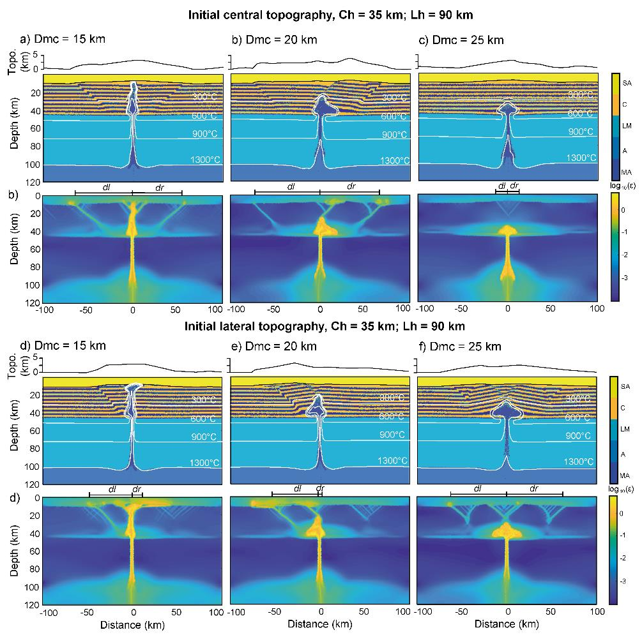
Supplementary Fig. 1. Final steps of simulations accounting for Ch = 35 km and Lh = 90 km. Symbols and definitions are the same of Fig. 2. a-c) The initial central topography is centered above the MMZ. d-f) The initial topography is laterally shifted (rightward) respect to the MMZ.
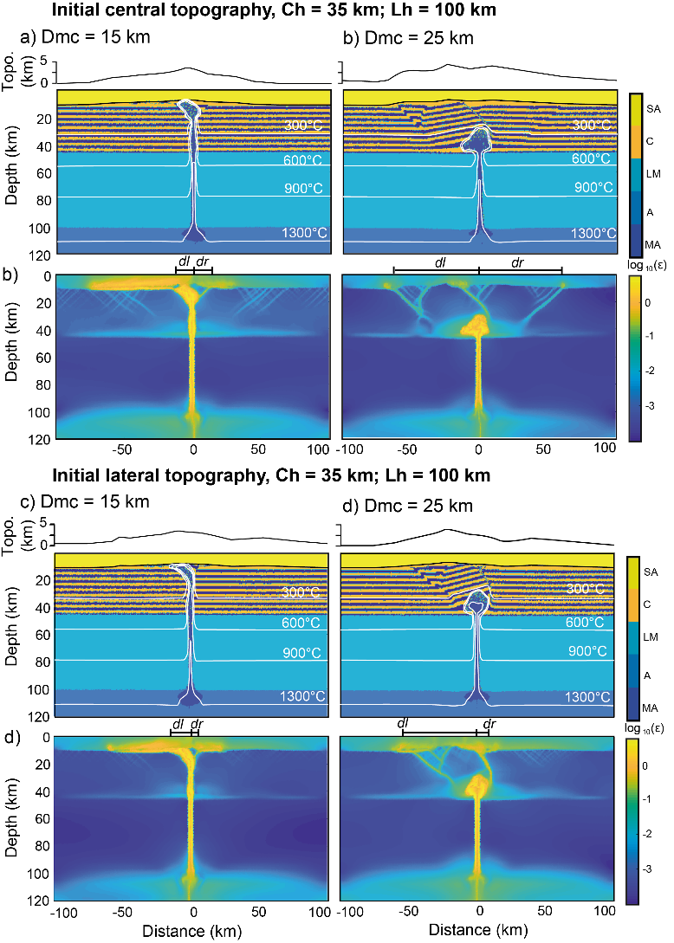
Supplementary Fig. 2. Final steps of simulations accounting for Ch = 35 km and Lh = 100 km. Symbols and definitions are the same of Fig. 2. a, b) The initial topography is centered above the MMZ. c, d) The initial topography is laterally shifted (rightward) respect to the MMZ.

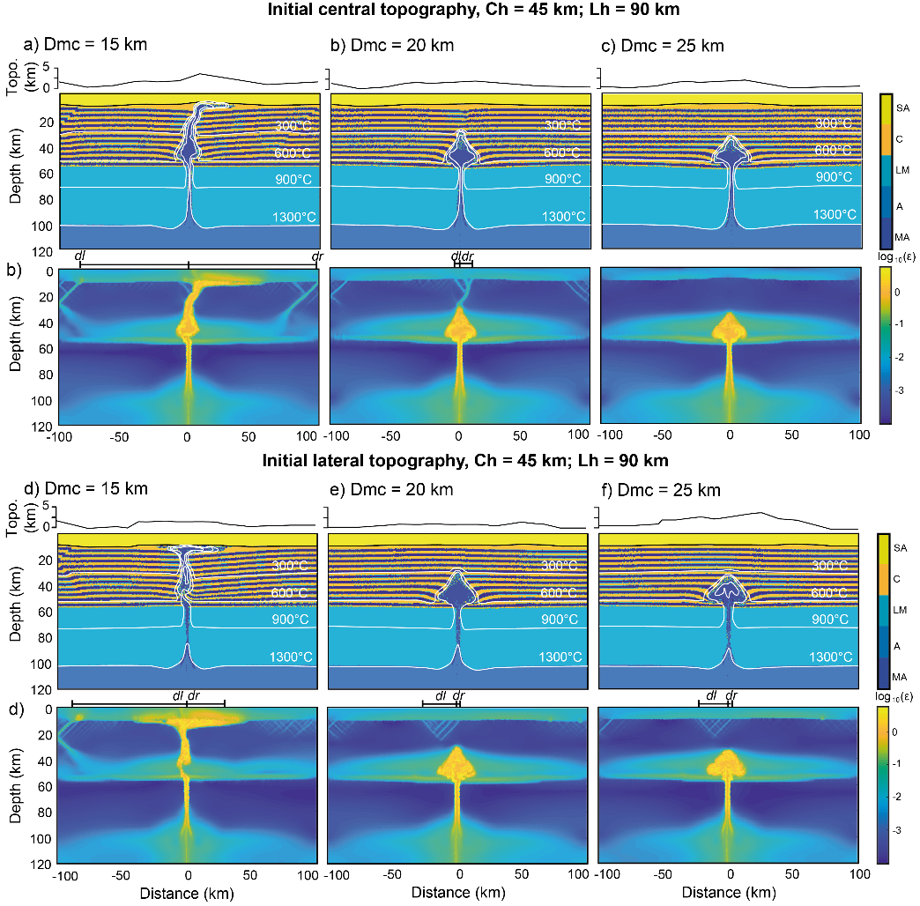
Supplementary Fig. 3. Final steps of simulations accounting for Ch = 45 km and Lh = 90 km. Symbols and definitions are the same of Fig. 2. a-c) The initial topography is centered above the MMZ. d-f) The initial topography is laterally shifted (rightward) respect to the MMZ.
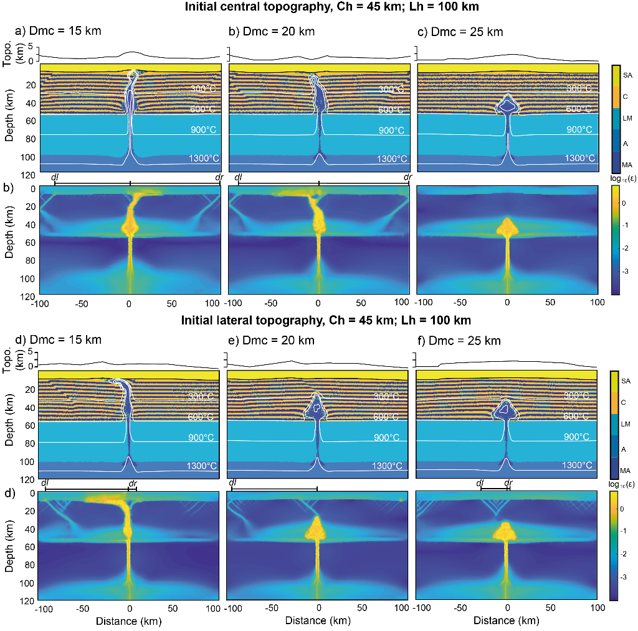
Supplementary Fig. 4. Final steps of simulations accounting for Ch = 45 km and Lh = 100 km. Symbols and definitions are the same of Fig. 2. a-c) The initial topography is centered above the MMZ. d-f) The initial topography is laterally shifted (rightward) respect to the MMZ.
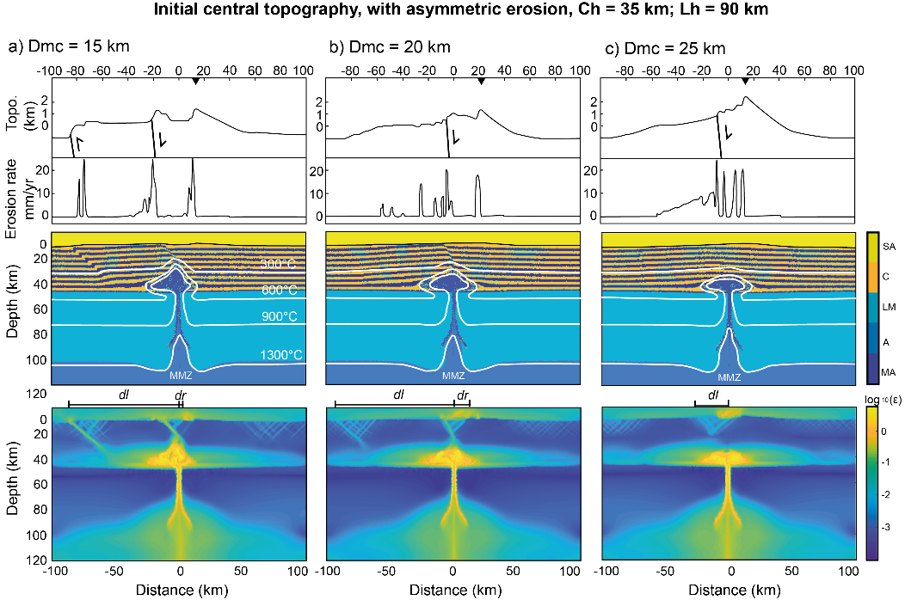
Supplementary Fig. 5. Final steps of simulations accounting for Ch = 35 km and Lh = 90 km with asymmetric erosion. Symbols and definitions are the same of Fig. 3. a-c) The initial topography is centered above the MMZ.
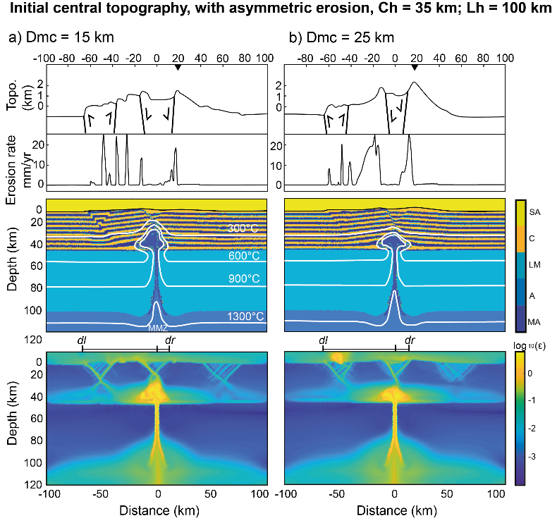
Supplementary Fig. 6. Final steps of simulations accounting for Ch = 35 km and Lh = 100 km with asymmetric erosion. Symbols and definitions are the same of Fig. 3. a-b) The initial topography is centered above the MMZ.

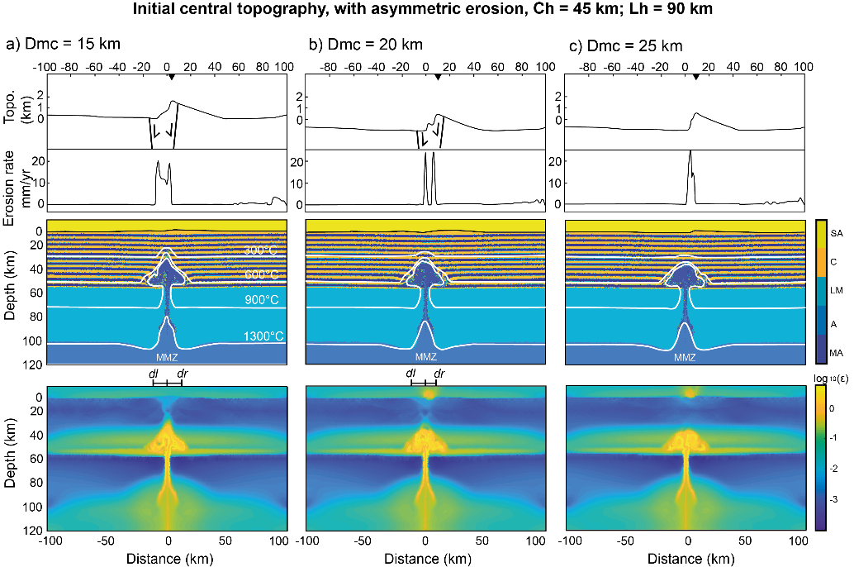
Supplementary Fig. 7. Final steps of simulations accounting for Ch = 45 km and Lh = 90 km with asymmetric erosion. Symbols and definitions are the same of Fig. 3. a-c) The initial topography is centered above the MMZ.

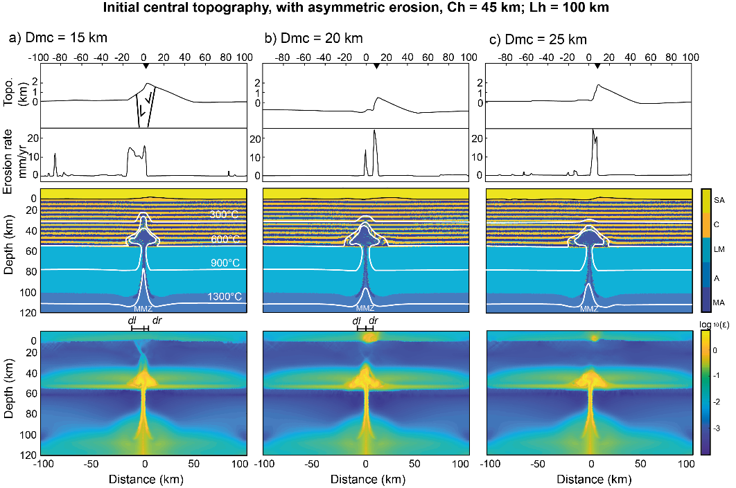
Supplementary Fig. 8. Final steps of simulations accounting for Ch = 45 km and Lh = 100 km with asymmetric erosion. Symbols and definitions are the same of Fig. 3. a-c) The initial topography is centered above the MMZ.

