Appendix to
Grøsland, Larsen, Reneflot, Hart (2022): The COVID-19 pandemic’s impact on the mental health of Norwegian students in higher education: a nation-wide register-based event study
Table A1. Descriptive statistics on group characteristics for pre-pandemic and pandemic students for the sample used for the prescribed drugs outcomes
 | Pandemic cohort |  | Pre-pandemic cohort
Sample characteristics
Persons, N | 12 501 |  | 12 750
Age, mean (SD) | 19 (0) |  | 19 (0)
Sex, N (%)
Females | 7 878(63) |  | 7 997 (62.7)
Males | 4 623(37) |  | 4 753 (37.2)
Birth country, N (%)
Norway | 11 192(89.5) |  | 11 541(90.5)
Abroad | 1 309(10.5) |  | 1 209(9.5)
Mental health outcomes, monthly % | Oct 2019-  Feb 2020 | Mar 2020-  Aug 2021 | Oct 2019-  Feb 2020ª | Mar 2020-  Aug 2021^{b}
Dispensed prescription drugs |  |  |  |  | ATC codes (prefix)
Anxiolytics, antidepressants, sedatives | 0.8 | 0.94 | 0.83 | 1.01 | N05B*, N06A*, N05C*
Anxiolytics, antidepressants | 0.51 | 0.65 | 0.49 | 0.68 | N05B*, N06A*
Sedatives | 0.33 | 0.32 | 0.37 | 0.38 | N05C*
Table 1 notes: Mental health outcomes show the monthly percentage of pandemic and pre-pandemic students with dispensed prescription drug (anxiolytic, antidepressant, or sedative). ^{a,b} October 2019-August 2021 refers to the measurement time (calendar month) for the pandemic students, i.e., measurements for the pre-pandemic students were made 12. ªOctober 2019-February 2020 corresponds to relative months -5 to -1 (pre-treatment period). ^{b} Mar 2020-Feb 2021 corresponds to relative months 0 to 11 (post-treatment period).

Figure A1. The impact of the pandemic on mental health care use among students, absolute coefficients
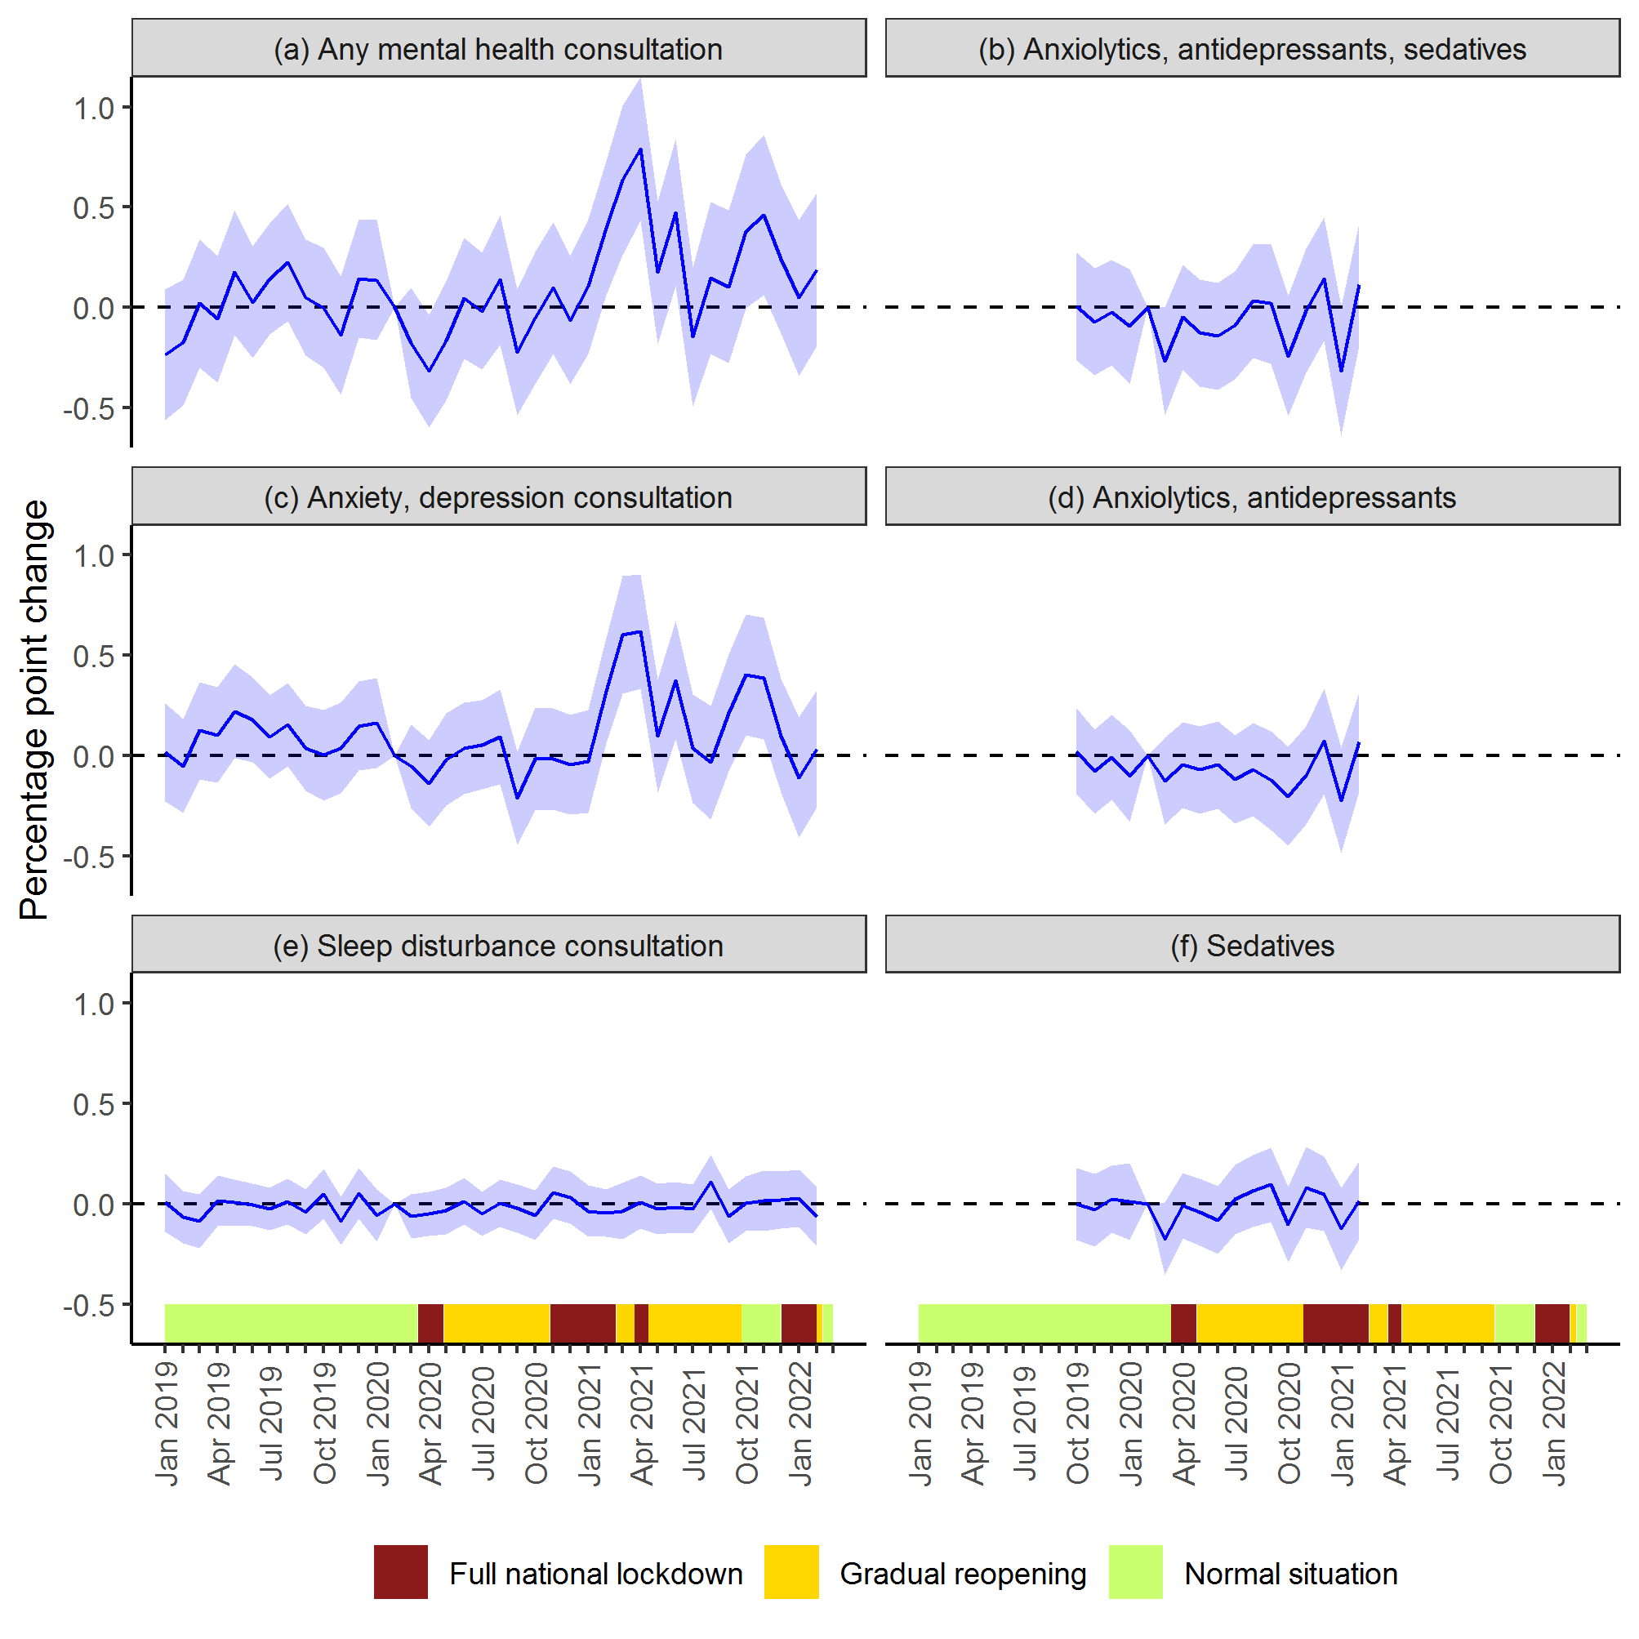
Figure A1 note: Results from event study models estimated separately for each outcome. Solid lines show monthly coefficients with corresponding 95 % confidence interval (shaded). Coefficients refer to the absolute change (measured in percentage points) in mental health care use among pandemic students, relative to pre-pandemic students. For more information on model specification see table note in table A2. The timeline of infection control measures, categorized by three levels of stringency, is illustrated on the x-axis (analogous to Figure 1).
Month | Any mental health consultation |  | Anxiety/depression consultation |  | Sleep disturbance consultation |  | Anxiolytics, antidepressants, sedatives |  | Anxiolytics/  antidepressants |  | Sedatives
 | β (SE) | Rel. % | β (SE) | Rel. % | β (SE) | Rel. % | β (SE) | Rel. % | β (SE) | Rel. % | β (SE) | Rel. %
01.2019 | -0.23 (0.17) | -21,57 | 0.02 (0.12) | 2,69 | 0.01 (0.07) | 4,3
02.2019 | -0.17 (0.16) | -16,05 | -0.05 (0.12) | -8,58 | -0.07 (0.07) | -46,35
03.2019 | 0.02 (0.16) | 1,88 | 0.12 (0.12) | 20,96 | -0.09 (0.07) | -59,19
04.2019 | -0.06 (0.16) | -5,3 | 0.1 (0.12) | 17,42 | 0.01 (0.06) | 9,74
05.2019 | 0.17 (0.16) | 16,13 | 0.22* (0.12) | 37,26 | 0.01 (0.06) | 5,41
06.2019 | 0.03 (0.14) | 2,49 | 0.18* (0.11) | 29,96 | -0.01 (0.05) | -3,8
07.2019 | 0.14 (0.14) | 13,35 | 0.09 (0.11) | 15,66 | -0.03 (0.05) | -17,47
08.2019 | 0.23 (0.15) | 20,87 | 0.15 (0.11) | 26,03 | 0.01 (0.06) | 7,64
09.2019 | 0.05 (0.15) | 4,5 | 0.04 (0.11) | 6,47 | -0.04 (0.06) | -27,45
10.2019 | 0 (0.15) | -0,22 | 0 (0.12) | 0,43 | 0.05 (0.06) | 34,02 | 0 (0.14) | 0,59 | 0.02 (0.11) | 4,39 | 0 (0.09) | -0,44
11.2019 | -0.14 (0.15) | -12,78 | 0.04 (0.11) | 6,5 | -0.08 (0.06) | -58,42 | -0.07 (0.14) | -8,95 | -0.08 (0.11) | -15,55 | -0.03 (0.09) | -9,44
12.2019 | 0.15 (0.15) | 13,45 | 0.15 (0.11) | 24,67 | 0.05 (0.06) | 36,47 | -0.02 (0.13) | -3,04 | -0.01 (0.11) | -1,52 | 0.02 (0.09) | 7,08
01.2020 | 0.14 (0.15) | 12,68 | 0.16 (0.11) | 27,39 | -0.06 (0.07) | -40,83 | -0.09 (0.15) | -11,75 | -0.1 (0.12) | -20,26 | 0.01 (0.1) | 3,05
02.2020 | 0 | 0 | 0 | 0 | 0 | 0 | 0 | 0 | 0 | 0 | 0 | 0
03.2020 | -0.18 (0.14) | -16,35 | -0.05 (0.11) | -8,86 | -0.06 (0.06) | -42,29 | -0.27* (0.14) | -33,59 | -0.13 (0.11) | -24,69 | -0.17* (0.09) | -52,78
04.2020 | -0.32** (0.14) | -29,2 | -0.14 (0.11) | -23,31 | -0.05 (0.06) | -35,18 | -0.05 (0.13) | -5,99 | -0.05 (0.11) | -9,15 | -0.01 (0.08) | -2,71
05.2020 | -0.17 (0.15) | -15,33 | -0.02 (0.12) | -3,18 | -0.03 (0.06) | -23,95 | -0.13 (0.14) | -15,75 | -0.07 (0.11) | -13,68 | -0.04 (0.08) | -12,23
06.2020 | 0.05 (0.15) | 4,27 | 0.04 (0.12) | 6,03 | 0.01 (0.06) | 8,29 | -0.14 (0.14) | -17,92 | -0.05 (0.11) | -9,15 | -0.08 (0.09) | -24,47
07.2020 | -0.02 (0.15) | -1,6 | 0.05 (0.11) | 9,15 | -0.05 (0.06) | -33,16 | -0.09 (0.14) | -11,07 | -0.12 (0.11) | -23,23 | 0.02 (0.09) | 6,72
08.2020 | 0.14 (0.16) | 12,74 | 0.09 (0.12) | 15,63 | 0 (0.06) | 3,01 | 0.03 (0.14) | 4,14 | -0.07 (0.12) | -13,59 | 0.06 (0.09) | 19,21
09.2020 | -0.22 (0.16) | -20,59 | -0.21* (0.12) | -35,84 | -0.02 (0.06) | -15,54 | 0.02 (0.15) | 2,45 | -0.12 (0.13) | -24,15 | 0.1 (0.09) | 28,89
10.2020 | -0.05 (0.17) | -4,79 | -0.02 (0.13) | -2,75 | -0.06 (0.06) | -38,93 | -0.24 (0.15) | -30,24 | -0.2 (0.13) | -39,63 | -0.1 (0.1) | -31,15
11.2020 | 0.1 (0.17) | 8,94 | -0.02 (0.13) | -2,79 | 0.06 (0.07) | 38,13 | -0.02 (0.16) | -2,08 | -0.1 (0.12) | -19,38 | 0.08 (0.1) | 24,99
12.2020 | -0.06 (0.16) | -5,74 | -0.04 (0.13) | -7,51 | 0.03 (0.07) | 21,57 | 0.14 (0.16) | 17,86 | 0.07 (0.13) | 14,03 | 0.05 (0.09) | 14,68
01.2021 | 0.11 (0.17) | 9,72 | -0.03 (0.13) | -4,55 | -0.04 (0.07) | -25,22 | -0.32* (0.16) | -39,54 | -0.22* (0.13) | -43,81 | -0.12 (0.1) | -37,58
02.2021 | 0.4** (0.17) | 36,6 | 0.32** (0.13) | 54,21 | -0.05 (0.06) | -31,84 | 0.12 (0.16) | 14,61 | 0.07 (0.13) | 13,47 | 0.02 (0.1) | 5,21
03.2021 | 0.63*** (0.19) | 58,61 | 0.6*** (0.15) | 101,45 | -0.04 (0.07) | -24,84
04.2021 | 0.79*** (0.18) | 73,11 | 0.62*** (0.14) | 104,12 | 0.01 (0.07) | 5,49
05.2021 | 0.17 (0.18) | 16,11 | 0.1 (0.14) | 16,21 | -0.02 (0.06) | -16,9
06.2021 | 0.47** (0.19) | 43,8 | 0.38** (0.15) | 63,29 | -0.02 (0.06) | -11,34
07.2021 | -0.15 (0.18) | -13,56 | 0.04 (0.14) | 6 | -0.02 (0.06) | -17,17
08.2021 | 0.15 (0.19) | 13,58 | -0.03 (0.14) | -5,66 | 0.11 (0.07) | 75,84
09.2021 | 0.1 (0.19) | 9,68 | 0.21 (0.15) | 35,83 | -0.06 (0.07) | -42,18
10.2021 | 0.38* (0.2) | 35,13 | 0.4*** (0.15) | 67,45 | 0 (0.07) | 2,13
11.2021 | 0.46** (0.2) | 42,6 | 0.38** (0.15) | 64,68 | 0.02 (0.08) | 10,37
12.2021 | 0.24 (0.19) | 22,45 | 0.1 (0.14) | 16,61 | 0.02 (0.07) | 13,27
01.2022 | 0.05 (0.2) | 4,44 | -0.11 (0.15) | -18,23 | 0.03 (0.07) | 18,81
02.2022 | 0.19 (0.19) | 17,5 | 0.03 (0.15) | 5,73 | -0.06 (0.08) | -44,6
Table A2. Event study estimates of the monthly difference in mental health consultations and dispensed prescribed drugs.
Table A2 notes: Results from event study models (β) quantify the change in mental health outcomes (measured as change in percentage points), controlling for age, year of enrollment and a dummy variable for the duration variable in month. March 2020 (t-1) is set to referance period. Standard errors (SEs) are clustered on individuals. In addition to the presentation of results in absolute terms, relative differences in percent (Rel. %) are also presented, calculated by dividing the absolute estimate (and corresponding standard error) for each of the post-periods by the monthly average health outcome for the pandemic students in the period prior to the pandemic (January 2019-February 2020 for consultations and October 2019-February 2020 for dispensed prescription drugs). Stars indicate confidence levels (*p≤0.1; **p≤0.05; ***p≤0.01).

